Low dose response results and detection limits of the EURADOS intercomparison IC2021area for passive H*(10) area dosemeters
Christian Hranitzky ^{a,f,*}, Christian Naber ^{b,f}, Julia Aslan ^{b,f}, Maria A. Duch ^{c,f},
Thomas Haninger ^{d,f}, Zˇeljka Kneˇzevi´c ^{e,f}
ª Seibersdorf Labor GmbH, Seibersdorf, Austria
^{b} Karlsruhe Institute of Technology, Karlsruhe, Germany
^{c} Universitat Polit`ecnica de Catalunya, Barcelona, Spain
^{d} Mirion Technologies (AWST) GmbH, Munich, Germany
^{e} Ruđer Boˇskovi´c Institute, Zagreb, Croatia
^{f} European Radiation Dosimetry Group (EURADOS) e.V., Neuherberg, Germany

Keywords:
EURADOS Intercomparison Area dosimetry
Passive dosemeter Dosemeter response Background dose Detection limit
A B S T R A C T

The EURADOS intercomparison IC2021area with its main focus on low dose measurements was carried out between May 2021 and April 2022 for passive H*(10) area dosimetry systems. Three measurement conditions were provided at locations of the Karlsruhe Institute of Technology: 3-months indoor, 3-months outdoor and 6- months outdoor. The challenge for the 65 participating dosimetry systems of this intercomparison was measuring additionally irradiated low dose ¹³⁷Cs gamma radiation of 150 μSv and 300 μSv. Despite the comparably high background dose values between about 200 μSv and 1600 μSv, more than 90% of the resulting response values of the irradiated dosemeters were within the recommended ISO 14146 response limits. The calculated detection limits of the participating dosimetry systems were in most cases clearly below the desired value of 150 μSv of this intercomparison.

Introduction

The European Radiation Dosimetry Group EURADOS (www.eurados. org) is a network of 80 European institutions and more than 600 indi- vidual members. EURADOS Working Group 3 on “Environmental Dosimetry” (WG3) carries out research projects and coordinated activ- ities in the field of area dosimetry. Subgroup 2 of WG3 is focused on “Passive Environmental Dosimetry” and had organized the first EUR- ADOS intercomparison IC2014env of passive H*(10) area dosemeters between 2014 and 2015 (Dombrowski et al., 2017). A second interna- tional intercomparison IC2017prep (Dombrowski, 2019) was carried out in collaboration with the EURAMET EMPIR Preparedness project between 2017 and 2018. The results obtained in the intercomparisons were important for the quality assurance systems of the participants as well as for the performance comparison and harmonization of passive area dosimetry systems in Europe. The current intercomparison IC2021area differs from all previous EURADOS intercomparisons because of its key aspect on low dose measurements. The organizing group decided to focus this intercomparison on testing the performance

of dosemeters in measuring low doses, since this is considered a very important - maybe the most important - capability of passive area dosemeters. The only information given by the organization group in advance to the participants was that 12 dosemeters must be provided per dosimetry system and that the extra dose values irradiated will be certainly below 0.5 mSv. Passive area dosemeters are widely used in environmental radiation monitoring for long-term dosimetry measure- ments of public areas or borders e.g. of nuclear installations with cor- responding low dose limits (e.g. 1 mSv per year) or even lower regulated dose constraints (e.g. 0.3 mSv per year for photon radiation emitted by a nearby facility).

Participating dosimetry systems, dosemeter handling and irradiations

65 passive H*(10) area dosimetry systems from 46 different in- stitutes from 17 European countries and 2 non-European countries participated in the intercomparison and reported their measured dose values. The names of the participating institutions are not mentioned in

* Corresponding author. Seibersdorf Labor GmbH, Seibersdorf, Austria.
E-mail address: christian.hranitzky@seibersdorf-laboratories.at (C. Hranitzky).

publications to guarantee anonymity of the participants and their re- sults. The number of participating systems per country are 14 (Italy), 9
Table 1
Detection limits H# for the 65 participating dosimetry systems.

(Germany), 5 (Slovenia, Spain), 4 (Belgium, Japan), 3 (Austria, France, Switzerland, United Kingdom), 2 (Croatia, Czech Republic, Sweden) and
Ranking number
Reporting number
Detector type
Meas. condition
H# in
μSv

1 (Bulgaria, Canada, Lithuania, Portugal, Romania.
Serbia). 70% of the systems used TL (Thermo Luminescence) detec- tor types, 12% RPL (Radio Photo Luminescence), 11% OSL (Optically Stimulated Luminescence), 6% film and 1 combined TL/RPL dosemeter system participated. The irradiating laboratory of the Karlsruhe Institute of Technology (KIT) provided 3 measurement conditions that could be chosen by the participants, i.e. 3-months outdoor at a free-field area (28 systems), 3-months indoor in a normal office (23 systems) and 6-months outdoor (14 systems). The measurement area of KIT with more than 500 dosemeters positioned for the 3-months and 6-months outdoor mea- surement conditions can be seen in Fig. 1. For each participating system the measurement condition and the system detector type can be found in Table 1. The ISO/IEC 17025 accredited calibration laboratory of KIT irradiated 3 dosemeters per system with a lower reference dose of 150 μSv and another 3 dosemeters with the slightly higher reference dose of 300 μSv, both roughly in the midterm of the measurement periods. The radiation quality was S–Cs, i.e. ¹³⁷Cs reference gamma radiation ac- cording to ISO 4037 (2019), with which 80% of the participating sys- tems are calibrated as reference energy. The expanded measurement uncertainty of the reference dose values was 4.3% (expansion factor k = 2).

Evaluation method

The participants had no prior information which radiation quality and dose values were used for the extra irradiations and which dose- meters were left unirradiated. The background dose was calculated by the organization group as the mean value of 6 unirradiated dosemeters of a dosimetry system. The net dose values of the 6 irradiated dosemeters of a system were calculated by subtracting the background dose from the reported dose values. Finally, the response results of the 6 irradiated dosemeters of a system were calculated as the ratio of the net dose and the reference dose. The response results of a system for the reference dose of 150 μSv were compared with the lower and upper ISO 14146 (2018) response limits for this reference dose, i.e. 0.50 and 1.87 respectively. Similarly, the response results at 300 μSv were compared with response limits for this reference dose, i.e. 0.60 and 1.80 respec- tively. These limits for the dosemeter response R were calculated ac- cording to the formula specified in section 7.1.1 of the ISO 14146 standard with irradiated dose values H_{ref} in μSv units:
  - 45 RPL 3/out 21
  - 22 TLD 3/in 16
  - 7 TLD 3/out 15
  - 6 TLD 3/out 12
  - 8 TLD 3/out 24
  - 65 TLD 6/out 21
  - 9 RPL 3/out 12
  - 62 TLD 6/out 17
  - 46 TLD 3/out 20
  - 26 TLD 3/out 26
  - 58 TLD 6/out 18
  - 10 TLD 3/out 17
  - 53 TLD 6/out 27
  - 44 RPL 3/in 28
  - 5 OSL 3/in 20
  - 3 TLD 3/out 11
  - 20 TLD 3/in 26
  - 32 RPL 3/in 69
  - 23 OSL 3/out 41
  - 43 TLD 3/out 28
  - 49 TLD 3/out 27
  - 25 TLD 3/out 45
  - 13 TLD 3/out 9
  - 12 TLD 3/in 29
  - 24 TLD 3/out 49
  - 21 TLD 3/out 13
  - 14 TLD 3/in 23
  - 61 OSL 6/out 55
  - 35 TLD 3/in 29
  - 37 Film 3/in 86
  - 40 TLD 3/in 99
  - 64 TLD 6/out 99
  - 4 OSL 3/out 21
  - 34 TLD 3/in 27
  - 50 OSL 3/in 38
  - 27 TLD 3/in 70
  - 63 RPL + TLD 6/out 83
  - 31 RPL 3/in 71
  - 38 Film 3/in 139
  - 42 TLD 3/out 88
  - 52 TLD 6/out 132
  - 16 TLD 3/out 73
  - 36 Film 3/in 77
  - 54 TLD 6/out 14
  - 28 TLD 3/out 47
  - 56 TLD 6/out 13
  - 39 TLD 3/in 36
  - 48 Film 3/in 85
  - 11 RPL 3/out 56
  - 1 TLD 3/in 92
  - 15 TLD 3/out 117
  - 60 TLD 6/out 89
  - 33 OSL 3/in 21
  - 2 OSL 3/out 176
  - 30 RPL 3/out 104
  - 41 TLD 3/out 90
  - 51 TLD 3/in 215
  - 57 TLD 6/out 34
  - 47 TLD 3/in 92
  - 29 RPL 3/out 432
  - 59 TLD 6/out 104
  - 17 TLD 3/out 102
  - 18 TLD 3/in 127
  - 19 TLD 3/out 116
  - 55 TLD 6/out 226
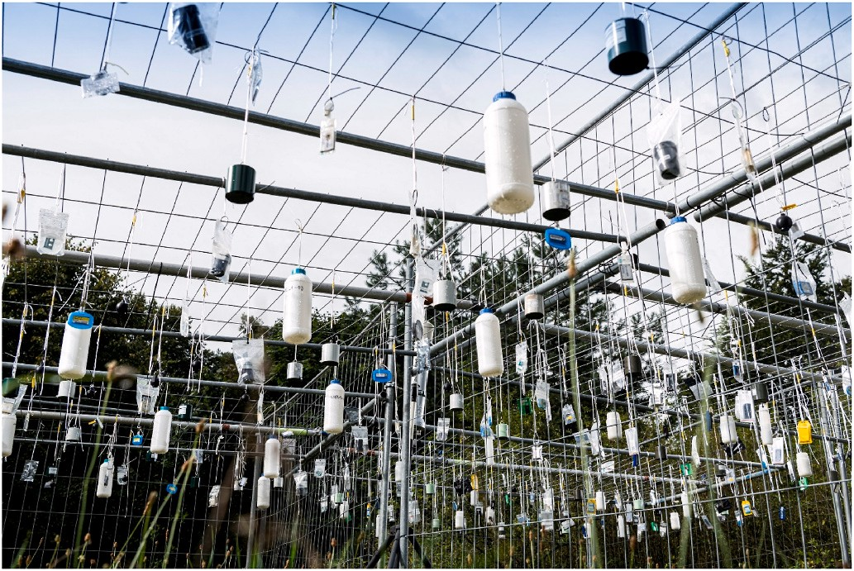
0.71(1 53 ) ≤ R ≤ 1.67(1 + 35 )

26 + H_{ref} 140 + H_{ref}

Fig. 1. Photo of various dosemeters from participating passive area dosimetry systems positioned and exposed to natural environmental radiation at a height of 1 m above ground at the KIT outdoor measurement area.
The lower dose limit parameter H₀ was chosen equal to 35 μSv. For the current revision of ISO 14146, this H₀ value is proposed as the rec- ommended lower dose limit for proficiency testing of environmental

dosemeters. An under-response below 0.50 (i.e. a measured net dose value that is more than a factor of 2 below the conventional true value) is therefore not tolerated in the intercomparison. 53 dosimetry systems met these limits with all of their 6 dosemeter response results. These systems are shown with green colour in the figures. 7 dosimetry systems met the criteria with 5 dosemeters but had a fail with 1 dosemeter. A fail of 10% of the dosemeters are allowed according to the ISO 14146 criteria. Due to the small number of dosemeters in this intercomparison, a system with 1 fail was considered to just pass the criteria. These sys- tems are shown with orange colour in the figures. Finally, 5 dosimetry systems had more than 1 fail and therefore did not pass the ISO 14146 criteria. These systems are shown with red colour in the figures.

Intercomparison results

The reported dose values, the calculated net dose values and the resulting dosemeter response values are presented in detail in chapter 5 of the EURADOS report (Hranitzky et al., 2022). In contrast to the EURADOS report, the average response values instead of the individual response values of the 6 irradiated dosemeters of a dosimetry system are presented in Fig. 2. These values are not used for the evaluation of a pass or fail of the applied ISO 14146 criteria but provide a better compara- bility of the dosimetry systems. For the same reason, the ideal response value 1 and the ISO 14146 limits for the reference dose of 150 μSv are included in Fig. 2. The dosimetry systems are sorted according to their ranking number which is not identical to the system number or reporting number of the intercomparison certificates. For this ranking, the root-mean-square deviation RMSD of the 6 individual response results from the ideal response 1 was calculated for each system. The RMSD of the system in first place was 0.04, whereas of the system in last place it was 1.8. A low variation in the individual response results is a key issue in area dosimetry and necessary to meet the response criteria. Therefore, the uncertainties of the mean response values were included as error bars (95% confidence interval) in Fig. 2. On the left side of Fig. 2, the first systems are close to the ideal response equal 1. Their uncertainty bars (around ± 0.04) are smaller than the size of the symbols. On the very right side, the uncertainty bars (±2.1) of the last dosimetry system number 65 cannot be fully displayed. These type A measurement un- certainties according to GUM (JCGM 100, 2008) were calculated by the experimental standard deviation of the mean multiplied by the Student’s t-distribution value 2.57 (5 degrees of freedom). As the mean values and error bars in Fig. 2 are based on averaging of different reference dose values (150 μSv and 300 μSv), these results should be used for com- parison purposes only. In addition, there are no type B uncertainties of the participating dosimetry systems included, an overall performance assessment is therefore not possible. No significant differences in the sorted distribution of the response results were observed for the different

measurement conditions and for the different detector materials. Dosimetry systems with high background dose values (i.e. higher than 500 μSv in this intercomparison) are indicated by black triangles in all figures.

Background dose and detection limits

The lower limit of detection H# of a dosimetry system represents the lowest net dose which can be measured with appropriate confidence. It depends on the statistical variation of the measured dose at low dose values, i.e. close to the detection limit, as well as on the statistical variation of the corresponding background dose. The precise determi- nation according ISO 11929 (2019) which is based on a recursion for- mula is not possible for this intercomparison. According to the standard, the first estimate of the detection limit can solely be determined by the type A standard uncertainty of the corrected background dose u(M_{BG}/R) times the multiplication factor 4.65:
H# = 2 × √̅2̅̅ × 1.645 × u(M_{BG} / R)
The multiplication factor 4.65 is the product of 2 times the square root of 2 times 1.645 presuming a 95% single-sided confidence interval for normal distributions. The factor of 2 is included because the detec- tion limit is approximated by the decision threshold times the factor of 2. The square root of 2 is necessary because there are two (in this approximation equal) uncertainty distributions involved in the deter- mination of the decision threshold. The background dose M_{BG} was cor- rected by the factor 1/R determined as the reciprocal of the mean response of the system. This corrective procedure can be explained by an extreme example of a system participated in this intercomparison with a mean response value of 0.34. This particular system provided net dose results which were about a factor of 3 too low. Consequently, the detection limit would be too low by a factor of 3 compared to the sys- tems with appropriate response values close to 1.
Fig. 3 shows the detection limits of all dosimetry systems of this intercomparison in sorted order, i.e. with increasing values of the detection limit from left to right. This graph is important for answering the question if the reference dose of 150 μSv can be detected by the participating dosimetry systems considering the conditions of this in- ternational comparison study. All participants had to provide the in- formation on the lower measurement limit H_{min} of their system upon registration. The performance criteria for H_{min} are defined in the IEC 62387 (2020) but this specification may not be used by all participants in this intercomparison. The lower measurement limits were stated by the participants according to the predefined ranges: 34% of the systems between 1 μSv and 36 μSv, 52% between 36 μSv and 70 μSv, 14% be- tween 71 μSv and 105 μSv and no system above 105 μSv. As can be seen in Fig. 3, the calculated detection limits H# were in most cases below the

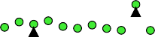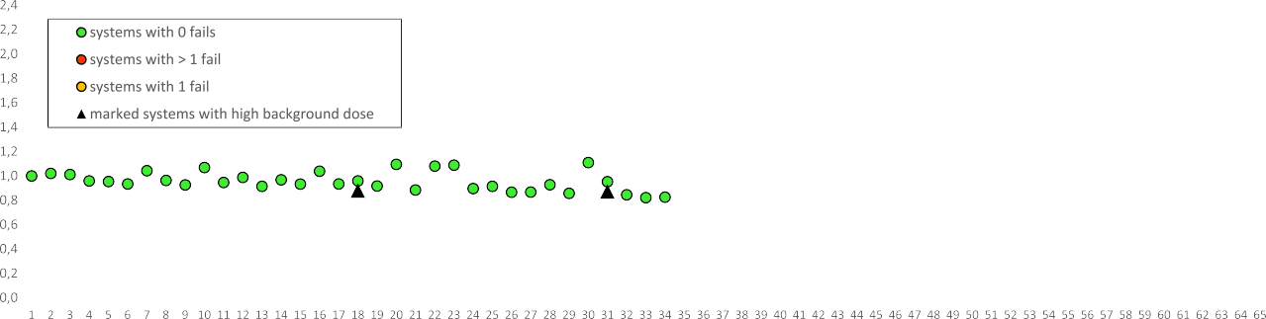
Fig. 2. For each dosimetry system the average response of the 6 individual dosemeter response results are shown with their expanded uncertainties. The systems are sorted according to their ranking number. The ideal response equal 1 is shown as black horizontal line. The red horizontal lines are the lower and upper ISO 14146 response limits for the reference dose of 150 μSv (solid red lines) and 300 μSv (dashed red lines).

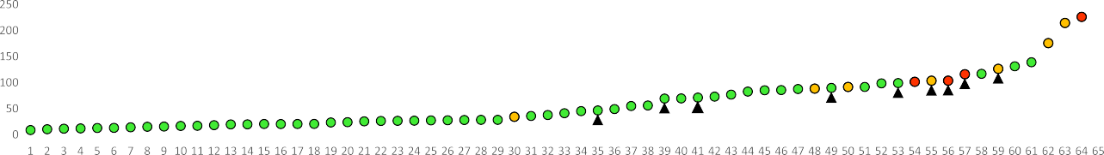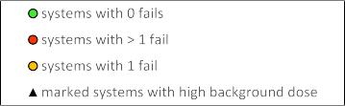Fig. 3. For each dosimetry system the approximate detection limits are shown here. The 150 μSv detection limit is delineated (black horizontal line). The systems are sorted in ascending order. On the left side, there are systems with very low detection limits and without out any fails concerning the ISO 14146 response criteria.

lowest reference dose of 150 μSv. Systems with one fail or even more than one fail of the response limits have obviously higher detection limits than most of the systems which passed all response limits.
Another interesting question is whether dosimeters with high back- ground dose values (i.e. higher than 500 μSv in this intercomparison) are capable of measuring a low dose of 150 μSv. In Fig. 3 these systems are on the right side which means that they have higher detection limits than the average of all systems. But all of these systems except one have detection limits below 150 μSv and should therefore be able (at least statistically) to meet the response criteria. Fig. 4 shows more clearly the dependence of the detection limit on the background dose. Most systems are in the range of the background dose from 200 μSv to 400 μSv. The expected background dose of a 3-month measurement period with a total of about 100 days and a widely accepted natural background dose rate of 2 μSv/d is 200 μSv. Similarly, a 6-month period with about 200 days may result in a background dose of about 400 μSv. For the systems with high background dose values a significant contribution from transport dose must be assumed. In addition, an increased variation in dose values due to additional exposure during the transport can be concluded from all the figures presented here. Increased dose variations can be expected because every irradiation is somehow spatially inho- mogeneous over the exposed dosemeters, e.g. due to cargo X-ray scan- ning of the package of dosemeters at the airports and the shipping companies.
In Table 1 the values of the detection limits are presented for all
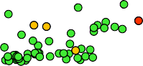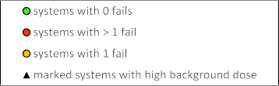participating dosimetry systems. The systems are listed according to their ranking number of the response results as explained earlier. In addition, the anonymous system reporting number is provided as spec- ified on the participant’s intercomparison certificate. For comparison purposes, the passive detector type and the measurement condition (3/
in means 3 months indoor, 3/out means 3 months outdoor, 6/out means 6 months outdoor) of each system are included.

Conclusions and outlook

From the point of view of the organization group the IC2021area was successfully carried out with some new aspects in addition to the low reference dose irradiations, e.g. the communication via the online platform or the assessment of conformity to ISO 14146 performance criteria in the certificates of participation. Some problems were also encountered which are discussed in detail in the EURADOS report (Hranitzky et al., 2022), e.g. customs formality problems, dosemeters provided without suspension device and some wet dosemeters in the outdoor location. Despite these challenges, most participants in the final online survey were quite positive about both the organization and their own results.
Some participants are interested in even lower reference dose values due to their national requirements and regulations. The detection limit evaluations in this intercomparison actually allow lower reference dose values but not for all participants. A solution for future intercomparisons could be to provide different levels of reference dose values depending on the lowest measurable dose specified by the participant.
In case of higher background dose due to significant transport dose contributions, the intercomparison can be considered as a worst-case scenario for routine transport conditions to customers. The evaluation of the response results and the lower detection limits indicates drawback for systems with higher background dose but not necessarily a failure of the recommended ISO 14146 response criteria.
As can be seen in Fig. 16 of the EURADOS report (Duch et al., 2021) about half of the European area dosimetry services in this questionnaire

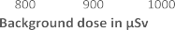
Fig. 4. For each dosimetry system the approximate detection limits as a function of the background dose of the system are shown. The 150 μSv detection limit is delineated (black horizontal line).

neither subtract a background dose nor provide a net dose to their customers, but many services correct for the transport dose contribution. A future intercomparison could include a way to determine and compare the transport dose values and consequently the natural background dose values during the exposure period, e.g. by storing additional dosemeters in a shielded room with significantly reduced background dose rate. This would allow a comparison of the measured background dose values during the exposure period and during the transport period. Another issue could be addressed in a future intercomparison for services providing personal dosemeters instead of area dosemeters for environ- mental radiation monitoring. This may be necessary due to a lack of area dosemeters, for example in case of a large-scale radiological emergency situation.

Declaration of competing interest

The authors declare that they have no known competing financial interests or personal relationships that could have appeared to influence the work reported in this paper.

Data availability

The data that has been used is confidential.

Acknowledgements

This work has been performed by the IC2021area intercomparison organization group within the scientific network of EURADOS notably within WG3 SG2 “Passive Environmental Dosimetry”. The authors thank all EURADOS working group members and intercomparison participants
for their interest and feedback, the KIT team for dosemeter handling and irradiations and Christian Ga¨rtner for administrating the online platform (www.eurados-intercomparison.org).

References

Dombrowski, H., Duch, M.A., Hranitzky, C., Kleinau, P., Neumaier, S., Ranogajec- Komor, M., Rodriguez, R., 2017. EURADOS intercomparison of passive H*(10) area dosemeters 2014. Radiat. Meas. 106, 229–234. https://doi.org/10.1016/j. radmeas.2017.05.008.
Dombrowski, H., 2019. Preparedness intercomparison of passive H*(10) area photon dosemeters in 2017/2018 (IC2017prep). J. Instrument., JINST 14, P10008. https:// doi.org/10.1088/1748-0221/14/10/P10008.
Duch, M.A., Dombrowski, H., Hranitzky, C., 2021. Overview of passive area dosimetry systems used in European countries. EURADOS 2021 (February). https://doi.org/ 10.12768/w4hj-ef08. Report 2021-02, Neuherberg.
Hranitzky, C., G¨artner, C., Naber, C., Aslan, J., Duch, M.A., Haninger, T., Knezevic, Z., 2022. Intercomparison IC2021area of passive area dosimetry systems. EURADOS 2022 (May). https://doi.org/10.12768/55t9-ms26. Report 2022-01, Neuherberg.
IEC 62387, 2020. Radiation Protection Instrumentation – Dosimetry Systems with Integrating Passive Detectors for Individual, Workplace and Environmental Monitoring of Photon and Beta Radiation, second ed..0. International Electrotechnical Commission, p. 2020. 01.
ISO 14146, 2018. Radiological Protection — Criteria and Performance Limits for the Periodic Evaluation of Dosimetry Services, , second ed.vol. 2018. International Organization for Standardization. 07.
ISO 4037, 2019. Radiological Protection — X and Gamma Reference Radiation for Calibrating Dosemeters and Doserate Meters and for Determining Their Response as a Function of Photon Energy, , second ed.vol. 2019. International Organization for Standardization 4037 series. 01.
ISO 11929-1, 2019. Determination of the Characteristic Limits (Decision Threshold, Detection Limit and Limits of the Coverage Interval) for Measurements of Ionizing Radiation — Fundamentals and Application — Part 1: Elementary Applications, 11929 series. International Organization for Standardization, p. 2019, 02.
JCGM 100, 2008. Evaluation of Measurement Data — Guide to the Expression of Uncertainty in Measurement, first ed. Joint Committee for Guides in Metrology, GUM 1995 with minor corrections, pp. 2008–2009.

