Article
New insight into geochemistry and mineralogy of deep caves in Croatian karst and its implications for environmental impacts
Dalibor Paar ¹, Stanislav Frančišković-Bilinski²*, Nenad Buzjak³ and Krešimir Maldini⁴
Academic Editor: Firstname Lastname
Received: date
Revised: date
Accepted: date
Published: date
Citation: To be added by editorial staff during production.
Copyright: © 2025 by the authors. Submitted for possible open access publication under the terms and conditions of the Creative Commons Attribution (CC BY) license (https://creativecommons.org/licenses/by/4.0/).
¹ Department of Physics, Faculty of Science, University of Zagreb, Bijenička c. 32, 10000, Zagreb, Croatia; dpaar@phy.hr
² Ruđer Bošković Institute, Bijenička c. 54, 10002, Zagreb, Croatia; francis@irb.hr
³ Department of Geography, Faculty of Science, University of Zagreb, Trg Marka Marulića 19,
10000 Zagreb, Croatia; nbuzjak@geog.pmf.hr
⁴ Department of Monitoring, Main Water Laboratory (MWL), Josip Juraj Strossmayer Water Institute,
Ulica Grada Vukovara 220, 10000 Zagreb, Croatia; kresimir.maldini@institutjjs.hr

* Correspondence: francis@irb.hr
Abstract: This study examines speleothems, sediments, rock, and water to assess geochemical and mineralogical processes in deep karst systems. Focusing on Slovačka jama cave (-1,320 m deep) and the Velebita cave system (-1,026 m deep), we identify elemental and mineralogical anomalies that provide valuable records of element transport, mineral formation, and paleoenvironmental changes. Heavy metal anomalies (Al, B, Co, Mn, Na, Tl, Ba, Be, Cr, Cu, Fe, K, Pb, Rb, Ti, U, Zn) at 300–400 m of depth in Slovačka jama indicate a complex interplay of geological conditions, geomorphological processes, atmospheric deposition, and potential anthropogenic influences. Factor analysis reveals two elemental associations: (1) Fe, Pb, Cu, and Zn, linked to terrigenous aluminosilicates, and (2) Cd, Cr, Mo, and Ni, suggesting airborne or geological sources. Mineralogical analysis confirms the dominance of calcite, with quartz, clay minerals, feldspars, magnetite, and goethite also detected. High magnetic susceptibility values in sediment-rich samples suggest Fe-rich mineral inputs from weathering, biogenic activity, or industrial sources. Ba anomalies in feldspar-rich samples and Sr accumulation at depth indicate distinct geochemical processes. These findings enhance our understanding of deep karst geochemistry, crucial for paleoenvironmental reconstructions and groundwater protection.
Keywords: Dinaric karst; deep caves; geochemistry; mineralogy; magnetic susceptibility

1. Introduction
The Croatian karst is primarily situated in the Dinaric karst, globally recognized as the locus typicus of Classical Karst, with a smaller portion extending into isolated karst areas of the Pannonian Basin [1]. Karst landscapes are among the most complex and hydrologically dynamic environments on Earth, characterized by high permeability, rapid water flow, and intricate interactions between surface and underground processes [2,3]. Despite its significance, the geochemistry and mineralogy of Croatian caves remained largely unexplored until recent years.
To address this research gap, a study was launched in 2016 with the aim of identifying speleothem proxies suitable for paleoenvironmental reconstructions [4]. The primary focus was to analyze the elemental composition and mineralogy of speleothems from various Croatian karst sites and assess how distinct climatic, geological, geomorphological and hydrological conditions influence their characteristics. A total of 37 speleothem samples from 32 caves across different geomorphological and climatic zones were analyzed. The elemental composition of 30 elements was determined using ICP-MS, while mineral phases—including calcite, quartz, dolomite, muscovite/illite, chlorite, and plagioclase—were identified via XRD. Among the most abundant elements, in addition to calcium, those exceeding 500 mg/kg included Al, Fe, Si, and Mg. Statistical analysis using boxplot methods revealed significant anomalies in the deep caves of Northern Velebit, particularly in Lukina jama, where extreme values were recorded for Pb, Cu, Zn, Mn, Ni, Cr, Co, Ba, K, Mg, Li, Be, Al, U, Si, Ti, W, Fe, and As. These findings align with previous studies indicating that deep karst environments often record significant geochemical anomalies due to their complex hydrological and tectonic histories [4,5].

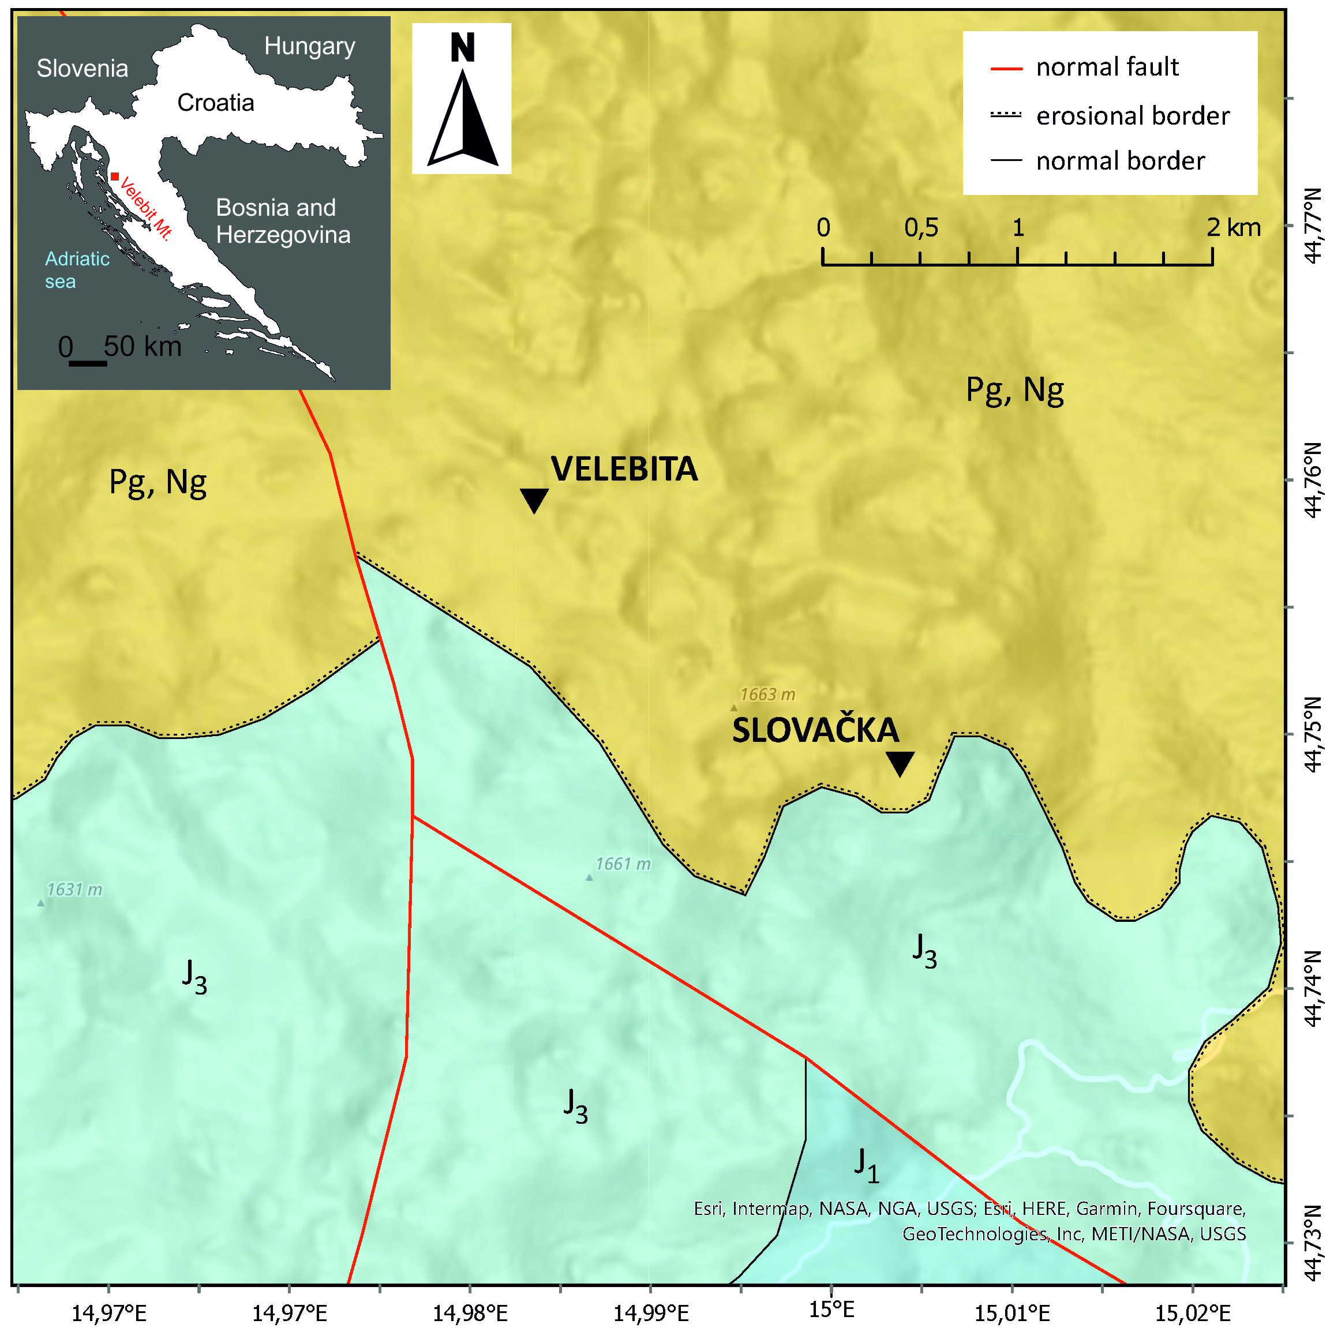
Fig 1. Position of Velebita cave system and Slovačka jama cave on the geological map of Velebit Mt. Litostratigraphical legend: J1 – limestones and dolomites (Lower Jurassic), J3 - limestones and dolomites (Upper Jurassic), Pg, Ng – carbonate breccia (Peleogene, Neogene). Map: Croatian Geological Survey (2009): Geological map of the Republic of Croatia M 1:300,000, Zagreb
Given that the most pronounced anomalies among 32 studied caves in different parts of Croatia were in our earlier study [4] identified in the deep caves of Velebit Mountain, a new study was initiated to investigate geochemical and mineralogical variations at depths of up to 1,320 m in Slovačka jama cave and 1,026 m in the Velebita cave system. These caves, which contain highest anomalies of heavy metals and other chemical elements among all 32 studied caves from different parts of Croatia, are located within a geologically complex karst terrain shaped by intensive tectonics, particularly during the Neotectonic period, which, in conjunction with prolonged karstification, has resulted in intricate subsurface structures (Figure 1). Recent research suggests that such deep cave environments provide valuable records of past climatic and geochemical conditions, making them critical sites for paleoenvironmental studies [6,7]. Sample 107 from Slovačka Jama Cave, the most anomalous site, showed elemental anomalies consistent with those found in our previous research [4], where this cave was analyzed along with other Croatian caves. Since both caves are situated within the same geological units and are only about 2 km apart, their geochemical profiles—reflected in speleothems, rocks, and sediments—are expected to be highly similar. Therefore, paleodata obtained from one cave should be applicable to the other, justifying our approach of evaluating both caves together in this study.
Velebita and Slovačka Jama caves are located in the strictly protected Northern Velebit National Park and are difficult to access due to the absence of nearby roads. Velebita lies approximately 6 km from the village of Krasno, while Slovačka is about 8 km from Krasno and a similar distance from the nearest coastal settlement. Both caves are predominantly vertical (Figure 2), making them unsuitable for tourism and accessible only to skilled speleologists and researchers. Consequently, entry is rare, occurring only during occasional speleological expeditions, typically a few times per decade.
The study of karst systems is not only important for understanding past environmental changes but also has direct implications for water resource management. Karst aquifers are highly vulnerable to contamination due to their rapid recharge and direct connectivity between surface and groundwater systems [8]. It is estimated that approximately 25% of the world’s population relies on groundwater extracted from karst aquifers [9]. Understanding the hydrogeochemical dynamics of these systems is particularly challenging due to their extreme heterogeneity [10,11]. Investigations in deep caves offer a unique opportunity for in situ sampling, measuring and analyses of karst processes in deep karst (>1.000 m), shedding light on the mechanisms controlling element mobility, mineral formation, and potential anthropogenic impacts [12] influencing epiphreatic and phreatic zone important for regional aquifer characteristics.
In our study, we expand upon previous research by analyzing multiple sampling media—including speleothems, cave clastic sediments, and water chemistry—to assess their geochemical and mineralogical properties and identify potential interactions. Such multi-proxy approaches remain relatively rare in karst research, particularly concerning cave sediments and water chemistry. However, several relevant studies provide useful comparisons. For instance, Rozkowski et al. [13] examined the migration and concentration of heavy metals in infiltration waters within a carbonate massif, linking these variations to both natural mobility and anthropogenic influences. Similarly, Pons-Branchu et al. [14] utilized urban speleothems to reconstruct heavy metal pollution histories in shallow groundwater systems, demonstrating how speleothem chemistry can serve as a long-term record of environmental changes. Other studies have explored the role of cave sediments and particulate matter in element transport, with Allan et al. [15] analyzing lead concentrations and isotopic compositions in Belgian caves to distinguish between anthropogenic and natural sources. More recently, Xu and Zeng [16, 17] investigated heavy metal contamination in cave water and suspended particulate matter, respectively, underscoring the importance of geochemical monitoring in karst systems.
The primary aim of this study is to systematically investigate geochemical and mineralogical variations in deep karst cave environments, assess the potential interactions between different sampling media, and evaluate their implications for paleoenvironmental reconstructions and pollution monitoring.

2. Materials and Methods

2.1. Sample preparation and analysis
Speleothems for this study were collected with minimal disturbance to the cave environment, ensuring that natural formations remained intact. The sampling locations in the Velebita cave system and Slovačka jama cave are shown in Figure 2 and Table 1. Samples were collected from sites where carbonate precipitation and karst drainage networks facilitate speleothem growth [18, 19, 20, 21]. These locations were carefully selected to ensure representative data on geochemical and mineralogical processes within the deep karst environment

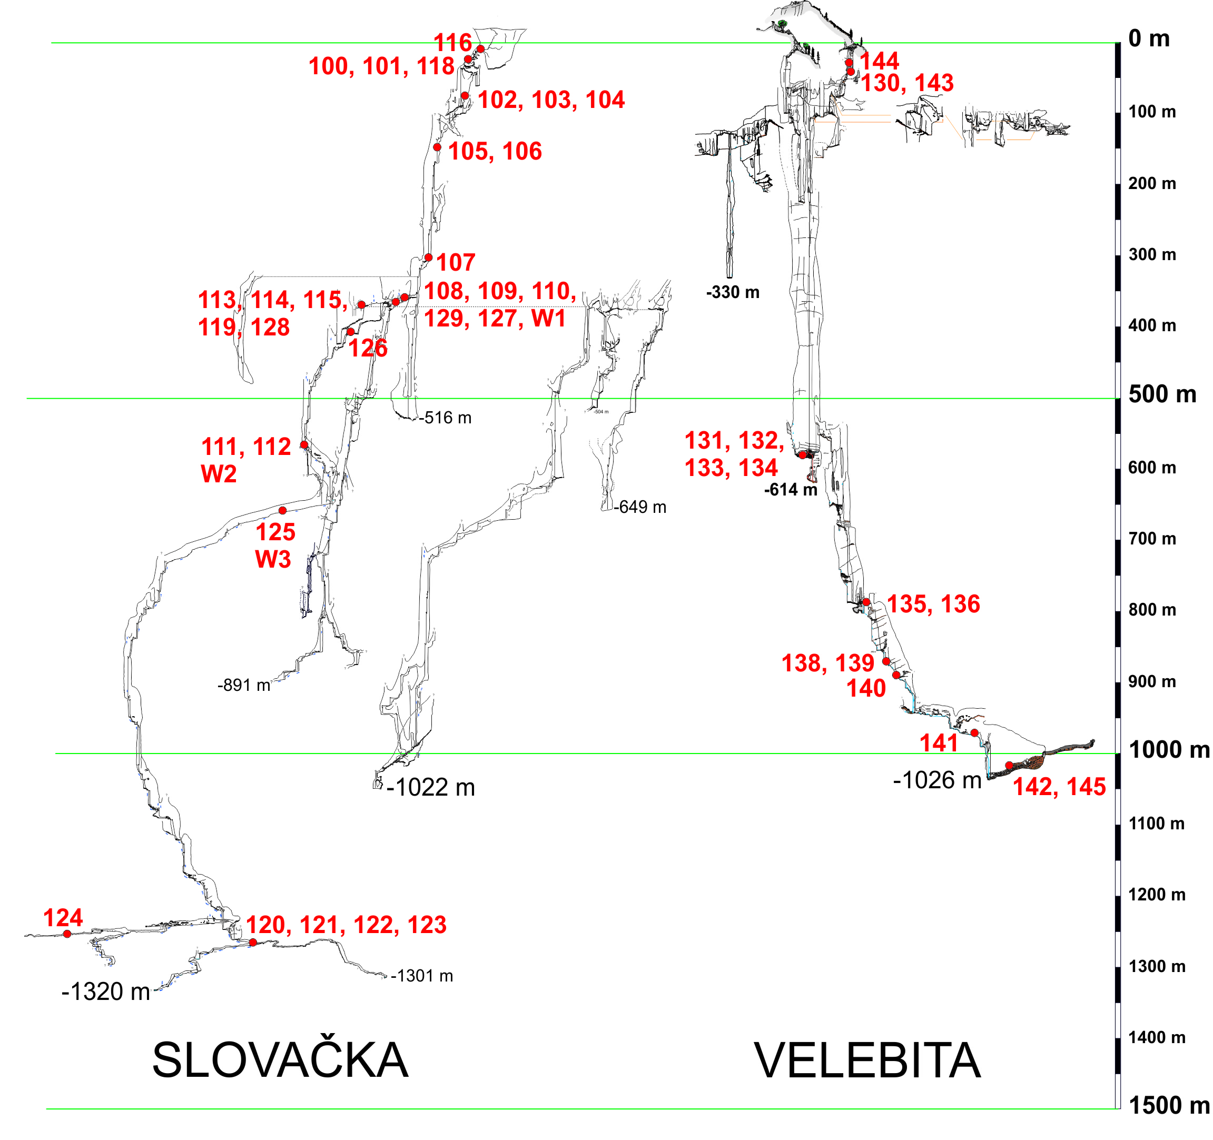
Fig. 2. Sampling locations in Slovačka jama and Velebita cave system, Velebit Mt., Croatia. Red numbers refer to samples. Map: Speleological Committee of CMA (1995-2017).

Table 1. List of samples, types and locations in Slovačka jama cave (S) and Velebita cave system (V)
Cave | Depth (m) | Speleothem | Sediment | Rock | Water
S | 0 |  | 116
S | 10 |  | 100 | 101, 118
S | 65 |  | 102, 104 | 103
S | 140 |  | 105 | 106
S | 285 |  | 107
S | 350 | 108, 119, 129 | 110, 127 | 109
S | 360 | 114 | 128 | 113, 115 | W1
S | 405 |  | 126
S | 550 |  | 112 | 111 | W2
S | 620 | 125 |  |  | W3
S | 1250 |  | 124
S | 1254 | 120, 121 |  | 122, 123
V | 30 | 144 A |  | 144 B
V | 50 | 143 | 130
V | 580 | 131 | 133, 134 | 132
V | 786 |  | 135, 136
V | 860 | 138, 139
V | 880 |  |  | 140
V | 975 |  |  | 141
V | 1000 | 142, 145

Samples were carefully handled to prevent contamination, washed with distilled water, air-dried, and then homogenized using a Retsch RM 200 mortar grinder (Retsch, Haan, Germany). Whole speleothems were crushed to obtain representative powders incorporating all growth layers. From these, 1 g of material was used for ICP-MS and XRD analysis.
For elemental analysis of solid samples, 0.1 g of powdered sample was digested in a mixture of suprapur nitric and puriss hydrochloric acid, heated in an Anton Paar Multiwave 3000 Oven (Anton Paar, Graz, Austria) following ISO 11466 standards. ICP-MS (Elan 9000, Perkin Elmer, Shelton, CT, USA) was used to determine elemental concentrations, employing internal standards (Ge, Rh, In, Re) according to ISO 17294-1 and ISO 17294-2. Precision (RSD) was within 10%, and accuracy was verified using reference material (RTC CNS392-050), with results aligning within 15% of certified values. Only two samples (64, 70) had values below the quantification limit for Tl (5.4%).
Mineralogical composition was identified using X-ray diffraction (XRD) with a Philips PW3040/60 X'Pert PRO diffractometer (Philips Analytical, Almelo, Netherlands), analyzed via Powder Diffraction File (1997) and X’Pert HighScore software. Semi-quantitative mineralogy followed [22].
Magnetic susceptibility (MS) was measured using an SM30 (ZH Instruments, Brno, Czech Republic) susceptibility meter, capable of detecting low-magnetic and diamagnetic materials such as limestone and quartz. Measurements were performed three times per sample, with the mean value recorded to ensure accuracy.
Electroconductivity and pH were measured using a SevenMulti instrument (Mettler Toledo, Schwerzenbach, Switzerland) in accordance with standards HRN EN ISO 10523:2012 and HRN EN 27888:2008. Turbidity was analyzed with a 2100 N turbidimeter (Hach, Loveland, CO, USA) following standard method SM:1995-2130 B.
Anions and cations were quantified via ion chromatography using an ICS 3000 system (Dionex, Sunnyvale, CA, USA) according to standards HRN EN ISO 10304-1:2009 and HRN EN ISO 14911:2001. Alkalinity was determined using a Mantech PC-Titrate system (Guelph, ON, Canada) following standard HRN EN ISO 9963-1:1998. Total dissolved solids and HCO₃⁻ concentrations were calculated as per [23, 24].
Orthophosphates were analyzed with a Lambda 25 spectrophotometer (PerkinElmer, Shelton, CT, USA) in accordance with standard HRN EN ISO 6878:2008. Total organic carbon (TOC) and total nitrogen (TN) were measured using a TOC-VCPH analyzer with a TNM-1 unit (Shimadzu Corporation, Kyoto, Japan) following standards HRN EN 1484:2002 and HRN EN 12260:2008. Chemical oxygen demand (COD) was determined using the titrimetric method in compliance with standard HRN EN 8467:2001.
Total phosphorus (TP) was measured via inductively coupled plasma mass spectrometry (ICP-MS, Elan 9000, PerkinElmer, USA), utilizing a 20 µg L⁻¹ In solution as an internal standard, according to HRN ISO 17294-2:2003.
To define hydrochemical facies, a Piper diagram was used (generated with USGS software GW Chart), which illustrates the relationships among major anions and cations (Ca²⁺, Mg²⁺, Na⁺, K⁺, HCO₃⁻, CO₃²⁻, SO₄²⁻, and Cl⁻).

2.2. Statistical analysis
Statistical analyses were conducted using Statistica 6.0 [25] and included:
a) Descriptive Statistics: Basic parameters (mean, median, standard deviation, skewness, kurtosis) were calculated to summarize the dataset. Pearson’s correlation coefficients were determined to assess relationships between elements (p < 0.05).
b) Boxplot Analysis: Used to identify anomalies in sediment samples based on interquartile range, with outliers and extreme values defined according to Tukey [26] and Reimann et al. [27].
c) Cluster Analysis (Q-mode): Performed to group similar samples using a hierarchical method, distinguishing sample clusters rather than elemental correlations [28].
d) Factor Analysis: Applied to reduce variable complexity and identify key natural or anthropogenic influences, assuming correlations between multiple elements are driven by a smaller set of main factors [29,30].

3. Results

3.1. Mineralogical analysis using X-ray diffraction
Mineralogical analysis using X-ray diffraction (XRD) identified 10 minerals across the samples: carbonates (calcite, dolomite), silicates (quartz, clay minerals—kaolinite, muscovite, chlorite, montmorillonite, and feldspar—plagioclase), spinels (magnetite), and oxihydroxides (goethite). This method is qualitative, with a detection limit of ~5%.
As expected, calcite was present in all samples due to the karstic environment, where speleothems form by limestone dissolution and carbonate precipitation (Table A1). Dolomite appeared in only three rock samples from Slovačka jama (samples 118, 122, 123), suggesting localized geochemical variations. In eight samples, only calcite was detected (e.g., 101, 111, 113).
Quartz, the second most abundant mineral, was found in 36 of 45 samples, likely originating from fine-grained clastic sediments introduced into the cave system [4]. Similar findings were reported in karstic river sediments [31].
Among clay minerals, muscovite and chlorite were most common, followed by kaolinite and montmorillonite. Samples containing at least two clay minerals (e.g., 105, 107, 110) often coincided with geochemical anomalies and high magnetic susceptibility (MS). Notably, samples 105 and 107, from the same vertical channel of Slovačka jama, displayed strong similarities despite a 145 m elevation difference. The abundance of clay minerals suggests a potential paragenetic relationship between quartz and kaolinite. This observation is consistent with the findings of Chen et al. [32], who proposed that quartz cementation likely resulted from feldspar dissolution, illitization of smectite and kaolinite, and pressure solution of quartz grains.
Feldspars (plagioclase) were detected in only four samples (112, 126, 130, 133), all from channel-bottom sediments in Slovačka jama and Velebita cave system. Among Fe-bearing minerals, magnetite and goethite were identified in samples from Slovačka jama, with sample 110 being the only one containing both. These minerals may indicate past hydrothermal influences or iron mobilization within the cave system.
The relationships between mineralogical composition, ICP-MS element concentrations, and magnetic susceptibility will be further explored in the discussion.

3.2. ICP-MS Analysis, Magnetic Susceptibility, and Elemental Anomalies
ICP-MS analysis results for speleothems and water samples are presented in Table A2 and Table A3. While elemental concentrations in speleothems will be statistically analyzed in later sections, water sample data were not statistically evaluated due to the limited number of results (n = 3).
The results of physico-chemical parameters, nutrients, ions, total nitrogen (TN), total phosphorus (TP), chemical oxygen demand (COD), and total organic carbon (TOC) in the three water samples are presented in Table A4.
Magnetic susceptibility (MS) values, expressed in 10⁻³ SI units, range from 0.000 to 0.168, with the highest value recorded in sample107 (Table A5). MS variations will be discussed in relation to elemental composition in later sections.
Elemental anomalies identified using the boxplot statistical method (Figure 3) indicate that sample 107 has the highest number of anomalies, followed by 127.

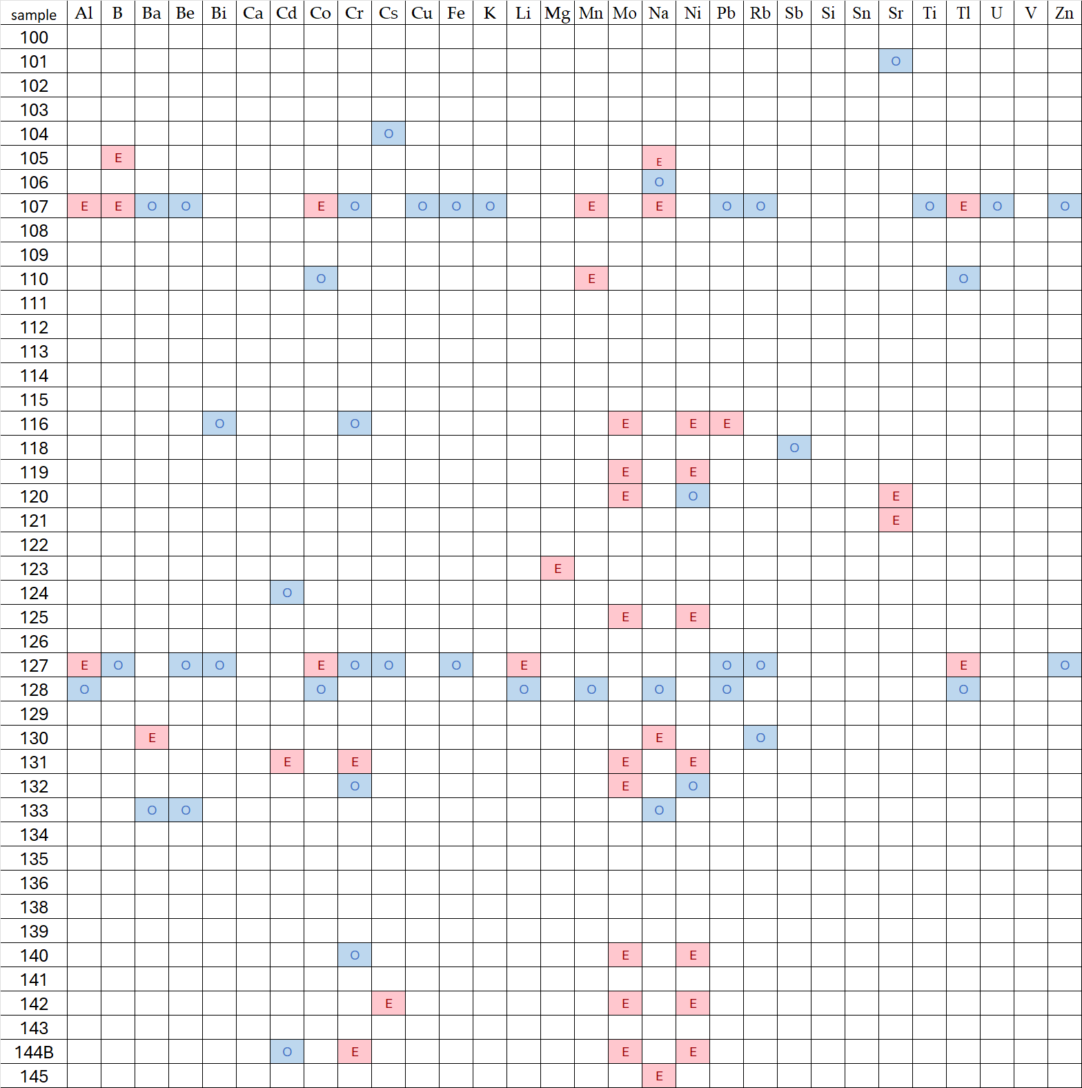
Fig. 3. Anomalies determined by boxplot method (E-extremes, O-outliers).
Outliers and extremes were observed for multiple elements, suggesting localized geochemical or environmental influences. These patterns will be further explored in the discussion.

3.3. Q-modality cluster analysis
Q-mode cluster analysis results are presented in Table A6 and Table A7. Three clusters were identified:
- Cluster 1 (Deepest, avg. depth 664.25 m): Composed of 8 sediments, 4 speleothems, and 4 rock samples, showing a moderate concentration of heavy metals.
- Cluster 2 (Intermediate, avg. depth 440.25 m): Contains 10 rocks, 9 speleothems, and 1 sediment sample, with the lowest heavy metal concentrations.
- Cluster 3 (Shallowest, avg. depth 323.89 m): Includes 8 sediments and 1 rock sample, exhibiting the highest heavy metal concentrations (except for Ni), suggesting accumulation near the surface due to airborne pollution, soil leaching, and surface runoff.

Both caves are formed within massive Velebit limestone breccias (previously referred to as Jelar deposits) down to a depth of approximately 250 m, where they transition gradually into intensely fractured to layered Upper Jurassic dolomitic limestones [33]. Between depths of 400 and 980 m, limestone breccias once again dominate, but they occur in irregular alternations with layered limestones of a normal stratigraphic sequence. The presence of breccias at depths of up to 980 m below the surface is explained by a model of tectonized zones filled with Velebit breccias, which intersect Jurassic limestones in a normal sequence.
Comparing available literature data with the average depth of our clusters reveals that the shallowest, Cluster 3, is located within fractured to layered Upper Jurassic dolomitic limestones. The intermediate Cluster 2 and the deepest Cluster 1 are positioned within limestone breccias that alternate irregularly with layered limestones. Thus, the cave's rock composition is unlikely to have a significant influence on heavy metal concentrations, while other processes mentioned are more likely to play a dominant role.
Heavy metals appear to migrate downward, accumulating first in shallow cave sections before being rinsed and redeposited in deeper zones. These transport mechanisms require further investigation.
Strontium concentrations notably increase in the deepest sections, but current data are insufficient to draw firm conclusions, warranting further research. Additionally, calcium concentrations in speleothems are lowest in shallow sections, nearly four times lower than in the middle depth, where they peak.

3.4. Factor analysis
Factor analysis was performed on 16 variables, including sample depth and elemental concentrations (Al, Be, Ca, Cd, Co, Cr, Cu, Fe, Li, Mn, Ni, Pb, Si, Sr, Zn). The results explained 83.7% of total variability, indicating a strong statistical model. Factor scores (Table A9) indicate the degree of influence of each factor on individual samples, while factor loadings (Table A8) reveal relationships between variables.

Interpretation of Factors:
Factor 1: Dominated by the aluminosilicate component, indicating high influence from soil and non-carbonate rocks. Ca shows a strong negative correlation, while Fe and Mn likely originate from natural aluminosilicates. Zn, Pb, and Co may have either natural or anthropogenic sources but strongly correlate with this factor.
Factor 2: Primarily associated with Cd, Cr, and Ni, forming a distinct elemental group. Their origin could be either atmospheric deposition from distant pollution sources or natural geological processes, differing from elements in Factor 1.
Factor 3: Shows negative correlations with depth and Sr, consistent with Q-mode cluster analysis, which indicated that Sr concentrations increase with depth.
These factors offer valuable insights into the geochemical processes influencing element distribution within the studied cave system. However, a more detailed characterization of mineral associations related to specific factors is not possible due to the limitations of the available XRD method, which has a detection limit of >3–5%.

4. Discussion
This section integrates mineralogical, geochemical, and geophysical data to explain the origin of detected elements and minerals, their distribution, and interactions within the cave system.

4.1. Mineralogy and Magnetic Susceptibility (MS) Relationships
Samples containing only calcite (or calcite + dolomite) exhibited very low MS values (≤0.002 × 10⁻³ SI units) and showed few or no elemental anomalies. A notable exception was sample 123, where an Mg anomaly coincided with the presence of dolomite, confirming its natural origin. This sample, collected from a horizontal channel at the bottom of Slovačka jama, suggests the presence of dolomitic bedrock at depth, though current geological maps lack subsurface detail.
In contrast, samples containing clay minerals displayed higher MS values and numerous elemental anomalies. The most abundant clay minerals were chlorite and muscovite, with kaolinite and montmorillonite present in smaller amounts. Chlorite, commonly found in metamorphic and volcanic environments, is known to contain Fe and Mn, which may explain the observed high MS values. It is likely formed through low-grade metamorphism or weathering of mafic minerals (e.g., pyroxenes, amphiboles, biotite).

4.2. Elements and Magnetic Susceptibility (MS) Relationships
Table A10 presents the correlations between magnetic susceptibility (MS) and chemical elements in the studied samples. MS exhibits strong to excellent correlations with Al, Ba, Be, Bi, Ca, Co, Cu, Fe, Li, Mn, Pb, Rb, Ti, Tl, and Zn, suggesting that MS can serve as a reliable proxy for detecting locations with elevated concentrations of these elements. The use of MS in environmental research as a promising, fast, and cost-effective method for detecting heavy metal anomalies is relatively new. It was only recently applied for the first time in Croatia [34]. Therefore, the correlations between MS and elemental concentrations in this study represent a significant step toward the routine application of this method in karst research.

4.3. Potential Sources of Clay Minerals and Heavy Metals
Clay minerals in the samples studied may originate from multiple sources:
- Terra rossa contribution: Similar to findings from Istria [35], terra rossa in karst regions often forms from insoluble residues of limestone and dolomite, but can also contain aeolian dust, volcanic debris, and transported sedimentary particles. These external sources may have introduced heavy metals over geological timescales.
- Aeolian and volcanic inputs: Past atmospheric processes could have deposited metal-rich dust and volcanic ash, leading to localized heavy metal anomalies.
- Hydrothermal activity: Though not confirmed, hydrothermal processes might have contributed to mineral transformations and heavy metal enrichment in deeper cave sediments.

4.4. Feldspars and Their Geochemical Significance
Feldspars (plagioclase) were detected in only four samples, often alongside clay minerals. While no major anomalies were associated with feldspar-rich samples, Ba anomalies were identified in samples 130 and 133. Since alkaline barium feldspars can form through Ba substitution for K in feldspar structures, it might be possible that crystallization processes in igneous or metamorphic rocks played a role in Ba enrichment, but to confirm that, additional research is needed. With the available XRD method, it is not possible to characterize minor minerals present in amounts below 3–5%. Therefore, it remains uncertain whether Ba originates from barite or is present in adsorbed forms.

4.5. Iron Minerals and Their Origins
Two Fe-rich minerals were detected:
1. Magnetite (spinels) – Found in cave sediments, possibly originating from:
a) Natural sources, such as weathering of bauxites (known to occur in Velebit Mt.).
b) Biogenic activity, as some microorganisms can precipitate magnetite.
c) Anthropogenic pollution, transported via airborne deposition.
2. Goethite (oxyhydroxides) – Typically forms through lateritic weathering and was found in samples where Fe anomalies were detected.
Samples 107 and 127, both from Slovačka jama, exhibited Fe anomalies and contained magnetite, suggesting an unusual geochemical environment in these sediments.

4.6. An Unusual Geochemical Outlier
Sample 107 (285 m depth, Slovačka jama) displayed:
- The highest MS value (0.168 × 10⁻³ SI units).
- A complex mineralogical composition (calcite, quartz, all four clay minerals, magnetite).
- Multiple elemental anomalies, including extremes for Al, B, Co, Mn, Na, Tl and outliers for Ba, Be, Cr, Cu, Fe, K, Pb, Rb, Ti, U, Zn.
These anomalies suggest a unique depositional or geochemical process, potentially involving multiple metal sources (natural and anthropogenic), deep sediment accumulation, and prolonged geochemical transformations. Further geochemical and isotopic studies are needed to fully understand its formation.

4.7. Factor Analysis and Elemental Associations
Factor analysis revealed a distinct grouping of Cd, Cr, and Ni, separate from other heavy metals. This suggests:
- Different sources or transport mechanisms compared to Zn, Pb, and Co.
- Possible atmospheric deposition (long-range transport of industrial pollutants).
- Alternatively, a unique natural geological source distinct from the aluminosilicate fraction.
Our results indicate that heavy metal anomalies in cave sediments and speleothems can be attributed to a combination of natural geochemical processes and potential atmospheric deposition. Similar findings were reported by Rozkowski et al. [13], who examined heavy metal transport within the unsaturated and saturated zones of a carbonate massif in Poland. Their study highlighted the influence of infiltration processes on metal migration, which aligns with our observations of metal transport from shallow to deep cave sections in Slovačka jama and the Velebita cave system. The accumulation of elements like Pb, Zn, and Cu in cave sediments suggests both allochthonous input (surface-derived material) and internal redistribution within the karst system.
Moreover, our analysis supports the idea that speleothems can serve as long-term environmental archives, recording changes in metal concentrations over time. Pons-Branchu et al. [36] demonstrated that speleothems in urban settings provide valuable records of historical heavy metal pollution, showing enrichment in Pb, Mn, V, Cu, Cd, and Al due to anthropogenic contamination. While our study is focused on deep karst environments rather than urban speleothems, the detection of Cd, Cr, and Ni as a distinct elemental association (factor analysis) raises the possibility of airborne metal deposition from distant pollution sources, a hypothesis also considered in their research.
While Pb anomalies in our samples could originate from natural sources (aluminosilicate components), the presence of additional metals associated with industrial activity suggests that long-range atmospheric transport may also contribute. The role of lead in karst environments has been extensively studied, with Allan et al. [15] demonstrating how Pb concentrations and isotopic ratios in speleothems can be used to trace atmospheric pollution since the Industrial revolution. Further isotopic analysis could help differentiate between these sources.

4.8. Geochemical characterization of three water samples
Dissolved anions and cations in water samples from Slovačka jama cave indicate that the groundwater belongs to the calcium-bicarbonate type (Ca–HCO₃) (Figure 4). Since the water samples have nearly identical compositions in terms of anions and cations, all three points are closely aligned in almost the same position on the Piper diagram. The measurement results for physico-chemical parameters, nutrients, ions, total organic carbon (TOC), and chemical oxygen demand (COD) at the three sampling sites are presented in Table A4. Since water in karst areas is buffered by carbonate, all three analyzed water samples are of a slightly alkaline type, with pH values ranging between 7.7 and 7.9. The dominant cation in all three water samples is Ca, with low concentrations of Mg, Na, and K. Low concentrations of ammonium, nitrates, nitrites, orthophosphates, TN, TP, and TOC indicate that the water in the Slovačka jama cave is not significantly impacted by pollution.
The solubility and transport of elements from speleothems are influenced by pH values and redox conditions. The relatively low concentrations of elements in the water samples suggest oxidative conditions, favoring their deposition in speleothems. This deposition is further supported by the relatively low concentrations of total organic carbon (TOC).
The mean values of pH, nitrates, total nitrogen, and all measured elements—except for Ba and Sr—were higher than the average values reported for Biokovo Mt. springs by [37]. This difference can be attributed to variations in geological composition, as the Velebit region contains both carbonate and non-carbonate rocks, such as clastic formations. Importantly, all measured indicators in the three water samples remained below the maximum permitted values.

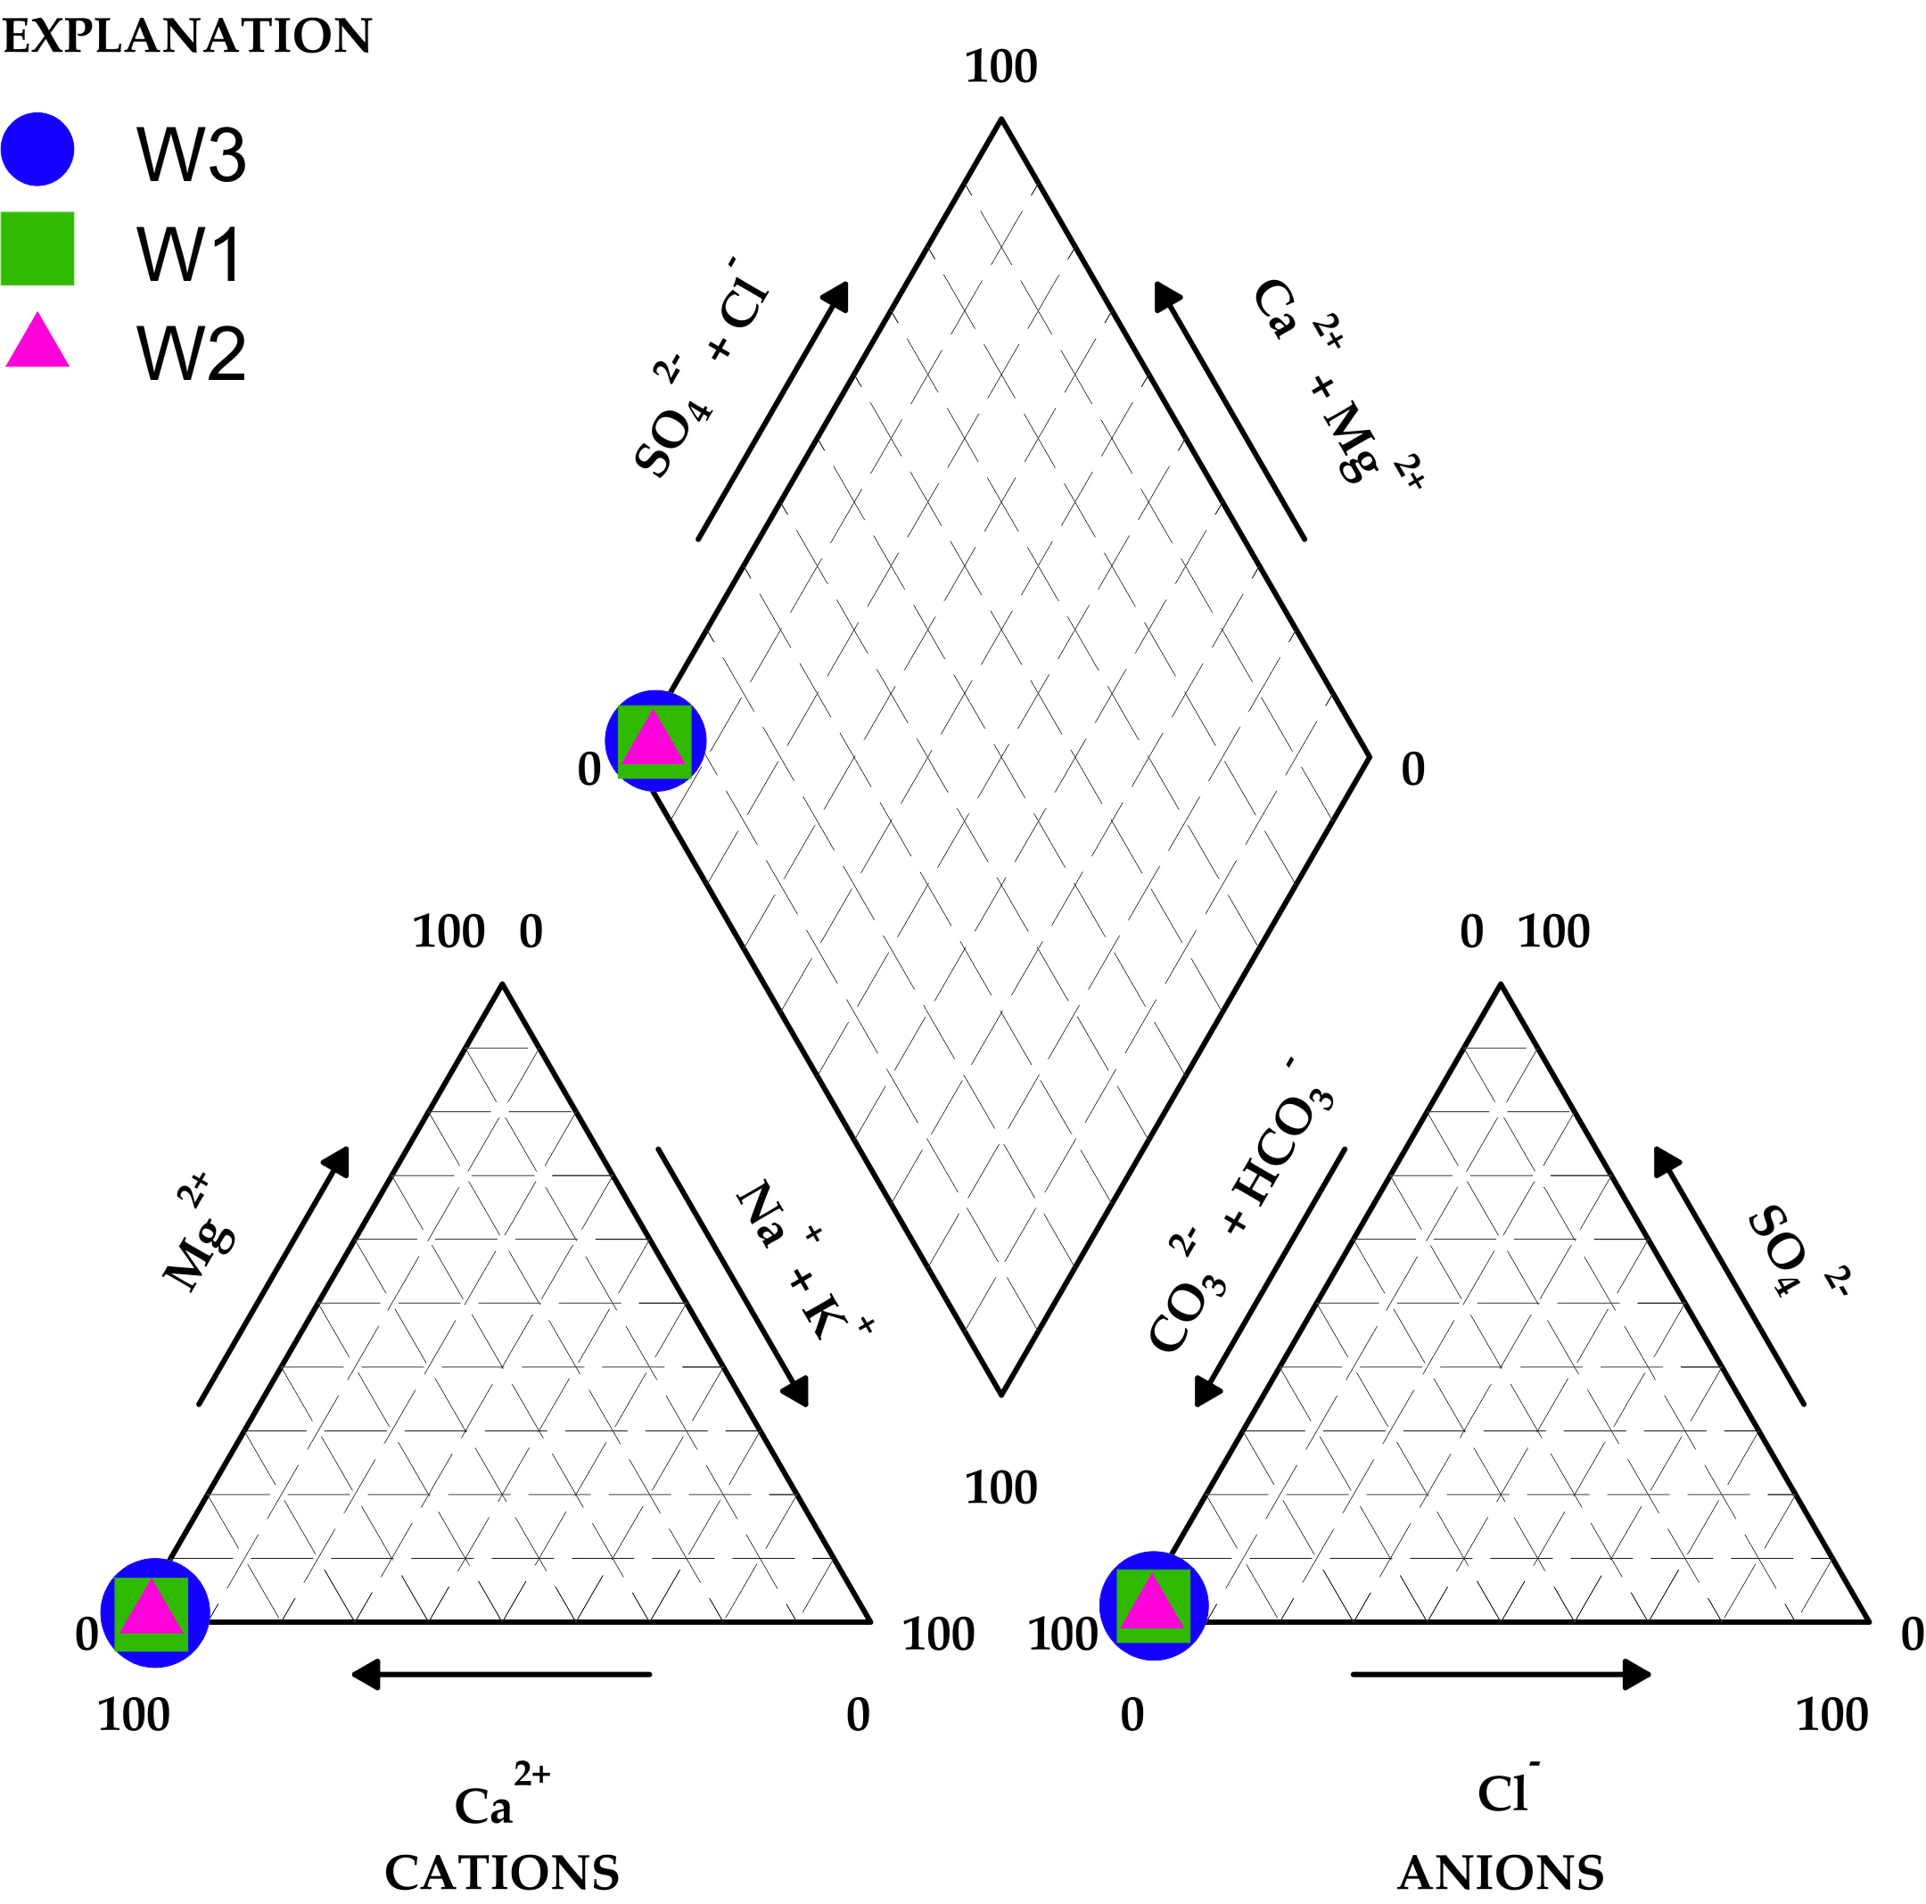
Fig. 4. Piper diagram of three water samples from Slovačka jama cave. Data for construction of Piper diagram are taken from Table A3 (ICP-MS and ion chromatography results of water samples) for Ca²⁺, Mg²⁺, Na⁺ and K⁺, while data for all other ions are taken from Table A4, which presents results of physico-chemical parameters, nutrients, ions, TN, TP, COD and TOC.
Overall, the combined use of mineralogical, geochemical, and statistical methods provided a comprehensive understanding of element distribution in deep karst environments, highlighting both natural and anthropogenic influences on cave sediments.

5. Conclusions and Future Research
This study highlights the complex geochemical interactions in deep karst environments, with speleothems and sediments serving as important archives of elemental transport and potential pollution pathways. Our results align with findings by Rozkowski et al. [13], Pons-Branchu et al. [36], and Allan et al. [15], all of whom investigated metal migration and accumulation in carbonate environments. The detection of heavy metal anomalies in sediments and speleothems suggests that karst systems are influenced by both natural geochemical processes and possible anthropogenic inputs.
Mineralogical analysis confirmed that calcite is the dominant mineral in all samples, as expected in a karst environment, while quartz was present in most samples, likely introduced via fine-grained clastic sediments. Clay minerals, including muscovite, chlorite, kaolinite, and montmorillonite, were found to be associated with higher magnetic susceptibility (MS) and heavy metal anomalies, indicating their role in metal transport. The presence of iron minerals such as magnetite and goethite, particularly in cave sediments, points to multiple possible origins, including natural sources such as bauxites, biogenic activity, or even airborne pollution.
Geochemical and statistical analyses provided additional insights into element distribution and transport within the cave system. Samples composed solely of calcite or calcite with dolomite exhibited the lowest MS values, indicating minimal influence from non-carbonate materials, whereas samples containing clay minerals displayed elevated MS values and a high number of elemental anomalies, supporting the hypothesis that clays play a significant role in metal retention. Boxplot analysis identified the highest number of anomalies in samples 107 and 127, suggesting a complex geochemical environment. Q-mode cluster analysis revealed that heavy metals are more concentrated in shallow cave sections, likely due to airborne deposition or surface leaching, with subsequent transport and accumulation in deeper parts of the cave system. Factor analysis identified cadmium, chromium, and nickel as a distinct group, indicating a different origin from other heavy metals, potentially related to atmospheric deposition or specific geological sources.
This research has advanced the understanding of deep cave geochemistry, particularly since such data are lacking in both the Dinaric karst and karst worldwide. Given the Dinaric Karst’s significance, studied region provides key insights into karst processes and supports remarkable geological and biological diversity. However, several aspects still require further investigation.
Future research should focus on stable isotope analysis of heavy metals, particularly Pb, to better identify the sources of these anomalies. A detailed examination of element transport to and within the caves, including more detailed geological mapping at depth and seismic profiling is essential. Additionally, continued monitoring of atmospheric deposition and identification of distant pollution sources could provide insights into the long-range transport of pollutants. Expanding both the spatial and depth range of sampling will improve our understanding of metal transport mechanisms and their implications for karst hydrology and groundwater protection in anthropogenically impacted areas. Investigating the role of aeolian dust and past volcanic activity in mineral deposition would also help to better understand the origins of clay minerals and associated elements. However, since the study sites are located within the Northern Velebit National Park and a strict nature reserve, with no nearby human settlements or roads, the designation of new protection zones is unnecessary.

Supplementary Materials: The following supporting information can be downloaded at: www.mdpi.com/xxx/s1, Figure S1-S4; Table S1-S10.
Author Contributions: Conceptualization, D.P., S.F.-B. and N.B.; methodology, K.M. and S.F.-B., D.P. and N.B.; software, S.F.-B., D.P.; analysis, S.F.-B., N.B., D.P. and K.M.; investigation, D.P., S.F.-B. and N.B..; collection data in the field, D.P..; writing—original draft preparation, D.P., S.F.-B. and N.B.; writing—review and editing, supervised the work, D.P., S.F.-B. and N.B. All authors have read and agreed to the published version of the manuscript.
Funding: This research was partially supported by the Northern Velebit National Park, Croatia and research funding in the Department of Geography at the Faculty of Science, University of Zagreb.
Data Availability Statement: The data will be made available on request.
Acknowledgments: The authors thank Prof. Nenad Tomašić for assistance with mineralogical analysis. We acknowledge the support provided by the Josip Juraj Strossmayer Water Institute, Main Water Laboratory (MWL), especially Mag. Simana Milović. We thank the members of the Speleological Society Velebit and Speleological Committee of CMA, Zagreb, for their assistance in field work. We also appreciate the journal’s reviewers for taking their precious time to review the manuscript.
Conflicts of Interest: The authors declare no conflicts of interest.

Appendix A

Table A1. Mineral (phase) composition of speleothem samples.
Sign “+” means that sample contains this mineral.

Sample | Calcite | Quartz | Kaolinite | Muscovite | Chlorite | Montmorill. | Magnetite | Goethite | Plagioclase | Dolomite
100 | + | +
101 | +
102 | + | +
103 | + | +
104 | + | + | +
105 | + | + |  | + | + | +
106 | + | +
107 | + | + | + | + | + | + | +
108 | + | +
109 | + | +
110 | + | + |  | + | + | + | + | +
111 | +
112 | + | + |  | + | + | + |  |  | +
113 | +
114 | + | + |  | + |  |  | +
115 | + | + | + | + |  |  | +
116 | + | + |  | + | +
118 | + | + |  |  |  |  |  |  |  | +
119 | + | + | + | + |  | +
120 | + | +
121 | + | + |  | + | +
122 | + | + |  |  |  |  | + |  |  | +
123 | + |  |  |  |  |  |  |  |  | +
124 | + | + |  | + | +
125 | + | +
126 | + | + |  |  | + |  |  |  | +
127 | + | + | + |  | + |  | +
128 | + | + | + | + | + |  | +
129 | + | +
130 | + | + |  | + | + | + |  |  | +
131 | + | +
132 | +
133 | + | + |  | + | + |  |  |  | +
134 | + | + |  | + | +
135 | + | + | +
136 | + | +
138 | + | +
139 | + | +
140 | +
141 | +
142 | + | +
143 | + | +
144A | +
144B | + | +
145 | +

Table A2. Results of ICP-MS analysis of 30 chemical elements in solid samples
Sample | Al  mg/ kg | B  mg/ kg | Ba  mg/ kg | Be  mg/ kg | Bi  mg/ kg | Ca  mg/ kg | Cd  mg/ kg | Co  mg/ kg | Cr  mg/ kg | Cs  mg/ kg | Cu  mg/ kg | Fe  mg/ kg | K  mg/ kg | Li  mg/ kg | Mg  mg/ kg
100 | 473 | 0.679 | 6.95 | 0.033 | 0.236 | 81855 | 0.054 | 0.391 | 3.78 | 0.436 | 1.62 | 1618 | 129 | 2.66 | 101
101 | 251 | 0.596 | 3.20 | 0.015 | 0.071 | 92465 | 0.040 | 0.287 | 4.93 | 0.532 | 0.660 | 558 | 94.2 | 5.18 | 156
102 | 472 | 0.760 | 8.21 | 0.036 | 0.213 | 74620 | 0.047 | 0.470 | 2.95 | 0.553 | 1.20 | 1387 | 136 | 2.75 | 200
103 | 375 | 0.253 | 3.60 | 0.020 | 0.098 | 86836 | 0.044 | 0.350 | 3.52 | 1.0 | 0.831 | 793 | 56.8 | 2.72 | 92.6
104 | 3502 | 2.19 | 35.3 | 0.156 | 1.36 | 49249 | 0.076 | 1.29 | 10.9 | 6.79 | 5.76 | 9876 | 731 | 14.1 | 377
105 | 4113 | 9.96 | 61.5 | 0.175 | 0.664 | 90203 | 0.153 | 1.98 | 12.4 | 2.07 | 4.20 | 5570 | 1143 | 5.56 | 507
106 | 409 | 1.73 | 4.85 | 0.015 | 0.103 | 128213 | 0.043 | 0.587 | 3.80 | 0.252 | 0.590 | 517 | 269 | 3.77 | 300
107 | 13737 | 13.1 | 112 | 0.452 | 2.0 | 3732 | 0.374 | 5.64 | 31.9 | 4.56 | 9.30 | 26293 | 1923 | 22.2 | 738
108 | 320 | 0.363 | 5.63 | 0.012 | 0.053 | 114421 | 0.031 | 0.531 | 3.58 | 0.170 | 0.545 | 500 | 76.7 | 0.618 | 45.2
109 | 180 | 0.145 | 7.82 | 0.016 | 0.072 | 87355 | 0.086 | 0.450 | 2.68 | 0.140 | 0.750 | 664 | 27.5 | 0.844 | 105
110 | 6171 | 4.90 | 71.2 | 0.273 | 1.12 | 26950 | 0.443 | 3.44 | 20.2. | 3.32 | 4.62 | 16480 | 853 | 23.9 | 321
111 | 30.8 | 0.145 | 0.845 | <0.005 | 0.023 | 106600 | 0.017 | 0.293 | 2.34 | <0.030 | 0.373 | 65.6 | 12.8 | 0.085 | 520
112 | 1719 | 0.694 | 46.4 | 0.091 | 0.481 | 64409 | 0.069 | 1.09 | 6.55 | 1.12 | 2.15 | 4898 | 569 | 3.06 | 389
113 | 122 | 0.144 | 2.12 | 0.010 | 0.044 | 88824 | 0.045 | 0.408 | 2.41 | 0.107 | 0.539 | 424 | 22.6 | 0.619 | 209
114 | 1962 | 0.602 | 10.5 | 0.105 | 0.323 | 75638 | 0.384 | 1.28 | 7.38 | 1.47 | 2.0 | 8520 | 328 | 9.94 | 190
115 | 1983 | 0.667 | 11.4 | 0.090 | 0.364 | 40678 | 0.232 | 0.959 | 7.61 | 1.19 | 2.12 | 6664 | 327 | 5.01 | 125
116 | 3938 | 3.40 | 40.7 | 0.195 | 2.95 | 35985 | 0.394 | 1.62 | 39.9 | 4.13 | 6.92 | 14301 | 762 | 18.1 | 534
118 | 125 | 0.203 | 2.71 | 0.011 | 0.045 | 82359 | 0.018 | 0.323 | 1.73 | 0.168 | 0.496 | 361. | 42.2 | 1.11 | 274
119 | 2779 | 1.26 | 15.5 | 0.175 | 1.18 | 55298 | 0.366 | 2.23 | 25.6 | 2.58 | 4.03 | 12326 | 317 | 14.8 | 213
120 | 19.5 | <0.100 | 13.1 | <0.005 | <0.030 | 79182 | 0.067 | 0.319 | 11.6 | <0.030 | 0.441 | 84.2 | 8.28 | 0.047 | 634
121 | 1851 | 0.804 | 31.8 | 0.105 | 0.884 | 72333 | 0.147 | 1.15 | 6.50 | 1.69 | 2.10 | 4454 | 323 | 3.89 | 712
122 | 923 | 2.0 | 7.47 | 0.035 | 0.169 | 66825 | 0.090 | 0.600 | 6.28 | 0.815 | 2.23 | 3845 | 767 | 1.09 | 396
123 | 105 | 0.205 | 1.57 | 0.011 | 0.044 | 69173 | 0.020 | 0.309 | 2.70 | 0.064 | 0.462 | 459 | 63.5 | 0.100 | 6630
124 | 2396 | 2.13 | 21.0 | 0.138 | 0.715 | 54126 | 0.505 | 1.37 | 8.49 | 1.25 | 3.58 | 8733 | 701 | 4.70 | 329
125 | 11.3 | <0.100 | 0.545 | <0.005 | 0.154 | 113734 | 0.072 | 0.264 | 12.0 | <0.030 | 0.298 | 77.5 | 4.67 | 0.068 | 10.3
126 | 1505 | 0.660 | 23.3 | 0.078 | 0.505 | 71445 | 0.058 | 1.02 | 6.31 | 1.05 | 3.67 | 4241 | 461 | 3.23 | 379
127 | 11202 | 7.18 | 76.1 | 0.503 | 2.46 | 15950 | 0.323 | 5.84 | 35.8 | 6.55 | 7.68 | 28640 | 1167 | 41.8 | 500
128 | 7388 | 3.74 | 63.5 | 0.370 | 1.71 | 28058 | 0.213 | 3.69 | 17.8 | 5.56 | 6.65 | 20436 | 1338 | 29.5 | 504
129 | 85.9 | <0.100 | 0.917 | <0.005 | <0.030 | 94922 | 0.047 | 0.319 | 2.52 | 0.069 | 0.460 | 257 | 14.6 | 0.300 | 19.4
130 | 4733 | 2.05 | 138 | 0.302 | 1.56 | 13320 | 0.105 | 2.62 | 14.8 | 3.46 | 5.98 | 17600 | 1502 | 15.2 | 1069
131 | 12.0 | 8.35 | 40.5 | 12.5 | 5.40 | 4.12 | 0.198 | 54.2 | 1.86 | 72.8 | 68.2 | 0.089 | 0.685 | 183 | 4.44
132 | 3.70 | 17.7 | 9.68 | 25.6 | 0.779 | 2.45 | 0.495 | 32.7 | 1.03 | 191 | 32.6 | 0.047 | 0.604 | 123 | 1.24
133 | 12.5 | 4.52 | 22.1 | 6.33 | 3.04 | 4.14 | 0.272 | 57.5 | 1.36 | 125 | 80.3 | 0.115 | 1.03 | 100 | 3.41
134 | 5.66 | 5.55 | 14.5 | 9.71 | 1.40 | 2.16 | 0.318 | 44.2 | 1.19 | 84.8 | 49.6 | 0.061 | 0.501 | 114 | 1.53
135 | 47.6 | 7.07 | 26.5 | 16.2 | 13.0 | 24.9 | 0.503 | 148 | 1.79 | 52.0 | 386 | 0.700 | 2.23 | 147 | 9.66
136 | 115 | 2.80 | 132 | 6.10 | 7.85 | 13.0 | 0.186 | 108 | 1.50 | 26.8 | 342 | 0.622 | 0.912 | 77.3 | 9.14
138 | 7.91 | 3.40 | 82.1 | 7.44 | 1.05 | 1.40 | 0.081 | 22.2 | 0.870 | 107 | 36.8 | 0.075 | 1.06 | 81.5 | 1.07
139 | 560 | 7.67 | 116 | 21.7 | 31.9 | 43.7 | 0.782 | 98.5 | 2.45 | 30.7 | 1068 | 1.62 | 4.29 | 212 | 24.5
140 | 11.0 | 3.98 | 16.0 | 6.85 | 0.730 | 1.64 | 0.250 | 20.4 | 0.523 | 11.3 | 38.3 | 0.079 | 0.292 | 69.6 | 0.892
141 | 73.3 | 5.07 | 11.7 | 6.83 | 1.43 | 0.898 | 0.150 | 18.7 | 1.19 | 47.0 | 40.2 | 0.131 | 0.600 | 113 | 1.27
142 | 477 | 8.24 | 36.0 | 18.0 | 20.2 | 22.9 | 0.656 | 80.7 | 1.63 | 38.7 | 496 | 1.18 | 2.25 | 98.1 | 14.0
143 | 0.767 | 5.0 | 29.6 | 7.35 | 0.251 | 0.176 | 0.359 | 2.76 | 1.35 | 116 | 5.41 | 0.009 | 0.975 | 137 | 0.711
144A | 70.6 | 3.58 | 31.0 | 6.14 | 5.50 | 11.6 | 0.098 | 76.5 | 0.830 | 85.5 | 287 | 0.264 | 0.900 | 68.4 | 4.10
144B | 16.1 | 5.08 | 15.2 | 7.20 | 0.827 | 0.650 | 0.039 | 15.0 | 1.22 | 93.4 | 29.0 | 0.038 | 0.870 | 104 | 0.739
145 | 126 | 5.45 | 17.3 | 7.50 | 6.76 | 7.66 | 0.202 | 106 | 0.772 | 18.1 | 214 | 0.308 | 0.920 | 76.7 | 5.08

Sample | Mn  mg/kg | Mo  mg/kg | Na  mg/kg | Ni  mg/kg | Pb  mg/kg | Rb  mg/kg | Sb  mg/kg | Si  mg/kg | Sn  mg/kg | Sr  mg/kg | Ti  mg/kg | Tl  mg/kg | U  mg/kg | V  mg/kg | Zn  mg/kg
100 | 12.0 | 8.35 | 40.5 | 12.5 | 5.40 | 4.12 | 0.198 | 54.2 | 1.86 | 72.8 | 68.2 | 0.089 | 0.685 | 183 | 4.44
101 | 3.70 | 17.7 | 9.68 | 25.6 | 0.779 | 2.45 | 0.495 | 32.7 | 1.03 | 191 | 32.6 | 0.047 | 0.604 | 123 | 1.24
102 | 12.5 | 4.52 | 22.1 | 6.33 | 3.04 | 4.14 | 0.272 | 57.5 | 1.36 | 125 | 80.3 | 0.115 | 1.03 | 100 | 3.41
103 | 5.66 | 5.55 | 14.5 | 9.71 | 1.40 | 2.16 | 0.318 | 44.2 | 1.19 | 84.8 | 49.6 | 0.061 | 0.501 | 114 | 1.53
104 | 47.6 | 7.07 | 26.5 | 16.2 | 13.0 | 24.9 | 0.503 | 148 | 1.79 | 52.0 | 386 | 0.700 | 2.23 | 147 | 9.66
105 | 115 | 2.80 | 132 | 6.10 | 7.85 | 13.0 | 0.186 | 108 | 1.50 | 26.8 | 342 | 0.622 | 0.912 | 77.3 | 9.14
106 | 7.91 | 3.40 | 82.1 | 7.44 | 1.05 | 1.40 | 0.081 | 22.2 | 0.870 | 107 | 36.8 | 0.075 | 1.06 | 81.5 | 1.07
107 | 560 | 7.67 | 116 | 21.7 | 31.9 | 43.7 | 0.782 | 98.5 | 2.45 | 30.7 | 1068 | 1.62 | 4.29 | 212 | 24.5
108 | 11.0 | 3.98 | 16.0 | 6.85 | 0.730 | 1.64 | 0.250 | 20.4 | 0.523 | 11.3 | 38.3 | 0.079 | 0.292 | 69.6 | 0.892
109 | 73.3 | 5.07 | 11.7 | 6.83 | 1.43 | 0.898 | 0.150 | 18.7 | 1.19 | 47.0 | 40.2 | 0.131 | 0.600 | 113 | 1.27
110 | 477 | 8.24 | 36.0 | 18.0 | 20.2 | 22.9 | 0.656 | 80.7 | 1.63 | 38.7 | 496 | 1.18 | 2.25 | 98.1 | 14.0
111 | 0.767 | 5.0 | 29.6 | 7.35 | 0.251 | 0.176 | 0.359 | 2.76 | 1.35 | 116 | 5.41 | 0.009 | 0.975 | 137 | 0.711
112 | 70.6 | 3.58 | 31.0 | 6.14 | 5.50 | 11.6 | 0.098 | 76.5 | 0.830 | 85.5 | 287 | 0.264 | 0.900 | 68.4 | 4.10
113 | 16.1 | 5.08 | 15.2 | 7.20 | 0.827 | 0.650 | 0.039 | 15.0 | 1.22 | 93.4 | 29.0 | 0.038 | 0.870 | 104 | 0.739
114 | 126 | 5.45 | 17.3 | 7.50 | 6.76 | 7.66 | 0.202 | 106 | 0.772 | 18.1 | 214 | 0.308 | 0.920 | 76.7 | 5.08
115 | 108 | 4.62 | 19.9 | 8.03 | 6.37 | 7.23 | 0.180 | 113 | 0.939 | 11.1 | 351 | 0.313 | 0.915 | 89.6 | 4.55
116 | 111 | 126 | 32.8 | 204 | 75.0 | 35.8 | 0.474 | 201 | 2.76 | 68.7 | 530 | 0.603 | 2.19 | 162 | 18.6
118 | 2.78 | 3.61 | 11.7 | 5.20 | 0.645 | 1.08 | 1.03 | 20.6 | 1.39 | 131 | 25.8 | 0.053 | 0.833 | 82.3 | 0.772
119 | 251 | 70.7 | 16.7 | 107 | 18.0 | 14.8 | 0.531 | 157 | 1.87 | 32.5 | 525 | 0.414 | 2.39 | 138 | 11.2
120 | 0.982 | 37.1 | 11.5 | 51.0 | 0.203 | 0.180 | 0.383 | 2.90 | 0.847 | 4342 | 6.65 | 0.010 | 3.52 | 75.2 | 0.444
121 | 52.9 | 4.72 | 20.1 | 8.34 | 8.0 | 11.0 | 0.475 | 100 | 0.939 | 1127 | 204 | 0.425 | 1.18 | 78.6 | 3.53
122 | 9.33 | 16.4 | 17.0 | 22.0 | 2.78 | 10.6 | 0.191 | 135 | 0.888 | 103 | 162 | 0.041 | 1.31 | 108 | 1.64
123 | 6.35 | 7.93 | 13.2 | 9.14 | 0.265 | 0.838 | 0.205 | 13.9 | 1.05 | 65.4 | 10.7 | 0.022 | 1.13 | 111 | 0.755
124 | 85.5 | 9.89 | 20.7 | 16.3 | 10.1 | 16.7 | 0.383 | 127 | 1.66 | 38.5 | 461 | 0.247 | 2.0 | 111 | 7.58
125 | 0.234 | 54.3 | 4.32 | 107 | 0.243 | 0.076 | 0.226 | 1.43 | 0.689 | 10.2 | 2.98 | 0.045 | 0.170 | 92.8 | 0.535
126 | 43.6 | 3.30 | 26.1 | 7.46 | 5.61 | 9.10 | 0.201 | 119 | 1.03 | 76.5 | 204 | 0.260 | 0.940 | 86.0 | 3.57
127 | 215 | 9.47 | 44.6 | 22.9 | 29.7 | 38.4 | 0.811 | 104 | 2.40 | 44.5 | 754 | 1.91 | 3.26 | 124 | 25.0
128 | 312 | 5.46 | 84.7 | 17.0 | 24.9 | 33.8 | 0.507 | 112 | 2.28 | 50.5 | 658 | 1.27 | 3.09 | 118 | 18.4
129 | 2.28 | 6.46 | 7.22 | 13.6 | 0.433 | 0.448 | 0.035 | 8.52 | 0.812 | 8.44 | 18.6 | 0.028 | 0.239 | 161 | 0.851
130 | 145 | 3.55 | 204 | 9.55 | 17.6 | 37.7 | 0.380 | 122 | 1.79 | 45.4 | 486 | 0.602 | 1.34 | 107 | 12.7
131 | 8.49 | 461 | 18.6 | 658 | 1.10 | 2.23 | 0.108 | 48.9 | 0.921 | 28.9 | 65.0 | 0.095 | 0.365 | 94.5 | 1.77
132 | 1.62 | 46.6 | 12.6 | 63.8 | 0.600 | 0.903 | 0.284 | 14.5 | 1.0 | 80.6 | 16.2 | 0.015 | 1.43 | 122 | 0.848
133 | 168 | 6.07 | 70.3 | 10.9 | 23.7 | 31.5 | 0.360 | 119 | 2.14 | 73.8 | 613 | 0.420 | 2.02 | 124 | 12.3
134 | 136 | 2.85 | 38.6 | 7.25 | 18.4 | 31.8 | 0.263 | 71.3 | 1.60 | 59.2 | 435 | 0.721 | 2.19 | 76.5 | 14.1
135 | 104 | 9.92 | 22.3 | 21.7 | 11.3 | 24.7 | 0.419 | 112 | 1.38 | 78.8 | 398 | 0.931 | 2.62 | 115 | 11.2
136 | 30.3 | 7.29 | 15.3 | 12.8 | 4.42 | 8.16 | 0.460 | 126 | 1.29 | 76.3 | 205 | 0.261 | 1.11 | 149 | 4.36
138 | 0.761 | 8.06 | 34.0 | 10.7 | 0.462 | 0.401 | 0.176 | 7.41 | 1.08 | 14.3 | 11.0 | 0.021 | 0.113 | 163 | 1.13
139 | 2.23 | 4.81 | 20.3 | 7.34 | 0.621 | 0.838 | 0.039 | 14.2 | 0.786 | 14.7 | 25.8 | 0.023 | 0.126 | 140 | 0.734
140 | 6.55 | 188 | 13.4 | 292 | 1.08 | 0.576 | 0.614 | 18.2 | 1.68 | 83.0 | 33.9 | 0.021 | 0.855 | 173 | 1.40
141 | 2.42 | 2.80 | 6.13 | 4.94 | 0.781 | 0.869 | 0.157 | 20.5 | 0.413 | 58.6 | 33.8 | 0.021 | 0.624 | 67.0 | 1.10
142 | 3.25 | 97.4 | 10.1 | 148 | 0.602 | 0.632 | 0.108 | 13.0 | 1.39 | 43.1 | 21.5 | 0.020 | 0.307 | 165 | 0.966
143 | 0.254 | 9.61 | 40.5 | 13.0 | 0.236 | 0.091 | 0.100 | 1.34 | 1.42 | 27.9 | 3.86 | 0.043 | 0.144 | 194 | 0.777
144A | 0.385 | 5.84 | 10.5 | 9.43 | 0.222 | 0.113 | 0.084 | 1.98 | 0.833 | 22.5 | 2.17 | 0.040 | 0.056 | 122 | 0.660
144B | 1.61 | 400 | 13.4 | 596 | 0.178 | 0.153 | 0.336 | 4.33 | 0.850 | 146 | 7.10 | <0.003 | 1.43 | 157 | 0.530
145 | 1.08 | 7.67 | 176 | 10.9 | 0.324 | 0.230 | 0.313 | 6.45 | 1.73 | 113 | 9.88 | 0.005 | 2.53 | 168 | 1.17

Table A3. Results of ICP-MS and ion chromatography analysis of 30 chemical elements in three water samples
Sample | Al  µg/L | As  µg/L | B  µg/L | Ba  µg/L | Be  µg/L | Ca  mg/L | Cd  µg/L | Co  µg/L | Cr  µg/L | Cs  µg/L | Cu  µg/L | Fe  µg/L | K  mg/L | Li  µg/L | Mg  mg/L
W3 | 30.3 | 0.441 | 2.85 | 5.45 | <0.005 | 37.1 | 0.020 | 0.097 | 0.260 | <0.030 | 1.72 | 38.4 | 0.900 | 0.226 | <0.500
W1 | 19.7 | 0.380 | 2.49 | 3.93 | <0.005 | 34.8 | <0.010 | 0.085 | 0.127 | <0.030 | 2.33 | 13.7 | 0.200 | 0.227 | <0.500
W2 | 64.1 | 0.355 | 2.85 | 3.70 | <0.005 | 35.1 | <0.010 | 0.090 | 0.162 | <0.030 | 1.06 | 14.3 | 0.250 | 0.157 | <0.500
MAC* | 200 | 10 | 1500 | 700 | n.a. | n.a. | 5 | n.a. | 25 | n.a. | 2000 | 200 | 12 | n.a. | n.a.

Sample | Mn  µg/L | Mo  µg/L | Na  mg/L | Ni  µg/L | Pb  µg/L | Rb  µg/L | Sb  µg/L | Si  mg/L | Sn  µg/L | Sr  µg/L | Ti  µg/L | Tl  µg/L | U  µg/L | V  µg/L | Zn  µg/L
W3 | 1.22 | 0.088 | 0.860 | 0.557 | 0.411 | 0.475 | 0.207 | 1.30 | 0.060 | 29.0 | 0.732 | 0.004 | 0.212 | 0.443 | 1.58
W1 | 0.509 | 0.043 | 0.620 | 2.90 | 0.190 | 0.216 | 0.036 | 1.16 | <0.020 | 30.1 | 0.579 | <0.003 | 0.153 | 0.316 | 1.38
W2 | 0.607 | 0.065 | 0.610 | 0.649 | <0.010 | 0.237 | 0.081 | 1.04 | <0.020 | 27.8 | 0.534 | <0.003 | 0.141 | 0.283 | 1.28
MAC* | 50 | n.a. | 200 | 20 | 5 | n.a. | 10 | n.a. | n.a. | n.a. | n.a. | n.a. | 30 | 5 | 3000
* Ordinance on compliance parameters, methods of analysis, monitoring and water safety plans for human consumption
and method of keeping a register of legal entities performing the activity of public water supply (OG 64/2023)

Table A4. Results of physico-chemical parameters, nutrients, ions, TN, TP, COD and TOC in three water samples
 | W3 | W1 | W2 | MAC*
pH | 7.7 | 7.8 | 7.9 | 6.5-9.5
Conductivity  (µScm⁻¹) | 182 | 167 | 170 | 2500
TDS | 122 | 112 | 114 | n.a.
Alkalinity (mgCaCO₃L⁻¹) | 90 | 84 | 87 | n.a.
Total Hardness (mgCaCO₃L⁻¹) | 94.4 | 88.5 | 89 | n.a.
HCO3⁻ (mgL⁻¹) | 110 | 102 | 106 | n.a.
Turbidity (NTU) | 16.2 | 0.75 | 0.87 | 4
Ammonium  (mgNL⁻¹) | 0.017 | < 0.008 | < 0.008 | 0.5
Nitrates (mgNL⁻¹) | 0.81 | 0.74 | 0.77 | 50
Nitrites (mgNL⁻¹) | < 0.002 | < 0.002 | < 0.002 | 0.5
Orthophosphates  (mgPL⁻¹) | 0.007 | < 0.005 | 0.005 | 0.3
Sulphates (mgL⁻¹) | 1.7 | 2.1 | 1.7 | 250
Chlorides (mgL⁻¹) | 1.82 | 1.0 | 1.07 | 250
Fluorides (mgL⁻¹) | < 0.025 | < 0.025 | < 0.025 | 1.5
TP (mgPL⁻¹) | 0.008 | < 0.003 | 0.016 | n.a.
TN (mgNL⁻¹) | 1.08 | 0.83 | 0.95 | n.a.
COD (mgL⁻¹) | 1.3 | < 0.7 | < 0.7 | 5
TOC (mgL⁻¹) | 2.21 | 0.45 | 0.58 | n.a.
* Ordinance on compliance parameters, methods of analysis, monitoring and water safety plans for human consumption
and method of keeping a register of legal entities performing the activity of public water supply (OG 64/2023)

Table A5. Magnetic susceptibility measured in cave samples from Velebit Mt.
Sample | 100 | 101 | 102 | 103 | 104 | 105 | 106 | 107 | 108 | 109 | 110
MS (10⁻³ SI units) | 0.008 | 0.000 | 0.014 | 0.000 | 0.047 | 0.043 | 0.002 | 0.168 | 0.002 | 0.001 | 0.064
Sample | 111 | 112 | 113 | 114 | 115 | 116 | 118 | 119 | 120 | 121 | 122
MS (10⁻³ SI units) | 0.000 | 0.094 | 0.000 | 0.026 | 0.009 | 0.070 | 0.000 | 0.038 | 0.000 | 0.033 | 0.005
Sample | 124 | 125 | 126 | 127 | 128 | 129 | 130 | 131 | 132 | 133 | 134
MS (10⁻³ SI units) | 0.015 | 0.001 | 0.099 | 0.024 | 0.069 | 0.002 | 0.152 | 0.003 | 0.002 | 0.089 | 0.060
Sample | 135 | 136 | 138 | 139 | 140 | 141 | 142 | 143 | 144A | 144B | 145
MS (10⁻³ SI units) | 0.042 | 0.008 | 0.002 | 0.005 | 0.001 | 0.000 | 0.003 | 0.000 | 0.002* | 0.001* | 0.000

Table A6. Members of obtained clusters and distances from respective cluster centers.
Cluster Number 1 |  |  | Cluster Number 2 |  |  | Cluster Number 3
 | Distance |  |  | Distance |  |  | Distance
100 | 2296.907 |  | 101 | 986.315 |  | 107 | 3840.709
102 | 1160.563 |  | 103 | 1949.649 |  | 110 | 707.108
104 | 3505.504 |  | 105 | 1746.685 |  | 115 | 3650.59
112 | 780.491 |  | 106 | 5148.341 |  | 116 | 2335.307
114 | 1327.349 |  | 108 | 2782.85 |  | 127 | 2383.742
118 | 2442.552 |  | 109 | 1859.763 |  | 128 | 995.872
119 | 2682.862 |  | 111 | 1447.447 |  | 130 | 1696.761
120 | 2068.802 |  | 113 | 1608.54 |  | 133 | 630.79
121 | 615.082 |  | 125 | 2667.503 |  | 134 | 857.839
122 | 428.126 |  | 129 | 568.616
123 | 1283.476 |  | 131 | 1669.34
124 | 2634.997 |  | 132 | 1892.675
126 | 454.429 |  | 138 | 241.428
135 | 3506.321 |  | 139 | 113.224
136 | 979.731 |  | 140 | 851.933
141 | 2363.343 |  | 142 | 923.613
 |  |  | 143 | 1501.29
 |  |  | 144A | 1315.248
 |  |  | 144B | 1271.849
 |  |  | 145 | 274.117

Table A7. Mean values of 10 elements and two other parameters for 3 obtained clusters.
Element's contents are given in mg/kg, elevation in m.
 | Cluster - No. 1 | Cluster - No. 2 | Cluster - No. 3
Depth | 664.25 | 440.25 | 323.89
Al | 1402.22 | 352.46 | 6420.78
B | 1.04 | 0.86 | 4.40
Ba | 17.68 | 5.55 | 79.56
Be | 0.08 | 0.02 | 0.32
Bi | 0.48 | 0.10 | 1.72
Ca | 68916.31 | 98196.25 | 23043.11
Cd | 0.13 | 0.13 | 0.26
Co | 0.91 | 0.46 | 3.06
Cr | 7.50 | 23.33 | 30.18
Cs | 1.47 | 5.56 | 4.00
Cu | 2.24 | 0.75 | 5.82
Fe | 4795.51 | 644.85 | 17686.45
K | 353.35 | 101.23 | 1105.11
Li | 4.90 | 1.24 | 20.72
Mg | 725.63 | 153.69 | 608.00
Mn | 53.62 | 13.11 | 248.00
Mo | 12.66 | 66.92 | 19.33
Na | 19.88 | 33.59 | 71.88
Ni | 19.66 | 100.34 | 35.48
Pb | 5.99 | 1.02 | 27.53
Rb | 9.40 | 1.45 | 31.43
Sb | 0.36 | 0.22 | 0.49
Si | 86.01 | 20.21 | 113.50
Sn | 1.21 | 1.10 | 2.00
Sr | 405.19 | 63.50 | 46.96
Ti | 204.47 | 39.59 | 599.00
Tl | 0.26 | 0.07 | 0.96
U | 1.46 | 0.68 | 2.39
V | 106.01 | 128.59 | 123.47
Zn | 4.55 | 1.40 | 16.02

Table A8. Factor Loadings (varimax normalized; Marked loadings are >0.7).
 | Factor - 1 | Factor - 2 | Factor - 3
Depth | -0.124302 | -0.023993 | -0.819019
Al | 0.954821 | 0.040576 | 0.065068
Be | 0.964641 | 0.013376 | 0.052559
Ca | -0.910654 | -0.035486 | 0.071048
Cd | 0.367832 | 0.870409 | 0.002824
Co | 0.943561 | 0.088319 | 0.060373
Cr | 0.097057 | 0.956666 | 0.030635
Cu | 0.965842 | 0.043518 | 0.106860
Fe | 0.987710 | 0.045008 | 0.063385
Li | 0.928842 | 0.059540 | 0.121091
Mn | 0.860786 | 0.107496 | 0.059534
Ni | -0.183442 | 0.940852 | 0.034932
Pb | 0.792268 | 0.117471 | 0.138042
Si | 0.722576 | 0.023701 | 0.062805
Sr | -0.060724 | -0.024627 | -0.804648
Zn | 0.979650 | 0.057248 | 0.111071
Expl.Var | 9.380962 | 2.606750 | 1.405087
Prp.Totl | 0.586310 | 0.162922 | 0.087818

Table A9. Factor Scores for analyzed samples.
 | Factor - 1 | Factor - 2 | Factor - 3
100 | -0.44969 | -0.468335 | 0.91344
101 | -0.66168 | -0.423453 | 0.83505
102 | -0.44930 | -0.507157 | 0.74082
103 | -0.61171 | -0.481194 | 0.81870
104 | 0.65183 | -0.469277 | 0.74884
105 | 0.34543 | -0.280647 | 0.72149
106 | -0.77655 | -0.455562 | 0.83723
107 | 2.91683 | 0.220452 | 0.07686
108 | -0.76396 | -0.477140 | 0.54742
109 | -0.59976 | -0.389911 | 0.39858
110 | 1.57251 | 1.230746 | 0.06671
111 | -0.80161 | -0.501358 | 0.12572
112 | -0.03876 | -0.442072 | -0.02598
113 | -0.68940 | -0.468341 | 0.36007
114 | 0.18179 | 0.138592 | 0.29450
115 | 0.16931 | -0.151257 | 0.20318
116 | 1.48445 | 0.983193 | 0.95783
118 | -0.70573 | -0.550535 | 0.84204
119 | 0.88586 | 0.531137 | 0.26291
120 | -0.34931 | -0.095727 | -4.94046
121 | 0.13086 | -0.249879 | -2.03191
122 | -0.13940 | -0.339670 | -1.09632
123 | -0.56206 | -0.484421 | -1.03985
124 | 0.47950 | 0.399545 | -1.17644
125 | -0.87972 | -0.012148 | 0.13909
126 | -0.01168 | -0.483615 | 0.24995
127 | 2.75371 | 0.126628 | 0.10225
128 | 1.96719 | -0.195167 | 0.15930
129 | -0.76242 | -0.443131 | 0.47835
130 | 1.28806 | -0.439484 | 0.58186
131 | -0.82480 | 4.817560 | -0.06662
132 | -0.72776 | 0.154602 | 0.02479
133 | 1.22900 | -0.462031 | -0.21315
134 | 1.10399 | -0.353444 | -0.18035
135 | 0.67268 | -0.338948 | -0.41738
136 | -0.08725 | -0.449788 | -0.31604
138 | -0.71929 | -0.485320 | -0.28463
139 | -0.70896 | -0.517329 | -0.27965
140 | -0.74195 | 1.245226 | -0.42709
141 | -0.59604 | -0.507463 | -0.55998
142 | -0.72349 | 0.332592 | -0.55415
143 | -0.86040 | -0.486455 | 0.96571
144A | -0.85409 | -0.514546 | 0.99775
144B | -1.02319 | 3.184189 | 0.74276
145 | -0.71303 | -0.439658 | -0.58319

Table A10. Correlations between MS and determined chemical elements.
Correlations are significant at p < ,05000 N=45
 | Al | B | Ba | Be | Bi | Ca | Cd | Co | Cr | Cs | Cu | Fe | K | Li | Mg
MS | 0.73 | 0.59 | 0.87 | 0.75 | 0.71 | -0.75 | 0.19 | 0.69 | 0 | -0.01 | 0.8 | 0.74 | 0.84 | 0.57 | 0.09
 | Mn | Mo | Na | Ni | Pb | Rb | Sb | Si | Sn | Sr | Ti | Tl | U | V | Zn
MS | 0.7 | -0.15 | 0.56 | -0.14 | 0.6 | 0.81 | 0.31 | 0.59 | 0.53 | -0.1 | 0.78 | 0.64 | 0.51 | 0.04 | 0.72

References
- Bognar, A.; Faivre, S.; Buzjak, N.; Pahernik, M.; Bočić, N. Recent Landform Evolution in the Dinaric and Pannonian Regions of Croatia. In Recent Landform Evolution: The Carpatho–Balkan–Dinaric Region; Lóczy, D., Stankoviansky, M., Kotarba, A., Eds.; Springer: Cham, Switzerland, 2012; pp. 313–344.
- White, W. B. Cave Geology; Cambridge University Press: Cambridge, UK, 2007.
- Sasowsky, I.D.; Mylroie, J. Studies of Cave Sediments: Physical and Chemical Records of Paleoclimate; Springer: Dordrecht, The Netherlands, 2004.
- Paar, D.; Frančišković-Bilinski, S.; Buzjak, N.; Maldini, K.; Milović, S.; Pichler, S. Geochemical and Mineralogical Characterization of Speleothems from the Karst of Croatia as Potential Sources of Data for Environmental Research. J. Geochem. Explor. 2016, 167, 20–37.
- Surić, M. Speleothem-Based Quaternary Research in Croatian Karst – A Review. Quat. Int. 2018, 490, 113–122.
- Höpker, R.; Müller, T.; Schmidt, F.; Becker, J. Recent Developments in Cave Sediment Studies. J. Karst Res. 2024, 58, 233–245.
- Çil, E.; Kaya, Ö.; Yılmaz, H.; Demir, A. Speleothem Geochemistry and Paleoenvironmental Interpretations. Earth Sci. J. 2023, 49, 120–135.
- Muri, G.; Kralj, P.; Krajcar Bronić, I.; Horvatinčić, N. Karst Aquifers and Their Vulnerability to Contamination. Hydrogeol. J. 2013, 21, 765–779.
- Chen, J.; Wang, S.; Liu, Y.; Zhang, Q.; Zhao, H. Groundwater Extraction from Karst Aquifers: A Global Perspective. Water Resour. Res. 2017, 53, 890–905.
- Kuhta, M.; Brkić, M. Hydrogeochemical Dynamics of Karst Systems. Environ. Geol. 2008, 56, 567–580.
- Paar, D.; Mance, D.; Stroj, A.; Pavić, M. Northern Velebit (Croatia) Karst Hydrological System: Results of a Preliminary ²H and ¹⁸O Stable Isotope Study. Geol. Croat. 2019, 72, 205–213.
- Addesso, R.; De Waele, J.; Cafaro, S.; Baldantoni, D. Geochemical Characterization of Clastic Sediments Sheds Light on Energy Sources and on Alleged Anthropogenic Impacts in Cave Ecosystems. Int. J. Earth Sci. 2022, 111, 919–927.
- Rozkowski, J.; Rozkowski, K.; Rahmonov, O. Heavy Metals in the Unsaturated and Saturated Zone of the Upper Jurassic Carbonate Massif in the Vicinity of Krakow. J. Elementol. 2015, 20, 395–406.
- Pons-Branchu, E.; Takahashi, C.; Frisia, S.; Borsato, A. Urban Speleothems as Records of Heavy Metal Pollution. Sci. Total Environ. 2015, 512, 435–448.
- Allan, M.; Fagel, N.; Van Rampelbergh, M.; Baldini, J.; Riotte, J.; Cheng, H.; Edwards, R.L.; Gillikin, D.; Quinif, Y.; Verheyden, S. Lead Concentrations and Isotope Ratios in Speleothems as Proxies for Atmospheric Metal Pollution Since the Industrial Revolution. Chem. Geol. 2015, 401, 140–150.
- Xu, H.; Li, Y.; Wang, X.; Zhang, L. Heavy Metal Contamination in Cave Water Systems. Hydrogeol. Contam. Transp. 2020, 12, 123–135.
- Zeng, J.; Han, G.L.; Yang, K.H. Assessment and Sources of Heavy Metals in Suspended Particulate Matter in a Tropical Catchment, Northeast Thailand. J. Clean. Prod. 2020, 265, Article 121898.
- Zupan Hajna, N. Speleothem Records and Karst Hydrology. J. Karst Hydrogeol. 2011, 28, 403–415.
- Surić, D.; Barešić, J.; Lončar, T.; Peh, Z. Evolution of Speleothem Deposition in Croatian Caves: Implications for Paleoenvironmental Changes. J. Karst Geochem. 2005, 21, 105–120.
- Surić, D.; Perica, D.; Tibljaš, D. Multi-Year Geochemical Analysis of Speleothems: A New Perspective on Karst Hydrology. Geochim. Cosmochim. Acta 2009, 73, 245–260.
- Bonacci, O. Karst Hydrology: With Special Reference to Dinaric Karst; Springer-Verlag: Berlin, Germany, 1987.
- Boldrin, A.; Juračić, M.; Mengazzo Vitturi, L.; Rabitti, S.; Rampazzo, G. Sedimentation of River-Borne Material in a Shallow Shelf Sea: Adiga River, Adriatic Sea. Mar. Geol. 1992, 103, 473–485.
- Gupta, S.K. Modern Hydrology and Sustainable Water Development; Wiley & Sons—Blackwell Publishing: Hoboken, NJ, USA, 2011.
- Boyd, C.E. Carbon Dioxide, pH and Alkalinity. In Water Quality; Springer: Cham, Switzerland, 2020
- StatSoft, Inc. STATISTICA (Data Analysis Software System), Version 6; StatSoft, Inc.: 2001. Available online: www.statsoft.com.
- Tukey, J.W. Exploratory Data Analysis; Addison-Wesley: Reading, PA, USA, 1977.
- Reimann, C.; Filzmoser, P.; Garrett, R.G. Background and Threshold: Critical Comparison of Methods of Determination. Sci. Total Environ. 2005, 346, 1–16.
- Kaufman, L.; Rousseeuw, P. Finding Groups in Data; John Wiley & Sons: New York, NY, USA, 1990.
- Halamić, J.; Peh, Z.; Bukovec, D.; Miko, S.; Galović, L. A Factor Model of the Relationship Between Stream Sediment Geochemistry and Adjacent Drainage Basin Lithology, Medvednica Mt., Croatia. Geol. Croat. 2001, 54, 37–51.
- Davis, J.C. Statistics and Data Analysis in Geology, 3rd ed.; John Wiley & Sons: Hoboken, NJ, USA, 2002.
- Frančišković-Bilinski, S.; Scholger, R.; Bilinski, H.; Tibljaš, D. Magnetic, Geochemical and Mineralogical Properties of Sediments from Karst and Flysch Rivers of Croatia and Slovenia. Environ. Earth Sci. 2014, 72, 3939–3953.
- Chen, B.; Wang, F.; Shi, J.; Chen, F.; Shi, H. Origin and Sources of Minerals and Their Impact on the Hydrocarbon Reservoir Quality of the PaleogeneLulehe Formation in the Eboliang Area, Northern Qaidam Basin, China. Minerals 2019, 9, 436.
- Stroj, A.; Velić, I. Geological Profile of the Lukina Jama–Trojama Cave System in Northern Velebit. In Proceedings of the 5th Croatian Geological Congress—Book of Abstracts; Croatian Geological Institute: Zagreb, Croatia, 2015; pp. 240–241
- Frančišković-Bilinski, S. Detection of Coal Combustion Products in Stream Sediments by Chemical Analysis and Magnetic-Susceptibility Measurements. Mineral. Mag. 2008, 72 (1), 43–48.
- Durn, G.; Aljinović, D.; Crnjaković, M.; Lugović, B. Heavy and light mineral fractions indicate polygenesis of extensive terra rossa soils in Istria, Croatia. In Heavy minerals in use; Elsevier: Amsterdam, The Netherlands, 2007; pp. 701–737.
- Pons-Branchu, E.; Ayrault, S.; Roy-Barman, M.; Bordier, L.; Borst, W.; Branchu, P.; Douville, E.; Dumont, E. Three Centuries of Heavy Metal Pollution in Paris (France) Recorded by Urban Speleothems. Sci. Total Environ. 2015, 518, 86–96.
- Matić, N.; Miklavčić, I.; Maldini, K.; Tomas, D.; Cuculić, V.; Cardellini, C.; Frančišković-Bilinski, S. Geochemical and Isotopic Characteristics of Karstic Springs in Coastal Mountains (Southern Croatia). J. Geochem. Explor. 2013, 132, 90–110.

Disclaimer/Publisher’s Note: The statements, opinions and data contained in all publications are solely those of the individual author(s) and contributor(s) and not of MDPI and/or the editor(s). MDPI and/or the editor(s) disclaim responsibility for any injury to people or property resulting from any ideas, methods, instructions or products referred to in the content.

