**Green nanocoatings prepared by crosslinking self-assembled fatty acids on metals**

Katarina Marušić*[a], Ena Pezić[a], Nives Matijaković Mlinarić[a], Pavo Dubček[b], Jordi Sancho- Parramon[b], Damir Kralj[a], Branka Mihaljević[a]

[a] K. Marušić*, E. Pezić, N. Matijaković Mlinarić, D. Kralj, B. Mihaljević Division of Materials Chemistry

Ruđer Bošković Institute

Bijenička cesta 54, HR-10000 Zagreb, Croatia

E-mail: [kmarusic@irb.hr,](mailto:kmarusic@irb.hr) [kejt.marusic@gmail.com](mailto:kejt.marusic@gmail.com)

[b] P. Dubček, J. Sancho-Parramon Division of Materials Physics Ruđer Bošković Institute

Bijenička cesta 54, HR-10000 Zagreb, Croatia

**Abstract:** Self-assembled monolayers (SAMs) are an important element of modern nanotechnology and surface functionalization. However, their application is still limited because they are easily removed from the surface of the object in corrosive environments. Crosslinking would make SAMs more resistant to the corrosive environment they are exposed to. In this work, we have demonstrated for the first time how to strongly crosslink SAMs made of non-toxic and biodegradable fatty acids (FA) on metal surfaces using ionizing radiation. We have shown that the crosslinked nanocoatings (CNCs) are stable over time and have significantly improved properties compared to SAMs. Thus, we have shown that crosslinking opens up the possibility of using SAMS in a variety of different systems and on different materials for surface functionalization to achieve stable and durable surface properties such as biocompatibility or selective reactivity.

# Introduction

Metals are used in numerous technological applications because of their numerous advantages. However, most metals are susceptible to corrosion upon long-term exposure to environmental conditions. According to the National Association of Corrosion Engineers (NACE), the global cost of corrosion in 2013 was estimated at 3.4% of global GDP. To extend the life of metal constructions, protective measures must be constantly improved. However, copper is one of the most important metals used in the construction of various products, so its price is an indicator of global economic growth. Toxic agents are still commonly used to protect items made of copper, which only provide short-term protection and need to be renewed frequently. Therefore, numerous compounds and media have been studied to introduce new systems for the protection of copper. Unfortunately, finding a solution that is environmentally friendly and has excellent protective properties is a great challenge.

Fatty acids (FA) are carboxylic acids with long aliphatic chains of carbon atoms. They are important components of living cells in humans, animals, plants and microorganisms. Their biodegradation to products with low toxicity is relatively easy [1,2], which makes them a good choice for various applications. FAs are known to have the ability to self-assemble on a variety of substrates, including metals, by forming molecular layers on the surfaces, usually referred to as self-assembled monolayers or multilayers [1,3–7]. Fig. 1a is a simplified schematic of the assembly of FA on copper, where binding to the substrate by chemisorption is a mode to completely cover the surface. The driving force for the spontaneous adsorption of carboxylic acids on metals is the

formation of a surface salt between the carboxylate anion and a metal cation on the surface [7,8]. The FAs are covalently bonded to the substrate surface and densely packed due to van der Waals interactions between neighboring FAs, which restricts their movement [7,9]. A major drawback of SAMs is their chemical instability and relatively easy removal from the surface [10,11]. Although the FA molecules cover the surface quite well and the film acts as a barrier, it is still possible for foreign molecules to get between the molecules onto the metal surface over time because there are only van der Waals interactions between the FAs, as shown in Fig. 1a. Therefore, various post-treatments, such as heating, were applied to increase the effectiveness of the SAMs. Converting the van der Waals interactions between adjacent FAs into covalent cross-links could eliminate this problem and consequently improve the film's protective properties by preventing foreign molecules' access to the substrate.

Radiation crosslinking refers to the process of using UV light, gamma rays, or electron beams to induce the rapid formation of chemical covalent bonds between two monomers or polymer chains. When UV light is used to induce crosslinking of SAMs [12– 15], the energy is typically too low to successfully complete the process, especially when irradiation occurs in the presence of oxygen. In such cases, the energy transfer to the film is too low and it is more likely that the molecular films will degrade rather than crosslink. On the other hand, high-energy gamma rays or accelerated electrons arrive at the surface of an object at extremely high velocity and cause rapid and homogeneous crosslinking without the use of solvents, initiators, and/or catalysts [16]. Another advantage of gamma rays and electrons is their deep penetration, which also ensures crosslinking of the inner surfaces [17]. It has been shown that in the presence of oxygen, even low doses of radiation up to 10 kGy enhance the protective properties of SAMs by increasing the adsorption of FA molecules on the surface [6]. A similar observation was made for SAMs of amphiphilic undecenylphosphonic acid molecules on carbon steel [18], but the authors incorrectly inferred crosslinking of the film. In fact, crosslinking was not possible because irradiation was done in the presence of oxygen, which is known to induce cleavage reactions under the conditions studied [11]. In this work, higher doses were applied in an oxygen-free environment to transform the FA molecular layer into a fully crosslinked nanocoating (CNC), with superior protective properties compared to SAM.

# Results and Discussion

The structural formula of the elaidic acid (EA) used in this work is shown in Fig. 1. EA is a C:18 monosaturated FA with a double

bond in *trans* configuration, which was supposed to serve as a reactive center for crosslinking. EA was spontaneously assembled to copper by immersion in an EA ethanol solution (dipping technique) [19,20]. A 60Co gamma source was used to study the effect of irradiation.

density by 23%, indicating that crosslinking had started. When the dose was further increased, the corrosion current densities decreased to even lower values, so that the current density at 110 kGy was 31 nA/cm2, which corresponds to a 26 times reduction or 96% of the protective effect caused by crosslinking. A simplified schematic illustration of the surface film formation is shown in Fig.

1. The crosslinking mechanism assumes that radicals are formed upon absorption of gamma radiation energy (Fig. 1b), which induce the formation of bonds between the FA molecules adsorbed on the metal surfaces (Fig. 1c). However, further irradiation led to the formation of radicals and thus to additional crosslinking. Formation of a fully crosslinked layer on the copper surface was achieved at 110 kGy (Fig. 1d), while after irradiation with doses above 110 kGy, the corrosion current densities begin to increase, indicating that the layer is over-irradiated and degradation has begun. At 300 kGy, the current was even greater than the current of the non-irradiated SAMs, indicating that such high doses significantly degrade the CNC. Although the data shown in Fig. 2a indicate that the optimal irradiation dose for preparing CNCs is 110 kGy, the entire range of coatings irradiated at 90 to 130 kGy can be considered to have significantly improved protective properties. Since the improvement in protective properties is related to crosslinking, it is possible, as explained earlier, to obtain an indication of the degree of crosslinking by comparing the corrosion current density of the non-irradiated

SAM (𝑗𝑗SAM) with that of the irradiated coatings according to the formula (𝑗𝑗𝐷𝐷 ):

𝐶𝐶NC

𝐷𝐷

**Figure 1. Simplified schematic illustration of the surface film formation studied.** (a) Self-anchored elaidic acid molecules on copper ("SAM"); (b) and

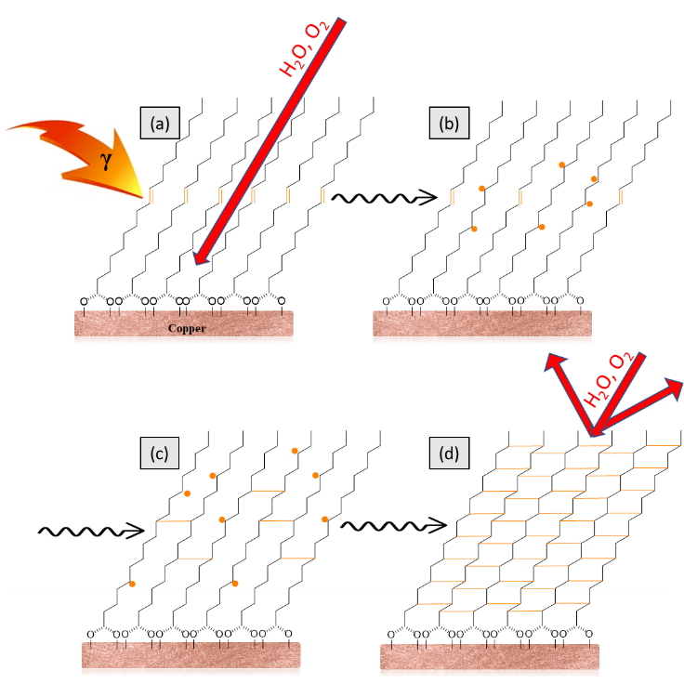

(c) intermediate stages of crosslinking stages during gamma irradiation; and (d) copper covered by a crosslinked nanocoating formed by gamma irradiation to 110 kGy ("CNC").

## Optimization of the irradiation procedure for crosslinking

*Effect of the absorbed dose*

To determine the optimal conditions for gamma radiation-induced crosslinking copper samples covered with an EA SAM were irradiated with different doses at a dose rate of 26 kGy/h. Irradiation in the presence of oxygen can produce peroxides, which can then lead to degradation of the molecular chains [6,19]. Therefore, irradiation was performed in the absence of oxygen. An important indication of the successful crosslinking process is determining the degree of crosslinking. For FAs to be crosslinked, they must be arranged on a substrate in a well-ordered and densely packed film. In addition, the coatings are very thin, so it is usually not easy to unequivocally extinguish the signal obtained for the coatings from that of the copper substrate, as is the case with most techniques used in polymer science. However, since crosslinking improves the protectivity of the crosslinked coatings, the degree of crosslinking is related to this improvement. The protective ability of the crosslinked coatings under atmospheric conditions was investigated by potentiodynamic polarization measurements in a solution that simulated atmospheric conditions which consisted of NaHCO3/NaNO3/Na2SO4 (0.2 g/L each) in water (corrosive test solution).

Fig. 2a presents the corrosion current densities obtained from the polarization curves by the Tafel extrapolation method. The corrosion current density of the sample covered by the non- irradiated SAM was 814 nA/cm2. However, it was found that even the first applied dose of 10 kGy decreased the corrosion current

𝜂𝜂 = 𝑗𝑗SAM−𝑗𝑗𝐶𝐶NC 100% (1)

𝑗𝑗SAM

where *η* is the crosslinking protective efficiency (%). For the

optimal irradiation dose of 110 kGy, the calculated crosslinking protection effect is 96%, and it can be assumed that the degree of crosslinking is similar. The polarization curves presented in Fig. 2b show that due to the slower increase of the currents upon irradiation, the anodic Tafel slope increases significantly from 33 mV/dec for the non-irradiated sample to 91 mV/dec for the samples irradiated with 110 kGy. This observation is consistent with the better resistance of copper surfaces to dissolution and shows that the crosslinked coated samples behave in a similar fashion as passive metals.

*Effect of the dose rate*

The effect of the dose rate, i.e., the rate at which energy is delivered to a material, is an important parameter in radiation chemistry. In general, it is believed that higher dose rates are preferred when crosslinking is intended, while lower dose rates are preferred for degradation of materials. To test the effect of dose rate on crosslinking of FA SAMs, 4 different dose rates were used to irradiate the SAMs at 110 kGy. Table 1 presents the contact angles obtained on the surface of the crosslinked coatings and the results of the potentiodynamic polarization measurements performed in the same corrosive test solution as previously.

**Table 1. Effect of dose rate on surface coatings.** Contact angle and corrosion parameters determined by wide-range polarization measurements in simulated atmospheric conditions on samples of SAM, irradiated with 110 kGy at four different dose rates.

|  |  |  |  |
| --- | --- | --- | --- |
| 𝑫𝑫̇ , kGy/h | ***θ****,* ° | ***E*corr***,* mVSCE | ***j*corr**, nAcm-2 |
| 26 | 99 ± 2 | 3 ± 8 | 31 ± 10 |
| 19 | 97 ± 5 | 2 ± 34 | 34 ± 13 |

|  |  |  |  |
| --- | --- | --- | --- |
| 1.8 | 98 ± 6 | -6 ± 4 | 40 ± 8 |
| 0.2 | 73 ± 7 | 7 ± 9 | 91 ± 59 |

The anti-corrosion properties of a metal can be improved by reducing the hydrophilicity of the surface. When FAs are adsorbed on the metal surface, they expose the hydrophobic methyl groups of molecules to the surrounding media (Fig. 1), and accordingly the coated copper surface should be hydrophobic. The hydrophilicity/hydrophobicity of surfaces was estimated by contact angle (*θ*) measurements using water as a solvent. A surface in contact with water is hydrophilic if *θ* < 90°, and hydrophobic if θ > 90° [20]. Accordingly, it can be concluded that the surface of the coatings is hydrophobic at a dose rate of 1.8 kGy/h without significant differences, since the contact angles are around 98° in all cases. In contrast, when irradiated at a dose rate of 0.2 kGy/h, the surface is clearly hydrophilic with a contact angle of 73°.

The polarization measurements showed a similar pattern. Although the samples irradiated at the highest dose rate had the lowest value of corrosion current density, i.e., *j*corr = 31 nA/cm2, the corrosion current density increases very slowly up to a dose rate of 1.8 kGy/h. A significant increase is observed only at 0.2 kGy/h, where the corrosion current density is practically three times higher than at the highest applied dose rate. It can be concluded that the influence of dose rate is almost negligible at dose rates of 1.8 kGy/h and above. For further investigations, a dose rate of 26 kGy/h was used.

## Surface characterization

FA molecules usually self-anchor in multiple layers, rather than into a monolayer depending on the assembling conditions like concentration of FA, the type of solvent, the temperature of the FA solution, the immersion time, etc. [21,22]. The thickness of the coatings used in this work was determined by ellipsometric measurements. Table 2 shows the determined thicknesses of the different layers. It can be seen that the oxide layer covering the copper and underlying the SAM and thus CNC is 10.4 nm thick. A SAM of 5.4 nm is adsorbed on the surface of the oxide. Considering that the thickness of the monolayer of a fatty acid with 18 carbon atoms is about 2.4 nm [23], the SAM consists of two- three layers of EA molecules. After irradiation, the thickness of the layer decreased slightly, indicating that the third molecular layer was not an integral part of the self-assembled layer. It was concluded that FAs are self-assembled in up to two layers on the copper surface.

**Table 2. Thickness of the layers covering copper** determined by ellipsometry.

|  |  |  |  |
| --- | --- | --- | --- |
| **Layer** | **Oxide** | **SAM** | **CNC (110 kGy)** |
| Thickness, nm | 10.4 | 5.4 | 4.2 |

FTIR-ATR analysis of typical samples (SAM irradiated with 0, 30, 110, 250 and 450 kGy) was performed to characterize their surfaces and to determine the chemical composition of the irradiated layers. Since the studied layers are very thin, the absorptions of specific vibrations are weak, but nevertheless the presence of characteristic peaks is evident. Fig. 2c shows

representative FTIR spectra obtained in the high frequency range on the non-irradiated sample and on the samples irradiated with up to 250 kGy. A spectrum of pure EA is shown for comparison. The peaks at 2850 and 2922 cm−1 are associated with the C-H stretching modes of methylene groups and characterize the ordered aliphatic monolayer with alkyl chains in an all-trans configuration [4,6,24]. The peaks observed at 2871 and 2957 cm−1 are assigned to the C-H stretching modes of methyl groups but are not always clearly distinguishable. These absorptions were observed in the spectra of 30 and 110 kGy samples, only sporadically in 250 kGy samples. In contrast, these vibrations were not observed at samples irradiated at 450 kGy, indicating a progressive degradation of FAs with increasing radiation dose. The lower frequency range of the spectra of unirradiated SAMs, as well as samples irradiated at 30, 110, and 425 kGy, is shown in Fig. 2d. Unirradiated samples show absorption peaks corresponding to C-O stretching at 1264 and 1105 cm−1 and C=O stretching at 1748 cm−1, while C=C bending is represented by a small but clearly observed peak at 966 cm−1 [25]. However, no double bond vibrations were observed in the irradiated samples, which is a consequence of gamma-induced crosslinking.

Irradiation of the samples was performed in an oxygen-free environment to avoid the formation of peroxides, which could subsequently lead to degradation of the chains in the FAs even before crosslinking. The initial breaking of double bonds is expected to lead to the formation of alkyl radicals with centered atoms. Two processes are particularly important for the formation of SAMs: the moderate to strong adsorption of the carboxyl group on the metal surface and the van der Waals interaction of the alkyl chains [1]. These processes result in the FA molecules being highly ordered and oriented on the metal surface (Fig. 1a). Thus, it can be assumed that crosslinking has occurred through a combination of free radicals from two adjacent molecules (see Fig. 1). This can be seen to some extent in the FTIR spectra by the absence of the C=C bend (966 cm-1). On the other hand, the CH2 bending peak shifts from 1460 cm-1 before irradiation to 1446 cm-

1 after irradiation at 30 and 110 kGy, indicating the interaction of two neighboring FA molecules and their crosslinking [25]. After irradiation with 250 kGy, the CH2 peaks were observed only in some samples, while they disappeared completely after irradiation with 425 kGy. The observed results clearly indicate that the surface layers of FA were degraded by gamma irradiation at high doses. The degradation induced by the excess radiation resulted in the breaking of chemical bonds and the formation of new radicals that could be available for subsequent recombination. Thus, the spectra of the samples irradiated with 425 kGy show several new peaks that can probably be assigned to C=C=O stretching (2159 cm-1), C=C=C stretching (1973 and around 2030 cm-1), O-H bending, characteristic of carboxylic acids or alcohols (broad peak around 1400 cm-1) and secondary alcohols (peak at 1100 cm-1), and C-H bending in mono-, di-, tri-, or tetrasubstituted compounds (peaks at 880 and 778 cm-1). All detected degradation products indicate a strong decomposition of the CNC at high doses, leading to the loss of the protective properties of the surface layers, as confirmed by polarization measurements.

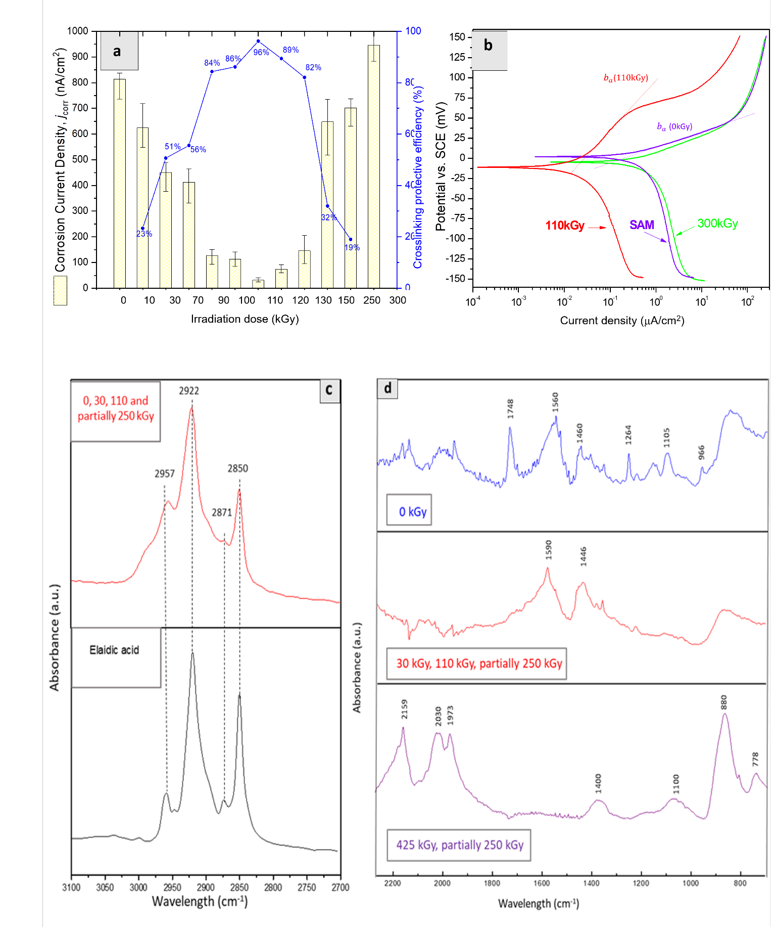

**Figure 2. Effect of irradiation dose on surface coatings.** Wide-range polarization measurements under simulated atmospheric conditions on the studied copper samples covered with the non-irradiated SAM ("0 kGy") and the copper samples coated with SAM irradiated with different irradiation doses: (a) the yellow columns represent corrosion current densities determined by the Tafel extrapolation method, while the blue dots represent the protective efficiencies determined from them;

(b) selected polarization curves. The presented curves are mean curves obtained from repeated measurements. Characterization of the chemical composition of the surface films: The (c) FTIR spectra in the high and (d) low frequency range obtained on the samples studied.

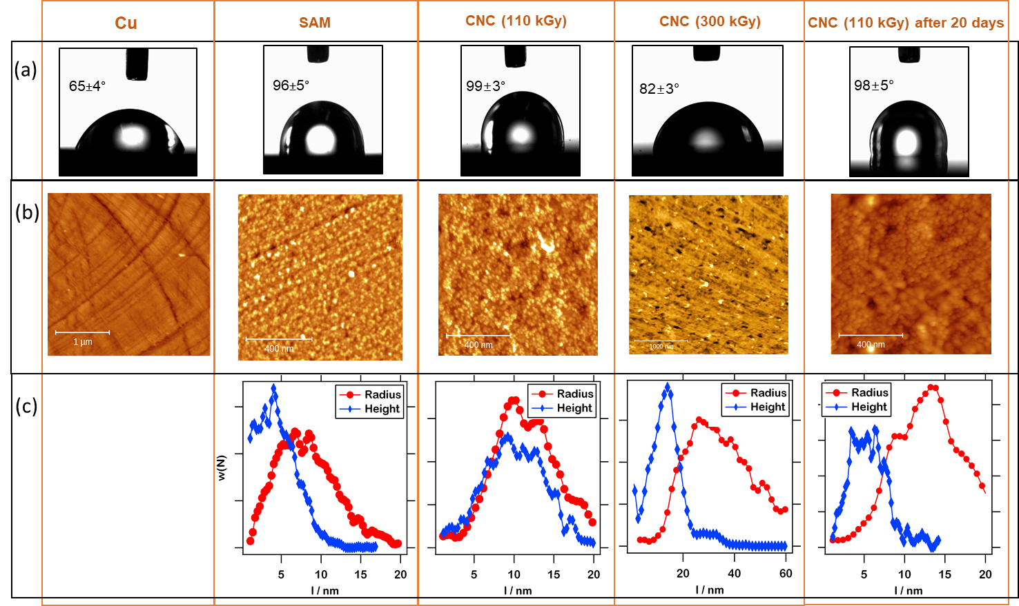

**Figure 3. Surface properties of the investigated coatings:** bare copper (Cu), nonirradiated SAM, CNC obtained by irradiation to 110 kGy, and CNC after exposure to atmospheric conditions for 20 days. (a) Contact angles; (b) AFM images; and (c) height and radius distributions of particle-like structures seen on the surface of the three types of samples and calculated from AFM images.

## The behavior of the different coatings under atmospheric conditions

As explained earlier, the presence of FAs on the copper surface can make the surface hydrophobic. Contact angle measurements were performed on various copper samples, which are shown in Fig. 3a. It can be seen that the *θ* of water droplets increases from 65⁰ on the untreated copper surface to 96⁰ when the surface is covered with EA. After crosslinking EA molecules, the *θ* value even increased to 99⁰, so it can be undoubtedly concluded that coating the copper surface with EA makes it hydrophobic, while after gamma irradiation and CNC formation, the hydrophobicity is further enhanced. It can also be seen that when over-irradiated with 300 kGy, the contact angle decreases to 82°, which means that the hydrophobic properties of the coatings are lost. The value again approaches the values determined for pure copper, confirming that the coatings are degraded at such high doses.

Since the hydrophobic properties of the coatings did not change significantly, while the protective properties improved dramatically after irradiation, additional studies of the anticorrosive properties were performed. For this purpose, electrochemical impedance spectroscopy (EIS) was measured in the corrosive solution on the different samples. Fig. 4a shows the measured EIS responses on the compared model systems in the form of Nyquist diagrams, while Fig. 4b shows schematically the equivalent electrical circuit (EEC) that was used to represent the physical system with the electrochemical cells. Each element in the equivalent circuit diagrams used to model the measured responses is associated with a physical phenomenon occurring on the metal surface, and as will be explained, different elements were observed for the different samples.

The common feature of the Nyquist diagram for bare Cu is a

single semicircle of the capacitive loop with a Warburg tail in the

low-frequency region (inset in Fig. 4a). The Warburg impedance reflects the anodic diffusion process of soluble copper species from the surface into the bulk solution and the cathodic diffusion of dissolved oxygen in the opposite direction. The semicircle reflects the relaxation time constant of the charge transfer resistance, which is approximately equal to the diameter of the capacitive loop, and the double layer capacitance at the copper/electrolyte interface [26,27]. Thus, the corrosion reactions at the bare copper substrate/solution interface are observed through the *R*ct-*C*dl circuit at low frequencies, while the Warburg element

(W) represents the Warburg impedance attributed to mass transport in the corrosion reactions. Similarly, the other curves shown in Fig. 4a consist of two semicircles, indicating that the experimental EIS exhibits two time constants under the capacitive loop, as a result of one additional process at high frequencies. This process involves the ionic leakage through the pores of the surface film (SAM or CNC) and is observed through the *R*f-*C*f circuit. *R*f represents the charge transfer resistance of electrons through the film, while *C*f corresponds to the capacitance due to the dielectric properties of the film.

The nonirradiated SAM does not behave like a perfect insulator and has defects or random pinholes that allow the penetration of electrons or ions [28], which can be observed as diffusion through the Warburg impedance in the EEC. No diffusion was observed upon irradiation even at low doses, so the Warburg element was not used. The value of n is related to the nonuniform distribution of the current due to roughness and surface defects, with n values equal to or close to one suggesting approximately ideal capacitive behavior. Thus, the coefficients *n*ct and *n*f represent the depressed feature of the *R*-*C* circuits respectfully. The numerical parameters were obtained by fitting the experimental data; the results are

presented in Figs. 4c-e. The lines in Fig. 4a present the calculated

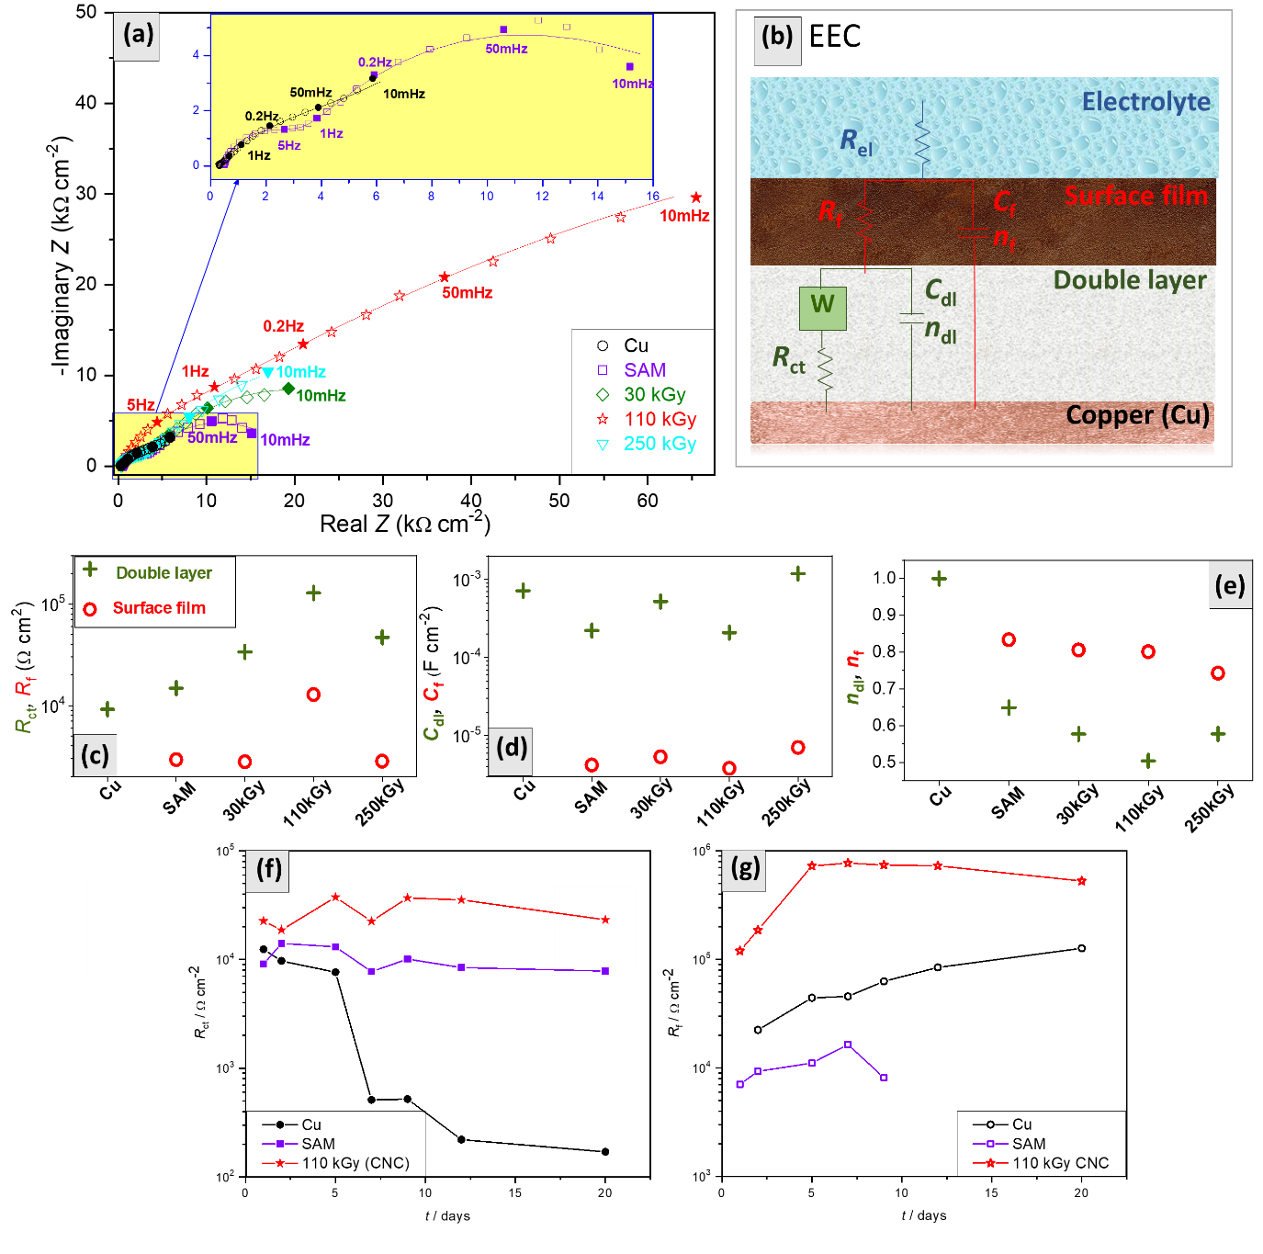

**Figure 4. Electrochemical impedance spectroscopy (EIS) investigations in simulated atmospheric conditions.** (a) Nyquist diagrams of the investigated samples. Presented are results obtained on: bare (non-treated) copper Cu (●), copper covered with the non-irradiated SAM (■), copper covered with a SAM irradiated to different irradiation doses: 30 kGy (♦), 110 kGy (), and 250 kGy (▼). (b) The equivalent electrical circuit (EEC) used for fitting the experimental EIS data. Results from fitting the experimental EIS data: (c) resistances, (d) capacitances, and (e) *n* coefficients. Long-term protective properties of the coatings expressed through resistances obtained from fitting EIS responses in simulated atmospheric conditions: (f) Charge transfer resistance and (g) film resistance vs. exposure time.

data obtained by fitting the measured data, which are represented by the scattered points. It can be seen that the fitted and measured data have good agreement, confirming that appropriate EECs were used for the fitting.

From Fig. 4c, it can be seen in Fig. 4c that the *R*ct value corresponding to the corrosion reaction at the metal/surface interface on bare copper is 9.2 kΩ cm2, indicating relatively low

corrosion resistance. When an unirradiated SAM was formed on

the surface, Rct was slightly higher at 14.8 kΩ cm2, while *C*dl decreased from 715 to 222 μF cm-2. The resistance to ionic leakage through the pores of the nonirradiated SAM film was *R*f =

2.9 kΩ cm2, while the capacitance of the film was 4.2 μF cm-2. It should be emphasized that in this case diffusion was observed through the Warburg impedance, just as in the case of bare copper. After irradiation with 30 kGy, the values of the *R*f-*C*f circuit showed no significant change, yet diffusion was no longer observed and *R*ct increased significantly to 33.7 kΩ cm2.

An unusual phenomenon was observed in Fig. 4d, namely the increase of *C*dl from 222 to 521 μF cm-2 upon irradiation with 30 kGy. Such increases are usually linked to the presence of a large number of redox reactions at the surface [29]. When they are accompanied by a decrease in resistance, it usually indicates deterioration of the layers and a lack of ability to shield the metal substrate from the environment. In this particular case, both resistances increased, so the increase in *C*dl is more likely related

to the alkyl radicals on the copper surface that are formed when the EA films are irradiated. Accordingly, after irradiation at 110 kGy, the resulting radicals reacted with each other and the FA molecules crosslinked to a maximum value, whereupon *C*dl decreased again to 209 μF cm-2, while *R*ct continued to increase to 128.6 kΩ cm2. After irradiation with 250 kGy, *C*dl increased even more, to 1.2 mF cm-2, although *R*ct was still quite pronounced, *R*ct

= 46.9 kΩ cm2. In this case, the substantial value of *C*dl indicates the presence of degradation products on the surface due to the overirradiation of the surface film [11], which was demonstrated by FTIR analyzes of the overirradiated films. Since both resistances of the sample irradiated with 110 kGy have the highest values (*R*f

= 12.8 and *R*ct = 128.6 kΩ cm2) and both capacitances have the lowest values (*C*f = 4 and *C*dl = 209 kΩ cm2), it is clear that this sample is the least active under the conditions studied.

## Long-term stability studies

The coatings were additionally compared by studying their long- term behavior by EIS measurements during a 20-day exposure to the corrosive medium. The EIS responses obtained were fitted to the EEC shown in Fig. 4b, using the Warburg element to fit the data obtained for bare copper throughout the period and for SAM after 7 days and longer exposure, while it was not used for CNC (irradiated with 110 kGy). The resistances obtained are presented in Figures 4f and 4g, which show that the charge transfer resistance on bare copper decreases significantly. On the other hand, the resistance attributable to the surface film *R*f (Fig. 4g), which is not observed on the first day, appears on the second day and increases with time. On bare copper, the appearance of film resistance after two days indicates that corrosion products have formed on the surface and the amount of corrosion products increases with time.

SAM shows only a slight decrease in *R*ct with time (Fig. 4f), while on the other hand, *R*f values are more or less similar during the first 7 days, whereas a decrease is observed after 9 days. After

12 days, the *R-C* circuit attributed to the film disappears completely, indicating that there is no SAM film on the surface.

In the case of CNC, both *R*ct and *R*f increase the most compared to the other samples. The high values are maintained even after 20 days, which clearly indicates that the film is stable even after 20 days in the corrosive solution.

The AFM images shown in Fig. 3b show the surface of bare copper, SAM and CNC, as well as the surface of CNC after 20 days of exposure to atmospheric conditions. All images are described with the same vertical scale and a false color range of

30 nm. Thus, the copper surface appears relatively smooth, except for the grooves caused by polishing. However, after self- anchoring of FAs on copper, the surface appears to be covered by particle-like structures. The statistics of these structures were analyzed using Gwyddion software [30] and the water scale algorithm was applied to characterize them. The distributions of equivalent radii (radius of a circle with the same area as the given particle) and heights (the difference between the maximum and minimum elevation within the given particle) are shown in Fig. 3c for the samples that had these structures (bare copper had none), as the number of particles versus particle size. It can be seen that when irradiated at 110 kGy, the height of the particle-like structures increases from an average of 5 (for SAM) to 12 (for CNC), while the radii generally increase, with additional extremely large structures of 15 nm or more. These structures appear to be spherical when irradiated, as their height is equal to their radius.

Since the protective properties of the coatings increased greatly upon irradiation, the increase in the size of the structures on the surface cannot be related to the breaking of the crosslinked coatings. However, the increase in size is more likely related to the free EA molecules deposited on the surface of the coating and not covalently bonded to the copper surface as part of the SAM. After irradiation, these molecules are not part of the crosslinked film, and chain scission occurs, resulting in smaller, more mobile molecules that can easily agglomerate. This agglomeration is probably the reason for the observed further increase of the contact angle from 96° to 99° after irradiation of the adsorbed EA (Fig. 3a). It can also be seen that the CNC coating is still present on the copper after 20 days under simulated atmospheric conditions. The only difference is that the height of agglomerates after 20 days is lower than before exposure to atmospheric conditions. Since the resistances obtained on CNC after 20 days of exposure were still stable and the contact angle also remained high (98°), this decrease confirms that the agglomerates observed on CNC before exposure were related to the free EA molecules that can be removed from the surface with time without contributing to the protective properties of CNC.

In the process presented in this work, crosslinking occurs between the aliphatic chains in the FA molecules, while there is no significant effect on the substrate metal or on the bond between the carboxylic acid and the metal. Accordingly, the presented method can be applied to different substrates as well as to different molecules containing aliphatic chains in their structure, although the irradiation doses must be determined separately in each case.

# Conclusion

We have demonstrated for the first time the successful crosslinking of a self-assembled molecular layer (SAM) of a trans fatty acid, elaidic acid, on copper obtained by gamma irradiation. It was shown that after gamma irradiation of SAM in oxygen-free environment, free radicals are formed, which gradually react with neighboring EA molecules and further **crosslink the surface molecules by forming a highly ordered and protective nanocoating** (CNC). The coatings with optimal properties were obtained by irradiation in a dose range of 90 to 130 kGy. It was also shown that gamma irradiation at dose rates of 1.8 kGy/h and higher leads to a similar crosslinking effect, while at low dose rates (0.2 kGy/h) the protective properties of the crosslinked coatings are significantly lower. Electrochemical impedance spectroscopy confirmed that the non-irradiated SAMs do not behave as perfect insulators under atmospheric conditions and allow electron or ion penetration, which was observed as diffusion through Warburg impedance. However, despite the thickness of the surface layer of several nanometers, the crosslinking greatly reduced the penetration of electrons or ions through the coatings and stopped the diffusion, while maintaining the hydrophobic properties of SAM. Consequently, the protective effect of the coating after crosslinking increases up to 96% compared to the non-irradiated SAM. It was also shown that the CNC coating is stable under long-term exposure to corrosive media and is still present on copper surfaces after 20 days, retaining the protective and hydrophobic properties.

The proposed method for **"clean" crosslinking** of SAMs to CNCs can be easily transferred to other systems to achieve stable and long-lasting surface properties. The method can be applied to different substrates and molecules. Therefore, we consider the present work as a starting point for a new research area of surface functionalization by crosslinking SAMs. It should be emphasized that no initiators or aggressive chemical agents were used in the presented method to prepare novel CNCs. Moreover, by using ionizing radiation, microbial decontamination or disinfection of the treated objects can be achieved simultaneously. Radiation dose of 25 kGy ensure the sterility of an object, while simultaneous crosslinking makes such processes suitable for the development of new functional materials in medicine and biomedical applications. However, due to the superior properties of CNCs demonstrated in this work, alternative classical processes should be developed without the use of ionizing radiation.

# Experimental Section

**Copper surface treatment**

**Pretreatment**: Investigations were carried out on bare copper (high purity: 99.9%). Specimens were cut from a rod with a diameter of 1.3 cm and thickness of 0.5 cm. Prior to all investigations and/or surface treatments, the plates were abraded with 400, 800, 1500, and 2500 grit emery paper, polished with 0.1 μm particle size α-Al2O3, washed under running tap water, rinsed with redistilled water and degreased in an ultrasonic bath with ethanol. Only one side of the plates was treated.

**Nontreated copper preparation**: After pretreatment, the copper samples were left in the air at room temperature for 3 days to allow an oxide layer to form naturally.

**SAM preparation procedure**: Elaidic acid, *trans*-octadec-9-enoic acid, CH3(CH2)7CH=CH(CH2)7COOH, (EA) was purchased from Sigma-Aldrich Chemie GmbH. EA was applied on the copper surface according to the procedures proposed earlier.[5,6] As carboxylic acids are known to preferentially bind on metallic oxides, thermal oxidation of copper’s surface is an important step prior to EA application. It has also been shown previously that heating of the fatty acid solution has a positive effect on the layer stability, as well as drying at higher temperatures after SAM application. [5] Thus, the preparation procedure used in this work assumed the following steps:

1. Copper samples were heated in a furnace at 80 °C for 24 hours to form an oxide layer (cuprite) on the surface;

**Ellipsometric measurements** were performed using a V-VASE spectroscopic ellipsometer (J.A. Woollam) in the spectral range between

0.57 and 5 eV at 55° and 75° angles of incidence. Measurements were performed on substrates before and after the formation of SAM layers to account for the contribution of the copper oxide layer (about 10 nm). **Fourier transform spectroscopy (FTIR) measurements**: FTIR was performed using Bruker's Tensor II (Bruker Optik GmbH, Ettlingen, Germany) equipped with an ATR module to check for the presence of functional groups of molecules on the copper surfaces. FTIR spectra were recorded at room temperature in the frequency range 500-4000 cm−1 with

4 cm−1 scan steps and a total of 16 scans per measurement. Each measurement was repeated 5-10 times.

**AFM measurements**: The surface of the specimens was examined using the NT-MDT N'Tegra Prima atomic force microscope in contact mode. Image analysis was performed using Gwyddion software.

**Electrochemical measurements**: Electrochemical investigations were conducted in a three-electrode cell. Copper plates after undergoing the different preparation procedures were placed into corrosion cell holders designed to accept cylindrical specimens where the exposed surface of the working electrodes was 0.785 cm2. This part of the surface of the prepared copper samples was exposed to the corrosive solution. A platinum foil was used as the counter electrode and a saturated calomel electrode (SCE) was used as the reference electrode. All potentials in the text refer to the SCE scale. The test solution consisted of 0.2 g/L NaHCO3

+ 0.2 g/L NaNO3 + 0.2 g/L Na2SO4 acidified to pH5 by diluted H2SO4. Before the electrochemical measurements, the electrodes were immersed in the test solution for 45 minutes to stabilize the open circuit potential. Each copper coating preparation procedure was measured on three samples prepared in the same manner.

**Polarization measurements** were performed by wide potential range (±150mV OCP) polarization at a potential scan rate of 0.166 mV/s. The polarization measurements were performed using a PAR 263 A and a 273 potentiostat/galvanostat.

The overall current density *j* is considered as the sum of two contributions, anodic and cathodic current respectively *j*a and *j*c. For the potential domain not too far from the open circuit one, one may consider that both processes follow the Tafel law, thus one can derive:

𝑗𝑗 = 𝑗𝑗𝑎𝑎 + 𝑗𝑗𝑐𝑐 = 𝑗𝑗𝑐𝑐𝑐𝑐𝑐𝑐𝑐𝑐 [exp{𝑏𝑏𝑎𝑎(𝐸𝐸 − 𝐸𝐸𝑐𝑐𝑐𝑐𝑐𝑐𝑐𝑐 )} − exp{𝑏𝑏𝑐𝑐 (𝐸𝐸 − 𝐸𝐸𝑐𝑐𝑐𝑐𝑐𝑐𝑐𝑐 )}] (1)

where *b*a and *b*c are the anodic and cathodic Tafel slopes. The corrosion

parameters were then evaluated by means of the non-linear least square method by applying this equation. For this calculation, the potential range applied was limited to ±70 mV with respect to *E*corr else a significant systematic divergence was sometimes observed for both anodic and cathodic branches. Protective efficiency was calculated from the data obtained from the polarization curves by the Tafel extrapolation method according to the equation:

1. Samples were immersed in EA diluted in ethanol (96%) at a

𝑗𝑗𝑐𝑐𝑐𝑐𝑐𝑐𝑐𝑐

𝑐𝑐𝑐𝑐𝑐𝑐𝑐𝑐

concentration of 10 mmol/L at 40 °C for 24 hours to form a SAM film;

𝜂𝜂 =

0 −𝑗𝑗

0 ∗ 100%. (2)

𝑗𝑗

𝑐𝑐𝑐𝑐𝑐𝑐𝑐𝑐

1. Samples were rinsed extensively with ethanol to remove the excess of

unbound EA molecules from the surface;

1. Samples were dried in a furnace at 50 °C for 5 hours.

**Irradiation of samples**: Copper samples covered with SAM were sealed in a flask purged with N2 prior to irradiation. Irradiation was performed at a panoramic gamma radiation facility with 60Co at the Radiation Chemistry and Dosimetry Laboratory, Division of Materials Chemistry, Ruđer Bošković Institute, at room temperature. Four different dose rates (26, 19,

1.8, and 0.2 kGy/h) and various radiation doses up to 450 kGy were used

Electrochemical impedance spectroscopy (EIS) was performed at *E*corr in

the frequency range 100 kHz–10 mHz with a 10 mV rms amplitude. The

EIS measurements were performed using a Bio-Logic SP-300

potentiostat/galvanostat/FRA.

Scattered elements in the Nyquist plot present the measured data, while the lines present the regression calculation of EIS data using the equivalent electrical circuits. Capacitive elements in real electrochemical systems are usually represented by constant phase element CPE due to the frequency dispersion. The impedance of CPE is defined as:

for the studies. The irradiation times were calculated based on the dose

𝑍𝑍(CPE) = 1

𝑄𝑄(𝑗𝑗𝑗𝑗)𝑛𝑛

(3)

mapping of the γ-source determined with the ECB dosimetry system and

confirmed by computational simulations [31]. The samples referred to as crosslinked nanocoatings (CNC) in the text were irradiated at the optimal

where Q is the constant of the CPE element, j imaginary number, ω the angular frequency, and *n* the CPE exponent where −1 ≤ *n* ≤ 1. The value of pseudocapacitance C was calculated using the relationship:

dose of 110 kGy, unless otherwise stated.

𝐶𝐶 = 𝑛𝑛�𝑄𝑄𝑅𝑅1−𝑛𝑛

(4)

**Characterization and analyses of copper samples**

**Contact angle measurements**: Contact angles on bare copper and on EA and radiation-treated copper samples were measured using a

Corrosion current densities were calculated using the Stern Geary

equation:

𝑗𝑗𝑐𝑐𝑐𝑐𝑐𝑐𝑐𝑐 = 𝐵𝐵/𝑅𝑅𝑝𝑝 (5)

where

Goniometer DataPhysics Contact Angle System OCA 20. Measurements were carried out with a drop of 1 μL water under atmospheric conditions.

Six measurements were performed on each surface.

*B*= 𝑏𝑏𝑎𝑎𝑏𝑏𝑐𝑐

2.303(𝑏𝑏𝑎𝑎+𝑏𝑏𝑐𝑐)

was calculated from polarization measurement data.

(6)

# Acknowledgements

The authors would like to thank the Croatian Science Foundation (HRZZ IP-2020-02-4344) for supporting this research.

**Keywords:** self-assembled monolayers • crosslinking • thin coating • corrosion • ionizing radiation

[1] A.-L. Fameau, A. Arnould, A. Saint-Jalmes, *Curr Opin Colloid Interface Sci* **2014**, *19*, 471.

[2] K. Siram, S. M. Habibur Rahman, K. Balakumar, N. Duganath, R. Chandrasekar, R. Hariprasad, in *Biomedical Applications of Nanoparticles*, Elsevier, **2019**, pp. 91–115.

[3] S. Jadhav, *Open Chem* **2011**, *9*, 369.

[4] M. Ukrainczyk, J. Kontrec, D. Kralj, *J Colloid Interface Sci*

**2009**, *329*, 89.

[5] K. Marušić, Z. Hajdari, O. Čurković, *Acta Chim Slov* **2014**,

*61*.

[6] K. Marušić, N. Matijaković, B. Mihaljević, *J Electrochem Soc* **2018**, *165*, C973.

[7] A. Ulman, *Chem Rev* **1996**, *96*, 1533.

[8] A. Ulman, *An Introduction to Ultrathin Organic Films*,

Elsevier, **1991**.

[9] A. Ulman, in *An Introduction to Ultrathin Organic Films*,

**1991**, pp. 237–304.

[10] M. A. Barbosa, M. C. L. Martins, J. N. Barbosa, in *Cellular Response to Biomaterials*, Elsevier, **2009**, pp. 85–113.

[11] C. R. Kaufmann, G. Mani, D. Marton, D. M. Johnson, C. M. Agrawal, *Biomedical Materials* **2010**, *5*, 025008.

[12] H. Menzel, S. Horstmann, M. D. Mowery, M. Cai, C. E.

Evans, *Polymer (Guildf)* **2000**, *41*, 8113.

[13] E. Giorgetti, M. Muniz-Miranda, A. Giusti, T. DelRosso, G. Dellepiane, G. Margheri, S. Sottini, M. Alloisio, C. Cuniberti, *Thin Solid Films* **2006**, *495*, 36.

[14] T. Kim, R. M. Crooks, *Tetrahedron Lett* **1994**, *35*, 9501. [15] V. Dérue, S. Alexandre, J. M. Valleton, *J Colloid Interface*

*Sci* **1999**, *213*, 546.

[16] H. I. Meléndez-Ortiz, G. H. C. Varca, A. B. Lugão, E. Bucio,

*Open Journal of Polymer Chemistry* **2015**, *05*, 17.

[17] U. v. Läuppi, *International Journal of Radiation Applications and Instrumentation. Part C. Radiation Physics and Chemistry* **1990**, *35*, 30.

[18] J. Telegdi, T. Abohalkuma, *International Journal of Corrosion and Scale Inhibition* **2018**, *7*, DOI 10.17675/2305-6894-2018-7-3-6.

[19] J. W. T. Spinks, R. J. Woods, in *Introduction to Radiation Chemistry*, **1990**, pp. 452–474.

[20] K.-Y. Law, *J Phys Chem Lett* **2014**, *5*, 686.

[21] Z. H. Gretić, E. K. Mioč, V. Čadež, S. Šegota, H. Otmačić Ćurković, S. Hosseinpour, *J Electrochem Soc* **2016**, *163*, C937.

[22] Z. Hajdari, H. O. Ćurković, V. Čadež, S. Šegota, *J Electrochem Soc* **2016**, *163*, C145.

[23] Y.-T. Tao, *J Am Chem Soc* **1993**, *115*, 4350.

[24] A. Raman, E. S. Gawalt, *Langmuir* **2007**, *23*, 2284.

[25] R. G. Sinclair, A. F. McKay, R. N. Jones, *J Am Chem Soc*

**1952**, *74*, 2570.

[26] O. E. Barcia, O. R. Mattos, N. Pebere, B. Tribollet, *J Electrochem Soc* **1993**, *140*, 2825.

[27] G. Žerjav, I. Milošev, *Corros Sci* **2015**, *98*, 180.

[28] G. K. Jennings, J. C. Munro, T.-H. Yong, P. E. Laibinis,

*Langmuir* **1998**, *14*, 6130.

[29] H. Otmacic Curkovic, E. Stupnisek-Lisac, H. Takenouti,

*Corros Sci* **2009**, *51*, 2342.

[30] D. Nečas, P. Klapetek, *Open Physics* **2012**, *10*, DOI 10.2478/s11534-011-0096-2.

[31] M. Majer, M. Roguljić, Ž. Knežević, A. Starodumov, D. Ferenček, V. Brigljević, B. Mihaljević, *Applied Radiation and Isotopes* **2019**, *154*, DOI 10.1016/j.apradiso.2019.108824.

**Entry for the Table of Contents**

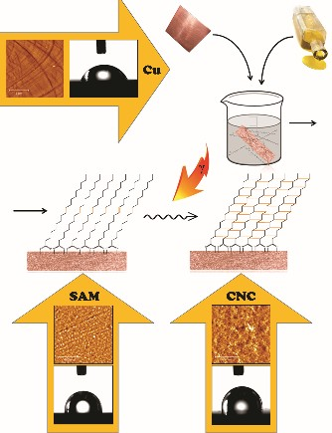

Crosslinking of self-assembled molecular layers (SAMs) of fatty acids on copper leads to the formation of a highly ordered and protective nanocoating. The protective properties of crosslinked SAM of elaidic acid are improved by 96%, and long-term protection and stability are achieved. The crosslinking thus opens up the possibility of using SAMs for surface functionalization in aggressive environments to achieve stable and durable surface properties.