**Vanadium redox speciation in the acid-extractable phase of Krka River estuary surface sediment**

**Lucija Kneževića,b*, Nuša Cukrova, Elvira Bura Nakića**

***a Division for Marine and Environmental Research, Ruđer Bošković Institute, Bijenička cesta 54, 10 000 Zagreb, Croatia***

***b Equipe Pollutions Environnement Santé Territoires, HydroSciences Montpellier – UMR 5151, CNRS– Université Montpellier, 15, avenue Charles Flahault 34093 Montpellier cedex 05, France***

***\*lknezev@irb.hr***

**Abstract**

This study investigated the redox speciation and mobility of V in the acid-extractable fraction of surface sediments from the Krka River estuary using an optimized IC-UV/Vis analytical method. The separation of V(IV) and V(V) redox species was done using anion-exchange based chromatographic method, while pseudo-total V concentrations were measured using HR ICP-MS analytical instrumentation. Extracted V concentrations from the sediment fraction (pH=5, HCl) and determined pseudo-total V concentrations were used to calculate the Enrichment Factor (EF) and Risk Assessment Code (RAC), indicating potential anthropogenic influence and environmental risk. A simple PHREEQC model was developed to asses V speciation in the oxic bottom seawater layer simulating possible remobilization of the leached sediment phase. The results of the study show that minor fraction of V is present in the acid-extractable phase across the surface sediment of Krka River estuary. Higher V mobility is mostly observed at locations rich with clay minerals, terrigenous input, and carbonates. Anthropogenic influence was linked to higher enrichment but lower mobility, suggesting binding to less mobile sediment phases (reducible, organic and residual fractions). The predominance of reduced V(IV) species in the acid-extractable sediment fraction indicates a potentially low V toxicity risk in the sediments of Krka River estuary, even in cases of high potential remobilization of V. However, the model predicted complete oxidation of V(IV) to V(V) upon remobilization into the oxic bottom water layer. This highlights the complexity of V behavior in natural estuarine systems, where the toxicity risks of possible V remobilization still remain unclear. Results of this study demonstrate the need for the strengthening efforts in speciation of V in the mobile sediment phase to obtain a cohesive outlook on its potential toxicity and biogeochemical cycling.

**Key words:** Vanadium redox speciation; Mobile sediment phase; Ion chromatography; Krka River estuary.

# **Introduction**

Vanadium (V), a redox sensitive trace metal (TM), is increasingly recognized as a potential pollutant in surface waters. While naturally abundant, anthropogenic activities have significantly increased V production, leading to its enrichment in the modern sediments (Schlesinger, Klein and Vengosh, 2017). Consequently, this led to its critical classification as an emerging pollutant (Schlesinger, Klein and Vengosh, 2017; Gustafsson, 2019a; Yang *et al.*, 2022). As our understanding of V chemical behavior in aquatic systems is still limited, leading world health and environmental agencies recommend strengthening research efforts of its chemical and toxicological characteristics as studies predict even greater anthropogenic pressure of V in the future (Yang *et al.*, 2022).

Vanadium exhibits complex redox chemistry and can be naturally present in several oxidation states (III, IV and V) which governs its chemical behavior. Distribution between these redox species highly depends on environmental redox conditions, pH, complexation with natural organic and inorganic ligands, etc. Vanadium(V) is the most mobile and toxic form due to its similarity to phosphorus, disrupting vital enzymes in microbes and humans (Rehder, 2015). When present in lower oxidation states, its affinity for binding to ligands and particles increases (Gustafsson, 2019a). This redox sensitivity of vanadium makes it also a promising tool for reconstructing past ocean oxygen levels (Bian *et al.*, 2022; Cui, Luther and Gomes, 2023). While sediment acts as a V sink, remobilization to overlying waters occurs under oxic conditions(~20x109 g/year on a global scale) (Schlesinger, Klein and Vengosh, 2017). This remobilization of V depends on various sediment process (redox changes of the sediment, changes in the nature and binding strength to the solid phase, particle surface in the sediment phase) and V chemical response (V redox speciation, mobility, complexation affinity etc.). Consequently, V can be partitioned between several sediment phases: carbonates, oxyhydroxides, organic matter, sulfides, and residual minerals (Filgueiras, Lavilla and Bendicho, 2002). Remobilization of V from the sediment to the overlaying waters is most likely to occur from the sediment water soluble and acid-extractable fraction. Herein binding is mostly controlled by weak electrostatic interaction and loose binding, where V species can be easily released by ion-exchange process (Filgueiras, Lavilla and Bendicho, 2002; Cappuyns and Swennen, 2014). Vanadium is mostly found bound to sediment reducible and residual fractions due to its higher affinity for solid phases (clay minerals, metal oxides, and organic matter) under more reducing conditions (Prohić and Kniewald, 1987; Nedrich *et al.*, 2018; William W. Bennett, Enzo Lombi, Edward D. Burton, Scott G. Johnston and Daryl L. Howard, 2018; Shaheen *et al.*, 2019). Sequential extraction procedures are generally used for determination of V distribution between different sediment phases. However, they usually lack information on V oxidation states in those phases (Filgueiras, Lavilla and Bendicho, 2002; Xu, Huang and Brandl, 2017). Experimental V speciation studies began only recently, with the development of X-ray spectroscopic techniques which enabled direct V speciation in the solid samples. Bennet et al. (2018), found mixed V(III)-V(IV) species in the marine sediment, while Nedrich et al. (2018) linked low V bioavailability in freshwater sediment to V(III)/V(IV) dominance Recently, Bian *et al.* 2022. suggested presence of a new V(IV)-S structure predominantly present in the sediment deposited under euxinic conditions (Bian *et al.*, 2022). Despite various advantages, X-ray techniques are expensive, time-consuming, and require complex data interpretation. (Feldmann, Salaün and Lombi, 2009). Furthermore, significant lack of experimental data on V redox speciation in aquatic sediments can be also explained by complex redox chemistry of V and maladjustment of other existing analytical instrumentation to the complex matrix of natural sediment systems (Chen & Owens, 2008). Thus, there is an ongoing need for using diverse analytical methodologies to address V redox speciation in the sediment phases and reconstruct V biogeochemical cycle and remobilization pathways. In addition, due to the varying toxicity of its different redox states, understanding V speciation in the mobile sediment phase is crucial for environmental risk assessment as well.

Usage of ion chromatography for the purpose of V redox speciation in the acid-extractable phase of surface estuarine sediment was adapted and applied in our earlier work (Knežević, Cukrov and Bura-Nakić, 2020). A novel analytical approach for V redox distribution in the samples of complex matrices which provides fast, simple, and accurate measurements of V redox speciation in the acid-extractable phase was presented. Limited data on V speciation in the sediment phases still prevents our comprehensive understanding of V sink and remobilization processes. Thus, obtaining new experimental evidences on the V redox state determination in the mobile sediment fraction presents valuable contribution to the existing knowledge. In addition, regarding the different toxic effect of V species, potential environmental risks can be elucidated as well. Estuarine sediment samples are especially ideal for assessing trace metal geochemistry due to the variety of chemical processes present in such dynamic surface aqueous systems (Prohić and Kniewald, 1987).

In this study, redox speciation of V is determined in a broad range of samples along the estuarine surface sediment. Altogether, this paper aims to provide cohesive assessment of V potential mobility across surface estuarine sediment, and its dependance on natural and anthropogenic factors. In addition, possible remobilization pathways are going to be discussed with respect to the determined distribution of V redox species in the acid-extractable phase of surface sediment samples.

1. **Materials and methods**
   1. **Study area**

The study area is presented in Figure 1., along with the notation of 35 sampling locations. The Krka River estuary, located in the central part of the Eastern Adriatic coast between Skradin waterfalls and St. Anthony Channel (Croatia), is a 22 km long estuary. The catchment area of the estuary is mainly composed of Upper Cretaceous and Eocene limestones, with a subordinate quantity of clastic rocks consisting primarily of Eocene flysch and flysch-like deposits, quaternary marls, and clays. Mean annual flow is reported between 40 and 60 m3s-1, while general tidal range within the estuary is low (0.2-0.5 m). These characteristics and its sheltered position led to permanent stratification. Sedimentation in the Krka River estuary is mainly controlled by the weathering of carbonate and noncarbonate rocks in the drainage area, abrasion of carbonate shores within the estuary and carbonate biogenic sedimentation (Prohić and Kniewald, 1987; Cukrov, 2021). Sedimentation rates vary throughout the estuary, from 4-5 mm/ year in the upper part of the estuary (K5 to K22) to 1 mm/year in the lower downstream part (K22 to K39), which is also accompanied by the increase in the mean grain size from Prokljan Lake toward the sea (Cukrov, Barišić and Juračić, 2007). These differences suggest different sediment sources or non-depositional environments (Prohić and Kniewald, 1987; Cukrov, 2021). Although generally unpolluted, recent studies report elevated trace metal concentrations like Hg, Cd, Zn, Pb, As and Cu in the lower part of estuary (Cukrov, Cmuk, *et al.*, 2008; Cukrov, Frančišković-Bilinski, *et al.*, 2008; J. Pađan, S. Marcinek, A.M. Cindrić, N. Layglon, V. Lenoble, P. Salaün, 2019; Cukrov *et al.*, 2020). The electrode and ferroalloy production, repair shipyard and a phosphate transshipment port are recognized as the main sources of pollution in the Krka River estuary. Although some of the established pollution have been eliminated in the past decades (Ferroalloy Factory), seasonal anthropogenic threats to the estuary ecosystem from developing nautical tourism have emerged (Nautical port, Marina shipyard) (Cukrov, Cmuk, *et al.*, 2008; Cukrov, Frančišković-Bilinski, *et al.*, 2008; J. Pađan, S. Marcinek, A.M. Cindrić, N. Layglon, V. Lenoble, P. Salaün, 2019; Cukrov, 2021).

Selected sampling locations allow for differentiating potential sources (terrigenous input, anthropogenic burdening) on V behavior in the surface sediment of the Krka River estuary. Additionally, results incorporate samples processed in the earlier study ( marked red on the map) (Knežević, Cukrov and Bura-Nakić, 2020), for a cohesive discussion.

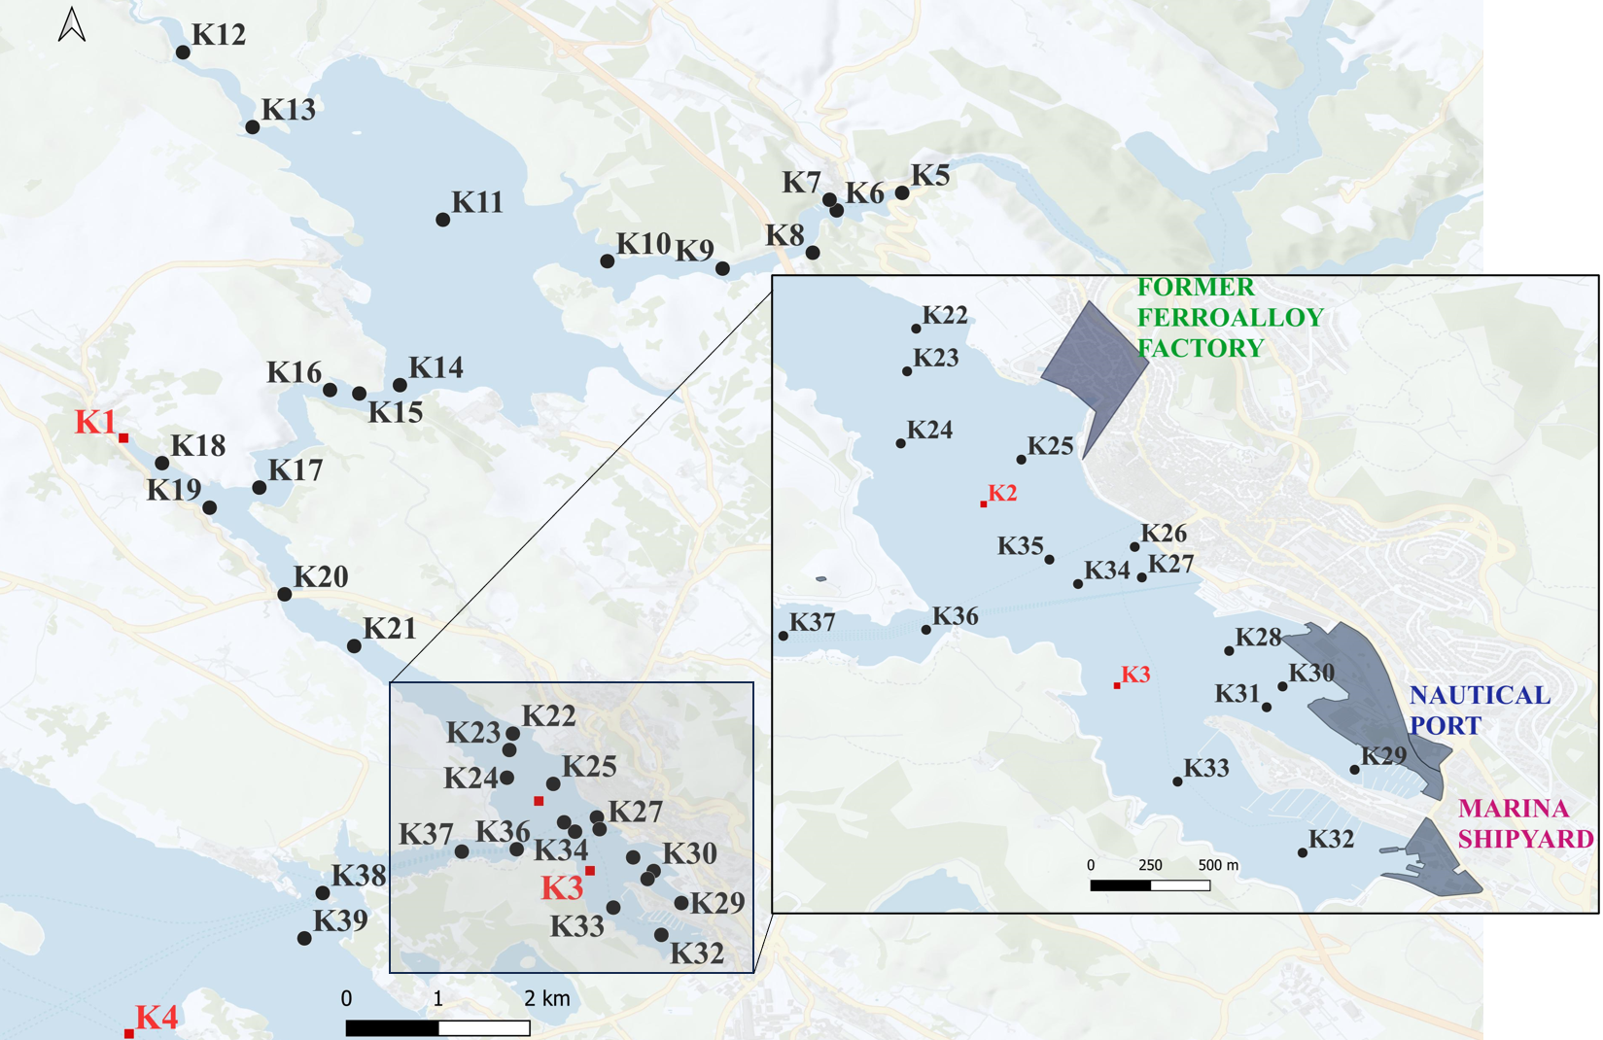

**Figure 1.** Map of the Krka River estuary with indicated sampling locations (K5-K39) and main sources of pollution (indicated as grey areas). Sampling locations which are covered in the work Knežević et al. 2020. are marked red (K1-K4) (Knežević, Cukrov and Bura-Nakić, 2020).

* 1. **Sample analysis and reagents**

High-resolution surface sediment sampling was performed on August 31st and September 2nd, 2016. A gravity corer (Uwitec) equipped with Plexiglas tubes (φ = 6 cm) was used for sampling from the research vessel “Ruđer Bošković Institute”. Only the top 5 cm were retrieved and used for analysis. After the sampling, sediment samples were deep-frozen (− 18 °C), freeze-dried, and sieved to < 2 mm. Sediment samples were digested as follows: 100 mg of sediment was weighed and placed in 50 mL Teflon (PTFE) bombs together with 10 mL of aqua regia (HNO3: HCl 1:3, Fisher Scientific® Trace, Analysis grade) and placed in microwave oven (ANTON PAAR® Multiwave 300). After digestion, samples were filtered using 0.2-μm pore size (filters cellulose-acetate, Minisart, Sartorius) and diluted to 100 mL for analysis. A certified material PACS-2 (National Research Council of Canada) was used for validation of the analysis. Vanadium concentrations in the surface sediment samples were determined in acid digested samples by using High Resolution Inductively Coupled Plasma Mass Spectrometer (HR ICP-MS, Element 2, Thermo). Other elements were measured in the same sequence as well (C, N, S, P, Hg, Li, Be, Rb, Mo, Ag, Cd, Sn, Sb, Cs, Tl, Pb, Bi, U, Al, Ti, Cr, Mn, Fe, Ni, Co, Cu, Zn, Sr, Ba, As, Pt). It has to be noted that the measured V and Al concentrations (VTOT and AlTOT) used throughout manuscript represent “pseudo-total” concentrations. While referred to as "TOT" for clarity, these values exclude contributions from residual minerals typically dissolved using hydrofluoric acid (HF) during digestion. Since these concentrations are used for enrichment indices calculations, which represent ratio of surface vs. deep core values, the term "TOT" was chosen for consistency.

For the chromatographic determination of acid-extractable vanadium applied approach in Knežević et al. 2020 was followed (Knežević, Cukrov and Bura-Nakić, 2020). Briefly, 1.0 g of each sediment sample, previously dried, homogenized and sieved to < 2 mm was weighed and mixed with 10 mL of acidic solution (0.12 mol L-1 HCl solution previously prepared in MQ water, 18.2 MΩ cm, Milipore, USA). Upon mixing of the sediment sample and acidic HCl solution, pH value of 5 was accomplished which allows leaching of the acid-extractable phase (Filgueiras, Lavilla and Bendicho, 2002). Generally, acid soluble sediment phase contains the metals which are loosely bound to mineral sediment phases, mainly carbonates, which can be easily mobilized with slightly lowering pH value. In addition, pH value of extraction also avoids potential oxidation of V(IV) species, as they readily oxidize on pH > 5 (Gustafsson, 2019b). Thus, it is believed that chosen extractant is not affecting V chemical behaviour (complexation or redistribution between mineral phases), avoids potential oxidation of V(IV) species in the extractant, matrix effects are less pronounced compared to potential usage of highly concentrated salts or other weak acids (MgCl2 or HOAc) and was compliant with the used analytical instrumentation. Prepared samples were left to dissolve in water for 40 min with occasional mixing. Afterward, they were filtrated through 0.2-μm filter pore size filters (cellulose-acetate, Minisart, Sartorius) After digestion, prepared samples were analyzed using ion chromatography and an anion exchange column (Metrosep A Supp 5-50/4.0; 50.0 mm length; 4.0 mm of inner diameter) with “944 Professional UV/Vis Detector Vario,” with wavelength set at 280 nm (ECO IC, Metrohm). The IC-UV/Vis operated at a flow rate of 0.7 mL min-1. The column temperature was ambient (22°C, air conditioned), and the sample injection volume was 100 µL.

Standard solutions of 1 g L-1 V(IV) were prepared by dissolving 0.50 g VOSO4 x 5 H2O in 100 mL of MQ water (18.2 MΩ cm, Milipore, USA). Standard solutions of 1 g L-1 V(V) were prepared by dissolving 0.23 g of ammonium metavanadate in 2 mL concentrated HNO3 and diluting in 100 mL ofMQ water (18.2 MΩ cm, Milipore, USA). Concentrated HCl (Fischer Chemical) was used for adjusting the pH of the solutions. The IC eluent consisted of 3% acetonitrile (VWR BDH Prolabo Chemicals), EDTA 2 x 10-3 mol L-1 (VWR BDH Prolabo Chemicals) and 8 x 10-2 mol L-1 ammonium hydrogen carbonate. After preparation, HCl was used to adjust the pH of the eluent to 6. Vanadium species were determined in the form of negatively charged EDTA complexes based on the ”on-column” complexation (details on the mechanism available in the previous study) (Knežević, Cukrov and Bura-Nakić, 2020). Exact concentrations were calculated using appropriate calibration curves.

* 1. **Calculation of enrichment indices**

Determined pseudo-total concentrations of V were used to calculate Enrichment factor (EF) and Geoaccumulation index (Igeo) which are widely used for the assessment of anthropogenic effect and possible contamination of trace metal compounds in estuarine and coastal waters surfacesediments (Muller, 1979; Cukrov, 2021; Birch, 2023). As natural background value, deepest layer (34-36 cm) of the K5 core was used. According to previous research (Cukrov et al. 2007), sedimentation in this area is 2 mm y-1. Thus, the chosen layer has been deposited before any industrial development in this area (Cukrov, 2021).

* + 1. **Enrichment Factor**

Enrichment Factor (EF) is the most often used index for recognition of TMs concentrations elevation due to the anthropogenic impact. This index is defined as a ratio between metal and conservative element concentration in the sample divided by the ratio of metal and conservative element concentrations in the background sample. Enrichment factor is calculated using following equation:

EF = $\frac{(\frac{Me}{X})_{sample}}{(\frac{Me}{X})_{background}}$

where X is a lithogenic element used for normalization, (Me/X) sample is the metal to X ratio in the sample of interest and (Me/X) background is the natural background value for the metal to X ratio for the studied location. Based on the EF values, anthropogenic enrichment of a certain TM can be classified into 5 categories: EF<2 – deficiency to low enrichment; EF = 2-5 – moderate enrichment; EF = 5-20 – significant enrichment; EF > 40 – extremely high enrichment (Sutherland, 2000).

* + 1. **Geoaccumulation Index**

Geoaccumulation Index (Igeo) is another commonly used index for assessment of TM enrichment in sediments. In this study, an expression which considers normalization to lithogenic element was used since it adjusts calculated values for variable grain size and content and enhances its applicability (Birch, 2023). The Igeo index was calculated using the following equation and the used marks are the same as for the calculation of EF.

Igeo = log2 (

Classification scheme for Igeo values is divided into seven classes: Igeo ≤ 0, unpolluted; 0 ≤ Igeo < 1; unpolluted to moderately polluted; 1 < Igeo < 2, moderately polluted; 2 < Igeo < 3, moderately to heavily polluted; 3 < Igeo < 4, heavily polluted; 4 < Igeo < 5, heavily to extremely polluted; > 5, extremely polluted (Muller, 1979).

* 1. **Risk Assessment Factor**

Determined concentrations of V redox species in the acid-extractable phase were used to calculate Risk Assessment Factor (RAC) in each sample to estimate potential risk of V mobility. This index was originally developed in the study of Perrin et al. (Perin *et al.*, 1985) and later used by others (Bo *et al.*, 2015; Abdallah, 2017; Zhou *et al.*, 2022).

Usually, RAC is defined as the ratio of extracted concentrations of a TM in the mobile fraction and concentration of a TM in other, less mobile sediment phases. Herein, the calculation of the stated indices was adjusted, and it represents the ratio between V concentrations found in the mobile phase using ion chromatography and pseudo-total V concentrations in the sample measured using ICP-MS (Nawrot *et al.*, 2021). The RAC index is calculated using the following equation:

RAC = $\frac{BF}{V_{TOT}}x100$

Where BF is defined as the bioavailable fraction of the pseudo-total V content in the sediment sample, expressed as a percentage. Values were interpreted as: <1%, no risk to the aquatic environment; 1-10%, low risk; 11-30%, medium risk; 31-50%, high risk; >50%, high risk to the aquatic environment (should be considered dangerous) (Perin *et al.*, 1985).

* 1. **PHREEQC model**

The PHREEQC code, developed by Parkhurst and Appelo (1999) is widely used to simulate an important range of aqueous geochemical processes including mixing, speciation, batch-reactions, thermodynamic calculation of water-rocks equilibrium etc. (Parkhurst and Appelo, 1999). The geochemical modeling program PHREEQC Interactive 3.7.3. , using minteq.v4 database, was applied. Data on the chemical composition of the overlaying bottom water column layer at locations K5, K11 and K28 were taken from the literature and used for this purpose (Cukrov, 2021). Shortly, the model simulates V speciation in the bottom seawater layer following the remobilization of the determined V species from the acid-extractable sediment phase. In addition, model predicts an equilibrium of the bottom seawater layer and leached sediment extract with the dominant mineral phase for each location.

1. **Results**
   1. **Vanadium enrichment in the surface sediment of Krka River estuary.**

Significant positive correlation of VTOT with AlTOT is visible on Figure 2. which is in agreement with the previous study. Due to the established linearity of VTOT with AlTOT, Al was chosen as a conservative element for the normalisation of VTOT concentration to natural background values, i.e. calculation of enrichment indices (EF and Igeo).



**Figure 2.**  Linearity of V and Al concentrations determined by ICP MS (VTOT and AlTOT) in the 35 surface sediment samples of Krka River estuary.

Exact values for each sample are given in Supporting document (Table S1) and the range of calculated values is visually shown on Figure 3. Minimum values of both EF and Igeo of all measured samples (K5 – K39) were calculated at the upper part of the estuary (stations K20 and K21) and amounted to 0.80 and -0.90, respectively. There was no significant difference between minimum values of stated parameters calculated in the upper part of the estuary and in the lower part of the estuary (EF = 0.83, Igeo = -0.85, station K23). However, pronounced difference was found for maximum values of used enrichment indices between the upper part of the estuary (EF = 1.11, Igeo = -0.43, station K7) and lower part of the estuary (EF = 1.72, Igeo = 0.20, station K26). Consequently, calculated average values differentiated between the upper part (EFav.= 0.95±0.10, Igeo, av. = - 0.67±0.16, K5 – K21) and the lower part of the estuary (EFav.= 1.10±0.24, Igeo, av. = - 0.48±0.28, K22 – K39 ).

Overall, results of enrichment indices suggest deficiency or low V enrichment in surface estuarine sediment based on the EF values, i.e., unpolluted, or moderately polluted based on the Igeo values. There is apparent agreement between the two enrichment indices used, and we can assume that V contamination did not occur along the surface sediment of Krka River estuary.

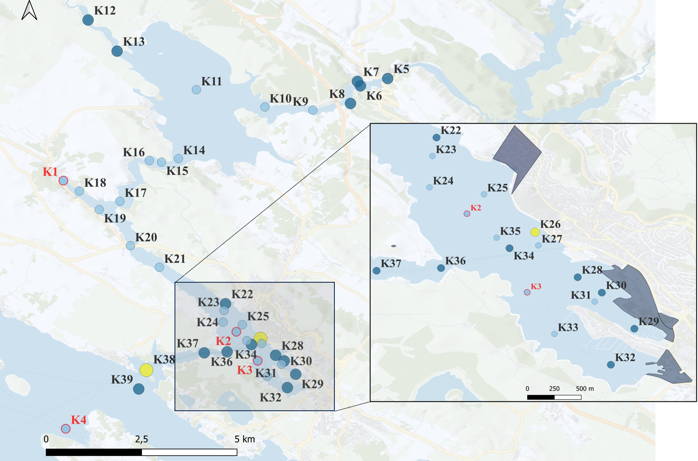

**Figure 3.** Spatial variability of calculated Enrichment Factor along the surface sediment of Krka River estuary (stations processed in the previous study are marked in red) (Knežević, Cukrov and Bura-Nakić, 2020).

* 1. **Vanadium redox speciation in the acid-extractable phase of surface estuarine sediment**

Figure 4. shows chosen chromatograms from processed surface sediment samples from Krka River estuary study site. In all of the samples, V(IV) species were found predominantly present. Obtained results agree with the previous study (Knežević, Cukrov and Bura-Nakić, 2020). Further on, selectivity of the method and accuracy of chromatograms interpretation is proven by adding V(IV) standard solution in a chosen surface sediment sample. Accurate V(IV) concentrations in the acid-extractable phase of each sediment sample is given in Supporting document and the calculated range of values is visually shown on Figure 4B.

The minimum value of RAC measured in the surface sediment samples was 11.24% on the station K29 located on the exit of Vrnaža port, recognized as an anthropogenically burdened location. Maximum RAC value was 54.13% on location site K5 located in the head of the estuary. Average values of RAC values amounted up to 23% with standard deviation of 11.5 % calculated for 35 samples (K5 to K39). Obtained RAC value can be defined as overall medium risk of V remobilization from the surface sediment to the water column of Krka River estuary.

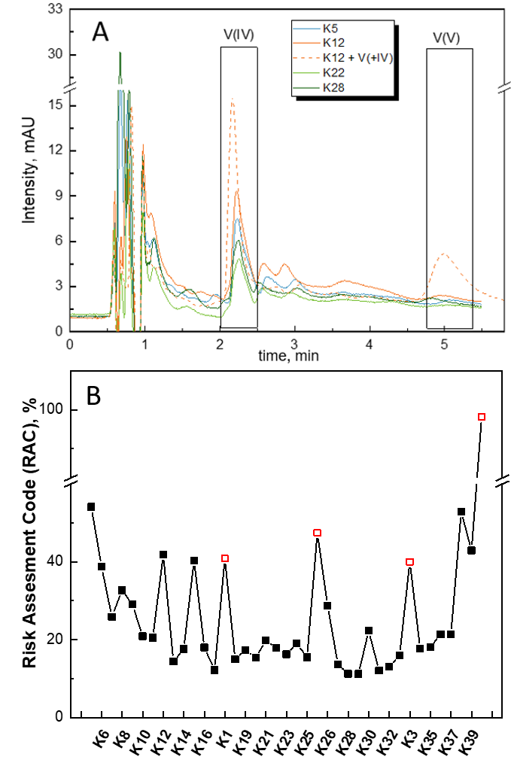

Figure 4. A. Chromatograms of several processed samples (K5, K12, K22, K8 and K12 spiked with 5x10-6 mol L-1 V(IV) standard solution) obtained using IC-UV/Vis analytical instrumentation. B. Determined calculated Risk Assesment Factor (RAC) along the surface sediment of Krka River estuary from river to sea-end member (stations processed in the earlier study (K1, K2, K3 and K4) are marked in red) (Knežević, Cukrov and Bura-Nakić, 2020).

1. **Discussion**

**4.1. Vanadium lithogenic character in the sediment of Krka River estuary**

In the section 3.1. possitive correlation of VTOT and AlTOT was presented, implying lithogenic origin of V in the sediment of Krka River estuary. Vanadium concentrations in the natural aqueous systems are usually controlled by the process of chemical weathering which surely impacts vanadium surface sediment concentrations as well and possitive correlation with conservative elements (Shiller and Mao, 2000; Schneider *et al.*, 2022) (Shiller & Mao, 2000). Moreover, V correlation to conservative elements in the Krka River estuary has been noticed in the previous studies (F1 > 0.95) and ascribed to erosion of terrigenic components from Eocene flysch terrains (Cukrov, Frančišković-Bilinski, et al., 2008). On the contrary, negative correlation was noticed with elements Sr and Ba, which are often used as carbonate and biological productivity proxies, respectively. This implies that carbonate and biological components are more likely to be dispersants of V in the Krka River estuary sediment. Exact concentrations of VTOT and proxy elements, along with linearity parameters of VTOT correlation with SrTOT and BaTOT are given in the Supporting document.

**4.2. Vanadium mobility in the upper part of the estuary**

At the head of the estuary (station K5), closer to the river source, no significant enrichment of VTOT was observed,, while over 50% of the V(IV) was mobilized from the surface sediments (Figure 4B). At the upper part of the estuary, sediment is a mixture of carbonates and terrigenous material. Sedimentation rates increase downward, from 2 mm/year at the head of the estuary to 4-5 mm/year in Prokljan lake (Cukrov, Barišić and Juračić, 2007). Affinity of V to carbonate phase could lead to its observed slight enrichment. Thus, used extraction method (pH=5, HCl solution) most probably causes enhanced leachability of V from these samples (Gehring et al., 1993, Burton et al., 2004) (Figures 4B and 5). Moving downstream from the head of the estuary (K6-K21), risk of V remobilization is generally low, with exceptions observed at locations K12 and K15 (Figure 4B). Specifically, these locations are directly influenced by the Guduča River and Prokljan Lake, respectively. Notably, these sites also have highest concentrations of terrigenous particulate material in the Krka River estuary. The high concentrations of terrigenous material can be attributed to the Guduča River. Specifically, the Guduča River catchment area has no calc tufa barrier and is mainly composed of flysch or flysch-like deposits, which are easily weathered. Consequently, Guduča River acts as the main supplier of particulate material to the Krka River through weathering process. Previous study show that this material is then largely deposited and retained within Prokljan Lake (Cukrov, 2021). This is further supported by the highest sedimentation rates measured in the estuary, amounting up to 4-5 mm/year in Prokljan Lake (Cukrov, Barišić and Juračić, 2007). Additionaly, sample influenced by terrigenous material from Litno spring (K1), processed in the earlier work by Knežević et al. 2020, also exhibits a peak in V mobility, which further supports the suggested hypothesis (Knežević, Cukrov and Bura-Nakić, 2020). Vanadium mobility in the remaining locations within this part of the estuary remained significantly lower compared to K12 and K15. Figure 5. Illustrates the correlation between VTOT, AlTOT and extracted V(IV). A previous study observed a negative correlation between extracted V(IV) and V enrichment in the processed samples, which is further supported by the results in this study. The lowest V enrichment among all processed samples was measured in this part of the estuary, particulary at stations K20 and K21. However, the specific factors influencing this observation remain unclear. Since AlTOT concentrations often correlate with the presence of clay minerals, the observed V mobility trend in the upper part of the estuary might reflect the influence of varying type of detrital material, and its irregular distribution (Prohić and Kniewald, 1987).

**4.3. Vanadium mobility in the lower part of the estuary**

The lower part of the Krka River estuary differs significantly from the upper estuary, primarily due to the introduction of the anthropogenic pollutants from the nautical port, marina shipyard and the former feroalloy factory. Notably, minimum value of V enrichment in this part of the estuary was measured upstream from these identified pollutant sources (section 3.1.). Additionally, the pronounced difference in maximum V enrichment values in the surface sediment between upper and the lower estuary showed in the section 3.1. further suggests the possibility of anthropogenic V contribution in this part of the estuary. However, it is important to acknowledge that other processes besides anthropogenic influence could also impact V mobility in the surface sediment. In the lower part of estuary (K22-K39), sediment is characterized by a higher carbonate fraction due to predominant biogenic sedimentation and appropriate low sedimentation rates (1 mm/year) compared to the upper estuary (Cukrov, Barišić and Juračić, 2007). Lower influence of Krka River plume is also reflected in more obvious negative correlation between VTOT and AlTOT with the acid-extractable V concentrations (Figure 4). The highest mobility of V is observed in the samples located furthest the Krka River plume, at the exit of the estuary (Figure 4B). On these locations acid-extractable V is likely bound primarily to the carbonate fractions, as observed in a previous study by Knežević et al. 2020. This work showed near-complete V mobilization (98% at station K4 in the Adriatic Sea) under leaching conditions, suggesting strong affinity of V to carbonates (Knežević, Cukrov and Bura-Nakić, 2020). Interestingly, the lowest V mobility was measured in samples collected from sites under anthropogenic impact. At the same time, lower part of the estuary, recognized as an area with higher anthropogenic contribution, exhibits higher V enrichment compared to the upper estuary (Figure 3) (Cukrov, Cmuk, *et al.*, 2008; Cukrov, Frančišković-Bilinski, *et al.*, 2008; J. Pađan, S. Marcinek, A.M. Cindrić, N. Layglon, V. Lenoble, P. Salaün, 2019; Cukrov *et al.*, 2020). This observation suggest complex relathionship between V mobility and anthropogenic vs. natural influence. Several recognized anthropogenic sources have been identified within the system, and all exhibited slightly elevated V concentrations.. The maximum V enrichment among all processed samples was measured at station K26, located between the former ferroalloy factory and the nautical port. The observed patterns of V mobility and enrichment suggest that V may bind to less mobile phases in the sediment under anthropogenic influence. Vanadium exhibits a well-documented high affinity for the organic/sulfidic sediment fraction, particularly when influenced by anthropogenic materials rich in organic matter (Prohić and Kniewald, 1987; William W. Bennett, Enzo Lombi, Edward D. Burton, Scott G. Johnston and Daryl L. Howard, 2018; Shaheen *et al.*, 2019). Previous study showed that even under oxic conditions, a significant portion (up to 15%) of V in the water column near Vrnaža port can exist in its reduced form (L. Knežević, D. Omanović, N. Bačić, J. Mandić, no date). This can be explained by redox reactions between V and organic ligands. This mechanism, observed in the overlaying water column, can certainly promote V binding to less mobile sediment phases.

Exceptionally, high V mobility correlated with higher enrichment of V at station K30, located in front of the Šibenik port. Here, 20% of the pseudo-total V was extracted from the acid-extractable sediment fraction (Figure 3 and 4B). This contradictory observation might be explained by the known strong correlation between V and P. Also, both elements can be incorporated into carbonate minerals. Šibenik port is known to be a significant source of P due to its transshipment activities involving phosphate ore and fertilizers. Potentially, this influx of P could promote the co-precipitation of V with carbonates, leading to the observed high enrichment (Cukrov, 2021). At the same time, the high V mobility at this location suggests that it may be loosely bound to the carbonate fraction, allowing for easier extraction.

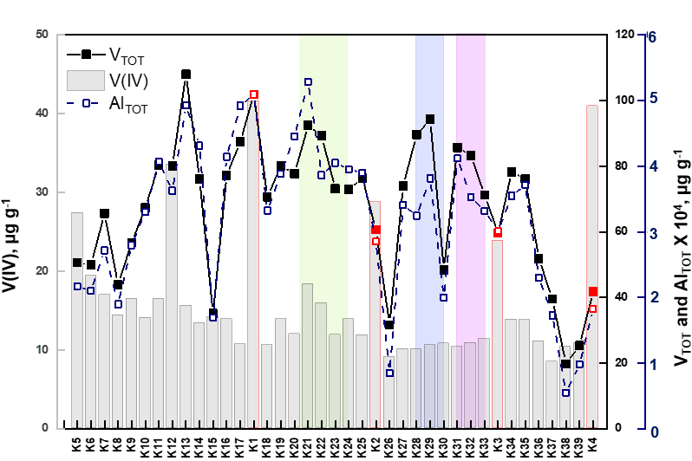

Figure 5. Trend of VTOT, AlTOT and extracted V(IV) concentrations from upstream to downstream of Krka River estuary. Results from the previous study are indicated in red (Knežević, Cukrov and Bura-Nakić, 2020). Sampling locations under anthropogenic sources are highlighted in green (former ferro-alloy factory), blue (phosphate and transshipment port) and pink (marina shipyard).

1. **Modelling remobilization of V in the seawater layer**

A geochemical mixing model to simulate the potential remobilization of V from the acid-extractable sediment phase to the overlaying bottom seawater in the Krka River estuary was developed. In addition, this model takes considered equilibration of the leached phase with calcite, the most abundant carbonate mineral in the estuary (Cukrov, 2021), which is mobilized under experimental conditions used for extraction. Sediment samples were selected from three locations representing key environmental factors affecting V remobilization: carbonates at the head of the estuary (K5), terrigenous input in the upper part of the estuary (K11) and anthropogenic input in the lower part of the estuary (K28). As complete remobilization of all V(IV) from the leached phase is highly unlikely, low mixing ratio between the leached solution and bottom seawater was used to mimic natural concentration range of V. Input and output file example is available in the Supporting document. Summary of obtained results is presented in the Table 2. Presented model predicts complete oxidation of V(IV) species upon remobilization into the bottom oxic seawater layer. It has to be noted that model suggests free V(IV) present in the leached phase, thus potentially overestimating oxidation. Unfortunately, the constraints of the used analytical technique do not allow to asses initial form of V(IV). Nevertheless, these data suggest an ongoing need for studying V redox speciation in the mobile sediment phases, especially since the conversion of extracted reduced species into the toxic V(V) under oxic conditions is highly plausible. Employing a multi-analytical approach to assess V speciation in the mobile phase could be crucial for a more comprehensive understanding of V's geochemical behavior and potential environmental risks.

*Table 1. Modelled V speciation in the bottom seawater layer on stations K5, K11 and K28 before and after mixing with acid-extractable sediment phase using PHREEQC.*

|  |  |  |  |  |
| --- | --- | --- | --- | --- |
| **sample** | **V tot, mol/L** | **V species** | **Concentration of V species1** | **Concentration of V species2** |
| K5 | 3.32e-08 | HVO42- | 3.318e-08 | 8.694e-08 |
| V(OH)3+ | 1.670e-23 | 1.582e-27 |
| V(OH)3 | 4.59e-24 | 3.175e-32 |
| K11 | 3.40e-08 | HVO42- | 3.396e-08 | 6.635e-08 |
| V(OH)3+ | 1.966e-22 | 2.187e-29 |
| V(OH)3 | 5.15e-23 | 1.663e-33 |
| K28 | 3.42e-08 | HVO42- | 3.416e-08 | 5.210e-08 |
| V(OH)3+ | 1.383e-23 | 2.985e-29 |
| V(OH)3 | 3.698e-24 | 3.972e-33 |

1 Vanadium speciation in the bottom water layer by PHREEQC before mixing.

2 Vanadium speciation in the bottom water layer by PHREEQC after mixing.

1. **Conclusion**

In the presented work previously published adapted chromatographic analytical methodology was used to assess the remobilization of V from the surface sediments of Krka River estuary and factors influencing it. Our analysis revealed low V enrichment, suggesting minimal overall pollution. Additionally, the predominance of reduced V(IV) species in the acid-extractable phase indicates low potential toxicity to surrounding biota. Different effects on acid-extractable V depending on prevailing terrigenous vs. anthropogenic contributions were observed. Although not-considered polluted with V, there is potentially an anthropogenic input of V in the lower part of Krka River estuary. Highest concentrations of remobilized V were observed at locations under terrigenous input in the upper part of the estuary and in the lower part of the estuary where carbonates predominate. Conversely, lowest mobility of V was detected on the locations characterized with input of anthropogenic material, suggesting V stabilization in less soluble sediment phases. Although less toxic V(IV) species were predominantly found in the mobile phase, modelled remobilization showed complete oxidation of determined V(IV) species in the oxic bottom seawater layer. This emphasizes the need for comprehensive V speciation analysis in both sediments and the overlying water column. In conclusion, this study provides necessary experimental evidence on V redox speciation in the surface sediment sample of estuarine system and points to the factors affecting possible remobilization of V from the sediment to the overlaying waters. As such, it is highly valuable for understanding natural and anthropogenic influence for remobilization mechanisms and biogeochemical cycling of V in natural surface environments. However, further experimental evidences on V redox speciation in less soluble mineral phases are needed in order to fully understand V biogeochemical cycling in the natural systems.

**Acknowledgments:** Research within this study was fully funded by the Croatian Science Foundation, project IP-2018-01-7813, “REDOX”.

**References:**

Abdallah, M.A.M. (2017) ‘Chemical speciation and contamination assessment of Pb and V by sequential extraction in surface sediment off Nile Delta, Egypt’, *Arabian Journal of Chemistry*, 10(1), pp. 68–75. Available at: https://doi.org/10.1016/j.arabjc.2012.06.001.

Bian, L. *et al.* (2022) ‘A new vanadium species in black shales: Updated burial pathways and implications’, *Geochimica et Cosmochimica Acta*, 338, pp. 1–10. Available at: https://doi.org/10.1016/j.gca.2022.09.035.

Birch, G.F. (2023) ‘A review and critical assessment of sedimentary metal indices used in determining the magnitude of anthropogenic change in coastal environments’, *Science of the Total Environment*, 854(July 2022), p. 158129. Available at: https://doi.org/10.1016/j.scitotenv.2022.158129.

Bo, L. *et al.* (2015) ‘Heavy Metal Speciation in Sediments and the Associated Ecological Risks in Rural Rivers in Southern Jiangsu Province, China’, *Soil and Sediment Contamination*, 24(1), pp. 90–102. Available at: https://doi.org/10.1080/15320383.2014.914465.

Cappuyns, V. and Swennen, R. (2014) ‘Release of vanadium from oxidized sediments: Insights from different extraction and leaching procedures’, *Environmental Science and Pollution Research*, 21(3), pp. 2272–2282. Available at: https://doi.org/10.1007/s11356-013-2149-0.

Cui, M., Luther, G.W. and Gomes, M. (2023) ‘Constraining the major pathways of vanadium incorporation into sediments underlying natural sulfidic waters’, *Geochimica et Cosmochimica Acta*, 359, pp. 148–164. Available at: https://doi.org/10.1016/j.gca.2023.08.008.

Cukrov, N., Frančišković-Bilinski, S., *et al.* (2008) ‘Natural and anthropogenic influences recorded in sediments from the Krka river estuary (Eastern Adriatic coast), evaluated by statistical methods’, *Fresenius Environmental Bulletin*, 17(7 A), pp. 855–863.

Cukrov, N., Cmuk, P., *et al.* (2008) ‘Spatial distribution of trace metals in the Krka River, Croatia: An example of the self-purification’, *Chemosphere*, 72(10), pp. 1559–1566. Available at: https://doi.org/10.1016/j.chemosphere.2008.04.038.

Cukrov, N. (2021) *Metal dynamics in the sediments of the Krka River estuary*, *Doctoral thesis*.

Cukrov, N., Barišić, D. and Juračić, M. (2007) ‘Calculated sedimentation rate in the Krka River estuary using vertical distribution of 137CS’, *Rapp. Comm. int. Mer Médit*, 38, p. 1.

Cukrov, Nuša *et al.* (2020) ‘Anthropogenic mercury contamination in sediments of Krka River estuary (Croatia)’, *Environmental Science and Pollution Research*, 27(7), pp. 7628–7638. Available at: https://doi.org/10.1007/s11356-019-07475-y.

Feldmann, J., Salaün, P. and Lombi, E. (2009) ‘Critical review perspective: Elemental speciation analysis methods in environmental chemistry-moving towards methodological integration’, *Environmental Chemistry*, 6(4), pp. 275–289. Available at: https://doi.org/10.1071/EN09018.

Filgueiras, A. V., Lavilla, I. and Bendicho, C. (2002) ‘Chemical sequential extraction for metal partitioning in environmental solid samples’, *Journal of Environmental Monitoring*, 4(6), pp. 823–857. Available at: https://doi.org/10.1039/b207574c.

Gehring, A.U. *et al.* (1993) ‘the Chemical Form of V a N a D I U M ( Iv ) in Kaolinite’, *Clays and Clay Minerals*, 41(6), pp. 662–667.

Gustafsson, J.P. (2019a) ‘Vanadium geochemistry in the biogeosphere –speciation, solid-solution interactions, and ecotoxicity’, *Applied Geochemistry*, 102(October 2018), pp. 1–25. Available at: https://doi.org/10.1016/j.apgeochem.2018.12.027.

Gustafsson, J.P. (2019b) ‘Vanadium geochemistry in the biogeosphere –speciation, solid-solution interactions, and ecotoxicity’, *Applied Geochemistry*, 102(December 2018), pp. 1–25. Available at: https://doi.org/10.1016/j.apgeochem.2018.12.027.

J. Pađan, S. Marcinek, A.M. Cindrić, N. Layglon, V. Lenoble, P. Salaün, D.O. (2019) ‘Improved voltammetric methodology for chromium redox speciation in estuarine waters.’, *Analytica Chimica Acta* [Preprint]. Available at: https://doi.org/10.1016/j.aca.2019.09.014.

Knežević, L., Cukrov, N. and Bura-Nakić, E. (2020) ‘Ion-exchange chromatography as a tool for investigating vanadium speciation in sediments: preliminary studies’, *Journal of Soils and Sediments*, 20(6), pp. 2733–2740. Available at: https://doi.org/10.1007/s11368-019-02484-3.

L. Knežević, D. Omanović, N. Bačić, J. Mandić, E.B.N. (no date) ‘Redox speciation of vanadium in estuarine waters using improved methodology based on anion exchange ion chromatography’, *Submitted to Journal of Analytical Atomic Spectrometry* [Preprint].

Muller, G. (1979) ‘Schwermetalle in den sedimenten des Rheins-Veranderungen seit’, *Umschav*, 79, pp. 133–149. Available at: https://doi.org/10.1007/s11356-013-2217-5.

Nawrot, N. *et al.* (2021) ‘Trace metal contamination of bottom sediments: A review of assessment measures and geochemical background determination methods’, *Minerals*, 11(8). Available at: https://doi.org/10.3390/min11080872.

Nedrich, S.M. *et al.* (2018) ‘Biogeochemical controls on the speciation and aquatic toxicity of vanadium and other metals in sediments from a river reservoir’, *Science of the Total Environment*, 612, pp. 313–320. Available at: https://doi.org/10.1016/j.scitotenv.2017.08.141.

Parkhurst, D.L. and Appelo, C.A.J. (1999) ‘Users guide to PHREEQC (Version 2) - a computer program for speciation, batch-reaction, one-dimensional transport, and inverse geochemical calculations’. Colorado. Available at: https://doi.org/10.2307/3459821.

Perin, G. *et al.* (1985) ‘Heavy metal speciation in the sediments of Northern Adriatic Sea: a new approach for environmental toxicity determination’, in Lekkas TD (ed.) *Heavy Metal in the Environment*. CEP Consultant, Edinburgh, pp. 454–456.

Prohić, E. and Kniewald, G. (1987) ‘Heavy metal distribution in recent sediments of the Krka River Estuary - an example of sequential extraction analysis’, *Marine Chemistry*, 22(2–4), pp. 279–297. Available at: https://doi.org/10.1016/0304-4203(87)90015-6.

Rehder, D. (2015) ‘The role of vanadium in biology’, *Metallomics*, 7(5), pp. 730–742. Available at: https://doi.org/10.1039/C4MT00304G.

Schlesinger, W.H., Klein, E.M. and Vengosh, A. (2017) ‘Global biogeochemical cycle of vanadium’, *Proceedings of the National Academy of Sciences of the United States of America*, 114(52), pp. E11092–E11100. Available at: https://doi.org/10.1073/pnas.1715500114.

Schneider, A.B. *et al.* (2022) ‘Mixing and partially non-conservative behavior of molybdenum, uranium and vanadium along the salinity gradients of the Amazon and Pará estuaries and associated plume’, *Marine Chemistry*, 247(October), p. 104182. Available at: https://doi.org/10.1016/j.marchem.2022.104182.

Shaheen, S.M. *et al.* (2019) ‘Redox chemistry of vanadium in soils and sediments: Interactions with colloidal materials, mobilization, speciation, and relevant environmental implications - A review’, *Advances in Colloid and Interface Science*, 265, pp. 1–13. Available at: https://doi.org/10.1016/j.cis.2019.01.002.

Shiller, A.M. and Mao, L. (2000) ‘Dissolved vanadium in rivers: Effects of silicate weathering’, *Chemical Geology*, 165(1–2), pp. 13–22. Available at: https://doi.org/10.1016/S0009-2541(99)00160-6.

Sutherland, R.A. (2000) ‘Bed sediment-associated trace metals in an urban stream, Oahu, Hawaii’, *Environmental Geology*, 39(6), pp. 611–627. Available at: https://doi.org/10.1007/s002540050473.

William W. Bennett, Enzo Lombi, Edward D. Burton, Scott G. Johnston, P.K. and Daryl L. Howard, D.E.C. (2018) ‘Synchrotron X-ray spectroscopy for investigating vanadium speciation in marine sediment: limitations and opportunities’, *Journal of Analytical Atomic Spectrometry* [Preprint]. Available at: https://doi.org/10.1039/C8JA00231B.

Xu, Y.H., Huang, J.H. and Brandl, H. (2017) ‘An optimised sequential extraction scheme for the evaluation of vanadium mobility in soils’, *Journal of Environmental Sciences (China)*, 53, pp. 173–183. Available at: https://doi.org/10.1016/j.jes.2016.02.019.

Yang, J. *et al.* (2022) ‘Vanadium: A Review of Different Extraction Methods to Evaluate Bioavailability and Speciation’, *Minerals*, 12(5), pp. 1–23. Available at: https://doi.org/10.3390/min12050642.

Zhou, F. *et al.* (2022) ‘Impacts of Human Activities and Environmental Changes on Spatial-Seasonal Variations of Metals in Surface Sediments of Zhanjiang Bay, China’, *Frontiers in Marine Science*, 9(June), pp. 1–16. Available at: https://doi.org/10.3389/fmars.2022.925567.