Mechanochemically Induced OSDA-free Interzeolite Conversion
Nikola Jakupec,‡ Karen J. Ardila-Fierro,‡ Valentina Martinez, Ivan Halasz, Janez Volavšek, Gerardo Algara-Siller, Martin Etter, Valentin Valtchev, Krunoslav Užarević* and Ana Palčić*
Nikola Jakupec - Division of Materials Chemistry, Ruđer Bošković Institute, Bijenička cesta 54, 10000 Zagreb, Croatia.
Karen J. Ardila-Fierro - Division of Materials Chemistry, Ruđer Bošković Institute, Bijenička cesta 54, 10000 Zagreb, Croatia.
Valentina Martinez - Division of Physical Chemistry, Ruđer Bošković Institute, Bijenička cesta 54, 10000 Zagreb, Croatia.
Ivan Halasz - Division of Physical Chemistry, Ruđer Bošković Institute, Bijenička cesta 54, 10000 Zagreb, Croatia.
Janez Volavšek - Department of Inorganic Chemistry and Technology, National Institute of Chemistry, Hajdrihova ulica 19, 1000 Ljubljana, Slovenia
Gerardo Algara-Siller - Institute of Physics, Humboldt University of Berlin, Newtonsraße 15, 12489 Berlin, Germany
Martin Etter - P02.1 Beamline, Deutsches Elektronen Synchrotron (DESY), Notkestraße 85, 22607 Hamburg, Germany.
Valentin Valtchev - Laboratorie Catalyse et Spectrochimie, Normandie Université, Esplanade de la paix - CS 14032, 14032 Caen, France; Faculty of Chemistry and Pharmacy, University of Sofia, 1 James Bourchier Blvd., 1164 Sofia, Bulgaria
Krunoslav Užarević - Division of Physical Chemistry, Ruđer Bošković Institute, Bijenička cesta 54, 10000 Zagreb, Croatia.
Ana Palčić - Division of Materials Chemistry, Ruđer Bošković Institute, Bijenička cesta 54, 10000 Zagreb, Croatia.
KEYWORDS: interzeolite conversion, zeolite Y, thermo-mechanochemistry, in situ crystallization, OSDA-free

Zeolites are versatile materials widely used in various aspects of modern society and are one of the most relevant industrial catalysts. Regardless of such ubiquity, the conventional hydrothermal synthesis of zeolite materials with pre-determined properties is challenging and, in some instances, not feasible, motivating a constant search for new synthesis avenues to expand their application potential. Here, thermally-controlled mechanochemistry results in rapid, controllable, and energy-efficient organic structure directing agent-free (OSDA-free) interzeolite conversions. Milling under elevated temperatures yields pure solid phases distinct from the parent commercial zeolite Y. In situ synchrotron X-ray diffraction monitoring revealed a strong effect of the composition of the reaction mixture on the reaction pathways and interconversion outcome. The properties of the formed material arise as an outcome of the subtle interplay of kinetic and thermodynamic factors. The findings reported here afford directions for broader zeolite mechanosynthesis.
Introduction

Zeolites are microporous crystalline materials comprised of TO₄ (T = Si, Al, P, Ge, Ga, …) tetrahedra building well-defined three-dimensional networks with channels and cavities up to 2 nm in diameter. They are broadly applied in everyday life and industry because of their stability, tunable chemical composition, acidity, active surface, size, catalytic activity, and ion exchange capability.¹⁻⁷ Due to their superior stability, environmental compatibility, and non-toxicity, zeolites will take an even more critical role in the sustainable technologies arising in the energy transition era.⁸⁻¹¹ Typical zeolite synthesis is a rather slow “geo-inspired” process involving hydrothermal treatment of (Al)Si-containing (amorphous) precursors in highly alkaline solutions at temperatures ≤250 ºC for several hours up to several weeks.^{15,16} As these processes come with great energy demand and generate a significant amount of corrosive waste, seeking more efficient, greener, and controllable zeolite production procedures represents constant aspiration in line with the UN and EU recommendations.
Rapid development in technology and society requires materials with new and modified properties, so producing novel zeolite materials with specific features is a necessity.¹²⁻¹⁴ The most common approach is the addition of organic structure directing agents (OSDAs) to the reaction mixture that, in some cases, yielded previously unknown zeolites and enabled the preparation of high- as well as all-silica zeolite materials.^{17,18} However, the urgency to establish more rapid and more environment-friendly processes prompted the research of alternatives to OSDA-aided zeolite synthesis.¹⁹ A promising approach is interzeolite conversion – a process where a crystalline parent zeolite is converted into another type of zeolite product under reaction conditions similar to conventional procedures.²⁰ This approach enables rapid zeolite synthesis and the ability to obtain materials of novel properties.²¹ The parent zeolite is a source of both T-atoms (Si, Al) and, generally, any potential amorphous phase in the reaction mixture. Despite advances in the field, robust procedures that yield zeolites of any desired structure and pre-determined framework composition are still not known.¹⁷ Thus, new preparation avenues are necessary to synthesize novel, versatile zeolite materials and expand their application potential.^{16,22,23}
Mechanochemical reactions induced by mechanical energy (compression, shear, or friction) are developing into a powerful green synthetic tool with unprecedented control over the reaction.²⁴⁻²⁶ Besides tackling issues such as solubility and solvation and reducing the time/energy demands, mechanochemistry may provide alternative reaction pathways toward products unavailable by other synthesis approaches.²⁷ Thus far, however, mechanochemistry in zeolite synthesis was unsuccessful and limited to the mechanical comminution of precursors before conventional oven hydrothermal treatment.²⁸ Milling these precursors was advantageous, but conventional oven heating was necessary for successful zeolite formation. Bowmaker pinpointed that chemical reactions not available to mechanochemistry due to energetic barriers may be surpassed by combining external thermal energy sources with milling.²⁹ Indeed, the recent coupling of milling with various energy sources has led to unique reactions not achievable solely by conventional milling techniques.³⁰ In particular, regulating the temperature of the milling vessel affects the reaction rate, its mechanisms, and selectivity.^{30,31} Developing a milling reactor operating at temperatures >100 °C opens the possibility of employing mechanochemistry for previously unexplored systems.³²
Herein, was demonstrated how thermally-controlled milling enables rapid and effective mechanochemical interzeolite conversion of commercial zeolite Y into five other zeolite phases with minimal added water. The combined thermal and mechanochemical processing significantly lowers time- and energy requirements compared to conventional synthetic routes. Synchrotron X-ray diffraction in situ monitoring (in situ syn-XRD), performed in the newly developed reactor enabling direct data collection while thermomilling, revealed that, in some cases, the process takes mere minutes to complete, and the synthesis mixture composition and reaction time affect the reaction outcome. Electron microscopy, nuclear magnetic resonance, X-ray diffraction, Raman spectroscopy, N₂ physisorption, and light scattering analysis demonstrate that the prepared materials are comparable to the ones obtained by the classical oven-based synthetic procedures.

Figure 1. Zeolite frameworks of the materials isolated in this study. The color of the three-letter designation of zeolite framework denotes the alkali hydroxide present in the reaction mixture from which the respective material was obtained. The molar volume of the zeolite framework structure (V_{m}; the value in the brackets corresponds to a particular framework) is proportional to its enthalpy of formation (ΔH_{f}), where the V_{m} is lower as the framework gets more thermodynamically stable.

Methods

Chemicals. The reagents were used as received from the supplier without further purification: starting FAU-type zeolite Y, Ventron GMBH Linde molecular sieve catalyst base SK-40 (Si/Al = 2.4); sodium hydroxide (NaOH), Gram-mol., 99%; potassium hydroxide (KOH), Gram-mol., 89%; cesium hydroxide monohydrate (CsOH×H₂O), Alfa Aesar, 96%; rubidium hydroxide hydrate (RbOH×H₂O), Sigma Aldrich, 99%; tetramethylammonium hydroxide pentahydrate (TMAOH×5H₂O), Sigma Aldrich, 97%.
Interzeolite conversion applying thermally controlled mechanochemical treatment. The reactions were carried out using In Solido Technologies 636 vibratory ball mill with a custom-built heating element described previously (consisting of a controller unit, a thermocouple, and the heating jacket) in 11 ml steel or aluminium jars with polytetrafluoroethylene (PTFE) linings using one ZrO₂ ball (1.623 g, diameter 6 mm) at 110 °C and shaking frequency of 30 Hz.³² The heating jacket was fitted to the jar, and the jar was mounted to the hands of the mill and heated to 110 °C. Milling started once the reaction temperature was reached. The reactions were performed by grinding with or without adding water, and the molar oxide ratios of the reaction mixtures are given in the Table 1. Typical synthesis mixture was obtained by mixing zeolite Y (200 mg), hydroxide (29.6 mg of NaOH; 42 mg or 84 mg of KOH; 124 mg of CsOH; 104 mg RbOH; 248 mg TMAOH) and water (82.5 mg). The thermo-milling treatment was carried out for given periods of time (Table 1), and the maximum duration was 2 h. The recovered solids were washed with doubly distilled water until pH 7 and dried in the oven at 80 °C. The samples are denoted by the following system: M-W-T; M = alkali metal in the base used, W = in the case when water was added to the reaction mixture, T = reaction time. The samples where double the amount of base was used are marked 2 (meaning “double”), e.g. 2K-27.
Reference sample experiments. The samples denoted with the prefix “Ref-” were prepared by mixing the same amount of chemicals as in the thermomechanically treated reaction systems, yet they were charged into polypropylene bottles and placed in a convection oven preheated at 110 °C, without milling – 0 Hz. Reactions were conducted for up to 2 h. The resulting powders were washed with doubly distilled water until neutral pH value was reached and subsequently dried in an oven at 80 °C.
Hydrothermal synthesis. Control experiments that may be considered as standard hydrothermal interzeolite conversion were performed in polypropylene bottles in a convection oven preheated at 110 °C. The molar oxide ratios were: 1 SiO₂ : 0.2 M₂O : 61 H₂O and the hydrothermal treatment was conducted for 48 h. The samples were isolated upon washing the mixture with doubly distilled water until pH 7 and dried in an oven at 80 °C. Products obtained by this approach are denoted with the prefix “ST-”.
In situ powder X-ray diffraction (PXRD) measurements of thermally controlled mechanochemical reactions. Synchrotron X-ray diffraction in situ monitoring (syn-XRD) experiments were performed at Deutsches Elektronen-Synchrotron (DESY) at the PETRA III, P02.1 beamline, PerkinElmer XRD1621 detector at 60 KeV (λ = 0.207 Å). The jars were designed to have a narrowed heater and a window cut-out in the aluminium jacket to allow the synchrotron radiation to pass through the Teflon lining during the milling. The synthesis mixtures were prepared as described for interzeolite conversion by applying thermally controlled mechanochemical treatment, but the thermo-milling was performed for 30 minutes due to time constraints with the 10 s per frame time resolution. The collected data were integrated in DAWN software and are visually represented by waterfall diagrams.
Physicochemical characterization. PXRD patterns were collected using PANalytical Aeris benchtop powder diffractometer (CuKα radiation with Ni filter; λ= 1.5418 Å, 45 kV, 40 mA) in Bragg-Brentano geometry in a 5°-50° 2θ range (0.025° step). PXRD patterns of sodalite, cancrinite, merlionite, and analcime were generated from their respective crystal structures using the Mercury program suite and the .cif files downloaded from the International Zeolite Association (IZA) online database.^{33,34} Particle size distribution (PSD) curves were obtained by laser light scattering analysis using Malvern Mastersizer 2000 laser light scattering granulometry. The samples were exposed to ultrasonication during the measurement. Scanning electron microscopy (SEM) images were acquired on a Jeol JSM 7000F scanning electron microscope and a MIRA-LMH (TESCAN) scanning electron microscope equipped with a field emission gun. Solid-state nuclear magnetic resonance spectroscopy measurements were performed on a 600 MHz Varian spectrometer, using 3.2 mm HX CPMAS probe to obtain ²⁷Al MAS, ²⁹Si MAS and ¹H-²⁹Si CPMAS spectra. All of the samples were measured under magic-angle spinning frequency of 20 kHz. Operating Larmor frequencies for ¹H, ²⁷Al, and ²⁹Si nuclei were 599.34 MHz, 156.17 MHz and 119.06 MHz, respectively. To obtain directly detected ²⁷Al and ²⁹Si MAS spectra a single pulse of 1.0 µs with recycle delay of 0.1 s and a single pulse of 2.8 µs with recycle delay of 60 s was used, respectively. In the case of ¹H-²⁹Si CPMAS measurements, a single pulse of 2.85 µs was used to excite ¹H nuclei with a following contact time of 5.0 ms to transfer the polarization to ²⁹Si nuclei, recycle delay was 1.0 s. NMR spectra were deconvoluted using dmfit software.³⁵ Transmission electron microscopy (TEM) analysis was carried out on a FEI Talos F200X microscope operated at 200 kV. The samples were measured with high-resolution TEM (HRTEM), fast Fourier transform (FFT), and electron diffraction (ED) techniques. Chemical composition of selected samples was assessed on the grounds of results obtained by a PerkinElmer AAnalyst 200 atomic absorption spectrometer. The N₂ physisorption isotherms were measured at −196 °C utilizing Micromeritics 3Flex high resolution volumetric adsorption analyser. About 100 mg of the sample was degassed at 300 °C under vacuum overnight prior to the analysis. Micropore volume (V_{mic}) was evaluated on the grounds of the t-plot method, and total pore volume (V_{tot}) was determined by the amount of adsorbed nitrogen at p/p₀ = 0.95. Mesopore volume (V_{meso}) is defined as V_{tot} - V_{mic}. Raman spectra of the powder samples were collected employing Maya2000 Pro spectrometer in Raman spectroscopy mode using red laser (λ = 785 nm). The interval time for each scan was set to 5000 ms, and the number of scans per interval was 80 at a laser power of 60 mW. Each sample was put on a thin glass slice and levelled with a spatula to ensure surface flatness.

Results and discussion

Mechanochemical Zeolite Y Interconversions. The mechanochemical interconversions were conducted by milling zeolite Y (FAU-type) with alkali hydroxides (details in Tables S1, S2; water content varies due to different compositions of the used chemicals) in PTFE vessels encased in the aluminium jacket (Figure S4.). To ensure homogeneous heating of the interior PTFE vessel, a thermocouple was embedded near the inner wall of the vessel, allowing precise heating of the reaction mixture by a PID-controlled heating system at 110 °C and 30 Hz operating frequency.³⁰ The crystalline phases formed after 120 minutes (Tables S1, S2; Figures 1, 2, S1, S2) involve small-pore (8MR pore openings) zeolite framework types such as MER-, GIS-, SOD- and ANA-, as well as large pore CAN-type material (12MR pore openings), similar to previous studies in SiO₂/Al₂O₃ <2.5 and SiO₂/M₂O <2.5 systems.³⁶ The milling products were compared to the gently preground reaction mixtures statically heated in the oven at 110 °C for 120 minutes (prefix Ref-) and to conventional interconversions conducted for 48 hours at 110 °C (prefix ST-) in polypropylene bottles with significantly higher water content.
Dry thermo-milling of FAU with NaOH yielded a mixture of ANA and CAN after 120 min. The addition of water (H₂O_{A}/SiO₂ = 2.74) in liquid-assisted grinding (LAG) yielded a pure ANA phase (Table S1). Dry thermo-milling of FAU with KOH switched the selectivity of interconversion, yielding a mixture of MER and dense potassium silicate (KSi), without FAU detectable in the milling product. LAG (H₂O_{A}/SiO₂ = 2.74) with KOH resulted in pure MER zeolite. Adding the double KOH content to the mixture governed the reaction towards the CAN material. LAG with the doubled quantity of KOH showed a short-lasting occurrence of the SOD phase mixed with CAN. Milling of FAU and CsOH yielded in both procedures (dry milling, LAG) exclusively ANA phase. Likewise, the textural properties of the solids isolated in the course of the thermomilling process follow the same trend as their phase composition; as more small pore zeolites get formed, the measured micropore volume and BET surface area decrease (Table S1, V_{mic}, S_{BET}; Figure S3).
The Ref- reactions, static heating the shortly premilled reaction mixtures (Table S1), did not achieve complete conversion in any of the tested systems, showing that mechanochemical treatment is necessary for successful solid-sate interzeolite conversion. Without milling, heating FAU with KOH produced a minute portion of MER and only a partial transformation to ANA in the CsOH system, whereas, in the presence of NaOH, no conversion occurs. The detection of amorphous materials in CsOH samples (Ref-Cs-5, Ref-Cs-10) as an intermediate phase indicates interzeolite conversion may be comparable to conventional zeolite synthesis from chemicals that usually proceeds through an amorphous phase.^{15,16} The hydrothermal reaction after 48 h in the oven, ST-KOH, yielded a small portion of MER with starting FAU, whereas ST-CsOH showed predominantly FAU in a mixture with ANA and MER. ST-NaOH hydrothermal treatment did not yield a different crystalline phase. The results of the milling and LAG experiments show that the directing role of cations in thermo-mechanochemical reactions follows similar trends as in solution procedures,^{18,36} where the cations affect the ordering of water and stabilize small alumo(silicate) precursor species that, in the end, lead to the specific zeolite framework. It is likely that in the preconcentrated and almost solventless environment of mechanochemical reactions, the competing effect of water is reduced, resulting in the observed acceleration of the zeolite transformation. Despite slowing the interzeolite transformation, the quantity of added water plays a critical role in filling the pores of the frameworks and stabilizing more porous phases, allowing for greater control over the product of the reaction, as will be discussed below.
In situ syn-XRD Study. The in situ syn-XRD monitoring was performed in a specially designed thermo-mechanochemical vessel.³⁷ The vessel is equipped with a window that allows the passing of the high-energy X-ray beam through the milling vessel and the acquisition of diffraction patterns of the heated reaction mixture without interrupting the milling process (Figure S1). 30 minutes experiments were performed due to the synchrotron time limitations. Time-resolved diffraction data revealed that these thermo-milling reactions are rather fast and dynamic, involving intermediates before the final product stabilizes. The in situ monitoring results are complemented with ex situ analysis of the products in repeated and prolonged experiments (Tables S1, S2, Figures 2, S1, S2).
Dry milling of FAU with NaOH shows the incidence of ANA material after 14 minutes, while in the sample milled for 31 minutes, additional GIS and CAN zeolites are present before the final conversion to the ANA-CAN mixture. The formation of a thermodynamically more stable phase before the appearance of a less stable zeolite phase (Figure 1, Table S1) and their coexistence indicate that the kinetic parameters significantly contribute to the outcome of the reaction. The water LAG experiment showed the occurrence of ANA and GIS after 15 minutes of thermomilling, and no other phase was detected before the final transformation to pure ANA.
The dry milling of FAU with KOH shows a small portion of CAN and GIS phases after 31 minutes. The milling with water and the additional equivalent of KOH shows the rapid formation of SOD in a mixture with remaining FAU straightaway upon starting the milling. In these systems after 120 minutes milling MER (thermodynamically less stable than SOD) and CAN are found, once again demonstrating the importance of kinetic parameters in zeolite synthesis. The real-time monitoring of dry thermomilling of FAU with two equivalents KOH shows the disappearance of the FAU Bragg peaks after 2 min milling before observing the FAU-SOD-CAN mixture after 9 min. This event may be explained by some experimental issue, e.g., agglomeration/retention/sticking of the reaction mixture on one side of the milling jar or the ZrO2 ball, which is already documented in several in situ monitoring studies.³⁷ Amorphization of zeolite Y could also be one of the reasons, yet this was not detected by ex situ experiments and thus considered less likely. Besides, FAU is present in the 9-minute sample, which could be due to the disintegration of material stuck to the walls of the milling jar or even some low silica FAU-type material appearing temporarily in the reaction mixture. This system yields CAN after 120 minutes.
Reactions with CsOH are the fastest, and dry milling results in a conversion to the pure ANA phase after 2 minutes. The LAG reaction shows comparable FAU-to-ANA conversion, yet the transformation rate is slower, in contrast to the often reported acceleration effect of the liquid additives in mechanochemical reactions³⁸ demonstrating that water affects zeolite crystallization pathways.^{1,15} Taking into account the possible competing of the water molecules and the zeolite framework to coordinate the cation³⁹ as well as potential (intermediate) states they may assume, and consequently the period of time needed to establish the most favorable interactions under reaction conditions, water may influence the phase composition of the end products, reaction rate as well as crystal growth mechanism. The observed inhibition in zeolite formation in LAG processing likely results from the competing of the water molecules and the zeolite framework to coordinate the cation.³⁹ However, a higher quantity of water has an additional benefit in yielding more porous phases by entering the pores of the material and stabilizing them against the mechanochemical treatment. This phenomenon was already reported for zeolitic-imidazolate framework materials where the occurrence of intermediates and the products is highly dependent on the volume of the added liquid.³⁷

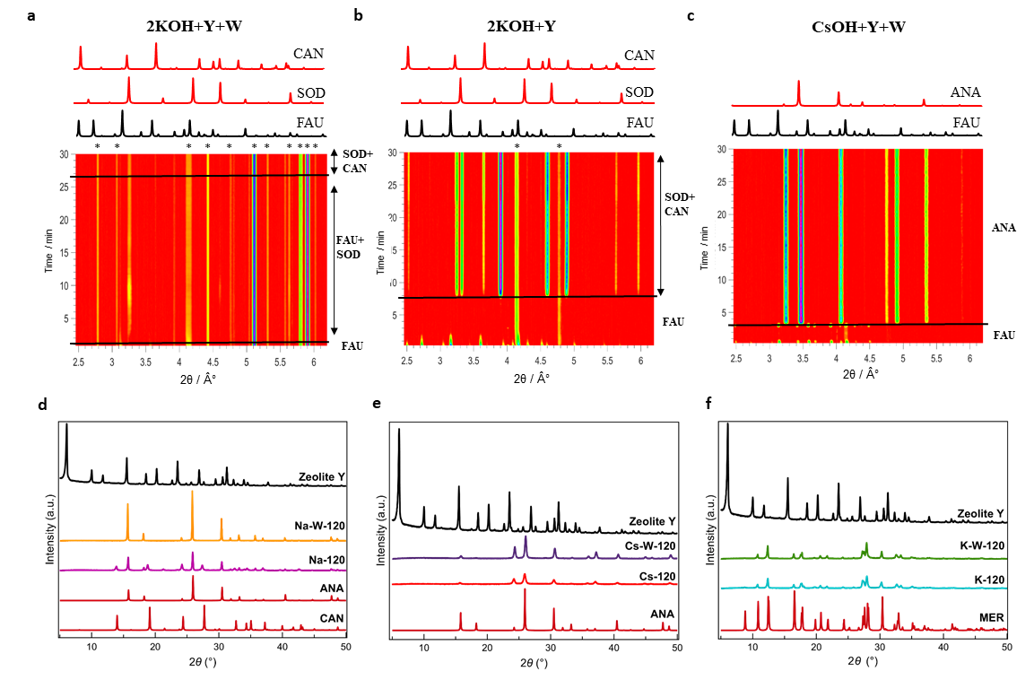
Figure 2. In situ and ex situ XRD patterns. a-c, in situ syn-XRD (λ = 0.207 Å) data of the systems 2 KOH + Y + W, 2 KOH + Y and CsOH + Y + W milled at 110 °C and representative patterns extracted from the diagram. d-f, Comparison of the ex situ XRD (λ = 1.5418 Å) of the samples obtained after 120 minutes of milling of zeolite Y with alkali hydroxides at 110 °C with the calculated PXRD patterns of the materials presenting corresponding zeolite framework types (ANA, CAN, and MER) generated from crystallographic data.
SEM analysis. Zeolite crystals formed after 120 min of milling at 110 °C present markedly different morphologies compared to the initial zeolite Y and the products obtained in the convection oven after 2 and 48 h at 110 °C (Figures 3, S5). The difference in the synthesis conditions (mechanical force, water content, and chemical composition of the reaction mixtures) promotes alternative crystal formation processes. For instance, ANA crystals obtained in the NaOH system are larger than those obtained with CsOH (Figures 3b, 3e). Additionally, in both samples, the crystals present spherical morphology.
Interestingly, the presence of potassium in the reaction mixture favors the formation of elongated rectangular crystals no matter the K+ quantity nor the phase composition of the end product (MER K-W-120, CAN 2K-120; Figures 3c, 3d). The particles are smaller when a double amount of KOH is used. Remarkably, the morphology of the zeolite crystals synthesized herein is independent of the mode of hydrothermal treatment; it is a function of a particular framework. ANA crystals obtained from the oven are also spherical (ST-CsOH, Figure S5u). In contrast, oven-derived MER crystals are elongated with sharp edges (ST-KOH, Figure 3f). Likewise, SOD exhibits rounded morphology and constitutes agglomerates of small crystallites (2K-W-27, 2K-31; Figures S5h, S5l).
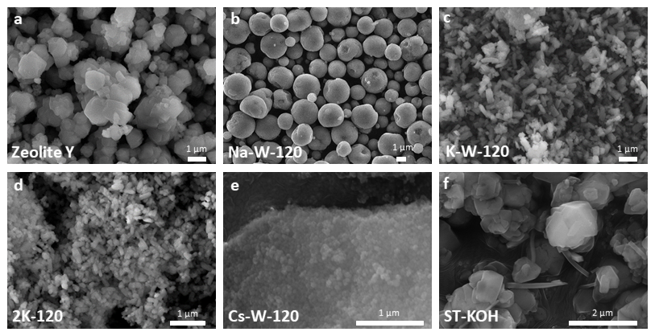
Figure 3. SEM images of the initial zeolite Y material and the selected end products of interzeolite conversion.
Particle size distribution (PSD). PSD curves of the samples taken in the course of thermo-milling FAU-type zeolite (Figures 3, S6, S7; Tables S1, S2) reveal notable changes in the crystals’ size. In general, the particle size diminishes in the early milling stage, which is attributed to the crystals breaking due to the applied mechanical force. As the milling proceeds, PSD curves ranges and respective D_{(N0.5)}/D_{(V0.5)} values vary depending on a particular system, leading to powders of distinct size compared to both the starting FAU-type zeolite Y and the materials obtained from the oven-heated systems (Ref- and ST- samples). E.g., there are variations in the PSD ranges in CsOH mixtures (Figures 4c, S6g-h, S7i-k), while with KOH (Figures 4a-b, S6d-e, S7d-g) the crystal size constantly decreases. N.b., although in dried powders recovered from the CsOH system without added water, the particles seem to get enlarged as the milling advances, the SEM images (Figure S5r) unveil these are agglomerates of particles smaller than 100 nm, as reflected in volume PSDs (Figure S7j). As expected, the crystals obtained from the oven are generally larger than those obtained by milling. The observed PSD trends, together with D_{(N0.5)}/D_{(V0.5)} values, demonstrate that the investigated zeolite formation processes are governed by numerous parameters (mechanical force, alkali hydroxide, amount of water, reaction period, etc.). Consequently, the cooperative action of these factors governs the properties of the obtained zeolites.
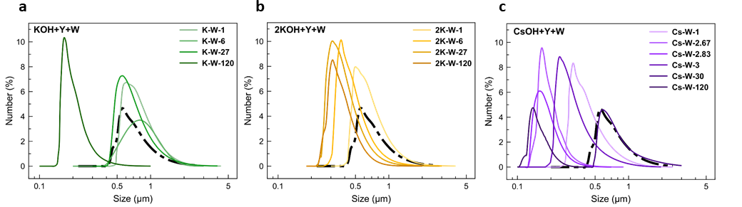
Figure 4. Number PSD curves of the selected series of samples obtained by thermo-milling at 110 °C.
Solid state nuclear magnetic resonance (NMR) and Raman spectroscopy analysis. The Al present in selected products exists solely in tetrahedral coordination, as seen in the respective 27Al NMR spectra, where only the resonance at ~60 ppm (Figure 4) can be observed. The absence of a signal at 0 ppm indicates a lack of octahedral (extra-framework) Al species. The ²⁹Si MAS NMR spectrum of FAU milled for 3 min with NaOH coincides with the XRD pattern of reduced intensity compared to parent zeolite Y (lower crystallinity) since additional resonance corresponds to Q0 Si moieties, suggesting a decline in the ordering level. Enhanced band intensity at -87 ppm in ¹H-²⁹Si cross-polarized (CP) MAS NMR spectrum of Na-3 indicates the presence of protons in the vicinity of Si atoms, possibly from water molecules within the pores and framework defects containing -OH groups. The latter may result from the mechanical force that causes deformation/structure degradation of the starting zeolite and induces defects in the formed solids.^{40,41}
K-W-120 and 2K-W-27 samples obtained by LAG also possess a certain number of framework defects, as indicated by their 1H-29Si CP MAS NMR spectra. The signal/noise ratio within each spectrum suggests that the number of defects in 2K-W-27 isolated after 27 min of milling could be greater than in the parent commercial FAU-type material. On the other hand, the spectra imply that MER (K-W-120) shows a comparable amount of defect sites to starting FAU, demonstrating the MER-type zeolite sample prepared after two hours of thermo-milling matches the one obtained by hydrothermal treatment, the commercial zeolite Y. Besides, once again is confirmed that the properties of a specific zeolite material are directly related to its preparation conditions.

Figure 5. Solid-state NMR analysis of selected samples. ²⁷Al, ²⁹Si and ¹H-²⁹Si CP MAS NMR spectra of the starting zeolite Y, FAU-type (Na-3), MER-type (K-W-120) and CAN-SOD product mixture (2K-W-27).
Raman spectra of the studied samples (Figure S8) reveal a change of the zeolite framework ring distribution in the course of thermomilling. Spectral features are characteristic of a particular zeolite framework, yet their discernibility and broadness vary among samples. Therefore, it is challenging to ascertain generic trends in the investigated systems. Generally, the most prominent band at 504 cm⁻¹ of zeolite Y gets shifted towards lower wavenumbers as the milling proceeds, suggesting the environment of the 4-membered rings has been altered. Besides, in ANA, the strongest Raman band appears at lower wavenumbers in the presence of heavier Cs⁺ (472 cm⁻¹, Cs-120) with respect to lighter Na+ (485 cm-1, Na-W-120).
High-resolution TEM (HRTEM). TEM images (Figures 6a-c) of the starting FAU-type zeolite Y show its high ordering, with sharp fringes and reflections in the FFT image. The measurements revealed d-spacings (Table S3, Figure S9) of 0.74 nm and 1.44 nm, which agrees with the values estimated from the PXRD data (0.75 nm, 1.44 nm). The MER phase after 120 min thermo-milling (Figures 6d-f, K-W-120) comprises rectangular crystals of different elongation levels and well-defined crystal lattices. FFT analysis (d-spacings: 0.69 nm, 0.7 nm, 0.81 nm) is in line with the PXRD (0.71 nm, 0.81 nm). Considering that NMR revealed a certain amount of defects in this sample, the TEM findings imply these are mostly point defects. Furthermore, the 2K-31 sample was identified by PXRD as a mixture of CAN and SOD. These phases are recognized as rectangular and spherical particles in TEM images (Figures 6g, 6i). The FFT d-spacings of 2K-31 (0.66 nm, 0.48 nm) concur with the PXRD analysis of CAN (0.63 nm, 0.47 nm).
Furthermore, the TEM image of the 2K-31 (Figure 6h) sample reveals the presence of amorphous phase, likely in an amount not sufficient to be detected by XRD. However, the amorphous solid in this system indicates that the interzeolite conversion process involves the formation of amorphous precursors, similar to the conventional zeolite synthetic processes. An experimental scheme to corroborate these findings in other systems is currently being devised.
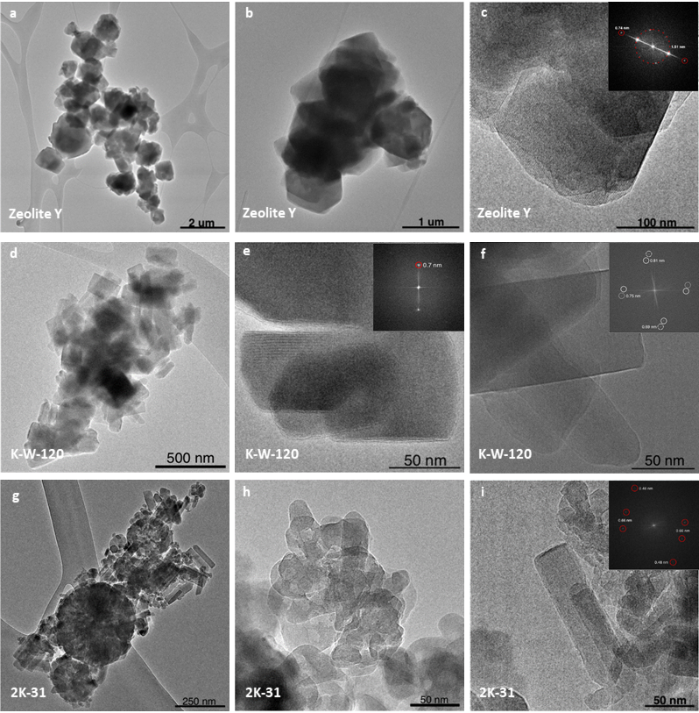
Figure 6. HRTEM images of the selected samples. a-c, starting zeolite Y material. Samples taken during milling at 110 °C of the systems: d-f, KOH + Y + W (K-W-120). g-i, 2 KOH + Y (2K-31).
Conclusions
Mechanochemical processing under controlled elevated temperatures allowed for a rapid, efficient, and controllable solid-state interzeolite conversion without added OSDAs. Milling FAU-type zeolite Y with alkali hydroxides at 110 °C afforded three phase-pure crystalline products (ANA, MER, CAN), mixtures of several zeolite phases, and an amorphous phase that was detected in some products. The thermo-milling proved critical for the said conversions, while the heating of the preground mixtures or oven processing showed sporadic or no interconversion despite longer reaction times. The synchrotron X-ray in situ monitoring of the mechanochemical reactions, performed in the newly designed vessels enabling simultaneous diffraction data acquisition during thermo-milling, showed that these mechanochemical interconversion reactions are prompt and dynamic, involving several intermediate phases (SOD, GIS, potassium silicate) depending on the alkali hydroxide and the amount of the added water before the final phase stabilizes. The mechanochemically obtained materials are smaller in particle size but have comparable framework ordering and faults to zeolite materials prepared by conventional solution-based synthesis methods.
These results indicate that phase composition and the material's properties formed upon thermo-milling arise from the subtle interplay of kinetic and thermodynamic factors. The findings reported here are expected to provide guidelines for designing and conducting further mechanochemical interzeolite conversion reactions to optimize preparation conditions to obtain materials with controlled properties (phase and chemical compositions, crystal size, morphology, acidity, lattice arrangement), i.e., materials customized for a particular purpose. The newly designed milling equipment can be used for monitoring other systems involving corrosive reaction environments. Furthermore, this study sheds light on the possible mechanism of interzeolite conversion processes in OSDA-free systems since, in two different systems, an amorphous phase was detected. This correlates with typical zeolite synthesis employing classical chemicals as sources of T-atoms. Our future work will focus on developing strategies to achieve the direct formation of advanced zeolite materials by mechanochemical processing and further our efforts presented herein to achieve selective interzeolite conversions.

ASSOCIATED CONTENT
Supporting Information. The following files are available free of charge.
Supporting tables, in situ PXRD data, ex situ PXRD data, N₂ ads./des. isotherms, SEM images, LLS data, TEM imaging and Raman spectra. (PDF)
AUTHOR INFORMATION
Corresponding Author
Ana Palčić - Division of Materials Chemistry, Ruđer Bošković Institute, Bijenička cesta 54, 10000 Zagreb, Croatia. ana.palcic@irb.hr
Krunoslav Užarević - Division of Physical Chemistry, Ruđer Bošković Institute, Bijenička cesta 54, 10000 Zagreb, Croatia. krunoslav.uzarevic@irb.hr
Author Contributions
‡These authors contributed equally.
Notes
The authors declare no competing financial interest.
ACKNOWLEDGMENT
Croatian Science Foundation is acknowledged for funding this research (projects ID: UIP-2019-04-4977 and IP-2020-02-4702). The authors acknowledge the CERIC-ERIC Consortium for the access to experimental facilities. We acknowledge DESY (Hamburg, Germany), a member of the Helmholtz Association HGF, for the provision of experimental facilities. Parts of this research were carried out at PETRA III beamline P02.1. Beamtime was allocated by an In-House contingent. A part of the research was supported through the "Research Cooperability" Program of the Croatian Science Foundation, funded by the European Union from the European Social Fund under the Operational Programme Efficient Human Resources 2014-2020, grant PZS-2019-02-4129. Janez Volavšek acknowledges the financial support from the Slovenian Agency (research core funding no. P1-0021). V. V. acknowledges the financing by the European Union-NextGenerationEU, through the National Recovery and Resilience Plan of the Republic of Bulgaria, project No BG-RRP-2.004-0008. Marie Desmurs-Lozier (UMR-6506) is gratefully acknowledged for acquiring microscope images and measuring N2 physisorption isotherms.
REFERENCES
- J. B. Nagy, P. Bodart, I. Hannus, I. Kiricsi, Synthesis and Use of Zeolitic Microporous Materials, DecaGen, Szeged, 1998.
- A. Dyer, J. Hriljac, N. Evans, I. Stokes, P. Rand, S. Kellet, R. Harjula, T. Moller, Z. Maher, R. Heatlie-Branson, J. Austin, S. Williamson-Owens, M. Higgins-Bos, K. Smith, L. O’Brien, N. Smith, N. Bryan, The use of columns of the zeolite clinoptilolite in the remediation of aqueous nuclear waste streams, J. Radioanal. Nuc. Chem., 2018, 318, 2473–2491.
- R. S. Leonard, US4066394A, 1974.
- E. Pérez-Botella, M. Palomino, S. Valencia, F. Rey, Nanoporous Materials for Gas Storage, Springer, Wiesbaden 2019.
- J. Pérez-Pellitero, G. D. Pirngruber, New Developments in Adsorption/Separation of Small Molecules by Zeolites, Springer, Wiesbaden 2020.
- E. T. C. Vogt, G. T. Whiting, A. D. Chowdhury, B. M. Weckhuysen, Zeolites and Zeotypes for Oil and Gas Conversion, Adv. Catal., 2015, 58, 143–314.
- G. Bellussi, R. Millini, P. Pollesel, C. Perego, Zeolite science and technology at Eni, New J. Chem., 2016, 40, 4061–4077.
- K. Iyoki, K. Kikumasa, T. Onishi, Y. Yonezawa, A. Chokkalingam, Y. Yanaba,T., Matsumoto, R. Osuga, S. P. Elangovan, J. N. Kondo, A. Endo, T. Okubo, T. Wakihara, Extremely Stable Zeolites Developed via Designed Liquid-Mediated Treatment, J. Am. Chem. Soc., 2020, 142, 3931–3938.
- A. Palčić, S. Babić, A. Maršavelski, M. Galić, N. T. Popović, I. S. Perović, R. Čož-Rakovac, J. Bronić, V. Valtchev, Nanosized Zeolite Beta - Determining the Safety of usage by Zebrafish Danio Rerio Embryos, Microporous Mesoporous Mater., 2020, 299, 110103–110113.
- A. Omran, N. Nesterenko, V. Valtchev, Zeolitic ice: A route toward net zero emissions, Renew. Sust. Energ. Rev., 2022, 168, 112768.
- M. Alabdullah, A. Rodriguez-Gomez, T. Shoinkhorova, A. Dikhtiarenko, A. D. Chowdhury, I. Hita, S. R. Kulkarni, J. Vittenet, J., S. M. Sarathy, P. Castaño, A. Bendjeriou-Sedjerari, E. Abou-Hamad, W. Zhang, O. S. Ali, I. Morales-Osorio, W. Xu, J. Gascon, One-step conversion of crude oil to light olefins using a multi-zone reactor, Nature Catal., 2021, 4, 233–241.
- Y. Liao, S.-F. Koelewijn, G. van Bossche, J. van Aelst, S. van den Bosch, T. Renders, K. Navare. T. Nicolai, K. van Aelst, M. Maesen, H. Matsushima, J. M. Thevelein, K. van Acker, B. Lagrain, D. Verboekend, B. F. Sels, A Sustainable Wood Biorefinery for Low-Carbon Footprint Chemicals Production, Science, 2020, 367, 1385–1390.
- M. Dusselier, P. Van Wouwe, A. Dewaele, P. A. Jacobs, B. F. Sels, Shape-Selective Zeolite Catalysis for Bioplastics Production, Green Chem., 2015, 349, 78–82.
- I. Vollmer, M. J. F. Jenks, R. M. González, F. Meirer, B. M. Weckhuysen, Plastic Waste Conversion over a Refinery Waste Catalyst, Angew. Chem. Int. Ed., 2021, 60, 16101–16108.
- B. Subotić, J. Bronić, T. Antonić-Jelić, Theoretical and practical aspects of zeolite nucleation, chapter in Ordered Porous Materials, Elsevier, Amsterdam, 2009.
- A. Palčić, B. M. Szyja, M. Mičetić, T. Čendak, M. Akouche, K. Juraić, M. Čargonja, D. Mekterović, V. Vušak, V. Valtchev, Impact of the Zn source on the RSN-type zeolite formation, Inorg. Chem. Front., 2019, 6, 2279–2290.
- A. Burton, Recent trends in the synthesis of high-silica zeolites, Catal. Rev., 2017, 60, 132-175.
- J. Mallete, S. Seo, J. D. Rimer, Synthesis strategies and design principles for nanosized and hierarchical zeolites, Nat. Synth., 2022, 1, 521–534.
- H. Awala, J.-P. Gilson, R. Retoux, P. Boullay, J.-M. Goupil, V. Valtchev, S. Mintova, Template-free nanosized faujasite-type zeolites, Nat. Mater., 2015, 15, 447–451.
- B. Subotić, D. Škrtić, I. Šmit, L. Sekovanić, Transformation of zeolite A into hydroxysodalite, J. Cryst. Growth., 1980, 50, 498–508.
- J. Devos, M. A. Shah, M. Dusselier, On the key role of aluminium and other heteroatoms during interzeolite conversion synthesis, RSC Adv., 2021, 11, 26188–26210.
- A. Corma, M. J. Díaz-Cabañas, J. L. Jorda, C. Martinez M. Moliner, High-throughput synthesis and catalytic properties of a molecular sieve with 18- and 10-member rings, Nature, 2006, 443, 842–845.
- K. Cheetham, H. Fjellvåg, T. E. Gier, K. O. Kongshaug, K. P. Lillerud, G. D. Stucky, Very open microporous materials: from concept to reality, Stud. Surf. Sci. Catal., 2001, 135, 158.
- T. Friščić, C. Mottillo, H. M. Titi, Mechanochemistry for Synthesis, Angew. Chemie Int. Ed., 2020, 59, 1018–1029.
- T. Stolar, K. Užarević, Mechanochemistry: an efficient and versatile toolbox for synthesis, transformation, and functionalization of porous metal–organic frameworks, CrystEngComm, 2020, 22, 4511–4525.
- A. A. L. Michalchuk, E. V. Boldyreva, A. M. Belenguer, F., Emmerling, V. V. Boldyrev, Tribochemistry, Mechanical Alloying, Mechanochemistry: What is in a Name?, Front. Chem., 2021, 9, 685789–685818.
- D. Katsenis, A. Puškarić, V. Štrukil, C. Motillo, P. A. Julien, K. Užarević, M.-H. Pham, T.-O. Do, S. A. J., Kimber, P. Lazić, O. Magdysyuk, R. E. Dinnebier, I. Halasz, T. Friščić, In situ X-ray diffraction monitoring of a mechanochemical reaction reveals a unique topology metal-organic framework, Nat. Commun., 2015, 6, 6662–6670.
- K. Kanie, M. Sakaguchi, F Muto, M. Horie, T. Nakaya, T. Yokoi, A. Muramatsu, Mechanochemically assisted hydrothermal synthesis of Sn-substituted MFI-type silicates, Sci. Technol. Adv. Mater., 2018, 19, 545–553.
- G. A. Bowmaker, Solvent-assisted mechanochemistry, Chem. Commun., 2013, 49, 334–348.
- V. Martinez, T. Stolar, B. Karadeniz, I. Brekalo, K. Užarević, Advancing mechanochemical synthesis by combining milling with different energy sources, Nat. Rev. Chem., 2023, 7, 51–65.
- J. Alić, T. Stolar, Z. Štefanić, K. Užarević, M. Šekutor, Sustainable Synthesis of Diamondoid Ethers by High-Temperature Ball Milling, ACS Sustainable Chem. Eng., 2023, 11, 617–624.
- N. Cindro, M. Tireli, B. Karadeniz, T. Mrla, K. Užarević, Investigations of Thermally Controlled Mechanochemical Milling Reactions, ACS Sustainable Chem. Eng., 2019, 7, 16301–16309.
- C. F. Macrae, P. R. Edgington, P. McCabe, E. Pidcock, G. P. Shields, R., Taylor, M. Towler, J. van der Streek, Mercury: visualization and analysis of crystal structures, J. Appl. Cryst., 2006, 39, 453–457.
- http://www.iza-online.org (accessed Devember 22, 2023)
- D. Massiot, F. Fayon, M., Capron, I. King, S. Le Calvé, B. Alonso, J. O., Durand, B. Bujoli, Z. Gan, G. Hoatson, Modelling one and two-dimensional solid-state NMR spectra, Magn. Reson. Chem., 2002, 40, 70–76.
- D. Oleksiak and J. D. Rimer, Synthesis of zeolites in the absence of organic structure-directing agents: Factors governing crystal selection and polymorphism, Rev. Chem. Eng., 2014, 30, 1–49.
- T. Friščić, I. Halasz, P. J. Beldon, A. M. Belenguer, F. Adams, S. A. J. Kimber, V. Honkimäki, R. E. Dinnebier, Real-time and in situ monitoring of mechanochemical milling reactions, Nat. Chem., 2013, 5, 66–73.
- T. Friščić, I. Halasz, V. Štrukil, M. Eckert-Maksić, R. E. Dinnebier, Clean and Efficient Synthesis Using Mechanochemistry: Coordination Polymers, Metal-Organic Frameworks and Metallodrugs, Croat. Chem. Acta, 2012, 85, 367–378.
- K. Asselman, D. Vandenabeele, N. Pellens, N. Doppelhammer, C. E. A. Kirschhock, E. Breynaert, Structural Aspects Affecting Phase Selection in Inorganic Zeolite Synthesis, Chem. Mater., 2022, 34, 11081−11092.
- C. Kosanović, J. Bronić, B. Subotić, I. Šmit, M. Stubičar, A. Tonejc, T. Yamamoto, Mechanochemistry of zeolites: Part 1. Amorphization of zeolites A and X and synthetic mordenite by ball milling, Zeolites, 1993, 13, 261–268.
- V. Valtchev, S. Mintova, V. Dimov, A. Toneva, D. Radev, Tribochemical activation of seeds for rapid crystallization of zeolite Y, Zeolites, 1995, 15, 193–197.

BRIEFS (Word Style “BH_Briefs”). If you are submitting your paper to a journal that requires a brief, provide a one-sentence synopsis for inclusion in the Table of Contents.
SYNOPSIS (Word Style “SN_Synopsis_TOC”). If you are submitting your paper to a journal that requires a synopsis, see the journal’s Instructions for Authors for details.

