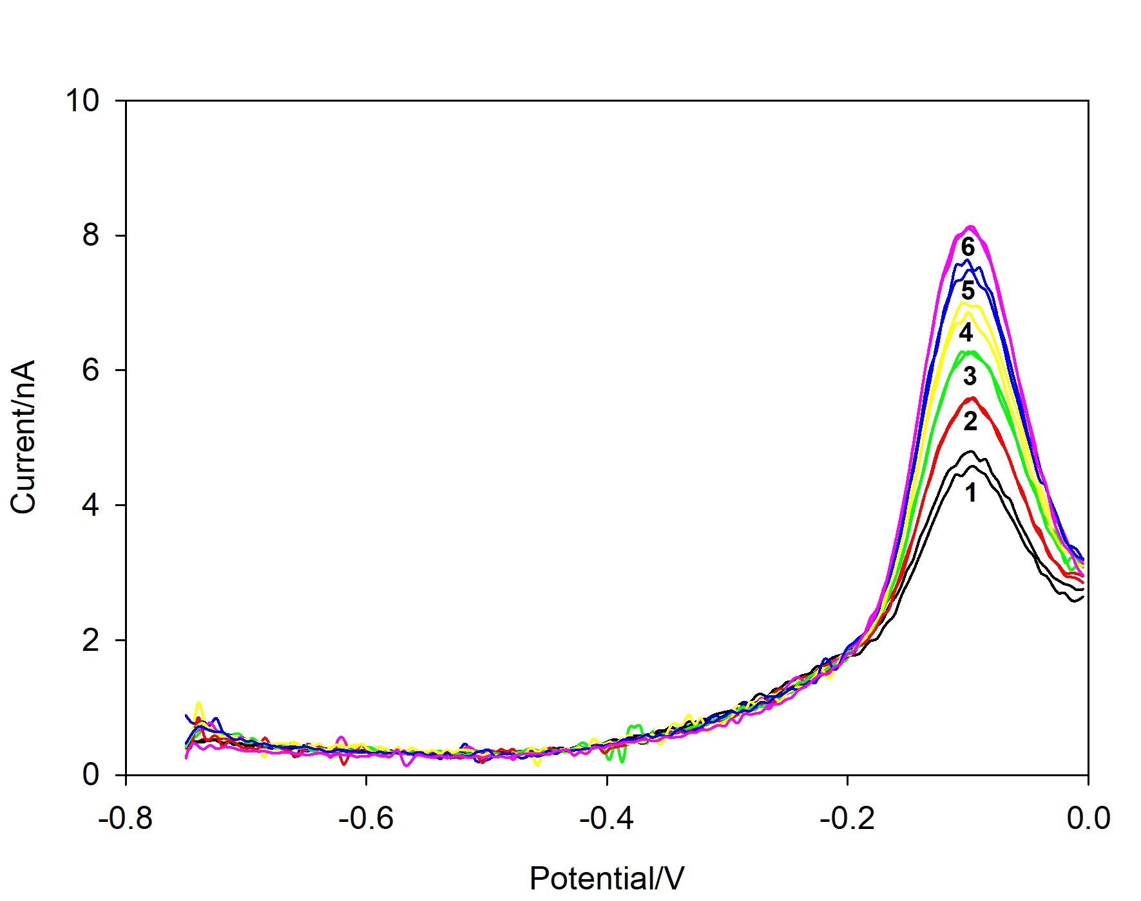
Figure 1S Determination of total dissolved Cu concentration using DP-ASV (t_{acc}/s = 120, E_{acc} = -0.85). Added Cu(II) as follows: 1 – 0, 2 – 1.9 x 10⁻⁸, 3 – 3.9 x 10⁻⁸, 4 – 5.8 x 10⁻⁸, 5 – 7.7 x 10⁻⁸, 6 – 9.6 x 10⁻⁸. Next scanning parameters were used: step of 0.005 V, modulation time of 0.05 s, interval time of 0.5 s and modulation amplitude of 0.025 V and frequency 25 s⁻¹. The sample was diluted 2.5 times with acidified MQ water before the measurements.

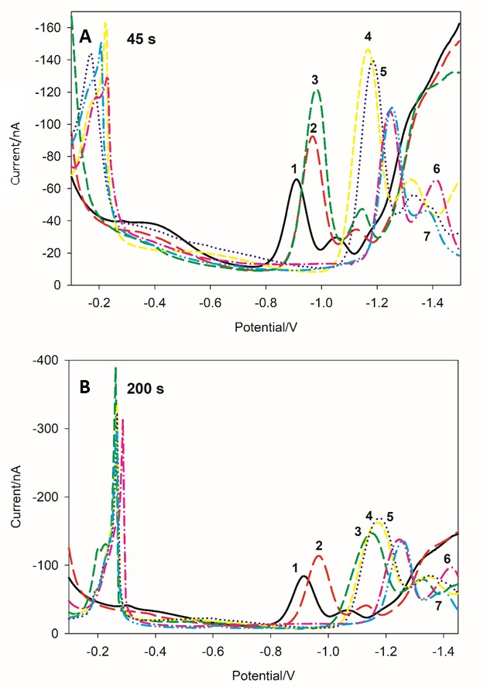
Figure 2S SWV of 6.6 x 10⁻⁷ mol dm⁻³ BCS in 0.55 mol dm⁻³ NaCl + 0.01 mol dm⁻³ borate buffer dependence on pH; t_{acc}/s = 45 s (A) and 200 s (B). pH: 1 – 2.5; 2 – 3.5; 3 – 4.5; 4 – 5.7; 5 – 6.7; 6 – 8.2; 7 – 9.0; deposition potential 0 V; A = 20 mV, f = 25 s.

Figure 3S The peak currents and potentials dependence on the accumulation time for reduction of Cu(I)-BCS at about -0.55 V (•) and Cu(II)-BCS at around -0.90 V (o).
Figure 4S Copper titration with BCS in 0.55 M NaCl; pH = 8.2; t_{acc} = 200 s, E_{acc} = 0.0 V, A = 20 mV, f = 25 s⁻¹, [Cu] = 4.2 x 10⁻⁷ mol dm⁻³; [BCS]/mol dm⁻³: 1 – 0; 2 – 2.1 x 10⁻⁷; 3 – 4.2 x 10⁻⁷; 4 – 6.4 X 10⁻⁷; 5 – 1.3 x 10⁻⁶.

Figure 5S Dependence of Cu(I)-BCS reduction peak current at -0.55 V ( ), at -0.90 V ( ), on SW frequency and amplitude (pH 8.2, t_{acc} = 200 s, E_{acc} = 0.0 V).

Figure 6S SWV at pH = 8.2; t_{acc} = 120 s, E_{acc} = 0.0 V, A = 20 mV, f = 25 s⁻¹. Red line - [Cu (I)] = 4.2 x 10⁻⁷ mol dm⁻³; [BCS/EDTA] = 0.66 x 10⁻⁷ mol dm⁻³ and 3.33 x 10⁻⁶ mol dm⁻³, respectivelly. Black line - [Cu(I)] = 4.2 x 10⁻⁷ mol dm⁻³ and BCS = 0.66 x 10⁻⁷. Blue line - [Cu (II)] = 4.2 x 10⁻⁷ mol dm⁻³; [BCS/EDTA] = 0.66 x 10⁻⁷ mol dm⁻³ and 3.33 x 10⁻⁶ mol dm⁻³, respectivelly. Supporting electrolyte = 0.55 mol dm⁻³ NaCl + 0.01 mol dm⁻³ borate buffer. Inset: Enlarged potential range from -0.4 to -0.8.

