**Vibrational dynamics background of the thermal stability of zinc zeolitic imidazolate lattices**

Yonger Xi,a Nikola Biliškov*a,b and Hatem M. Titi* a

(a) Department of Chemistry, McGill University, Montreal, QC, H3A 0B8, Canada;

(b) Ruđer Bošković Institute, Bijenička c. 54, 10000 Zagreb, Croatia

Email: [nbilis@irb.hr](mailto:nbilis@irb.hr) and [hatem.titi@mcgill.ca](mailto:hatem.titi@mcgill.ca)

**Table of content**

1. **Materials and methods** 1
2. **Synthetic procedures 2**
3. **Powder X-ray diffraction (PXRD) 3**
4. **ATR-IR spectroscopy 5**
5. **Surface area measurements 11**
6. **Thermogravimetric analysis (TGA) 13**
7. **Derivative Thermogravimetry (DTG) 16**
8. **Kinetics of ZIFs 19**
9. **References 27**

-----------------------------------------------------------------------------------------------------------------------------------

1. **Materials and methods**

The compounds imidazole (**H**Im), 2-methylimidazole (**Me**Im), 2-ethylimidazole (**Et**Im), 2-propylimidazole (**Pr**Im), 2-butylimidazole (**Bu**Im), zinc oxide, zinc nitrate hexahydrate, ammonium nitrate, methanol (MeOH), dimethylformamide (DMF), benzene and triethylamine (TEA) were obtained from Sigma-Aldrich (St. Louis, MO, USA) and used as received.

* 1. **Powder X-ray diffraction (PXRD).**

PXRD data were collected on a Bruker D2 Phaser diffractometer equipped with a LYNXEYE linear position sensitive detector (Bruker AXS, Madison, WI, USA), using Ni-filtered Cu*K*α radiation.

* 1. **Activation and surface area measurements.**

All samples were activated by washing with MeOH (30 mL X 3 times), All MOFs were activated ahead of use for 48 hours in an oven at 85 °C. Nitrogen sorption isotherms of the activated MOFs were measured on a Quantachrom instrument, and the experiments were conducted at 77 K.

* 1. **Fourier-transform attenuated total reflectance infrared (FTIR-ATR) spectroscopy.**

The spectra were conducted using a Bruker Alpha FT-IR spectrometer (Bruker Optics Ltd., Milton, ON, Canada) with single-reflection ATR element made of diamond crystal. Spectral resolution was set to 2 cm-1, and each spectrum is obtained by averaging 128 individual interferograms. Spectra were acquired in the 4000-400 cm-1 range.

* 1. **Thermogravimetric analysis (TGA).**

TGA data were recorded on a TGA/DSC 1 thermal balance (Mettler-Toledo, Columbus, Ohio, USA), and samples were placed in open 70 μL alumina crucibles containing 4-5 mg of material. All measurements were done in a dynamic atmosphere of air (gas flow of 25 mL/min), by heating up to 800 °C at different heating rates of 5, 10, 15, and 30 K min-1.

1. **Synthetic procedures.**

The MOFs were prepared using the following procedures1-2:

* 1. Synthesis of SOD-Zn(**Me**Im)2:

SOD-Zn(**Me**Im)2 (ZIF-8) was prepared by dissolving 2-methylimidazole (H**Me**Im, 22 mmol) and triethylamine (22 mmol) in 80 mL of MeOH, followed by a dropwise addition of a Zn(NO3)26H2O (10 mmol) solution in 100 mL of MeOH. The solution was stirred for an additional 2 hours and left at ambient conditions overnight without disruption.

* 1. Synthesis of RHO-Zn(**Et**Im)2:

RHO-Zn(**Et**Im)2 was prepared using a modified synthetic route of the previously published aging procedure, wherein a mixture of 2-ethylimidazole (H**Et**Im, 30 mmol), ZnO (10 mmol) and adipic acid (2 mmol% with respect to ZnO) was mixed well in a Petri dish before it was placed in an aging chamber. The mixture was exposed for a course of two days at 100% relative humidity and a temperature of 45 °C.

* 1. Synthesis of ANA-Zn(**Et**Im)2:

ANA-Zn(**Et**Im)2 was prepared by milling a solid mixture of ZnO (10 mmol), 2- ethylimidazole (21 mmol) and catalytic ammonium acetate (1 mmol). All the corresponding compounds were placed in a 50 mL stainless steel jar, with two stainless steel balls 10 mm in diameter and the addition of 1 mL of benzene. The reaction mixtures were milled for 30 minutes at 30 Hz.

* 1. Synthesis of qtz-Zn(**Et**Im)2:

qtz-Zn(**Et**Im)2 was prepared by milling a solid mixture of ZnO (10 mmol), 2- ethylimidazole (21 mmol) and catalytic NH4NO3 (1.25 mmol). All the corresponding compounds were placed in a 50 mL stainless steel jar, with two stainless steel balls 10 mm in diameter and the addition of 1 mL of DMF. The reaction mixtures were milled for 40 minutes at 30 Hz.

* 1. Synthesis of ANA-Zn(**Pr**Im)2 and ANA-Zn(**Bu**Im)2:

ANA-Zn(**Pr**Im)2 and ANA-Zn(**Bu**Im)2 were prepared by milling a solid mixture of ZnO (10 mmol), 2- propylimidazole or 2- butylimidazole (21 mmol) and catalytic ammonium acetate (1 mmol). All the corresponding compounds were placed in a 50 mL stainless steel jar, with two stainless steel balls 10 mm in diameter and the addition of 1 mL of ethanol. The reaction mixtures were milled for 30 minutes at 30 Hz.

1. **Powder X-ray diffraction (PXRD).**

**Figure S1**. Overlay of PXRD patterns for simulated and synthesized SOD-Zn(**Me**Im)2 after activation.

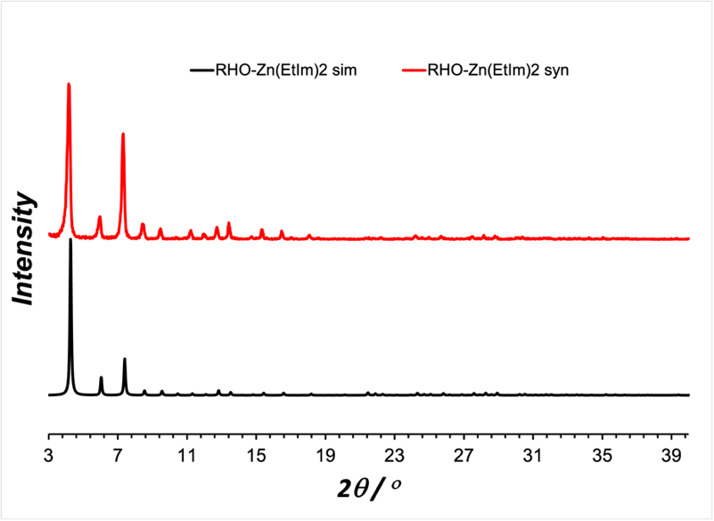

**Figure S2**. Overlay of PXRD patterns for simulated and synthesized RHO-Zn(**Et**Im)2 after activation.

**Figure S3**. Overlay of PXRD patterns for simulated and synthesized ANA-Zn(**Et**Im)2 after activation.

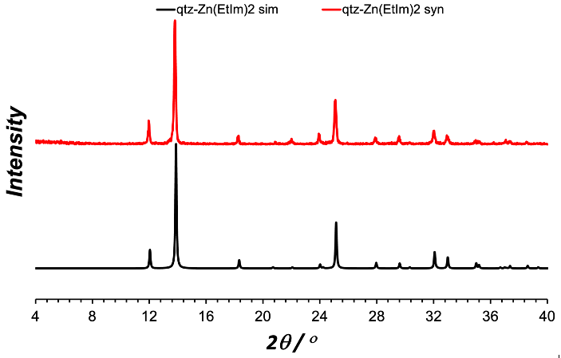

**Figure S4**. Overlay of PXRD patterns for simulated and synthesized qtz-Zn(**Et**Im)2 after activation.

**Figure S5**. Overlay of PXRD patterns for simulated and synthesized ANA-Zn(**Pr**Im)2 after activation.

**Figure S6**. Overlay of PXRD patterns for simulated and synthesized ANA-Zn(**Bu**Im)2 after activation.

1. **ATR-IR spectroscopy.**

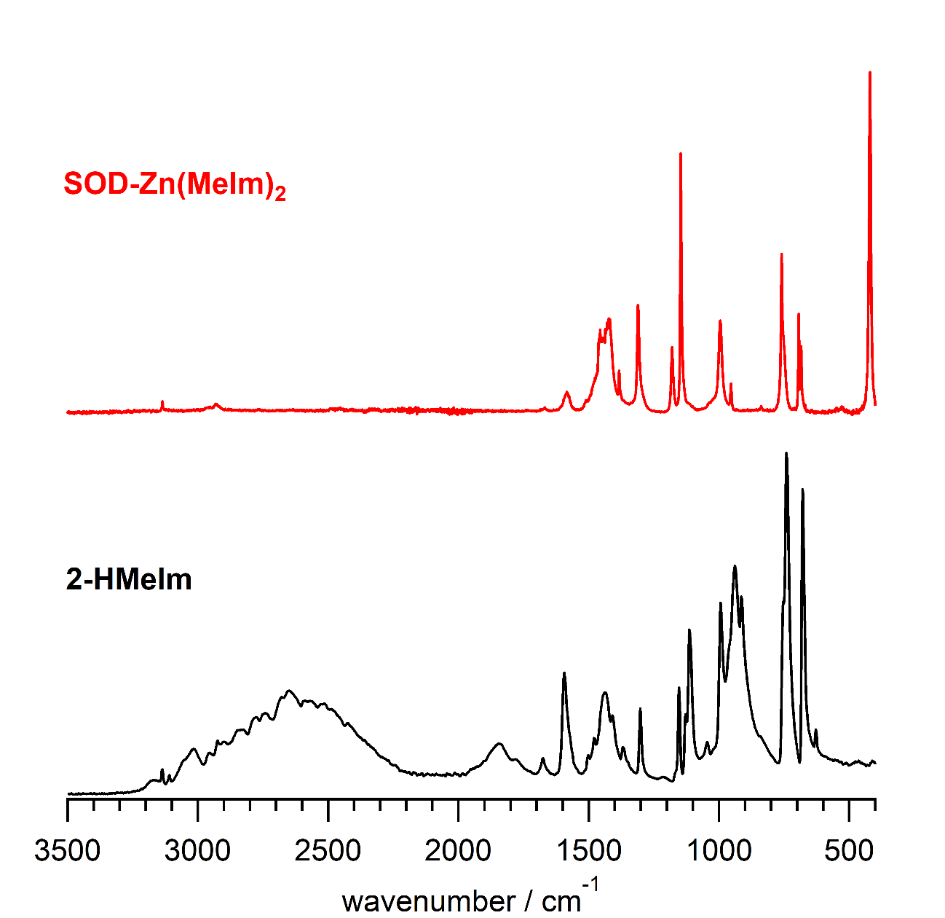

**Figure S7:** IR spectrum of SOD-Zn(**Me**Im)2 (ZIF-8) and its corresponding linker, 2-methylimidazole (2-H**Me**Im).

**Table S1:** IR spectral features and assignation for SOD-Zn(**Me**Im)2.

|  |  |  |
| --- | --- | --- |
| **SOD-Zn(MeIm)2** | **2-**H**MeIm** | **Assignation5** |
|  | 3173 | (NH) |
| 3136 | 3136 | (CH) |
|  | 3110 | s(CH3) |
| 2963 | 3019 | op(CH3) |
| 2929 | 2925 | s(CH2) |
|  | 2898 |  |
|  | 3000 – 2200 | (NH) hydrogen bonded |
|  | 1853 | combination  |
| 1672 | 1672 | (C=N) |
| 1584 | 1595 | (CN) |
|  | 1503 | (CH3) |
|  | 1478 | (CN) |
| 1457 | 1445 | (CN) |
| 1422 | 1407 | (CC) |
| 1383 | 1370 | (NH) + (CN) |
| 1310 | 1303 | (ring) + (CC) |
|  | 1209 |  |
| 1180 | 1169 | (CH3) |
| 1146 | 1153 | (CH3) |
|  | 1129 | (CH3) |
|  | 1114 | (CH3) + (CN) |
|  | 1046 | (NH) + (CH) |
| 995 | 996 | ip(CH3) |
| 954 | 962 | op(CH3) |
|  | 937 | (CH) + (CC) |
|  | 914 | (NH) |
|  | 840 | (CH) |
| 760 | 753 | (CH) + (CN) |
|  | 740 | (CC) + (CN) |
| 694 | 678 | (CCH3) |
| 685 | 653 | (ring) |
|  | 627 | (CH) + (CC) |
| 420 |  | (ZnN) |

Vibrational notation in accordance to standard recommendations.4

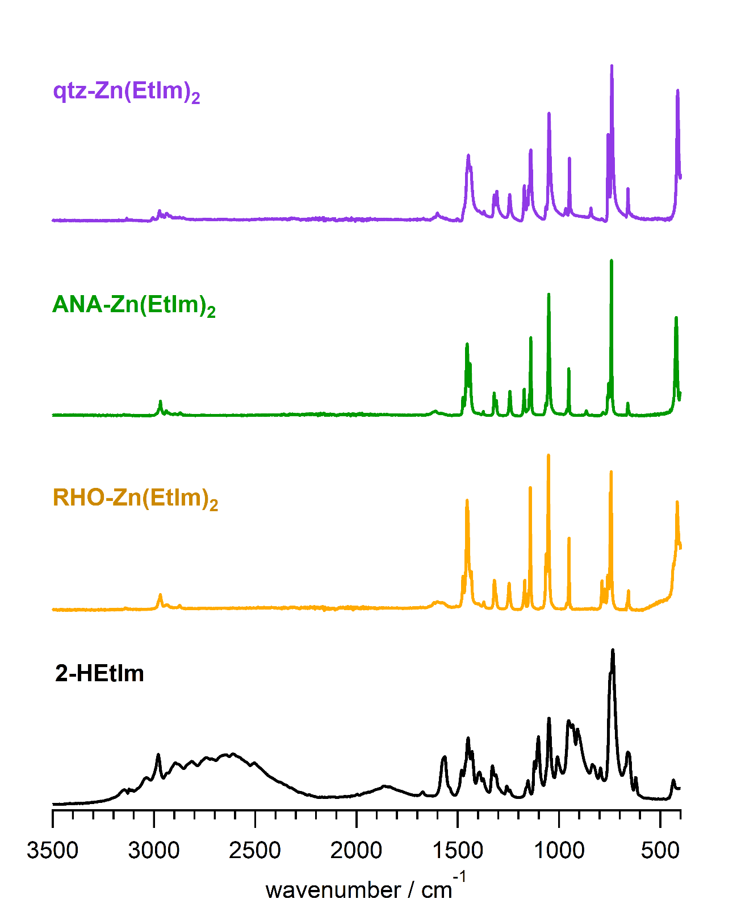

**Figure S8:** IR spectra of various polymorphs of Zn(**Et**Im)2 and their corresponding linker, 2-ethylimidazole (2-H**Et**Im).

**Table S2:** IR spectral features and assignation for various Zn(**Et**Im)2 polymorphs.

|  |  |  |  |  |
| --- | --- | --- | --- | --- |
| **2-**H**EtIm** | **RHO-Zn(EtIm)2** | **ANA-Zn(EtIm)2** | **qtz-Zn(EtIm)2** | **Assignation3** |
| 3260 |  |  |  | (NH) |
| 3134 |  |  |  | (CH) |
| 3110 |  |  |  | s(CH3) |
| 3045 |  |  |  | as(CH3) |
|  |  |  | 3004 |  |
| 2980 | 2976 | 2975 | 2972 | s(CH2) |
|  | 2968 | 2967 | 2956 | as(CH2) |
|  | 2935 | 2939 | 2937 |  |
| 2889 | 2873 | 2871 | 2874 |  |
| 1675 | 1617 | 1623 | 1616 | (C=N) |
| 1666 | 1600 | 1609 | 1600 | (C=C) |
| 1575 | 1577 | 1579 | 1575 | (C-N) |
| 1562 |  |  |  | (C-N) |
| 1540 |  |  |  | (C-N) |
| 1482 | 1473 | 1474 | 1470 | (C-N) |
| 1453 | 1454 | 1453 | 1455 | (C-N) |
| 1451 | 1449 |  | 1448 | (C-C) |
| 1399 | 1432 | 1439 | 1436 | (C-C) |
| 1375 | 1371 | 1374 | 1371 | (NH) + (CN) |
| 1352 | 1319 | 1320 | 1320 | ring) + (CC) |
| 1312 | 1310 | 1309 | 1307 | ring) + (CC) |
| 1260 |  |  |  | CH) + (CN) |
| 1245 | 1246 | 1243 | 1243 | (CH) + (CN) |
| 1165 | 1170 | 1171 | 1172 | ip(CH3) |
| 1153 | 1149 | 1157 | 1146 | s(CH3) |
|  | 1142 | 1149 | 1139 | op(CH3) |
| 1123 | 1141 | 1140 | 1139 |  |
| 1106 | 1064 | 1065 | 1064 | (CH2) + (CN) |
| 1053 | 1052 | 1050 | 1050 | (NH) + (CH) |
| 1010 |  |  |  | ip(CH3) |
| 968 | 961 |  | 967 |  |
|  | 951 | 951 | 949 | op(CH3) |
| 911 |  | 864 | 843 | (CH) + CC |
| 796 | 788 | 781 |  | (CC) + CN |
| 763 | 774 |  |  |  |
|  | 759 | 759 | 757 | (CH) + (CN) |
|  | 754 | 754 |  |  |
|  | 746 |  |  |  |
| 737 | 742 | 741 | 739 | (CC) + (CN) |
| 655 | 663 | 660 | 660 | (ring) |
| 646 | 656 | 654 |  | (ring) |
| --- | 417 | 422 | 414 | (ZnN) |

Vibrational notation in accordance to standard recommendations.4

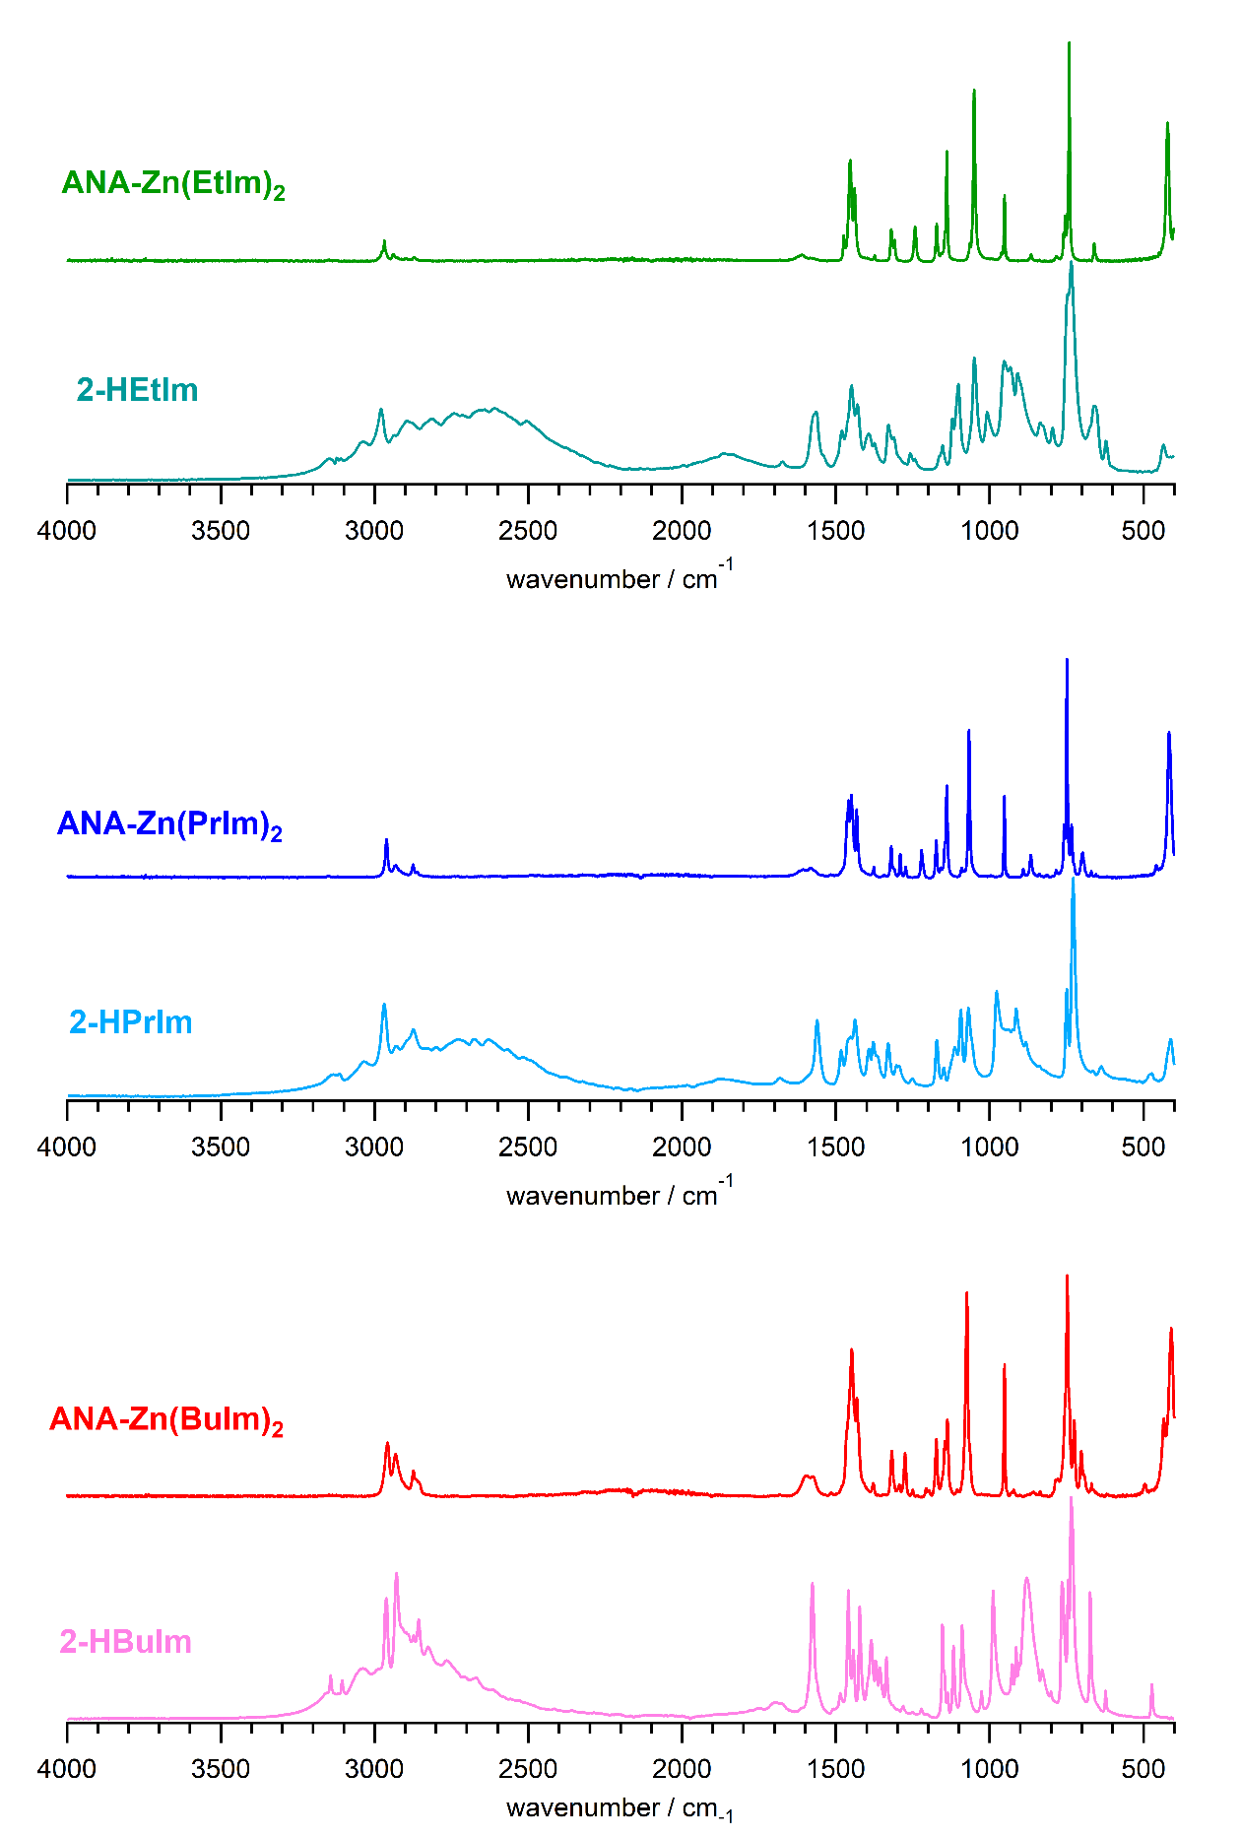

**Figure S9:** IR spectra of various forms of Zn-imidazolate MOFs adopting the ANA-topology and their comparison with their corresponding imidazole linkers.

**Table S3:** IR spectral features for MOFs of ANA-topology and their comparison with corresponding imidazole linkers.

|  |  |  |  |  |  |
| --- | --- | --- | --- | --- | --- |
| **ANA-Zn(EtIm)2** | **2-**H**EtIm** | **ANA-Zn(PrIm)2** | **2-**H**PrIm** | **ANA-Zn(BuIm)2** | **2-**H**BuIm** |
|  | 3260 |  |  |  |  |
|  | 3134 |  | 3131 |  | 3142 |
|  | 3110 |  |  |  | 3105 |
|  | 3045 |  | 3035 |  | 3041 |
|  |  |  |  |  |  |
| 2975 | 2980 |  |  |  |  |
| 2967 |  | 2961 | 2970 | 2958 | 2962 |
| 2939 |  | 2931 | 2931 | 2932 |  |
| 2871 | 2889 | 2874 | 2874 | 2873 |  |
|  |  | 2862 |  | 2858 |  |
|  |  |  | 2728 |  |  |
|  |  |  | 2676 |  |  |
|  |  |  | 2627 |  |  |
| 1608 | 1675 | 1608 | 1683 | 1598 | 1695 |
|  | 1666 |  |  |  |  |
| 1583 | 1578 | 1581 | 1561 | 1574 |  |
|  |  | 1517 |  | 1516 |  |
| 1474 | 1482 | 1464 | 1484 | 1466 |  |
| 1453 | 1453 | 1459 | 1461 |  |  |
|  | 1451 | 1450 | 1452 | 1448 |  |
| 1439 |  | 1432 | 1437 | 1432 |  |
|  | 1399 |  | 1393 |  |  |
| 1374 | 1375 | 1376 | 1378 | 1379 | 1370 |
|  |  |  | 1365 |  | 1357 |
| 1320 | 1352 | 1320 | 1330 | 1318 | 1335 |
| 1309 | 1312 | 1310 | 1303 |  |  |
|  | 1260 | 1291 | 1294 | 1294 | 1282 |
|  |  | 1273 |  | 1275 |  |
| 1243 | 1245 | 1221 | 1252 | 1251 | 1222 |
|  |  |  |  | 1206 |  |
|  |  |  |  | 1197 |  |
| 1172 | 1165 | 1174 | 1171 | 1173 |  |
|  | 1153 | 1159 | 1149 |  | 1154 |
| 1145 |  | 1146 |  | 1146 |  |
| 1139 |  | 1139 |  | 1138 |  |
|  | 1123 |  | 1113 | 1106 |  |
| 1065 | 1106 | 1091 | 1094 |  |  |
| 1050 |  |  |  | 1074 |  |
|  | 1053 | 1067 | 1069 | 1064 |  |
|  | 1010 |  |  |  | 1026 |
|  | 968 |  | 977 |  | 989 |
| 951 |  | 952 |  | 952 |  |
|  | 911 | 890 | 913 |  |  |
| 864 |  | 865 | 881 |  |  |
| 781 | 796 | 784 |  | 782 |  |
| 759 | 763 | 758 |  | 755 |  |
| 754 |  | 749 | 749 | 748 |  |
| 741 | 737 | 734 | 729 | 741 |  |
|  |  |  |  | 725 |  |
|  |  |  |  | 702 |  |
|  |  | 698 |  | 692 |  |
| 660 | 655 | 669 | 666 | 669 |  |
| 654 | 646 |  | 638 |  |  |
|  |  |  |  | 495 |  |
|  |  | 458 | 478 | 433 |  |
| 422 | --- | 416 | 411 | 409 |  |

Vibrational notation in accordance to standard recommendations.4

1. **Surface area measurements**

**Figure S10**. Nitrogen surface area measurements at 77K based on (a) BET and (b) Langmuir methods for SOD-Zn(**Me**Im)2.

**Figure S11**. Nitrogen surface area measurements at 77K based on (a) BET and (b) Langmuir methods for RHO-Zn(**Et**Im)2.

**Figure S12**. Nitrogen surface area measurements at 77K based on (a) BET and (b) Langmuir methods for ANA-Zn(**Et**Im)2.

**Figure S13**. Nitrogen surface area measurements at 77K based on (a) BET and (b) Langmuir methods for qtz-Zn(**Et**Im)2

**Figure S14**. Nitrogen surface area measurements at 77K based on (a) BET and (b) Langmuir methods for ANA-Zn(**Pr**Im)2.

**Figure S15**. Nitrogen surface area measurements at 77K based on (a) BET and (b) Langmuir methods for ANA-Zn(**Bu**Im)2.

1. **Thermogravimetric analysis (TGA).**

**Figure S16**. TGA illustration of SOD-Zn(**Me**Im)2 at different heating rates 5, 10, 15, and 30 K min-1.

**Figure S17**. TGA illustration of RHO-Zn(**Et**Im)2 at different heating rates 5, 10, 15, and 30 K min-1.

**Figure S18**. TGA illustration of ANA-Zn(**Et**Im)2 at different heating rates 5, 10, 15, and 30 K min-1.

**Figure S19**. TGA illustration of qtz-Zn(**Et**Im)2 at different heating rates 5, 10, 15, and 30 K min-1.

**Figure S20**. TGA illustration of ANA-Zn(**Pr**Im)2 at different heating rates 5, 10, 15, and 30 K min-1.

**Figure S21**. TGA illustration of ANA-Zn(**Bu**Im)2 at different heating rates 5, 10, 15, and 30 K min-1.

* 1. **A comment on accuracy of the activation energy**

The uncertainty of *E*a as determined by means of TG, arises from two sources. The first arise from differences in experimental conditions, including distribution of powder grain sizes, inhomogeneity of the sample, packing of the powder in measurement pan etc. The other cause of uncertainty arise from the method of determination of *E*a values from experimental data. In practice, these uncertainties are minimized by applying a multiple heating rate isoconversional method, which is applied here. Further, since the samples of individual MOF were taken from the same batch, the non-systematic uncertainties due to the experimental conditions were practically eliminated, which makes the uncertainties due to the application of data analysis method the main source of uncertainty of *E*a here. Particle sizes for all the prepared materials, as determined by Scherrer analysis of PXRD lines, range between 15-65 nm, and we believe that crystal sizes, in this case, have a negligible effect on the combustion kinetics of studied materials.Now, by considering possible sources of uncertainties, they come from 1. determination of Tonset and Tmid temperatures from TG data; 2. data fitting; 3. applied model. There is a large body of literature which analyses all of these sources of uncertainties in *E*a, but it is out of scope of this publication to review them. It is shown that, in practice, the uncertainty mainly arise from the choice of the applied model. Kissinger method is considered as 1 % accurate, while the derivation of *E*a by Ozawa-Flynn-Wall method can result in larger deviations. Some of the authors consider this method highly inaccurate,6,7 so Kissinger method is generally recommended. However, we applied both of them here.

1. **Derivative Thermogravimetry (DTG)**
   1. **First DTG and data fitting.**

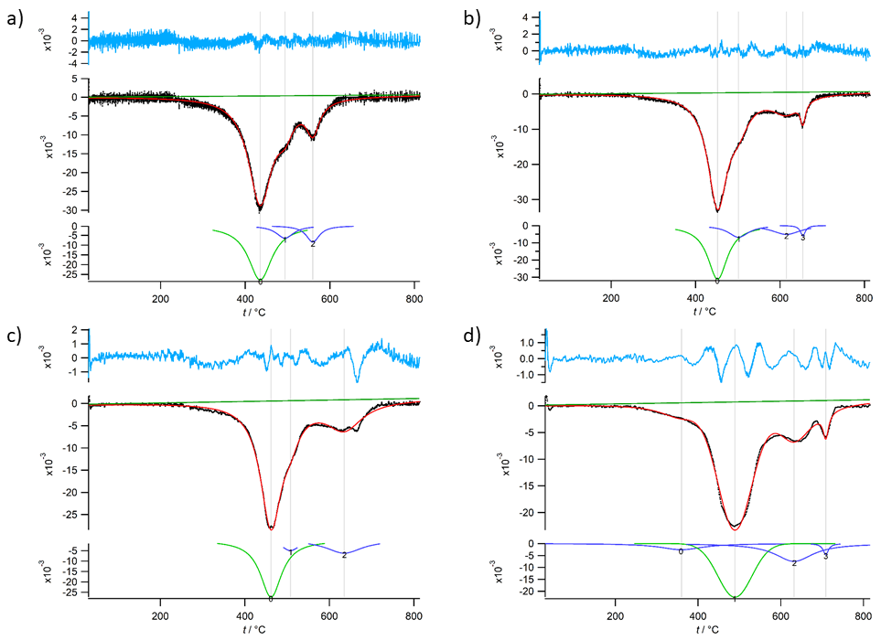

**Figure S22**. Data fitting of the TG first derivative of SOD-Zn(**Me**Im)2 at different heating rates (a) 5, (b) 10, (c) 15, and (d) 30 K min-1.

**Figure S23**. Data fitting of the TG first derivative of RHO-Zn(**Et**Im)2 at different heating rates (a) 5, (b) 10, (c) 15, and (d) 30 K min-1.

**Figure S24**. Data fitting of the TG first derivative of ANA-Zn(**Et**Im)2 at different heating rates (a) 5, (b) 10, (c) 15, and (d) 30 K min-1.

**Figure S25**. Data fitting of the TG first derivative of qtz-Zn(**Et**Im)2 at different heating rates (a) 5, (b) 10, (c) 15, and (d) 30 K min-1.

**Figure S26**. Data fitting of the TG first derivative of ANA-Zn(**Pr**Im)2 at different heating rates (a) 5, (b) 10, (c) 15, and (d) 30 K min-1.

**Figure S27**. Data fitting of the TG first derivative of ANA-Zn(**Bu**Im)2 at different heating rates (a) 5, (b) 10, (c) 15, and (d) 30 K min-1.

1. **Kinetics of ZIFs**
   1. **Kinetic calculations based on Tonset**

**Table S5:** Basic data of kinetics of of the studied ZIFs from TGA and DTG based on Tonset

|  |  |  |  |  |  |  |  |  |  |
| --- | --- | --- | --- | --- | --- | --- | --- | --- | --- |
|  | | | | **FWO** | | | **Kissinger** | | |
| **Material** | **β /**  **K min-1** | **Tonset /**  **K** | **1000/Tonset /**  **K-1** | **log β** | **R2 fitting** | ***E*a / kJ mol-1** | **ln (β/Tonset2)** | **R2 fitting** | ***E*a / kJ mol-1** |
| SOD-Zn(**Me**Im)2 | 5 | 657.363 | 1.521 | 0.699 | 0.92654 | 160.7(5) | -11.367 | 0.91689 | 157.8(2) |
| 10 | 679.608 | 1.471 | 1.000 | -10.740 |
| 15 | 686.976 | 1.456 | 1.176 | -10.357 |
| 30 | 694.942 | 1.439 | 1.477 | -9.686 |
| RHO-Zn(**Et**Im)2 | 5 | 651.971 | 1.534 | 0.699 | 0.98487 | 185.6(9) | -11.351 | 0.98314 | 184.1(6) |
| 10 | 666.943 | 1.499 | 1.000 | -10.703 |
| 15 | 675.506 | 1.480 | 1.176 | -10.323 |
| 30 | 685.342 | 1.459 | 1.477 | -9.659 |
| ANA-Zn(**Et**Im)2 | 5 | 673.159 | 1.486 | 0.699 | 0.99476 | 221.5(3) | -11.415 | 0.99426 | 221.5(3) |
| 10 | 686.016 | 1.458 | 1.000 | -10.759 |
| 15 | 692.945 | 1.443 | 1.176 | -10.374 |
| 30 | 703.252 | 1.422 | 1.477 | -9.710 |
| qtz-Zn(**Et**Im)2 | 5 | 685.147 | 1.460 | 0.699 | 0.96899 | 248.3(5) | -11.450 | 0.96623 | 249.5(6) |
| 10 | 698.846 | 1.431 | 1.000 | -10.796 |
| 15 | 704.959 | 1.419 | 1.176 | -10.408 |
| 30 | 712.125 | 1.404 | 1.477 | -9.735 |
| ANA-Zn(**Pr**Im)2 | 5 | 657.100 | 1.522 | 0.699 | 0.93454 | 197.6(8) | -11.366 | 0.92757 | 196.7(1) |
| 10 | 672.310 | 1.487 | 1.000 | -10.719 |
| 15 | 681.952 | 1.466 | 1.176 | -10.342 |
| 30 | 686.720 | 1.456 | 1.477 | -9.663 |
| ANA-Zn(**Bu**Im)2 | 5 | 642.535 | 1.556 | 0.699 | 0.99363 | 189.5(3) | -11.321 | 0.99412 | 188.3(6) |
| 10 | 656.337 | 1.524 | 1.000 | -10.671 |
| 15 | 661.213 | 1.512 | 1.176 | -10.280 |
| 30 | 675.329 | 1.481 | 1.477 | -9.629 |

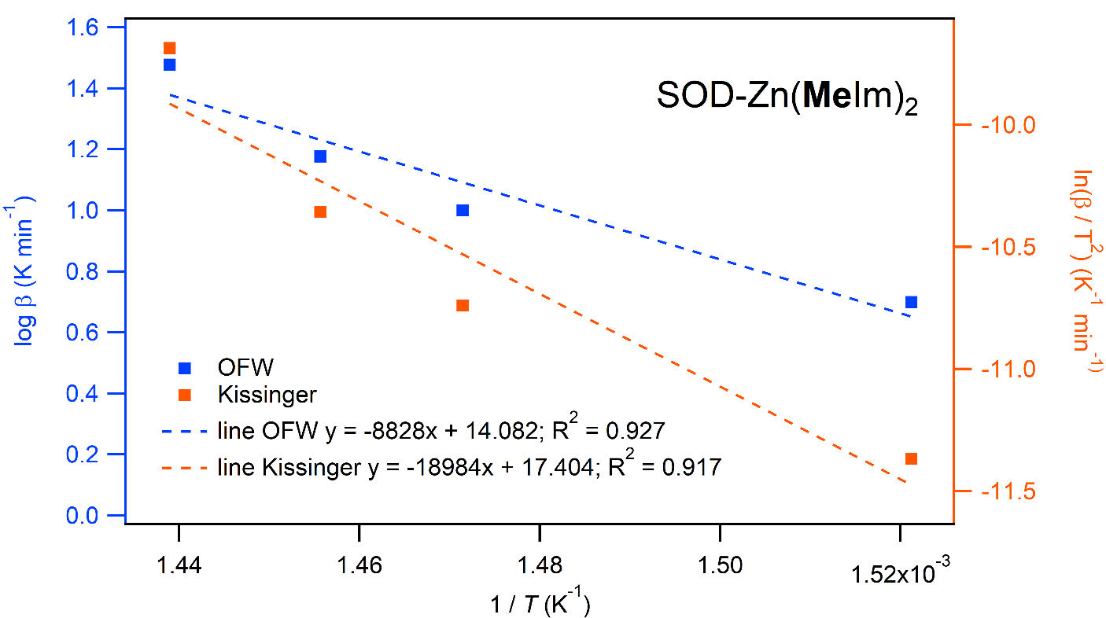

**Figure S28**. Kinetic plot based on Tonset using FWO and Kissinger methods for SOD-Zn(**Me**Im)2.

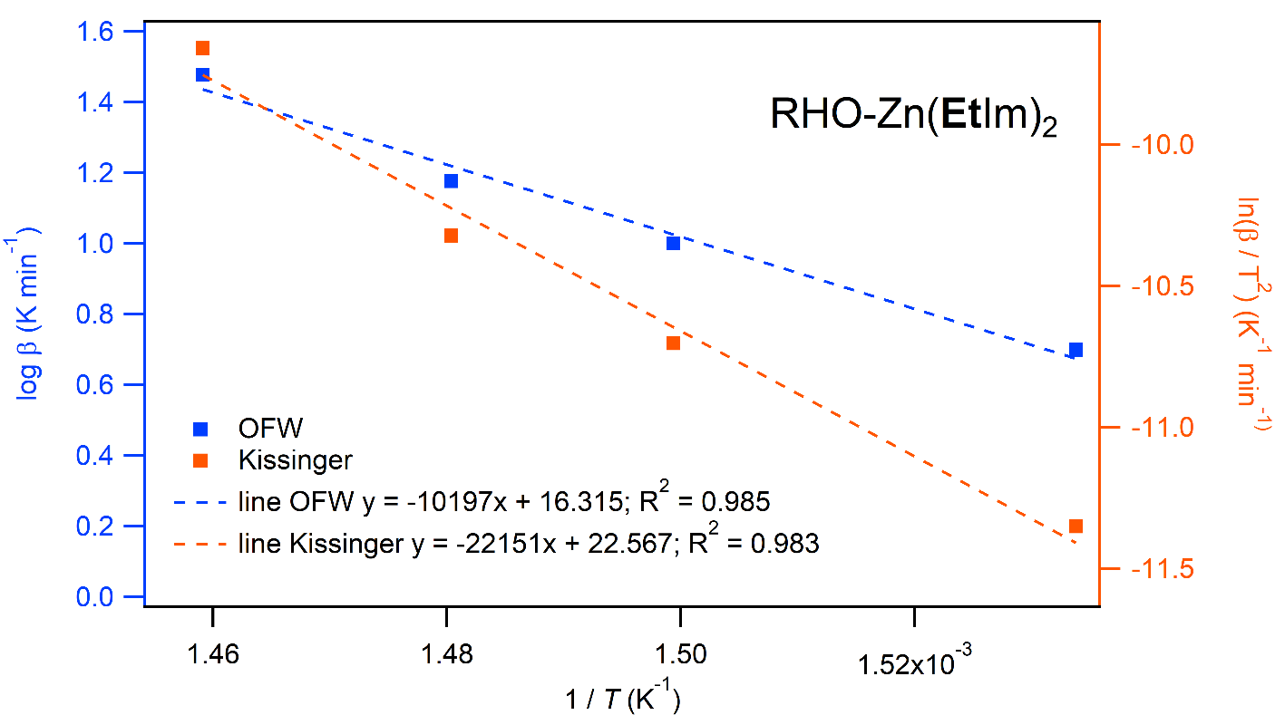

**Figure S29**. Kinetic plot based on Tonset using FWO and Kissinger methods for RHO-Zn(**Et**Im)2.

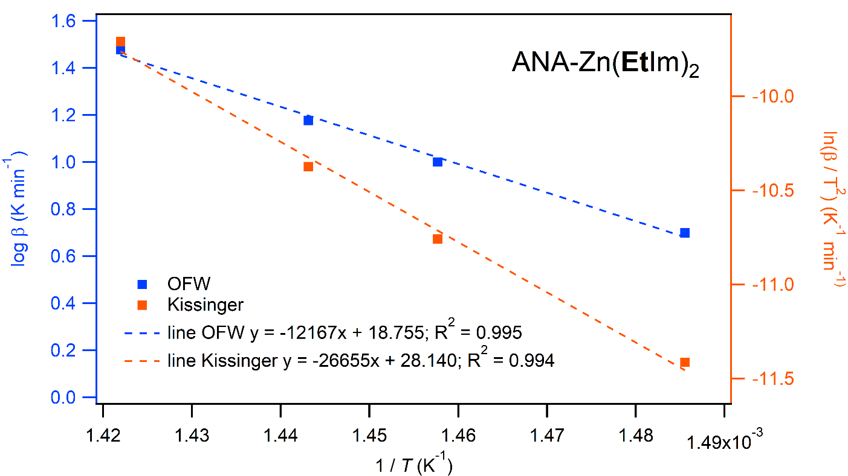

**Figure S30**. Kinetic plot based on Tonset using FWO and Kissinger methods for ANA-Zn(**Et**Im)2.

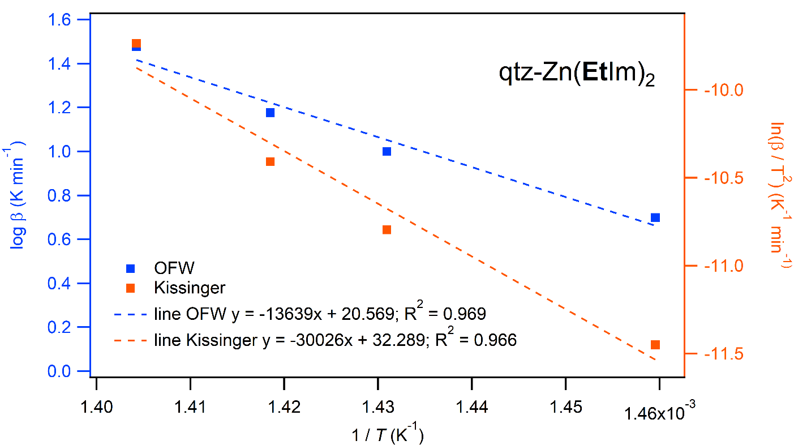

**Figure S31**. Kinetic plot based on Tonset using FWO and Kissinger methods for qtz-Zn(**Et**Im)2.

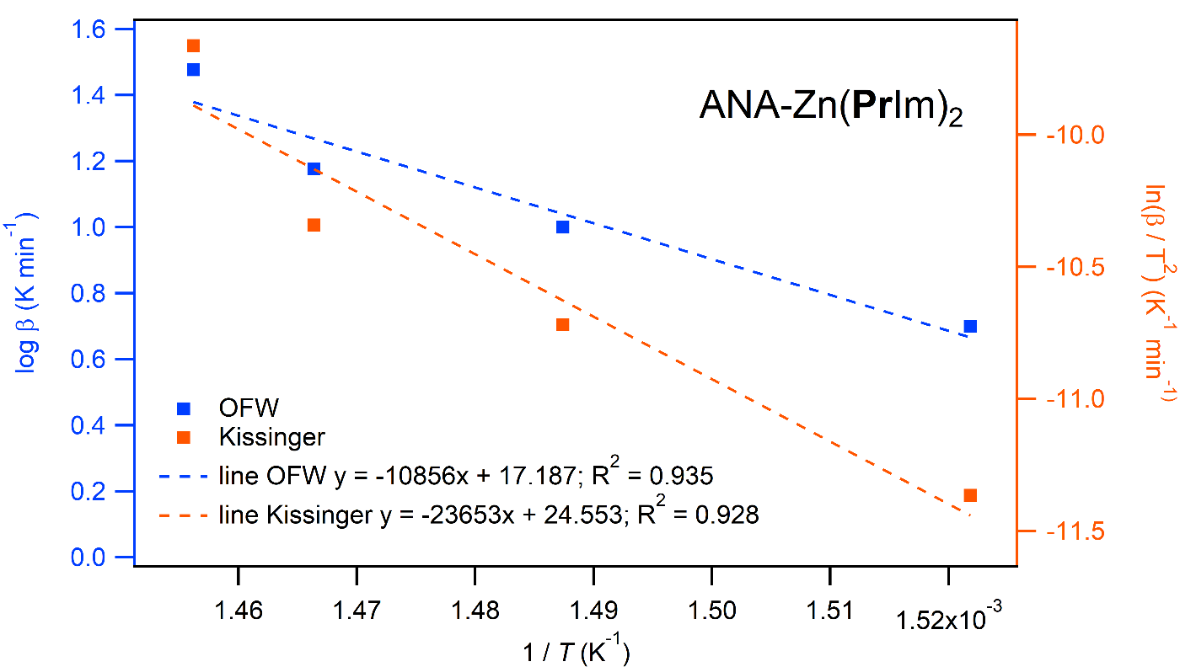

**Figure S32**. Kinetic plot based on Tonset using FWO and Kissinger methods for ANA-Zn(**Pr**Im)2.

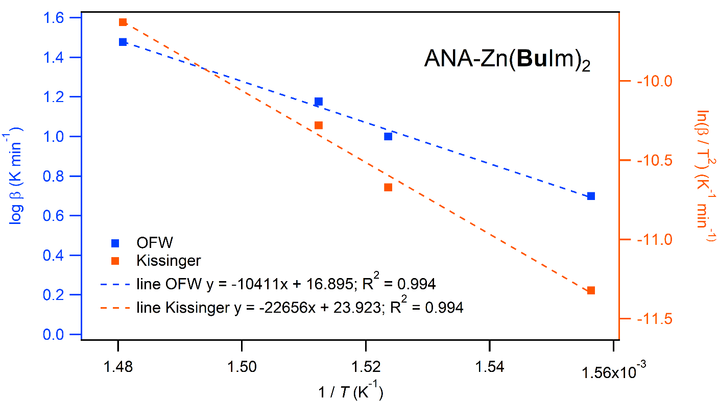

**Figure S31**. Kinetic plot based on Tonset using FWO and Kissinger methods for ANA-Zn(**Bu**Im)2.

* 1. **Kinetic calculations based on Tmid**

**Table S6:** Basic data of kinetics of of the studied ZIFs from TGA and DTG based on Tmid

|  |  |  |  |  |  |  |  |  |  |
| --- | --- | --- | --- | --- | --- | --- | --- | --- | --- |
|  | | | | **FWO** | | | **Kissinger** | | |
| **Material** | **β /**  **K min-1** | **Tmid /**  **K** | **1000/Tmid /**  **K-1** | **log β** | **R2 fitting** | ***E*a / kJ mol-1** | **ln (β/Tmid2)** | **R2 fitting** | ***E*a / kJ mol-1** |
| SOD-Zn(**Me**Im)2 | 5 | 705.939 | 1.417 | 0.699 | 0.99446 | 139.6(3) | -11.510 | 0.99643 | 134.6(5) |
| 10 | 725.027 | 1.379 | 1.000 | -10.870 |
| 15 | 734.750 | 1.361 | 1.176 | -10.491 |
| 30 | 760.652 | 1.315 | 1.477 | -9.867 |
| RHO-Zn(**Et**Im)2 | 5 | 676.096 | 1.479 | 0.699 | 0.99651 | 127.5(9) | -11.423 | 0.99321 | 122.4(7) |
| 10 | 696.936 | 1.435 | 1.000 | -10.791 |
| 15 | 706.456 | 1.416 | 1.176 | -10.413 |
| 30 | 731.461 | 1.367 | 1.477 | -9.789 |
| ANA-Zn(**Et**Im)2 | 5 | 697.884 | 1.433 | 0.699 | 0.99057 | 157.0(6) | -11.487 | 0.99723 | 153.1(9) |
| 10 | 715.282 | 1.398 | 1.000 | -10.843 |
| 15 | 728.463 | 1.373 | 1.176 | -10.474 |
| 30 | 743.861 | 1.344 | 1.477 | -9.823 |
| qtz-Zn(**Et**Im)2 | 5 | 714.399 | 1.400 | 0.699 | 0.99057 | 192.4(9) | -11.533 | 0.98934 | 190.2(4) |
| 10 | 730.362 | 1.369 | 1.000 | -10.885 |
| 15 | 741.155 | 1.349 | 1.176 | -10.508 |
| 30 | 753.204 | 1.328 | 1.477 | -9.847 |
| ANA-Zn(**Pr**Im)2 | 5 | 684.181 | 1.462 | 0.699 | 0.99274 | 174.8(0) | -11.447 | 0.99172 | 172.1(2) |
| 10 | 699.225 | 1.430 | 1.000 | -10.797 |
| 15 | 705.513 | 1.417 | 1.176 | -10.410 |
| 30 | 724.682 | 1.380 | 1.477 | -9.770 |
| ANA-Zn(**Bu**Im)2 | 5 | 668.369 | 1.496 | 0.699 | 0.99816 | 146.9(4) | -11.400 | 0.99818 | 143.0(3) |
| 10 | 683.836 | 1.462 | 1.000 | -10.753 |
| 15 | 694.566 | 1.440 | 1.176 | -10.379 |
| 30 | 714.221 | 1.400 | 1.477 | -9.741 |

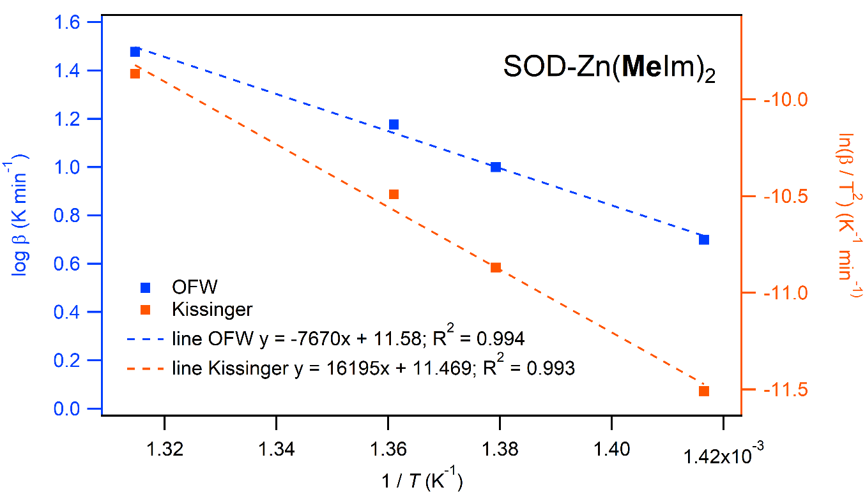

**Figure S32**. Kinetic plot based on Tmid using FWO and Kissinger methods for SOD-Zn(**Me**Im)2.

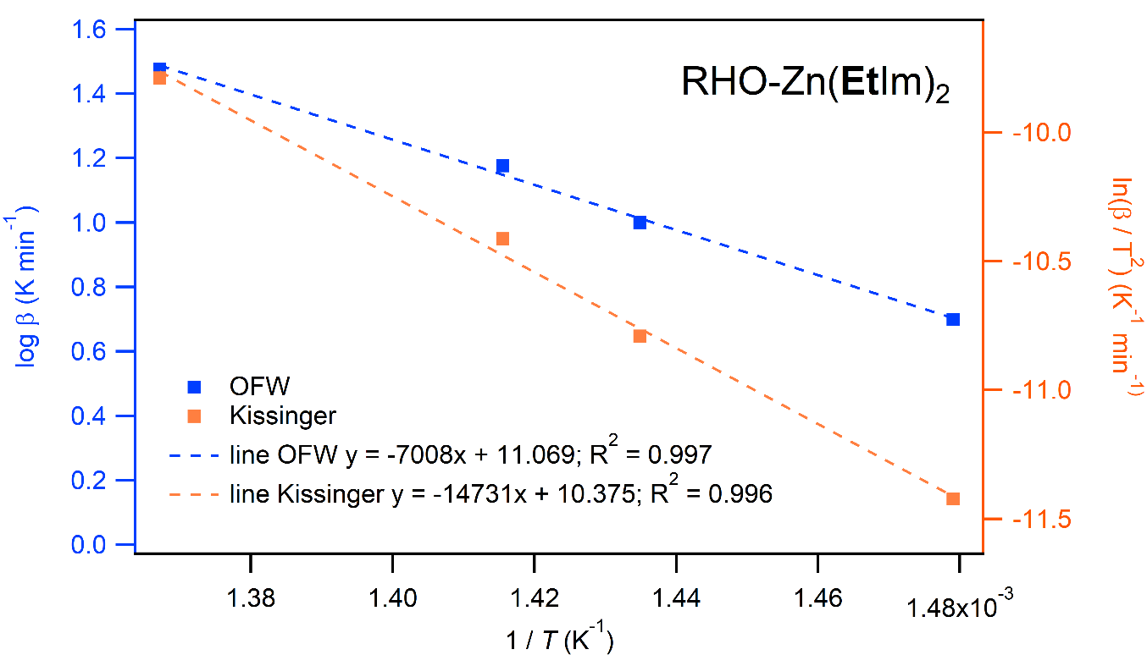

**Figure S33**. Kinetic plot based on Tmid using FWO and Kissinger methods for RHO-Zn(**Et**Im)2.

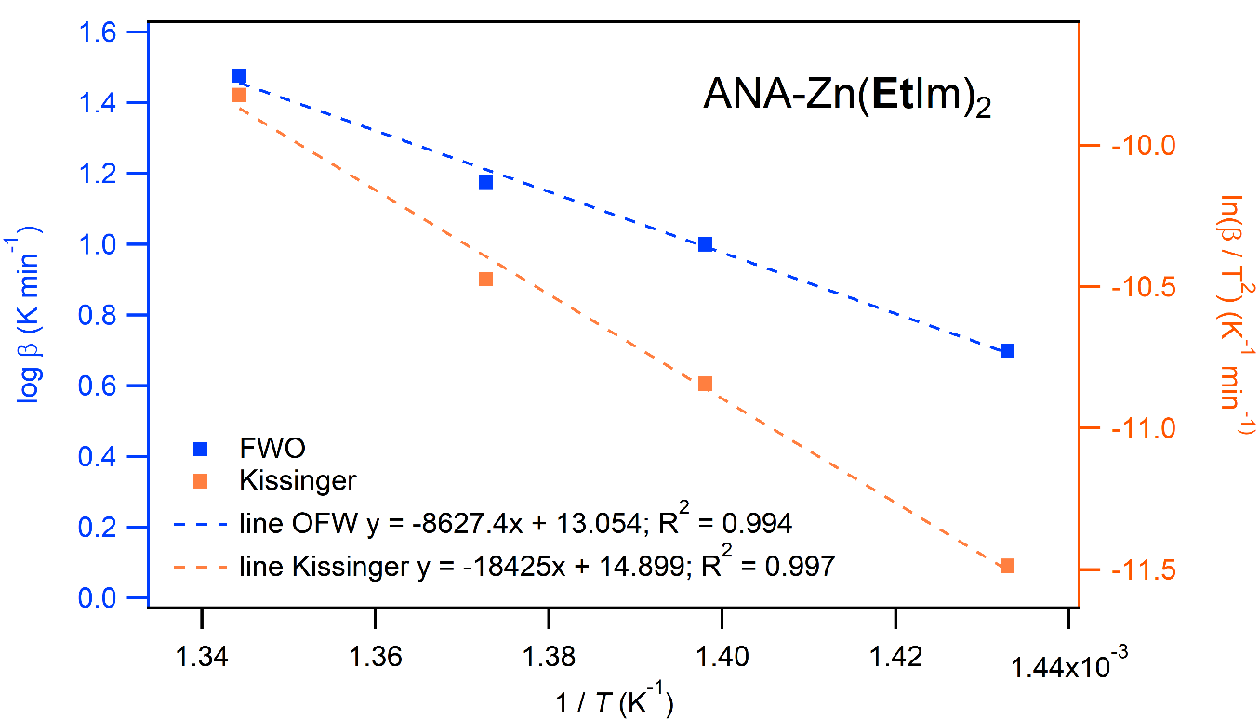

**Figure S34**. Kinetic plot based on Tmid using FWO and Kissinger methods for ANA-Zn(**Et**Im)2.

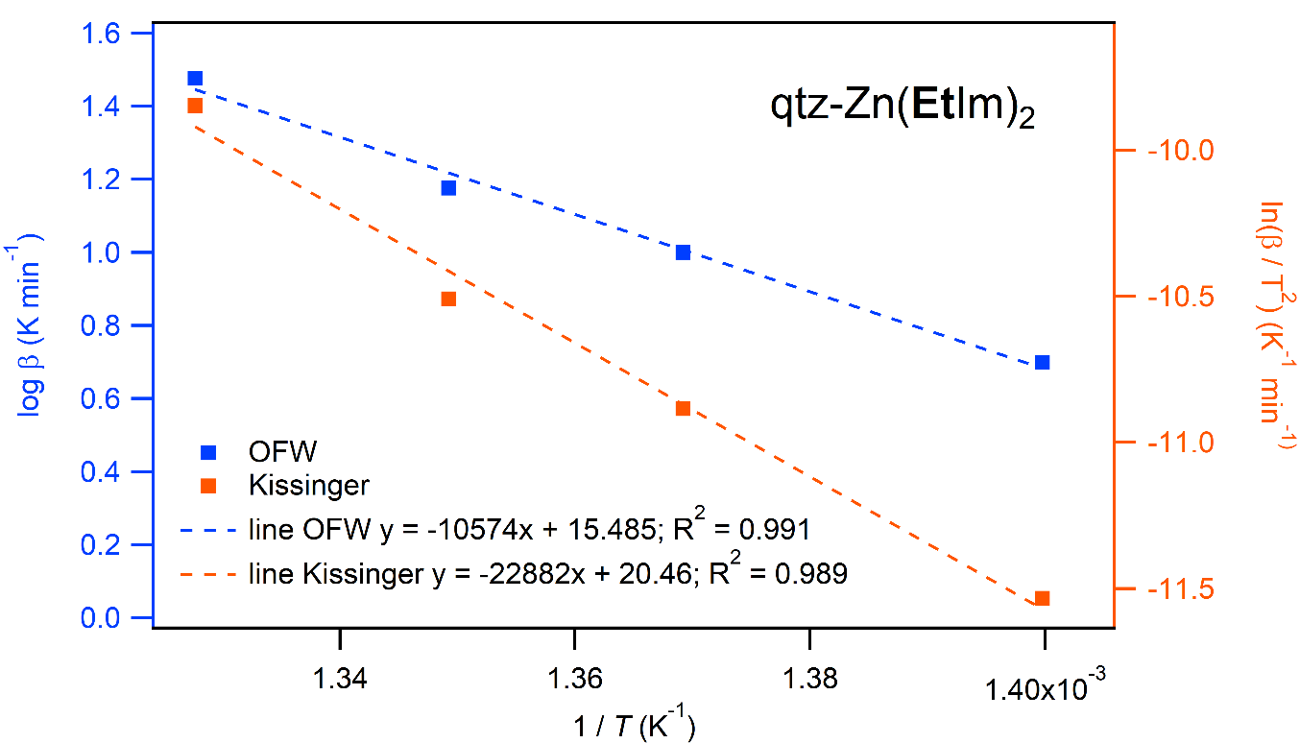

**Figure S35**. Kinetic plot based on Tmid using FWO and Kissinger methods for qtz-Zn(**Et**Im)2. Note that the values obtained by linear fitting excluding ** = 30 °C min-1 point.

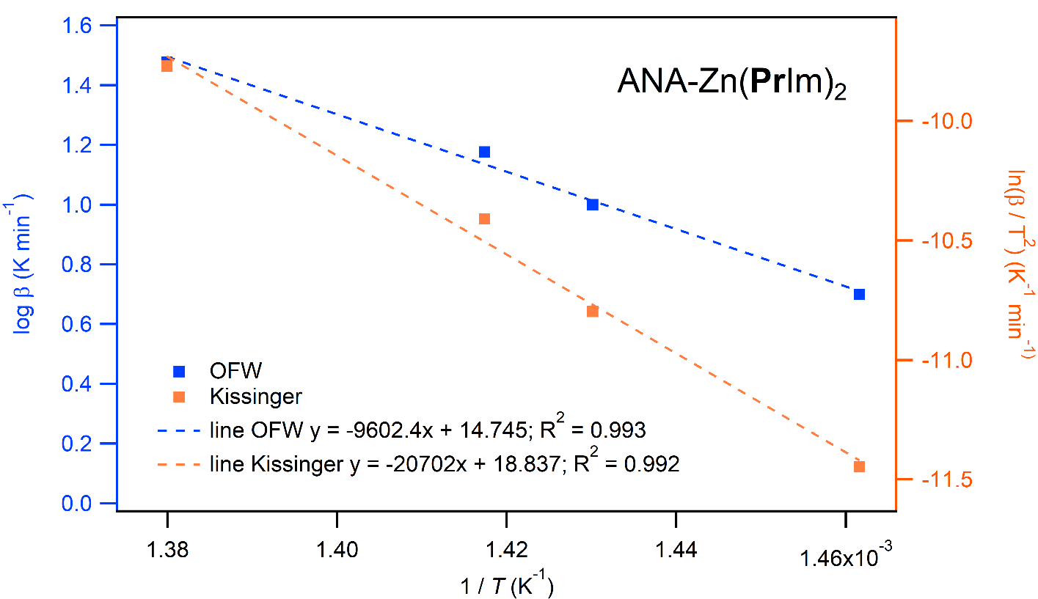

**Figure S36**. Kinetic plot based on Tmid using FWO and Kissinger methods for ANA-Zn(**Pr**Im)2.

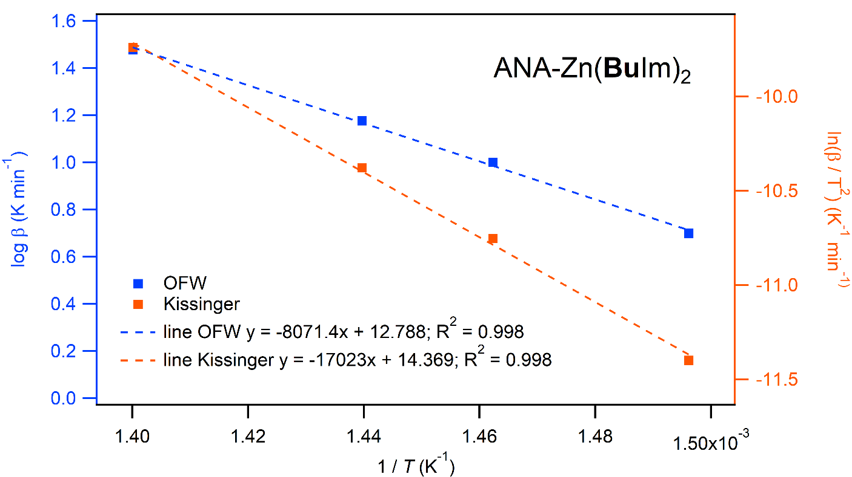

**Figure S37**. Kinetic plot based on Tmid using FWO and Kissinger methods for ANA-Zn(**Bu**Im)2. Note that the values obtained by linear fitting excluding ** = 5 °C min-1 point.

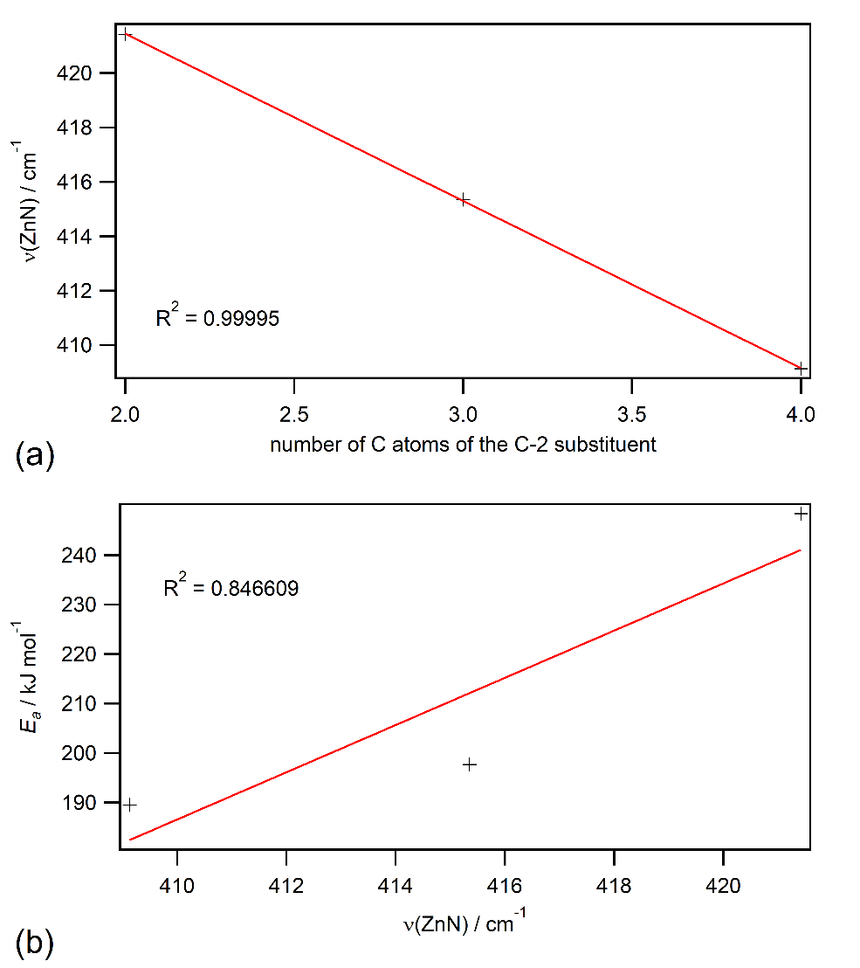

**Figure S38**. Dependence of Zn-N stretching band position with respect to (a) and C-2 alkyl chain substituent (expressed by number of C atoms in the chain) and (b) activation energy. Red line represents linear fit of the data.

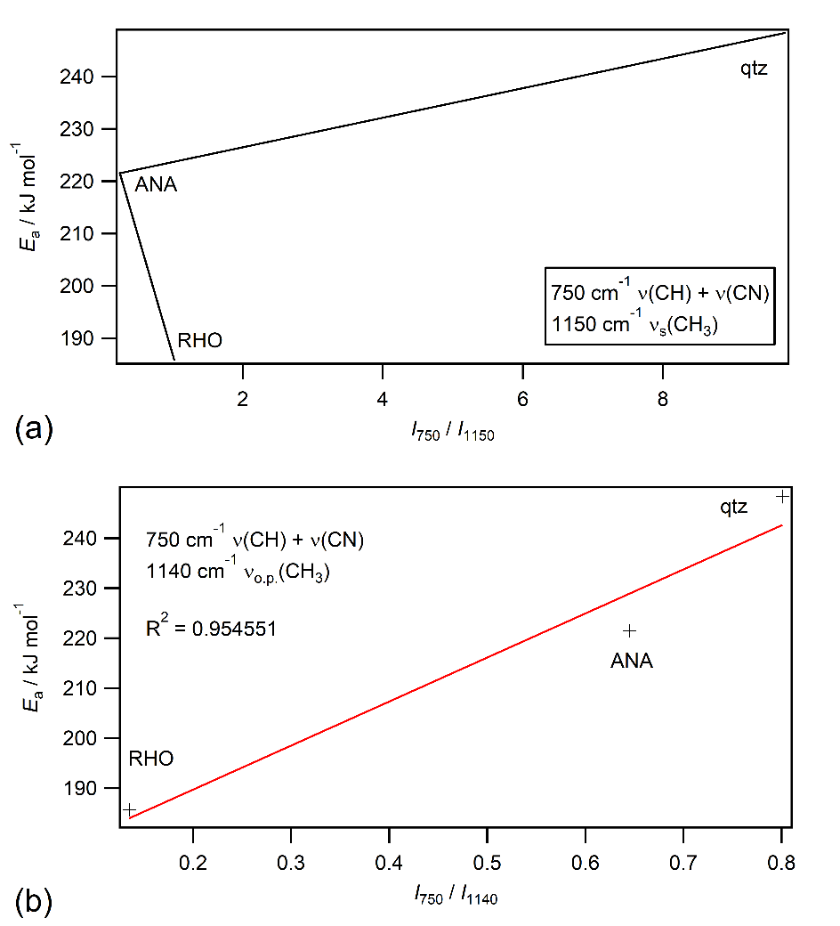

**Figure S39**. Ratio of intensity of the stretching band of imidazole C-N bridge and terminal CH3 group of the ethyl substituent of the various forms of Zn(**Et**Im)2.

1. **References**

1. H. M. Titi, M. Arhangelskis, A. D. Katsenis, C. Mottillo, G. Ayoub, J.-L. Do, A. M. Fidelli, R. D. Rogers, T. Friščić, *Chem. Mater.* 2019, **31,** 4882

2. C. Motillo, Y. Lu, M.H. Pham, M. J. Cliffe, T. O. Do, T. Friščić, *Green Chem.* 2015, **15**, 2121.

3. M. Arivazhagan, S. Manivel, S. Jeyavijayan, R. Meenakshi, *Spectrochim. Acta A.* 2015, **134**, 493.

4. R. Mulliken, *J. Chem. Phys.* 1955, **23**, 1997.

5. V. Martinez, B. Karadeniz, N. Biliškov, I. Lončarić, S. Muratović, D. Žilić, S. M. Avdshenko, M. Roslova, A. A. Popov, K. Užarević, *Chem. Mater.* 2020,**32**, 10628.

6. V. Mamleev, S. Bourbigot *Chem. Eng. Sci.* **60** (2005) 747-766

7. M. J. Starink, *Int. J. Hydrogen En.* **43** (2018) 6632-6641