Size-dependent distribution of metal(loid)s in recent marine sediments (Adriatic Sea)

Ivanić Maja¹*, Mikac Nevenka¹, Lučić, Mavro¹, Durn Goran², Sondi Ivan²

¹Ruđer Bošković Institute, Division for Marine and Environmental Research, Bijenička 54, 10000 Zagreb, Croatia
²Faculty of Mining, Geology and Petroleum Engineering, University of Zagreb, Pierottijeva 6, 10000 Zagreb, Croatia

*Corresponding author: Maja Ivanić, email: mivanic@irb.hr, Ruđer Bošković Institute, Bijenička c. 54, 10 000 Zagreb, Croatia

Abstract
This paper investigates occurrence of metal(loid)s, and size-dependent changes in their concentration in recent marine sediments from coastal and open-sea environments in the eastern Adriatic. Size fractionation of sediments was performed after removal of organic matter (OM), and the individual fractions, comprising particles below 8 μm, 4 μm, 2 μm, 1 μm and 0.45 μm, were analysed using HR ICP-MS. The concentrations of most elements increased with decreasing particle size, as a result of accumulation of clay minerals and Fe and Mn (oxyhydr)oxides. A decrease in concentrations was observed for Ba, Sr, Ti and U, due to lowering of the carbonate content and presence in the coarse-grained and heavy mineral fraction. The highest element concentrations were determined in the fraction comprising particles below 1 μm. Occasionally, depending on the sedimentological environment and/or the element in question, the peak concentrations occurred in the fractions <2 μm or <0.45 μm. The lowest size-dependent enrichment was observed for elements associated with aluminosilicates (Al, Be, Cs, Co, Fe, K, Li, Rb). A different size-dependent behaviour of the elements was observed between open-sea and coastal areas, mainly due to differences in sediment sorting, and between the northern and central vs. southern Adriatic due to the different catchment geologies. The Fe and Mn (oxyhydr)oxides, abundant in the open-sea sediments, played an important role in the geochemical cycle of As, Cd, Co, Mo, Sb and V.
Keywords: marine sediments, particle size, submicron particles, metals, organic matter, Adriatic Sea

- Introduction
The distribution and accumulation of trace metals in modern marine sediments is largely controlled by their complex relationship with mineral particles (Bradl, 2004; Ivanić et al., 2018; Sondi et al., 2017). Understanding the multiple processes that influence their interaction in complex natural environments is critical for assessing the transport, sequestration and fate of trace metals in aquatic systems.
The role of mineral particles in binding of trace metals depends on their surface reactivity, which is controlled by their size and mineralogical composition (Bertsch & Seaman 1999; Breiner et al., 2006, Hochella et al., 2008; Ivanić et al., 2020; Theng & Yuan, 2008), as well as surface coatings and impurities that may hinder or promote sorption (Ivanić et al., 2015; 2020). It has been known for some time that submicron particles, especially nanominerals, are the most reactive inorganic surfaces in the environment (Breiner et al., 2006; Plathe et al., 2013; Tang et al., 2009) and determine the transport, deposition and fate of organic and inorganic compounds (Christian et al., 2008; Plathe et al., 2013; Tang et al., 2009).
The role of submicron mineral particles in the transport, accumulation and binding of trace metals has been studied in suspended material in rivers, lakes and marine areas (Lead et al., 1999; Pokrovsky et al., 2012; Ran et al., 2000; Stolpe et al., 2010), different types of soils (Acosta et al., 2009; Citeau et al., 2006; Durn et al., 2021; Liu et al., 2003; Luo et al., 2011; Tang et al., 2009) and sediments (Palleiro et al., 2016; Plathe et al., 2013; Unda-Calvo et al., 2019), street dust (Fedotov et al., 2014) and modelled systems inspired by environmental conditions (Breiner et al., 2006). Besides the medium (water, air, soil/sediment), these studies also differ in the method of particle collection (centrifugation, filtration, settling), the pre-treatment of the samples (chemical and physical methods), the parameters investigated, and most importantly, the defined size range of the fine fraction. While it is well known that the finest particles are crucial for the transport and binding of trace metals (Christian et al., 2008; Plathe et al., 2013), when it comes to operational limits, the term "fine fraction" is arbitrarily used for a very wide size range.
Understanding the multiple processes affecting the colloid-associated transport of elements requires different approaches, studies on modelled systems and on samples from the environment. The present study is based on the latter, relying heavily on the separation of particles in the desired size range and focusing on sediments from distinct sedimentological environments along the eastern Adriatic coast. When studying the input of particles and pollutants into the marine environment, the coastal environments, especially transitional fluvio-marine environments, are of particular interest. Here, a significant proportion of particles are deposited in the sediment, making these environments particularly vulnerable to pollution (Fiket et al., 2019). However, most of the clayey material that reaches the coastal zone is transported further by currents and deposited in low-energy open-sea environments, where the finest particles eventually settle.
Most studies on the distribution of metals in the sediments of the Adriatic Sea are site- and region-specific and concern only certain groups of elements. The most comprehensive studies on element concentrations, covering the entire Adriatic area, are those by Paul and Meschner (1976) and Dolenec et al. (1998). The results of the latter defined the main factors governing the distribution of metals in the Adriatic: the catchment geology, the distribution of sediments, the hydrodynamic circulation of the waters in the Adriatic and the anthropogenic influence through river discharges and near-shore sources. The importance of fine particles containing metal (oxyhydr)oxides as one of the key factors for metal distribution in the Adriatic Sea was exemplified by De Lazzari et al. (2004). However, size-dependent changes in concentrations of elements, crucial for understanding the behaviour and cycling of elements in the aquatic environment, have not been studied in Adriatic sediments.
With this in mind, this study focused on the partition of metals in different size ranges (<8 μm, <4 μm, <2 μm, <1 μm and <0.45 μm), in sediments from coastal and open-sea environments of the northern, central and southern Adriatic Sea. The separation of sediment particles according to their size enabled the study of the size-dependent composition of major and trace elements, the comparison of the corresponding fractions of sediments of different mineral composition and the determination of the specific size range that provides the most relevant geochemical information. The influence of organic and inorganic coatings (Fe and Mn (oxyhydr)oxides) on element concentrations in sediments was also investigated. The results of this study broaden the knowledge on the interactions of solids and trace elements in aquatic environments in relation to (i) different sedimentological regimes, (ii) mineral composition and (iii) particle size.

- Materials and Methods
  - Study area and sampling
The investigated locations, distributed along the eastern part of the Adriatic Sea, are shown in Figure 1. They include areas under the strong influence of the Po (S1), Neretva (S5) and Drin (S8) rivers, the central (S3) and outer parts (S4) of the Jabuka Pit, e.g. the Mid-Adriatic deep (MAD), and Risan Bay in the Bay of Kotor (S7). They can be divided into areas under greater coastal influence (S1, S5, S7) and open-sea locations (S3, S4, S8) in the central (S3, S4, S5) and southern (S7, S8) Adriatic. For a detailed description of the investigated sedimentological environments and sampling see Ivanić et al. (2020).
Figure 1.
  - Methods
The investigated samples at each location consist of: (i) the native sediment (bulk/native), (ii) the sediment after removal of organic matter (OM) (bulk/OM removed), (iii) the separated sediment fractions collected from sediment after OM removal. The native sediments comprise freeze-dried (FreeZone 2.5, Labconco, USA) surficial (0-5 cm) sediment samples. The OM was removed from the native sediments with sodium hypochlorite according to the slightly modified treatment proposed by Kaiser and Guggenberger (2003) (Ivanić et al., 2020). Samples of the bulk sediment after OM removal were collected from aqueous dispersions prior to the size fractionation. Fractions (<8 μm, <4 μm, <2 μm, <1 μm and <0.45 μm) were collected from aqueous dispersions after OM removal by gravitational settling, verified by laser diffraction (LS 13320 Beckman Coulter, USA) and freeze-dried. The preliminary investigation involved the collection of fractions from several native sediments. It was found that the presence of OM prevented efficient separation of particles by size. The major limitation of this approach was the inability to collect particles finer than 0.45 μm, regardless of settling time. This was undoubtedly the result of their presence in macro- and micro-aggregates, as it has been shown that OM has an affinity for the finest mineral particles (Kahle et al., 2003; Mikutta et al., 2005). The further approach therefore focused on the fractions collected from the sediment samples after OM has been removed (bulk/OM removed). Fe and Mn (oxyhydr)oxides were removed from the fractions containing particles <2 μm of the selected samples (S3, S8) using the dithionite-citrate-bicarbonate (DCB) method of Mehra and Jackson (1960), modified after Durn (1996). For details on the sediment treatments, see Ivanić et al. (2020).
The concentration of trace elements was determined by high-resolution inductively coupled plasma mass spectrometry (HR ICPMS; Element 2, Thermo, Germany). Prior to analysis, sediment subsamples (~0.05 g) were digested in a microwave oven (Multiwave 3000, Anton Paar, Austria) using a two-step total digestion procedure (I: 4 mL HNO₃ + 1 mL HCl + 1 mL HF; II: 6 mL 40 g L⁻¹ H₃BO₃). After digestion, the samples were diluted with Milli-Q water to achieve the optimal concentrations for the ICP-MS measurements. Quality control was performed by simultaneous measurements of blank samples and the certified reference materials (CRM) for marine sediment (MESS -3, NRC, Canada), soil (NCS DC 77302, also known as GBW 07410, China National Analysis Centre for Iron and Steel, Beijing, China) and oﬀshore marine sediment (NCS DC 75301, also known as GBW 07314, China National Analysis Centre for Iron and Steel, Beijing, China), for which satisfactory results were obtained. Details of the method are described in Fiket et al. (2017).
To gain a better insight into the data structure and to define the main processes controlling the elemental distributions at the sampling locations, a partial least squares discriminant analysis (PLS-DA) was performed. Prior to PLS-DA, the data matrix was standardised as the element concentrations were of different orders of magnitude (Makvandi et al., 2016). PLS-DA is a supervised algorithm that combines feature extraction and discriminant analysis in one algorithm and is well suited for high-dimensional data, i.e. when there are more variables than samples within groups. PLS-DA was performed using the R package 'mixOmics' in the R platform (R Core Team, 2017).
- Results and Discussion
  - Geochemical characterisation of native sediments
The concentrations of the elements in the native sediments are listed in Table 1 and the correlations between elements and associated sedimentological and surface physicochemical properties (data from Ivanić et al., 2020) in native sediments are in the Supplementary (Table S1).
Table 1.
The determined concentrations generally agree with those of Dolenec et al. (1998). Higher concentrations of Al and K were found in sediments from the central Adriatic open-sea area (S3) and the southern Adriatic (S7, S8). This is due to the deposition of the very fine-grained phyllosilicate material at these locations (Ivanić et al., 2020). Indeed, these sediments showed the lowest particle mean size (Mz), an abundance of smectites (S3, S8) and, accordingly, the highest specific surface area (SSA) and cation exchange capacity (CEC) (Ivanić et al., 2020). Similar content of Fe and a significant positive correlation (Table S1) between Fe and Al (r = 0.89, p < 0.05) and K (r = 0.94, p < 0.05) show a close association of clayey particles and Fe (oxyhydr)oxides, which is in agreement with the results of Dolenec et al. (1998). The sediment at station S4, in the open-sea of the central Adriatic (Fig.1), had the same proportion of clay, silt and sand as the sediment at station S3 (Ivanić et al., 2020). However, the concentrations of Al, K and Fe determined at station S4 were closer to those found at stations under greater coastal influence (S1, S5). This is also true for the determined SSA and CEC values at station S4, which showed a greater similarity with those determined at station S5 than at station S3. This could be due to the higher content of carbonates in the sediment at station S4 (37%) compared to station S3 (28%) (Ivanić et al., 2020).
The lowest concentration of Mn was found at the stations under coastal influence in the northern (S1) and central (S5) Adriatic (Table 1). Significantly higher Mn concentrations were found in the deep-sea environments (S4, S8) (Table 1), where low sedimentation rates and limited input of sedimentary material leading to oxic conditions at the sediment surface favour the recycling and precipitation of Mn as (oxyhydr)oxides (Koschinsky & Hein, 2003). Up to three times higher Mn concentrations (3757 mg kg⁻¹) were found in the open-sea station S3. This shallow depression in the central Adriatic, e.g. the Mid-Adriatic deep (MAD), has already been identified as the site of significant enrichment of Mn in the surface sediments (Dolenec, 2003a,b; DeLazzari et al., 2004), where it precipitates in the form of todorokite, an Mg-rich 10 Å manganate phase that appears as crusts on biogenic detritus (Dolenec, 2003a,b). Todorokite is an Fe-poor manganese oxide which, together with vernadite, is the main mineral in ferromanganese nodules and often contains high levels of Cu, Ni and Co (Li & Schoonmaker, 2005), which is consistent with the results obtained (Table 1). Due to the important role of Fe and Mn (oxyhydr)oxides in the sequestration of trace metals, station S3 was also characterised by higher concentrations of trace metals associated with them (Co, Mo, Sb, V; Table 1). The distribution of Mo showed statistically significant positive correlation with Mn (r = 0.83, p < 0.05, Table S1). In oxygen-rich environments, Mo is usually present as molybdate ions, Mo(VI)O₄²⁻, associated with Mn (oxyhydr)oxides (Helz et al., 1996; Scott & Lyons, 2012).
Contrary to Mn, the concentrations of U were lowest in the open-sea environments (S3, S4, S8), resulting in a significant negative correlation between U and Mn (r = -0.83, p < 0.05, Table S1). The highest concentrations of U at locations under significant coastal influence (S5, S7) could be related to its association with OM, which was more abundant at these stations (Ivanić et al., 2020). A significant positive correlation between U and TOC was not found (Table S1) which could be related to the different characteristics of OM (marine vs. terrigenous) in coastal and open-sea areas. The significant positive correlation between U and Pb (r = 0.94, p < 0.05, Table S1) suggests a similar mechanism controlling the transport of the two elements. Jurina et al. (2015) demonstrated the crucial role of OM in the distribution of Pb in the sediments of the Neretva Channel (S5), suggesting that OM may play an important role in the transport of both U and Pb. It is evident that the coastal influence is crucial for the distribution of Pb and U in the investigated sediments, which together with OM may be influenced by their higher content in felsic minerals (Cumberland et al., 2016) that enter these sediments through continental runoff.
The highest concentrations of Cs, Li and Tl were determined in enclosed coastal areas (S5, S7) characterised by the deposition of flysch (Jurina et al., 2015; Mikac et al., 2022). Their grouping in the investigated sediments is supported by the observed statistically significant positive correlation, (r = 0.94, between Tl and Li, and 0.89 between Tl and Cs, p < 0.05, Table S1). These elements are commonly found in the structure of mica, feldspar and clay minerals, all of which occur in the environments studied (Ivanić et al., 2020).
The highest content of Ti found in the sediments of the southern Adriatic agree with the results of Dolenec et al. (1998) and Ilijanić et al. (2014). In coastal sediments, Ti is often used as an indicator of detrital components (Wang et al., 2023), and is common in high specific gravity minerals, e.g. heavy minerals (Reimann & de Caritat, 2005). The significant positive correlation between Ti and Al and Li (r = 0.89, for Li and 0.83 for Al, p < 0.05, Table S1) in the native sediments indicates its association with clays and detrital aluminosilicates.
Higher Ba concentrations were found in the open-sea areas (204-210 mg kg⁻¹ at stations S1, S3, S4) than in the enclosed coastal environments (181-185 mg kg⁻¹ at stations S5 and S7). This could be related to its affinity for Fe and Mn (oxyhydr)oxides or to intense biological productivity in the open-sea environments, as Ba is often associated with sinking OM and biogenic detritus (Carter et al., 2020). The main mineral hosts of Ba in marine sediments are detrital plagioclase and authigenic barite (Tribovillard et al., 2006). While Ba readily substitutes K in aluminosilicates (Dolenec et al., 1998), the lack of correlation between Ba and K and with other elements characteristic of aluminosilicates contradicts this assumption. The highest Ba concentrations (237 mg kg⁻¹) were found in the Albanian coastal region (S8) where it is probably supplied by the rivers draining mafic and ultramafic rocks in the hinterland.
The higher Sr content in the sediments at stations S1, S3 and S4, e.g. >400 mg kg⁻¹, is due to increased deposition of biogenic detritus (plankton debris), compared to its lower content, e.g. <300 mg kg⁻¹, in the deltaic environment with predominantly detrital carbonate deposition (S5) and the carbonate-poor environments of the southern Adriatic (S7, S8) (Ivanić et al., 2020; Jurina et al., 2015). Even though the carbonate content at station S5 is similar to that at stations S1-S4 (Ivanić et al., 2020), it is evident from the content of Sr and other elements, as discussed later, that the coastal influence, the geology of the catchment area and confinement of the location resulted in a geochemical composition more similar to that of the sediments of the southern Adriatic.
A distinct geochemical signature, with the highest concentrations of metals (As, Bi, Co, Cr, Fe, Ni, Pb, Ti, V, Zn) was characteristic for the sediments of the southern Adriatic (S7, S8), especially for the open-sea (S8) off the Albanian coast (Table 1). Here, the coastal sediments are strongly influenced by the Drim river input (Rivaro et al., 2004). These sediments are characterised by a low share of carbonates (<15%) and an abundance of phyllosilicates (smectites, illite, mixed-layer clay minerals (MLCM) and chlorite) (Ivanić et al., 2020). According to Dolenec et al. (1998), weathering of mafic and ultramafic rocks in the hinterland, as well as mining and industrial activities, are the main sources of the high content of most metals, while Amorosi et al. (2022) found that the majority of Cr and Ni in the Albanian coastal area is of geogenic origin. The maximum concentrations of Zn in sediment at station S7 could be partly related to the weathering of flysch deposits in the surrounding area, but also to the increased anthropogenic pressures in the coastal area of Boka Kotorska Bay (Jokanović et al., 2021; Mikac et al., 2022).
The highest Cd concentration was found at the open-sea station S4 (0.32 mg kg⁻¹). A statistically significant positive correlation between Cd and clay content (r = 0.83, p<0.05, Table S1) indicates its occurrence in the finest particulate material. The two main pathways for the sequestration of Cd in sediments are binding to organic material and precipitation of sulphides (Bryan et al., 2021). However, its distribution could also be under anthropogenic influence.
    - The influence of OM removal on the geochemical composition of bulk sediments
The concentrations of elements in the bulk sediments after the removal of OM are shown in Table 1. For most elements a slight increase in concentration (10-30%) was observed, for some elements (Mg, K, Cr, Rb, Ti) the concentrations did not change, while several elements (As, Mn, Mo, Sr, U) showed a slight decrease (10-20%) after the OM removal. The slight increase in the content of most elements is probably due to the observed changes in the granulometric properties of the samples after removal of OM. Namely, the content of clay increased by ~10% in all samples after OM removal (Ivanić et al., 2020), except at station S1 where the increase was more significant, e.g. from 9 to 27%, due to the very coarse grain size of the native sediment (silty sand). The bulk sediments after the removal of OM were collected from a suspension that was probably more biased towards finer particles due to the faster settling of larger particles. This assumption is supported by the fact that the highest increase was observed for major constituents of the aluminosilicate mineral phases (Al, Fe) and the associated trace elements (Table 1).
Elements whose concentration decreased slightly after removal of OM (As, Mn, Mo, Sr and U) are bound to a lesser extent to the clay fraction (aluminosilicates), and are more strongly associated with OM, oxides or carbonates (Beck et al., 2008; Koschinsky & Hein, 2003; Neaman et al., 2008; Scott & Lyons, 2012). However, the fact that only a small proportion (10 - 20%) of these metals were removed with the OM suggests that they are mainly associated with other sediment phases, although their association with the part of OM that is resistant to chemical degradation cannot be neglected.
Only two metals at two locations showed significantly lower levels after removal of OM: Mo at station S1 (59% lower) and Cd at station S4 (46 % lower). The amount of Mo and Cd removed is similar to the amount of OM removed at these stations (64% at S1 and 50% at S4). Their higher removal in these two samples could be due to their presence in a different chemical form more prone to dissolution during the OM removal, or a particular association of the metal with OM.
In general, the results obtained show that the efficient but variable (S1-64%; S3-82%; S4-53%, S5-82%, S7-80%, S8-54%, Ivanić et al., 2020) removal of OM from the sediments was not reflected in the differences in element concentrations at these locations, except for Cd and Mo at two locations, as described above.
  - Influence of Fe and Mn (oxyhydr)oxides on elemental concentrations
Fe and Mn (oxyhydr)oxides were removed from the <2 μm fraction of the two sediments with the highest Fe and Mn content, the open-sea stations S3 and S8. Concentrations of most elements did not change following the DCB treatment, so Table 2 shows the results for the metals whose concentrations were affected by the removal of Fe and Mn (oxyhydr)oxides.
Table 2.
The DCB treatment removed only a small amount of Fe (15% at S3 and 16% at S8) and most of Mn (82% at S3 and 74% at S8) and resulted in almost complete removal of Mo (93% at S3 and 79% at S8). Lower concentrations of As (58% at S3 and 62% at S8), Co (31% at S3 and 19% at S8), Sb (41% at S3 and 35% at S8), V (14% at both stations) and Cd (8% at S3 and 20% at S8) were found after the DCB treatment (Table 2). The obtained results indicate that only a small proportion of the Fe is in the form of (oxyhydr)oxides and that it is mainly incorporated into the mineral structure, which is consistent with previous observations (Davison & De Vitre, 1992). In contrast, most of the Mn in the investigated sediments is in the form of (oxyhydr)oxides. Its strong positive correlation with SSA (r = 0.94, p<0.05; Table S1) suggests that it occurs mainly in the form of nanosized (oxyhydr)oxides (Coppola et al., 2007).
The significant decrease in Mo content is consistent with previous results showing that the cycling of Mo under oxic conditions is controlled by Mn (oxyhydr)oxides (Helz et al., 1996; Scott & Lyons, 2012). The observed decrease in concentrations of other trace elements clearly show that they are associated to varying degrees with (oxyhydr)oxides, which is consistent with numerous findings in the literature for As (Neaman et al., 2008; Shi et al., 2021), Co (Lienemann et al., 1997; Neaman et al., 2004), Sb, V and Cd (Bolan et al., 2022; Dong et al., 2000; Koschinsky & Hein, 2003; Shi et al., 2021).
  - Size-dependent distribution of elements
To facilitate interpretation of the changes in element concentrations with particle size, Table 3 shows the granulometric parameters of the collected fractions. As it can be observed, all fractions generally contain much finer particles than the indicated fraction maximum (Table 3). The particle sizes show a successive decrease, but the differences between the fractions are not always prominent, especially in the fractions <4 µm and <2 µm which also showed minor differences in the surface physicochemical properties (SSA and CEC) (Ivanić et al., 2020). Exceptions were the fraction <2 µm at station S1 and the fraction <4 µm at station S8, where the concentration of most elements decreased compared to the coarser and finer fractions, showing a rather sharp separation of mineral phases between successive fractions. Thus, when interpreting and discussing metals concentrations in the analysed size fractions one should have in mind the span of real particles size in these fractions.
Table 3.
The concentrations of the elements in the different fractions are given in Table 1. Figure 2 shows the ratios between the concentrations of elements in a particular fraction compared to the bulk (OM removed) sediment.
Figure 2.
The concentrations of most elements increased with lowering of the particle size, with the exception of Ba, Mg, Sr, Ti and U. The observed variations in the content of elements are due to their different behaviour depending on the main component contributing to their occurrence, e.g. detrital, biogenic and authigenic components, and the main mineral host. The greatest increase was generally observed in the finest fractions (<1 μm and <0.45 μm), where concentrations of many elements were 2-3 times higher compared to their bulk concentration. This highlights the affinity of metals for colloidal particles, especially nanoparticles (Hochella et al., 2008; Plathe et al., 2013), and shows the importance of mineral particles with large surface reactivity in the transport and geochemical cycling of trace metals. The size-related increase in the content of most metals is consistent with the previously observed increase in SSA and CEC with particle size lowering, resulting from the decrease in carbonate content and the accumulation of clay minerals (smectites in particular) and associated Fe and Mn (oxyhydr)oxides (Ivanić et al., 2020).
Figure 2a shows the concentration ratios between the fractions and the bulk samples for elements (Ba, Mg, Sr, Ti, U) whose concentrations generally decrease with decreasing particle size. A particularly significant decrease in concentration was observed for Sr, which can be attributed to the decrease in carbonate content in these samples (Ivanić et al., 2020). Indeed, terrigenous and biogenic carbonates, the most common source of sedimentary carbonates, are usually found in coarser fractions (Buffle et al., 1998; Wilkinson & Reinhardt, 2005), unless intensive authigenic formation produces a significant proportion of nanoscale carbonate minerals (Ivanić et al., 2020; Sondi & Juračić, 2010).
Similar distributions of Ba, U and Ti with decreasing particle size (Fig. 2a) indicate that their distribution in the environment is controlled by heavy mineral assemblage and/or coarse mineral grains. In almost all environments studied, the content of U and Ba initially increases or remains unchanged and then decreases. Plagioclase, a potential mineral host of Ba and U, was found in coarser fractions in the investigated environments, but was absent in the submicron fraction (Ivanić et al., 2020). This could explain the observed decrease, since at station S8 no plagioclase was detected, and the Ba content strongly decreased (Fig. 2a). Similarly, carbonates as a potential mineral host of Ba and U are also constrained to coarser fractions, and could contribute to their observed decrease with particle size. The decrease of Ti with decreasing particle size suggests that it is mainly associated with coarse grain size and the heavy minerals that cannot be easily transported (Reimann & de Caritat, 2005). The results obtain show that Ti correlates significantly with Al (Fig. 3a) in the bulk sediments, both native (r=0.83, p<0.05) and after removal of OM (r=0.89, p<0.05). However, this correlation was limited to the bulk samples and not present in fractions, as there is a clear separation between the two elements with decreasing particle size due to the size-related separation of aluminosilicates (finest fractions) and heavy minerals (coarse fractions). Nonetheless, statistically significant correlation between Al and Ti in the finest fraction <0.45 μm (r = 0.76, p < 0.05; Fig. 3b) probably relates to the Ti present in the aluminosilicate mineral phases.
Figure 3.
The size-dependent behaviour of Mg varied between the environments studied, decreasing at stations S1, S3, S4 and S5, increasing at station S8 and showing mostly unchanged content at station S7. This indicates diverse and variable sources of Mg in these sediments and different processes controlling its accumulation at specific location. The highest Mg concentrations were found off the Albanian coast (S8), where it is supplied by rivers draining mafic and ultramafic rocks and by ophiolite deposits in the Albanian hinterland (Amorosi et al., 2022). Its increase with decreasing particle size is consistent with the increase in the content of smectites in the finest fractions, although it may also be present in illite, chlorite and I/S MLCM (Ivanić et al., 2020). At stations S1 and S5, according to the mineralogical characterization (Ivanić et al., 2020) and previous studies (Dolenec et al., 1998; Amorosi et al., 2022), the dominant host for Mg is dolomite. While dolomite is mostly present in coarse fractions, it was also found in the submicron fraction at station S5 (Ivanić et al., 2020). Plagioclase to a lesser extent and illite, chlorite, smectite and I/S MLCM to a greater extent (Ivanić et al., 2020) may also have hosted Mg and thus contributed to its content in the finer fractions, resulting in overall minor changes in Mg content with particle size. The increase in Mg content with decreasing particle size in the central Adriatic region (S3, S4, Fig. 2a), may be controlled by the abundance of biogenic detritus containing Mg-calcite (Ivanić et al., 2020) and Mn-coated structures enriched in Mg (Dolenec, 2003a,b), both of which contribute to its abundance in the <2 μm fraction (Fig. 2a). The largely unchanged Mg content at station S7 may be related to the consistent proportion of smectites with particle size lowering (Ivanić et al., 2020).
Although most elements showed an increase in content with decreasing particle size (Fig. 2b-d), the magnitude and continuity of the increase was more station-specific and depended on grain sorting and the distribution of mineral phases in specific size domains. The observed increase in metal concentrations is a consequence of accumulation of aluminosilicates, especially clay minerals, smectites in particular, Fe and Mn (oxyhydr)oxides and greater surface reactivity (SSA, CEC) of the finest mineral particles (Ivanić et al., 2020).
Lithogenic elements Al, K, Fe, Li, Co, Cs, Be, Rb (Fig. 2b) showed two types of curves: (i) a pronounced increase down to the <1 μm fraction, followed by a decrease in the finest (<0.45 μm) fraction (S1, S3, S4), and (ii) similar concentrations in all fractions in the southern Adriatic sediments (S7, S8). The behaviour of the lithogenic elements at station S5 lies between these two types: Be, Co and Fe behave similarly to the elements at stations S3 and S4, while Al, Cs, Li and K are more related to the trends observed at station S7.
At semi-enclosed locations under greater coastal influence, S5 and S7, Rb showed different patterns than at the other locations (Fig. 2b), decreasing in content down to the <1 μm (S5) and <2 μm (S7) fractions and increasing in the finest fraction (Fig. 2b). Rubidium is mostly associated with mica, feldspar and clay minerals, it is tightly bound to silicates and frequently replaces K (Kabata-Pendias, 2001). Abundance of illite found in the finest fractions of these sediments (Ivanić et al., 2020) is the most likely host of Rb.
For the detrital trace metals (Pb, Bi, Cu, Cr, Ni, Zn), a comparable behaviour to that of the lithogenic elements was observed (Fig. 2c), although the increase was more pronounced with decreasing particle size. In general, Pb, Cu and Bi showed a higher increase than Zn, Cr and Ni, although the patterns were similar for all. The similarity of the Zn, Cr and Ni trends results from their common origin in ophiolite deposits in the Albanian hinterland and in the Po River drainage area, from where they are distributed by currents to the central Adriatic Sea (Dolenec et al., 1998, Amorosi et al., 2022). Ilijanić et al. (2014) suggest the possibility of their atmospheric input to the central Adriatic area from soils in the coastal area, as they contain high concentrations of Ni and Cr and are easily erodible due to the lack of vegetation (Ilijanić et al., 2014; Miko et al 2001; Halamić et al., 2012).
The ratios for the redox sensitive elements (As, Cd, Mn, Mo, Sb, Tl and V) are shown in Figure 2d. The smallest increase was observed for Mn, whose concentration did not vary significantly, except at stations S3 and S4 characterised by intense precipitation of Mn in the form of todorokite (Dolenec, 2003a,b), where its concentrations decreased in the finest fraction. For As and Mo, a strong increase was observed at all stations, especially in the submicron fraction, most likely due to their strong association with Mn (oxyhydr)oxides, as shown earlier. At stations S3 and S4 however, the increase in Mo content in fraction <0.45 μm diverged from the observed decrease in the Mn content. Since this was observed only for Mo, it could be related to the OM remaining after the OM removal, whose content increases with particle size decreasing, as shown in Ivanić et al. (2020).
The highest increase was observed for Cd in the central Adriatic (S4) with a 4-5 times higher content in the submicron fraction compared to the bulk sample. This sample also showed a significant decrease in Cd concentration after removal of OM (Table 1). Although additional research is needed to clarify its accumulation at this location, one of the contributing factors could be the nearshore influence of the Neretva River and its catchment, as a similar, although less significant, size-dependent behaviour of Cd was observed here. Hasan et al. (2020) demonstrated the presence of anthropogenic inputs of Cd in the topsoils surrounding station S5. Similar to Ni and Cr, the finest fraction containing Cd could have been transported by winds and currents and accumulated in the open-sea area. The statistically significant positive correlation between Cd and clay (r = 0.83, p < 0.05, Table S1) supports this assumption.

  - Geographic differences in the geochemical composition and elements partitioning
The data on the variations of element concentrations with particle size have shown that these variations are not only element sensitive, but also depend on the location, e.g. sediment properties and mineralogical composition. The PLS-DA clearly separated the open-sea sediments (S3, S4, S8) from those under direct coastal influence (S1, S5, S7) along the second PLS component (Fig. 4a). This may be due to differences in the deposition and transport of different sediment fractions, changes during long distance sediment transport, and also the predominant types of OM (marine vs. terrigenous) deposited in these two types of sedimentary environments. In open-sea environments (S3, S4, S8), the content of lithogenic elements increases continuously with size, resulting in smooth curves, probably due to more efficient sorting of the deposited material. In environments under direct coastal influence (S1, S5, S7) a significant increase in the content of lithogenic elements (Al, Be, Cs, Fe, K, Li, Rb, Tl) was observed already in the fraction <8 µm. The specific changes occurring with size in these environments caused a saw-like appearance of the concentration curves (Fig. 2a), which is probably related to poor sorting of the coastal sediments.
Figure 4.
When looking at the range of concentrations of a particular metal(loid) at different sites, it can be observed that the concentrations in the fractions fluctuate within a similar range of values regardless of their original content in the sediment (Table 1). However, higher concentrations of Li, Tl and U were specific to stations S5 and S7 and of Co to the open-sea stations (S3, S8) (Fig. 4a). In addition, station S8 exhibited the highest levels of As, Cr, Mg and Ni (Fig. 4a), station S3 of Mn and Mo (Fig. 4b), and station S1 of Rb (Fig. 4b). These results, as mentioned above, are related to the origin of the material deposited in certain areas, especially detrital lithogenic components at stations S1, S5 and S7, elements associated with Fe and Mn (oxyhydr)oxides (Co, Mo) at the open-sea stations, station S3 in particular, and weathering of mafic and ultramafic deposits in the Albanian hinterland (S8).
The PLS-DA also separated sediments from environments in the northern and central Adriatic (S1, S3, S4) from those in the southern Adriatic (S7, S8) including station S5, along the first PLS component (Fig. 4a). In the northern and central Adriatic samples, the concentrations of aluminosilicate elements and associated trace metals decreased significantly in the finest fraction (<0.45 µm) (Fig. 2b,c). This was unexpected considering the crucial role of nanoparticles in the transfer of elements. However, the observed peaks in metal concentration in the <2 µm and <1 µm fractions, followed by a decrease in the <0.45 µm fraction, are consistent with similar behaviour of SSA and/or CEC in these sedimentological environments (Ivanić et al., 2020). Although this is not striking at all stations, it shows that there are certain factors that influence the surface reactivity and stability of particles in this size range. This could be due to several factors, including some methodological artefacts. The prolonged wetting required to collect these particles (several months) could have caused the dissolution of certain mineral phases and the release of bound metals into solution. Studies on nanoparticles have shown that their surface properties and reactivity change with ageing, mainly due to passivation of the outer core of the particles (Sarathy et al., 2008). The increase in OM content (the part remaining after removal of OM) with decreasing particle size (Ivanić et al., 2020) may also have contributed to the observed trend through the formation of aggregates of nanosized particles. All this may lead to incomplete size separation of the submicron particles. Contrarily, the samples from the southern Adriatic (S7, S8) had similar element contents in the fractions <2 µm, <1 µm and <0.45 µm, indicating that little or no change occurs in the finest fractions.
Conclusion
The results of this study show that the distribution of metals in the surface sediments of the Adriatic Sea is controlled by particle size and mineralogical composition, while the amount of OM had only a minor influence. However, different effects of OM removal on metals in sediments deposited in open-sea areas and under direct coastal influence suggest that the type of OM (marine vs. terrigenous) can influence elements partitioning.
Removal of surface-associated Fe and Mn (oxyhydr)oxides revealed that most of the Fe in open-sea areas is present in the crystal lattice of minerals (e.g. aluminosilicates/sulphides), while only a small fraction is in the form of Fe (oxyhydr)oxides, whereas Mn is almost entirely in the form of Mn (oxyhydr)oxides. The results illustrate the crucial role of Fe and Mn (oxyhydr)oxides for the cycling of As and Mo and to a lesser extent Cd, Co, Sb and V.
Considering all elements, the most significant changes in concentration with decreasing particle size occurred in the fraction <8 µm, due to the elimination of coarse particles, and in the finest fractions <1 µm and <0.45, where minerals in the nanorange predominate.
Concentrations of most elements increased with decreasing particle size, except for Ba, Sr, Ti, and U, whose share decreased, and Mg, whose trends varied depending on the investigated location and the main mechanism contributing to its occurrence.
The highest concentrations of metal(loid)s (As, Bi, Cd, Cu, Mo, Pb, Sb, V, Zn) were determined in the submicron fraction (<1 µm), due to the abundance of clay minerals and associated Fe and Mn (oxyhydr)oxides.
Sediments from areas under strong coastal influence were characterised by elevated levels of Cs, Li, Pb, Sb, Ti, Tl, U and Zn. Higher levels of Mn and Mo were characteristic for the central Adriatic open-sea sediments, while higher levels of Ba, Fe, Co, Cr, Mg, Ni, Ti, V and Zn for sediments influenced by the material from the Albanian coastal area.
Different particle size-related trends of elements were observed in the coastal and open-sea environments, and in the northern and central versus southern Adriatic area.
The results show that in order to determine the factors governing the distribution of a particular element, it is important to study not only the bulk sediment but also the fractions. The fractions <8 µm and <1 µm provided the most information, while the <0.45 µm fraction cannot be recommended due to possible alterations of particles in this size range during separation.
Acknowledgements
This work was supported by the Croatian Science Foundation within the NanoMin project (grant no. 2504).

Supplementary information
Table S1.

References
Acosta, J. A., Cano, A. F., Arocena, J. M., Debela, F., Martínez-Martínez, S., 2009. Distribution of metals in soil particle size fractions and its implication to risk assessment of playgrounds in Murcia City (Spain). Geoderma, 149(1-2), 101-109.
Amorosi, A., Sammartino, I., Dinelli, E., Campo, B., Guercia, T., Trincardi, F., Pellegrini, C., 2022. Provenance and sediment dispersal in the Po-Adriatic source-to-sink system unraveled by bulk-sediment geochemistry and its linkage to catchment geology. Earth-Science Reviews, 104202.
Beck, M., Dellwig, O., Schnetger, B., Brumsack, H.-J., 2008. Cycling of trace metals (Mn, Fe, Mo, U, V, Cr) in deep pore waters of intertidal flat sediments. Geochim. Cosmochim. Ac. 72, 2822-2840.
Bertsch, P.M., Seaman, J.C., 1999. Characterization of complex mineral assemblages: Implications for contaminant transport and environmental remediation. P. Natl. Acad. Sci. USA 96, 3350-3357.
Bolan, N., Kumar, M., Singh, E., Kumar, A., Singh, L., Kumar, S., Keerthanan, S., Hoang, S.A., El-Naggar, A., Vithanage, M., Sarkar, B., Wijesikara, H., Diyabalanage, S., Sooriyakumar, P., Vinu, A., Wang, H., Kirkham, M.B., Shaheen, S.M., Rinklebe, J., Siddique, K. H., 2022. Antimony contamination and its risk management in complex environmental settings: A review. Environ. Int. 158, 106908.
Bradl, H.B., 2004. Adsorption of heavy metal ions on soils and soils constituents. J. Colloid Interf. Sci. 277, 1-18.
Breiner, J.M., Anderson, M.A., Tom, H.W.K., Graham, R.C., 2006. Properties of surface-modified colloidal particles. Clay. Clay Miner. 54, 12-24.
Bryan, A. L., Dickson, A. J., Dowdall, F., Homoky, W. B., Porcelli, D., Henderson, G. M., 2021. Controls on the cadmium isotope composition of modern marine sediments. Earth Planet. Sc. Lett. 565, 116946.
Buffle, J., Wilkinson, K.J., Stoll, S., Filella, M., Zhang, J., 1998. A Generalized Description of Aquatic Colloidal Interactions: The Three-colloidal Component Approach. Envir. Sci. Tech. 32, 2887-2899.
Carter, S. C., Paytan, A., Griffith, E. M., 2020. Toward an improved understanding of the marine barium cycle and the application of marine barite as a paleoproductivity proxy. Minerals, 10(5), 421.
Christian, P., Von der Kammer, F., Baalousha, M., Hofmann, Th., 2008. Nanoparticles: Structure, properties, preparation and behaviour in environmental media. Ecotoxicology, 17, 326-343.
Citeau, L., Gaboriaud, F., Elsass, F., Thomas, F., Lamy, I., 2006. Investigation of physico-chemical features of soil colloidal suspensions. Colloid Surface A 287(1-3), 94-105.
Coppola, L., Gustafsson, Ö., Andersson, P., Eglinton, T.I., Uchida, M., Dickens, A.F., 2007. The importance of ultraﬁne particles as a control on the distribution of organic carbon in Washington Margin and Cascadia Basin sediments. Chem. Geol. 243, 142-156.
Cumberland, S. A., Douglas, G., Grice, K., Moreau, J. W., 2016. Uranium mobility in organic matter-rich sediments: A review of geological and geochemical processes. Earth-Sci. Rev. 159, 160-185.
Davison, W., De Vitre, R., 1992. Iron particles in freshwater. In: Buffle, J., van Leeuwen, H.P., (Eds): Environmental particles volume 1. Environmental analytical and physical chemistry series, International union of pure and applied chemistry, Lewis publishers, USA, 315-355.
De Lazzari, A., Rampazzo, G., Pavoni, B., 2004. Geochemistry of sediments in the northern and central Adriatic Sea. Estuar. Coast Shelf Sci. 59, 429-440.
Dolenec, T., Faganeli, J., Pirc, S., 1998. Major, minor and trace elements in surficial sediments from the open Adriatic Sea: a regional geochemical study. Geol. Croat. 51, 59-73.
Dolenec, T., 2003a. Ferromanganese coated structures from the Jabuka Pit (Central Adriatic): Mineralogical, geochemical and genetic considerations. Croat. Chem. Acta, 76, 207-215.
Dolenec, T., 2003b. Todorokite - a 10 Å manganate from the Jabuka Pit (Central Adriatic). RMZ-Materials and Geoenvironment, 50, 453-466.
Dong, D., Nelson, Y. M., Lion, L. W., Shuler, M. L., Ghiorse, W. C., 2000. Adsorption of Pb and Cd onto metal oxides and organic material in natural surface coatings as determined by selective extractions: new evidence for the importance of Mn and Fe oxides. Water Res. 34(2), 427-436.
Durn, G., 1996. Podrijetlo, sastav i uvjeti nastanka terra rosse Istre. PhD thesis, University of Zagreb.
Durn, G., Perković, I., Stummeyer, J., Ottner, F., Mileusnić, M., 2021. Differences in the behaviour of trace and rare-earth elements in oxidizing and reducing soil environments: Case study of Terra Rossa soils and Cretaceous palaeosols from the Istrian peninsula, Croatia. Chemosphere, 283, 131286.
Fedotov, P.S., Ermolin, M.S., Karandashev, V.K., Ladonin, D.V, 2014. Characterization of size, morphology and elemental composition of nano-, submicron, and micron particles of street dust separated using field-flow fractionation in a rotating coiled column. Talanta 130, 1-7.
Fiket, Ž., Mikac, N., Kniewald, G., 2017. Mass fractions of forty-six major and trace elements, including rare earth elements, in sediment and soil reference materials used in environmental studies. Geostand. Geoanal. Res. 41, 123–135.
Fiket Ž., Fiket T., Ivanić M., Mikac N., Kniewald G., 2019. Pore water geochemistry and diagenesis of estuary sediments—an example of the Zrmanja River estuary (Adriatic coast, Croatia). J. Soil Sediment 19 (4), 2048 – 2060.
Halamić, J., Peh, Z., Miko, S., Galović, L., Šorša, A., 2012. Geochemical atlas of Croatia: environmental implications and geodynamical thread. Journal of geochemical exploration, 115, 36-46.
Hasan, O., Miko, S., Ilijanić, N., Brunović, D., Dedić, Ž., Šparica Miko, M., Peh, Z., 2020. Discrimination of topsoil environments in a karst landscape: An outcome of a geochemical mapping campaign. Geochemical Transactions, 21(1), 1-22.
Helz, G.R., Miller, C.V., Charnock, J.M., Mosselmans, J.F.W., Pattrick, R.A.D., Garner, C.D., Vaughan, D.J., 1996. Mechanism of molybdenum removal from the sea and its concentration in black shales: EXAFS evidence. Geochim. Cosmochim. Ac. 60, 3631-3642.
Hochella, M.F., Lower, S.K., Maurice, P.A., Penn, R.L., Sahai, N., Sparks, D.L., Twining, B.S., 2008. Nanominerals, mineral nanoparticles, and Earth systems. Science 319, 1631-1634.
Ivanić, M., Durn, G., Škapin, S.D., Sondi, I., 2020. Size-related mineralogical and surface physicochemical properties of the mineral particles from the recent sediments of the Eastern Adriatic Sea. Chemosphere, 249, 126531, 1-12.
Ivanić, M., Lojen, S., Grozić, D., Jurina, I., Škapin, S.D., Troskot-Čorbić, T., Mikac, N., Juračić, M., Sondi, I., 2018. Geochemistry of sedimentary organic matter and trace elements in modern lake sediments from transitional karstic land-sea environment of the Neretva River delta (Kuti Lake, Croatia). Quatern. Int. 494, 286-299.
Ivanić, M., Vdović, N., Barreto, S. de B., Bermanec, V., Sondi, I., 2015. Mineralogy, surface properties and electrokinetic behaviour of kaolin clays derived from naturally occurring pegmatite and granite deposits. Geol. Croat. 68, 2; 139-145.
Ilijanić, N., Miko, S., Petrinec, B., Franić, Z., 2014. Metal deposition in deep sediments from the Central and South Adriatic Sea. Geol. Croat. 67, 185-205.
Jokanović, S., Kajan, K., Perović, S., Ivanić, M., Mačić, V., Orlić, S., 2021. Anthropogenic influence on the environmental health along Montenegro coast based on the bacterial and chemical characterization. Environ. Pollut. 271, 116383.
Jurina, I., Ivanić, M., Vdović, N., Troskot-Čorbić, T., Lojen, S., Mikac, N., Sondi, I., 2015. Deposition of trace metals in sediments of the deltaic plain and adjacent coastal area (the Neretva River, Adriatic Sea). J. Geochem. Explor. 157, 120-131.
Kabata-Pendias, A., 2010. Trace Elements in Soils and Plants; CRC Press: Florida, United States of America.
Kaiser, K., Guggenberger, G., 2003. Mineral surfaces and soil organic matter. Eur. J. Soil Sci. 54, 219-236.
Kahle, M., Kleber, M., Torn, M.S., Jahn, R., 2003. Carbon storage in coarse and fine clay fractions of illitic soils. Soil Sci. Soc. Am. J. 67, 1732-1739.
Khaustova, N., Tikhomirova, Y., Korost, S., Poludetkina, E., Voropaev, A., Mironenko, M., Spasennykh, M., 2021. The study of uranium accumulation in marine bottom sediments: effect of redox conditions at the time of sedimentation. Geosciences, 11(8), 332.
Koschinsky, A., Hein, J.R., 2003. Uptake of elements from seawater by ferromanganese crusts: Solid-phase associations and seawater speciation. Mar. Geol. 198, 331-351.
Lead, J. R., Hamilton-Taylor, J., Davison, W., Harper, M., 1999. Trace metal sorption by natural particles and coarse colloids. Geochim. Cosmochim. Ac. 63, (11-12), 1661-1670.
Li, Y. H., Schoonmaker, J. E., 2003. Chemical composition and mineralogy of marine sediments. In: Holland, H.D., Turekian, K.K. (Eds): Treatise on Geochemistry (2nd Edition), Elsevier, 1-35.
Lienemann, C. P., Taillefert, M., Perret, D., Gaillard, J. F., 1997. Association of cobalt and manganese in aquatic systems: chemical and microscopic evidence. Geochim. Cosmochim. Ac. 61(7), 1437-1446.
Liu, C., Li, X., Xu, F., Huang, P. M., 2003. Atomic force microscopy of soil inorganic colloids. Soil Sci. Plant Nutr. 49(1), 17-23.
Luo, X.-S., Yu, S., Li, X.-D., 2011. Distribution, availability, and sources of trace metals in different particle size fractions of urban soils in Hong Kong: Implications for assessing the risk to human health. Environ. Pollut. 159, 1317-1326.
Makvandi, S., Ghasemzadeh-Barvarz, M., Beaudoin, G., Grunsky, E.C., McClenaghan, M.B., Duchesne, C., Boutroy, E., 2016. Partial least squares-discriminant analysis of trace element compositions of magnetite from various VMS deposit subtypes: application to mineral exploration. Ore Geology Reviews 78, 388–408.
Mehra, O.P., Jackson, M.L., 1960. Iron oxides removal from soils and clays by a dithionite-citrate-bicarbonate system buffered with sodium carbonate. 7th National Conference on Clays and Clay Minerals, 7, 312-327.
Mikac, N., Sondi, I., Vdović, N., Pikelj, K., Ivanić, M., Lučić, M., Bačić, N., Furdek Turk, M., Škapin, S.D., Krivokapić, S., 2022. Origin and history of trace elements accumulation in recent Mediterranean sediments under heavy human impact. A case study of the Boka Kotorska Bay (Southeast Adriatic Sea). Marine Pollution Bulletin, 179, 113702.
Miko, S., Halamić, J., Galović, L., 2001. Geochemical baseline mapping of soils developed on diverse bedrock from two regions in Croatia. Geologia croatica, 54(1), 53-118.
Mikutta, R., Kleber, M., Jahn, R., 2005. Poorly crystalline minerals protect organic carbon in clay subfractions from acid subsoil horizons. Geoderma 128, 106-115.
Neaman, A., Martínez, C.E., Trolard, F., Bourrié, G., 2008. Trace element associations with Fe- and Mn-oxides in soil nodules: Comparison of selective dissolution with electron probe microanalysis. Appl. Geochem. 23, 778–782.
Neaman, A., Mouélé, F., Trolard, F., Bourrié, G., 2004. Improved methods for selective dissolution of Mn oxides: applications for studying trace element associations. App. Geochem. 19(6), 973-979.
Palleiro, L., Patinha, C., Rodríguez-Blanco, M. L., Taboada-Castro, M. M., Taboada-Castro, M. T., 2016. Metal fractionation in topsoils and bed sediments in the Mero River rural basin: bioavailability and relationship with soil and sediment properties. Catena 144, 34-44.
Paul, J., Meischner, D., 1976. Heavy Metal Analyses from Sediments of the Adriatic Sea. Senckenberg. Marit. 8, 1-3, 91-102.
Plathe, K.L., von der Kammer, F., Hassellöv, M., Moore, J.N., Murayama, M., Hofmann, T., Hochella, M.F.Jr., 2013. The role of nanominerals and mineral nanoparticles in the transport of toxic trace metals: Field-flow fractionation and analytical TEM analyses after nanoparticle isolation and density separation. Geochim. Cosmochim. Ac. 102, 213-225.
Pokrovsky, O. S., Shirokova, L. S., Zabelina, S. A., Vorobieva, T. Y., Moreva, O. Y., Klimov, S. I., Chupakov, A. V., Shorina, N. V., Kokryatskaya, N. M., Audry, S., Viers, J., Zoutien, Freydier, R., 2012. Size fractionation of trace elements in a seasonally stratified boreal lake: control of organic matter and iron colloids. Aquatic Geochemistry, 18, 115-139.
R Core Team, 2017. R: a language and environment for statistical computing. URL. R Foundation for statistical computing, Vienna, Austria. http://www.R-project.org.
Ran, Y., Fu, J. M., Sheng, G. Y., Beckett, R., Hart, B. T., 2000. Fractionation and composition of colloidal and suspended particulate materials in rivers. Chemosphere, 41(1-2), 33-43.
Reimann, C., de Caritat, P., 2005. Distinguishing between natural and anthropogenic sources for elements in the environment: regional geochemical surveys versus enrichment factors. Science of the total environment, 337(1-3), 91-107.
Rivaro, P., Ianni, C., Massolo, S., Ruggieri, N., Frache, R., 2004. Heavy metals in Albanian coastal sediments. Toxicol. Environ. Chem. 86, 85-97.
Sarathy, V., Tratnyek, P.G., Nurmi, J.T., Baer, D.R., Amonette, J.E., Chun, C.L., Penn, R.L., Reardon, R.E., 2008. Aging of iron nanoparticles in aqueous solution: Effects on structure and reactivity. J. Phys. Chem. C, 112, 2286-2293.
Scott, C., Lyons, T.W., 2012. Contrasting molybdenum cycling and isotopic properties in euxinic versus non-euxinic sediments and sedimentary rocks: Refining the paleoproxies. Chem. Geol., 324-325, 19-27.
Shi, M., Min, X., Ke, Y., Lin, Z., Yang, Z., Wang, S., Peng, N., Yan, X., Luo, S., Wu, J., Wei, Y., 2021. Recent progress in understanding the mechanism of heavy metals retention by iron (oxyhydr) oxides. Sci. Total Environ. 752, 141930.
Sondi, I., Juračić, M., 2010. Whiting events and the formation of aragonite in Mediterranean karstic marine lakes: New evidence on its biologically induced inorganic origin. Sedimentology 57, 85-95.
Sondi, I., Mikac, N., Vdović, N., Ivanić, M., Furdek, M., Škapin, S.D., 2017. Geochemistry of recent aragonite-rich sediments in Mediterranean karstic marine lakes: Trace elements as pollution and palaeoredox proxies and indicators of authigenic mineral formation. Chemosphere 168, 786-797.
Stolpe, B., Guo, L., Shiller, A. M., Hassellöv, M., 2010. Size and composition of colloidal organic matter and trace elements in the Mississippi River, Pearl River and the northern Gulf of Mexico, as characterized by flow field-flow fractionation. Mar. Chem. 118(3-4), 119-128.
Tang, Z., Wu, L., Luo, Y., Christie, P., 2009. Size fractionation and characterization of nanocolloidal particles in soils. Environ. Geochem. Hlth. 31, 1-10.
Theng, B.K.G., Yuan, G., 2008. Nanoparticles in the soil environment. Elements 4, 395-399.
Tribovillard, N., Algeo, T.J., Lyons, T., Riboulleau, A., 2006. Trace metals as paleoredox and paleoproductivity proxies: An update. Chem. Geol. 232, 12-32.
Unda-Calvo, J., Ruiz-Romera, E., de Vallejuelo, S. F. O., Martínez-Santos, M., Gredilla, A., 2019. Evaluating the role of particle size on urban environmental geochemistry of metals in surface sediments. Sci Total Environ. 646, 121-133.
Wang, X., Algeo, T.J., Liu, W., Xu, Z., 2023. Effects of weathering and fluvial transport on detrital trace metals. Earth-Science Reviews, 241, 104420.
Wilkinson, K.J., Reinhardt, A., 2005. Contrasting roles of organic matter on colloidal stabilization and ﬂocculation in freshwaters. In: Droppo, I.G., Leppard, G.G., Liss, S.N., Milligan, T.G. (Eds.), Flocculation in Natural and Engineered Environmental Systems. CRC Press, pp. 147-170.

Figures and Tables
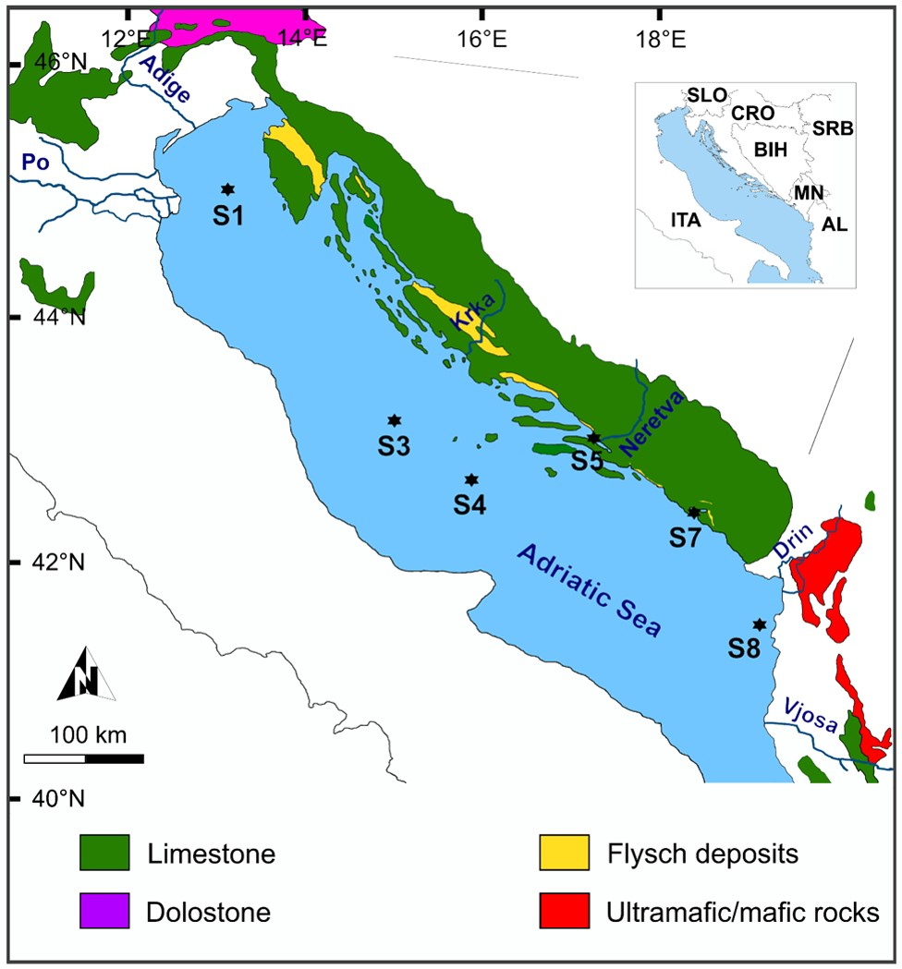

Figure 1. Simplified map of the study area. The main lithological units that could have a major influence on the geochemical composition of the sampling sites were also indicated. Modified from Amorosi et al. (2022).

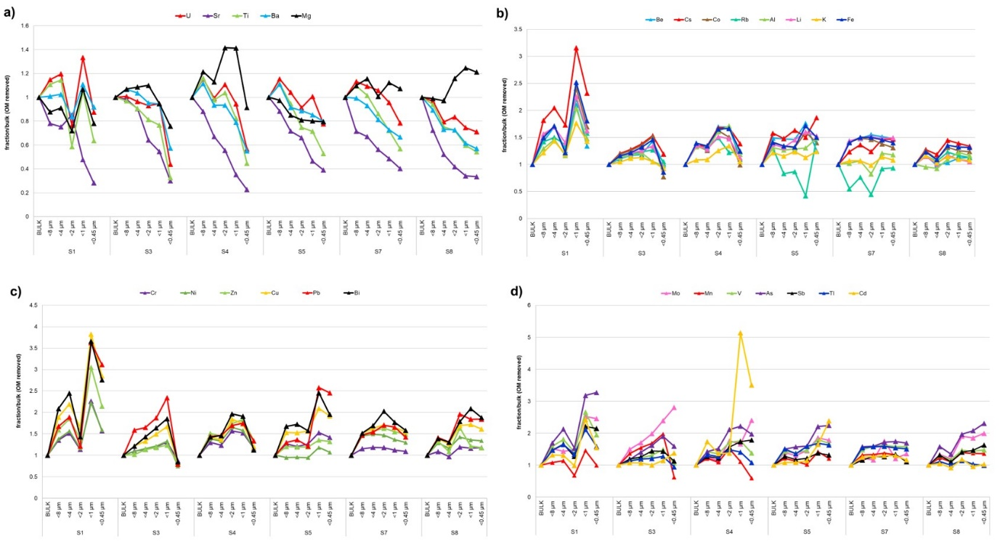
Figure 2. Ratios between the concentration of an element in a particular size fraction compared to the bulk (OM removed) sediment.

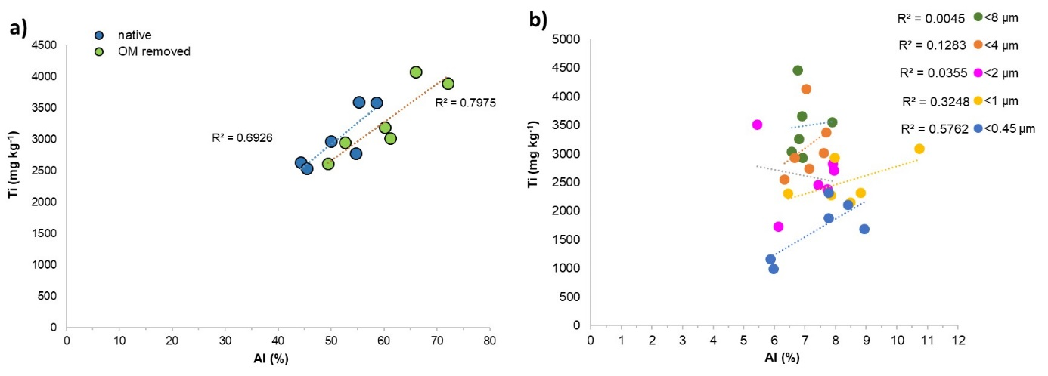 Figure 3. The content of Ti vs. Al in a) bulk (native) sediments and bulk (OM removed) sediments, and b) in the size fractions collected from the investigated sedimentological environments.
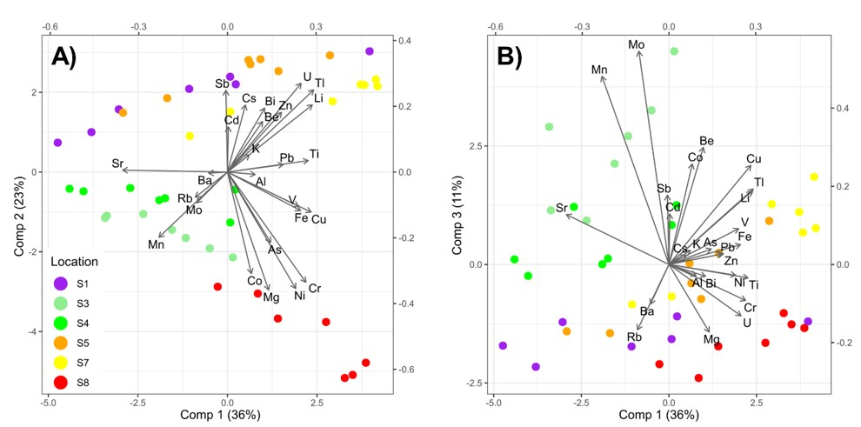 Figure 4. Partial Least Squares Discriminant Analysis (PLS-DA) differentiating investigated samples based on their location.

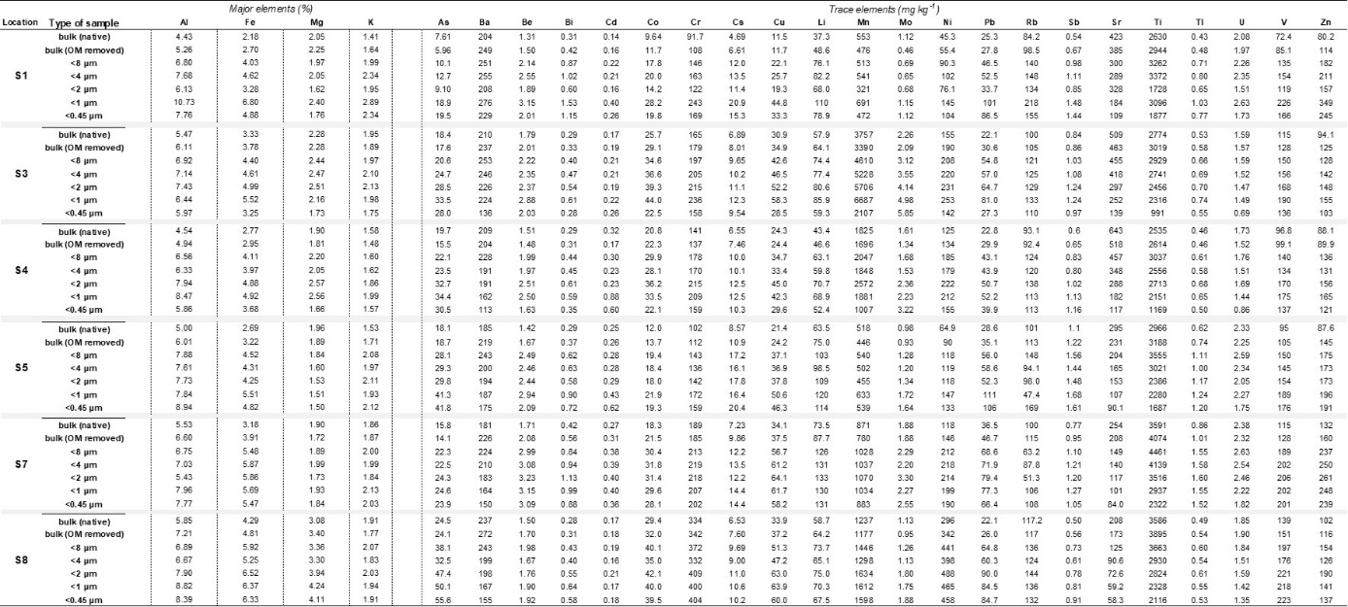
Table 1. The concentration of major and trace elements in native sediments, sediments after the OM removal (bulk (OM removed)) and the collected size fractions.

Table 2. The concentration of metal(loid)s (mg kg⁻¹) in the size fraction <2 μm from stations S3 and S8 before and after the DCB treatment.
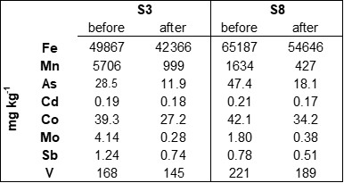
Table 3. Granulometric properties of the collected size fractions; range of mean sizes (Mz), and range of particles with size below 10% (d₁₀) and 90% (d₉₀) of material in samples from the investigated locations.
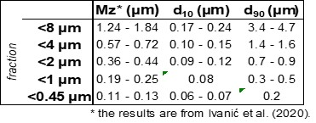

Supplementary material

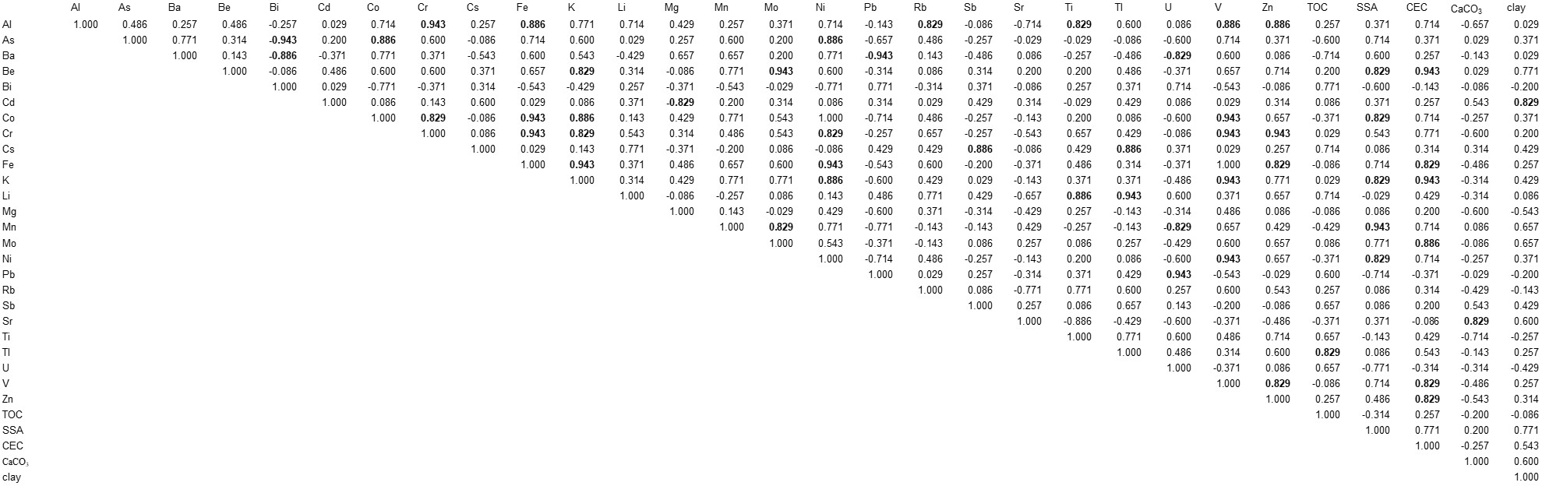
Table S1. Correlation coefficients (Spearman, p<0.05) for the investigated elements and sediment properties (TOC, SSA, CEC, share of carbonates and % of clay) in the investigated bulk (native) sediments. The sediment properties are from Ivanić et al. (2020). Significant correlations are marked as bold.

