Resolution and signal enhancement of Raman mapping by photonic nanojet of a microsphere

Vlatko Gašparić ^{1,2}, Davor Ristić ^{1,2}, Hrvoje Gebavi ^{1,2}, Mile Ivanda ^{1,2,*}
¹ Center of excellence for Advanced Materials and Sensing Devices, Research Unit New Functional Materials, Ruđer Bošković Institute, Bijenička cesta 54, 10000 Zagreb, Croatia
² Laboratory for Molecular Physics and Synthesis of New Materials, Ruđer Bošković Institute, Bijenička cesta 54, 10000 Zagreb, Croatia
* Corresponding author: e-mail: ivanda@irb.hr
address: Bijenička cesta 54, 10000 Zagreb, Croatia

Abstract
The field of Raman spectroscopy is constantly under improvement by development of methods of enhancement. One of the latest methods, based on photonic nanojet of a microsphere, has already been proven as simple, reliable and promising method for enhancement of single point micro Raman acquisition, but so far not for imaging. To extend the photonic nanojet method to Raman mapping, we have developed microsphere attached to two perpendicularly connected tapered optical fibers. When the sample is mapped, our two stemmed microsphere stays under the laser beam of the objective, providing enhancement on all points of the image. In addition to the demonstration of the feasibility of such enhancement, the first results reported here with 5-µm two stemmed microsphere on polycrystalline silicon substrate show ~4× signal enhancement of every point, and estimated ~3× resolution enhancement compared to the same setup without the microsphere. Detailed description of fabrication and characteristics of two stemmed microspheres is provided. Mapping images are analyzed and compared to atomic-force and scanning electron microscope images. Also, theoretical calculations of the photonic nanojet are provided. Successful implementation of two stemmed microsphere opens up a gateway and could serve as foundation for future improvements and applications in Raman imaging.

1. Introduction

In the fields of materials science, physics, chemistry, biomedical sciences and many other areas, Raman spectroscopy is an indispensable technique for identification, characterization and examination of substances and materials. Raman spectrum shows unique “fingerprints” of a given molecule or crystal material, where vibrational states are portrayed by Raman bands. When analyzing solid substrates under Raman microscope, it is often needed to gather spectra from an area, i.e. perform Raman mapping (imaging). The basic Raman signal is very weak because of the inelastic process and small cross section. This is especially hindering in mapping, where a large number of spectra (tens of thousands or more) need to be collected in a reasonable amount of time, but the faster the scanning is, the lower the acquisition time for each point is, and consequently, the weaker the signal is. Besides technical improvements (e.g. electron multiplying charge-coupled device – EMCCD), there are many experimental methods aimed to improve Raman spectroscopy in general. Some examples of enhancement methods are: Resonant Raman scattering, stimulated Raman scattering (SRS), coherent anti-stokes Raman scattering (CARS), surface-enhanced Raman scattering (SERS) and tip-enhanced Raman scattering (TERS) [1].
An underexplored and promising new method for Raman enhancement, with interest of researchers and number of papers increasing each year, is based on dielectrics [2]. Especially interesting variant of the method is based on photonic nanojet (PNJ), an elongated and narrow beam of concentrated light emerging on the shadow side of the illuminated microsphere (or similar microlens). PNJ has gained a lot of attention and significant amount of research has emerged since the first paper [3] in 2004. The distinct characteristics of PNJ are narrow width, which can be below a third of the wavelength ($λ/3$), and concentrated intensity, which can be orders of magnitude higher than the incident light. Besides Raman enhancement, PNJ has been used for various other applications, such as luminescence enhancement [4], nanopatterning [5–7], nanolithography [8–10], super-resolution [11–13], photonic hook [14], optical waveguiding [15], optical forces [16], data storage [17], and laser surgery [18]. For the emergence of PNJ, the size of the microsphere needs to be between 2λ and 40λ, and refractive index ratio between the sphere and medium less than 2 [19–21].
For Raman enhancement, PNJ of a microsphere has been investigated in several different ways and configurations. It was firstly observed by Yi et al. [22], using silica microspheres monolayer. In their calculations, they have shown subdiffractional property of PNJ and electric field concentration. Alessandri et al. [23] have acquired three orders of magnitude better detection of Methylene blue and investigated enhancement on thin anatase film. Others have reported an enhancement with polystyrene spheres [24,25], BaTiO₃ microsphere-embedded film [26], analyte on top of microspheres [27], and multilayer of T-rex shell spheres [28,29]. The effects of microsphere size [22,24,25,30,31], different microscope objectives [23,24,32,33] and refractive index contrast [34] have been investigated. In our previous study [35], we have shown that the incident beam position is another important parameter for PNJ Raman enhancement, and performed vertical Raman mapping of the microsphere on substrate. In general, all of the research has shown that PNJ of a microsphere is a simple, reliable and powerful method of enhancement of Raman signal locally under the microsphere.
However, in order to apply all the benefits of PNJ to Raman mapping, additional obstacles need to be overcome. So far majority of papers about PNJ Raman enhancement used stationary microspheres to enhance just the local area below it, i.e. single point acquisition with no mapping possibility. Besides stationarity, there are two more issues: firstly, the microspheres are deployed to the substrate by drop casting, inevitably contaminating the substrate surface with solution liquid and thousands of microspheres, and secondly, the position on which each microsphere will land cannot be controlled nor the location of enhancement. In the case of microsphere-embedded film [26], the substrate is not contaminated by microspheres, and positions of the microspheres are evenly arranged, but the microspheres are still stationary relative to the sample.
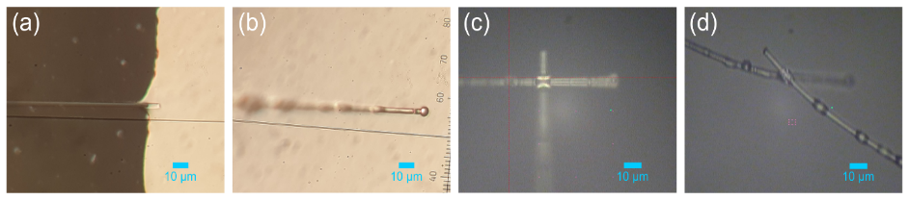
In order to have a microsphere which can scan the sample, it needs to be fixed by optical tweezers or a mechanical probe or holder, which is the matter which overlaps with the field of scanning near-field optical microscopy (SNOM). This intersection of PNJ and microsphere field on the one side, and scanning probe methods on the other side is a novel and exciting area with various applications [36]. The majority of research here investigates super-resolution optical microscopy and different methods how to employ PNJ of a microsphere for microscopy. One elegant mechanical holder for a microsphere is an atomic force microscope (AFM) cantilever, where microsphere can be glued to the front of the cantilever [37,38]. Wang et al. [39] have performed super-resolution optical microscopy this way, and have shown by numerical simulations that cantilever does not influence PNJ. Punctured cantilever with microsphere inside the hole has also been used for super-resolution optical microscopy [40], or recently, a special holder for multiple microspheres [41]. Objective adapter which holds microsphere was also used [42], attaching the microsphere directly to the objective [43], or gluing the microsphere to a single stem (glass rod) [44,45]. All of these methods have been tested for optical microscopy, but not for Raman spectroscopy or Raman imaging. Raman research with manipulated microspheres is scarce. Punctured cantilevers have been used [46,47], but without the microspheres. The microsphere was however manipulated optically by optical tweezers for Raman measurements. Kasim et al. [48] used 532-nm laser as both optical entrapment and excitation laser and performed Raman mapping of SiGe and gold nanopatterns with 3-µm polystyrene microsphere achieving spatial resolution of about 80 nm, however the signal enhancement is not reported. Chen et al. [49] achieved Raman enhancement of optically trapped droplet microlenses, but did not perform mapping. Arya et al. [31] have recently developed a microsphere on a stem, melted from a tapered optical fiber tip, which can be mounted on a stage and positioned under the microscope at desired location. They have also shown that the presence of the stem does not degrade the enhancement value. The melted microspheres were relatively large (over 22 µm) and the enhancement was only done with stationary microspheres relative to the substrate, without mapping. PNJ from microsphere on a stem has also been shown in simulations [33]. However, to this date, there is no report of Raman mapping with mechanical probe/holder with a microsphere.
Fig. 1 Two stemmed microsphere fabrication. (a) Dipping the tapered fiber into optical adhesive. (b) Joining the microsphere with the taper. (c) Connecting the second taper (dipped in adhesive) perpendicularly to the first. (d) Testing the endurance of the joint.
Here we present, for the first time to our knowledge Raman mapping enhancement by PNJ of a mechanically supported microsphere, and unique design and implementation of two stemmed microsphere (TSMS). In our method, the microsphere stays in the position with the microscope objective, while the substrate moves under it. This way, the microsphere and the objective dynamically scan the substrate surface, enabling enhancement of a single microsphere on all points of the map. In addition to signal enhancement, our method showed better resolution compared to the maps without the TSMS, using simple non-piezo microscope stage.

2. Materials and methods

2.1. Two stemmed microsphere fabrication

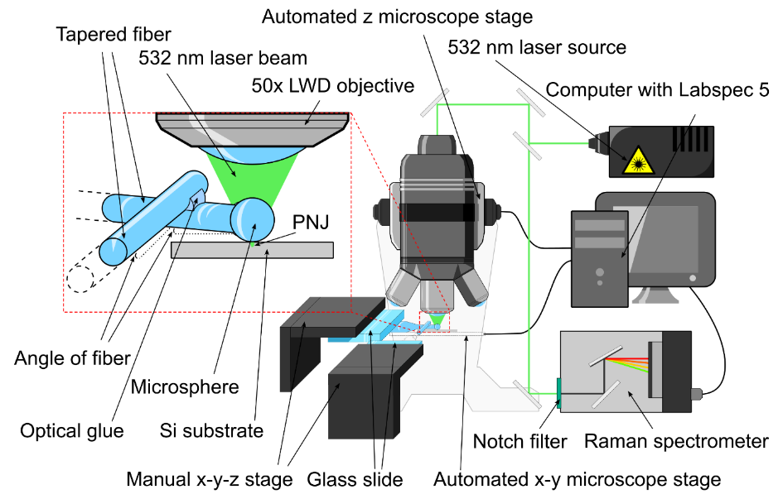
TSMSs were prepared by the following procedure: Standard telecom optical fiber was cleaved and cleaned with ethanol. It was mounted on a homemade fiber stretcher and stretched under the flame of natural gas and oxygen till breaking point. The end-tapered fiber was mounted on x-y-z manual micrometer stage adjacent to an optical microscope. A drop of optical adhesive (Norland Optical Adhesive 61, Norland Products Inc., Cranbury, New Jersey) was placed on a glass slide and positioned under the microscope. The taper end was then immersed into an adhesive drop and pulled out by manually operating both taper stage and microscope stage (Fig. 1a). 5-µm silica (SiO₂) microspheres (Whitehouse Scientific Ltd, Chester, United Kingdom) were suspended in ethanol, drop-casted onto the glass slide and left to dry on air. By manually operating the stages, tapered end covered in glue was carefully glued to a single microsphere on the glass slide (Fig. 1b). The glue was cured using 365-nm UV lamp. This way, one stemmed 5-um microsphere was obtained. The second tapered fiber was mounted on a second x-y-z stage adjacent to the microscope, perpendicularly positioned to the first x-y-z stage, immersed in a drop of glue and pulled out by operating the stages. The second glue immersed taper was then positioned and glued perpendicularly to the first stem (Fig. 1c). The second gluing was also cured using 365-nm UV lamp.
Fig. 2 Experimental setup for two stemmed microsphere Raman measurement. The setup consists of standard Raman elements: 532-nm laser source, microscope with automated x-y-z stage, Raman spectrometer and computer. Additional part is two stemmed microsphere (TSMS) mounted on two manual x-y-z stages. TSMS is tilted at slight angle and aligned under the laser beam, in contact with the substrate.
Polycrystallinity of the measured sample was achieved by crystallization of melted silicon. Prior to Raman measurements, the sample was optically inspected and adequate location was found with different kinds of borders and structural details (Fig. 3d).

2.2. Raman measurements

Raman measurements were performed on a high-resolution Raman spectroscope (Horiba Jobin Yvon T64000) in micro single mode (Fig. 2). The measurements with TSMS and control measurements without TSMS were done with 50× long working distance (LWD) objective with 0.50 numerical aperture (NA). Additional measurements without TSMS were done with 100× objective with 0.90 NA to have control measurements with even more resolution and precision, which could then be compared to 50× LWD TSMS. Continuous wave (CW) laser of 532-nm wavelength was used. Mapping images were acquired by measuring Raman spectra of the silicon phonon line at 520.7 cm⁻¹ for each pixel. The range of spectra taken into the pixel signal intensity was 30 cm⁻¹ (from 505.7 to 535.7 cm⁻¹) as in our previous study [35]. Movement of the sample was controlled by a motorized x-y stage; the vertical position of the microscope objective was controlled by a motorized z stage, all programmed in Labspec 5. For horizontal maps, the lateral (x, y) step was 0.50 µm for coarse maps, 0.20 µm for finer maps, and 0.06 µm for the finest maps. Three levels of steps in maps were used in order to show the feasibility of PNJ Raman mapping for both large and coarse maps, and also small but detailed maps. Since PNJ properties can be tailored by changing the parameters (microsphere size and material, beam size and wavelength, etc.) there could be an optimal choice in step size to achieve best work efficiency. However, these investigations are not in the scope of current paper and deserve separate research. The size of coarse maps was 30×20 µm, of finer map 9×5 µm and of finest maps 2.5×1.5 µm. The acquisition time per pixel was 1s, with refresh time of 1s, with and without TSMS. The coarse maps consisted of ~3500 pixels, which gives us ~2h of mapping time. Smaller maps with an average of 1100 pixels took around 30 minutes to complete. Mapping times did not depend whether TSMS is used or not, they were determined by the Raman system. The direction of scanning for a line was right to left, and then when finished with the line, back to start and one step down when going to the next line. The z position was fixed for horizontal maps. For depth scans, the vertical (z) step was 1.00 µm. Depth of field (DOF) was set with the help of the confocal hole, in order to have better vertical spatial resolution. The laser power under the microscope objective was held constant for all the measurements at 12.7 mW. This power is comparable to the average power of pulsed lasers in papers where PNJ nanopatterning was performed [5,6], however, our laser is CW. When considering damaging the sample, pulsed lasers have much lower ablation threshold and peak power needs to be considered. Furthermore, any damage to the microsphere or the sample would firstly show on the silicon, in form of silicon Raman band movement and broadening, however no changes were recorded. Therefore, the laser power was below any damaging influence. The position of TSMS was controlled by the two perpendicular manual x-y-z stages adjacent to the microscope stage, each controlling one stem. Because of the prototypic nature of this setup, during the mappings, occasional adjustments of the TSMS under the objective had to be made, in order to preserve correct alignment with the incident laser beam. Such TSMS misalignments caused some rows or the group of the pixels in the map to be weaker or shifted one pixel relative to the neighboring rows, resulting in some weaker spots and misalignment of rows in the mapping images.

2.3. Atomic force microscopy and scanning electron microscopy

Atomic force microscopy (AFM) images of the sample were obtained on atomic force microscope NT-MDT Spectrum Instruments NTEGRA Prima. AFM images were collected in order to determine the height profiles of the domains and borders at the location where Raman maps were performed. The imaging of the whole main location was performed with pixel size of 40 nm, in oscillation mode, while for the detail images, the pixel size was 10 nm, in contact mode. All the images were recorded in two channels. One is the oscillation amplitude (in oscillation mode) or the actual height (in contact mode) of the cantilever measured by reflected laser beam, which directly shows the vertical topography of the area. The other is the measure of the “friction”, i.e. the potential between the surface and the AFM tip, which can be affected not only by the vertical differences, but also by the other atomic-scale differences, such as in our case, the domain crystal orientation. We call this second channel “lateral force” (LF) channel.
Scanning electron microscopy (SEM) images were obtained on scanning electron microscope Jeol JSM 7000F. SEM images of the sample were collected at the same main location, in order to provide additional information about the location topography. The source voltage was 5 kV, and the current was 115 µA. The probe current was 10 mA. SEM images of the TSMS were acquired in order to determine the position of the microsphere on the taper tip, with 10 kV voltage and 115 µA current.

3. Calculation

3.1. Generalized Lorenz-Mie theory

Theoretical calculations were performed in order to determine PNJ shape, size and intensity for our experimental situation. The calculations are based on Generalized Lorenz-Mie theory (GLMT) developed by Gouesbet and Grehan [50] which is the generalization of the standard Mie scattering theory. Unlike Mie theory, which deals only with plane waves, GLMT enables calculating the electric field of the Gaussian beam illuminating a microsphere. The electric fields are separated to ${\vec{E}}_{i}$ (incident), ${\vec{E}}_{s}$(scattered) and ${\vec{E}}_{sp}$ (inside sphere), which are separated to TM (transverse magnetic) and TE (transverse electric) modes and also radial ($r$) and angular ($θ, φ$) components. The equation for the radial component of the TM scattered electric field is:
$$\begin{aligned}E_{r,TM}^{s}= -kE_{0}\sum_{n=1}^{∞}{\sum_{m=-n}^{+n}{c_{n}^{pw}A_{n}^{m}\left[{ξ"}_{n}\left(kr\right)+ξ_{n}\left(kr\right)\right]P_{n}^{\left|m\right|}\left(\cos{θ}\right)e^{imφ}}} \#\left(1\right)\end{aligned}$$
where $k=2π/λ$, $E_{0}$ is the amplitude of the incident field and $P_{n}^{\left|m\right|}$ Legendre polynomials. Also:
$$\begin{aligned}c_{n}^{pw}=\frac{1}{ik}{\left(-i\right)}^{n}\frac{2n+1}{n\left(n+1\right)} \#\left(2\right)\end{aligned}$$
$$\begin{aligned}A_{n}^{m}=a_{n}g_{n,TM}^{m} \#\left(3\right)\end{aligned}$$
$$\begin{aligned}ξ_{n}\left(kr\right)=krh_{n}^{\left(2\right)}\left(kr\right)\#\left(4\right)\end{aligned}$$
where $a_{n}$ is the standard Mie coefficient, $g_{n,TM}^{m}$ is the beam shape coefficient and $h_{n}^{\left(2\right)}(kr)$ is spherical Hankel function of the second kind. Beam shape coefficients can be calculated from:
$$\begin{aligned}g_{n,TM}^{m}=\frac{{\left(2n+1\right)}^{2}}{2π^{2}n\left(n+1\right)c_{n}^{pw}}\frac{\left(n-\left|m\right|\right)!}{\left(n+\left|m\right|\right)!} \\ \int_{0}^{π}{\int_{0}^{2π}{\int_{0}^{∞}{\frac{E_{r}\left(r,θ,φ\right)}{E_{0}}rΨ_{n}^{\left(1\right)}(kr)P_{n}^{\left|m\right|}(cosθ)e^{-imφ}\sin{θ}dθdφd(kr)}}} \#\left(5\right)\end{aligned}$$
$$\begin{aligned}Ψ_{n}^{\left(1\right)}\left(kr\right)=krj_{n}\left(kr\right)\#\left(6\right)\end{aligned}$$
where $j_{n}(kr)$ is spherical Bessel function of the first kind.
Rest of 23 electric field components follow the similar form and, together with detailed theoretical analysis, are written in the literature [50]. The intensity of the total electric field inside ($I_{sp}$) and outside the sphere ($I_{out}$) can be calculated from:
$$\begin{aligned}I_{sp}={\left|E_{r,TM}^{sp}+E_{r,TE}^{sp}\right|}^{2}+{\left|E_{θ,TM}^{sp}+E_{θ,TE}^{sp}\right|}^{2}+{\left|E_{φ,TM}^{sp}+E_{φ,TE}^{sp}\right|}^{2} \#\left(7\right)\end{aligned}$$
$$\begin{aligned}I_{out}={\left|E_{r,TM}^{i}+E_{r,TE}^{i}+E_{r,TM}^{s}+E_{r,TE}^{s}\right|}^{2}+{\left|E_{θ,TM}^{i}+E_{θ,TE}^{i}+E_{θ,TM}^{s}+E_{θ,TE}^{s}\right|}^{2}+ \\ +{\left|E_{φ,TM}^{i}+E_{φ,TE}^{i}+E_{φ,TM}^{s}+E_{φ,TE}^{s}\right|}^{2} \#\left(8\right)\end{aligned}$$
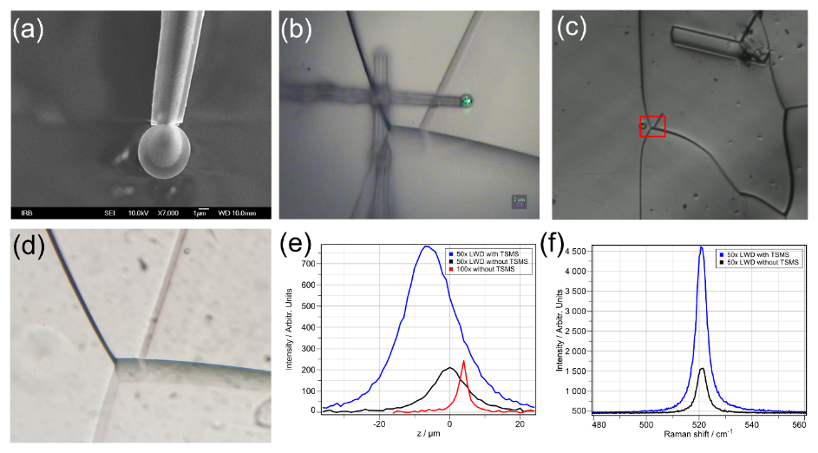
Fig. 3 TSMS, substrate and signal depth profile. (a) SEM image of microsphere on tapered fiber. The taper is thinner than microsphere to allow contact between the microsphere and surface. (b) TSMS at the sample surface, aligned under laser beam. The field of view is nearly 100% visible. (c) Wide view of polycrystalline silicon. (d) Main location on substrate, corresponds to red rectangle in (c). (e) Raman depth profiles of TSMS and standard measurements. TSMS profile is widest (antenna effect) and is shifted to lower z positions of the incident beam. (f) Raman spectrum of silicon 520.7 cm⁻¹ phonon band with and without TSMS. [Color should be used for print.]

Theoretical calculations of the Gaussian laser beam interaction with the microsphere were performed on the computer workstation HP Z640 with dual Intel Xeon (12 cores) processor and 32 GB ECC registered RAM using home-made C++ program.

4. Results

4.1. Two stemmed microspheres

Since the last step of connecting the second fiber is the most fragile to macroscopic movements and is best to be performed already under Raman microscope, the resulting TSMS is ready and aligned for Raman mapping. On scanning electron microscope (SEM) image in Fig. 3a we can see silica microsphere on stem. The microsphere is well positioned and there is no taper edge which prevents it from contacting the substrate. The surface of the sphere is clean, the adhesive is only applied on a small area at the tapered fiber tip. The microsphere on stem (before connecting the second stem) can withstand transport, deployment on the substrate, movement of the substrate and removal from the substrate. Fig. 3b shows TSMS at the substrate surface, with microsphere positioned under the laser beam. Only the bottom part of the microsphere is in the contact with the substrate surface, the rest of TSMS is above. This is accomplished by slight tilt of the stages (5-10 degrees) and with the help of electrostatic forces which attract microsphere to the substrate when it is close enough. We estimated that roughly anywhere under 10 µm of vertical distance, the microsphere will be attracted to the substrate. By the attractive forces and by pressing with tilted elastic stems, contact between the microsphere and surface was provided, which was shown to be needed for Raman enhancement by PNJ in our experiments. Consequently, any small vertical irregularities of the surface will not pose a problem for TSMS mapping. If there is a type of substrate that would not provide attractive force to the microsphere, the pressing of the stems would provide the contact. Alternatively, if the material of interest is deeper inside the sample, or the microsphere is at some distance from the substrate, PNJ position can be extended by focusing the incident beam in front of the microsphere or by tuning technique by surrounding medium proposed by Wang et al. [7]. Also, no damage to the sample was observed by contact with the microsphere. To perform mapping, two stems instead of one are necessary in order to hold the microsphere steady under the microscope objective while the substrate moves. With only one stem, the microsphere drags together with the sample surface because of the attractive forces. The bond between the fibers is considerably strong and elastic. As can be seen in Fig. 1d, even under extreme tension when each fiber is deliberately moved far away opposite of each other, the bond will not snap.

4.2. Raman maps and AFM and SEM images

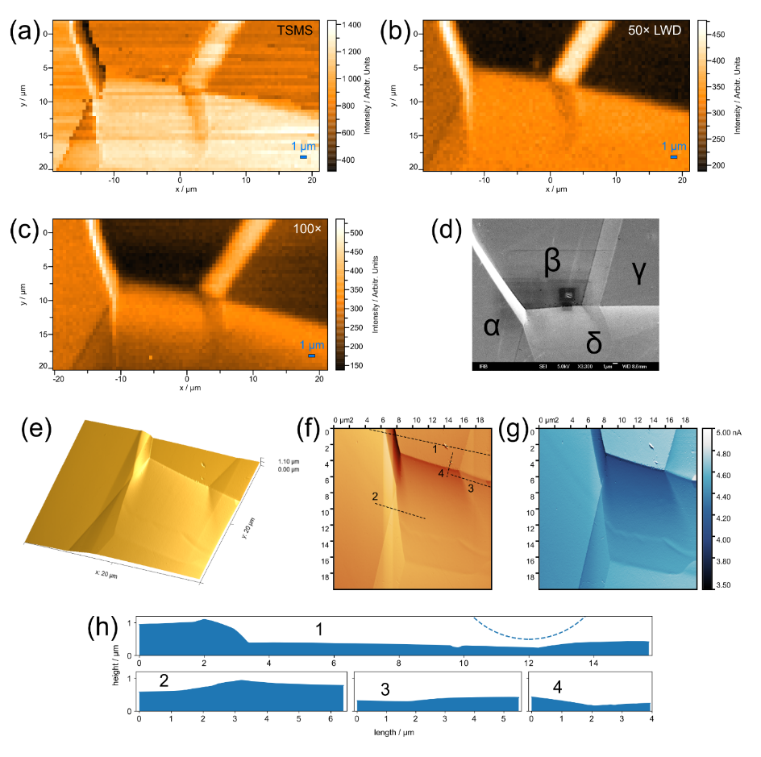
The sample on which mappings were performed is a polished polycrystalline silicon substrate with domains separated by visible borders (Fig. 3c,d). Each domain is a monocrystal with irregular size and shape. In order to properly acquire horizontal maps, Raman depth profiles had to be measured to determine the optimal beam waist position with and without TSMS, which are shown in Fig. 3e. For 50× long working distance (LWD) without TSMS, the maximum signal with intensity of 210 is at 0 µm, where we defined the substrate surface. With TSMS, the maximum signal is at -6 µm (8.5 µm below the center of the sphere). As expected, the profile measured with 100× objective has the shallowest depth of field (DOF), while the signal is basically the same as 50x LWD without TSMS. The maximum intensity height position is at +4 µm, which is because of the difference in the objectives. The maximum intensity height positions in both cases with and without TSMS were maintained for all horizontal mappings, i.e. all mappings were conducted in the optimal focus of the beam. The optimal incident beam focus position is always after the microsphere, which automatically means that the PNJ will be adjacent to the microsphere surface, which is a good match with the fact that the microsphere is in contact with the substrate surface. The intensity with TSMS of 780 is an enhancement of 3.7× (integrated peak value). Through our testing of various TSMSs, it was shown that the enhancement can vary, even though all the microspheres were the same size (5 µm). The cause of such differences was the variation in microsphere placement and thickness of the fiber. For TSMSs where the taper was thicker, the enhancements were much smaller, even nonexistent in some cases. On the other hand, TSMSs with thinner tapers, with diameter smaller than the diameter of the microsphere, regularly showed high enhancement, up to 6×. Typical Raman spectrum of our sample is shown in Fig. 3f, with and without TSMS.
Fig. 4 Main location measurements. (a) 50× LWD TSMS mapping with 0.5 µm step. The signal is enhanced ~4× and more details are visible, especially dark edge of top left border and triangular shape at bottom left. (b) 50× LWD objective mapping with 0.5 µm step. (c) 100× objective mapping with 0.5 µm step. (d) SEM image of the main location. Domains are designated as α, β, γ and δ. There is a slight burn-in from e-beam at lower right part of domain β. (e) 3D AFM image of the main location. Sharpest border is upper-left. Total height difference is ~1 µm. (f) Height AFM channel. Colors are not heatmap of height, but an illustration of terrain when there is a light source above. (g) LF AFM channel which represents crystalline properties of the substrate and height. Colors are heatmap of force on cantilever. Borders and δ domain show the least force. (h) Vertical substrate profiles taken from (f) (black dashed lines in (f)). α-β domain border is the steepest and sharpest. Particles in β domain are small indentations with slight protrusions at edges. The bottom of the microsphere is illustrated in dashed line in profile 1 for size comparison.
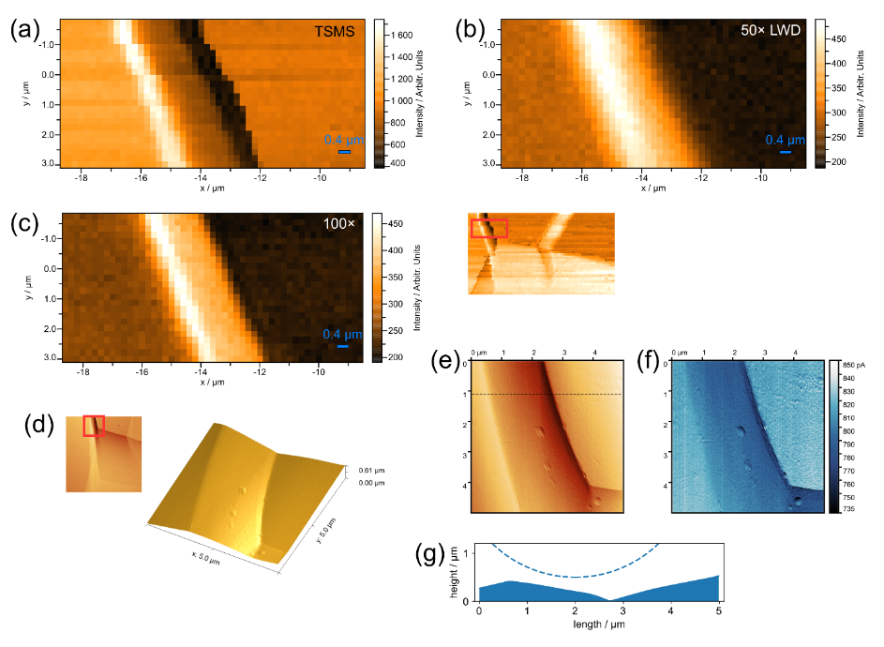
Main location horizontal mapping with step of 0.5 µm is shown in Fig. 4 for the case with TSMS 50× LWD (Fig. 4a) and without TSMS for 50× LWD (Fig. 4b) and for 100× objective (Fig. 4c). In (Fig. 4d) SEM image of the main location is shown, where four distinctive domains are marked with letters α, β, γ, and δ, for easy referencing. Firstly, it can be seen by comparing to the optical image (Fig. 3d), that maps faithfully display the area. TSMS map (Fig. 4a) shows significant signal enhancement at every domain, namely: at domain α the enhancement is 3.3×, at domains β and γ is 4×, and at domain δ is 3.9×, compared to standard 50× LWD (Fig. 4b). 100× intensities are very similar to 50× LWD. Some line artifacts can be seen because of TSMS instability under the beam, since it is a prototype. On SEM image (Fig. 4d) larger particles in the lower right part of the domain β, and smaller particles and spots on other positions can also be seen. Additional topographical information can be seen on AFM images and surface profiles in Fig. 4e-h. In Fig. 4e, the main location’s topography is shown in 3D, as well as in height channel in artificial colors in Fig. 4f. Although the domains are at different vertical levels, the borders in between are not simple steps, as we could imagine from optical or SEM image. Also, the domains themselves are slanted and slightly curved. The difference between the highest and the lowest point on the main location is 1.1 µm, which is 1/5 of the microsphere diameter. The “lateral force” (LF) channel of the AFM image (Fig. 4g) suggests that domains have different crystal orientation, the biggest difference being between the domains β and δ. This is also indicated in Raman maps since between domains β and δ is a biggest signal difference. Also, the border areas seem to have different orientations which could be one of the contributions to their different Raman signal intensity.
Fig. 5 α-β domain border measurements. (a) 50× LWD TSMS mapping with 0.2 µm step. Besides signal enhancement, resolution enhancement can be seen compared to 50× LWD (b) and 100× (c) mappings. (b) 50× LWD objective mapping with 0.2 µm step. (c) 100× objective mapping with 0.2 µm step. (d) 3D AFM image. The height difference is 0.6 µm. (e) Height AFM channel. Colors are not heatmap of height, but an illustration of terrain. (f) LF AFM channel. Colors are heatmap of force on cantilever. (g) Vertical profile taken from (e) (black dashed line in (e). The bottom of the microsphere is illustrated for size comparison(blue dashed line).
The most abrupt transition between the domains is the border between the domains α and β, measuring almost 1 µm of vertical difference over only 1 µm of horizontal length (profile 1 in Fig. 4h). Other borders are softer and have less vertical change, as can be seen in profiles 2-4 in Fig. 4h. Even for the coarse step used in Fig. 4a for Raman map with TSMS, the distinction between the abrupt α-β border, and other softer borders can be seen, while standard Raman mapping (Fig. 4b) shows all the borders more or less the same. Even if we include the standard map with 100× objective (Fig. 4c), which has a more focused beam, much shallower DOF and significantly higher NA than 50× LWD objective, the level of details is worse than TSMS map. Standard 100× map has expectedly better resolution than standard 50× LWD map, but not better than 50× LWD TSMS map. TSMS map shows additional structure inside the border. The situation can be seen better in Fig. 5 where mapping step was 0.2 µm. TSMS map (Fig. 5a) shows sharper and more defined features. Moreover, besides higher signal with TSMS, the noise and the granular appearance are much more pronounced in maps without TSMS. As we can see from the AFM images and profiles (Fig. 5d-g), the right dark edge on TSMS map corresponds to the right valley of the border, while the left bright edge corresponds to the left hill of the border. Those details are less noticeable in standard 100× map (Fig. 5c), and virtually non-existent in standard 50× LWD map (Fig. 5b). The LF channel (Fig. 5f) shows that the whole border is darker, and also has gradient, which could be the consequence of both vertical change and crystal orientation. The surface profile across the border (Fig. 5g) shows some difference to the same area profile in Fig. 4h, e.g. the right-hand domain is slanted in Fig. 5g, but flat in Fig. 4h. This can be attributed to unavoidable AFM artifacts, but it does not affect the conclusions from the results.
The large border between the domains β and δ (and, γ and δ), is a simple line contact between mildly slanted domains, which is in agreement with Raman mappings and AFM images. The border between domains β and γ is similarly mild, but it is not a simple line. The analysis of this detail is given in the supplement.
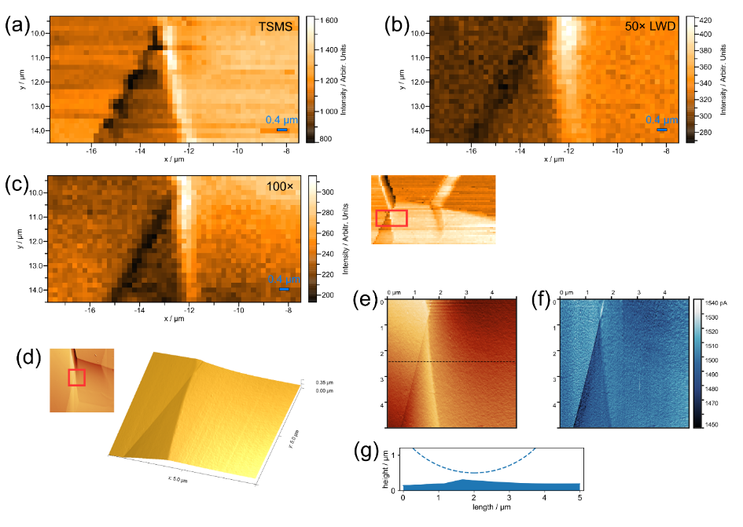
The border between domains α and δ is a simple line in the optical image, but the maps uncover more information. This area is mapped in more details with a step 0.2 µm in Fig. 6. The 50× LWD map without TSMS (Fig. 6b) shows two lines, one on the left darker, the other on the right lighter, but the lines are faint, fuzzy, and the whole map is grainy and noisy. The standard 100× map (Fig. 6c) offers some improvement, indicates that the right-hand domain is slanted, but the improvement is not substantial. The map with TSMS (Fig. 6a) reveals more information than standard 50× LWD map. The lines are much sharper and defined, the triangular area between dark and light line has a different signal strength than both domains α and δ. The whole map has less noise and the resolution is enhanced. Some line artifacts can be seen, especially at left edge of the triangle. The AFM images of the detail (Fig. 6d-g) confirm TSMS map. The triangle is clearly visible in the LF channel (Fig. 6f), which means the crystal orientation of the triangle could be different, which supports the TSMS map.
Fig. 6 α-δ domain border measurements. (a) 50× LWD TSMS mapping with 0.2 µm step. Resolution and signal enhancement can be seen compared to 50× LWD (b) and 100× (c) mappings. (b) 50× LWD objective mapping with 0.2 µm step. (c) 100× objective mapping with 0.2 µm step. Slightly darker bottom part of domain δ could arise from very short depth of field which can sense domain tilt. (d) 3D AFM image. (e) Height AFM channel. Colors are not heatmap of height, but an illustration of terrain. (f) LF AFM channel. Colors are heatmap of force on cantilever. (g) Vertical profile taken from (e) (Black dashed line in (e)) with microsphere (blue dashed line).
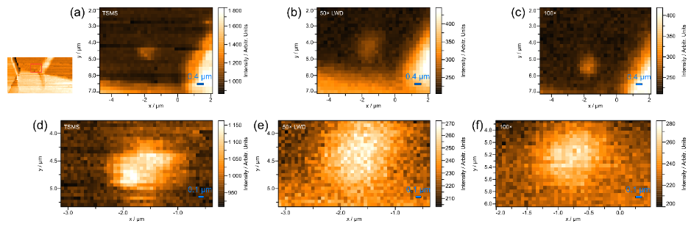
Besides borders, we mapped in detail small particle in the lower right corner of the domain β, shown in Fig. 7. In addition to all the previous improvements of TSMS map, here we can see (Fig. 7a) that the particle size is smaller than what the 50× LWD standard Raman map shows (Fig. 7b). Standard 100× map (Fig. 7c) is similar to 50× LWD TSMS here, however, it cannot match it in signal strength and low noise. Finer maps with step of 60 nm are presented in Fig. 7d-f. The particle in TSMS map is much more defined and has two details inside the particle with higher intensity, sized 120-180 nm. The SEM image (Fig. 4d) shows that there are in fact two particles, more extended in x than y direction. The AFM measurements (Fig. 4f-h) suggests that those are small punctures with slight protrusion at the edge.
Fig. 7 Detail Raman measurements of particle at domain β. (a) TSMS mapping with 0.2 µm step. The signal is enhanced. The resolution is similar to 100x map (c). (b) 50x LWD objective mapping with 0.2 µm step. (c) 100x objective mapping with 0.2 µm step. (d) TSMS mapping with 0.06 µm step. Both signal and resolution are enhanced. (e) 50x LWD objective mapping with 0.06 µm step. (f) 100x objective mapping with 0.06 µm step.

4.3. GLMT calculations

The parameters used for GLMT calculations were: wavelength $λ=532 nm$, microsphere refractive index $n=1.4607$, microsphere radius $r=2.5 μm$, Gaussian beam waist radius $w=0.68 μm$ (the value for 50x LWD objective [35]), and the incident beam intensity was normalized to 1. The parameters were chosen to match our experimental parameters, which are the same as in our previous experimental study [35]. The microsphere center was positioned at the origin of the coordinate system, and the incident beam waist position was on the z axis. The direction of light propagation was along the z axis, from negative to positive values.
Fig. 8a shows y-z plane of electric field intensity when the incident beam waist position is at $z=8.5 µm$, which corresponds to the experimental optimal position of the beam waist relative to the microsphere in mapping measurements. PNJ is visible on the shadow side of the microsphere. PNJ intensity is over 6 and the shape is oval. It is adjacent to the microsphere surface but extends in the z axis direction. Inside the sphere, second maximum is visible near PNJ. Both inside, and outside on the illuminating side of the microsphere, interference of the incident and backscattered light is visible.
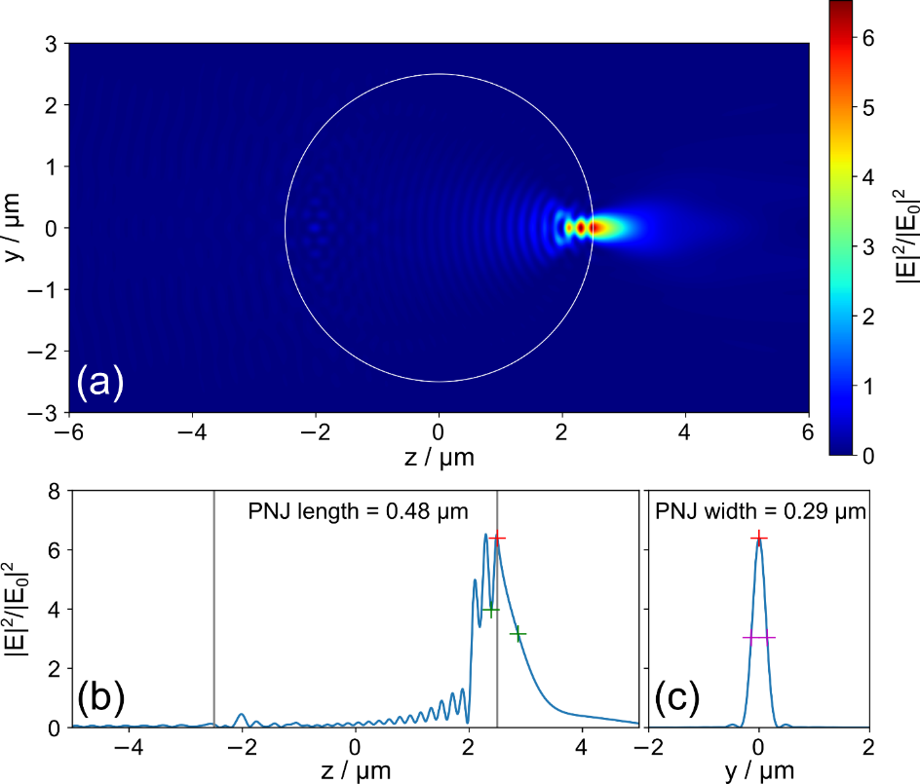
Fig. 8b shows z cross section of the Fig. 8a at $y=0$. The length of PNJ of 0.48 µm (FWHM) can be determined, which is comparable to λ. Fig. 8c shows y cross section at $z=z_{Imax}$, where $z_{Imax}$ is the z coordinate of the PNJ maximum. Here it can be seen that the width of PNJ is 0.46 µm ($1/e^{2}$ convention), or 0.29 µm (FWHM), comparable to $λ/2$, which is significant focusing compared to the incident beam width of 1.36 µm ($1/e^{2}$) of 50× LWD objective, and even to 0.87 µm ($1/e^{2}$) of 100× objective. Based on this, an estimate of TSMS resolution is around $1/3$ of the resolution of 50× LWD objective, and $1/2$ of the 100× objective. For the resolution of microscope objective, the equation which gives an estimate can be written as:
Fig. 8 GLMT calculations. (a) y-z plane electric field intensity of 532-nm laser beam (waist 0.68 µm) incident on silica microsphere (diameter 5 µm). The incident beam waist position is at 8.5 µm. Photonic nanojet of intensity ~6× stronger than incident beam maximum can be seen on the shadow side of the microsphere. (b) z profile (at y=0) from image (a). Photonic nanojet length (FWHM) is 0.48 µm. (c) y profile across photonic nanojet from image (a). Photonic nanojet width (FWHM) is 0.29 µm. [Color should be used for print.]
$$\begin{aligned}res\sim 0.61\frac{λ}{NA} \#\left(9\right)\end{aligned}$$
For 50× LWD this gives ~0.65 µm. The estimate of TSMS resolution is therefore ~0.22 µm. An effective NA of the microsphere (NA_{eff}) can also be determined (see Figure 6d in reference [49]):
$${NA}_{eff}=n\frac{r}{L}$$
where L is the distance from the microsphere center to the substrate surface. In our case L ≈ r, which gives us NA_{eff} = 1.46 which in equation (9) gives us an estimate of resolution to be also 0.22 µm.

5. Discussion

5.1. Two stemmed microspheres

Compared to other handling methods - optical tweezers [48], cantilever [38–40], special holder [41] or direct mount on objective [42,43], some conclusions can be made. There are some disadvantages of TSMS method: two axes (fibers) need to be controlled instead of one, the problems with alignment under the objective can arise, the diameter of the taper tip needs to be smaller than the microsphere and TSMS is fragile to macroscopic movements (e.g. taking TSMS out after measurements). However, some of listed issues are also common to other handling methods. Secondly, it should be noted that our current form of TSMS is a prototype, currently not a direct competitor to a long time established method such as AFM, nor the idea of TSMS is to perform surface topography or to challenge plasmonic enhancement such as TERS, which is a completely different physical mechanism. Current approach is a new strategy to facilitate photonic nanojet for Raman mapping.
The issues of TSMS can be greatly reduced by optimizing the design of TSMS, which is aimed to increase the stability under the beam, prevent artifacts because of misalignment and reduce the number of positioning stages to one. These ideas include solution to enable two fibers on one stage, mechanical optimization (fiber length, thickness and sphere size etc.) and sample stage improvement, which implementations are the matter of our future report. Thirdly, there are some advantages over other methods: TSMS does not obstruct the field of view as opposed to cantilever. It is elastic, as opposed to rigid cantilever and special holder, which allows the sphere to easily connect to the substrate and stay connected. Lowering the AFM cantilever requires more complicated automated apparatus with feedback loop, while TSMS is able to approach the surface with basic manual stage. It is resilient to extreme stage movements (Fig. 1d). The system does not need to be submerged in fluid like in the case of optical tweezers, making the operation simpler from that point of view, and any sample sensitive to fluid can also be mapped. Also, the implementation of TSMS to existing Raman systems in labs is accessible and cheap: the ingredients are tapered telecom fibers, microspheres, some glue, and two stages (which are the most expensive part), which can be even manual micrometer stages. All the benefits of TSMS design can be also applied to super-resolution microscopy, the field where even greater impact could be accomplished.

5.2. PNJ enhanced Raman mapping

Raman depth profile showed maximum intensity which is inside the hotspot range determined in our previous study [35], indicating again the importance of proper incident beam positioning relative to the microsphere when using PNJ Raman enhancement. The optimal position is different for different microspheres, laser wavelengths and microscope objectives, and should be determined before the measurements. DOF is greater for TSMS profile, confirming the antenna effect of microspheres previously identified in the literature [51]. 4× TSMS enhancement of signal is 30% smaller than before [35], but it depends on the parameters of TSMS. Ones with thinner taper were in the agreement with the study. The TSMSs with thin tapers behaved like free microspheres from the enhancement point of view. Moreover, we have observed that the enhancement drops down significantly if the microsphere is close but not in contact with the substrate. Thicker tapers prevent microsphere from getting fully into the contact with the substrate and reduce the enhancement. The value of 4x is near the values from other PNJ enhancement papers [24,26,31]. The comparison with metalic SERS can be made if we take into account the interaction volumes, which can be approximated to cylinders. The ratio of PNJ cylinder (radius 145 nm and height 480 nm), and incident beam cylinder (radius 400 nm and height 817 nm – penetration depth of silicone) is 0.077. Taking also absorption of the microsphere into account of around 8%, in the end gives enhancement factor of 59. Also if we take into account power density, which is for PNJ higher than for the incident beam by a ratio of incident beam area over PNJ area (400²/145²), this gives us 59×(145²/400²)≈8. So the enhancement factor is 8 by this definition. Both of these values are substantially less that metallic SERS values of ~10¹⁰, or 10³-10⁸ in recent flexible SERS research [52]. This is expected since metallic SERS is a different mechanism of enhancement (plasmonics). However, it is an informative comparison since great potential lies in combining PNJ and metallic SERS in future.
Besides near-field super-resolution properties of the microsphere and PNJ [11–13,39,48,49], other mechanisms could contribute to Raman resolution enhancement, because scattering is different from optical white light image collection. Substantial signal dependence on the distance between the microsphere and surface could be one of the contributions. At α-β domain border (Fig. 5), at right darker edge which is a valley, this dependence could be the reason for lower signal. Another contribution could be the angle of surface. If the scattering occurs at an angle, fewer photons will be collected with a microsphere. This could be a reason for left dark edge on maps in Fig. 6. Lastly, crystal orientation has a lot of influence on the signal. The crystal planes inside the small puncture (Fig. 7) could yield higher Raman signal and outcompete contributions from the angle and distance of the microsphere. In the case of signal enhancement, the mechanism is still not clear. There is major influence of the PNJ itself, however the signal collection capability of the microsphere could also add a contribution. Some discussion was provided previously [35], but also further research is needed.
Although here is demonstrated PNJ Raman mapping on silicon substrate, all other substrates where PNJ has been proven as enhancement method in the literature can be used also for mapping. Taking all Raman maps into account, it is clear that TSMS provides better resolution than control measurements with the same objective. In the case of 100x control measurements, the conclusion is somewhat subjective in Figs. 4-6. However, clear improvement can be seen in Fig. 7. Also, the rough calculations from GLMT results can only give us an estimate of the resolution of this particular TSMS. The experimental resolution values of the microsphere can be of order of 100 nm [48,49]. Therefore, for more definitive answers, additional experimental measurements need to be done with TSMS on piezo stage with nanometer steps and on adequate substrate. These experiments are under implementation and planned for the future.

6. Conclusions

In this research, PNJ enhanced Raman mapping with mechanically supported two stemmed microsphere (TSMS) has been demonstrated for the first time, with ~4× signal and ~3× resolution enhancement for the 5-µm silica microsphere. The maps were confirmed with SEM and AFM images, and the properties of PNJ were simulated by GLMT calculations which show PNJ width of 0.29 µm. Detailed fabrication and unique design and feasibility of TSMS was shown. We believe several paths have now opened, from mechanical optimization, parameter optimization (e.g. microsphere size), to resolution tests and theoretical research. The reduction of number of needed position stages for TSMS and improving the stability under the laser beam will be the first and most valuable improvements which could bring TSMS to great adoption in the scientific community. Even greater adoption of TSMS could be achieved in optical microscopy, and pose a great competition to cantilever and other handling methods. Furthermore, the mechanism of Raman resolution enhancement by PNJ is not yet understood. Here we proposed three mechanisms: near-field effect, distance dependence and angle dependence, all of which deserve separate detailed investigations. We hope this research will serve as a guidance and motivation for future research.
Acknowledgements
This work has been fully supported by a project co-financed by the Croatian Government and the European Union through the European Regional Development Fund - the Competitiveness and Cohesion Operational Programme (KK.01.1.1.01).
Conflict of interest
The authors declare no conflict of interest.
References
[1] E. Smith, G. Dent, Modern Raman spectroscopy—a practical approach, John Wiley & Sons, Ltd, 2005. https://doi.org/10.1002/jrs.1320.
[2] I. Alessandri, J.R. Lombardi, Enhanced Raman Scattering with Dielectrics, Chem. Rev. 116 (2016) 14921–14981. https://doi.org/10.1021/acs.chemrev.6b00365.
[3] Z. Chen, A. Taflove, V. Backman, Photonic nanojet enhancement of backscattering of light by nanoparticles: a potential novel visible-light ultramicroscopy technique, Opt. Express. 12 (2004) 1214. https://doi.org/10.1364/OPEX.12.001214.
[4] Y. Yan, Y. Zeng, Y. Wu, Y. Zhao, L. Ji, Y. Jiang, L. Li, Ten-fold enhancement of ZnO thin film ultraviolet-luminescence by dielectric microsphere arrays, Opt. Express. 22 (2014) 23552. https://doi.org/10.1364/OE.22.023552.
[5] A. Shakhov, A. Astafiev, A. Gulin, V. Nadtochenko, Femtosecond Nanostructuring of Glass with Optically Trapped Microspheres and Chemical Etching, ACS Appl. Mater. Interfaces. 7 (2015) 27467–27472. https://doi.org/10.1021/acsami.5b09454.
[6] A.M. Shakhov, A.A. Astafiev, D.O. Plutenko, O.M. Sarkisov, A.I. Shushin, V.A. Nadtochenko, Femtosecond Optical Trap-Assisted Nanopatterning through Microspheres by a Single Ti:Sapphire Oscillator, J. Phys. Chem. C. 119 (2015) 12562–12571. https://doi.org/10.1021/acs.jpcc.5b00478.
[7] Z.B. Wang, W. Guo, A. Pena, D.J. Whitehead, B.S. Luk’yanchuk, L. Li, Z. Liu, Y. Zhou, M.H. Hong, Laser micro/nano fabrication in glass with tunable-focus particle lens array, Opt. Express. 16 (2008) 19706. https://doi.org/10.1364/OE.16.019706.
[8] A. Jacassi, F. Tantussi, M. Dipalo, C. Biagini, N. Maccaferri, A. Bozzola, F. De Angelis, Scanning Probe Photonic Nanojet Lithography, ACS Appl. Mater. Interfaces. 9 (2017) 32386–32393. https://doi.org/10.1021/acsami.7b10145.
[9] X. Liu, J. Wang, L. Li, J. Gou, J. Zheng, Z. Huang, R. Pan, Fabrication of hexagonal star-shaped and ring-shaped patterns arrays by Mie resonance sphere-lens-lithography, Appl. Surf. Sci. 440 (2018) 378–385. https://doi.org/10.1016/j.apsusc.2017.12.200.
[10] Y. Wu, L. Ji, Z. Lin, Q. Li, Y. Jiang, Substrate effect of laser surface sub-micro patterning by means of self-assembly SiO2 microsphere array, Appl. Surf. Sci. 357 (2015) 832–837. https://doi.org/10.1016/j.apsusc.2015.09.066.
[11] L. Li, W. Guo, Y. Yan, S. Lee, T. Wang, Label-free super-resolution imaging of adenoviruses by submerged microsphere optical nanoscopy, Light Sci. Appl. 2 (2013) e104–e104. https://doi.org/10.1038/lsa.2013.60.
[12] Z. Wang, W. Guo, L. Li, B. Luk’Yanchuk, A. Khan, Z. Liu, Z. Chen, M. Hong, Optical virtual imaging at 50 nm lateral resolution with a white-light nanoscope, Nat. Commun. 2 (2011) 218. https://doi.org/10.1038/ncomms1211.
[13] G. Huszka, M.A.M. Gijs, Turning a normal microscope into a super-resolution instrument using a scanning microlens array, Sci. Rep. 8 (2018) 601. https://doi.org/10.1038/s41598-017-19039-6.
[14] A.S. Ang, A. Karabchevsky, I. V. Minin, O. V. Minin, S. V. Sukhov, A.S. Shalin, ‘Photonic Hook’ based optomechanical nanoparticle manipulator, Sci. Rep. 8 (2018) 2029. https://doi.org/10.1038/s41598-018-20224-4.
[15] Z. Chen, A. Taflove, V. Backman, Highly efficient optical coupling and transport phenomena in chains of dielectric microspheres, Opt. Lett. 31 (2006) 389. https://doi.org/10.1364/OL.31.000389.
[16] X. Cui, D. Erni, C. Hafner, Optical forces on metallic nanoparticles induced by a photonic nanojet, Opt. Express. 16 (2008) 13560. https://doi.org/10.1364/OE.16.013560.
[17] S. Kong, A. Sahakian, A. Taflove, V. Backman, Photonic nanojet-enabled optical data storage, Opt. Express. 16 (2008) 13713. https://doi.org/10.1364/OE.16.013713.
[18] V. Astratov, Photonic nanojets for laser surgery, SPIE Newsroom. (2010). https://doi.org/10.1117/2.1201002.002578.
[19] S. Lecler, Y. Takakura, P. Meyrueis, Properties of a three-dimensional photonic jet, Opt. Lett. 30 (2005) 2641–2643. https://doi.org/10.1364/OL.30.002641.
[20] A. Heifetz, S.-C. Kong, A. V. Sahakian, A. Taflove, V. Backman, Photonic Nanojets, J. Comput. Theor. Nanosci. 6 (2009) 1979–1992. https://doi.org/10.1166/jctn.2009.1254.Photonic.
[21] B.S. Luk’yanchuk, R. Paniagua-Domínguez, I. Minin, O. Minin, Z. Wang, Refractive index less than two: photonic nanojets yesterday, today and tomorrow [Invited], Opt. Mater. Express. 7 (2017) 1820–1847. https://doi.org/10.1364/OME.7.001820.
[22] K.J. Yi, H. Wang, Y.F. Lu, Z.Y. Yang, Enhanced Raman scattering by self-assembled silica spherical microparticles, J. Appl. Phys. 101 (2007) 063528. https://doi.org/10.1063/1.2450671.
[23] I. Alessandri, N. Bontempi, L.E. Depero, Colloidal lenses as universal Raman scattering enhancers, RSC Adv. 4 (2014) 38152–38158. https://doi.org/10.1039/C4RA07198K.
[24] C.L. Du, J. Kasim, Y.M. You, D.N. Shi, Z.X. Shen, Enhancement of Raman scattering by individual dielectric microspheres, J. Raman Spectrosc. 42 (2011) 145–148. https://doi.org/10.1002/jrs.2684.
[25] X.M. Lin, X. Wang, Z. Liu, B. Ren, Enhanced Raman scattering by polystyrene microspheres and application for detecting molecules adsorbed on Au single crystal surface, Acta Phys. - Chim. Sin. 24 (2008) 1941–1944. https://doi.org/10.1016/S1872-1508(08)60075-3.
[26] C. Xing, Y. Yan, C. Feng, J. Xu, P. Dong, W. Guan, Y. Zeng, Y. Zhao, Y. Jiang, Flexible Microsphere-Embedded Film for Microsphere-Enhanced Raman Spectroscopy, ACS Appl. Mater. Interfaces. 9 (2017) 32896–32906. https://doi.org/10.1021/acsami.7b09884.
[27] M.S. Anderson, Nonplasmonic surface enhanced Raman spectroscopy using silica microspheres, Appl. Phys. Lett. 97 (2010) 2010–2013. https://doi.org/10.1063/1.3493657.
[28] I. Alessandri, Enhancing raman scattering without plasmons: Unprecedented sensitivity achieved by TiO2 shell-based resonators, J. Am. Chem. Soc. 135 (2013) 5541–5544. https://doi.org/10.1021/ja401666p.
[29] N. Bontempi, I. Vassalini, I. Alessandri, All-dielectric core/shell resonators: From plasmon-free SERS to multimodal analysis, J. Raman Spectrosc. (2018) 1–11. https://doi.org/10.1002/jrs.5330.
[30] V.R. Dantham, P.B. Bisht, C.K.R. Namboodiri, Enhancement of Raman scattering by two orders of magnitude using photonic nanojet of a microsphere, J. Appl. Phys. 109 (2011) 103103. https://doi.org/10.1063/1.3590156.
[31] A. Arya, R. Laha, G.M. Das, V.R. Dantham, Enhancement of Raman scattering signal using photonic nanojet of portable and reusable single microstructures, J. Raman Spectrosc. 49 (2018) 897–902. https://doi.org/10.1002/jrs.5350.
[32] G.M. Das, R. Laha, V.R. Dantham, Photonic nanojet-mediated SERS technique for enhancing the Raman scattering of a few molecules, J. Raman Spectrosc. 47 (2016) 895–900. https://doi.org/10.1002/jrs.4928.
[33] G.M. Das, A.B. Ringne, V.R. Dantham, R.K. Easwaran, R. Laha, Numerical investigations on photonic nanojet mediated surface enhanced Raman scattering and fluorescence techniques, Opt. Express. 25 (2017) 19822–19831. https://doi.org/10.1364/OE.25.019822.
[34] H.S. Patel, P.K. Kushwaha, M.K. Swami, Photonic nanojet assisted enhancement of Raman signal: Effect of refractive index contrast, J. Appl. Phys. 123 (2018) 023102. https://doi.org/10.1063/1.4994944.
[35] V. Gašparić, S. Taccheo, H. Gebavi, D. Ristić, M. Ivanda, Photonic nanojet mediated Raman enhancement: Vertical Raman mapping and simple ray matrix analysis, J. Raman Spectrosc. 51 (2020) 165–175. https://doi.org/10.1002/jrs.5747.
[36] L. Chen, Y. Zhou, Y. Li, M. Hong, Microsphere enhanced optical imaging and patterning: From physics to applications, Appl. Phys. Rev. 6 (2019) 021304. https://doi.org/10.1063/1.5082215.
[37] Y. Gan, Attaching Spheres to Cantilevers for Colloidal Probe Force Measurements: A Simplified Technique, Micros. Today. 13 (2005) 48–50. https://doi.org/10.1017/S155192950005402X.
[38] F. Wang, L. Liu, H. Yu, Y. Wen, P. Yu, Z. Liu, Y. Wang, W.J. Li, Scanning superlens microscopy for non-invasive large field-of-view visible light nanoscale imaging, Nat. Commun. 7 (2016) 13748. https://doi.org/10.1038/ncomms13748.
[39] S. Wang, D. Zhang, H. Zhang, X. Han, R. Xu, Super-resolution optical microscopy based on scannable cantilever-combined microsphere, Microsc. Res. Tech. 78 (2015) 1128–1132. https://doi.org/10.1002/jemt.22595.
[40] M. Duocastella, F. Tantussi, A. Haddadpour, R.P. Zaccaria, A. Jacassi, G. Veronis, A. Diaspro, F. De Angelis, Combination of scanning probe technology with photonic nanojets, Sci. Rep. 7 (2017) 3474. https://doi.org/10.1038/s41598-017-03726-5.
[41] T. Zhang, P. Li, H. Yu, F. Wang, X. Wang, T. Yang, W. Yang, W.J. Li, Y. Wang, L. Liu, Fabrication of flexible microlens arrays for parallel super-resolution imaging, Appl. Surf. Sci. 504 (2020) 144375. https://doi.org/10.1016/j.apsusc.2019.144375.
[42] L.-W. Chen, Y. Zhou, M.-X. Wu, M.-H. Hong, Remote-mode microsphere nano-imaging: new boundaries for optical microscopes, Opto-Electronic Adv. 1 (2018) 170001. https://doi.org/10.29026/oea.2018.170001.
[43] B. Yan, Y. Song, X. Yang, D. Xiong, Z. Wang, Unibody microscope objective tipped with a microsphere: design, fabrication, and application in subwavelength imaging, Appl. Opt. 59 (2020) 2641–2648. https://doi.org/10.1364/ao.386504.
[44] L.A. Krivitsky, J.J. Wang, Z. Wang, B. Luk’Yanchuk, Locomotion of microspheres for super-resolution imaging, Sci. Rep. 3 (2013) 3501. https://doi.org/10.1038/srep03501.
[45] M. Aakhte, V. Abbasian, E.A. Akhlaghi, A.-R. Moradi, A. Anand, B. Javidi, Microsphere-assisted super-resolved Mirau digital holographic microscopy for cell identification, Appl. Opt. 56 (2017) D8–D13. https://doi.org/10.1364/ao.56.0000d8.
[46] A. Mai, L. Zhu, M. Hecker, J. Rinderknecht, C. Georgi, Y. Ritz, E. Zschech, Aperture based Raman spectroscopy on SiGe film structures with high spatial resolution, J. Raman Spectrosc. 38 (2007) 1538–1553. https://doi.org/10.1002/jrs.
[47] Y. Jiang, A. Wang, B. Ren, Z.Q. Tian, Cantilever tip near-field surface-enhanced raman imaging of tris(bipyridine)ruthenium(II) on silver nanoparticles-coated substrates, Langmuir. 24 (2008) 12054–12061. https://doi.org/10.1021/la801376p.
[48] J. Kasim, Y. Ting, Y.Y. Meng, L.J. Ping, A. See, L.L. Jong, S.Z. Xiang, Near-field Raman imaging using optically trapped dielectric microsphere, Opt. Express. 16 (2008) 7976–7984. https://doi.org/10.1364/OE.16.007976.
[49] X. Chen, T. Wu, Z. Gong, Y. Li, Y. Zhang, B. Li, Subwavelength imaging and detection using adjustable and movable droplet microlenses, Photonics Res. 8 (2020) 225–234. https://doi.org/10.1364/prj.377795.
[50] G. Gouesbet, G. Gréhan, Generalized Lorenz-Mie Theories, Springer Berlin Heidelberg, Berlin, Heidelberg, 2011. https://doi.org/10.1007/978-3-642-17194-9.
[51] Y. Yan, C. Xing, Y. Jia, Y. Zeng, Y. Zhao, Y. Jiang, Self-assembled dielectric microsphere array enhanced Raman scattering for large-area and ultra-long working distance confocal detection, Opt. Express. 23 (2015) 25854–25865. https://doi.org/10.1364/OE.23.025854.
[52] K. Xu, R. Zhou, K. Takei, M. Hong, Toward Flexible Surface‐Enhanced Raman Scattering (SERS) Sensors for Point‐of‐Care Diagnostics, Adv. Sci. 6 (2019) 1900925. https://doi.org/10.1002/advs.201900925.

