Hydrochemical regime of the fractured rock aquifer of Simonos Petra Monastery, Holy Mountain
M.M. Ntona^{1,2}, I. Krajcar Bronić³, J. Barešić³, J. Parlov⁴, Z. Kovač⁴, D. Lampropoulou¹, V. Koulos⁵, P. Neofotistos¹, A. Plougarlis¹, K. Voudouris¹, N. Kazakis¹
(1) Aristotle University of Thessaloniki, Thessaloniki, Greece, kazakis@geo.auth.gr (2) Università degli Studi della Campania "Luigi Vanvitelli", Caserta, Italy (3) Ruđer Bošković Institute, Zagreb, Croatia (4) University of Zagreb, Zagreb, Croatia (5) Koulos: BD Inventions.

Research highlights
- The fractured rock aquifer of Simonos Petra Monastery in Holy Mountain discharges from a fracture zone artesian spring.
- The spring water is characterized by low electrical conductivity (126.8 μS/cm), and the absence of anthropogenic pollution such as nitrogen species and potentially toxic elements.

The Athos peninsula is located in Northern Greece and constitute one of the last unexplored areas of Greece regarding hydrogeological conditions (Figure 1). This study is focused on the Hydrosystem of the Holy Monastery of Simonos Petra with the aim of determining the hydrochemical regime of the fracture zone aquifer. The Territory of the Holy Monastery of Simonos Petra covers an area of 13 km², has a coastline of 5.9 km, the mean elevation is 473 m, and the maximum is 892 m in Tsamantara peak. The study area is located at the boundary of the Hellenic Hinterland and the Internal Hellenides and consists of granitoid rocks, of the Eocene age (Christofides et al., 1990). It constitutes facies of extensive magmatism, which geotectonically belongs to the late-Alpine stage of the Hellenic Hinterland and the Innermost Hellenides deformation and is characterized by such granitic bodies. The Gregoriou type granite is, according to Kockel et al., (1977), a mainly biotitic granite, rich in quartz, perthitic orthoclase, microcline, plagioclase with a 30% anorthite, biotite, and hornblende. Frequently enough veins of leucocratic aplitic muscovite granite occur rich in quartz, perthite and orthoclase, microcline, and plagioclase with a 15-20% anorthite, muscovite and secondary minerals. The main aquifer of the Simonopetra spring stretches in an area of 0.87 km² and is developed within the fractured formation of the Granodiorite, Gabbro, and Diorite (Figure 1). The aquifer discharge from a fracture zone artesian spring (Busico et al., 2022). The gush points of the spring are more than 15, however, five gushes are the main discharge points that we focused this hydrochemical research. The water demands of the study area are exclusively covered by the spring water.
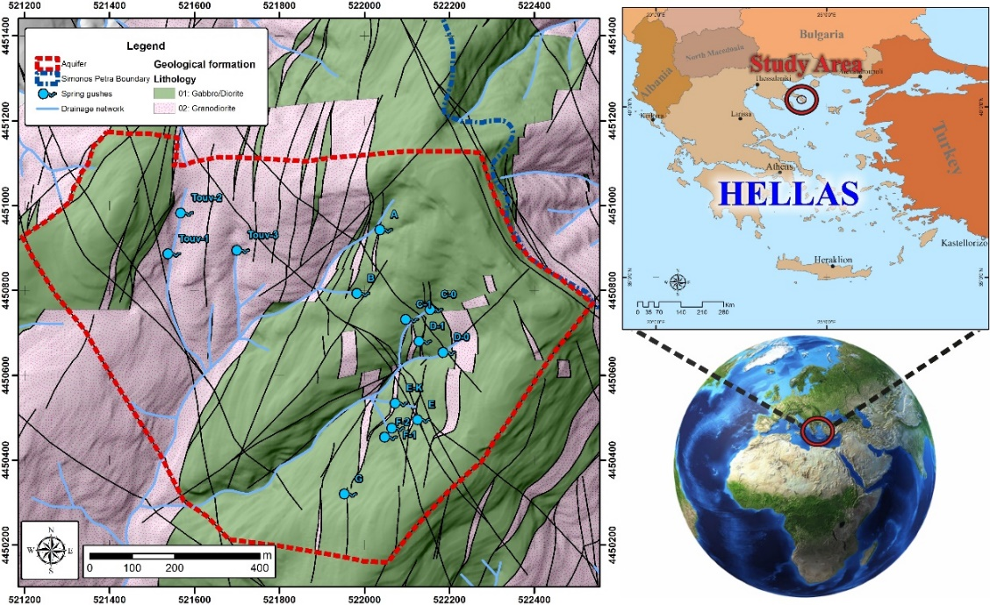
Figure 1. Geological map of the study area.
Water samples were collected from 5 gushes from the Simonopetra spring in November 2020 for hydrochemical, isotope and tritium analysis. The physicochemical parameters of temperature (T), pH, and electrical conductivity (EC) were measured in situ using a multi‐parametric probe, HANNA (HI98194). All water samples were filtered using a 0.45 μm Millipore filter and stored in two 50 mL PE bottles (one acidified with ultrapure HNO₃⁻) for laboratory analysis (ICP-MS) according to standard methods (Lenore et al. 1998). According to the hydrochemical data all gushes have similar water quality verifying the spring mechanism. The spring pH is 7.1, the electrical conductivity 126.8 μS/cm and the temperature 9.6 ºC, with the absence of potentially toxic elements, nitrate, nitrite, and ammonium ions (Table 1). Based on the sample classification in the Piper (Piper, 1944) and Durov (Durov, 1948) diagrams in Figure 2, the water type of the spring is Mg-HCO₃.
Table 1. Results from the underground water isotope analyses from the spring systems of Mount Athos Simonopetra spring for the sampling period of November 2020.
Spring gushes | d¹⁸O | d²H | ³H | Mg²⁺ | Ca²⁺ | NO₃⁻ | NO₂⁻ | NH₄⁺ | Cr | As | U
 | ‰ VSMOW | ‰ VSMOW | TU | mg/L | mg/L | mg/L | mg/L | mg/L | μg/L | μg/L | μg/L
Ε | -8.76 | -50.53 | 3.1 | 3.2 | 5.3 | ND | ND | ND | ND | ND | ND
C0 | -8.55 | -49.75 | 3.2 | 3.3 | 5.7 | ND | ND | ND | ND | ND | ND
C1 | -8.78 | -50.34 | 3.6 | 3.3 | 6.5 | ND | ND | ND | ND | ND | ND
D0 | -8.89 | -51.2 | 3.4 | 2.8 | 5.6 | ND | ND | ND | ND | ND | ND
D1 | -8.73 | -51.27 | 3.5 | 3.1 | 6.5 | ND | ND | ND | ND | ND | ND
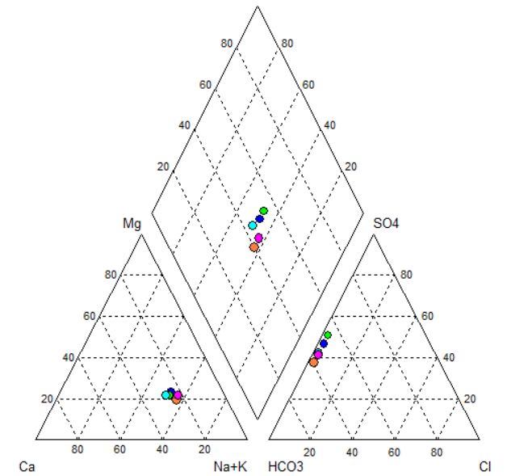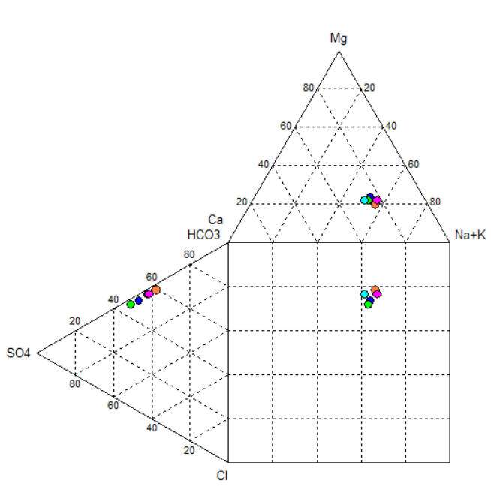
Figure 2. Classification of the water samples from the main spring system in Piper (left) and Durov (right) diagrams for the sampling period of November 2020.
The meteoric water line for Greece was used to characterize the samples, developed by Argiriou and Lykoudis (2006). The relationship of the Greek meteoric water line (HellasMWL) is given by the formula: δD = 7.2 × δ¹⁸Ο + 8.2‰. According to the stable isotope analysis, groundwater of the Simonopetra aquifer has meteoric origin and has not been subject to secondary evaporation (Table 1). Additionally, the Simonopetra aquifer recharged from a maximum altitude of 890 meters. Regarding the tritium analyses of groundwater of Simonopetra aquifer, it is characterized as contemporary water, according to classification by Clark and Fritz (1997). The relatively young age of the aquifer’s groundwater fortifies the theory of the high flow speed of the aquifer, as well as its direct supply from atmospheric precipitation (meteoric origin).
Conclusions
In the study area, there is an absence of human activity, therefore, the physicochemical characteristics of groundwater solely depend on the interaction and hydrodynamics of water with the geological formations. Groundwater of Simonopetra aquifer is characterized as potable with the absence of potentially toxic elements, nitrate, nitrite, and ammonium ions. The aquifer recharge occurs from a maximum altitude of 890 meters and is characterized as contemporary water. The next step of this work is the timeseries analysis of the hydrochemical data from the Simonopetra aquifer and correlation with the hydrodynamic analysis of the Simonopetra spring.

References
Argiriou, A.A., Lykoudis, S., 2006. Isotopic composition of precipitation in Greece. Journal of Hydrology, 327, 486-495.
Busico G., Ntona M.M., Kazakis N., Mastroccico M., 2022. Simulating historical, actual and future water balance in mountainous watershed. 12th International Hydrogeological Conference, Cyprus, 20-22 March 2022, pp. 172-175.
Clark, I.D., Fritz, P., 1997. Environmental Isotopes in Hydrogeology. Lewis Publishers, New York, p. 328.
Christofides, G., D’Amico, C., Del Moro, A., Eleftheriadis, G., Kyriakopoulos, C., 1990. Rb-Sr-geochronology and geochemical characters of the Sithonia plutonic complex (Greece). European Journal of Mineralogy, 2, 79–87.
Durov, S.A., 1948. Natural water and graphical representation of their composition. Dokl. Akad. Nauk. U.S.S.R., 59, 87-90.
Kockel, F., Mollat, H., Walther, H.W., 1977. Erlauterungenzur Geologischen Karte der Chalkidiki und angrenzender Gebiete 1:100000 (Nord-Griechenland). Bundesanstalt fur Geowisseschaften und Rohstoffe, Hannover, 119.
Lenore, S.C., Arnold, E.G., Andrew, D.E. 1998. Standard Methods for Examination of Water and Wastewater, 20th ed. American Public Health Association, American Water Works Association, World Environment Federation: Washington, DC, USA.
Piper, A.M., 1944. Agraphic procedure in the geochemical interpretation of water analyses. American Geophysical Union, Transactions, 25, 914 – 923.

