Mild toxicity of polystyrene and polymethylmethacrylate microplastics in Paracentrotus lividus early life stages
Philippe J. Thomas¹, Rahime Oral², Giovanni Pagano³, Serkan Tez², Maria Toscanesi³, Pasquale Ranieri³, Marco Trifuoggi³, Daniel M. Lyons^{4 *}

¹ Environment and Climate Change Canada, Science & Technology Branch, National Wildlife Research Center – Carleton University, Ottawa, Ontario, Canada K1A 0H3
² Faculty of Fisheries, Ege University, TR-35100 Bornova, İzmir, Turkey
³ Department of Chemical Sciences, ACELAB, University of Naples Federico II, I-80126 Naples, Italy
⁴ Center for Marine Research, Ruđer Bošković Institute, HR-52210 Rovinj, Croatia

* To whom correspondence may be addressed: lyons@irb.hr, +385 52 804725

Abstract
The vast category of microplastics in the marine environment, encompassing among other aspects their persistence, degradation and impact on biota, has become an important topic of research. In spite of environmental health concerns, much work has yet to be done on understanding the potential roles of polymer sources, composition and particle sizes in causing adverse effects which have already been observed in a number of biota. The present study was aimed at adding to current knowledge by verifying if, and to what extent, embryogenesis in the sea urchin species Paracentrotus lividus is adversely affected by polystyrene and polymethylmethacrylate virgin microparticles over a size range 1-230 μm and at concentrations of 0.1 to 10 mg L⁻¹. Developing embryos which came in contact with the microplastics only after fertilisation did not display a significant increase of developmental defects. Unlike embryo exposures, when P. lividus sperm were exposed to the microplastics or their leachates, modest, yet significant effects were observed, both in terms of decreased fertilisation rate and increase of transmissible damage to offspring. Further, it was noted that larvae more readily ingested polymethylmethacrylate than polystyrene microparticles after 3 days which may represent a route for enhancing the toxity of the former compared to the latter. Overall, these findings provide evidence for lesser sensitivity of P. lividus early life stages to microplastics compared to other urchins such as Sphaerechinus granularis. In turn, the more robust response of P. lividus highlights the importance of choosing an appropriate test species with the highest sensitivity when investigating mildly harmful materials.

Key words: microplastics; sea urchins; early life stages; embryo; toxicity; fertilisation; offspring; developmental anomaly

Introduction
Ever increasing production of plastics has inevitably led to growing quantities of plastics entering the environment, typically as primary bulk items and as secondary plastics derived from the breakdown of this primary waste under the influence of abiotic factors such as, for example, UV light and the mechanical action of waves in the marine environment. While plastic particles are now ubiquitous in all environmental compartments, more recently production and use of micro-scale plastics in a wide range of consumer products has led to an additional source of polymer particles in urban wastewater streams which may reach rivers, estuaries and eventually marine systems, and particularly for the latter near large urban centres in coastal areas (Ryan et al., 2009). As a measure of the quantity of plastic present in marine waters, it has been estimated that there are over 5 trillion pieces of plastic floating in the oceans (Eriksen et al., 2014).

While macroscale plastics such as the remnants of discarded fishing nets represent a significant danger to larger species, smaller sized particles (microplastics) present a hazard to smaller organisms at lower levels in the marine food web. Research on microplastics has to a great degree focused on particles in the 300 μm – 5 mm size range, with the lower bound deriving from the mesh size of phytoplankton nets typically used to gather microplastics from marine waters. However, with decreasing size, in particular from 300 μm down to 1 μm, the potential for interaction between microparticles and marine organisms increases greatly (Auta et al., 2017).

The most commonly reported microplastic particles encompass polystyrene (PS), polyethylene (PE) and polypropylene (PP) yet such particles comprise not only of the primary polymers but may also include a range of chemical additives which were used in the manufacturing process to impart specific properties to the plastics. As complex mixtures, microplastics thus have the potential to exert broad-ranging adverse effects on a wide range of biota (Rochman et al., 2019).

Recent research investigating microplastics’ potentially harmful effects has focused on a broad range of organisms ranging from algae and phytoplankton to mussels and crabs. In many cases microplastics have not been found to cause significant harm to marine organisms including, for example shrimp Aristeus antennatus (Carreras-Colom et al., 2018), mussel Perna perna (Santana et al., 2018) and fish Sparus aurata (Jovanović et al., 2018). On the contrary, Espinosa et al. (2017) found some adverse effects from polyvinylchloride microparticles on the immune system of the same fish species S. aurata. Sea urchins have been used in several studies probing the effects of microparticles and, as with studies on other organisms, effects range from none or very mild to moderate. For example, PE microparticles were not found to have a significant effect on Tripneustes gratilla (Kaposi et al., 2014) yet were noted to have caused developmental defects in Lytechinus variegates (Nobre et al., 2015). PS and PMMA microparticles were recently reported to cause cytogenetic anomalies in embryogenesis of the urchin Sphaerechinus granularis although concentration-dependent trends were not clearly established (Trifuoggi et al., 2019). Among sea urchins Paracentrotus lividus is one of the most utilised species with tested endpoints ranging from microparticle ingestion to developmental abnormalities, and to fertilisation success following sperm exposure (Martínez-Gómez et al. 2017). That work showed decreased fertilisation success and increased developmental defects after exposure to PE and PS microparticles while, to the best of our knowledge, there are no reports focused on P. lividus sperm exposure to microplastics. Other recent pertinent research focused on determining the effects of untreated “virgin” microplastics compared to their beached analogues, microplastics with various surface-linked functional groups or those containing pigments (Della Torre et al. 2014; Beiras et al. 2018; Oliviero et al. 2019). Further, not only are polymer microparticles a cause for concern in their own right but also due to their ability to act as a vector for the transport of other compounds and contaminants (Alimi et al., 2018). For example, Mato et al. (2018) reported on the ability of polypropylene resin microparticles to sorb and accumulate significant quantities of PCBs from the surrounding water with adsorption coefficients of up to 10⁶. Further, not only can microplastics sequester harmful pollutants from the water column but they may in turn transfer such compounds to biota (Chua et al., 2014).

Taking into consideration this research, and based on recent findings where microparticles equivocally have, or have not, adverse effects on marine biota (Foley et al., 2018), the present study was aimed at determining the potential toxicity of a wide size range of PS and PMMA microparticles to the early life stages of P. lividus, as likely the most widely used test urchin. In particular, the ability of these microplastics or their leachates to reduce fertilisation success, cause transmissible damage to offspring or show toxicity in developing embryos, either due to chemical (leachate) or mechanical (particle size) cues, were probed.

Materials and methods
Commercially produced spherical PS microparticles with nominal diameters of 1, 4, and 30 μm were obtained from Sigma Aldrich/Supelco as 10% w/v aqueous dispersions (catalogue no. 89904, 81494 (2% w/v) and 84135 respectively), while PS microparticles of 10, 80 and 230 μm nominal diameters (product no. TS10, TS80 and TS230, respectively) and PMMA microparticles with nominal diameters of 10 and 50 μm (product no. CA10 and CA50, respectively) were purchased as dry powders from Microbeads SA, Norway. All microparticles were used directly without physical or chemical modification, or ageing. Primary stock suspensions of the microplastics were prepared at a concentration of 1 g L⁻¹ in ultrapure water (18 MΩ∙cm), with subsequent serial dilutions ×10 and ×100 giving suspensions of concentration 100 mg L⁻¹ and 10 mg L⁻¹, respectively.

Microparticle characterisation
Microparticles with nominal diameters ≥10 μm were imaged during the experiment in natural filtered seawater (FSW) on a Nikon Diaphot-TMD inverted microscope with Moticam 10 camera, and particle size distributions (n=100) were calculated by ImageJ software. Stock suspensions of microparticles with nominal diameters ≤4 μm were ultrasonicated at 40 °C for 1 h and diluted ×100 before measurement by dynamic light scattering (DLS). Data were collected on a Zetasizer Nano ZS (Malvern Panalytical, UK) and the hydrodynamic diameters were determined from the number size distributions. To determine the settling rates of microplastics with size ≥10 μm, 3 mg of each were weighed into 4.5 mL polystyrene cuvettes (1 cm path length) to which was added 3 mL ultrapure water. The cuvettes were vortexed for 1 min and collection of absorption data for these suspensions was immediately initiated on a Shimadzu UV-1800 spectrometer. The centre of the beam was 1.5 cm below the surface of the suspension. Data were collected at a wavelength of 600 nm and 0.5 s acquisition rate.

Sea urchin assays
Sea urchins P. lividus were collected off the coast of Pula, Croatia and held in aquaria with running seawater until use. Gametes were collected by excision of the gonads from adult urchins, with those of females placed in FSW (Munktell 21/N filter paper) while male gonads/sperm were held ‘dry’ on clock glasses. Gametes at a final concentration of 100 eggs mL⁻¹ and sperm at a final dilution factor of ×10⁵ were used to generate embryos in FSW in a glass beaker prior to exposure to microplastics (Pagano et al. 2001; 2017). Previously prepared microplastic stock solutions were vortexed for 30 s immediately prior to use, and 100 uL aliquots of these stock suspensions were immediately placed in each well of polystyrene 6-well tissue culture plates to which were subsequently added 9.9 mL of the embryo suspension 10 min post fertilisation (p-f). Thus, the exposed embryos were reared in microplastic suspensions at concentrations ranging from 0.1 to 10 mg L⁻¹, with embryo exposure lasting throughout embryogenesis, starting from 10 min p-f up to the pluteus larval stage (72 h p-f). Embryos were incubated in FSW (salinity S•38.1, pH 8.0-8.2, 18±1 °C) with a total of 6 replicates for all size classes of both polymer types at each of three concentrations. Controls consisted of unexposed embryos in triplicate culture plates, each with 6 replicates. Previous work (data not shown) did not show a significant difference between embryos reared in glass or polystyrene petri-dishes.

Embryological analysis
After 72 h an aliquot of aqueous potassium chromium sulfate was added to each replicate (final concentration 10⁻⁴ M) to immobilise the embryos (Pagano et al. 1983), and after 10 min the first 100 plutei in each replicate were visually scored by microscope for the number of normally developed larvae, developmentally delayed larvae, i.e. less than half the size of normally developed larvae, malformed larvae with damaged skeletal structures (P1) and abnormal blastulae or gastrulae (P2). The total number of developmental defects (DD) in each replicate was considered the sum of P1 and P2.

Sperm bioassays
Aliquots (50 μL) of neat sperm were diluted in 5 mL FSW containing three particle concentrations, both polymer types and all particles sizes, and left for 1 h with periodic gentle agitation. From each treatment 50 μL was withdrawn and the sperm contained therein used to inseminate 10 mL of egg suspensions (100 eggs mL⁻¹) in 6-well culture plates. In the period of 1 to 3 h p-f, the percent of fertilised eggs (fertilisation rate) was recorded based on visual identification of live cleaving embryos by microscope. These embryos were reared up to the pluteus larval stage and subsequently scored for developmental defects 72 h p-f, as described previously. The bioassay was carried out with 6 replicates for each microparticle size and concentration.

Leachate spermiotoxicity and embryotoxicity
Microparticles were kept in FSW (10 mg L⁻¹; 0.2 μm Whatman cellulose nitrate membrane filter) for a period of 1 month, with agitation, under a natural light-dark cycle. These dispersions were subsequently centrifuged at 2000 g for 5 min, and the supernatants retrieved for use in sperm bioassays. Specifically, 50 μL dry sperm was added to 5 mL supernatant and after 1 h this sperm suspension was used to fertilise eggs as previously described. Fertilisation rate was recorded, and the offspring of the exposed sperm were reared for 72 h upon which the plutei were scored for developmental defects.

Statistical analysis
Results are given as the mean ± standard deviation. The assumptions of data being drawn from a normal distribution and homogeneity of variance across groups were tested by Shapiro-Wilk (p<0.05 level) and Levene (p<0.05 level) tests, respectively. Where these assumptions were met, significant differences in population means among each treatment group (i.e. three concentrations of each microplastic studied) and compared to the control were tested by one-way ANOVA followed by Tukey post hoc test. Where the data were not drawn from a normally distributed population or homoscedasticity not shown, statistical differences among groups were analysed by the non-parametric Kruskal-Wallis analysis of variance followed by Mann-Whitney U-test. Differences were considered significant when p<0.05. Statistical analysis was carried out using OriginPro v.2016 (OriginLab) and SigmaPlot v.11 (Systat) software. ANOVA tables giving degrees of freedom, sum of squares, mean square, F ratio and the p-value are given in Supplementary Information

Results
Microparticles dispersed in the FSW in the multi-well plates were imaged by light microscopy and the size distributions (n=100) for a range of microparticles is shown in Figure 1(a-e). The average diameters ± standard deviations were found to be 10.29±0.45 for PS 10 μm, 78.71±2.91 for PS 80 μm, 232.3±11.81 for PS 230 μm, 9.83±0.75 for PMMA 10 μm, and 51.87±2.69 for PMMA 50 μm microparticles. Particle diameter coefficients of variation (CV) were ≤5% except for PMMA10 with CV=8%. There was no apparent change in microparticle size or morphology in FSW over 72 h, and the particles visually remained well dispersed. Analysis of microparticles ≥10 μm by DLS did not detect the presence of any particles smaller than 6 μm (instrument upper measurement limit) after 72 h suggesting that nano- or micro-scale fragments had not detached from the primary particles. Microparticles with nominal diameters of 1 and 4 μm showed Z_{ave} hydrodynamic diameters of 1.430 and 4.813 μm, respectively, based on DLS number size distributions. The sinking rates of microparticles were determined from absorption spectroscopy for a range of stock suspensions with change in absorption over time, as a percentage of their initial absorption values, shown in Figure 1(f). Microparticles with sizes of 10 μm remained well suspended while larger particles gradually sank over a period of 2 min as a function of size and density. For example, the larger PS80 settled more slowly than PMMA50 as the latter has a greater density (1.20 g mL⁻¹) compared to the PS density of 1.05 g mL⁻¹. PS230 settled the fastest with a rapid decrease in absorption after several seconds.

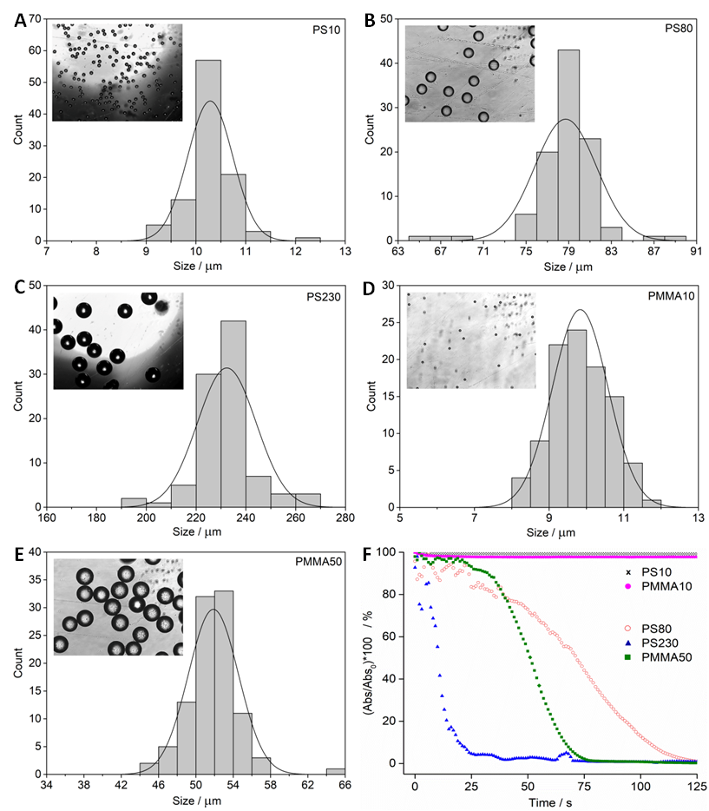
Figure 1. Size distributions and corresponding light microscopy images (insets) for a) PS 10 μm, b) PS 80 μm, c) PS 230 μm, d) PMMA 10 μm and e) PMMA 50 μm –diameter microparticles. f) Temporal change in absorption (λ=600 nm) for suspensions of microparticles in ultrapure water.

These data indicated that to achieve the targeted concentration in the test wells of the multi-well plates an aliquot had to be drawn from a stock suspension within 10 s after vortexing, while for PS230 aliquots had to be withdrawn within 5 s of vortexing and from depths of at least 3 cm in the tubes containing these suspensions. This step was carried out for every aliquot of PS230. Subsequently, after addition of fertilised embryos to the microplastic-containing wells, microparticles of ≥10 μm diameters were noted to have soon settled to the bottom of the wells with the embryos, with the smaller particles settling within 24 h.

Embryo exposures
Developing embryos exposed to the PS and PMMA microparticles, for all sizes and at concentrations ranging from 0.1 to 10 mg L⁻¹, did not result in any increase in developmental defects after a period of 72 h p-f (data not shown). The percentage of developmental defects in all cases did not surpass 10%, and overlapped with control values. No statistically significant differences between treatment schedules and control values were found. However, it was noted that plutei in some treatment schedules clearly showed ingestion and accumulation of microparticles in their gut. Specifically, 10 μm PMMA microparticles were oftentimes observed in the gut of larvae 72 h p-f with the particle accumulations appearing as black areas under microscope inspection. In contrast, the corresponding 10 μm PS microparticles were not observed to be taken up (Figure 2).

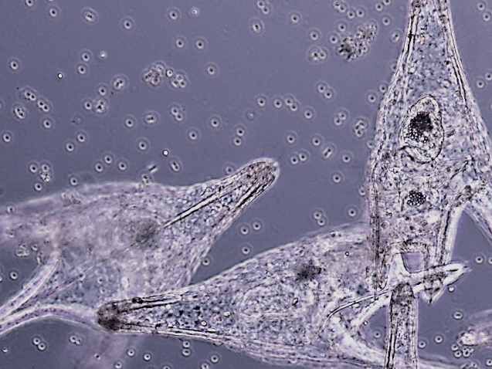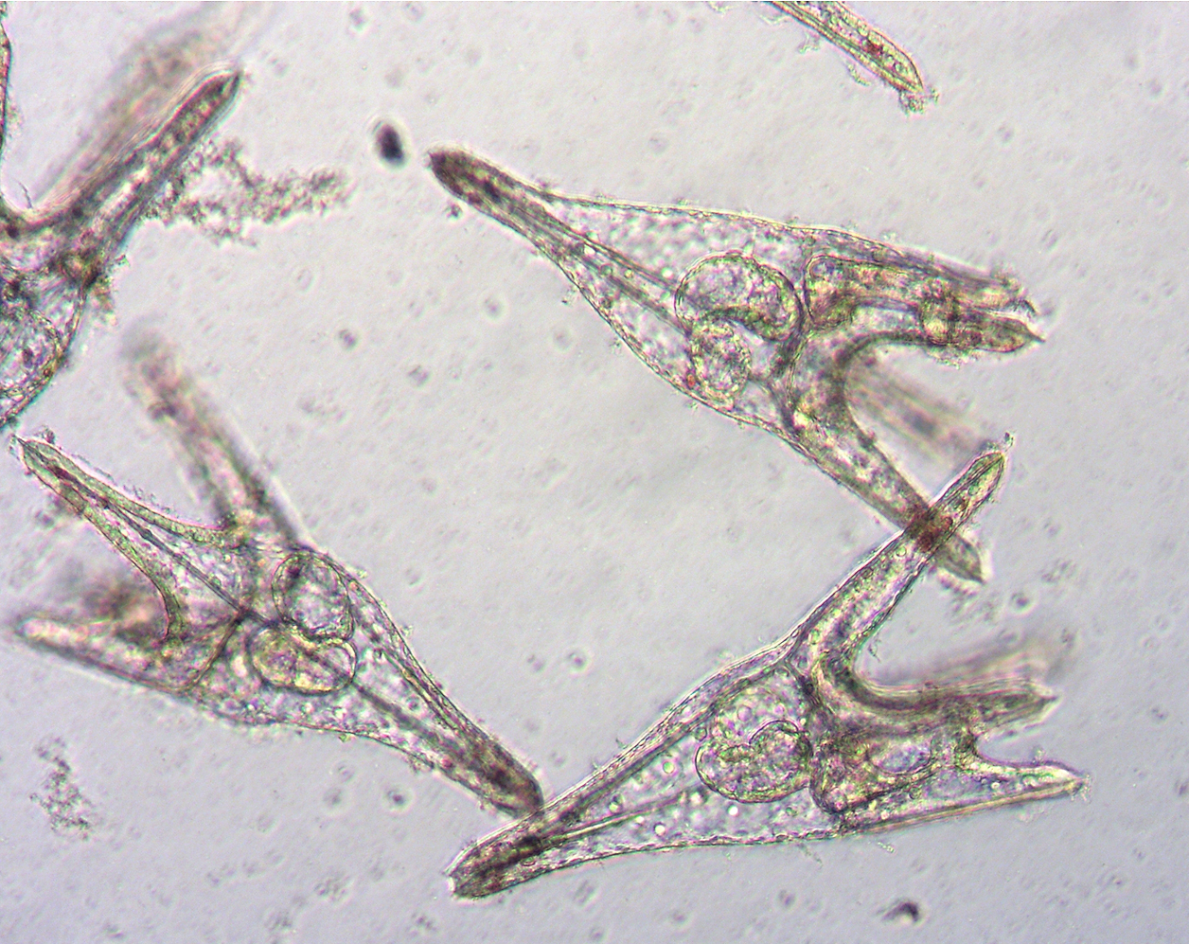
A
B

Figure 2. P. lividus larvae 72 h post fertilisation showing the A) absence of PS and B) presence of PMMA microparticles in the gut (all microparticles 10 μm diameter; scale bar 100 μm).

Sperm exposure
The fertilisation rates of eggs from sperm pre-exposed to PS microplastics, ranging in diameter from 1 to 230 μm and at concentrations from 0.1 to 10 mg L⁻¹, are given in Figure 3. For all sizes and concentrations of PS microplastics, the percentage of successfully fertilised eggs (52-72%) was found to be less than control values (75%). Comparing the group of three concentrations of each microplastic and the control sample, some treatments with larger microplastics (diameters of 10, 30, 80 and 230 μm) were found to show statistically significant reductions in fertilisation success compared to controls (ANOVA tables in Supplementary Information (SI)) although no significant difference was found between the different concentrations of the same microplastic sample. Subsequent Tukey post hoc tests indicated significant differences at the p<0.05 and p<0.01 levels, as shown in Figure 3. However, a clear trend in reduced ability to fertilise eggs as a function of particle concentration was not found. For example, treatments with particles of 30 and 80 μm diameters showed significant effects at the lowest concentration of 0.1 mg L⁻¹, while particles with diameters of 10 and 230 μm gave significantly reduced fertilisation rates only at the highest concentration of 10 mg L⁻¹.

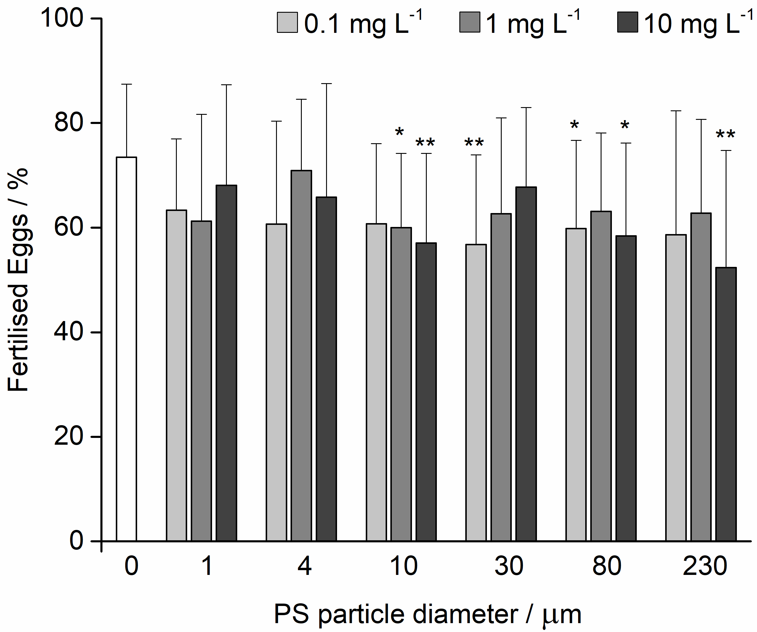
Figure 3. Fertilisation success (mean ± SD) after sperm pre-treatment with various sizes and concentrations of PS microparticles. Significance differences from the control are indicated at the levels *p<0.05, **p<0.01 (Tukey post hoc test).

However, clearer trends were noted for the fertilisation ability of sperm pre-exposed to 10 and 50 μm diameter PMMA microparticles as shown in Figure 4. Just as for PS microparticles, the pre-treated sperm showed reduced ability to fertilise eggs in all cases, with fertilisation rates in the range 50–62%. In nearly all cases, these differences with respect to controls (75%) were significant. For example, for 10 μm particles, fertilisation reduction was statistically significant (ANOVA tables in SI) for the 0.1 mg L⁻¹ treatment (Tukey; p<0.05) with greater significance for the 10 mg L⁻¹ treatment (Tukey; p<0.01). This trend was also noted for the larger 50 μm diameter particle treatments (SI). Surprisingly, treatment of sperm with PMMA particles at a concentration 1 mg L⁻¹ had a slightly less pronounced effect.

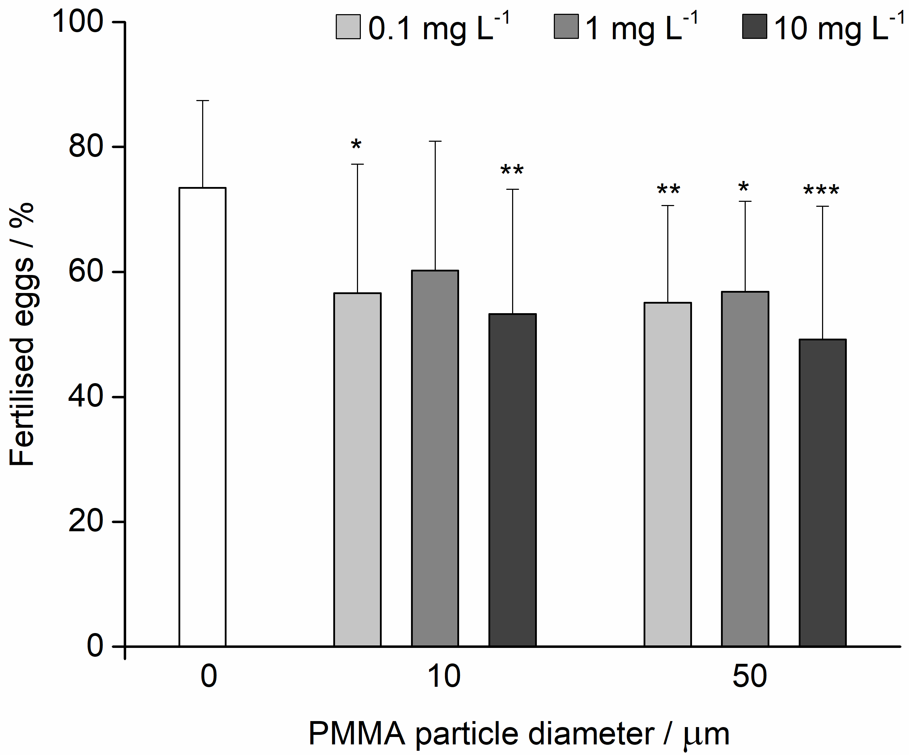
Figure 4. Fertilisation success (mean ± SD) after sperm pre-treatment with various sizes and concentrations of PMMA microparticles (Tukey post hoc test; significance level *p<0.05, **p<0.01, ***p<0.001).

Offspring Quality
The offspring larvae derived from eggs fertilised with sperm pre-exposed to PS microparticles in nearly all cases showed increased developmental defects, as shown in Figure 5. While 10% of control pluteus larvae displayed developmental defects including skeletal deformations such as crossed or separated tips or arms, offspring from pre-treated sperm showed such developmental defects, including developmental delays due to embryos remaining at gastrula or blastula phases 72 h p-f, in 9-30% of larvae. The increased developmental defects were found to be significant (ANOVA tables in SI) for the 1 mg L⁻¹ treatments for 4 μm and 80 μm particles (p<0.05) while the highest concentration of 10 μm particles corresponded with significantly increased (p<0.01) development defects.

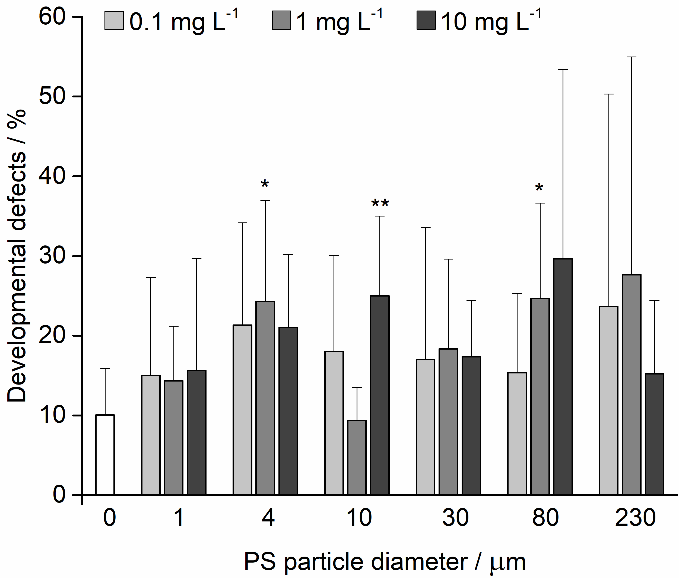
Figure 5. Developmental defects (mean ± SD) in offspring after treatment of sperm with various sizes and concentrations of PS microparticles (significance level *p<0.05, **p<0.01).

More consistent data were recorded for PMMA microparticles where the percentage developmental defects were greater (16–18%) in all treatment schedules compared to control values (10%) except for the 1 mg L⁻¹ treatment with 50 μm PMMA particles (26%; Figure 6). Shapiro-Wilk test indicated that all PMMA data groups were drawn from normally distributed populations except for the 10 mg L⁻¹ PMMA50 group, which was excluded from analysis of variance. At a significance level of p<0.05, Levene’s test indicated that the data for the 0.1 and 1 mg L⁻¹ groups were homoscedastic (SigmaPlot software P=0.061) or heteroscedastic (OriginPro software F=3.438, P=0.047). Such differences are known to arise on occasion from the specific algorithms used by different software packages, hence both scenarios of equal or unequal variance are presented (Bergmann et al., 2000). ANOVA with equal variance indicated means statistically different from the controls (F=6.629, P=0.005) while KW for unequal variance gave a similar result (Chi-square=6.044, P=0.049). The rate of developmental defects in urchins after treatment with 1 mg L⁻¹ of 50 μm PMMA was correspondingly determined by post hoc Tukey test to be significant at p<0.01 and Mann-Whitney U-test at p(exact)=0.01 (U=16.5). It should be noted that applying the Mann-Whitney U-test in cases where there are unequal variances may tend towards Type 1 error (Kasuya, 2001).
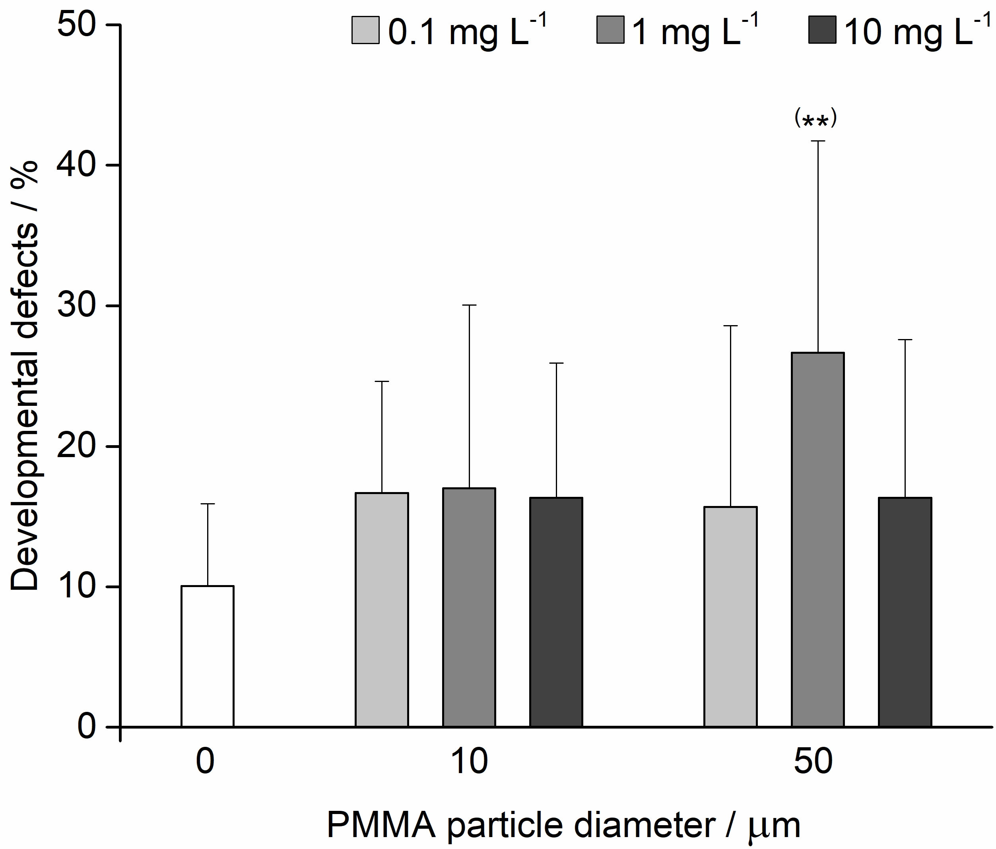
Figure 6. Developmental defects (mean ± SD) in offspring after treatment of sperm with various sizes and concentrations of PMMA microparticles (significance level **p<0.01).

Leachates
The ability of microplastic leachate to negatively impact on fertilisation success after sperm pre-treatment in most cases showed only slightly reduced numbers of fertilised eggs (Figure 7) although a more significant effect was noted for PS10 with 4.5% lower fertilisation success compared to the control (Tukey post hoc test p<0.05; ANOVA tables in SI).

Scores for offspring of sperm pre-treated with microplastic leachate in terms of developmental defects are given in Figure 8. While PMMA50 showed a similar level of developmental defects to the control (8%), the other treatments were noted to have caused a higher level of developmental defects (12-24%). The number of developmental malformations in offspring of PMMA50 was significantly different (p<0.05) from the control (ANOVA tables in SI).

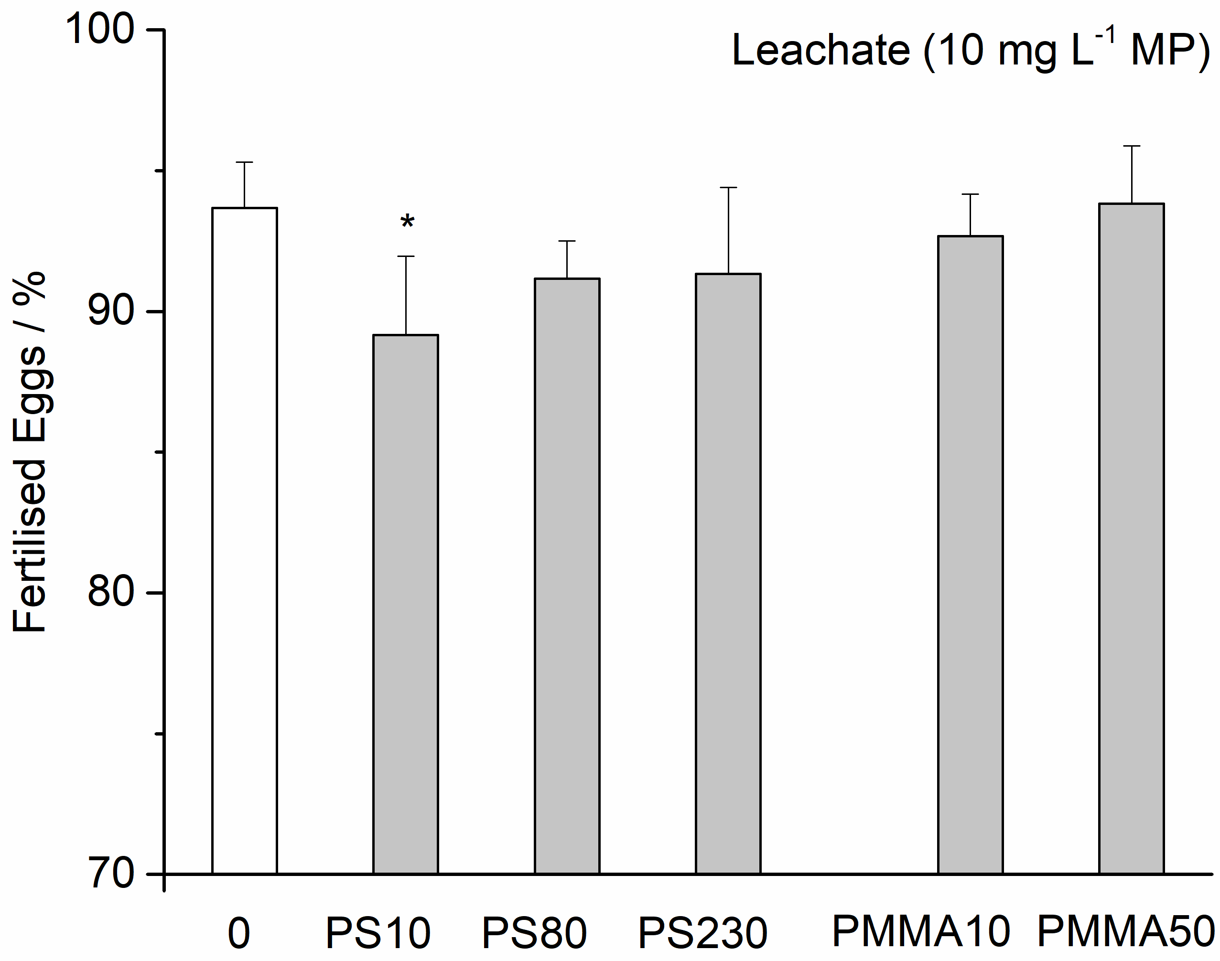
Figure 7 Fertilisation success (mean ± SD) after sperm pre-treatment with leachate (derived from 10 mg L⁻¹ microplastic in FSW) from various sizes of PS and PMMA microparticles (Tukey post hoc test; significance level *p<0.05).

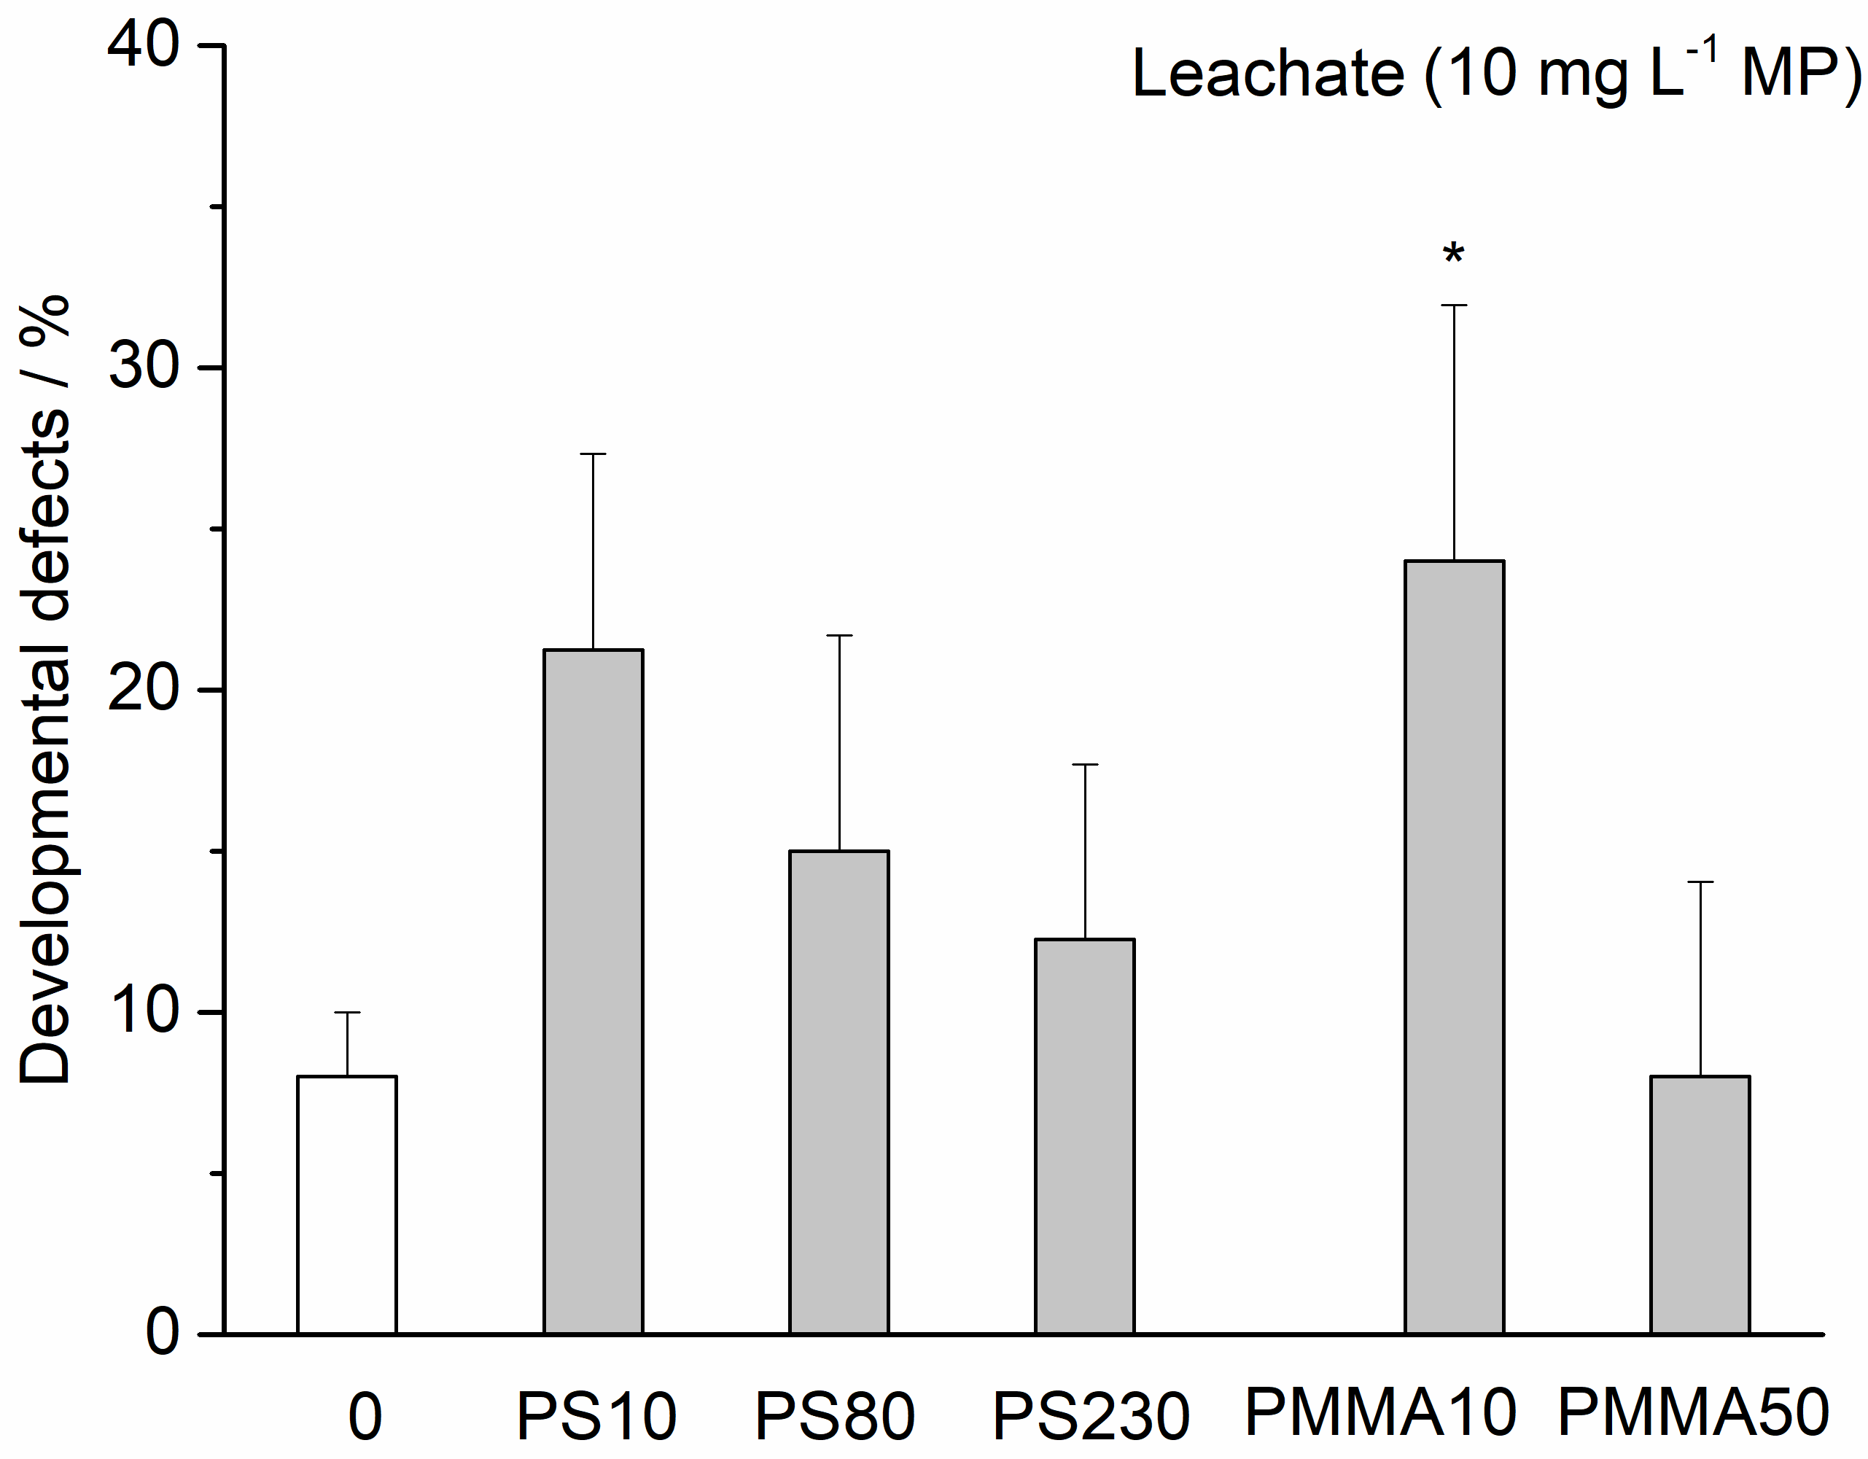
Figure 8 Developmental defects (mean ± SD) in offspring after treatment of sperm with leachate (derived from 10 mg L⁻¹ microplastic in FSW) from various sizes of PS and PMMA microparticles (Tukey post hoc test; significance level *p<0.05).

Discussion
The data presented herein show the effects of small (1-10 μm), mid-sized (30-80 μm) and large (230 μm) PS microparticles on P. lividus sperm and their corresponding offspring after a period of three days. The sizes were selected as being similar to urchin eggs (mid-sized) and larvae (large) while the small-sized microparticles were sufficiently small so as to allow them to be accommodated in the gut of urchins should they be taken up. The fertilisation ability of sperm decreased and developmental defects in offspring increased after sperm exposure to these microplastics suggesting the potential for harm to male gametes which may in turn be transferred to offspring. These results are in line with those of Martínez-Gómez et al. (2017) who found that fertilisation of P. lividus eggs by sperm in the presence of 6 μm PS microparticles at concentrations of 10³-10⁵ particles mL⁻¹ led to a significantly reduced fertilisation rate (Table 1). In comparison, a recent study on the potential for transmissible damage from sperm pre-treated with PS microparticles to their offspring in the urchin Sphaerechinus granularis (Trifuoggi et al., 2019), showed even greater negative effects in terms of fertilisation ability, with fertilisation rates reduced by up to 50% for 10, 80 and 230 μm virgin PS microparticles at concentrations of 0.1 mg L⁻¹. Interestingly, both these investigations found the greatest negative effect on fertilisation success at lower rather than higher tested concentrations. Offspring from PS-treated gametes were further shown by Martínez-Gómez et al. (2017) to have significant reductions in larval length while in the present work the offspring generally displayed only a mild level of developmental arrest or defects. In contrast, a consistently higher level of developmental defects was noted in the offspring of S. granularis sperm exposed to various sizes and concentrations of PS microparticles (Table 1) with 5-8 times greater developmental anomalies than in controls (Trifuoggi et al., 2019). It was found in the present work that leachate from virgin PS microparticles also negatively affected fertilisation success, with leachate from PS10 showing a similar effect to sperm treated with PS10 microparticles where there was a significant reduction in fertilisation success. A monotonic increase in developmental defects in offspring from pre-treated sperm with decreasing particle size was also noted, with PS10 leachate giving rise to 3 times more malformations than control samples.

Table 1. Summary of key findings in investigations of the impact of microplastics on sea urchin early development.

Urchin MP Size Concentration Exposure End-point Effects Reference
μm mg L⁻¹ h
P. lividus PS 0.1 0.001, 0.01, 0.1, 24 development defects, no effect on larval development or Gambardella et al. (2018)
1, 10 immobilisation, speed immobilisation; increased swimming speed
alteration of swimming for 0.001-0.1 mg L⁻¹, LOEC 0.001 mg L⁻¹

P. lividus PS 10 0.125, 1.25, 12.5, 48 larval length, no effect on survival; arm length and body Messinetti et al. (2018)
25 survival width alterations at all concentrations;
ingestion noted

S. granularis PS 10, 80, 230 0.1, 1, 5, 50 72 development defects, concentration-dependent increase in Trifuoggi et al. (2019)
PMMA 10, 50 cytogenetic anomaly, defects; cytogenetic damage ≥5 mg L⁻¹;
transmissible damage offspring damage, ingestion noted

P. lividus PS 6 10³-10⁵ spheres mL⁻¹ 48 larval length, reduced fertilisation; retarded growth and Martínez-Gómez et al.
PE >0-80 fluff 5, 500, 5000 developmental defects, developmental anomalies for virgin and (2017)
fertilisation rate aged particles, and leachates; ingestion
T. gratilla PE 25-32 1, 10, 100, 300 120 larval length, smaller body widths at the highest dose, Kaposi et al. (2014)
spheres mL⁻¹ development defects, dose; ingestion in the absence of food,
ingestion/egestion egestion within 7 h

P. lividus PE 4-15, <40ª 0, 1, 3, 10, 30, 100 48 larval length LOEC ≥100 mg L⁻¹; ingestion noted Beiras et al. (2018)

P. lividus PE 4-6 1, 10 48 larval length no acute effects; ingestion noted Beiras and Tato (2019)

P. lividus PVC ≤20^{b} 0.3, 1, 3, 10, 30 48 larval length growth retarded at 10, 30 mg L⁻¹; Oliviero et al. (2019)
LOEC 10 mg L⁻¹, EC50 16.2 mg L⁻¹

P. lividus PET 5-60, 61-499, 0.1 72 h larval length, mixed effects from leachates and Piccardo et al. (2020)
500- flakes^{c} development defects particles depending on pH (7.5 / 8)
and if larvae fed or not

MP – microplastic; LOEC – lowest observed effect concentration; ª micronised from 500 μm pellets; ^{b} micronized from inflatable toys; ^{c} micronised from 1 mm pellets

Experiments focused towards determining the effects on developing P. lividus embryos exposed to PS microparticles after fertilisation have given a diverse range of results. Compared to the present work or investigations by Gambardella et al. (2018) where an increase in developmental defects was not found, other investigations have noted a significant increase in developmental anomalies (Martínez-Gómez et al., 2017), and significant reductions in larval arm length and body width (Messinetti et al., 2018) (Table 1). Significant increases in developmental defects after exposure to larger PS microparticles were also noted in S. granularis plutei (Trifuoggi et al., 2019). In addition to growth retardation and occurrence of deformities, PS microparticles have also been reported to have an impact on larval swimming speed (Gambardella et al., 2018).

Just as for polystyrene, polyethylene microparticles have also shown varied behaviour although this may be related to the test organism used, for example no adverse effects on larval growth were found in P. lividus (Beiras et al., 2018; Beiras and Tato, 2019) yet growth retardation was noted in T. gratilla (Kaposi et al., 2014). Unlike PE, other microplastics such as PVC (Oliveiro et al., 2019) and PET (Piccardo et al., 2020) have also been reported to cause growth retardation in P. lividus larvae.

As the sizes of microparticles and concentrations being tested are in many cases similar, it is becoming increasingly possible to draw general conclusions on the ability of these materials to induce negative effects on developing embryos, particularly as the same test organism, P. lividus, is commonly used. However, the few studies carried out on other species of urchin hint at the possibility that not all species are equally sensitive to specific sizes, concentrations and types of microplastics. Indeed a similar conclusion was reached regarding the toxicity of a wide range of rare earth elements to the embryos of three urchin species (Trifuoggi et al., 2017), with S. granularis broadly found to be the most, and P. lividus the least, sensitive. Silver nanoparticles were also found to cause significant defects during embryonic development of S. granularis, P. lividus and Arbacia lixula, with the latter proving to be the most sensitive, followed by S. granularis, and P. lividus being the least sensitive (Burić et al., 2015). The use of P. lividus embryos in toxicity testing is convenient for a number of reasons including ease of rapidly determining fertilisation, their well differentiated early life stages and skeletal features, and adults which may yield fertile gametes for much of the year. However, as this species may be the most robust among Mediterranean urchin species, it may be worthwhile to use potentially more sensitive species such as S. granularis for determining baselines in microplastics toxicity testing.

For comparison with more widely researched PS microplastics, this study also probed the effect of small (10 μm) and mid-sized (50 μm) PMMA microparticles. PMMA microparticles may be an important pollutant in the marine environment; for example, while significantly less researched than other microplastics, PMMA microparticles have been found in North Sea fish while all other types of microplastic (>100 μm) were absent (Hermsen et al., 2017). In the present study, even greater deleterious effects on embryonic development of offspring of sperm pre-exposed to PMMA particles compared to PS particles were noted. This is consistent with data previously reported for S. granularis by Trifuoggi et al. (2019) where PMMA microparticles also caused greater negative effects than PS microparticles. However, it should be noted that leachate from PMMA microparticles in the present study only showed a significant increase in offspring developmental defects for PMMA10 although, again, this was greater than that induced by PS. Thus, in addition to possible sensitivity differences between urchin species, the chemical identity of the microplastics may also play a role in governing toxicity. For example, the hydrophobicity of a range of microplastics, deriving from their chemical identity, has been shown to affect larval survival and settlement of the barnacle Amphibalanus amphitrite (Li et al., 2016). Hence, not only can the specific microplastic polymers potentially give rise to different effects but also the life stages of test organisms may not be equally sensitive to toxicants as previously shown for fertilised eggs, blastula, gastrula and plutei phases in early urchin development (Burić et al., 2015).

In addition to the impact of polymer composition of the microparticles on embryos and larvae, consistent increases, monotonic or otherwise, in toxicity as a function of concentration were generally not observed. The mid-sized and large microparticles were too big to be ingested yet in cases showed the greatest negative effects on larvae. Further, the small-sized microparticles typically did not show any strong negative effect on the larvae even though they were ingested and accumulated in the larvae. Thus, developmental defects noted in other studies of microplastics in P. lividus larvae and ascribed to ingestion effects (Beiras et al. 2018) contrast with the results of the present study, hence the exact source of the toxicity of the microparticles used herein remains unresolved. Ingestion of a range of microplastics by P. lividus has also been shown, including PS (Messinetti et al., 2018), PVC (Oliveiro et al., 2019) and high density PE (Martínez-Gómez et al., 2017) with an egestion rate for PE microparticles calculated at 7 h in T. gratilla (Kaposi et al., 2014). However, it was not possible to unambiguously ascribe deleterious effects to microparticle uptake alone. Further, why the PMMA microparticles in the present work seemed to be preferentially ingested compared to the PS microparticles is unclear, and how such ingestion might lead to any adverse effects on subsequent larval growth and eventual metamorphosis remains a topic to be investigated. For example, in terms of feeding, microplastics may impede movement of food through the intestinal tract (Tourinho et al., 2010) or cause a decrease in food intake due to pseudo-satiation (Derraik, 2002).

Bio-physical interactions between developing embryos or larvae and microplastics, based on varying surface curvature deriving from different microparticle radii, is not thought to be a basis for negative effects and no adherence of larvae to microparticles was noted, as also reported by Martínez-Gómez et al. (2017). Larger particles individually have a much greater surface area than the smaller particles, and greater toxicity was noted for larger particles. However, on the basis of equal mass, the total surface area of the larger particles is actually far less than the total surface area of small particles, thus the small particles present a greater potential for interaction with the embryos and larvae. While external physical interaction between the particles and larvae might not be of significance in its own right, the large surface area of the small particles increases the potential for increased and faster leaching of secondary chemicals such as plasticisers, emollients, colourants and unreacted monomers. Further, it has been postulated that microplastics at higher concentrations may tend to aggregate, thus presenting a smaller surface-water interface that may lead to reduced leaching rates and thus less toxicity (Martínez-Gómez et al., 2017). Indeed, leaching of chemicals from microplastics has been suggested as an important source of toxicity (Gandara e Silva et al., 2016) apart from many polymers in their own right representing a significant hazard (Lithner et al., 2011). In particular, even very low concentrations of such chemicals may be sufficient to cause signals of endocrine disruption, for example as found for Japanese medaka Oryzias latipes exposed to polyethylene microplastics (Rochman et al., 2014). Leachates from microparticles did not prove particularly deleterious for treated sperm in terms of fertilisation ability or the quality of the ensuing offspring, suggesting that chemical cues from these specific virgin microplastics is not a major source of toxicity. However, it should be borne in mind that volatilisation of chemicals such as polystyrene monomers leaching from the microplastics may provide a pathway to lower toxicity of leachates than might otherwise be expected (Fu and Alexander, 1992). In the present work, ingestion of PMMA microparticles and lack of uptake of PS microparticles corresponds with the more negative effects of the former. Indeed, studies on even smaller PS particles (0.1 μm) also did not find ingestion of these polymer spheres (Gambardella et al., 2018). However, this does not explain why larger particles with a lower overall surface area for a given mass of microparticles have, in cases, stronger negative effects than smaller particles which may potentially leach chemicals faster. Efforts at determining the presence of secondary chemicals in microparticle leachates by high performance liquid chromatography - mass spectrometry (HPLC Agilent 1200, MS Agilent 6410), that would indicate a possible source for toxicity in this study, gave equivocal results (data not shown). Similar difficulty, due to likely very low concentrations of such chemicals, was also reported in other studies that found biological signals of endocrine disruption in oysters after exposure to 6 μm PS microparticles (Sussarellu et al., 2016). However, more research is required to unequivocally determine the primary source of toxicity of virgin and/or aged microplastics.

Conclusion
Exposure of P. lividus sperm to PS and PMMA microparticles in the size range 1-230 μm, and their corresponding leachates, resulted in modestly reduced fertilisation success and offspring quality, with the greatest effects noted for PMMA. P. lividus larvae were found to have ingested PMMA microparticles but not those of PS, indicating a potential mode for enhancing toxicity. Developing embryos/larvae generally did not display strong developmental defects after exposure to the microplastics over a range of concentrations, with leachates aslo showing only mild spermiotoxic effects. These limited embryo- and spermiotoxicity outcomes in P. lividus sharply differ from the previously reported data from S. granularis indicating potential interspecies sensitivity to microplastics. By extension, different species sensitivities, or different life stage sensitivity within a species, indicate that diverse microplastics – and possibly other xenobiotics – may cause different responses and impacts in terms of environmental effects at the community level, pointing to the need for future relevant mesocosm studies.

Acknowledgement
This work has been supported by the Croatian Science Foundation under grant number IP-2018-01-5351, and Environment and Climate Change Canada. The authors are grateful to Dr. Özge Kozguş Güldü for DLS measurements. Declarations of conflict: none.

References
Alimi OS, Farner Budarz J, Hernandez LM, Tufenkji N (2018). Microplastics and nanoplastics in aquatic environments: Aggregation, deposition, and enhanced contaminant transport. Environ. Sci. Technol. 52:1704-1724. https://doi.org/10.1021/ acs.est.7b05559.
Auta HS, Emenike CU, Fauziah SH (2017). Distribution and importance of microplastics in the marine environment: A review of the sources, fate, effects, and potential solutions. Environ. Int. 102:165–176. http://doi.org/10.1016/j.envint.2017.02.013.
Beiras R, Bellas J, Cachot J, Cormier B, Cousin X, Engwall M, Gambardella C, Garaventa F, Keiter S, Le Bihanic F, López-Ibáñez S, Piazza V, Rial D, Tato T, Vidal-Liñán L (2018). Ingestion and contact with polyethylene microplastics does not cause acute toxicity on marine zooplankton. J. Hazard. Mater. 360:452-460. https://doi.org/10.1016/j.jhazmat .2018.07.101.
Beiras R, Tato T (2019). Microplastics do not increase toxicity of a hydrophobic organic chemical to marine plankton. Mar. Pollut. Bull. 138:58-62. https://doi.org /10.1016/j.marpolbul.2018.11.029.
Bergmann R, Ludbrook J, Spooren WPJM (2000). Different outcomes of the Wilcoxon—Mann—Whitney test from different statistics packages, Am. Stat. 54::72-77. https://doi.org/10.1080/00031305.2000.10474513
Burić P, Jakšić Ž, Štajner L, Dutour Sikirić M, Jurašin D, Cascio C, Calzolai L, Lyons DM (2015). Effect of silver nanoparticles on Mediterranean sea urchin embryonal development is species specific and depends on moment of first exposure. Mar. Environ. Res. 111:50-59. https://doi.org/10.1016/j.marenvres.2015.06.015.
Carreras-Colom E, Constenla M, Soler-Membrives A, Cartes JE, Baeza M, Padrós F, Carrassón M (2018). Spatial occurrence and effects of microplastic ingestion on the deep-water shrimp Aristeus antennatus. Mar. Pollut. Bull. 133:44-52. https://doi.org /10.1016/j.marpolbul.2018.05.012.
Chua EM, Shimeta J, Nugegoda D, Morrison PD, Clarke BO (2014). Assimilation of polybrominated diphenyl ethers from microplastics by the marine amphipod,Allorchestes compressa. Environ. Sci. Technol. 48:8127–8134. http://doi.org/10.1021/es405717z.
Della Torre C, Bergami E, Salvati A, Faleri C, Cirino P, Dawson KA, Corsi I (2014). Accumulation and embryotoxicity of polystyrene nanoparticles at early stage of development of sea urchin embryos Paracentrotus lividus. Environ. Sci. Technol. 48:12302-12311. https://doi.org/10.1021/es502569w.
Derraik JGB (2002). The pollution of the marine environment by plastic debris: a review. Mar. Pollut. Bull. 44:842–852. https://doi.org/10.1016/s0025-326x(02)00220-5
Eriksen M, Lebreton LCM, Carson HS, Thiel M, Moore CJ, Borerro JC, Reisser J (2014). Plastic Pollution in the World’s Oceans: More than 5 Trillion Plastic Pieces Weighing over 250,000 Tons Afloat at Sea. PLoS ONE, 9:e111913. https://doi.org/10.1371/journal .pone.0111913.
Espinosa C, Cuesta A, Esteban MÁ (2017). Effects of dietary polyvinylchloride microparticles on general health, immune status and expression of several genes related to stress in gilthead seabream (Sparus aurata L.). Fish Shellfish Immunol. 68:251-259. https://doi.org/10.1016/j.fsi.2017.07.006.
Foley CJ, Feiner ZS, Malinich TD, Höök TO (2018). A meta-analysis of the effects of exposure to microplastics on fish and aquatic invertebrates. Sci. Total Environ. 631-632:550-559. https://doi.org/10.1016/j.scitotenv.2018.03.046.
Fu MH, Alexander M (1992). Biodegradation of styrene in samples of natural environments. Environ. Sci. Technol. 26:1540–1544. https://doi.org/10.1021/es00032a007.
Gambardella C, Morgana S, Bramini M, Rotini A, Manfra L, Miglior, L, Piazza V, Garaventa F, Faimali M (2018). Ecotoxicological effects of polystyrene microbeads in a battery of marine organisms belonging to different trophic levels. Mar. Environ. Res. 141:313-321. https://doi.org/10.1016/j.marenvres.2018.09.023.
Gandara e Silva PP, Nobre CR, Resaffe P, Pereira CDS, Gusmão F (2016). Leachate from microplastics impairs larval development in brown mussels. Water Res. 106:364-370. https://doi.org/10.1016/j.watres.2016.10.016.
Hermsen E, Pompe R, Besseling E, Koelmans AA (2017). Detection of low numbers of microplastics in North Sea fish using strict quality assurance criteria. Mar. Pollut. Bull. 122:253-258. https://doi.org/10.1016/j.marpolbul.2017.06.051
Jovanović B, Gökdağ K, Güven O, Emre Y, Whitley EM, Kideys AE (2018). Virgin microplastics are not causing imminent harm to fish after dietary exposure. Mar. Pollut. Bull. 130:123-131. https://doi.org/10.1016/j.marpolbul.2018.03.016.
Kaposi KL, Mos B, Kelaher BP, Dworjanyn SA (2014). Ingestion of microplastic has limited impact on a marine larva. Environ. Sci. Technol. 48:1638-1645. https://doi.org /10.1021/es404295e.
Kasuya E (2001). Mann–Whitney U test when variances are unequal. Anim. Behav. 61: 1247–1249. https://doi.org/10.1006/anbe.2001.1691
Li HX, Getzinger GJ, Ferguson PL, Orihuela B, Zhu M, Rittschof D (2016). Effects of toxic leachate from commercial plastics on larval survival and settlement of the barnacle Amphibalanus amphitrite. Environ. Sci. Technol. 50: 924-31. https://doi.org /10.1021/acs.est.5b02781
Lithner D, Larsson Å, Dave G (2011). Environmental and health hazard ranking and assessment of plastic polymers based on chemical composition. Sci. Total Environ. 409:3309–3324. https://doi.org/10.1016/j.scitotenv.2011.04.038
Martínez-Gómez C, León VM, Calles S, Gomáriz-Olcina M, Vethaak AD (2017). The adverse effects of virgin microplastics on the fertilisation and larval development of sea urchins. Mar. Environ. Res. 130:69-76. https://doi.org/10.1016/j.marenvres.2017.06.016
Mato Y, Isobe T, Takada H, Kanehiro H, Ohtake C, Kaminuma, T (2001). Plastic resin pellets as a transport medium for toxic chemicals in the marine environment. Environ. Sci. Technol. 35:318-324. https://doi.org/10.1021/es0010498.
Messinetti S, Mercurio S, Parolini M, Sugni M, Pennati R (2018). Effects of polystyrene microplastics on early stages of two marine invertebrates with different feeding strategies. Environ. Pollut. 237:1080-1087. https://doi.org/10.1016/j.envpol.2017.11.030.
Nobre CR, Santana MFM, Maluf A, Cortez FS, Cesar A, Pereira CDS, Turra A (2015). Assessment of microplastic toxicity to embryonic development of the sea urchin Lytechinus variegatus (Echinodermata: Echinoidea). Mar. Pollut. Bull. 92:99-104. https:// doi.org/10.1016/j.marpolbul.2014.12.050.
Oliviero M, Tato T, Schiavo S, Fernández V, Manzo S, Beiras R (2019). Leachates of micronized plastic toys provoke embryotoxic effects upon sea urchin Paracentrotus lividus. Environ. Pollut. 247:706-715. https://doi.org/10.1016/j.envpol.2019.01.098.
Pagano G, Esposito A, Bove P, de Angelis M, Rota A, Giordano GG (1983). The effects of hexavalent and trivalent chromium on fertilisation and development in sea urchins. Environ. Res. 30:442-452. https://doi.org/10.1016/0013-9351(83)90230-X.
Pagano G, Korkina LG, Iaccarino M, De Biase A, Deeva IB, Doronin YK, Guida M, Melluso G, Meriç S, Oral R, Trieff NM, Warnau M (2001). Developmental, cytogenetic and biochemical effects of spiked or environmentally polluted sediments in sea urchin bioassays. In: Garrigues P, Walker CH, Barth H (Eds) Biomarkers in Marine Ecosystems: A Practical Approach. Elsevier, Amsterdam, pp 85-129.
Pagano G, Guida M, Trifuoggi M, Thomas PJ, Palumbo A, Romano G, Oral R (2017). Sea urchin bioassays in toxicity testing: I. Inorganics, organics, complex mixtures and natural products. Expert Opin. Environ. Biol. 6:1. https://doi.org/10.4172/2325-9655.1000142.
Pinsino A, Bergami E, Della Torre C, Vannuccini ML, Addis P, Secci M, Dawson KA, Matranga V, Corsi I (2017). Amino-modified polystyrene nanoparticles affect signalling pathways of the sea urchin (Paracentrotus lividus) embryos. Nanotoxicology 11:201-209. https://doi.org /10.1080/17435390.2017.1279360.
Rochman CM, Kurobe T, Flores I, Teh SJ (2014). Early warning signs of endocrine disruption in adult fish from the ingestion of polyethylene with and without sorbed chemical pollutants from the marine environment. Sci. Total Environ. 493:656–661. https://doi.org/10.1016/j.scitotenv.2014.06.051.
Rochman CM, Brookson C, Bikker J, Djuric N, Earn A, Bucci K, Athey S, Huntington A, McIlwraith H, Munno K, De Frond H, Kolomijeca A, Erdle L, Grbic J, Bayoumi M, Borrelle SB, Wu T, Santoro S, Werbowsk LM, Zhu X, Giles RK, Hamilton BM, Thaysen C, Kaura A, Klasios N, Ead L, Kim J, Sherlock C, Ho A, Hung C (2019). Rethinking microplastics as a diverse contaminant suite. Environ. Toxicol. Chem. 38:703-711. https://doi.org/10.1002/etc.4371.
Ryan PG, Moore CJ, van Franeker JA, Moloney CL (2009). Monitoring the abundance of plastic debris in the marine environment. Phil. Trans. Royal Soc. B 364:1999–2012. https://doi.org/10.1098/rstb.2008.0207.
Santana MFM, Moreira FT, Pereira CDS, Abessa DMS, Turra A (2018). Continuous exposure to microplastics does not cause physiological effects in the cultivated mussel Perna perna. Arch. Environ. Contam. Toxicol. 74:594-604. https://doi/10.1007/s00244-018-0504-3.
Sussarellu R, Suquet M, Thomas Y, Lambert C, Fabioux C, Pernet MEJ, Le Goïc N, Quillien V, Mingant C, Epelboin Y, Corporeau C, Guyomarch J, Robbens J, Paul-Pont I, Soudant P, Huvet A (2016). Oyster reproduction is affected by exposure to polystyrene microplastics. PNAS 113:2430-2435. https://doi.org/10.1073/pnas.1519019113.
Tourinho PS, Ivar do Sul JA, Fillmann G (2010). Is marine debris ingestion still a problem for the coastal marine biota of southern Brazil? Mar. Pollut. Bull. 60:396–401. https://doi.org/10.1016/j.marpolbul.2009.10.013.
Trifuoggi M, Pagano G, Guida M, Palumbo A, Siciliano A, Gravina M, Lyons DM, Burić P, Levak M, Thomas PJ, Giarra A, Oral R (2017). Comparative toxicity of seven rare earth elements in sea urchin early life stages. Environ. Sci. Poll. Res. 24:20803-20810. https://doi.org/10.1007/s11356-017-9658-1.
Trifuoggi M, Pagano G, Oral R, Pavičić-Hamer D, Burić P, Kovačić I, Siciliano A, Toscanesi M, Thomas PJ, Paduano L, Guida M, Lyons DM (2019). Microplastic-induced damage in early embryonal development of sea urchin Sphaerechinus granularis. Environ. Res. 179:108815. https://doi.org/10.1016/j.envres.2019.108815.

