Imaging of organic samples with Megaelectron Volt Time-of-flight Secondary Ion Mass Spectrometry capillary microprobe
Marko Brajković*, Ivančica Bogdanović Radović, Marko Barac, Donny Domagoj Cosic, Zdravko Siketić
Ruđer Bošković Institute, Bijenička c. 54, HR-10000 Zagreb, Croatia
*corresponding author, mbrajkov@irb.hr
Keywords: MeV TOF-SIMS, capillary microprobe, imaging applications, start trigger, secondary electrons

Address reprint requests to:
Marko Brajković, Bijenička c. 54, 10000 Zagreb, Croatia, +38514571227, mbrajkov@irb.hr
Abstract
Time-of-flight Secondary Ion Mass Spectrometry (TOF SIMS) with MeV primary ions offers a fine balance between secondary ion yield for molecules in the mass range from 100 to 1000 Da and beam spot size, both of which are critical for imaging applications of organic samples. Using conically shaped glass capillaries with an exit diameter of a few micrometers, a high energy heavy primary beam can be collimated to less than 10 µm. In this work, imaging capabilities of such a setup are presented for some organic samples (leucine-evaporated mesh, fly wing section, ink deposited on paper). Lateral resolution measurement and molecular distributions of selected mass peaks are shown. The negative influence of beam halo, an unavoidable characteristic of primary beam collimation with conical capillary, is also discussed. A new start trigger for TOF measurements based on the detection of secondary electrons released by the primary ion is presented. This method is applicable for a continuous primary ion beam, and for thick targets that are not transparent to the primary ion beam. The solution preserves the good mass resolution of the thin target setup, where the detection of primary ions with a PIN diode is used for start trigger, reduces the background, and enables a wide range of samples to be analyzed.

Introduction
Secondary ion mass spectrometry (SIMS) with MeV primary ions can be a useful technique for imaging of organic samples. Higher yield of heavier molecules (100-1000 Da) and less fragmentation due to different interaction mechanism is a significant advantage for analysis of samples with molecules of interest in this mass range [1,2]. Lateral resolution as low as few microns can be exploited for determination of spatial distribution of heavy molecules. In the last 15 years, several accelerator facilities have installed MeV Time-of-Flight SIMS setups and started to use this technique routinely [3-7]. Usually, magnetic or electrostatic lenses are used to focus the primary beam. One disadvantage of this kind of beam focusing is its inability to focus heavy primary ions with high energy (such as 20 MeV Iodine) which have been shown to produce a higher secondary ion yield [1,2,8,9]. One cheap and relatively simple alternative is beam collimation with borosilicate capillaries with exit diameter of few micrometers [10-12]. In this way, any primary beam that can be delivered by the accelerator will be collimated to approximately the same dimension, independently of ion mass and energy. Another advantage of capillaries is the possibility of beam extraction into the air without an additional window which separates the high-vacuum part of the setup and negatively affects beam spot size.
In our setup [12], capillaries have a conical shape, with an inlet diameter of 0.8 mm and an exit diameter of 2.5 – 5 µm. As a result, the collimated beam consists of two distinct parts: a core, made of ions directly transmitted through the capillary, and a halo. The halo is made of ions that are scattered at the capillary walls near the capillary end and ions that pass through the capillary walls at the very end of the capillary tip. While the beam core ions have full energy, ions from the halo can have much lower energy, depending on the amount of energy loss inside the capillary walls. Halo to core ratio, as well as the halo’s shape, is different for every capillary because they are not produced in a perfectly controllable manner. For the homemade capillaries used in our system, produced by ETH in Switzerland, that also works with these capillaries [13], the ratio varied from 30 to 50 percent, which presents a significant disadvantage for imaging applications.
In this work, the application of the capillary MeV TOF-SIMS setup for imaging of organic sample will be presented. Previously, a particle detector behind the sample was used to detect primary ions and start the TOF measurement, limiting the use of the setup only to thin targets, transparent to the primary ion beam. To expand the number of available targets and facilitate the preparation of the targets, a new trigger for start signal of the TOF measurements based on the detection of secondary electrons is introduced.
Experimental setup
Measurements were performed at the MeV TOF SIMS capillary microprobe of the Ruđer Bošković accelerator facility. A 6 MV Van de Graaff accelerator was used to obtain Cu and I primary beams. Two different options for triggering the start signal of the TOF measurements are available: a) detection of primary ions with a particle detector placed behind the transparent target (thin target or transmission mode), and b) detection of secondary electrons emitted from the sample surface upon the impact of the primary ion with an electron multiplier (thick target mode). Primary beam pulsing before the capillary is not an option because the continuous beam current after passing through the capillary is already low, up to 15 kHz. In the first mode, which can be only used for thin targets, signal from a Hamamatsu S3590-09 silicon PIN diode placed 10 mm behind the target, is used as a start trigger. More details about the transmission setup can be found in Ref 12.
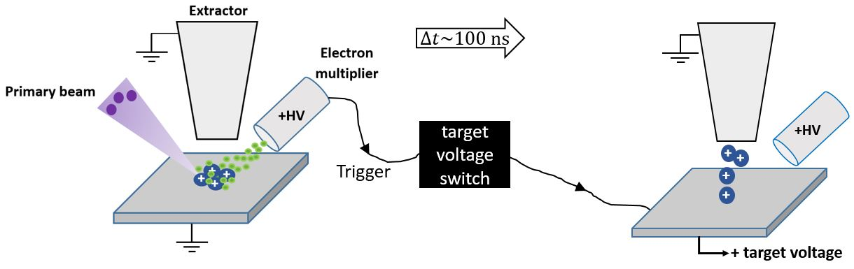
Fig. 1 Schematic overview of the setup and operating principle for thick targets: detection of secondary electrons (left) triggers the start signal of the TOF measurements and sends a signal to the high voltage switch which increases the extraction voltage to +3 kV (right).
To enable the analysis of targets with arbitrary thickness, the setup has been upgraded with the electron multiplier to detect the secondary electrons released from the target upon primary ion impact. The implementation of electron detection is complicated by the positive target voltage that is necessary for the acceleration of positive secondary ions toward grounded extractor. To resolve this issue, a high voltage transistor switch (Behlke HTS 61-01-GSM) is introduced to change the target voltage from zero to acceleration voltage and vice versa (see Figure 1.). After the primary ion hits the sample placed on a grounded holder, secondary ions and electrons are released from the sample. The electron multiplier, placed at a distance of ~10 mm from the sample, collects the secondary electrons in a few nanoseconds after the ion impact. The logical signal from the multiplier (created with a fast preamplifier followed by a Constant Fraction Discriminator) is sent to the acquisition system [14] and used as a start signal for the TOF measurement. Additionally, a digital signal from the acquisition system is sent to the control gate of the switch which then increases the target voltage from zero to the designated positive voltage in a few ns. The delay between the start signal, from the electron multiplier, and the signal to the control gate of the switch is ~ 80 ns. A 10 eV ion with a mass of 100 Da travels ~ 350 um during this time, less than 10% of the distance between the target and extractor tip, so no significant loss of secondary ions is expected during this delay. As soon as the extraction voltage is increased, the secondary ions are accelerated toward the mass spectrometer. After 2 µs, the target voltage is switched back to zero and during the time interval of 100 µs (which is a window for TOF measurement), the acquisition system prohibits triggering of the switch. This assures that even if a new primary ion arrives at the target in a time interval smaller than 100 µs, newly created secondary ions won’t be extracted toward the spectrometer. Only primary ions, that arrive after the acquisition window of 100 µs, will trigger a new TOF measurement and target voltage switch. In this way, the background due to non-coincident events (non-correlated primary and secondary ions) is greatly reduced, in contrast to transmission mode setup where the target is constantly kept at the high voltage and any primary ion arriving during the acquisition window will create random events in the mass spectrum. Maximum nominal continuous frequency for the switch is 20 kHz, but usual rates in the measurements are from 5 – 15 kHz. The addition of another electronic unit used for delaying the signal that goes to the control gate of the switch enables a delayed extraction, that is shown to positively influence a mass resolution of the SIMS [15].
A dual slope TOF reflectron analyzer with a MCP detector (from © Kore Technology Ltd) is used for the collection of positive secondary ions. In the transmission mode, the system was previously optimized for the best mass resolution and the same values for setup parameters are used: V_{target} = 4.5 kV, V_{Einzel lens} = 2.33 kV, V_{reflect} = 4.6 kV, V_{retard} = 3.2 kV (all values are positive). The time resolution of the SIMS spectra was approximately 5 ns for hydrogen (m/q = 1). In the other mode of operation (with the electron start trigger) the maximum target voltage was +3 kV. For this extraction voltage, the best setup parameters, with respect to the mass resolution are: V_{reflect} = 3.01 kV, V_{retard} = 2.05 kV, V_{Einzel lens} = 1.5 kV. As for the DeTech 2300 channel electron multiplier, the voltages used are: V_{front} = 360 V, V_{interediate} = 1.8 kV and V_{back} = 1.9 kV.
Results and discussion
- Mass resolution of the thick target setup
Mass spectrum of the leucine (m = 131.2 Da) target with secondary electrons used as a start trigger is shown in Figure 2. Mass resolution, defined as a ratio between centroid of the peak and its full width at half maximum, for the main molecular peak (m/q = 132.2 Da) is 1250, which is approximately the same as in the transmission setup for the same target voltage. In the figure inset, it can be clearly seen that the background level is a few times lower compared to the transmission mode: signal to noise ratios for the leucine peaks (M+H at 132.2 Da, 2M+H at 263.4 Da, 3M+H at 394.6 Da and 4M+H at 525.8 Da) are 1318, 688, 150 and 48 respectively in the thick target setup, while in transmission mode these ratios are 721, 180, 32 and 20.
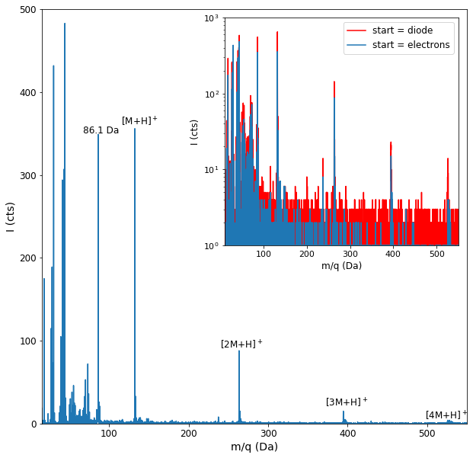
Fig. 2 Leucine (m = 131. 2 Da) mass spectrum obtained with secondary electrons used as a trigger for start of the TOF measurement. In the figure inset, leucine spectra for both trigger modes are compared (extraction voltage is 4.5 kV in transmission mode and 3 kV in thick target setup). Primary beam for both measurements, which were done on the same sample, was 14 MeV Cu⁴⁺ with the beam current in the range 4 – 5 kHz.

- Lateral resolution
Lateral resolution of the setup is defined by the beam spot size and shape after transmission through the capillary. The minimum size of the beam core is defined by the capillary exit diameter (~ 2.5 µm), but the real size at the sample surface is larger due to beam divergence (~1°, defined by ~ 1 mm collimator opening 1.5 m before the capillary). For lateral resolution measurement, the leucine-evaporated carbon-coated copper mesh (Figure 3) was placed on a scanning stage and the setup was operated in transmission mode with the 8 MeV Cu³⁺ primary beam. The beam current at the capillary inlet was used as a normalization for the movement of the piezo stage during scanning. Measured resolution in x direction, defined as the distance required for the number of counts to rise from 10% to 90% percent of the gap between minimum and maximum values of a logistic fit curve, is 3 – 8 µm, depending on the side of the mesh edge. As the angle between capillary axis and normal to the sample surface is 45°, it is expected that one side of the mesh appears sharper than the other. In y – direction, the resolution is worse (15 – 17 µm), because the collimator placed in front of the capillary chamber cuts the beam (and beam divergence) only in the x – direction.
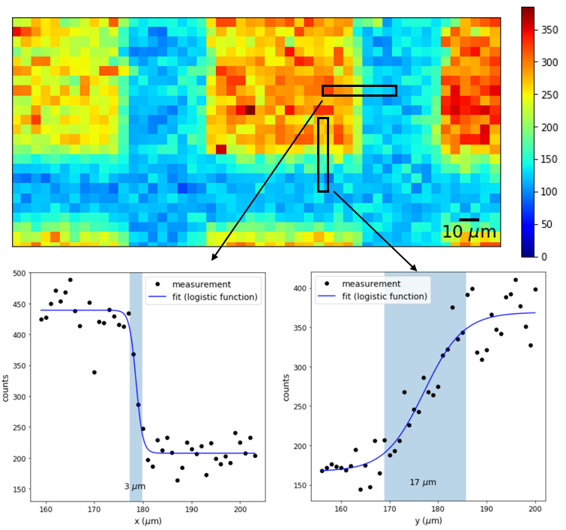
Fig. 3 Total mass spectrum map of leucine-evaporated carbon-coated copper mesh with 127 µm pitch (above). Line scans in x and y directions (1 µm per pixel) were recorded to measure resolution in both directions (below). Shaded blue regions mark calculated resolution.
- Imaging in the transmission mode
The optical image of the analyzed sample, a fly wing, is shown in Figure 4. 23 MeV I⁷⁺ was used as a primary beam. The beam current at the capillary inlet was used for pixel normalization and to trigger the movement of the sample scanning stage. 2D spatial distribution (250 x 250 µm²) of the most significant peak (Na) in the mass spectrum collected in 112 minutes is shown in the same figure. Total mass spectrum follows the same spatial distribution, which indicates that surface morphology is responsible for all features in this image.
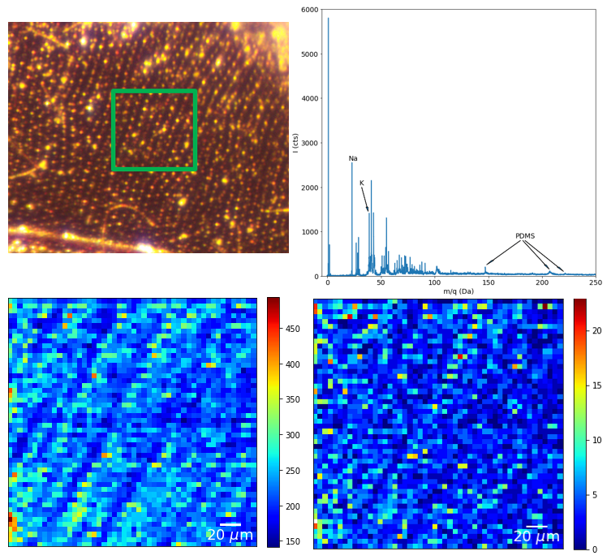
Fig. 4 Fly wing imaging in transmission mode: photo of the sample with the green square denoting imaged area (up), total mass spectrum (upper right), spatial distribution of total mass spectrum (lower left) and sodium peak, m/q = 23 Da (lower right).
- Imaging with the thick target setup
An example of a sample that cannot be examined in the transmission mode is shown in Figure 5. To analyze ink deposited on paper, a setup for thick targets with electrons used as a start trigger needs to be used. An area of 1 x 1 mm² (20 µm per pixel) was analyzed with a 14 MeV Cu⁴⁺ primary ions. A signal from electronic multiplier was used for normalization and triggering of the scanning stage movement (multiplier/ion beam rate was approximately constant in all regions of analyzed area).
Signature peaks from BV3 pigment (m = 372.5 Da) and its degradation products and fragments (a product with CH₃ group removed and substituted with hydrogen at mass 357.5 Da, a product with two CH₃ groups substituted with hydrogen at 344.4 Da, and others) are shown in the inset of the mass spectrum. Relatively low yield of these heavier molecules points to poor efficiency of the setup for a detection of heavy molecules. These molecules can be lost during the flight in the reflectron tube due to delayed fragmentation, but the dominant factor is probably low efficiency of the MCP detector for the detection of heavier ions [8,16]. Spatial distribution of signature molecules shows clear correlation with the ink distribution. Looking at the number of counts in the areas where no ink was deposited, it can be concluded that halo contribution is quite strong – average number of counts in these parts of the imaged area goes from 10% (lower right corner) to more than 50% (upper left corner) of the average number of counts in the parts with deposited ink. Sodium is homogeneously distributed over the analyzed area, which is expected, except for the stronger signal in the upper part of the image, as a consequence of the asymmetrical shape of the halo.
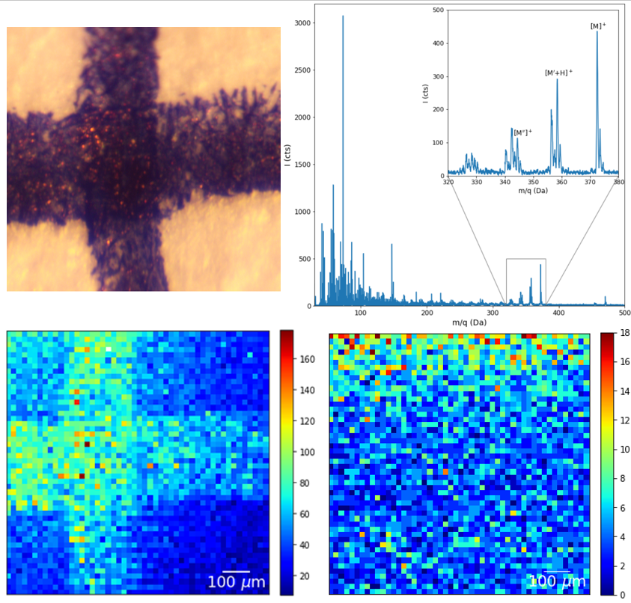
Fig. 5 Imaging of ink deposited on paper with electrons as start trigger: a photo of the sample (upper left), total mass spectrum with characteristic peaks (BV3 pigment and its degradation products and fragments: M = 372.5 Da, M’ = 357.5 Da and M’’ = 344.4 Da) featured in the inset (upper right), spatial distribution of the BV3 products and fragments from the mass spectrum figure inset (lower left), and spatial distribution of sodium (lower right).
Conclusion
A new start trigger that uses secondary electrons shows to be a good solution for thick targets. It offers the same mass resolution as the particle detector in the transmission mode, with additional benefits: possibility to analyze samples of arbitrary thickness mounted on thick substrates (in case of transmission mode sample and backing thickness is limited to few micrometers), reduced background and radiation hardness.
To fully utilize the setup with a heavy high energy primary beam, a detection efficiency of heavier molecules must be improved. A new secondary ion detector, with 10 kV post-acceleration, is currently being installed to address this issue.
With respect to the lateral resolution of the setup, there is no room for improvement. Capillaries with smaller exit diameters will further reduce the available current and could make the measurement time too long to be practical. Halo, on the other side, is shown to be a big obstacle to produce a reliable and clear image of the sample. Straight heavy wall capillaries with the same inlet and exit diameter of 10 µm and length of 5 mm, were tested as an alternative solution. But the beam transmission was disappointingly low, less than 100 Hz for the same inlet current as for conically-shaped capillaries. A beam with almost zero divergence, required for the good transmission through the straight capillaries, is impossible to obtain in our setup. What needs to be mentioned is also the unreliability of the capillaries in the long run – sometimes transmission suddenly worsens, without any obvious cause, and a new capillary must be installed. All of this points to alternative solutions if the goal is to routinely perform molecular imaging with a resolution better than 10 – 20 µm without features attributed to the halo. Our initial measurements with simple round 5 um aperture have been very promising and have shown it could be a better solution than conical capillary for imaging applications. Therefore, our further efforts will be focused to increase the efficiency of the secondary ion detector for heavier masses and exploit the potential of aperture based microprobe for molecular imaging of different types of samples.

Acknowledgments
M. Brajković acknowledges support by the Croatian Science Foundation (CSF) project "Young Researchers’ Career Development Project - Training of Doctoral Students" co-financed by the European Union, Operational Program “Efficient Human Resources 2014-2020” and the ESF. I. B. R. and Z. S. acknowledge support by the CSF project IP-2016-06-1698 “Development of a capillary microprobe for MeV SIMS for analysis of biological materials– BioCapSIMS” and by the RADIATE project under the Grant Agreement 824096 from the EU Research and Innovation program HORIZON 2020. The authors also acknowledge financial support from the European Regional Development Fund for the ‘Center of Excellence for Advanced Materials and Sensing Devices’ (Grant No. KK.01.1.1.01.0001). The authors also wish to thank Dr. Max Döbeli and Dr. Klaus-Ulrich Miltenberger from ETH Zürich for help with micro-capillary production.
References
1. Kamensky, I.; Hakansson, P.; Sundqvist, B.; McNeal, C.J.; Macfarlane, R. Comparison of biomolecule desorption yields for low and high energy primary ions. Nucl. Instum. Methods Phys. Res. 1982, 198, 65-58.
2. Nakata, Y.; Honda Y.; Ninomiya, S.; Seki, T.; Aoki, T.; Matsuo, J. Yield enhancement of molecular ions with MeV ion-induced electronic excitation. Appl. Surf. Sci. 2008, 255, 1591-1594.
3. Nakata, Y.; Honda, Y.; Ninomiya, S.; Seki, T.; Aoki, T.; Matsuo, J. Matrix-free high-resolution imaging mass spectrometry with high-energy ion projectiles. J. Mass. Spectrom. 2009, 44, 128–136.
4. Jones, B. N.; Palitsin, V.; Webb, R. Surface analysis with high energy time-of-flight secondary ion mass spectrometry measured in parallel with PIXE and RBS. Nucl. Instrum. Methods Phys. Res. B. 2010, 268, 1714-1717.
5. Tadić, T.; Radović, I. B.; Siketić, Z.; Cosic, D. D.; Skukan, N.; Jakšić, M.; Matsuo, J. Development of a TOF SIMS setup at the Zagreb heavy ion microbeam facility. Nucl. Instrum. Methods Phys. Res. B. 2014, 332, 234-237.
6. Jeromel, L.; Siketić Z.; Ogrinc Potočnik, N.; Vavpetič, P.; Rupnik, Z.; Bučar, K.; Pelicon, P. Development of mass spectrometry by high energy focused heavy ion beam: MeV SIMS with 8 MeV Cl7+ beam. Nucl. Instrum. Methods Phys. Res. B. 2014, 332, 22-27.
7. Schulte-Borchers, M.; Döbeli, M.; Müller, A.M.; George, M.; Synal, H.-A. Time-of-flight MeV-SIMS with beam induced secondary electron trigger. Nucl. Instrum. Methods Phys. Res. B. 2016, 380, 94-98.
8. Jenčič, B.; Vavpetič, P.; Kelemen, M.; Pelicon, P. Secondary ion yield and fragmentation of biological molecules by employing 35Cl primary ions within the MeV energy domain. J. Am. Soc. Mass Spectrom. 2020, 31, 117-123.
9. Brajković, M.; Barac, M.; Bogdanović Radović, I.; Siketić, Z. Dependence of Megaelectron Volt time-of-flight secondary ion mass spectrometry secondary molecular ion yield from phthalocyanine blue on primary ion stopping Power. J. Am. Soc. Mass Spectrom. 2020, 31, 1518-1524.
10. Miltenberger, K.-U.; Schulte-Borchers, M.; Döbeli, M.; Müller, A. M.; George, M.; Synal, H.-A. MeV-SIMS capillary microprobe for molecular imaging. Nucl. Instrum. Methods Phys. Res. B. 2017, 412, 185-189.
11. Ikeda, T.; Kanai, Y.; Iwai, Y.; Kojima, T.M.; Maeshima, K.; Meissl, W.; Kobayashi, T.; Nebiki, T.; Miyamoto, S.; Pokhil, G.P.; Narusawa, T.; Imamoto, N.; Yamazaki, Y. Glass capillary optics for producing nanometer sized beams and its applications. Surface & Coatings Technology 2011, 206, 859–863.
12. Brajković, M.; Barac, M.; Cosic, D.; Bogdanović Radović, I.; Siketić, Z. Development of MeV TOF-SIMS capillary microprobe at the Ruđer Bošković Institute in Zagreb. Nucl. Instum. Methods Phys. Res. B 2019, 461, 247-242.
13. Miltenberger, K.-U. Secondary ion emission in MeV-SIMS. Diss. ETH Zurich. 2020.
14. Cosic, D.; Bogovac, M.; Jakšić, M. Data acquisition and control system for an evolving nuclear microprobe. Nucl. Instum. Methods Phys. Res. B 2019, 451, 122-126.
15. Jenčič, B.; Vavpetič, P.; Kelemen, M.; Vencelj, M.; Vogel-Mikuš, K.; Kavčič, A.; Pelicon, P. MeV-SIMS TOF imaging of organic tissue with continuous primary beam. J. Am. Soc. Mass Spectrom. 2019, 30, 1801-1812.
16. Gilmore, J. S.; Seah, M. P. Ion detection efficiency in SIMS: dependencies on energy, mass and composition for microchannel plates used in mass spectrometry. Int. J. Mass Spectrom. 2000, 202, 217−229.

List of figures
Fig. 1 Schematic overview of the setup and operating principle for thick targets: detection of secondary electrons (left) triggers the start signal of the TOF measurements and sends the signal to the high voltage switch which increases the extraction voltage to +3 kV (right).
Fig. 2 Leucine (m = 131. 2 Da) mass spectrum obtained with secondary electrons used as a trigger for start of the TOF measurement. In the figure inset, leucine spectra for both trigger modes are compared (extraction voltage is 4.5 kV in transmission mode and 3 kV in thick target setup). Primary beam for both measurements, which were done on the same sample, was 14 MeV Cu⁴⁺ with the beam current in the range 4 – 5 kHz.
Fig. 3 Total mass spectrum map of leucine-evaporated carbon-coated copper mesh with 127 µm pitch (above). Line scans in x and y directions (1 µm per pixel) were recorded to measure resolution in both directions (below). Shaded blue regions mark calculated resolution.
Fig. 4 Fly wing imaging in transmission mode: photo of the sample with the green square denoting imaged area (up), total mass spectrum (upper right), spatial distribution of total mass spectrum (lower left) and sodium peak, m/q = 23 Da (lower right).
Fig. 5 Imaging of ink deposited on paper with electrons as start trigger: a photo of the sample (upper left), total mass spectrum with characteristic peaks (BV3 pigment and its degradation products and fragments: M = 372.5 Da, M’ = 357.5 Da and M’’ = 344.4 Da) featured in the inset (upper right), spatial distribution of the BV3 products and fragments from the mass spectrum figure inset (lower left), and spatial distribution of sodium (lower right).

Figures

Fig. 1
Fig. 2
Fig. 3
Fig. 4
Fig. 5

For Table of Contents Use Only
Manuscript title: Imaging of organic samples with Megaelectron Volt Time-of-flight Secondary Ion Mass Spectrometry capillary microprobe
Authors: Marko Brajković, Ivančica Bogdanović Radović, Marko Barac, Donny Domagoj Cosic, Zdravko Siketić
Description of graphic: 2D spatial distribution of organic molecules is measured at capillary microprobe where secondary electrons released upon the continuous primary beam impact are used to trigger the start of the TOF measurement and establish the positive extraction voltage.

