Structural, Electrical and Magnetic Versatility of the Oxalate-Based [CuFe] Compounds Containing 2,2':6',2"-terpyridine: Anion Directed Synthesis
Lidija Kanižaj,ª Dario Barišić,^{b} Filip Torić,^{b,c} Damir Pajić,^{b} Krešimir Molčanov,ª
Ana Šantić,ª Ivor Lončarić,ª and Marijana Jurić^{a,}*

ªRuđer Bošković Institute, Bijenička cesta 54, 10000 Zagreb, Croatia
^{b}Department of Physics, Faculty of Science, University of Zagreb, Bijenička cesta 32,
10000 Zagreb, Croatia.
^{c}Hebrew University Center for Nanoscience and Nanotechnology, 9190401 Jerusalem, Israel.

ABSTRACT. The heterodimetallic [CuFe] compounds [Cu^{II}₄(terpy)₄Cl₅][Fe^{III}(C₂O₄)₃]·10H₂O (1; terpy = 2,2':6',2''-terpyridine), [Cu^{II}₂(H₂O)₂(terpy)₂(C₂O₄)][Cu^{II}Fe^{III}(CH₃OH)(terpy)(C₂O₄)₃]₂ (2) and {[Cu₂^{II}Fe^{III}(H₂O)(terpy)₂(C₂O₄)_{7/2}]·6H₂O}_{n} (3) were obtained using building block approach, from reaction of aqueous solution of [Fe(C₂O₄)₃]^{3–} and methanol solution containing Cu²⁺ ions and terpy by the layering technique. Interestingly, by changing only the anion of starting salt of copper(II), Cu(NO₃)₂·3H₂O instead of CuCl₂·2H₂O, an unexpected change in the type of bridge, oxalate (2 and 3) versus chloride (1), was achieved, thus affecting the overall structural architecture. Two polymorphs of 3D coordination polymer [Cu^{II}Fe^{II}₂(H₂O)(terpy)(C₂O₄)₃]_{n} (4), crystallizing in the triclinic (a) and monoclinic (b) space groups, were formed hydrothermally, depending on whether CuCl₂·2H₂O or Cu(NO₃)₂·3H₂O was added to the water, beside K₃[Fe(C₂O₄)₃]∙3H₂O and terpy, respectively. By hydrothermal conditions iron(III) from initial building block is reduced to the divalent state, creating 2D honeycomb [Fe^{II}₂(C₂O₄)₃]_{n}^{2n–} layers, which are bridged by [Cu(H₂O)(terpy)]²⁺ cations. Compounds were investigated by single-crystal X-ray diffraction, IR and impedance spectroscopies, magnetization measurements, and DFT calculations. In compounds 1 and 2 the 0-dimensional magnetism is observed; 1 having ground state spin 1 due to different interactions through chloride bridges of Cu²⁺ ions in tetramer [Cu^{II}₄(terpy)₄Cl₅]⁴⁺ and 2 showing strong antiferromagnetic coupling of Cu²⁺ ions mediated by oxalate ligand in [Cu^{II}₂(H₂O)₂(terpy)₂(C₂O₄)]²⁺, and weak ones between Cu²⁺ and Fe³⁺ ions through oxalate bridge in [Cu^{II}Fe^{III}(CH₃OH)(terpy anion)(C₂O₄)₃]⁻. Polymer 4 exhibits antiferromagnetic phase transition at 25 K; the [Fe^{II}₂(C₂O₄)₃]_{n}^{2n–} layers are antiferromagnetically ordered and small interlayer interaction is transferred through [Cu(H₂O)(terpy)]²⁺ cations via O_{ox}−Cu−O_{ox} bridges. Additionally, compounds 1 and 2 are electrical insulators, while 4a and 4b show significantly higher electrical conductivity.
INTRODUCTION
Due to the rich variety of metal species and ligands, coordination geometry, guests inside the pores and supramolecular structures, an enormous number of the coordination polymers with various structures, dimensionality and nuclearity have been synthesized and reported.¹ This area of molecular chemistry is the basis for design of the molecule-based materials that combine two (or more) physical properties of interest, especially upgrading and expanding the molecular magnetism toward multifunctional systems.
In this context, the oxalate-based compounds of various transition metals have been the subject of numerous studies; the oxalate moiety, C₂O₄²⁻ (ox), acts as a linker between metal centres, with various possibilities of coordination to metal centres yielding open structures with dimensionalities ranging from zero to three. A property of oxalate ions that has been of specific interest is their ability to mediate electronic effects between paramagnetic metal ions.
The combination of magnetic oxalate-based coordination polymers with organic/inorganic functional cations provides a suitable approach for designing hybrid magnetic materials exhibiting multifunctional properties.^{2–4} Most of the oxalate-based molecular magnets described to date have been obtained by the "complex-as-ligand approach". In this synthetic strategy a molecular building block, the tris(oxalato)metalate [M^{III}(C₂O₄)₃]^{3–} anion (M^{III} = Cr, Fe, Ru, Rh, Mn or V) is used as a ligand towards other metal cations.¹ The topology of these oxalate-bridged compounds is controlled by a templating counterion. Therefore, layered two-dimensional (2D) honeycomb structures of the formulas {[M^{II}₂(C₂O₄)₃]}_{n}^{2n–} and {[M^{II}M^{III}(C₂O₄)₃]}_{n}^{n–}, showing ferro-, ferri- or canted antiferromagnetic ordering have been obtained using a bulky charge-compensating molecular cation. Magnetic multilayers, photochromic magnets, ferromagnetic molecular metals, or chiral magnets could be formed by combining the cooperative magnetism of the oxalate systems and the electronic properties supplied by the cationic molecular lattice, as using paramagnetic decamethylferrocenium or organic radical cations, photochromic molecules, nonlinear optical (NLO)- active molecules, organic p-electron donors, and chiral cations. Other magnetic networks, different from the 2D honeycomb-like network, can also be obtained depending on the nature of the templating cation (size, shape and charge). The use of the tris-chelated [M(bpy)₃]²⁺ or [M(bpy)₃]³⁺ (bpy = 2,2'-bipyridine) entities provides the family of 3D networks of the formulae [M^{II}₂(C₂O₄)₃]_{n}^{2n–}, [M^{I}M^{III}(C₂O₄)₃]_{n}^{2n–} and [M^{II}M^{III}(C₂O₄)₃]_{n}^{n–}. The homochiral 3D anionic networks have lower critical temperatures than their heterochiral 2D analogues, although the pathway for magnetic interaction is mainly the same, due to different relative orientation of the magnetic orbitals and to longer metal-to-metal distances.^{1,2} Several compounds were reported which were formed by inserting the complexes of Fe^{III}, as [Fe(sal₂-trien)]⁺ or [Fe(bpp)₂]²⁺ (H₂sal₂-trien = N,N′-disalicylidenetriethylene-tetramine; bpp = 2,6(bispyrazol-3-yl)pyridine), between 2D [Mn₂^{II}(C₂O₄)₃]_{n}^{2n–} and [Mn^{II}Cr^{III}(C₂O₄)₃]_{n}^{n–} layers, or by encapsulating in three-dimensional (3D) [Mn^{II}Cr^{III}(C₂O₄)₃]_{n}^{n–} network, in order to afford materials with coexistence of magnetic ordering and spin-crossover, in which the critical temperature of the magnet can be tuned by applying an external stimulus (light, pressure) acting on the spin crossover component.^{5–10}
Hydrothermal reactions have been extensively applied to the synthesis of inorganic-organic hybrid materials giving structural novelty and unique properties. It has been shown that hydrothermal conditions often produce (meta)stable compounds that may otherwise not be accessible by conventional methods. Coordination polymers are synthesized by combining organic ligands and metal salts in solvothermal reactions at relatively low temperatures (below 300 °C). The most important parameters of this synthesis which affect the topology of the networks are temperature, concentrations of metal salt and ligand (which can be varied across a large range), the extent of solubility of the reactants in the solvent, the rate of crystallization and the pH of the solution. This method also gives precise control over the size, shape, distribution, and crystallinity of metal-organic materials.^{11–13}
In our previous works we reported structural and magnetic properties of the heterometallic oxalate-bridged coordination polymers of different dimensionality obtained using [M^{III}(C₂O₄)₃]^{3–} (M^{III} = Cr, Mn and Fe) as building blocks.^{14–17} Following these previous investigations and obtained cognition, we have now focused on the preparation of novel [CuFe] compounds by the layering technique and under the hydrothermal conditions using [Fe^{III}(C₂O₄)₃]^{3–} as precursor and tridentate 2,2':6',2"-terpyridine (terpy) ligand, unlike our previous studies in which we exploited bidentate N-donor ligands, mostly 2,2'-bipyridine and 1,10-phenathroline. It is known that the use of the capping ligands, in addition to the stabilization of the solid-state structures, can control and influence the dimensionality of coordination systems.²
In this publication, we report structural diversity reflected on magnetic and electrical properties of novel oxalate-based [CuFe] compounds containing terpy as N-donor ligand: mono-chloride- and oxalate-bridged complex salts [Cu^{II}₄(terpy)₄Cl₅][Fe^{III}(C₂O₄)₃]·10H₂O (1) and [Cu^{II}₂(H₂O)₂(terpy)₂(C₂O₄)][Cu^{II}Fe^{III}(CH₃OH)(terpy)(C₂O₄)₃]₂ (2), respectively, and two polymorphs of compound [Cu^{II}Fe^{II}₂(H₂O)(terpy)(C₂O₄)₃]_{n} (4), containing well-known 2D honeycomb layers [Fe^{II}₂(C₂O₄)₃]_{n}^{2n–}, which are bridged by paramagnetic [Cu(H₂O)(terpy)]²⁺ cations, ultimately giving 3D network showing long-range magnetic order. Additionally, the resulting one-dimensional (1D) oxalate-bridged ladder-like coordination polymer {[Cu₂^{II}Fe^{III}(H₂O)(terpy)₂(C₂O₄)_{7/2}]·6H₂O}_{n} (3) was also structurally and spectroscopically characterized.
EXPERIMENTAL SECTION
Materials and Physical Measurements. All chemicals were purchased from commercial sources and used without further purification. The starting species K₃[Fe(C₂O₄)₃]∙3H₂O was prepared according to the method described in the literature.¹⁸ Elemental analyses for C, H and N were performed with a Perkin–Elmer Model 2400 microanalytical analyzer. The infrared spectra were recorded with samples as KBr pellets with a Bruker Alpha-T spectrometer in the 4000–350 cm^{–1} region (compounds 2, 3, 4a and 4b) and with an ABB Bomem FT model MB 102 spectrometer in the 4000–200 cm^{–1} region (compound 1).
Synthesis of [Cu^{II}₄(terpy)₄Cl₅][Fe^{III}(C₂O₄)₃]·10H₂O (1). An aqueous solution (4 mL) of K₃[Fe(C₂O₄)₃]∙3H₂O (0.043 g; 0.1 mmol) was layered with a mixture of methanol solutions of CuCl₂·2H₂O (0.018 g; 0.1 mmol; 4 mL) and terpy (0.023 g; 0.1 mmol; 4 mL) and left in the dark, in an open test tube. Deep green prismatic crystals of compound 1 were formed after 10 days, together with a few light-green crystals of known compound [Cu(terpy)Cl₂]·3H₂O,¹⁹ washed with a small amount of water and dried in air. The yield was 32%. Anal. Calc. for C₆₆H₄₄Cl₅Cu₄FeN₁₂O₂₂ (1): C, 42.98; H, 2.41; N, 9.11: Found. C, 42.99; H, 2.38; N, 9.09 %. IR (KBr, cm^{–1}): 3443 (m) 1712 (s), 1677 (vs), 1655 (sh), 1596 (m), 1576 (m), 1499 (w), 1472 (m), 1448 (m), 1397 (m), 1331 (w), 1302 (w), 1290 (w), 1271 (w), 1257 (w), 1194 (w), 1160 (w), 1114 (w), 1092 (w), 1034 (w), 1021 (m), 971 (w), 909 (w), 896 (w), 830 (w), 803 (m), 778 (vs), 731 (m), 668 (w), 652 (m), 534 (m), 509 (w), 437 (w), 410 (w), 353 (w), 337 (w), 324 (w), 308 (w) cm⁻¹.
Synthesis of [Cu^{II}₂(H₂O)₂(terpy)₂(C₂O₄)][Cu^{II}Fe^{III}(CH₃OH)(terpy)(C₂O₄)₃]₂ (2) and {[Cu^{II}₂Fe^{III}(H₂O)(terpy)₂(C₂O₄)_{7/2}]·6H₂O}_{n} (3). An aqueous solution (4 mL) of K₃[Fe(C₂O₄)₃]∙3H₂O (0.049 g; 0.1 mmol) was layered with a mixture of methanol solutions of Cu(NO₃)₂·3H₂O (0.025 g; 0.1 mmol; 4 mL) and terpy (0.023 g; 0.1 mmol; 4 mL) in a test tube. Dark blue rod-like crystals of 2 were formed after two weeks in the dark, washed with a small amount of water and dried in air. The yield was 45%. Together with compound 2 a few green single-crystals of compound 3 were obtained in negligible yield. Anal. Calc. for C₃₈H₂₈Cu₂FeN₆O₁₆ (2): C, 45.30; H, 2.80; N, 8.34: Found. C, 45.33; H, 2.82; N, 8.33 %. IR data (KBr, cm^{–1}): 3431 (m), 1705 (m), 1672 (vs), 1654 (vs), 1638 (sh), 1619 (vs), 1603 (sh), 1577 (m), 1500 (w), 1475 (m), 1449 (m), 1408 (sh), 1375 (sh), 1360 (m), 1327 (m), 1301 (m), 1291 (m), 1254 (m), 1239 (m), 1188 (w), 1165 (w), 1139 (w), 1115 (w), 1099 (w), 1070 (w), 1040 (w), 1021 (m), 1001 (m), 895 (w), 877 (w), 830 (w), 796 (m), 777 (s), 733 (m), 673 (w), 651 (m), 528 (m), 482 (w), 438 (w), 410 (w).
Anal. Calc. for C₃₇H₃₆Cu₂FeN₆O₂₁ (3): C, 41.01; H, 3.35; N, 7.76: Found. C, 41.03; H, 3.34; N, 7.77 %. IR data (KBr, cm^{–1}): 3423 (m), 1712 (m), 1678 (vs), 1640 (sh), 1597 (m), 1574 (m), 1499 (w), 1472 (m), 1448 (m), 1386 (s), 1329 (m), 1303 (m), 1270 (m), 1256 (m), 1159 (w), 1091 (w), 1033 (w), 1021 (m), 892 (w), 829 (w), 800 (m), 777 (s), 730 (m), 651 (m), 529 (m), 498 (m), 437 (w).
Synthesis of [Cu^{II}Fe^{II}₂(H₂O)(terpy)(C₂O₄)₃]_{n} (4a and 4b). Dark green prismatic crystals of 4a or 4b were formed hydrothermally under autogenous pressure in a 30 mL Teflon-lined stainless steel vessel with a 60% fill factor. A mixture of K₃[Fe(C₂O₄)₃]∙3H₂O (0.292 g; 0.6 mmol), terpy (0.141 g; 0.6 mmol), CuX₂·mH₂O (X = Cl–, m = 2; 0.102 g; 0.6 mmol for 4a and X = NO₃–, m = 3; 0.145 g; 0.6 mmol for 4b) and H₂O (20 mL) was heated at 150 °C for 30 h and left to cool to the room temperature. Dark green crystals of 4a or 4b obtained in the autoclave were washed with a small amount of water and dried in air. The yield was 43% for 4a and 46% for 4b Anal. Calc. for C₂₁H₁₁CuFe₂N₃O₁₃ (4a): C, 36.63; H, 1.61; N, 6.10: Found. C, 36.65; H, 1.62; N, 6.12 %. IR data (KBr, cm^{–1}): 3427 (m), 1703 (m), 1620 (vs), 1503 (w), 1477 (m), 1456 (m), 1444 (m), 1413 (w), 1355 (m), 1312 (m), 1249 (w), 1184 (w), 1160 (w), 1096 (w), 1070 (w), 1049 (w), 1025 (w), 793 (m), 776 (m), 746 (w), 730 (w), 668 (w), 652 (w), 592 (w), 485 (m), 397 (w) cm⁻¹. Anal. Calc. for C_{8.40}H_{4.40}Cu_{0.40}Fe_{0.80}N_{1.20}O_{5.20} (4b): C, 36.63; H, 1.61; N, 6.10: Found. C, 36.59; H, 1.63; N, 6.09 %. IR data (KBr, cm^{–1}): 3440 (m), 1701 (m), 1620 (vs), 1506 (w), 1476 (m), 1456 (m), 1444 (m), 1413 (w), 1355 (m), 1312 (m), 1249 (w), 1184 (w), 1159 (w), 1096 (w), 1070 (w), 1049 (w), 1025 (w), 979 (w), 915 (w), 905 (w), 793 (m), 776 (m), 747 (w), 730 (w), 673 (w), 652 (w), 582 (w), 485 (m), 397 (m) cm⁻¹.
Single-Crystal X-ray Structural Study. The X-ray data for single crystals of compounds 1, 3 and 4b were collected by ω-scans on an Oxford Diffraction Xcalibur Nova R diffractometer with mirror-monochromated Cu-Kα radiation (λ = 1.54179 Å, microfocus tube, CCD detector) at room temperature [293(2) K], and for compounds 2 and 4b on Enraf Nonius CAD4 diffractometer with graphite-monochromated Mo-Kα radiation (λ = 0.71073 Å, scintillation LiI detector) at room temperature [293(2) K]. The crystal data and details of data collections and refinements for the reported structures are summarized in Table 1. Data reduction, including the multi-scan absorption correction, was performed by the CrysAlisPRO software package²⁰ for 1, 3 and 4b, and for compounds 2 and 4a by XCAD4²¹ within WinGX software package.²² The solution, refinement and analysis of the structures were performed using the program integrated in the WinGX system.²² The structures were solved by direct methods (SIR92)²³ and refined by the full-matrix least-squares method based on F² against all reflections (SHELXL-2017/1).²⁴ All non-hydrogen atoms were refined anisotropically. The hydrogen atoms attached to the carbon atoms of aromatic ligands were treated as riding entities in idealized positions, with the C–H distances of 0.93 Å and displacement parameters assigned U_{iso}(H) = 1.2U_{eq}(C). The geometry of the water molecules was constrained to d(O–H) = 0.85(2) Å and d(H⋯H) = 1.50(4) Å with displacement parameters assigned as U_{iso}(H) = 1.5U_{eq}(O). Due to a large size of the unit cell of 1, hydrogen atoms on its 10 symmetry-independent uncoordinated water molecules could not be properly refined (in fact, most of them could not be located from difference Fourier map). Therefore, uncoordinated water molecules in 1 were refined without hydrogen atoms. Geometrical calculations were carried out with PLATON²⁵ and the figures were made by the use of the CCDC-Mercury,²⁶ and VESTA²⁷ programs. Topology of coordination polymers was analysed using ToposPRO.²⁸

Table 1 Crystallographic Data and Structure Refinement for Compounds [Cu₄(terpy)₄Cl₅][Fe(C₂O₄)₃]·10H₂O (1), [Cu₂(H₂O)₂(terpy)₂(C₂O₄)][CuFe(CH₃OH)(terpy)(C₂O₄)₃] (2), {[Cu₂Fe(H₂O)(terpy)₂(C₂O₄)_{5/2}]·6H₂O}_{n} (3) and [Cu^{II}Fe^{II}₂(H₂O)(terpy)(C₂O₄)₃]_{n} (4a and 4b)
Compound | 1 | 2 | 3 | 4a | 4b
Empirical formula  Formula wt. / g mol^{–1}  Colour  Crystal dimensions / mm  Space group  a / Å  b / Å  c / Å  α / °  β / °  γ / °  Z  V / Å³  D_{calc} / g cm^{–3}  λ / Å  µ / mm^{–1}  Θ range / °  T / K  Diffractometer type  h, k, l range  No. of measured reflections  No. of independent reflections  No. of observed reflections  R_{int}  R, wR [I ≥ 2σ(I)]  R, wR [all data]  Goodness-of-fit  Absorption correction  No. of parameters. restraints  Δρ_{max}, Δρ_{min} (e Å^{–3}) | C₆₆H₄₄Cl₅Cu₄FeN₁₂O₂₂  1844.39  green  0.28 x 0.12 x0.11  $$P\overline{1}$$  12.857(5)  15.330(5)  20.204(5)  80.305(5)  78.368(5)  83.899(5)  2  3834(2)  1.598  1.54179 (CuKα)  4.998  3.81–76.83  293(2)  Xcalibur Nova  –12 < h < 16  –18 < k < 19  –23 < l < 25  41554  15774  11718  0.0356  0.0551, 0.1638  0.0735, 0.1807  0.957  Multi-scan  1021, 0  0.879, –0.537 | C₃₈H₂₈Cu₂FeN₆O₁₆  1007.59  dark blue  0.30 x 0.20 x0.18  $$P\overline{1}$$  10.4286(10)  11.2488(7)  19.286(2)  81.370(8)  89.561(9)  63.299(7)  2  1993.7(3)  1.678  0.71073 (MoKα)  1.499  2.054–24.981  293(2)  CAD4  –12 < h < 12;  –13 < k < 13;  0 < l < 22  7528  7010  5320  0.1317  0.0494, 0.1316  0.0785, 0.1481  1.026  None  580, 4  1.036, –0.854 | C₃₇H₃₆Cu₂FeN₆O₂₁  1083.65  dark green  0.26 x 0.10 x 0.08  $$P\overline{1}$$  12.7168(5)  12.9004(3)  15.4453(6)  99.080(2)  111.581(4)  108.571(3)  2  2122.08(14)  1.696  1.54179 (CuKα)  4.685  4.099–76.427  293(2)  Xcalibur Nova  –15 < h < 16  –13 < k < 16  –19 < l < 19  20664  8734  7502  0.0308  0.0430, 0.1198  0.0499, 0.1264  1.044  Multi-scan  593, 0  0.545, –0.632 | C₂₁H₁₁CuFe₂N₃O₁₃  688.57  dark green  0.25 x 0.25 x 0.15  $$P\overline{1}$$  9.314(6)  11.438(4)  11.452(8)  94.91(5)  98.60(6)  98.56(4)  2  1185.7(13)  1.929  0.71073 (MoKα)  2.174  1.81–24.98  293(2)  CAD4  0 < h < 11;  –13 < k < 13;  –13 < l < 13  4752  4152  2753  0.0757  0.0683, 0.1623  0.1232, 0.1942  1.103  None  369, 3  1.059, –1.335 | C_{8.40}H_{4.40}Cu_{0.40}Fe_{0.80} N_{1.20}O_{5.20}  275.43  dark green  0.15 x 0.06 x 0.05  C2/c  15.4899(4)  16.9114(3)  9.3337(2)  90  102.633(2)  90  10  2385.83(9)  1.917  1.54179 (CuKα)  11.373  5.855–76.300  293(2)  Xcalibur Nova  –19 < h < 19;  –19 < k < 21;  –11 < l < 11  11765  2486  2358  0.0383  0.0376, 0.1016  0.0393, 0.1033  1.116  Multi-scan  183, 0  0.513, –0.462

Electrical Study. The electrical properties of compounds 1, 2, 4a and 4b were measured by impedance spectroscopy (Novocontrol Alpha-N dielectric analyser) in the frequency range from 0.01 Hz to 1 MHz and temperature range from 0 °C to 50 °C. The measurements were performed on polycrystalline samples pressed into pellets of approximate thickness 1 mm. For the electrical contacts, gold electrodes (3.8 mm in diameter) were sputtered on the opposite surfaces of the pellets. The impedance spectra were analysed by equivalent circuit modelling using the complex nonlinear least-squares fitting procedure (ZView software). Electrical properties were not investigated for compound 3 since it was not possible to prepare a sufficient amount of sample required for measurements.
Magnetization Study. The magnetization M of polycrystalline samples of compounds 1, 2, 4a and 4b was measured on an MPMS 5 commercial superconducting quantum interferometer device (SQUID) magnetometer. Both modes of M(T) measurements were used, after zero-field cooling (ZFC) and after cooling in field (FC). The M(H) dependences were measured at a temperature of 2 K. The measured magnetic moments of the samples were corrected by taking into account the sample holder, temperature-independent contributions of the core electrons in accordance with the well-known Pascal constants and temperature independent paramagnetic contribution of copper(II). Calculations of numerical fits and simulations were performed using the own developed program in Python. As for the electrical properties, the magnetic ones were not studied for compound 3 due to the small amount of obtained sample (only a few single crystals of insufficient size for magnetic measurements were formed).
DFT Calculations. All density functional theory (DFT) calculations were performed with QuantumATK code²⁹ using prebuild PseudoDojo³⁰ medium basis set and PBE exchange-correlation functional³¹ Brillouin zone was sampled with a Monkhorst-Pack grid with density of at least 5 A. Geometry was optimized until forces on all atoms were smaller than 0.05 eV/Å. Exchange parameters J were estimated following literature data^{32,33} as implemented in QuantumATK. Due to known DFT problems with electron localization, exchange parameters are usually overestimated.
RESULTS AND DISCUSSION
Synthesis. The titled [CuFe] compounds [Cu^{II}₄(terpy)₄Cl₅][Fe^{III}(C₂O₄)₃]·10H₂O (1), [Cu^{II}₂(H₂O)₂(terpy)₂(C₂O₄)][Cu^{II}Fe^{III}(CH₃OH)(terpy)(C₂O₄)₃]₂ (2) and {[Cu₂^{II}Fe^{III}(H₂O)(terpy)₂(C₂O₄)_{7/2}]·6H₂O}_{n} (3) were obtained using building block approach, from the reaction of aqueous solution of [Fe(C₂O₄)₃]^{3–} and methanol solution containing Cu²⁺ ions and 2,2':6',2"-terpyridine in the molar ratio of 1:1:1, by the layering technique,³⁴ without presence of the daylight. Fascinatingly, by altering only the anion of the starting salt of copper(II) in the methanol layer, Cu(NO₃)₂·3H₂O instead CuCl₂·2H₂O, an unexpected change in type of the bridge, chloride versus oxalate, was achieved, thus affecting the overall structural architecture (Scheme 1). It appears that due to steric effect related to terpyridine molecule, i.e. due to the use of the more bulky tridentate N-donor ligand, smaller chloride ions present in the reaction solution kinetically favour formation of the bridge in regard to the oxalate ligand. This is substantiated by the fact that the bridging by chloride did not occur when smaller bidentate 2,2'-bypiridine ligand was used instead of terpy species by utilization of the slow liquid diffusion.¹⁷ In a test tube containing nitrate anions, partial decomposition of the tris(oxalato)ferrate(III) anion leads to the release of oxalate group from the coordination sphere of iron(III). During the crystallization process these oxalate ligand is consequently coordinated to copper(II) ions in reaction mixture, yielding oxalate-bridged dinuclear [{Cu^{II}(H₂O)(terpy)}₂(μ-C₂O₄)]²⁺ cationic unit of compound 2 or coordination polymer 3 containing oxalate-bridged dinuclear entity of copper(II) [{Cu^{II}(terpy)}₂(μ-C₂O₄)]²⁺ extra linked.^{16,17}
Two polymorphs of 3D coordination polymer [Cu^{II}Fe^{II}₂(H₂O)(terpy)(C₂O₄)₃]_{n} (4), crystallizing in the triclinic $P\overline{1}$ (a) and monoclinic C2/c (b) space groups, were formed hydrothermally at 150 °C for 30 h, depending on whether CuCl₂·2H₂O or Cu(NO₃)₂·3H₂O was added to the water, beside K₃[Fe(C₂O₄)₃]∙3H₂O and terpy, respectively (Scheme 1). By hydrothermal conditions iron(III) from initial building block [Fe(C₂O₄)₃]^{3–} is reduced to the divalent state,¹⁷ creating 2D {[Fe^{II}₂(C₂O₄)₃]}_{n}^{2n–} networks which are further connected to the complex cations [Cu(H₂O)(terpy)]²⁺, leading to original and unique structures of 4a and 4b.
Scheme 1 Schematic Representation of the Synthesis of Compounds 1−4
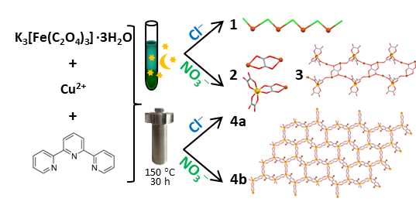
Molecular and Crystal Structure of Compounds 1–4. Compound [Cu^{II}₄(terpy)₄Cl₅][Fe^{III}(C₂O₄)₃]·10H₂O (1). Compound 1 crystalizes in a triclinic space group $P\overline{1}$ and its crystal structure consists of a mono-chloro-bridged tetranuclear cation of copper(II) ions, [Cu₄(terpy)₄(µ-Cl)₃Cl₂]³⁺, a mononuclear oxalate anion of iron(III), [Fe(C₂O₄)₃]^{3–} (Figures 1 and S1, Supporting Information), and ten molecules of water of crystallization. The complexes of copper(II) exhibiting only one chloride bridge are quite scarce, and almost all of these compounds have the one-dimensional linear structure, with the chloride bridge placed at the equatorial-axial positions in the chain.³⁵ The unusual zigzag asymmetric [Cu₄(terpy)₄Cl₅]³⁺ cation in 1 contains four copper(II) centres bridged by chloride anions, each displaying a square-pyramidal CuN₃Cl₂ coordination. The coordination sphere of atoms Cu2 and Cu3 includes three N atoms from the terpy molecule and two bridging chloride ions, while atoms Cu1 and Cu4 are coordinated, beside three N-donor atoms from terpy ligand, by one bridging and one terminal/peripheral chloride ion (Figures 1a and S1, Supporting Information). The distortion index (τ) was calculated for each copper(II) centre using the formula τ = (β—α)/60 (α, β are the largest basal angles),³⁶ which indicates distortions from the ideal square pyramidal coordination (τ = 0). Obtained values (0.033–0.143) confirmed square pyramidal coordination around each of the four copper centres in compound 1.
The distances Cu–Cl, in which the chloride ions are terminal are 2.1994(11) Å (Cu1–Cl1) and 2.4589(15) Å (Cu4–Cl5); Cl5 is in apical position of the coordination geometry of Cu4, so this distance is longer, which is to be expected (Figure 1a).^{35,37} The values of the distances Cu–Cl [2.7430(15), 2.6189(14) and 2.5783(14) Å], in which bridging chloride ions are located in the apical positions of the square-pyramidal environment (Cu1–Cl2, Cu2–Cl3 and Cu3–Cl4, respectively; Figures 1a and S1, Supporting Information) are longer than the corresponding bonds in which bridging chloride ions are located in the basal plane [Cu2–Cl2, Cu3–Cl3 and Cu4–Cl4 are 2.2265(11), 2.2444(11) and 2.2793(11) Å, respectively].³⁸ The Cu–N distances [1.948(3)–2.033(3) Å] are similar to those found in related copper(II) complexes containing coordinated terpyridine ligand.³⁹⁻⁴¹ Detailed geometric parameters describing the coordination polyhedra in cation and anion are given in Table S1, Supporting Information.
The Cu···Cu distances through three chloride bridges are 3.8583(13) Å (Cu1···Cu2), 3.7605(12) Å (Cu2···Cu3) and 3.8537(12) Å (Cu3···Cu4), which are somewhat shorter than in the similar compounds with mono-chloro-bridge, containing coordinated tridentate molecule.⁴²⁻⁴⁴ The Cu–Cl–Cu bridging angles are in the range 101.01(3)–104.83(3)°; the corresponding reported for complexes which exhibit CuY₃(µ-X) cores as repeating units are 114–145°.⁴⁴
The iron(III) in [Fe(C₂O₄)₃]^{3–} displays an approximately octahedral coordination geometry, involving six oxygen atoms from the three bidentate oxalate groups (Figures 1b and S1, Table S1, Supporting Information). The average Fe–O distance is somewhat shorter than literature data.^{45,46}
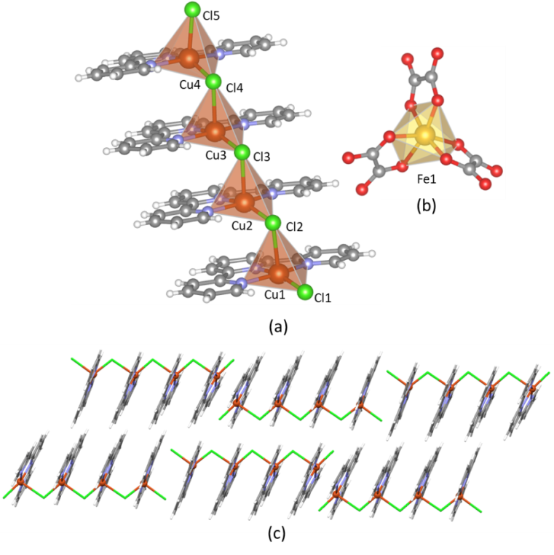
Figure 1. The mono-chloro-bridged tetranuclear [Cu₄(terpy)₄(µ-Cl)₃Cl₂]³⁺ cation (a) and the mononuclear [Fe(C₂O₄)₃]^{3–} anion (b) of compound 1, showing coordination polyhedra around metal centers. The Cu and Fe atoms are depicted in orange and yellow colours, respectively. Crystal packing of the cations [Cu₄(terpy)₄(µ-Cl)₃Cl₂]³⁺ in the [$\overline{1}$01] direction, arranged through the interactions of the aromatic systems (c).
The chloride bridging showed priority over oxalate bridging in structure 1 also due to stabilization by interactions between the aromatic rings from the coordinated terpy molecules appearing within the cation itself. Also stacking between neighbouring cations in the [$\overline{1}$01] direction is noted, thus forming zigzag 1D chains (Figure 1c). The details of aromatic stacking interactions are given in Table S2, Supporting Information. Further, a series of intra- and inter-cationic C–H···Cl contacts holds together the [Cu₄(terpy)₄Cl₅]³⁺ units in the (110) plane. Cations [Cu₄Cl₅(terpy)₄]³⁺ and anions [Fe(C₂O₄)₃]^{3–} are mutually connected through water molecules by hydrogen bonds.
Compound [{Cu^{II}₂(H₂O)₂(terpy)₂(C₂O₄)][Cu^{II}Fe^{III}(CH₃OH)(terpy)(C₂O₄)₃]₂ (2). The structure of compound 2, crystalizing in a triclinic space group $P\overline{1}$, contains one homodinuclear oxalate-bridged [{Cu(H₂O)(terpy)}₂(μ-C₂O₄)]²⁺ cation and two heterodinuclear oxalate-bridged [Cu(CH₃OH)(terpy)(μ-C₂O₄)Fe(C₂O₄)₂]– anions. There is a crystallographic inversion centre in the middle of the oxalate bridge of the cation; in this way, just one half of the cationic unit and only one of the two anionic units are symmetry-independent (Figures 2 and S2, Supporting Information).
Copper(II) atoms in the symmetric complex cation [Cu(H₂O)(terpy)(μ-C₂O₄)Cu^{i}(H₂O)(terpy)]²⁺ [symmetry operator: (i) 1 – x, 1 – y, 2 – z] display elongated octahedral coordination, involving three N atoms from the terpy molecule [Cu1–N = 1.934(4)–2.062(4) Å] and one O atom from the bridging bis(bidentate) oxalate group [Cu1–O12 = 1.928(3) Å] in the basal plane, together with other O atom of bridging group [Cu1–O11 = 2.357(3) Å] and one O atom of coordinated water [Cu1–O13 = 2.375(4) Å] in the apical positions (Figures 2a and S2, Supporting Information). Similar elongated octahedral geometry copper(II) atom has in the heterometallic [Cu(CH₃OH)(terpy)(μ-C₂O₄)Fe(C₂O₄)₂]– anion; it is surrounded by three N atoms from a terpy ligand and one O atom of the oxalate bridge, having four short equatorial bonds [Cu2–N = 1.928(4)–2.026(4) Å; Cu2–O15 = 1.974(3) Å] and by two O atoms, one from oxalate bridge [Cu1–O14 = 2.424(4) Å] and other from coordinated methanol solvate [Cu1–O16 = 2.348(4) Å] with two longer axial bonds (Figure 2b). The iron(III) ion is coordinated by six O atoms; four from two bidentate oxalate groups [Fe1–O = 1.988(4)–2.000(3) Å] and two from oxalate bridge [Fe1–O are 2.029(3) and 2.081(3) Å].^{47,48} Selected distances and angles in the complex cation and anion of compound 2 are given in Table S3, Supporting Information.

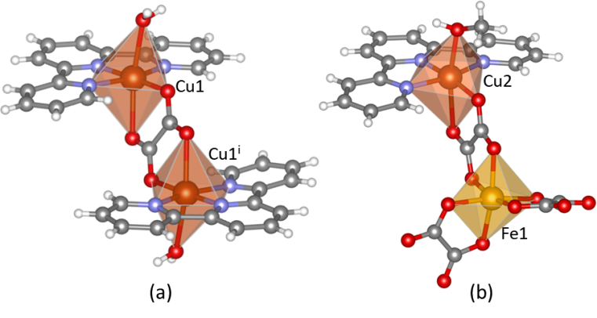
Figure 2. The homodinuclear oxalate-bridged [Cu(H₂O)(terpy)(μ-C₂O₄)Cu^{i}(H₂O)(terpy)]²⁺ cation [symmetry operator: (i) 1 – x, 1 – y, 2 – z] (a) and the heterodinuclear oxalate-bridged [Cu(CH₃OH)(terpy)(μ-C₂O₄)Fe(C₂O₄)₂]– anion (b) of compound 2, showing coordination polyhedra around metal centres. The Cu and Fe atoms are depicted in orange and yellow colours, respectively.
The Cu1···Cu1^{i} [symmetry operator: (i) 1 – x, 1 – y, 2 – z] and Cu2···Fe1 distances across the oxalate bridges are 5.4998(12) and 5.5019(9) Å, respectively.
Each coordinated water from cation is involved in hydrogen bonds with uncoordinated oxygen atoms of oxalate groups of two different symmetric neighbouring anionic units, forming a ladder-like hydrogen bonding motif along the a axis (Figure S3a, Supporting Information). Further, hydroxyl group of the coordinated methanol molecule and oxygen atoms (one uncoordinated and one coordinated) from oxalate group from two anionic units participate in hydrogen bonding, resulting in 1D arrangement parallel to the b axis (Figure S3b, Supporting Information), thus forming an overall 2D hydrogen bonding architecture. The details describing the hydrogen bonding geometry are given in Table S4, Supporting Information.
The crystal structure of 2 is stabilized by stacking interactions between the aromatic rings in the terpy molecules of cations and between those of anions. The rings of the neighbouring [{Cu(H₂O)(terpy)}₂(μ-C₂O₄)]²⁺ species are stacked along [010] direction forming alternating, sandwich-like π-stacks (Figure S4a, Supporting Information), while those of the neighbouring [Cu(CH₃OH)(terpy)(μ-C₂O₄)Fe(C₂O₄)]– anions generate 1D motif along the [$\overline{1}$10] direction (Figure S4b, Supporting Information). The details of aromatic stacking interactions in 2 are given in Table S2, Supporting Information.
Compound {[Cu^{II}₂Fe^{III}(H₂O)(terpy)₂(C₂O₄)_{7/2}]·6H₂O}_{n} (3). Structural analysis has showed that in compound 3, crystallizing in a triclinic space group $P\overline{1}$, coordinated oxygen atom from the oxalate group of the [Fe(C₂O₄)₃]³⁻ anion is connected to the copper(II) atom of the [Cu(terpy)(H₂O)]²⁺ unit, while terminal one of the other oxalate group to the copper(II) atom from the symmetric unit [Cu(terpy)(μ-C₂O₄)Cu^{ii}(terpy)]²⁺ [symmetry operator: (ii) 2 – x, 1 – y, 2 – z]; there is a crystallographic inversion centre in the middle of the oxalate bridge of this cation. Oxygen atoms from the oxalate bridge are coordinated to the copper(II) atoms of the [Cu(terpy)(H₂O)]²⁺ units, thus forming 1D ladder-like [Cu^{II}Fe^{III}] coordination polymer along the a axis (Figures 3 and S5, Supporting Information).

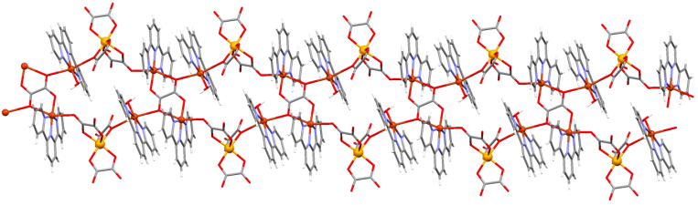
Figure 3. The ladder-like 1D chain motif in compound {[Cu^{II}₂Fe^{III}(H₂O)(terpy)₂(C₂O₄)_{7/2}]·6H₂O}_{n} (3) along the a axis.
The Cu1 atom, besides two O atoms from two oxalate groups of the [Cu(terpy)(μ-C₂O₄)Cu^{ii}(terpy)]²⁺ and [Fe(C₂O₄)₃]³⁻ units [Cu1−O14 = 2.522(2)Å and Cu1−O6^{i} = 2.7258(18) Å, respectively; symmetry operator: (i) 1 – x, 1 – y, 1 – z] in apical positions, is coordinated by three N atoms from the terpy ligand [Cu1–N = 1.916(2)–2.040(3) Å] and O atom of water molecule [Cu1−O15 = 1.928(2) Å] (Figures 3 and 4; Table S5 in the Supporting Information ). The observed axial Cu1–O distances are significantly longer than the typical Cu–O covalent bonds (1.98 Å),¹ but they are considerably shorter than the sum of the van der Waals radii (2.92 Å).⁴⁹
As in above described compound 2, the oxalate release of [Fe(C₂O₄)₃]³⁻ and its delivery allow obtaining symmetrical oxalate-bridged cations [Cu(terpy)(μ-C₂O₄)Cu^{ii}(terpy)]²⁺, in which copper(II) ion displays elongated octahedral coordination, involving three N atoms from the terpy molecule [Cu2–N = 1.928(2)−2.049(2) Å], and one O atom from the bridging bis(bidentate) oxalate group in the basal plane [Cu2−O13 = 1.9326(18) Å], together with another O atom from the same oxalate bridge [Cu2−O14^{ii} = 2.4229(19) Å] and that one from terminal oxalate group of the [Fe(C₂O₄)₃]³⁻ anion [Cu2−O12 = 2.398(2) Å] in apical positions (Figures 3, 4 and S5, Supporting Information). The iron(III) ion from [Fe(C₂O₄)₃]³⁻ building block displays an approximately octahedral coordination geometry, involving six O atoms from three oxalate groups. The values of the Fe−O bond lengths are in the relatively good agreement with literature data.⁵⁰ Selected bond distances and angles for 3 are listed in Table S5, Supporting Information.
Figure 4. Coordination polyhedra around metal centres (Fe1, Cu1 and Cu2) in compound {[Cu^{II}₂Fe^{III}(H₂O)(terpy)₂(C₂O₄)_{7/2}]·6H₂O}_{n} (3). The Cu and Fe atoms are depicted in orange and yellow colours, respectively. Symmetry operator: (i) 1 – x, 1 – y, 1 – z.
Uncommonly, three different bridging modes of the oxalate group are observed in compound 3: bidentate-monodentate [µ-1,1,2] and bidentate-monodentate [µ-1,2,3] between copper(II) and iron(III) centres and bis(bidentate)-bis(monodentate) [µ₄-1,1,2,3,3,4] between four copper centres (Scheme 2a).¹⁶ The oxygen atoms from the oxalate groups from the side parts of the ladder-like motifs and coordinated and uncoordinated water molecules in 3 generate very interesting hydrogen-bonding framework (Figure S6 and Table S4 in the Supporting Information).
Compound [Cu^{II}Fe^{II}₂(H₂O)(terpy)(C₂O₄)₃]_{n} (4). Two polymorphs of the coordination polymer [CuFe₂(H₂O)(terpy)(C₂O₄)₃]_{n} (4), one crystallizing in the triclinic $P\overline{1}$ space group (4a) and other in the monoclinic C2/c (4b), comprise 3D structural arrangement. Polymers contain homometallic 2D oxalate-bridged honeycomb anionic layers with (6³) or hcb topology, [Fe^{II}₂(C₂O₄)₃]_{n}^{2n–}, mutually linked by complex cations of copper(II) ions, [Cu(H₂O)(terpy)]²⁺, through oxygen atoms from oxalate bridges (Figure 5; Scheme 2b). Thus overall 3D structural network of a novel topology (12³·2·12^{5.16}·12·3) is formed in both compounds (Figure S8, Supporting Information).²⁸ The structure of 4a contains one symmetric {[Cu(H₂O)(terpy)]²⁺ cation and one symmetric [Fe₂(C₂O₄)₃]^{2–} anion mutually bridged, while in compound 4b just one half of the cationic unit and one half of the anionic unit are symmetry-independent (Figures 6 and S7, Supporting Information).
The Fe^{II} atoms in both polymorphs are coordinated by six O atoms from three bridging oxalate ligands, displaying approximately octahedral coordination geometry (Figure 6); the Fe–O distances fall into the range of the lengths for only one known oxalate-bridged 2D honeycomb anion of Fe^{II} containing the 5-oxo-1,4,7-triazabicyclo[4.3.0]non-6-en-7-yl ammonium ion as a templated cation.⁵¹ The bis(bidentate) oxalate ligands repeatedly bridge adjacent Fe^{II} ions in all three dimensions, which finally leads to a polymeric net parallel to the (011) plane in 4a and to (100) plane in 4b. In Table S6, Supporting Information, selected bond lengths and angles for polymers 4a and 4b are presented. Each honeycomb of the [Fe^{II}₂(C₂O₄)₃]_{n}^{2n–} layer in 4a and 4b contains 6 oxalate bridges; two diagonal O atoms from each bridge in the [100] direction for 4a and the [101] direction for 4b are coordinated to two copper(II) ions (Figures 5a and 5c). So, two different bridging modes of the oxalate group are observed in compounds 4a and 4b: bis(bidentate), [µ-1,2,3,4], between two iron(II) ions and bis(bidentate)-bis(monodentate) [µ₄-1,1,2,3,3,4] between two copper(II) and two iron(II) centres (Scheme 2b).

Scheme 2 Observed Bridging Modes of the Oxalate Group in Compound 3: Bidentate-Monodentate, [µ-1,2,3], Bidentate-Monodentate [µ-1,1,2], and Bis(bidentate)-Bis(monodentate) [µ₄-1,1,2,3,3,4] (a) and in Compounds 4a and 4b: Bis(bidentate), [µ-1, 2,3,4], and Bis(bidentate)-Bis(monodentate) [µ₄-1,1,2,3,3,4] (b).
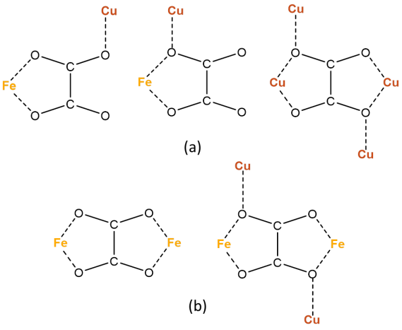
Copper(II) atom from complex cation displays elongated octahedral coordination, involving three N atoms from the terpy molecule [1.908(7)–2.028(7) Å for 4a and 1.909(3)–2.012(2) for 4b; Table S6 in the Supporting Information] and one O atom from coordinated water molecule [1.936(6) and 1.931(3) Å for 4a and 4b, respectively] in the basal plane, together with O atoms from the bridging oxalate groups from the neighbouring [Fe^{II}₂(C₂O₄)₃]_{n}^{2n–} layers in the apical positions (Figure 6). The observed axial Cu–O distances [Cu1–O9 = 2.618(7) Å and Cu1–O11^{i} = 2.619(6) Å; symmetry operator: (i) 1 – x, 1 – y, 1 – z for 4a and Cu1–O6 = Cu1–O6^{i} = 2.6233(16) Å; symmetry operator: (i) 1 – x, y, 3/2 – z for 4b; Table S6 in the Supporting Information] are slightly elongated but it is still within a typical range (~2.32–2.80 Å) indicating a semi-coordination character of Cu–O bonds.¹

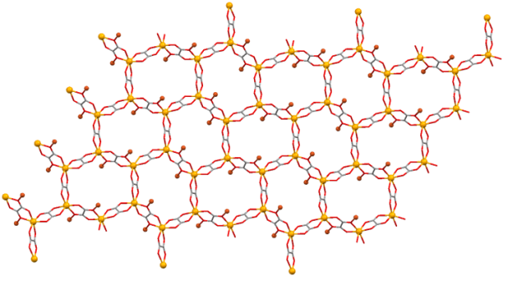
(a)
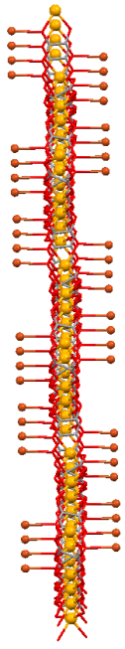
(b)
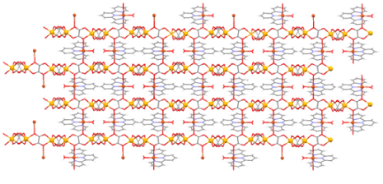
(c)
Figure 5. A 2D honeycomb anionic network [Fe^{II}₂(C₂O₄)₃]_{n}^{2n–} of compound 4a connected to the copper ions: in the (011) plane (a) and in the [011] direction (b). Water and terpyridyne molecules are ommited for clarity. Coordination of the oxygen atoms from oxalate bridges of the [Fe^{II}₂(C₂O₄)₃]_{n}^{2n–} network to the copper(II) ions from the [Cu(H₂O)(terpy)]²⁺ cations in the [100] direction (c).
Up to now, all known 2D honeycomb anionic layers in the compounds {(A)₂[M^{II}₂(C₂O₄)₃]}_{n} or {A[M^{II}M^{III}(C₂O₄)₃]}_{n} were only interleaved by the templating cations,¹ except in compounds {[Cu(en)₂][Mn₂(С₂О₄)₃]}_{n}, {[Cu(en)₂][Co₂(C₂O₄)₃]·3H₂O}_{n} and {[Cu(Me₂en)₂][Mn₂(C₂O₄)₃]·2H₂O}_{n} (en = ethylenediamine; Me₂en = N,N-dimethylethylenediamine), in which the cationic units are linked with the layers.^{52,53}
The average Fe⋯Fe separations across the oxalate bridges are 5.534 and 5.5486 Å in 4a and 4b, respectively. Additionally, distance between Cu^{II} and Fe^{II} metal centres bridged by oxygen atoms from oxalate bridges are 4.172(3) Å [Cu1···Fe1] and 4.174(4) Å [Cu1···Fe2^{i}; symmetry operator (i): 1 – x, 1 – y, 1 – z] in polymorph 4a and 4.1823(4) [Cu1···Fe1^{i}; symmetry operator (i) –x + 1/2, –y + 1/2, –z + 1] in polymorph 4b. The distance between two honeycomb anionic layers in 4a is 7.544 Å and in 4b 7.553 Å, and these interlayer separations are significantly shorter than in the similar compounds.^{52,53}
Figure 6. Coordination polyhedra around metal centres in the polymorph 4a (a) and 4b (b). The Cu and Fe atoms are depicted in orange and yellow colours, respectively.
Infrared study of compounds 1–4. The IR spectra of compounds 1–4 show characteristic absorption bands of the oxalate groups and coordinated N-donor ligand. All absorption bands observed in the IR are described in the Experimental part. The absorption bands corresponding to the stretching vibrations of the coordinated [bis(bidentate) and bis(bidentate)-bis(monodentate)] and uncoordinated [bidentate and bidentate-monodentate] CO groups of the oxalate ligands^{16,50} for all compounds are summarized in Table S7, Supporting Information. The terminal and bridging Cu–Cl stretching vibrations in compound 1 appear at 324 and 308 cm⁻¹, respectively.⁵⁴ Other significant absorption bands in the spectra originate from different vibrations of coordinated 2,2′:6′,2′′-terpyridine.
Electrical Properties of Compounds 1, 2, 4a and 4b. The complex impedance plots of compounds 1 and 4b at 30 °C and 40 °C, respectively, are shown in Figure 7. Compound 1 exhibits arcs at high values of impedance indicating low electrical conductivity (Figure 7a), whereas 4b shows well defined impedance semicircles at much lower values of impedance (Figure 7b). Similar result was obtained for compounds 2 and 4a, respectively (Figure S9 in the Supporting Information). Obtained impedance data can be well approximated by the equivalent electrical circuit consisting of a parallel combination of resistor and constant phase element (CPE). From the values of electrical resistance (R) obtained from equivalent circuit modelling and electrode dimensions (A is the electrode area and d is the sample thickness) the values of DC conductivity for all compounds were calculated according to relation: σ_{DC} = d/(A⋅R).
Figure 7. Complex impedance plot and corresponding equivalent circuit for compounds 1 (a) and 4b (b) at 30 °C and 40 °C.
The temperature dependence of DC conductivity, σ_{DC}, of compounds 1, 2, 4a and 4b is shown in an Arrhenius type plot of log(σ_{DC}) versus 1000/T (Figure 8). Compounds 1 and 2 exhibit insulating behaviour with similar, very low values of conductivity [≈10⁻¹⁵ (Ω cm)⁻¹] over temperatures from 30 to 50 °C. On the other hand, polymers 4a and 4b show more than two orders of magnitude higher electrical conductivity, reaching the values of 2.6 × 10⁻¹³ (Ω cm)⁻¹ and 5.4 × 10⁻¹³ (Ω cm)⁻¹ at 20 °C, respectively. As can be seen from Figure 7 the conductivity of 4a and 4b is thermally activated and from the slope the activation energy for DC conductivity, E_{DC}, is calculated according to the Arrhenius relation, σ_{DC} = σ₀exp(−E_{DC}/k_{B}T). The values of E_{DC} for both 4a and 4b are found to be very similar, 0.57 and 0.58 eV, respectively. The difference in electrical conductivity between two sets of compounds, namely 1/2 and 4a/4b is directly related to their structural diversity.
Figure 8. Electrical conductivity as a function of reciprocal temperature for 1, 2, 4a and 4b. Solid lines represent least-square linear fit to experimental data.
The well-defined crystalline structures of coordination polymers can enable viewing the exact proton-conducting pathways, giving deeper insight into their electrical properties. Proton conductivity requires proton carries such as H₃O⁺, NH₄⁺, or H⁺ belonging to acid groups or to networks of hydrogen bonds. The simplest method to obtain conductive materials is to introduce proton carries directly into polymers as counterions. The strategy developed for the oxalate-based compounds relies on the introduction of acidic or hydrophilic residues into the cationic component in order to construct proton-conductive pathways between the layers.⁵⁵⁻⁵⁸ So, probably due to hydrogen-bonding between hydrogen atoms as proton source from water molecule coordinated to cooper(II) ions, [Cu(H₂O)(terpy)]²⁺, present as counterion, and oxalate oxygen atoms from two neighbouring honeycomb layers [Fe^{II}₂(C₂O₄)₃]_{n}^{2n−} (Figure S10, Supporting Information), compared to compounds 1 and 2, polymers 4a and 4b exhibit proton conductivity.
Measured conductivities can be correlated to the electronic structure obtained from DFT calculations. Figure S11 in the Supporting Information shows density of states of compounds 1, 2, 3, and 4b. It can be seen that DFT predicts electronic band gaps of 1.8 eV for 1, 0.6 eV for 2, 0.8 eV for 3, and 0.1 eV for 4b. Note that DFT at this level is known to underestimate electronic gaps. Nevertheless, the small electronic band gap found for 4b is in line with a significantly higher conductivity of this compound.
Magnetic Properties of Compounds 1, 2, 4a and 4b. The χT(T) dependences for 1 is shown in Figure 9. By increasing the temperature from 2 K as the lowest, χT is rapidly increasing to its maximum value at about 14 K after which it slightly falls before becoming the final straight horizontal line at high temperatures.
The M(H) curve measured at 2 K is not fully saturated even in the largest measured field of 50 kOe (inset in Figure 9). Value of the magnetic moment at 50 kOe is around 8.85Nμ_{B}. The expected value of the saturated moment for four Cu²⁺ centres with spin S = 1/2 from [Cu₄(terpy)₄Cl₅]³⁺ cation and one Fe³⁺ with spin S = 5/2 from [Fe(C₂O₄)₃]³⁻ anion is (4∙g_{cu}∙1/2 + g_{Fe}∙5/2)Nμ_{B}, which is slightly higher than the measured one.
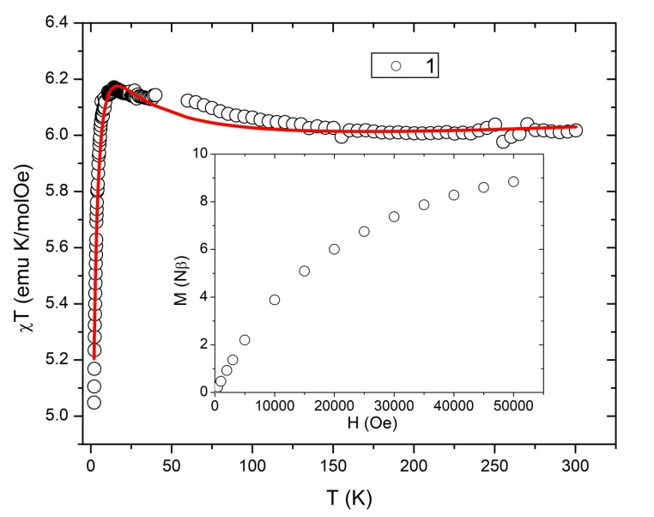
Figure 9. Temperature dependence of the product χT for compound 1. The red solid line is model curve. Inset: Measured M(H) dependence at T = 2 K for 1.
Magnetic interactions of copper(II) centres mediated by one^{35,37,42,43,59−63} or two Cl− bridges^{38,40,59,62,64,65} have been studied. The most promising structural feature that determines the character and strength of the magnetic interaction is the ratio between the angle at the Cu^{II}–Cl–Cu^{II} bridge (θ) and longer Cu−Cl distance (R). There is a simple correlation between the exchange parameter J and this ratio θ/R; overall ferromagnetic behaviour can be expected for values of the ratio θ/R lower than approximately 40 and higher than 58 (in units of °/Å) while antiferromagnetic character appears when this quotient θ/R is between these two values.⁶³ The values of the ratios θ/R found in complex salt 1 (Table S1, Supporting Information) are 37.95 (Cu1/Cu2), 38.56 (Cu2/Cu3) and 40.65 (Cu3/Cu4), announcing the existence of both ferro- and antiferromagnetic interactions between copper(II) ions through chloride bridges. These values are close to the border value between the ferro- and antiferromagnetic characters of the interaction. Therefore, to reproduce the magnetic behaviour of 1 all three different Cu^{II}–Cl–Cu^{II} interaction (Cu1···Cu2, Cu2···Cu3; Cu3···Cu4) have been taken in the model. Magnetic behavior of 1 is modelled by the Hamiltonian:
$H= -J_{1}S_{1}∙S_{2} -J_{2}S_{2}∙S_{3}-J_{3}S_{3}∙S_{4}+\sum_{i=1}^{5}{g_{i}μ_{B}H∙S_{i}}$ (1)
where S₁, S₂, S₃ and S₄ are spins of Cu²⁺ and S₅ of Fe³⁺ spin, and other symbols have their usual meaning. The zero-field splitting contribution of Fe³⁺ is expected to be negligible. Best-fit modelled curve reproduces the measured data well (Figure 9); the best fitting was obtained for parameters: g_{Cu} = 2.075, g_{Fe} = 1.98, J₁ = 23.98 cm⁻¹, J₂ = 16.43 cm⁻¹, J₃ = −5.01 cm⁻¹. Obtained results suggest dominant ferromagnetic interactions over antiferromagnetic interaction across the Cu²⁺ tetramer. The values of the interactions J₁ and J₂ indicate so far the strongest ferromagnetic interaction in (µ-chloro)copper(II) compounds.⁶³ Numerical calculation of the Hamiltonian model treats different Cu magnetic centres as indistinguishable, but according to the proposed magneto-structural correlation these interactions nevertheless would lead to the spin S = 1 of the ground state determining therefore its magnetic character. Obtained values of the magnetic interactions J are in agreement with those obtained from the DFT calculations, which also confirm competing ferromagnetic and antiferromagnetic interactions resulting with S = 1 ground state spin.
The χT(T) dependence for compound [Cu^{II}₂(H₂O)₂(terpy)₂(C₂O₄)][Cu^{II}Fe^{III}(CH₃OH)(terpy)(C₂O₄)₃]₂ (2) is shown in Figure 10. By decreasing temperature χT(T) is falling in the whole temperature interval. The value of the product χT(T) at room temperature is 10.0 emu K mol⁻¹ Oe⁻¹. The expected moment coming from four Cu²⁺ ions (two from cation and two from two anions) with spin S = 1/2 and g_{Cu} = 2.1 and from two Fe³⁺ (from two anions) with spin S = 5/2 and g_{Fe} = 2.0 is 10.4 emu K mol⁻¹ Oe⁻¹, which is a slightly higher value compared to the measured one. The M(H) curve measured at 2 K is shown in the inset of Figure 10; this curve is not saturated even in the highest measured fields of 50 kOe. The value of the moment in 50 kOe is 9.23Nμ_{B}, which is notably less than the value corresponding to that of saturation of four Cu²⁺ and two Fe³⁺ magnetic centers (14.2Nμ_{B}), signaling strong interaction between these ions.
Magnetic behavior could be explained by the Hamiltonian model:
$H= -J_{1}S_{1}∙S_{2} -J_{2}{(S}_{3}∙S_{4}+S_{5}∙S_{6})+\sum_{i=1}^{6}{g_{i}μ_{B}H∙S_{i}}$ (2)
where S₁, S₂, S₃ and S₅ are spins of Cu²⁺ and S₄ and S₆ of Fe³⁺. Best-fit curve (shown in Figure 10) reproduces the measured data very well. Data below 14 K were avoided from fitting due to thermal instability of the instrument which made measured points unreliable. The best fitting was obtained for parameters: g_{Cu} = 2.16, g_{Fe} = 1.99, J₁ = −72.50 cm⁻¹ and J₂ = −4.62 cm⁻¹. Interaction between Cu²⁺ ions across oxalate group in cation [Cu(H₂O)(terpy)(µ-C₂O₄)(terpy)(H₂O)Cu]²⁺ is antiferromagnetic (J₁) as well as those between Cu²⁺ and Fe³⁺ centres (J₂) in two anions [Cu(CH₃OH)(terpy)(µ-C₂O₄)Fe(C₂O₄)₂]⁻. A very strong interaction of order of almost hundred of K between copper(II) ions mediated by the oxalate bridge is observed in present cation. This very strong interaction is significant compared to the thermal energy even at the room temperatures what results in a measured non-saturated χT value at the room temperature. Such strong antiferromagnetic interactions are confirmed also from DFT calculations. However, DFT calculations suggest somewhat stronger J₂ interaction, but with this value it was not possible to reproduce the measured temperature dependence of magnetization; it is well known that the used DFT method usually overestimate the exchange energies.
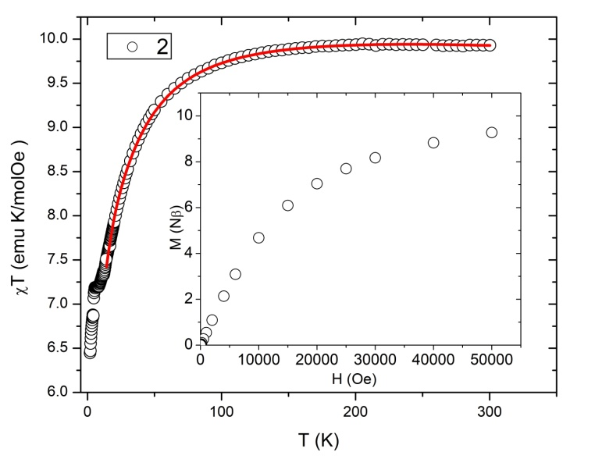
Figure 10. Temperature dependence of the product χT for compound 2. The red solid line is model curve. Inset: Measured M(H) dependence at T = 2 K for 2.
Interestingly, search of the CSD¹ does not find any compound in which Cu²⁺ and Fe³⁺ ions are bridged by bis(bidentate) oxalate group. Also, only one compound containing [{Cu(H₂O)(terpy)}₂(µ-C₂O₄)]²⁺ unit was found, but no magnetic investigation was done.⁶⁶ Therefore, the obtained value of the magnetic interaction is a pioneer one and in order to set magneto-structural correlations new compounds are desirable.
In 3D coordination polymers 4a and 4b, both with formula [CuFe₂(H₂O)(terpy)(C₂O₄)₃]_{n}, magnetic interactions are conveyed through the network and produce long-range order. Magnetic order is studied and confirmed by the more detailed magnetization measurements. The χ(T) dependences (inset of Figure 11 for 4a and Figure 12S in the Supporting Information for 4a and 4b) were measured in different magnetic fields in order to identify magnetic transition. Peaks at the χ(T) dependence show that both samples undergo antiferromagnetic transition around 25 K (inset of Figure 11). The same behavior of susceptibility is obtained at different values of external magnetic fields ranging from 20 Oe to 1000 Oe, for both samples. Below the magnetic transition at 25 K well observable splitting between the zero-field-cooled (ZFC, lower branch) and field-cooled (FC, upper branch) curves appears, being very small for moderate fields (around 100 Oe), unobservable for high fields (above 1000 Oe), but considerable for small fields (below 20 Oe). This splitting shows that the ordered phase has some thermal irreversibility which might be connected with weak ferromagnetism and/or canted spins, as was already observed in some 3D coordination polymers.¹⁴⁻¹⁶ Magnetic phase transition at 28 K was already observed in a previously reported polymer in which 2D honeycomb [Fe^{II}₂(C₂O₄)₃]_{n}^{2n–} layers are templated by organic cations.⁵¹
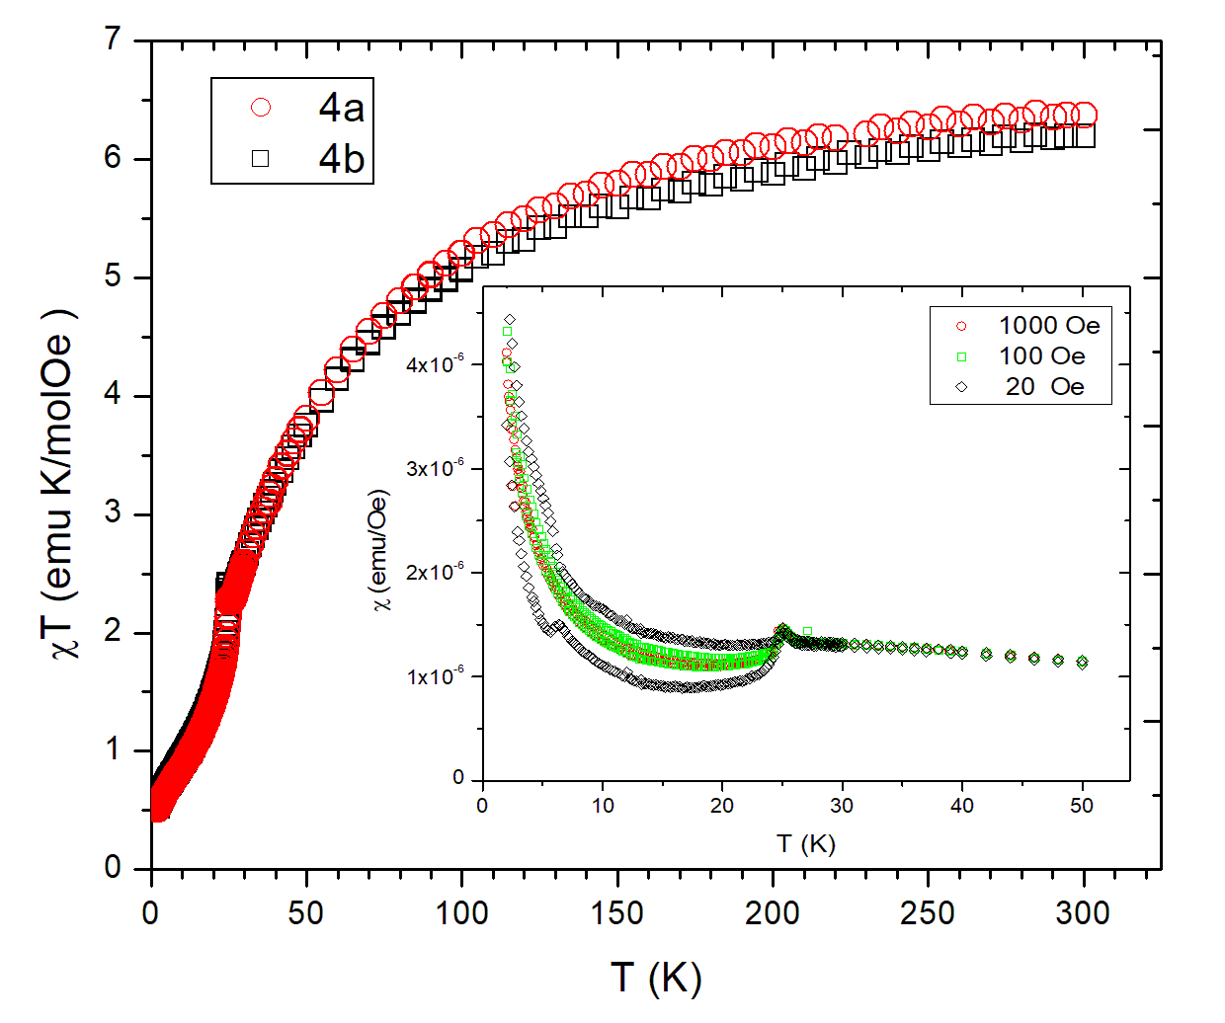
Figure 11. Temperature dependence of the product χT for compounds 4a and 4b. Inset: The χ(T) around transition temperature for 4a in different fields, where lower branches are ZFC and upper branches FC parts.
Plotting the χT(T) dependences (Figure 11) points to relatively strong antiferromagnetic interactions in the systems. Temperature dependence of reciprocal susceptibility in the paramagnetic phase, χ^{–1}(T), for both 4a and 4b has linear behavior as predicted by the Curie-Weiss law χ = C/(T–θ) (Figure S13, Supporting Information). Fitting the data for both samples the following Curie constants C and Weiss temperatures θ have been obtained: C = 8.0(2) emu K mol⁻¹ Oe⁻¹, θ = −52(2) K for 4a and 8.2(3) emu K mol⁻¹ Oe⁻¹, θ = −53(3) K for 4b. These Weiss constants confirm that the antiferromagnetic interactions dominate in the systems. Their values are in agreement with the exchange couplings obtained from the DFT calculations from which it could be expected that the Weiss parameter is negative and of the order ~100 K. Into account only the dominant interactions between Fe²⁺ spins in the honeycomb lattice have been taken as those who generate the mean field in the magnetic lattice. The obtained values of C have been compared with the expected values for non-interacting spins. Using the value of S_{Fe} = 2 and S_{Cu} = 1/2, and published g-factors, which are for Cu²⁺ in elongated octahedral environments between 2 and 2.1⁶⁷ and for Fe²⁺ having octahedral geometry this value can be anywhere between 1.975 and 2.245,⁶⁸ for Curie constant it follows 8.1(2) emu K mol⁻¹ Oe⁻¹. Good agreement of this value with the experimentally determined points to the paramagnetic state of non-interacting spins in 4a and 4b at high temperatures.
At low temperature exchange interactions between iron(II) ions through oxalate bridges in the honeycomb lattice [Fe₂(C₂O₄)₃]_{n}^{2n−} come into account and lead to the magnetic order. The magnetic interaction between Fe²⁺ and Cu²⁺ magnetic centers is expected to be small due to relatively large distances between Cu²⁺ ions and O atoms from oxalate bridges of two neighboring layers. However, the Weiss parameters of −52 K (4a) and −53 K (4b) point out the dominant magnetic interactions which are antiferromagnetic, and their effective values are of considerable strength, although being a combination of intralayer and much weaker interlayer interactions. This is confirmed with DFT calculations, which give the values of intralayer (Fe−ox−Fe) interactions between 20−50 K with antiferromagnetic sign, while the values for interlayer interaction transferred through O_{ox}−Cu-O_{ox} bridges (see Molecular and crystal structure of compounds 1–4) and some type of interlayer Fe···Fe interactions are much smaller, ~ 1K and ~ 0.1K respectively.
Another useful comparison for resolving the character of the dominant magnetic interaction between Fe²⁺ centers is shown in Figure 12, where the measured M(H) dependence at 2 K and Brillouin function for S_{Cu} = 1/2 are compared. Brillouin function would simulate the strongly bound antiferromagnetic Fe-layers and isolated Cu magnetic centers. As shown in the Figure 12, magnetization is higher than expected for single Cu paramagnetic ion, but significantly lower than what would be the case for the ferromagnetic interaction between Fe²⁺ magnetic centers. From this we can also confirm that the interaction between Fe²⁺ magnetic centers within honeycomb layers is antiferromagnetic and strong. Discrepancy between the measured M(H) and the Brillouin function for S_{Cu} = 1/2 suggests that there is some kind of interaction between Cu²⁺ and Fe²⁺ − they feel each other, although weakly. As already noted, DFT suggested ferromagnetic interaction of ~1K between Cu²⁺ ion and nearest Fe²⁺ ions. Also, the response of antiferromagnetic layer of iron(II) contributes slightly to the increase of magnetization with increase of applied field, raising the measured M(H) slightly above the Brillouin function. There is no magnetic hysteresis in M(H) measurements, that is in accordance with the fact that the small ZFC-FC splitting is observable only in very small fields.
Low-temperature behaviour is not typical one for pure antiferromagnetic state since the χT does not tend to zero as T → 0, but rather extrapolates to the finite value between 0.33 and 0.34 (units of Nμ_{B}²/3k_{B}), or eventually would make a plateau at around 0.4 that would correspond to independent Cu²⁺ ions, but this is not observed down to temperature of 2 K. For the lowest temperatures, corresponding rise in susceptibility (inset in Figure 11) can be attributed to paramagnetic Cu²⁺ ions almost as independent spins (paramagnetic) or weakly bound to the Fe-planes (or even other Cu²⁺ ions), as suggested by DFT, calculated small super-exchange value.
In conclusion, antiferromagnetic transition at around 25 K (Figure 9) occurs due to relatively strong antiferromagnetic super-exchange interactions in the honeycomb Fe²⁺-lattice and much weaker coupling between the layers coming from ferromagnetic super-exchange transferred mainly through complex cation over O_{ox}−Cu−O_{ox} bridges.
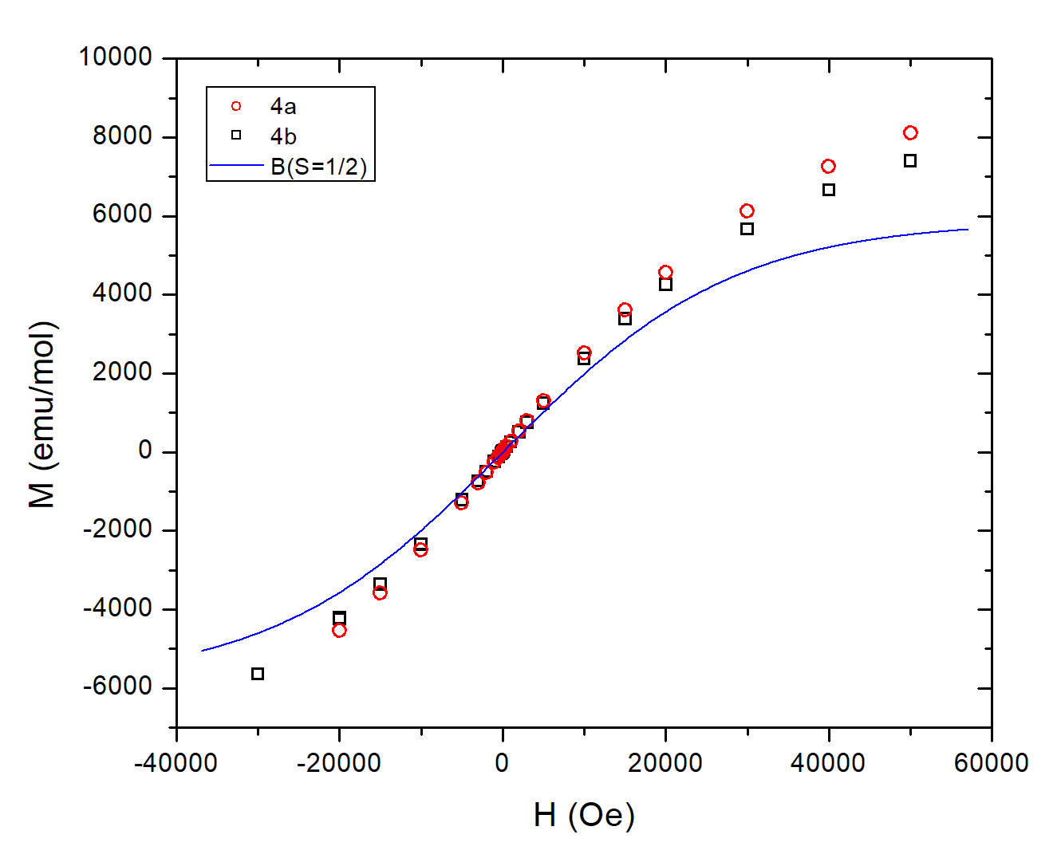
Figure 12. The M(H) measurements at 2 K for compounds 4a and 4b. The blue line is a simulated curve of the Brillouin function with spin S = 1/2.
CONCLUSIONS
Results described in this paper show the great influence of simple ions (Cl– and NO₃–) of used copper(II) salts on the type of bridge and overall structural arrangements of investigated oxalate-based compounds reflecting on magnetic and electrical properties, or on the occurrence of polymorphic forms.
Four novel heterometallic [CuFe] compounds, polymorphs (a and b) of 3D [Cu^{II}Fe^{II}₂(H₂O)(terpy)(C₂O₄)₃]_{n} (4) and 1D {[Cu^{II}₂Fe^{III}(H₂O)(terpy)₂(C₂O₄)_{7/2}]·6H₂O}_{n} (3) coordination polymers, and complex salts [Cu^{II}₄(terpy)₄Cl₅][Fe^{III}(C₂O₄)₃]·10H₂O (1) and [{Cu^{II}₂(H₂O)₂(terpy)₂(C₂O₄)][Cu^{II}Fe^{III}(CH₃OH)(terpy)(C₂O₄)₃]₂ (2) have been synthesized using building block [Fe^{III}(C₂O₄)₃]³⁻ and characterized.
These compounds show unique structures and related properties:
- Depending on which copper salt [CuCl₂·2H₂O or Cu(NO₃)₂·3H₂O] has been utilized in the methanol layer during liquid diffusion, chloro-bridged (1) or oxalate-bridged (2 and 3) compounds have been obtained. Also, the use of the chloride salt of copper(II) in the hydrothermal reactions produces a triclinic polymorph (4a), while monoclinic (4b) has been formed by nitrate salt;
- The partial decomposition of the tris(oxalate)ferate(III) anion during crystallization process of 2 and 3 has occurred;
- Uncommonly, compound 3 shows three different bridging modes of the oxalate group, while polymer 4 two;
- Compound 2 is the first structurally characterized compound in which Cu²⁺ and Fe³⁺ ions are bridged by bis(bidentate) oxalate group; the super-exchange interaction between these ions is weakly antiferromagnetic. Much stronger it appears within homodinuclear oxalate-bridged cation of copper(II) of the same compound;
- Compound 1 is also interesting magnetically, since there is a chloro-bridged zigzag tetramer where two super-exchange interactions are ferromagnetic and stronger, and one is antiferromagnetic and weaker between copper(II) ions through chloride ions, making the ground state S = 1 of this magnetic unit;
- Polymorphs 4a and 4b are the first magnetically and electrically investigated compounds in which the 2D honeycomb layers [Fe₂(C₂O₄)₃]_{n}^{2n−} are bridged by cationic [Cu(H₂O)(terpy)]²⁺ units forming 3D structural network of a novel topology (12³·2·12^{5.16}·12·3). Magnetic phase transition appears at 25 K, and long-range order establishes as a consequence of stronger antiferromagnetic interactions within the honeycomb layer and weaker interlayer interactions transferred via cation units.
ASSOCIATED CONTENT
Supporting Information
The Supporting Information is available free of charge on theACS Publications website at DOI: Selected distances and angles for 1, 2, 3, 4a and 4b (Tables S1, S3, S5 and S6), ORTEP-3 drawing of 1−4 (Figures S1, S2, S5 and S7), parameters of the aromatic stacking for 1 and 2 (Table S2), hydrogen bonding geometry and motifs in 2, 3 and 4a (Figures S3, S6, and S10, Table S4), stacking in 2 (Figure S4), selected IR bands for 1−4 (Table S7), topological representation of 4a and 4b (Figure S8), impedance plot for 2 and 4a (Figure S9), density of states (Figure S11), χ(T) of 4a and 4b (Figure S12), Curie-Weiss fits of 4a and 4b (Figure S13).
Accession Codes
CCDC 2017977–2017981 contain the supplementary crystallographic data for this paper. These data can be obtained free of charge via www.ccdc.cam.ac.uk/data_request/cif, or by emailing data_request@ccdc.cam.ac.uk, or by contacting The Cambridge Crystallographic Data Centre, 12 Union Road, Cambridge CB2 1EZ, UK; fax: +44 1223 336033.

AUTHOR INFORMATION
Corresponding Author
*Dr. Marijana Jurić
Ruđer Bošković Institure
Bijenička cesta 54
10000 Zagreb, Croatia
Phone: +385 1 4561189. Fax: +385 1 4680098.
E-mail: Marijana.Juric@irb.hr. (M.J.)

Funding Sources
This work has been funded and supported by the Croatian Science Foundation Project No. IP-2019-04-5742.
ACKNOWLEDGMENT
L.K. thanks L’Oréal ADRIA d.o.o. and Croatian Commission for UNESCO for a scholarship. D.P. acknowledges the support of project CeNIKS co-financed by the Croatian Government and the European Union through the European Regional Development Fund – Competitiveness and Cohesion Operational Programme (Grant KK.01.1.1.02.0013). I.L. acknowledges support from the European Union through the European Regional Development Fund within the Competitiveness and Cohesion Operational Programme (Grant No. KK.01.1.1.06) and Center of Excellence for Advanced Materials and Sensing Devices (Grant No. KK.01.1.1.01.0001).
REFERENCES
(1) Groom, C. R.; Bruno, I. J.; Lightfoot, M. P.; Ward, S. C. The Cambridge Structural Database, Acta Crystallogr., Sect. B: Struct. Sci., Cryst. Eng. Mater. 2016, 72, 171–179.
(2) Clemente-León, M.; Coronado, E.; Martí-Gastaldoz, C.; Romero, F. M. Multifunctionality in hybrid magnetic materials based on bimetallic oxalate complexes, Chem. Soc. Rev. 2011, 40, 473–497.
(3) Coronado, E.; Espallargas, G. M. Dynamic magnetic MOFs, Chem. Soc. Rev. 2013, 42, 1525–1539.
(4) Espallargas, G. M.; Coronado, E. Magnetic functionalities in MOFs: from the framework to the pore, Chem. Soc. Rev. 2018, 47, 533–557.
(5) Clemente-León, M.; Coronado, E.; López-Jordà, M.; Espallargas, G. M.; Soriano-Portillo, A.; Waerenborgh, J. C. Multifunctional Magnetic Materials Obtained by Insertion of a Spin-Crossover Fe^{III} Complex into Bimetallic Oxalate-Based Ferromagnets, Chem. Eur. J. 2010, 16, 2207–2219.
(6) Clemente-León, M.; Coronado, E.; Giménez-Loópez, M. C.; Soriano-Portillo, A.; Waerenborgh, J. C.; Delgado, F. S.; Ruiz-Pérez, C. Insertion of a Spin Crossover Fe^{III} Complex into an Oxalate-Based Layered Material: Coexistence of Spin Canting and Spin Crossover in a Hybrid Magnet, Inorg. Chem. 2008, 47, 9111–9120.
(7) Clemente-León, M.; Coronado, E.; López-Jordà, M.; Desplanches, C.; Asthana, S.; Wang, H.; Làtard, J.-F. A hybrid magnet with coexistence of ferromagnetism and photoinduced Fe(III) spin-crossover, Chem. Sci., 2011, 2, 1121–1127.
(8) Clemente-León, M.; Coronado E.; López-Jordà, M. 2D and 3D bimetallic oxalate-based ferromagnets prepared by insertion of different Fe^{III} spin crossover complexes, Dalton Trans. 2010, 39, 4903–4910.
(9) Coronado, E.; Mascarós, J. R. G.; Giménez-López, M. C.; Almeida, M.; Waerenborgh, J. Spin crossover Fe^{II} complexes as templates for bimetallic oxalate-based 3D magnets, Polyhedron 2007, 26, 1838–1844.
(10) Clemente-León, M.; Coronado, E.; Lopez-Jordà, M.; Waerenborgh, J. C.; Desplanches, C. Wang, H.; Létard, J.-F.; Hauser, A.; Tissot, A. Stimuli Responsive Hybrid Magnets: Tuning the Photoinduced Spin-Crossover in Fe(III) Complexes Inserted into Layered Magnets, J. Am. Chem. Soc. 2013, 135, 8655–8667.
(11) Suh, M. P.; Cheon, Y. E.; Lee, E. Y. Syntheses and functions of porous metallosupramolecular networks, Coord. Chem. Rev. 2008, 252, 1007–1026.
(12) Ahmad, N.; Chughtai, A. H.; Younus, H. A.; Verpoort, F. Discrete metal-carboxylate self-assembled cages: Design, synthesis and applications, Coord. Chem. Rev. 2014, 280, 1–27.
(13) Kuppler, R. J.; Timmons, D. J.; Fang, Q.-R.; Li, J.-R.; Makal, T. A.; Young, M. D.; Yuan, D.; Zhao, D.; Zhuang, W.; Zhou, H.-C. Potential applications of metal-organic frameworks, Coord. Chem. Rev. 2009, 253, 3042–3066.
(14) Habjanič, J.; Jurić, M.; Popović, J.; Molčanov, K.; Pajić, D. A 3D Oxalate-Based Network as a Precursor for the CoMn₂O₄ Spinel: Synthesis and Structural and Magnetic Studies, Inorg. Chem. 2014, 53, 9633–9643.
(15) Jurić, M.; Pajić, D.; Žilić, D.; Rakvin, B.; Molčanov, K.; Popović, J. Magnetic order in a novel 3D oxalate-based coordination polymer {[Cu(bpy)₃][Mn₂(C₂O₄)₃]·H₂O}_{n}, Dalton Trans. 2015, 44, 20626–20635.
(16) Kanižaj, L.; Molčanov, K.; Torić, F.; Pajić, D.; Lončarić, I.; Šantić, A.; Jurić, M. Ladder-like [CrCu] coordination polymers containing unique bridging modes of [Cr(C₂O₄)₃]³⁻ and Cr₂O₇²⁻, Dalton Trans. 2019, 48, 7891–7898.
(17) Kanižaj, L.; Androš Dubraja, L.; Torić, F.; Pajić, D; Molčanov, K.; Wenger, E.; Jurić, M. Dimensionality controlled by light exposure: 1D versus 3D oxalate-bridged [CuFe] coordination polymers based on an [Fe(C₂O₄)₃]³⁻ metallotecton, Inorg. Chem. Front. 2019, 6, 3327–3335.
(18) Brauer G. (Ed.), Handbuch der Präparativen Anorganischen Chemie, Ferdinand Enke Verlag, Stuttgart, 1954.
(19) Henke, W.; Kremer, S.; Reinen, D. Cu²⁺ in five-coordination: A case of a second-order Jahn-Teller effect. 1. Structure and spectroscopy of the compounds Cu(terpy)X₂·nH₂O, Inorg. Chem. 1983, 22, 2858–2863.
(20) Agilent. CrysAlis PRO; Agilent Technologies Ltd: Yarnton, England, 2016.
(21) Harms, K.; Wocadlo, S. XCAD-4, Program for processing CAD4 diffractometer data, University of Marburg, Germany, 1995.
(22) Farrugia, L. J. WinGX and ORTEP for Windows: An Update, J. Appl. Crystallogr. 2012, 45, 849–854.
(23) Altomare, A.; Cascarano, G.; Giacovazzo, C.; Guagliardi, A.; Burla, M. C.; Polidori, G.; Camalli, M. SIR92 - A Program for Automatic Solution of Crystal Structures by Direct Methods, J. Appl. Crystallogr. 1994, 27, 435.
(24) Sheldrick, G. M. SHELXT - Integrated Space-Group and Crystal-Structure Determination, Acta Crystallogr. 2015, A71, 3–8.
(25) Spek, A. L. Structure Validation in Chemical Crystallography, Acta Crystallogr. 2009, D65, 148–155.
(26) Macrae, C. F.; Edgington, P. R.; McCabe, P.; Pidcock, E.; Shields, G. P.; Taylor, R.; Towler, M.; van de Streek, J. Mercury: Visualization and Analysis of Crystal Structures, J. Appl. Crystallogr. 2006, 39, 453–457.
(27) Momma, K.; Izumi, F.; VESTA 3 for Three-Dimensional Visualization of Crystal, Volumetric and Morphology Data, J. Appl. Crystallogr. 2011, 44, 1272–1276.
(28) Blatov, V. A.; Shevchenko A. P.; Proserpio, D. M. Applied Topological Analysis of Crystal Structures with the Program Package ToposPro, Cryst. Growth Des. 2014, 14, 3576–3586.
(29) Smidstrup, S.; Markussen, T.; Vancraeyveld, P.; Wellendorff, J.; Schneider, J.; Gunst, T.; Verstichel, B.; Stradi, D.; Khomyakov, P. A.; Vej-Hansen, U. G.; Lee, M.-E.; Chill, S. T.; Rasmussen, F.; Penazzi, G.; Corsetti, F.; Ojanperä, A.; Jensen, K.; Palsgaard, M. L. N.; Martinez, U.; Blom, A.; Brandbyge, M.; Stokbro, K. QuantumATK: An Integrated Platform of Electronic and Atomic-Scale Modelling Tools, J. Phys.: Condens. Matter. 2020, 32, 015901.
(30) van Setten, M. J.; Giantomassi, M.; Bousquet, E.; Verstraete, M. J.; Hamann, D. R.; Gonze, X.; Rignanese, G.-M. The PseudoDojo: Training and Grading a 85 Element Optimized Norm-Conserving Pseudopotential Table, Comput. Phys. Commun. 2018, 226, 39–54.
(31) Perdew, J. P.; Burke, K.; Ernzerhof, M. Generalized Gradient Approximation Made Simple, Phys. Rev. Lett. 1996, 77, 3865–3868.
(32) Joon Han, M.; Ozaki, T.; Yu, J. Electronic Structure, Magnetic Interactions, and the Role of Ligands in Mn_{n} (n = 4, 12) Single-Molecule Magnets, Phys. Rev. B 2004, 70, 184421.
(33) Liechtenstein, A. I.; Katsnelson, M. I.; Antropov, V. P.; Gubanov, V. A. Local Spin Density Functional Approach to the Theory of Exchange Interactions in Ferromagnetic Metals and Alloys, J. Magn. Magn. Mater. 1987, 67, 65–74.
(34) Spingler, B.; Schnidrig, S.; Todorova, T.; Wild, F. Some thoughts about the single crystal growth of small molecules, CrystEngComm 2012, 14, 751–757.
(35) Li, X.-L.; Liu, B.-L.; Song, Y. Synthesis, crystal structure and magnetic properties of 1D chain Cu(II) complex with the single-μ-chloro bridging, Inorg. Chem. Commun. 2008, 11, 1100–1102.
(36) Addison, A. W.; Rao, T. N.; Reedijk, J.; van Rijn, J.; Verschoor, G. C. Synthesis, structure, and spectroscopic properties of copper(II) compounds containing nitrogen–sulphur donor ligands; the crystal and molecular structure of aqua[1,7-bis(N-methylbenzimidazol-2′-yl)-2,6-dithiaheptane]copper(II) perchlorate, J. Chem. Soc., Dalton Trans. 1984, 1349–1356.
(37) Hernández-Molina, M.; González-Platas, J.; Ruiz-Péret, C.; Lloret, F.; Julve, M. Crystal structure and magnetic properties of the single-μ-chloro copper(II) chain [Cu(bipy)Cl₂] (bipy = 2,2′-bipyridine), Inorg. Chim. Acta 1999, 284, 258–265.
(38) Rojo, T.; Arriortua, M. I.; Ruiz, J.; Darriet, J.; Villeneuve, G.; Beltrán-Porter, D. Magnetostructural correlations in parallel square-planar chloride bridged copper(II) dimers: structure, dynamic nuclear magnetic resonance study, and magnetic properties of [Cu₂(terpy)₂Cl₂][PF₆]₂, J. Chem. Soc. Dalton Trans. 1987, 285–291.
(39) Valdés-Martíez, J.; Salazar-Mendoza, D.; Toscano, R. A. Di-µ-chloro-bis-[(2,2':6,2''-terpyridine)copper(II)] diperchlorate, Acta Crystallogr. 2002, E58, m712–m714.
(40) Folgado, J.-V.; Gomez-Romero, P.; Sapiña, F.; Beltrán-Porter, D. Magnetostructural correlations for hexachlorodicuprate(II) salts: crystal structure and magnetic properties of the tetrameric complex [{Cu₂(terpy)Cl₄}₂] (terpy = 2,2′:6′,2″-terpyridine), J. Chem. Soc. Dalton Trans. 1990, 2325–2329.
(41) Gasser, G.; Labat, G.; Stoeckli-Evans, H. Di-µ-chloro-bis[(2,2':6,2''-terpyridine-κ³N)copper(II)] diperchlorate: the triclinic polymorph, Acta Crystallogr. 2004, E60, m244–m246.
(42) Rojo, T.; Mesa, J. L.; Arriortua, M. I.; Savariault, J. M.; Galy, J.; Villeneuve, G;. Beltrán, D. Structure, dynamic nuclear magnetic resonance study, and magnetic properties of the two novel chains [Cu(paphy)X](PF₆)·H₂O (paphy = pyridine-2-carboxaldehyde 2-pyridylhydrazone; X = Cl, Br). Synthetic strategy of one-dimensional systems of copper(II), Inorg. Chem. 1988, 27, 3904–3911.
(43) Foigado, J. V.; Coronado, E.; Beitrán-Porter, D.; Burriel, R.; Fuertes, A.; Miravitlles, C. Crystal structures and magnetic properties of the mono-µ-halogeno-bridged copper(II) chains Cu(pcpci)X [pcpci =N-(2′-pyridylcarbonyl)pyridine-2-carboximidate, X = Cl or Br], J. Chem. Soc. Dalton Trans. 1988, 3041–3045.
(44) Cortés, R.; Lezama, L.; Ruiz de Larramendi, J. I.; Madariaga, G.; Mesa, J. L.; Zuñiga, F. J.; Rojo, T. Crystal Structure and Spectroscopic and Magnetic Properties of Two Novel Mono(µ-halo) Copper(II) Chains with an Unusual Zigzag Arrangement: [Cu(C₁₃H₁₃N₃)X]PF₆ (X = Cl, Br), Inorg. Chem. 1995, 34, 778–786.
(45) Muzioł, T. M.; Wrzeszcz, G. Spontaneous resolution of heterometallic complex: cis-[Co(NH₃)₄(H₂O)₂][Fe(ox)₃]·2H₂O – A rare example for labile iron(III) complex, Polyhedron 2016, 109, 138–146.
(46) Chygorin, E. N.; Petrusenko, S. R.; Kokozay, V. N.; Omelchenko I. V.; Shishkin, O. V. Tris(2,2'-bipyridine-κ²N,N')cobalt(III) tris(oxalato-κ²O¹,O²)ferrate(III), monohydrate, Acta Crystallogr. 2012, E68, m233–m234.
(47) Sun, Y.-Q.; Zhang, J.; Yang, G.-Y. One- and two-dimensional coordination assemblies of a novel redox-active bipyridinium dimer ligand with magnetic oxalate complexes, Dalton Trans. 2003, 3634–3638.
(48) Maxim, C.; Ferlay, S.; Train, C. Binuclear heterometallic M(III)–Mn(II) (M = Fe, Cr) oxalate-bridged complexes associated with a bisamidinium dication: a structural and magnetic study, New J. Chem. 2011, 35, 1254–1259.
(49) Cordero, B.; Gómez, V.; Platero-Prats, A. E.; Revés, M.; Echeverría, J.; Cremades, E.; Barragán, F.; Alvares, S. Covalent radii revisited, Dalton Trans. 2008, 2832–2838.
(50) Chygorin, E. N.; Makhankova., V. G.; Kokozay, V. N.; Dyakonenko, V. V.; Shishkin, O. V.; Jezierska, J. Ammonium tris-oxalatoferrate(III) as a source of metalloligand in direct synthesis of Cu/Fe coordination polymer, Inorg. Chem. Commun. 2010, 13, 1509–1511.
(51) Duan, Z.; Zhang, Y.; Zhang, B.; Pratt, F. L. Two Homometallic Antiferromagnets Based on Oxalato-Bridged Honeycomb Assemblies: (A)₂[M^{II}₂(C₂O₄)₃] (A = Ammonium Salt Derived from Dethylenetriamine; M^{II} = Fe²⁺, Co²⁺), Inorg. Chem. 2009, 48, 2140–2146.
(52) Buvailo, H. I.; Desiatkina, O. V.; Makhankova, V. G.; Kokozay, V. N.; Omelchenko, I. V.; Dyakonenko, V. V. Heterometallic Cu/Co and Cu/Mn oxalate complexes as single-source precursors for spinel-type oxides, J. Solid State Chem. 2019, 270, 563−568.
(53) Beznischenko, A. O.; Makhankova, V. G.; Kokozay, V. N.; Zubatyuk, R. I.; Shishkin, O. V. Novel heterobimetallic Cu/Mn coordination polymers prepared by “direct permanganate” synthesis, Inorg. Chem. Commun. 2007, 10, 1325–1329.
(54) Thakurta, S.; Roy, P.; Rosair, G.; Gómez-García, C. J.; Garribba, E.; Mitra, S. Ferromagnetic exchange coupling in a new bis(μ-chloro)-bridged copper(II) Schiff base complex: Synthesis, structure, magnetic properties and catalytic oxidation of cycloalkanes, Polyhedron 2009, 28, 695–702.
(55) Sadakiyo, M.; Yamada, T.; Kitagawa, H. Rational Designs for Highly Proton-Conductive Metal−Organic Frameworks, J. Am. Chem. Soc. 2009, 131, 9906–9907.
(56) Sadakiyo, M.; Yamada, T.; Kitagawa, H. Proton Conductivity Control by Ion Substitution in a Highly Proton-Conductive Metal–Organic Framework, J. Am. Chem. Soc. 2014, 136, 13166–13169.
(57) Sadakiyo, M.; O̅kawa, H.; Shigematsu, A.; Ohba, M.; Yamada, T.; Kitagawa, H. Promotion of Low-Humidity Proton Conduction by Controlling Hydrophilicity in Layered Metal–Organic Frameworks, J. Am. Chem. Soc. 2012, 134, 5472–5475.
(58) Lim, D.-W.; Sadakiyo, M.; Kitagawa, H. Proton transfer in hydrogen-bonded degenerate systems of water and ammonia in metal–organic frameworks, Chem. Sci. 2019, 10, 16–33.
(59) Zhang, C.-D.; Liu, S.-X.; Sun, C.-Y.; Ma, F.-J.; Su, Z.-M. Assembly of Organic−Inorganic Hybrid Materials Based on Dawson-Type Polyoxometalate and Multinuclear Copper−Phen Complexes with Unique Magnetic Properties, Cryst. Growth Des. 2009, 9, 3655–3660.
(60) Barros-Garcia, F. J.; Bernalte-Garcia, A.; Higes-Rolando, F. J.; Luna-Giles, F.; Pizarro-Galan, A. M.; Vinuelas-Zahinos, E. Crystal Structure and Magnetic Exchange in the Single Chloride‐Bridged Copper(II) Chain Compound [CuCl₂(TzHy)] [TzHy = (4,5‐dihydro‐1,3‐thiazol‐2‐yl)hydrazine], Z. Anorg. Allg. Chem. 2005, 631, 1898–1902.
(61) Estes, W. E.; Hatfield, W. E.; van Ooijen, J. A. C.; Reedijk, J. Magnetic properties and superexchange in single chloride-bridged copper(II) chain compounds, J. Chem. Soc., Dalton Trans. 1980, 2121–2124.
(62) Singh, R.; Lloret, F.; Mukherjee, R. Mono‐ and Di‐chloro‐bridged Discrete Dimers and Trimers and Mono‐Chloro‐Bridged 1D‐Coordination Polymer of Copper(II). Magneto‐structural Studies, Z. Anorg. Allg. Chem. 2014, 640, 1086–1096.
(63) Alves, W. A.; Matos, I. O.; Takahashi, P. M.; Bastos, E. L.; Martinho, H.; Ferreira, J. G.; Silva, C. C.; de Almeida Santos, R. H.; Paduan-Filho, A.; Da Costa Ferreira, A. M. A Chloro-Bridged Linear Chain Imine-Copper(II) Complex and Its Application as an Enzyme-Free Amperometric Biosensor for Hydrogen Peroxide, Eur. J. Inorg. Chem. 2009, 2219–2228.
(64) Koohzad, S.; Golchoubian, H.; Jagličić, Z. Structural, solvatochromism and magnetic properties of two halogen bridged dinuclear copper(II) complexes: A density functional study, Inorg. Chim. Acta 2018, 473, 60–69.
(65) Marsh, W. E.; Patel, K. C.; Hatfield, W. E.; Hodgson, D. J. Magnetic Interactions in Chloro-Bridged Copper(II) Dimers. Structural and Magnetic Characterization of Bis(µ-chloro)bis[chloro(N,N,N'-triethylethylenediamine)copper(II)], [Cu(Et₃en)Cl₂]₂, Inorg. Chem., 1983, 22, 511–515.
(66) Castro, I.; Faus, J.; Julve, M.; Gleizes, A. Complex formation between oxalate and (2,2′:6′,2″-terpyridyl)copper(II) in dimethyl sulphoxide solution. Synthesis and crystal structures of mono- and di-nuclear complexes, J. Chem. Soc., Dalton Trans. 1991, 1937–1944.
(67) Garribba, E.; Micera, G. The Determination of the Geometry of Cu(II) Complexes: An EPR Spectroscopy Experiment, J. Chem. Educ., 2006, 83, 1229–1232.
(68) Birchall ,T.; Morris, F. M. Mossbauer and Infrared Spectra of Octahedral Complexes of Iron(I1) Halides with Amides and Related Ligands, Can. J. Chem. 1972, 50, 201–210.

TABLE OF CONTENTS SYNOPSIS
A change in the type of bridge affecting thus the overall structural architecture was achieved, or different polymorphs of a 3D network were formed by altering the anion (Cl⁻/NO₃⁻) of the copper(II) salt in the preparation of [CuFe] compounds.

