scCVD Diamond Membrane based Microdosimeter for Hadron Therapy
Izabella A. Zahradnik^{*,1}, Michal T. Pomorski^{**,1}, Ludovic De Marzi⁴, Dominique Tromson², Philippe Barberet^{5,6}, Natko Skukan⁷, Philippe Bergonzo³, Guillaume Devès^{5,6}, Joël Herault⁹, Wataru Kada⁸, Thierry Pourcher^{10,11}, Samuel Saada¹
¹CEA-LIST, Diamond Sensors Laboratory, 91191, Gif-sur-Yvette, France
²CEA-LIST, Sensors and Electronic Architectures Laboratory, 91191, Gif-sur-Yvette, France
³CEA-LIST, 91191, Gif-sur-Yvette, France
⁴Institut Curie, Centre de Protonthérapie d’Orsay, 91400, Orsay, France
⁵Université de Bordeaux, CENBG, Chemin du Solarium, 33175 Gradignan, France
⁶CNRS, UMR5797, CENBG, Chemin du Solarium, 33175 Gradignan, France
⁷Division of Experimental Physics, Ruđer Bošković Institute, 10000 Zagreb, Croatia
⁸Faculty of Science and Technology, Gunma University, Kiryu, Gunma 376-8515, Japan
⁹Centre Antoine-LACASSAGNE, Institut Méditerranéen de Protonthérapie, 06189 Nice, France
¹⁰CEA, Laboratoire TIRO, 06189 Nice, France
¹¹Université de Nice-Sophia Antipolis, University Côte d’Azur, 06189 Nice, France
Received ZZZ, revised ZZZ, accepted ZZZ
Published online ZZZ (Dates will be provided by the publisher.)
Keywords Microdosimetry, diamond microdosimeter, hadron therapy, micro-sensitive volumes, IBIC, lineal energy.
----------------------
* Corresponding author: e-mail Izabella.zahradnik@cea.fr, Phone: +33 169 08 14 35,
** e-mail michal.pomorski@cea.fr, Phone: +33 169 08 44 17

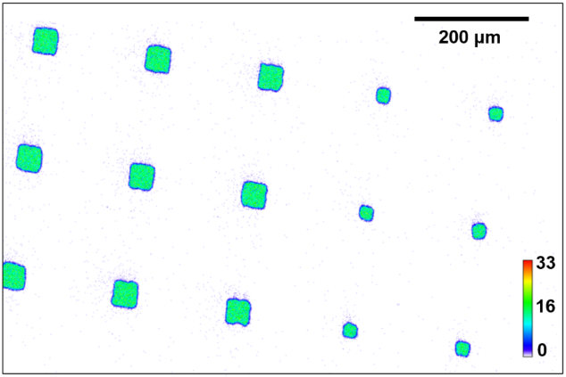

Hadron therapy is an innovative mode of radiotherapy (RT) for cancer treatment which enables tumour cells to be more effectively destroyed than conventional RT using photons. The precise knowledge of the lineal energy of particles is used in the field of microdosimetry (MKM model) as a fundamental parameter in the prediction of the relative biological efficiency (RBE) of clinical beams. Based on single-crystal CVD (scCVD) super-thin diamond membranes obtained using deep Ar/O plasma etching, prototypes of solid-state microdosimeters for lineal energy measurements were produced at the Diamond Sensors Laboratory of CEA-LIST. The response of a diamond membrane microdosimeter to single projectiles was investigated in ion microbeams. The microdosimeter was irradiated using a raster scanning method and the charge transport properties of the device were determined with sub-micron precision by measuring the charge collection efficiency (CCE), the µSVs 3D spatial definition and the pulse-height spectra. A prototype of this novel microdosimeter was then tested in a 100 MeV therapeutic proton beam at the Institute Curie – Proton Therapy Centre in Orsay. All results effectively demonstrate the great potential for this device to be used for studies of the RBE in clinical applications.

Active micro-sensitive volumes (µSVs) of the tested scCVD diamond membrane based microdosimeter. The coloured pixels represent detected ion hits (interactions/pixel) during the ion beam induced charge - IBIC - collection study at AIFIRA facility in CENBG, Bordeaux in France.
Copyright line will be provided by the publisher
1 Introduction In the 21st century, death due to cancer is still a major issue on a global scale. According to the 2017 annual report of the World Health Organization an estimated 8.8 million deaths occurred due to cancer worldwide in 2015, accounting for 22% of all deaths [1]. The most common treatment methods of cancer are invasive surgery, chemotherapy, radiotherapy or combinations of these. Each year approximately 30% of cancer patients worldwide are treated using external radiotherapy (RT). Most of the external RT treatments are based on irradiating tumours with photons. However, hadron therapy (using protons or carbon ions) is an innovative and very promising mode of RT for cancer treatment. It enables tumour cells to be more effectively destroyed than conventional radiation therapy using photons [2].
Charged particles exhibit the advantage of having an inverse depth dose distribution in comparison to photons. This kind of distribution implies the increase of the dose with penetration depth up to a maximum at the end of the particles path with the highest energy loss (Bragg peak). This advantage maximises the dose to the cancer region and spares as much as possible of the healthy tissue. By using hadron therapy, the dose to the surrounding of the tumour’s tissue can be reduced by around 60% compared with modern intensity-modulated radiation therapy (IMRT) with photons [3]. Alongside the physical advantages, ion beams additionally show an increased relative biological effectiveness (RBE), which is defined as the ratio of the irradiated dose of ions to that of a reference photon energy that would be required to result in the same biological effect for both [2]. This increased effectiveness can be explained by the different microscopic energy deposition patterns of photons and ions. Finally, these mentioned properties make the therapy with ions highly attractive for challenging radioresistant tumours.
Due to the advantages of hadron therapy and thus it’s increasing interest, a treatment planning system based on radiobiological effects needs to be considered. This system is supposed to ensure a safe dose delivery to the treated patients and is important to fully exploit the advantages of all relevant ions for this kind of therapy. The RBE of ions in tissue is one of the most significant parameters to be considered for the radiobiological treatment planning. Worldwide, there are two clinically employed radiobiological models for the prediction of the RBE in hadron therapy: the local effect model (LEM), which is a pure theoretical model and based on track structure [4] and the microdosimetric kinetic model (MKM) [5] based on measured microdosimetric quantities.
In routine clinical proton therapy, a constant RBE value of 1.1 is being used as the golden standard [6] despite a high number of publications on this subject, as is summarised in [6], clearly showing that the RBE changes even for light ions with different linear energy transfer (LET) values in clinical beams. As a result, a radiobiological optimisation of the treatment plans based on simulated dose averaged LET values has been introduced in [6,7].
In radiotherapy, the value of the LET is used to describe the average energy deposited per unit length (in keV/μm) in an absorber material e.g.: biological cell or tissue. However, serious limitations of the LET concept with respect to the RBE and radiation quality have been discussed in the ICRU report no.16 [8]. These limitations in LET values resulted in developing a set of measurable stochastic quantities in volumes compared in size to a human cell, such as lineal energy of particles, which would provide the fundamental basis for microdosimetry [9]. The lineal energy is used to describe the energy deposited by a single event, namely $ε$, in a micron-size sensitive volume (SV), along the mean particle track length,$\overline{l}$, which according to [8] is given by:
$y=\frac{ε}{\overline{l}}$. (1)
Furthermore, due to the random fluctuations of the measured lineal energy, its probability distribution is also an important function for microdosimetric studies. From the measured data it is possible to display the dose lineal energy distribution, $d(y)$. More details on microdosimetric quantities can be found in [8].
A first device capable of measuring spectra of pulse- heights from each individual event in a microscopic scale was a low pressure proportional counter called “Rossi”, which was developed in the early 1950s [10]. Today, several devices such as the Tissue Equivalent Proportional Counter (TEPC) or silicon-based semiconductor microdosimeter are commercially available or still being developed. Both types of these micro-detectors are well studied and documented in the following literature [9, 11]. In the pioneering and commercial TEPC technique, a tissue-equivalent gas (propane-based) is used for measuring microdosimetric quantities. However, limitations of the TEPC method with respect to microdosimetry include the high-voltage and the gas system, both of which are needed for operating the device. Pulse pile-up problems, as well as the low spatial resolution of the TEPC due to its relatively large size (cm), are also further limitations.
Solid-state detectors, such as silicon-based microdosimeters, have been developed over the last 20 years at the Centre for Medical Radiation Physics (CMRP) of the University of Wollongong in Australia. The last generation of silicon-based devices is called the “bridge” [12] and “mushroom” [13] microdosimeters. Their use in lineal energy measurements offers high spatial resolution and counting rates at low costs [9]. Using the new generation of silicon-based microdosimeters, a good agreement with the results from the well-established TEPC was possible. Furthermore, better spatial resolution and rate capability was observed for silicon-based detectors [9].
Although, a frequently raised issue is the question of tissue equivalence in the case of silicon material (Z=14), leading to complex correction factors when compared to e.g. diamond material (Z=6). Further advantages such as the radiation hardness and physical properties e.g. a large-band gap, temperature stability, fast drift velocity and low capacitance, make diamond an interesting potential material for producing microdosimetric devices. At present, significant developments in diamond-based microdosimeters with different approaches have been made at the Tor Vergata University [14] in Italy and at the CMRP [15]. Although so far, none of them has fully succeeded to obtain a functional device appropriate for microdosimetric quantity measurements in clinical beams.
For more than ten years, CEA-LIST has been developing diamond dosimeters for RT applications. The starting point of the research was the development of dosimeters for complex photon irradiation beams such as IMRT or stereotactic beams and continued with dosimeters designed for high dose-rate proton beams [16,17]. Currently, based on scCVD diamond membranes, new prototypes of microdosimeters are being developed at the CEA-LIST-Diamond Sensors Laboratory (LCD). The primary aim of this paper is to introduce these innovative microdosimeter prototypes to the scientific community.
2 Material and methods
2.1 Diamond microdosimeter concept Figure 1 shows the schematic diagram of a single micro-sensitive volume (µSV) of a scCVD diamond membrane based microdosimeter prototype. The top layer (in green) of the µSV consists of a thin (approx. 400 nm) layer of homoepitaxial boron-doped diamond (p⁺). This layer is deposited onto an intrinsic diamond membrane (i) with a typical thickness of 1-3 µm (in blue). This layer can be shaped into the desired forms and sizes. Typically, µSVs with a side length of between 25-100 µm are produced, which is comparable in size to a human cell. On the bottom side of the membrane an electrical contact kept at the ground potential (in grey) is assured by a large pad electrode.
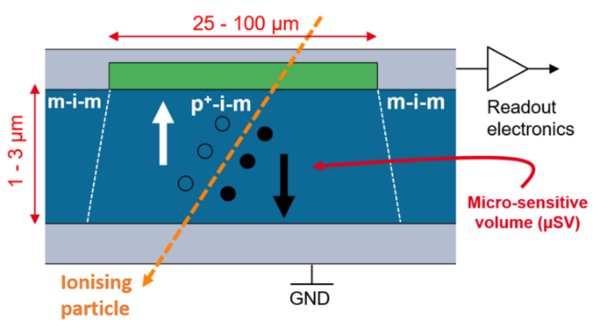

Figure 1 Simplified schematic diagram illustrating the configuration design of one self-biased micro-sensitive volume of the scCVD diamond membrane based microdosimeter. The device contains three different layers including the boron doped diamond (p⁺) (in green), an electronic grade diamond (i) (in blue) and the electrical contacts based on metal or carbon (m) (in grey). During irradiation with ions (orange dashed arrow) charge drift at 0 V is possible due to the built-in potential within p⁺-i-m junction of the µSV.

This pad can be made of metal- or carbon-based material (m). Additionally, the top p⁺-diamond layer is interconnected with other µSVs, also by the same electrical contact (m) deposited on top of the structure, which is finally fed into the readout electronics (in grey).
Two different junction regions can then be distinguished within such a microdosimeter configuration, namely the p⁺-i-m junction inside of the µSV, and the m-i-m junction outside of it. The charge transport within the µSV and outside of it is schematically illustrated as a band-diagram in Figure 2. Due to the p⁺-i-m junction, as shown in Figure 2 a), the bands bend resulting in an experimentally measured built-in potential of 1.8 V [18]. When an ionisation event inside of the μSV volume occurs, excess charge carriers - electrons and holes - are generated and start to drift in the presence of a built-in electric field. These then induce the current signal in the readout electronics. No device biasing is needed in this configuration. By integrating the induced current signal (I), it is possible to obtain the collected charge (Q) with a 100% charge collection efficiency (CCE). This CCE is then directly proportional to the energy deposited by a single ionisation event.
The region outside of the µSV is illustrated in Figure 2 b). Here no p⁺-i-m junction formation takes place, thus a built-in potential or a residual electric field can only be generated if non-perfect ohmic contacts are formed. The created excess charges carriers can only undergo isotropic diffusion, with no directional drift.
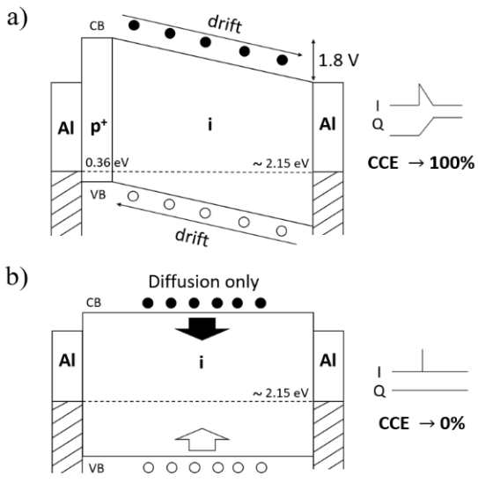

Figure 2 Band structures representing the signal formation a) within and b) outside one single µSV of a scCVD diamond membrane based microdosimeter. When the microdosimeter is irradiated with ionising radiation, due to natural potential difference of the p⁺ and the intrinsic diamond (i) layer, charge drift at 0 V (applied external bias) inducing the current signal is possible. By integrating the induced current signal (I), it is possible to obtain the collected charge (Q) with a 100% charge collection efficiency (CCE). In the area outside of the µSV, only isotropic diffusion takes place and no current signal is generated.
However, it is worth noting that for this particular diamond membrane microdosimeter setup, certain possible signal distortions need to be considered. For example, if ionisation appears outside yet still within the direct vicinity of the µSV, a part of the charge cloud diffuses into the µSV region and undergoes drift diffusion or partial extension of the electric field from p⁺-layer. This could cause signal formation with a reduced CCE, however this must be verified with detailed electric field simulations in the near future. Similar effects of reduced CCE from the edge of the active volumes have been also observed in [30] for other metal-diamond-metal structures however when applying bias voltage. It is also possible to have surface-pinning states or m-i-m regions if perfect ohmic contact is not achieved between the metal and diamond. This could also result in partial drift and thus residual signal formation with a reduced CCE.
2.2 Diamond membrane microdosimeter prototyping The scCVD diamond membrane based
microdosimeter investigated in this study is based on an electronic grade scCVD diamond from Element Six, UK [19] and was produced at the CEA-LIST Diamond Sensors Laboratory (LCD) in France.
-
In Figure 3, the six steps of the membrane production are presented. Firstly, (1-2) electronic grade single crystal diamonds with a thickness of ca. 300-500 µm are sliced and polished by Almax easyLab in Belgium [20]. The cut slices result in a thickness of only 20-60 µm with surfaces parallelism below 1 µm on all sample surface. Afterwards, (3) a thin boron-doped diamond layer (p⁺) on the top of a polished intrinsic diamond (i) is grown [21]. For this purpose, a thin highly boron-doped single crystal diamond layer is produced via chemical vapor deposition (CVD) onto the surface of the intrinsic diamond slab. To create a below 10 µm thick membrane suspended over bulky frame, a deep Ar/O plasma etching is used (4) [22].
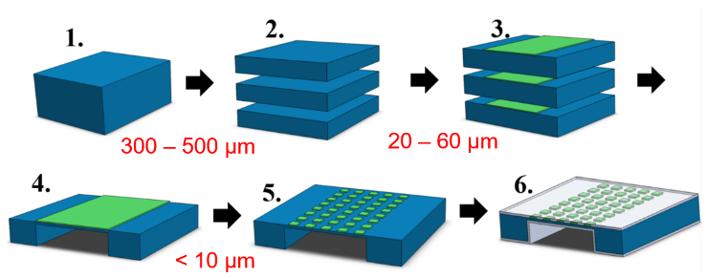

Figure 3 Production steps of the scCVD diamond membrane based microdosimeter. (1-2) Slicing and polishing of the intrinsic diamond. (3) CVD growth of a thin boron-doped diamond layer (p+). (4) Creation of a thin < 10µm diamond membrane due to deep Ar/O plasma etching technique. (5) Patterning and shallow Ar/O etching of p⁺ layer for the realisation of multiple µSVs. (6) PVD deposition of electrical contacts (metal- or carbon-based) on the top and bottom of the diamond membrane based microdosimeter.

This step is followed by (5) a photolithographic patterning of the p⁺ layer with a deposited metal mask and a successive shallow Ar/O plasma etching step. Various shaped pixels defining the microdosimeter’s µSVs can be produced in this manner. Finally, (6) the metal- or carbon-based electrical contact can be deposited on the back side of the membrane in a form of a full pad electrode. Similarly, on top of the membrane a second electrical contact must be deposited, interconnecting the µSVs with tracks, strip or pad electrodes.
In Figure 4 and 5, a 3D and scanning electron microscope (SEM) images of the scCVD diamond membrane based microdosimeter as used in this study are presented. For this microdosimeter prototype, both electrical contacts are made from Aluminium, deposited by physical vapor deposition (PVD) and using shadow masks. The various size (25 x 25 µm², 45 x 45 µm² and 90 x 90 µm²) µSVs are connected by a 500 µm wide and 3 mm long single strip upper electrode.
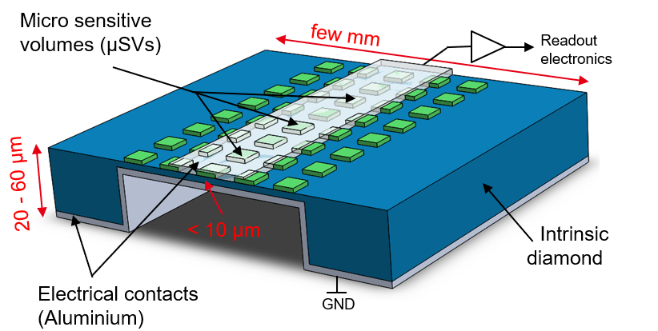

Figure 4 3D image of the scCVD diamond membrane based microdosimeter as used in this study. The electrical contacts are based on Aluminium. Only one single strip upper electrode is used for studying charge collection.
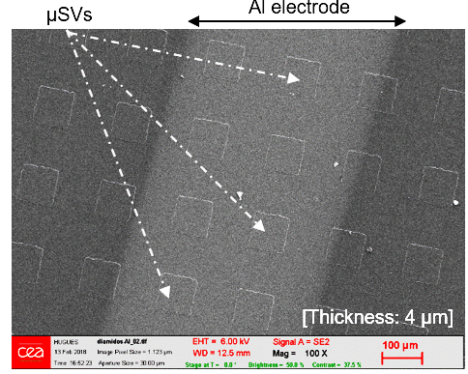

Figure 5 Scanning electron microscope (SEM) image of a sample Al strip region of the scCVD diamond membrane based microdosimeter prototype with micro-sensitive volumes (µSVs), as used in this study. The square-shaped sensitive volumes were created in three different sizes: 25 x 25 µm², 45 x 45 µm² and 90 x 90 µm² (not all shown in this image).
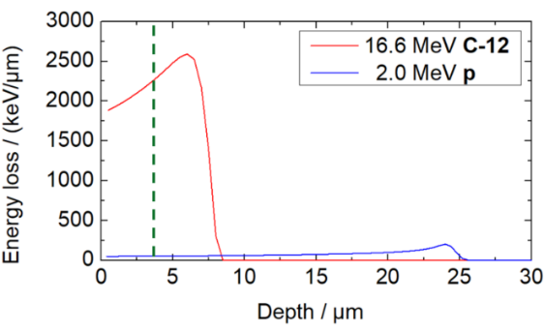
These presented µSVs are in their size comparable with the silicon state-of-the-art microdosimeters [9] and much smaller than related state-of-the-art diamond-based devices i.e. one macro SV (200 x 200 µm²) from Tor Vergata University [14]. The resulting thickness of the scCVD diamond membrane for detecting ionisation events is 4 µm. This thickness is again much smaller than the related state-of-the-art diamond-based devices with i.e. 30 – 500 µm thick CVD diamond samples used at CMRP [15].
2.3 Charge transport studies with the ion beam
Induced charge technique The charge collection
efficiency for the scCVD diamond membrane based microdosimeter was investigated using the ion beam induced charge technique (IBIC). Essentially, a focused ion beam is raster scanned across the microdosimeter membrane. The single ion induced current (I) signals are then individually
amplified and integrated resulting in a measured collected charge (Q), which is then digitalised and stored together with the coordinates for the position of the microbeam. The spatial position, along with the area and the CCE of the micro-sensitive volumes, can be determined accurately using this method. A more detailed description can be found in [23, 24, 25].
For this study, 16.6 MeV carbon and 2.0 MeV proton microbeams were used. The access to the carbon ions nuclear microprobe was provided by the Laboratory for Ion Beam Interactions, Ruđer Bošković Institute in Zagreb, Croatia [23]. This facility hosts a 6 MV EN Tandem electrostatic Van der Graaff accelerator with a heavy ion microbeam line. Measurements with a proton nuclear microprobe were performed at the AIFIRA facility in CENBG, Bordeaux in France. This facility is equipped with a commercially available HVEE 3.5 MeV Singletron accelerator, delivering light ions (protons, deuterons and helium) [24, 25]. At both sites, the microbeam line with a focus of approximately 1 µm in diameter enables the collected charge to be precisely mapped.
During the experiment, the scCVD diamond membrane based microdosimeter prototype was mounted inside of a vacuum chamber. The upper strip electrode (see Figure 4) was then connected to the charge sensitive readout electronics, which included as a first stage a low noise CoolFet Amptek 250 preamplifier [26]. In general, we used positive polarity input signals as microdosimeter signal readout. The recorded data was processed into mean charge collection maps (pulse-height) or so-called hit maps, corresponding to the number of counts/interactions per pixel.
When charged particles pass through a target material (e.g. diamond microdosimeter), they lose kinetic energy. In Figure 6, the SRIM simulated energy loss (equivalent to lineal energy) [27] demonstrates the difference between 2.0 MeV protons and 16.6 MeV carbon ions passing through a diamond material.
The green dashed line represents the thickness of the scCVD diamond membrane based microdosimeter, thus demonstrating that both projectiles fully penetrate the membrane at the energies used in this study. By integrating the simulated energy loss between 0 and 4 µm, a rough estimation of the measured energy corresponding to a theoretical LET value of 50 keV/µm for protons and 1863 keV/µm for carbon ions can be made [27]. These values almost correspond to both extremities of the LET range used in hadron therapy (protons and carbon ions).

Figure 6 SRIM simulation of protons and carbon ions energy loss within diamond. Due to their lower linear energy transfer (LET) protons penetrate diamond material much deeper than carbon ions. The green dashed line marks the thickness of the diamond membrane and demonstrates that both projectiles are able to penetrate the membrane at the given energies.
3 Results I:
3.1 Preliminary laboratory tests Before testing the prototype, a scCVD diamond membrane with only one large single p⁺-layer (as shown in Figure 3, step (4)) was tested in laboratory conditions with a 5.5 MeV Am-241 $α$- source. A classical charge sensitive electronics chain, including a low noise preamplifier, Amptek CoolFet A250 [26] was used.
In Figure 7, two pulse-height spectra of 5.5 MeV alpha particles traversing this diamond membrane of 4 µm are displayed. In black the signal detected with no applied external bias and in red with a +16 V applied bias to the device can be distinguished. The latter corresponds to an applied electric field of 3.2 V/µm, which is a field strength significantly exceeding the value of 0.3 V/µm at which a 100% CCE is expected for an electronic grade diamond material from Element Six [19]. Furthermore, a strong indication of a full CCE at 0 V bias can be made due to the significant similarity of both detected spectra.
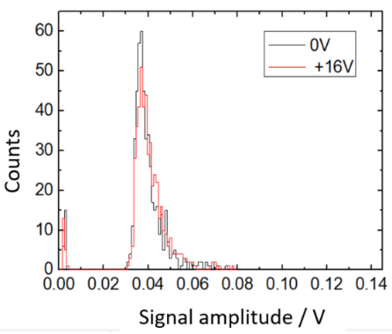

Figure 7 Pulse-height spectra detected by a scCVD diamond membrane with only one large single p⁺-layer µSV during the exposure to a 5.5 MeV Am-241 $α$- source. No bias (in black) and a +16 V external bias (in red) were applied to the device. The strong similarity of both spectra suggests a 100% CCE at 0 V bias.
3.1 Response of the diamond microdosimeter
to ion microbeams - micro sensitive volumes
definition The self-biased scCVD diamond membrane based microdosimeter prototype (Figures 4 and 5) was raster scanned with 2.0 MeV protons and 16.6 MeV carbon ions microbeam in different spatial areas.
In Figure 8 a) a global hit map resulting from a raster scanned area with 2.0 MeV protons of the self-biased diamond membrane is shown. Here, the positive input polarity of the microdosimeter signal was used as a readout. This hit map with colour-coded pixels represents the detected ion interactions within the diamond membrane. The colours pink up to orange, represent a high number of hits per pixel, with those in black representing no detected interactions. According to our concept of the p⁺-i-m and m-i-m junction, it can be observed that only the regions of p⁺ and intrinsic diamond (i) µSVs covered with Al contacts are active and register ion hits. This result confirms our concept previously explained in section 2.1. In Figure 8 b) a microscopic picture of the exact same region of the device as in Figure 8 a) is shown. From directly comparing both images, significant changes in the size, shape and position of the micro-sensitive volumes can be excluded. Similar results were observed for the 16.6 MeV carbon ion microbeam raster scan of the same device.
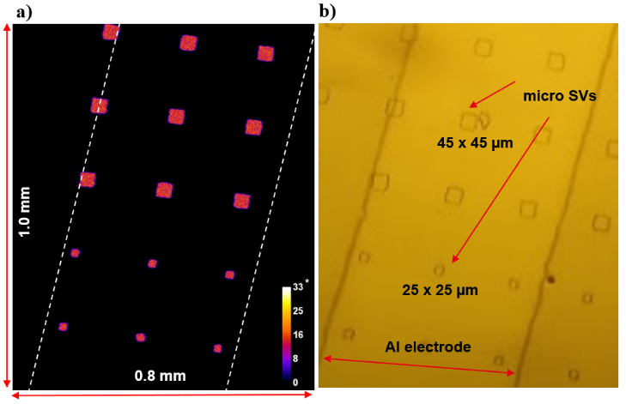

Figure 8 a) Response of diamond membrane microdosimeter to a global raster scan at 0 V bias with 2 MeV proton microbeam. b) A microscopic image of the exact same spatial region as raster scanned image.

In Figure 9, mean charge collection (pulse-height) maps from single raster scanned µSVs and their corresponding pulse-height spectra are shown. On the left side in Figure 9 a), the deposited energy distribution in a 25 x 25 µm² µSV from the proton microbeam and in b) in a 45 x 45 µm² µSV from the carbon ion microbeam is presented. The spectra plotted in blue and red represent the pulse-heights distribution for all events detected from the full area as shown left in the mean charge collection maps. These spectra include the area outside the µSV as well as its edges. For both ion types, the deposited energy distribution peak is well defined, but an additional tail at lower energies appears. At first, it appears that the lower tail signal was more pronounced for proton irradiation than carbon, however, the contribution of incomplete charge collection signal to the spectra is linked to the size of the investigated µSV. The larger the µSV the smaller the contribution due to ratio between inside of the µSV and the edges, which might be the origin of the lower signal. Furthermore, the green spectra in Figure 9 a) and b) correspond to the events located only in the centre of the µSV (indicated by the green box). These spectra do show a perfect definition of FWHM with no tail contributing to lower energies and are ideal for lineal energy measurements in clinical settings.
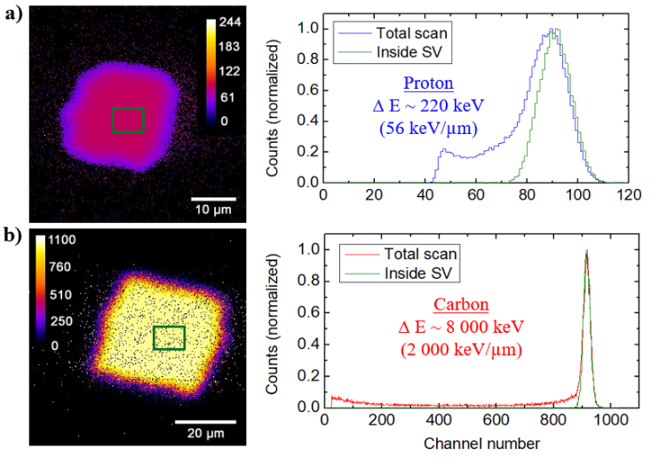

Figure 9 Response of the scCVD diamond membrane based microdosimeter to a) 2 MeV protons and b) 16.6 MeV carbon ions. (Left) Mean pulse-height maps and (Right) pulse-height spectra at 0 V bias applied to the device.

A closer analysis of the origin of the low energy tail has been made for proton irradiation. In Figure 10, different regions of the pulse-heights distribution and their corresponding hit maps are shown.
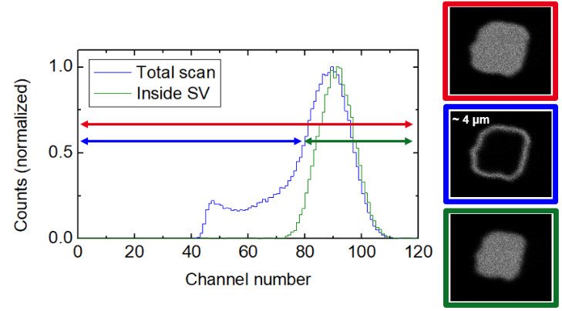

Figure 10 Analysis of the pulse-height spectra and the tail at lower energies. Displayed hit maps clearly identify the region of low energy contribution, which is linked to a reduced CCE at the edges of the µSV. The imperfect defined edges produce an approximately 4 µm large region of reduced CCE signal around the µSV.

It can be clearly seen that the lower energy signals are related to the incomplete CCE close to the edges of the µSV.
Furthermore, in Figure 11 a hit map is shown which was obtained at 0 V, accepting only negative polarity signals from the microdosimeter and the corresponding pulse-height spectra. In the large m-i-m region (outside of the µSVs) a weak residual signal can be observed. The generated signal is inverted in polarity and about 20 times weaker than the positive polarity signals from µSVs. This can be better translated to much narrower depletion zones, thus charge displacement achieved. This effect is most likely to occur as a result of imperfect ohmic contact between the metal and diamond material, in which surface-pinning states are then introduced. This could also be due to the surfaces of the diamond sample not being perfectly cleaned prior to Al coating, since slight irregularities in the shape regions would not significantly affect the signal. Another point is that slightly higher than average signals are induced at the electrodes borders/interfaces and small-localised defects (marked with red arrow) appear. These defects are most probably structural-like dislocations or bundles of dislocations.
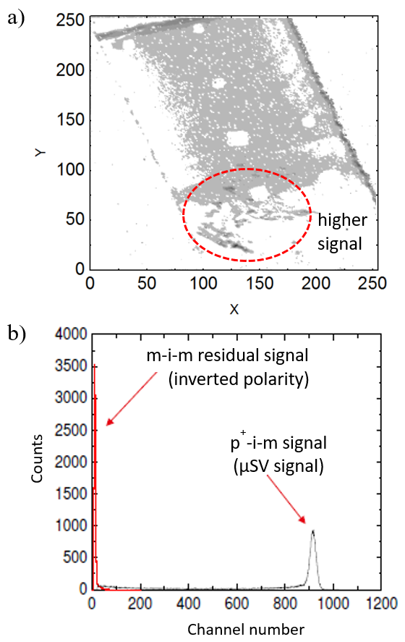

Figure 11 a) A hit map image with marked regions of higher-than-average signal and b) pulse-height spectrum of the scCVD diamond membrane based microdosimeter for inverted polarity of generated signal acquired at 0V.

It is also more likely that at these sites a non-isotropic strain is introduced into the diamond bulk which can result in non-isotropic diffusion and thus signal generation. These effects can also result in partial drift and thus residual signal formation with a reduced CCE. However, as these have an opposite polarity with respect to the main signal, they are easy to differentiate from such, and thus do not contribute negatively to the signal formation under normal operating conditions of the microdosimeter.
Possible changes in the design and production of the diamond-based microdosimeter could improve the shape of the pulse-height spectra. This could be obtained for example by introducing radiation damage (ion implantation) to the areas outside of µSVs. Also, aspects of ohmic-contact formation must be explored in more detail.
Finally, compared with the responses of silicon-based microdosimeters [9] to ion microbeams, the results from the scCVD diamond membrane based microdosimeter show already very good characteristics and a good agreement with the theoretical values, confirming the microdosimeter’s ability to measure microdosimetric quantities in single ion beams.
3.2 Charge collection efficiency Figures 12 and 13 show the charge collection characteristics of a single µSV (p⁺-i-m) and the region outside of it (m-i-m), while applying different bias voltage ranging from -5 V to +5 V. The red curve corresponds to the values measured under irradiation of the proton microbeam and blue under irradiation of the carbon ion microbeam. Pulse-height is normalised to maximum measured value at relatively high electric field which should represent 100% CCE in electronic grade scCVD material. The following important parameters can be extracted from these graphs.
In Figure 12, the intersection of the x-axis at -1.8 V corresponds to the flat band conditions where the internal electric field is compensated by the externally applied bias and equals zero and was previously measured to identical value for other devices [18]. This shows the built-in potential within the µSVs due to the p⁺-i-m junction formation between the intrinsic diamond membrane and the boron-doped diamond electrode, corresponding to an electric field of 0.45 V/µm for this device. For the operational condition at 0 V for protons, almost 100% CCE was observed. However, for carbon ions, which have a higher linear energy (LET) than protons, pulse-height defects appeared and therefore a CCE of only 80% was reached. At this point the electric field of 0.45 V/µm is not enough to efficiently separate e-h pairs created from dense ionisation, and thus some recombine. This recombination effect could be reduced if a thinner membrane (e.g. 1.4 µm) is used, since 100% CCE is reached at around 1.25 V/ µm, even for carbon ions.
In Figure 13, as expected for the m-i-m junction at 0 V, no charge collection for both particle types was observed. Additionally, for both polarities quick saturation of collected charge was observed, as was expected for electronic grade material. A small shift in the saturated levels for positive and negative biases can be explained by ADC offset, which was not corrected in these measurements.

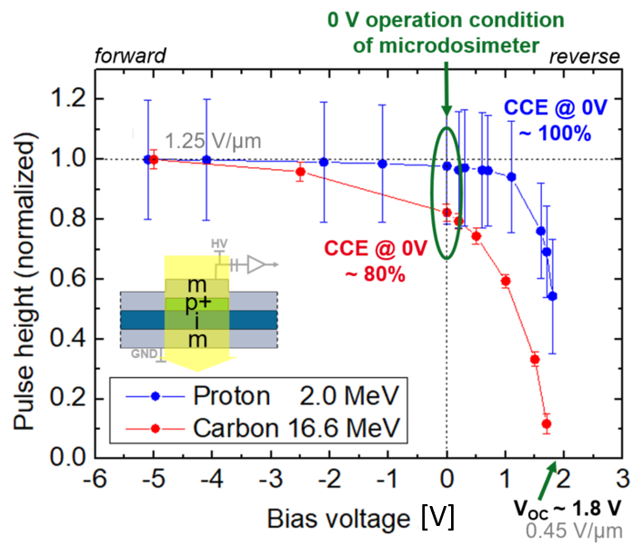

Figure 12 Charge collection characteristics vs. microdosimeter bias voltage inside of a micro-sensitive volume. At 1.8 V a build-in potential and thus electric field of 0.45 V/µm for our device, can be measured. For the operation condition at 0 V a CCE of almost 100% for protons only 80% for carbons was reached.
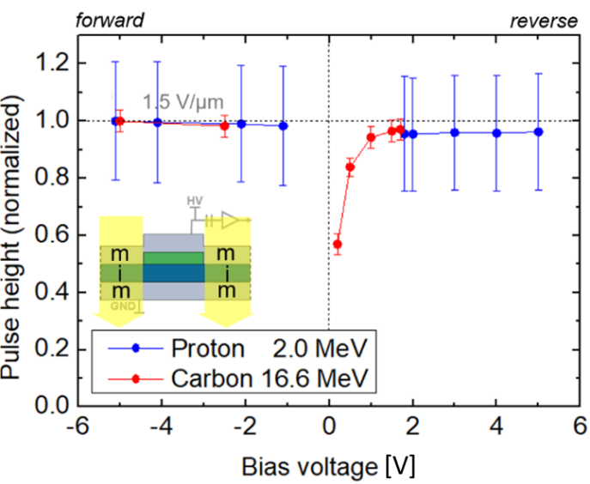

Figure 13 Charge collection characteristics vs. microdosimeter bias voltage outside of a micro-sensitive volume. No significant charge collection for the m-i-m junction at 0 V was detected.

3.3 Insight into radiation hardness Compared to classical radiotherapy where gammas or electrons are used, particle therapy dosimetry or microdosimetry devices must deal with much higher radiation damage risk. Charge particles interacting with semiconductor material will create primary defects like vacancies and interstitials which will strongly contribute to life time reduction of charge carriers. This can result in a reduced CCE, thus altering the performance of the scCVD diamond membrane based microdosimeter. Preliminary radiation hardness tests were performed to determine the device’s suitability for medical applications. A single µSV and surrounding regions were irradiated locally by means of proton and carbon microbeam. The results are presented in Figures 14 a) and b).
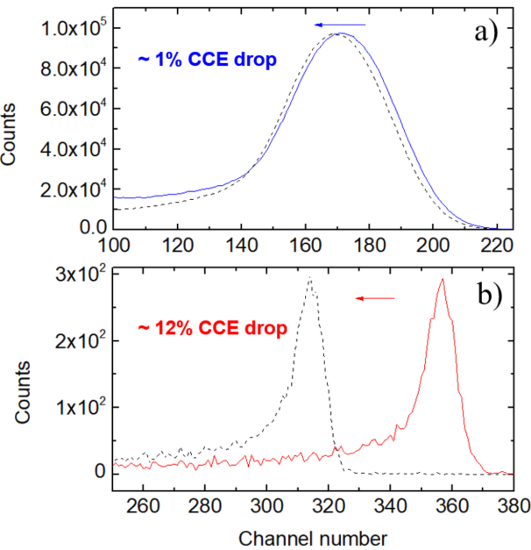

Figure 14 Pulse-height spectra from the scCVD diamond membrane based microdosimeter before (solid line) and after (dashed line) exposure to a high a) proton and b) carbon ion fluence.

Figure 14 a) shows the pulse-height spectra of a single µSVs irradiated with up to 2.5∙10¹³ ions per cm². This high fluence of protons caused only a 1% drop of the CCE of the device. For heavier carbon ions, shown in Figure 14 b), a drop of 12% was observed after 0.64∙10¹² carbon ions per cm². Although, the fluence in the particle therapy with carbon ions is much lower than for protons. This means that these presented results are very good even for carbon ions.
It is also important to note that any changes in the spectrum shape, peak FWHM or μSV geometry were insignificant. With these results, over 500 treatments for both particle types would be possible before a CCE drop of 1%.
4 Results II:
Preliminary measurements in clinical proton beam Preliminary tests of a scCVD diamond
membrane based microdosimeter in mixed radiation field were conducted at the Institute Curie – Proton Therapy Centre in Orsay. The therapy centre hosts the C235 cyclotron which delivers proton beams with energies of up to 235 MeV in both scattered and pencil beam scanning modes [28].
For the purpose of this study, a 100 MeV clinical proton beam in scattered scanning mode was used. The readout of previously tested µSVs was performed with a low noise CoolFet Amptek 250 preamplifier, and classical charge sensitive chain including Amptek MCA-8000 Multichannel analyser [26]. As shown in Figure 15, the diamond membrane device was placed on the movable patient treatment table and centred in front of the proton beam with help of Gafchromic films. The so-called Plastic Water plates were used to simulate different depth in the water phantom or patient body. In Figure 16, dose-weighted-microscopic distributions were obtained by applying algorithms [29] to the measured pulse-height spectra from the scCVD diamond membrane based microdosimeter at three different experimental points as shown in Figure 16 (inset): the entrance at 0 mm (1), and the Bragg peak regions at 68 mm (2) and 78 mm (3). The spectrum (in non-calibrated units) represents the spread of the lineal energy over two decades.
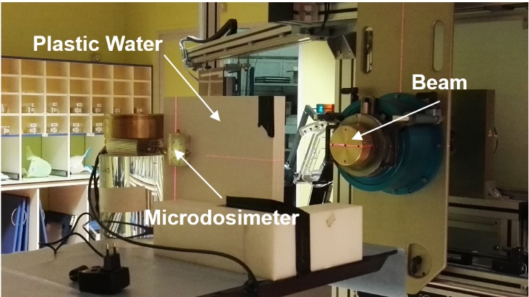

Figure 15 A picture of the experimental setup at the Institute Curie – Proton Therapy Centre in Orsay with a 100 MeV clinical proton beam.

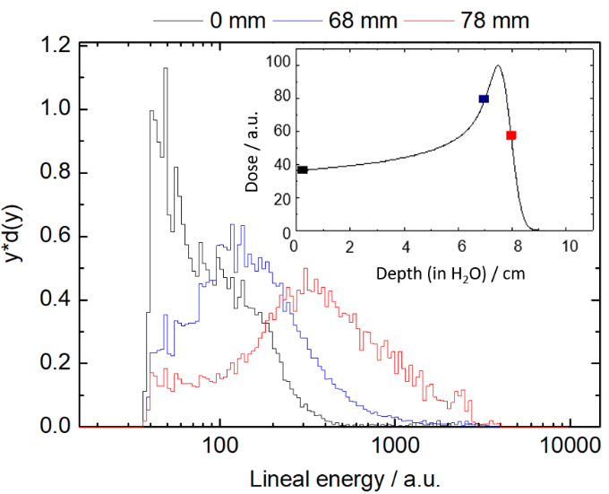

Figure 16 Microscopic spectra obtained using the scCVD diamond membrane based microdosimeter at three different experimental points. Inset: Simulated Bragg peak of a 100 MeV therapeutic beam in a water phantom with experimental points taken at 0, 68 and 78 mm depths.

Although not calibrated with the energy and therefore not directly comparable to related microdosimeters responses, a general trend can be observed in which there is an increase in pulse-height (lineal energy) at higher energies (distal part) for the Bragg peak. However, this similar behaviour of the scCVD diamond membrane based microdosimeters can be also observed for known measurements obtained from TEPC [11] and silicon dosimeters [9, 12, 13, 31], which demonstrates the microdosimeter’s ability to measure microdosimetric quantities in clinical ion beams.
5 Summary and outlook Initial prototypes of scCVD diamond membrane based microdosimeters have been characterised with 2.0 MeV proton and 16.6 MeV carbon ion microbeams. Furthermore, preliminary measurements in mixed radiation fields at the Institute Curie – Proton Therapy Centre, Orsay with 100 MeV clinical proton beam have been conducted.
The present results from the prototypes demonstrate that scCVD diamond membrane based microdosimeters are relatively easy to fabricate and provide high spatial resolution measurements. When operated at 0 V, a CCE of almost 100% for protons and 80% for carbons was reached with good spatial definition of µSV.
Furthermore, the radiation hardness tests have demonstrated the device’s suitability for medical applications. Possible optimisation of the µSVs signal could be achieved by introducing radiation damage due to ion implantation.
Finally, preliminary tests in clinical environments with therapeutic proton beams have shown typically expected lineal energy characteristics of a 100 MeV therapeutic proton beam. Additionally, very good characteristics were observed compared with other micro-detectors like TEPC and silicon-based microdosimeters.
Acknowledgements This research has been performed within the framework of the DIAmiDOS (Diamond membrane microdosimeter) project founded by the French Alternative Energies and Atomic Energy Commission (CEA). The authors would like to acknowledge DiamFab.eu for growing excellent quality homoepitaxial p⁺ diamond films. Furthermore, we would like to thank all collaboration partners and especially the IBIC microbeam teams in Ruđer Bošković Institute in Zagreb, Croatia and AIFIRA facility of CENBG in Bordeaux, France.

This project has received funding from the European Union’s Horizon 2020 Research and Innovation programme under Grant Agreement no. 654168.
References
[1] World health stat. 2017, Licence: CC BY-NC-SA 3.0 IGO.
[2] G. Kraft, Prog. Part Nucl. Phys. 2000, 45, 473.
[3] J. Loeffler et al., Nat. Rev. Clin. Oncol. 2013, 10, 411.
[4] M. Scholz et al., Radiat. Environ. Biophys. 1997, 36, 59.
[5] R. Hawkins, Med. Phys. 2013, 40, 705.
[6] H. Paganetti, Phys. Med. Biol. 2014, 59, 419.
[7] C. Grasberger et al., Int. J. Rad. Onc. Bio. Ph. 2011, 80, 1559.
[8] Intern. Com. on Rad. Units and Measur. ICRU. 1970, 16.
[9] A. Rosenfeld, Nucl. Instr. Meth. Phys. Res. A. 2016, 809, 156.
[10] H. Rossi et al., Radiology. 1955, 64, 404.
[11] M. Farahmand et al., Nu. Ins. Met. Ph. Res. A. 2003, 509, 262.
[12] T. Linh et al., Med. Phys. 2017, 44, 6085.
[13] T. Linh et al., IEEE Trans. Nucl. Sci. 2018, 65, 467.
[14] C. Verona et al., Rad. Measur. 2018, 110, 25.
[15] J. A. Davis et al., IEEE Trans. Nucl. Sci. 2012, 59, 3110.
[16] C. Moignier et al., Med. Phys. 2016, 43, 6.
[17] C. Moignier et al., Phys. Med. Biol. 2017, 62, 5417.
[18] M. Pomorski et al., Appl. Phys. Lett. 2016, 108, 2521.
[19] https://www.e6.com.
[20] https://www.almax-easylab.com.
[21] M. A. Pinault-Thaury et al., Appl. Surf. Sc. 2017, 410, 464.
[22] M. Pomorski et al., Appl. Phys. Lett. 2013, 103, 112.
[23] M. Jaksic et al., Nuc. Inst. Met. Ph. Res. B. 2007, 260, 114.
[24] G. Devès et al., Nuc. Inst. Met. Ph. Res. B. 2015, 348, 62.
[25] S. Sorieul et al., NIM B. 2014, 332, 68.
[26] https://amptek.com.
[27] J. F. Ziegler, SRIM. 2013.
[28] A. Patriarca et al., Cyclotrons (WEPSH010). 2013.
[29] S. Najm Al-Bayati, Master Thesis - Uni. of Ontario. 2012.
[30] C. Cazzaniga et al., Nucl. Instr. Meth. B. 2017, 405, 1.
[31] S. Anderson et al., Med. Phys. 2017, 44, 6029.

