Electroanalytical characterization of Zn (II) complexes with D-mannosamine and Glycine in aqueous solutions
Petra Vukosav^{a1}, Marina Mlakar^{a1,*}, Atiđa Selmani^{b}, Nikola Bregović^{b} and Blaženka Gašparovićª
ª Ruđer Bošković Institute, Division for Marine and Environmental Research, Bijenička st. 54, P.O. Box 180, 10000 Zagreb, Croatia
^{b}Division of Physical Chemistry, Department of Chemistry, Faculty of Science, University of Zagreb, Horvatovac 102a, 10002 Zagreb, Croatia; Tel: +385 (1) 4606130; E-mail: aselmani@chem.pmf.hr, nbregovic@chem.pmf.hr
¹ISE - member
*Corresponding author, e-mail: mlakar@irb.hr; phone: +38514561190, fax: +38514680231.
Abstract
A detailed study of Zn(II)-D-mannosamine and mixed ligand complex Zn(II)-D-mannosamine-glycine in aqueous solution (θ = 25 ◦C, I_{c} = 0.55 mol L⁻¹) was carried out by voltammetry and potentiometry, allowing their characterization. Redox process of the [ZnManN]²⁺ complex was registered at E_{p} ~ -1.01 V, [ZnGly]⁺ at
-1.02 V, ZnGly₂ at -1.18 V, while [ZnManNGly]⁺ at -1.12 V (pH = 8.0). Stoichiometry and stability constants of Zn (II) complexes were determined by potentiometric titrations. Calculated stability constants were found to be: log β_{ZnManN}²⁺ = 2.7, log β_{ZnMaNGly}⁺ = 7.7 and log β_{MaNZnGlyH-1} = -0.15. Voltammetric and potentiometric data were in good agreement, both indicating formation of two different ternary complexes, i.e. [ZnGlyManN]⁺ and [ZnGlyManNH_{–1}]. Calculated speciation revealed the presence of the [ZnManN]²⁺ complex, as well as ternary complexes ([ZnManNGly]⁺) in significant amount. This study was the first attempt to quantify complexation processes of Zn (II) with naturally occurring amino sugar and mixed complex with amino acid, important for bioavailability of zinc (II) in seawater.
Keywords: zinc, D-mannosamine, Glycine, stability constants, electrochemistry
- Introduction
Knowledge on metal speciation is crucial for better understanding of metal bioavailability, bioaccumulation and, therefore, toxicity to organisms [1 - 4]. Trace metals are present in natural waters as simple hydrated ions, as various inorganic and organic complexes and/or are adsorbed at different particles [5]. Therefore, besides information regarding total concentration of a particular metal in a given environment, its speciation is of great interest [6]. Essential elements, iron and/or zinc are one of the most important trace elements in biochemistry of organisms (from simple, e.g. various microorganisms, to the most complex ones, e.g. humans).
Zinc (II) is the essential trace metal, especially important for phytoplankton growth [7 - 9]. Furthermore, essentiality of zinc (II), coupled with a nutrient-like vertical distribution, motivated extensive studies of its speciation in marine ecosystem [9]. Zinc has significant functions in many enzymes rather important for phytoplankton growth: carbonic anhydrase and alkaline phosphatase. There are several mechanisms in which the presence of ligands can affect metal uptake by microorganisms. However, active transport of M into the cell from weak complexes ML can occur, whenever ternary complex XML forms, where X is a cellular transporter, M stands for metal cation, and L is a weak organic ligand.
In oceanic waters zinc occurs in nanomolar range of concentrations [9 - 11], while its concentrations in estuarine and coastal waters are usually much higher [12]. Vertical distribution of total dissolved zinc (II) in seawater is nutrient-like, depleted at the surface due to biological activity, whereas its concentration increases with depth [9]. About 98 % of zinc (II) in seawater is complexed with organic ligands [13], but little is known about the ligands that bind it [9, 14]. Recent studies showed that binding of Zn (II) to weak organic ligands increase its availability for phytoplankton in presence of strong chelating agents [15]. Carbohydrates represent a large fraction of the characterized marine dissolved and particulate organic matter [15]. Carbohydrates, i.e. sugars, are present in seawater as exudation products from phyto- and bacterioplankton, herbivorous grazing, microbial degradation and cell lysis [16, 17]. Redox behaviour, structure and stability of some metal-sugar complexes were studied extensively [19 - 20]. These studies included neutral (e.g. glucose, galactose, mannose, etc.), acidic (mainly uronic acids) and amino sugars (e.g. glucosamine, galactosamine, mannosamine). Regarding amino sugars concentrations in seawater, recent paper of Engel and Handel [18] reported that amino sugars ranged between 10 and 40 nmol L⁻¹ (in both, dissolved (< 0.45 μm) and particulate phase) in surface seawater samples (Bay of Biscay). Amino sugars are important chelating agents for transition metal ions since they can form strong complexes with various metal ions [19 - 25]. D-mannosamine (ManN) is a monomeric amino sugar whose structure is analogue to glucosamine (GlcN) and galactosamine (GalN) and differs only in position of substituents on the C-2 and/or C-4 atoms [24]. While chemistry of some trace metals such as copper(II), nickel(II) and cobalt(II) with mentioned amino sugars, i.e. GlcN, GalN and ManN, were explored with different analytical techniques that allowed determination of stoichiometry and stability constants of the corresponding complexes [21 - 24, 26], chemistry of Zn-ManN complexes is unknown .
In this work speciation and electrochemical behaviour Zn (II) complexes with weak organic ligands, amino sugar D-mannosamine and amino acid glycine in aqueous solution were investigated by electroanalytical techniques, voltammetry and potentiometry. Stoichiometry and stability constants of Zn-ManN and mixed Zn-ManN-Gly complexes were determined and discussed for the first time.
2. Experimental
2.1. Equipment and measurements procedure
2.1.1. Voltammetric measurements
Voltammetric experiments were performed using µ-AUTOLAB multi-mode potentiostat (ECO Chemie, Utrecht, The Netherlands) equipped with Metrohm 663 VA stand (Metrohm, Herisau, Switzerland). GPES 4.9 software was used for the instrument computer-control, while voltammograms were analyzed by using the ElectroChemical Data SOFTware (ECDSOFT) program made in our laboratory [24]. The working electrode was a static mercury drop electrode (SMDE, size 2, i.e. 0.40 mm²), the counter electrode was a glassy carbon rod and the reference electrode was Ag/AgCl (sat. NaCl) (+0.197 V vs. standard hydrogen electrode, SHE). Measurements were performed in an electroanalytical quartz cell at (25 ± 1) °C. Applied voltammetric techniques were: square-wave voltammetry (SWV) with pulse amplitude, a = 25 mV; frequency, f = 50 s⁻¹; potential step increment, E_{inc} = 2 mV; cyclic voltammetry (CV) with scan rate, v = 0.05 V s⁻¹ and alternate current voltammetry (ACV) with phase angle Φ = 90° and other parameters: a = 25 mV, f = 77.35 s⁻¹, E_{inc} = 10.05 mV. Solutions were deaerated by bubbling with extra pure nitrogen for about 15 min with stirring (3000 rpm) prior to electrochemical measurements. Nitrogen circulated above the solution during measurements.
The pH values were measured with a combined glass-Ag/AgCl electrode connected to an ATI Orion PerpHecTMeter, model 320 (Cambridge, USA). pH electrode was immersed into electroanalytical cell throughout hole on the top cover, thus providing pH measurement before, during and after the voltammetric scan. Standard buffer solutions were used for the glass electrode calibration.

2.1.2. Potentiometric titrations
Potentiometric titrations were carried out using combined glass electrode 6.0228.010 (Metrohm), while Metrohm 827 pH-meter was used to measure the electromotive force. Electrode calibration was carried out in concentration scale by titrating standard HClO₄ solution with NaOH solution at ionic strength I_{c} = 0.55 mol L^{–1} (NaClO₄). pH values were calculated as –log c[H⁺], which corresponded to perchloric acid concentration in excess, in acidic region. After neutralization of HClO₄, in the basic region pH was defined as pK_{w} = log[OH–]. K_{w} was the autoprotolysis constant of water at the ionic strength used. Good linearity of calculated pH and electromotive force was attained, with the slope close to the one expected by Nernst equation.
All solutions used for potentiometric titrations were prepared using de-ionised and carbonate free water (R >18 MΩ). Sodium hydroxide (c ≈ 0.55 mol L^{–1} and ≈ 0.1 mol L^{–1}) titrant solutions were standardized potentiometrically with potassium hydrogenphthalate used as a primary standard, whereas the standardized sodium hydroxide solutions were used for potentiometric standardization of perchloric acid solutions (c ≈ 0.55 mol L^{–1}).

2.1.2.1. Determination of the D-mannosamine and glycine pK values
The solution (V = 10 mL) containing ManN·HCl (c_{ManN} = 5 × 10^{–3} mol L^{–1}) and NaClO₄ (c = 0.55 mol L⁻¹) was titrated with sodium hydroxide solution (c ≈ 0.55 mol L⁻¹) in order to determine protonation equilibrium constant. In order to determine reliable pK values of glycine it was necessary to have sufficiently high, fully protonated form, which was ensured by the addition of HClO₄ prior to titration with NaOH. Solutions were stirred with a magnetic stirrer continuously during titrations and thermostated at (25.0 ± 0.1) °C under argon. pH value was recorded after each addition of NaOH by Dosimat (Metrohm). pK values were determined by nonlinear regression analysis of the pH vs. V(NaOH) curves using Hyper quad software [28, 29].
2.1.2.2. Study of the Zn(II) complexation by ManN and formation of Zn-ManN-Gly complexes
In order to determine stoichiometry and stability of zinc(II) complexes with ManN, titrations with NaOH were carried out at different Zn:ManN molar ratios. Zinc was added as nitrate salt and NaClO₄ was used to adjust the ionic strength to avoid Zn-Cl complexes formation. The titration procedure used was equivalent to the one for pK values determination. ManN·HCl concentration was ≈ 5 × 10^{–3} mol L^{–1}, while the Zn²⁺ concentrations were 1 × 10^{–3}, 2 × 10^{–3} and 3 × 10^{–3} mol L^{–1}. Obtained curves were analyzed by Hyperquad program simultaneously [28, 29].
Similar procedure was used to study ternary Zn-ManN-Gly complexes stability. In this case, two titrations were differing in ManN concentrations, which were ≈ 4 × 10^{–3} and ≈ 1 × 10^{–3} mol L^{–1}. Glycine concentration was ≈ 4 × 10^{–3} mol L^{–1}, and Zn²⁺ ≈ 2 × 10^{–3} mol L^{–1}. Again, both curves were analyzed simultaneously. pH range used in the fitting procedure, depended on the precipitation pointand it was not higher than pH = 9.2. All Zn hydroxides as well as Zn-Cl complexes, were included in the fitting model [30].

2.2 Chemicals and solutions
Standard zinc (II) solution (TraceCERT®) of (1.51 × 10⁻² mol L⁻¹) for atomic absorption spectrometry (Fluka Sigma-Aldrich, Buchs, Switzerland) was used in all voltammetric experiments. Zinc nitrate hexahydrate (Zn(NO₃)₂ x 6 H₂O, p.a., Acros Organics, Belgium) was used for potentiometric titrations. The aqueous stock solution of D-mannosamine was prepared by dissolving solid D-mannosamine hydrochloride (Sigma-Aldrich Chemie, Steinheim, Germany) in deionized water from a Milli-pore Mili-Q system (Bedford, USA). Glycine (p.a., Merck, Darmstadt, Germany), as well as sodium chloride, were also dissolved in deionized water, for stock solutions (NaCl, p.a., Kemika, Croatia).
Diluted p.a. HCl/HClO₄ or p.a. NaOH were used to adjust pH of all solutions. All measurements were performed at room (θ = 25 °C) temperature.

3. Results and discussion
3.1. Zn (II)-mannosamine complex
SW voltammograms recorded in aqueous NaCl solution of 0.55 mol L⁻¹ with
D-mannosamine addition, Figure 1, showed an electrode process at -1.36 V that is most likely related to proton reduction catalyzed by nitrogen atom from D-mannosamine molecule amino-group [31]. AC voltammograms indicated D-mannosamine adsorption at Hg-electrode, as capacitive current decreased in the potential range in which water molecules reorientation occurred (peak at -0.4 V in the inset, AC voltammogram) [32].
Figure 1.
Reduction of “free” Zn²⁺ ions (c_{Zn} = 5 ×10⁻⁶ mol L⁻¹) occurred at -0.98 Vat pH = 8, in 0.55 mol L⁻¹ sodium chloride aqueous solution, Fig. 2. By the addition of D-mannosamine in concentration range c_{ManN} = (0.5 - 500) ×10⁻⁵ mol L⁻¹, the reduction peak current (I_{p}) increased, while the peak potential (E_{p}) gradually shifted towards more negative values due to increasing portion of (labile) Zn(II)-mannosamine complexes (E_{p} ~ -1.01 V) [33 - 35], Figure 2. Since the reduction process is not reversible and Zn-mannosamine complex(es) showed adsorption characteristics, it was not possible to use E_{p} vs. [ManN] dependence for calculating their stability constants [33-36]. Namely, I_{p} increased for about 30 % with the accumulation time of 60 s at the potential (E_{acc}) of 0 V, while with t_{acc} = 600 s about 2.8 times.
Figure 2.
Analysis of “forward-backward” scans (Fig. 3), and cathodic and anodic scans in cyclic voltammograms (inset in Fig.3), led to the conclusion that Zn-mannosamine complex(es) reduction process was quasireversible, similar to the “free” Zn(II) ions reduction process [37]. Peak potentials of forward and backward scans were separated by 17 mV and peak current of backward scan was significantly smaller than forward scan. Moreover, the value of half-peak width was 84 mV (with a = 25 mV and E_{inc} = 2 mV), which was considerably higher than theoretical value of 62 mV for reversible, two-electron reduction process [38]. E_{p} was shifted for about 11 mV by changing SW-frequency in the range from 8 to 150 Hz. The peak current didn’t depend linearly on the SW-frequency root, supporting our previous statement on quasireversible character of the corresponding electrode process [38]. The difference between peak potentials of cathodic and anodic process on cyclic voltammogram (CV)(inset of Fig.3) was 45 mV, being considerably greater than the theoretical value for reversible two-electron reduction process (29.5 mV) [39]. The influence of electrode kinetics (i.e. quasireversibility) was expressed even more by variation of the scan rate (from 10 to 300 mV) in CV, while cathodic and anodic peak potentials changed for about 30 mV.
Figure 3.
Additionally, Zn-ManN complex peak current depended on f^{1/2} nonlinearly, which is indicative for quasireversible redox reactions [38]. However, the reduction peak current depends linearly on frequency variation with the slope 14.85 nA s⁻¹, implying the reactant adsorption.
The influence of pH on Zn(II)-mannosamine reduction peak, at constant c_{Zn} and c_{ManN}, is presented in Figure 4. It can be noticed that from pH = 6.0 to 7.4, reduction current slightly increased and reduction peak shifted towards negative potentials. I_{p} started to decrease above pH = 7.4, while E_{p} shifted significantly towards negative potentials most probably due to the possible formation of ZnManN(OH)_{x} complexes. The results described were considerably different from those obtained for Zn(II) without ManN in 0.55 mol L⁻¹ NaCl solution (Inset of the Fig. 4). Zn(II) reduction peak current (and potential) remained constant in the pH range from 3.5 up to the pH = 5.0, while above pH = 5.0 Zn(II) reduction peak current progressively decreased since Zn(II)-hydroxides were formed. Reduction peak potential of Zn²⁺ didn’t change significantly in investigated pH range (3.5 – 9.4).
Figure 4.
Voltammetric results pointed out that the formation of Zn²⁺ complex(es) with D-mannosamine occurs in the aqueous solutions. However, they could not have been used for the quantitative characterisation of Zn-ManN complexes, because of the above described characteristics of the redox process, i.e. quasireversibility and adsorption. Therefore, potentiometric titrations were used to determine the complex stoichiometries and the corresponding stability constants.
In order to characterize the complexation equilibria it was necessary to determine the D-mannosamine pK value under the experimental conditions (θ = 25 °C, I_{c} = 0.55 mol L^{–1}) used in course of voltammetric measurements, since the Zn-ManN complex formation was pH dependent. Potentiometric titration in given conditions was carried out (Figure 5) and the pK = 7.73 value was attained, which was in agreement with previous studies [21 - 23].
It is well known that the amino nitrogen acts as one of the most important donor groups stabilizing Zn(II) complexes with amino carbohydrates [21, 22, 24, 26]. This interaction could not be achieved with protonated NH₂ group. Therefore, complexation did not occur in acidic medium, that is, at pH significantly lower than ManN pK value. Potentiometric and voltammetric results corroborated this presumption. Namely, the data fit was not improved by including species with protonated HManN⁺ in the equilibrium model, and no changes were recorded at low pH values by voltammetry. Experimental and calculated potentiometric data were in good agreement when the model including only [ZnManN]²⁺ complex formation was applied. Equilibrium constants of complex formation are presented in Table 1. The increase of reduction peak was registered in the pH range 6.0 – 7.8 and this coincides with the pH region in which [ZnManN]²⁺ complex concentration increased considering potentiometric results (Fig. 5). Furthermore, significant peak current decrease observed above pH 8.0 (Fig. 4), can be explained by the formation of Zn-hydroxides, which was also predicted by the distribution diagram. However, as stated, the reduction peak shift above pH = 8, does not occur when the solution is ligand free. That indicated that reactions, other than Zn-hydroxides formation took place, possibly [ZnManN]²⁺ complex deprotonation or OH– binding with the complex. Such equilibrium could not be characterized by potentiometry due to poor solubility of the species present in pH region where corresponding complex is expected to form.

Figure 5.

Table 1 D-mannosamine protonation constant and [ZnManN]²⁺ complex stability constant in water at 25.0 °C, I_{c} = 0.55 mol L^{–1} (NaClO₄).
Species | log β | SD
[HManN]⁺ | 7.73 | 0.02
[ZnMan]²⁺ | 2.7 | 0.1

3.2. Mixed Zn(II)-mannosamine-glycine complexes
Seawater and other natural environments contain different ligands that bind metal ion, forming “simple” (binary), but also mixed ligand (ternary) complexes. Amino acid glycine (Gly) was used to explore the possibility of Zn²⁺ ion mixed complexes formation with D-mannosamine, as group of important, naturally occurring ligands [40].
Zn (II) reduction in the solution containing only glycine as a ligand (no ManN was present) in the concentration range of c_{Gly} = (0.5 – 55) × 10⁻³ mol L⁻¹, was recorded by SW voltammetry. With c_{Zn} = 2 × 10⁻⁴ mol L⁻¹ at pH = 8.0, gradual addition of Gly into the solution up to the c_{Gly} = 5 × 10⁻⁴ mol L⁻¹ resulted in the Zn(II) reduction peak current decrease and slight E_{p} shift toward more negative potentials. This indicated formation of a labile complex, most probably [ZnGly]⁺ [36]. With increase of Gly concentrations (≥ 5 × 10⁻⁴ mol L⁻¹), I_{p} continued to decrease, while simultaneously, a new reduction peak aroused at more negative potentials (E_{p} = -1.18 V). These reduction peaks of irreversible character were a response of [ZnGly]⁺ and/or ZnGly₂ complexes reduction [6, 36].
Figure 6 shows voltammograms of Zn (II) (c_{Zn} = 2 ×10⁻⁴ mol L⁻¹) (a), with D-mannosamine (c_{ManN} = 1 × 10⁻² mol L⁻¹) (b), with 4 × 10⁻³ mol L⁻¹ Gly (c), and with D-mannosamine and Gly mixture (d) of corresponding concentrations. By analysing the recorded voltammograms in solutions containing Zn, ManN and Gly, it can be concluded that Zn(II) forms mixed [ZnManNGly]⁺ complex. Namely, Ep shifted towards more negative values compared to those of Ep of [ZnManN]²⁺ or [ZnGly]⁺ complexes, and more positive then Ep of [ZnGly₂] complex. Changing the pH of solution, E_{p} shifted slightly, from -1.05 to -1.12 V in the pH range from 6 to about 8.0, while I_{p} remained approximately the same. With further increase of pH from 8.0 to 9.5, E_{p} changed from -1.12 to -1.32 V and I_{p} increased linearly with the slope of 92.4 mV. Such behaviour suggested the formation of [ZnManNGly(OH)] complex, which was corroborated by potentiometric measurements.
Figure 6.
In order to get a more detailed insight into the [ZnManNGly]⁺ complex redox process, a backward-forward SW scan was analysed showing that it is quasireversible, as the E_{p} shifted (E_{p,c} − E_{p,a} ≈ 10 mV) and reduction currents were not equal. Furthermore, reduction current dependence on the f^{1/2} was nonlinear, which confirmed quasireversibilty of the mixed ligand complex, and implied EC reduction mechanism.
As already stated, results obtained by voltammetric measurements were corroborated with potentiometric measurements. This allowed further insight regarding ternary Zn²⁺ complexes stoichiometry and stability. The Gly protonation constants were determined at the same conditions used in other experiments in this research, and the obtained values agreed with the ones described in literature [41 – 44]. Solutions containing ManN, Zn²⁺, and Gly were titrated with NaOH solution in order to study the formation of ternary complexes. Two titrations were carried out using solutions of different ManN concentration, while the Gly and Zn²⁺ concentrations were kept constant. ManN and Gly protonation constants, as well as [ZnManN]⁺ complex stability constant determined in this work, were fixed during data fitting procedure. The Zn-Gly complexes formation constants were kept constant at values recommended by IUPAC [45]. These values were determined at conditions rather similar to ones used in this work (I_{c} = 0.5 mol L^{–1}).
Table 2. Gly protonation constant and Zn-ManN-Gly ternary complexes stability constants in water at 25.0 °C, I_{c} = 0.55 mol L^{–1} (NaClO₄).
species | log β | SD
[GlyH]⁺ | 9.46 | 0.01
[GlyH₂]⁺ | 11.93 | 0.01
[ZnGly]⁺ ª | 4.88 | –
[ZnGly₂] ª | 9.11 | –
[ZnManNGly]⁺ | 7.7 | 0.1
[ZnManNGlyH_{–1}] | –0.15 | 0.09
ªrecommended values from [45].
Good agreement of experimental and calculated data was obtained by including two different ternary complexes, i.e. [ZnManNGly]⁺ and [ZnManNGlyH_{–1}], in the model. The later species was most probably [ZnManNGlyOH], but it is possible that the OH group of the ManN ligand in the complex was deprotonated, which would enable further favourable interactions with the Zn²⁺ cation. It should be noted that the [ZnManNGlyH_{–1}] became the predominant species at pH > 8 (Fig. 7) and most likely precipitated from the solution. Low solubility of such species can be poorly soluble due to its electroneutrality. Consequently, a narrow pH region was used to calculate the stability constants, causing somewhat greater errors in the determined values. However, the mixed ligand complex [ZnManNGlyOH], was evenly dissolved at high pH because the Zn²⁺ concentration was lower in the voltammetric measurements. The calculated distribution curves correlated to results obtained by voltammetry are presented in figure 7.
Figure 7
The successive equilibrium constants for the reactions of the Gly binding with Zn-ManN complex, as well as binding of ManN with the Zn-Gly complex, were calculated using the gathered data. The obtained log K values 5.01 and 2.83, respectively, were significantly higher than stability constants of “simple” binary complexes (Table 2). The Δlog K value, defined by eq. 1 was positive and amounts to 0.15.
Δlog K = log β_{ManNZnGly+} – (log β_{ManNZn2+} + log β_{ZnGly+}) (1)
These findings can be attributed to favourable interactions between D-mannosamine and Gly, most likely by formation of hydrogen bonds with the carboxyl group acting as the acceptor, and OH moiety of ManN being the donor. Unfavourable interactions, i.e. electrostatic repulsions between ligands, were not present in the mixed complex due to electroneutrality of D-mannosamine ligand. It was stated in literature that stabilizing effect of interactions between ligands in ternary complexes, have a more pronounced effect in ternary complexes of tetrahedral geometry [40]. The fact that the increase in stability of [ZnManNGly]⁺ complex is significant, it could be considered as an indication of tetrahedral complex geometry.

4. Conclusions
Zinc (II) is an essential element for phytoplankton, mostly because it acts as a cofactor in many enzymes. Complexes of zinc (II) with natural organic ligands play an important role in phytoplankton biochemical processes and have a major influence on its growth. This is in part due to the Zn(II) uptake rate increase in case of various marine microorganisms as a consequence of complexes formation with weak ligands.
Voltammetric measurements preformed in this work gave qualitative data on formation of [ZnManN]²⁺, [ZnGly]⁺/[ZnGly₂] and [ZnManNGly]⁺/[ZnManNGlyH₋₁] complexes in seawater model solution, pH =8. Redox processes were registered at E_{p} ~ -1.01 V, -1.02 V / -1.18 V, and -1.12 V, respectively. Detailed analysis of potentiometric titration resulted in quantitative data regarding the complexes, offering the corresponding stability constants: log β_{ZnMan}²⁺ = 2.7, log β_{MaNZnGly}⁺ = 7.7 and log β_{MaNZnGlyH-1} = -0.15. Speciation calculated from the determined stability constants was in good agreement with presumptions arised from voltammetric data. It was found that a stable complex [ZnManNGlyH₋₁] was formed at pH above 8. This species should be taken into account in marine environment as important bioavailable species.
It can be concluded that the presented study on the speciation and electrochemical behavior of Zn²⁺ complexes with naturally occurring amino sugar D-mannosamine, amino acid glycine, and the Zn-ManN-Gly mixed ligand complexes is a valuable contribution for understanding of Zn (II) bioavailable species formation in the marine ecosystem.

Acknowledgement
We gratefully acknowledge the support of the Croatian Science Foundation under grant number 8607 “Appearance and interaction of biologically important organic molecules and micronutrient in marine ecosystem under environmental stress” and 7309 “Development of supramolecular receptors for cations and anions”.

Literature:
[1] T. M. Florence, The speciation of trace elements in waters, Talanta 29 (1982) 345.
[2] W. G. Sunda, Trace metal interactions with marine phytoplankton, Biol. Oceanogr. 6 (1989) 411.
[3] T. M. Florence, G. M. Morrison, J. L. Stauber, Determination of trace element speciation and the role of speciation in aquatic toxicity, Sci. Total Environ. 125 (1992) 1.
[4] H. E. Allen, D. J. Hansen, The importance of trace metal speciation to water quality criteria, Water Environ. Res. 68 (1996) 42.
[5] W. Stumm, J. J. Morgan, Aquatic chemistry, John Wiley & Sons, Inc., New York, 1996.
[6] M. L. S. Simoes Gonçalves, P. Valenta, Voltammetric and potentiometric investigations on the complexation of Zn(II) by glycine in seawater, J. Electroanal. Chem. 132 (1982) 357.
[7] W. G. Sunda, S. A. Huntsman, Feedback interactions between zinc and phytoplankton in seawater, Limnol. Oceanogr. 37 (1992) 25.
[8] F. M. M. Morel, J. R. Reinfelder, S. B. Roberts, C. P. Chamberlain, J. G. Lee, D. Yee, Zinc and carbon co-limitation of marine phytoplankton, Nature 369 (1994) 740.
[9] M. Sinoir, E. C. V. Butler, A. R. Bowie, M. Mongin, P. N. Nesterenko, C. S. Hassler, Zinc marine biogeochemistry in seawater: a review, Mar. Freshwater Res. 63 (2012) 644.
[10] K. W. Bruland, M. C. Lohan, Controls of Trace Metals in Seawater in Chpt. 2 in: The Oceans and Marine Geochemistry, Vol. 6 (Ed. Harry Elderfield) in: Treatise on Geochemistry (Ed.: H. D. T. Holland, K. K.), Pergamon, Oxford, 2004, p. 43.
[11] J. Bermin, D. Vance, C. Archer, P. J. Statham, The determination of the isotopic composition of Cu and Zn in seawater, Chem. Geol. 226 (2006) 280.
[12] P. Matthiessen, J. Reed, M. Johnson, Sources and Potential Effects of Copper and Zinc Concentrations in the Estuarine Waters of Essex and Suffolk, United Kingdom, Mar. Pollut. Bull. 38 (1999) 908.
[13] K. W. Bruland, Complexation of zinc by natural organic ligands in the central North Pacific, Limnol. Oceanogr. 34 (1989) 269.
[14] L. Aristilde, Y. Xu, F. M. M. Morel, Weak organic ligands enhance zinc uptake in marine phytoplankton, Environ. Sci. Technol. 46 (2012) 5438.
[15] Y. Xu, D. Shi, L. Aristilde, F. M. M. Morel, The effect of pH on the uptake of zinc and cadmium in marine phytoplankton: Possible role of weak complexes, Limnol. Oceanogr. 57 (2012) 293.
[16] R. Benner, Chapter 3 - Chemical Composition and Reactivity, in: Biogeochemistry of Marine Dissolved Organic Matter (Eds.: D. Hansell, C. A. Carlson), Academic press, 2002, pp. 59-90.
[17] C. A. Carlson, Chapter 4 - Production and Removal Processes, in: Biogeochemistry of Marine Dissolved Organic Matter (Eds.: D. Hansell, C. A. Carlson), Academic Press, 2002, pp. 91-151.
[18] A. Engel, N. Händel, A novel protocol for determining the concentration and composition of sugars in particulate and in high molecular weight dissolved organic matter (HMW-DOM) in seawater, Mar. Chem. 127 (2011) 180.
[19] B. Gyurcsik, L. Nagy, Metal complexes of carbohydrates and their derivatives: coordination equilibrium and structure, Coord. Chem. Rev. 203 (2000) 81.
[20] L. Nagy, A. Szorcsik, Equilibrium and structural studies on metal complexes of carbohyrates and their derivatives J. Inorg. Biochem. 89 (2002) 1.

[21] G. Micera, S. Deiana, A. Dessi, P. Decock, B. Dubois, H. Kozlowski, Copper(II) complexation by d‐glucosamine. Spectroscopic and potentiometric studies. Inorg. Chim. Acta 107 (1985) 45.
[22] J. Lerivrey, B. Dubois, P. Decock, G. Micera, J. Urbańska, H. Kozlowski, Formation of D-glucosamine complexes with Cu(II), Ni(II) and Co(II) ions, Inorg. Chim. Acta 125 (1986) 187.
[23] J. Urbańska, H. Kozlowski, A. Delannoy, J. Hennion, Polarographic studies on the complexation of cobalt(II), nickel(II) and copper(II) with d-glucosamine and
d-galactosamine, Anal. Chim. Acta 207 (1988) 85.
[24] J. Urbańska, H. Kozlowski, Polarographic studies of copper(II), nickel(II) and cobalt(II) complexes with D-mannosamine, J. Coord. Chem. 21 (1990) 175.
[25] H. Kozlowski, P. Decock, I. Olivier, G. Micera, A. Pusino, L. D. Pettit, Stability and structure of copper(II) complexes with 2-amino-2-deoxy-D-mannose and some derivatives thereof, Carbohydr. Res. 197 (1990) 109.
[26] B. Radomska, H. Kozlowski, P. Decock, B. Dubois, G. Micera, D-galactosamine complexes with copper(II), nickel(II), and cobalt(II), J. Inorg. Biochem. 33 (1988) 153.
[27] D. Omanović, M. Branica, Automation of voltammetric measurements by polarographic analyser PAR 384B, Croat. Chem. Acta 71 (1998) 421.
[28] L. Alderighi , P. Gans, A. Ienco , D. Peters, A. Sabatini, A. Vacca, Hyperquad simulation and speciation (HySS): a utility program for the investigation of equilibria involving soluble and partially soluble species, Coord. Chem. Rev. 184 (1999) 311.
[29] P. Gans, A. Sabatini, A. Vacca, Investigation of equlibria in solution. Determination of equilibrium constants with the HYPERQUAD suite program, Talanta 43 (1996) 1739.
[30] NIST Standard Reference Data, http://www.nist.gov/srd/nist46.cfm.
[31] M. Heyrovsky, Research Topic-Catalysis of Hydrogen Evolution on Mercury Electrodes Croat. Chem. Acta 79 (2006) 1.
[32] P. Vukosav, L. Frkanec, M. Mlakar, Voltammetric investigation of iron(III) complexes with siderophore Chrysobactin in aqueous solution, Electrochim. Acta 59 (2012) 479.
[33] P. Vukosav, V. Tomišić, M. Mlakar, Iron(III)-complexes engaged in the biochemical processes in seawater. II. Voltammetry of Fe(III)-malate complexes in model aqueous solution, Electroanal. 22 (2010) 2179.
[34] P. Vukosav, M. Mlakar, V. Tomišić, Revision of iron(III)-citrate speciation in aqueous solution. Voltammetric and spectrophotometric studies Anal Chim Acta 745 (2012) 85.
[35] P. Vukosav, M. Mlakar, Speciation of biochemically important iron complexes with amino acids: L-aspartic acid and L-aspartic acid - glycine mixture, Electrochim. Acta 139 (2014) 29.
[36] M. Fernandez, C. Ariño, J. M. Diaz-Cruz, R. Tauler, M. Esteban, Voltammetric Soft Modelling Approach for Systems with both Electrochemically Labile and Inert Complexes: the Zn-glycine case, Electroanal. 13 (2001) 1405.
[37] W. S. Go, J. J. Odea, J. Osteryoung, Square wave voltammetry for the determination of kinetic parameters: The reduction of zinc(II) at mercury electrodes, J. Electroanal. Chem. 255 (1988) 21.
[38] V. Mirčeski, Š. Komorsky-Lovrić, M. Lovrić, Square-wave voltammetry, Springer-Verlag, Berlin, 2007.
[39] J. Wang, Analytical electrochemistry, 3rd ed., John Wiley & Sons, Inc., New Jersey, 2006.
[40] M. M. Correia dos Santos, M. L. Simões Gonçalves, Electroanalytical chemistry of copper, lead and zinc complexes of amino acids at the ionic strength of seawater (0.70 M NaClO4 part III, J. Electroanal. Chem. 208 (1986) 137.
[41] A. Varghese, P. K. Bhattacharya, Enhanced intramolecular interligand interaction in tetrahedral Zn(II) and Cd(II) mixed-ligand complexes, J. Inorg. Biochem. 46 (1992) 223.
[42] V. Manjula, P. K. Bhattacharya, Interligand interaction in mixed amino acid complexes, J. Chem. Sot. Dalton Trans. (1989) 567.
[43] G. Arena, R. Cali, V. Cucinotta, S. Musumeci, E. Rizzarelli, S. Sammartana, Thermodynamics of metal complexes with ligand–ligand interaction, simple and mixed complexes of copper(II) and zinc(II) with adenosine 5′-triphosphate and L-tryptophan or L-alanine, J. Chem. Soc. Dalton Trans. (1983) 1271.
[44] G. Arena, R. Cali, V. Cucinotta, S. Musumeci, E. Rizzarelli, S. Sammartano, Thermodynamics of metal complexes with ligand—ligand interaction. Mixed complexes of copper(II) and zinc(II) with adenosine 5′-triphosphate and l-phenylalanine or l-tyrosine, Thermochim. Acta 74 (1984) 77.
[45] T. Kiss, I. Sóvágo, A. Gergely, Critical survey of stability constants of complexes of glycine, Pure Appl. Chem. 63 (1991) 597.
Figure captions:
Figure 1 SW voltammograms of D-mannosamine in 0.55 mol L⁻¹ NaCl at pH = 8. Inset: AC voltammograms of D-mannosamine.
Figure 2 SW voltammnograms of Zn(II)-mannosamine complex at different concentrations of D-mannosamine. c_{Zn}= 2 × 10⁻⁵ mol L⁻¹, pH = 8.01 ± 0.03, I_{c}= 0.55 mol L⁻¹(NaCl).
Figure 3 Backward-forward SW voltammograms of Zn-mannosamine complex. Inset: Cyclic voltammogram of Zn-mannosamine complex. c_{Zn}= 2 × 10⁻⁵ mol L⁻¹, c_{ManN} 5 ×10⁻³ mol L⁻¹, pH = 8.01 ± 0.03, I_{c}= 0.55 mol L⁻¹(NaCl).
Figure 4 SW voltammograms of Zn-mannosamine at different pH. Inset: SW voltammograms of Zn(II) at different pH. c_{Zn}= 2 × 10⁻⁵ mol L⁻¹, c_{ManN}= 5 ×10⁻³ mol L⁻¹, I_{c}= 0.55 mol L⁻¹(NaCl).
Figure 5 Distribution diagram for solution of ManN (c = 5 × 10^{–3} mol L^{–1}) and Zn²⁺ (c = 2 × 10^{–5} mol L^{–1}) in water at 25 °C; I_{c} = 0.55 mol L–.
Figure 6 SW voltammnograms of: (a) Zn(II); (b) Zn(II)-mannosamine complex; (c) Zn(II)-mannosamine-glycine complex; (d) Zn(II)-glycine complex. Inset: SW backward-forward voltammogram of Zn(II)-mannosamine-glycine complex. c_{Zn}= 2 × 10⁻⁴ mol L⁻¹, c_{ManN} = 1 ×10⁻² mol L⁻¹, c_{Gly}= 4 ×10⁻³ mol L⁻¹, pH = 8.01 ± 0.03, I_{c}= 0.55 mol L⁻¹.
Figure 7 Distribution diagram for solution of ManN (c = 1 × 10^{–2} mol L^{–1}), Gly (c = 4 × 10^{–3} mol L^{–1}), and Zn²⁺ (c = 2 × 10^{–3} mol L^{–1}) in aqueous solution at 25 °C; I_{c} = 0,55 mol L^{–1}.

Fig. 1
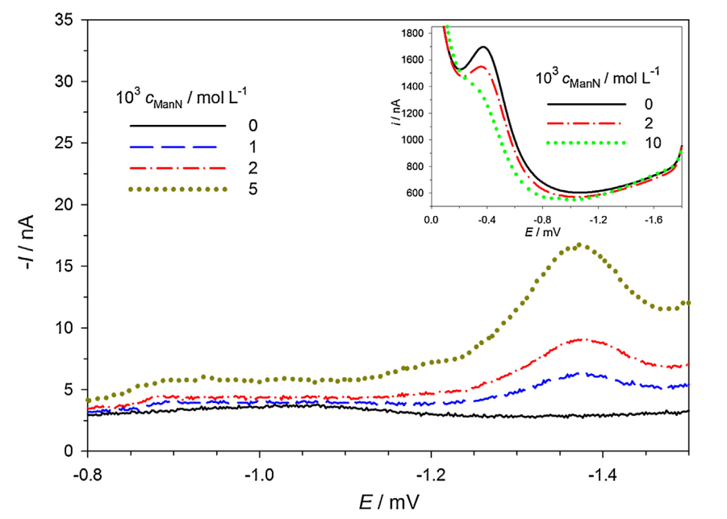

Fig. 2.
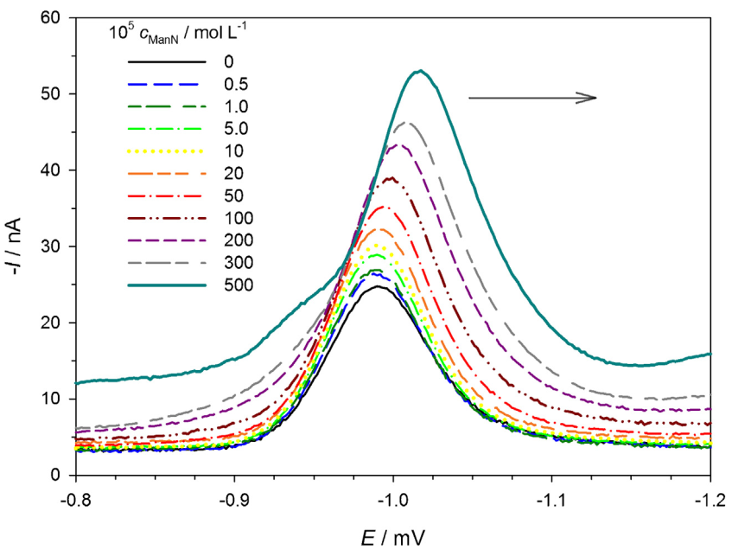

Fig. 3
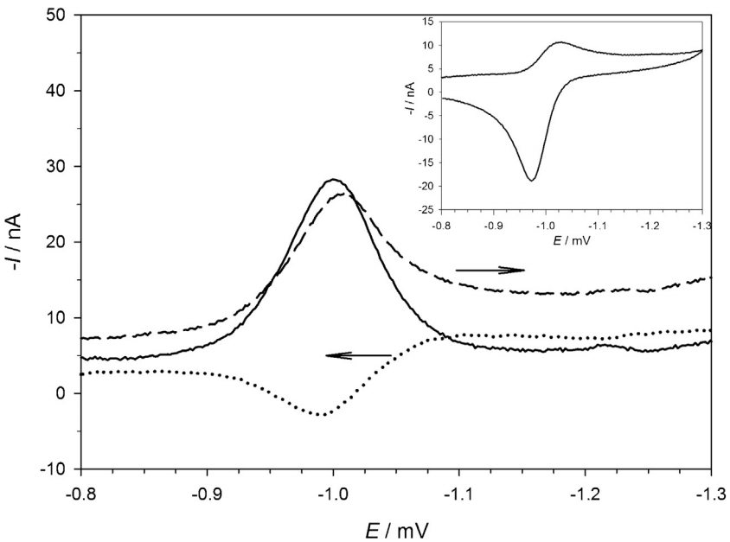
Fig. 4
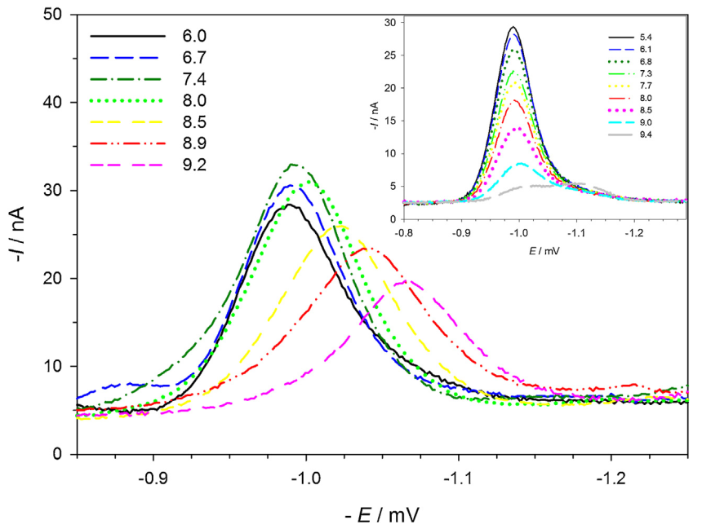

Fig. 5
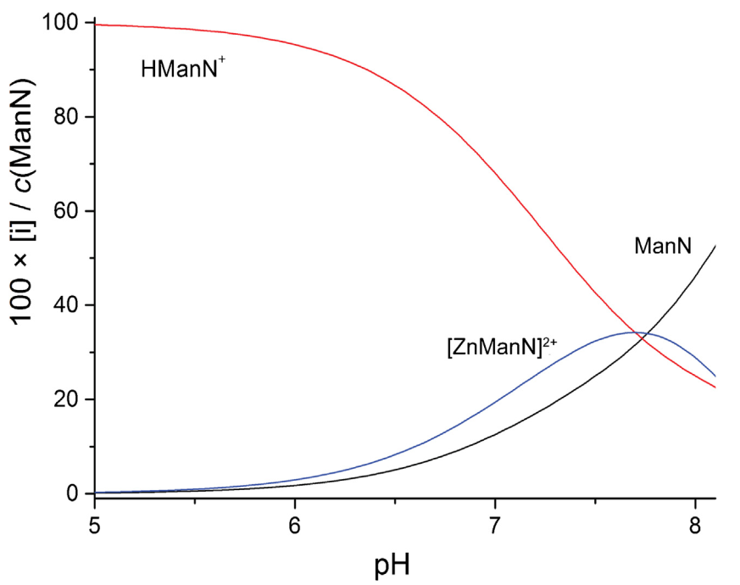
Fig. 6
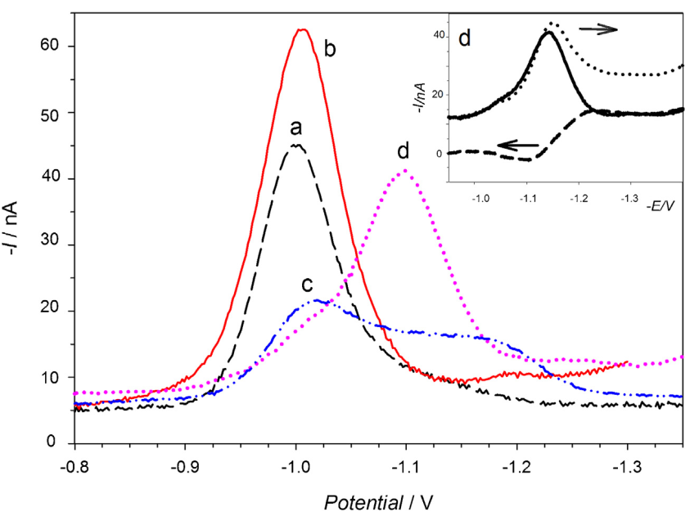

Fig. 7
