Adaptation of marine plankton to environmental stress by glycolipid accumulation

Blaženka Gašparovića*, Jelena Godrijanb, Sanja Frkaa, Igor Tomažića, Abra Penezića, Daniela Marićb, Tamara Djakovacb, Ingrid Ivančićb, Paolo Paliagab, Daniel Lyonsb, Robert Precalib, Nataša Tepićc

*aDivision for Marine and Environmental Research, Ruđer Bošković Institute, Bijenička 54, 10000 Zagreb, Croatia*

*bCenter for Marine Research, Ruđer Bošković Institute, G. Paliaga 5, 52210 Rovinj, Croatia*

*cNational Center for External Evaluation of Education, Petračićeva 4, Zagreb, Croatia*

*Corresponding author: tel: 0038514561148, fax: 0038514680242, *E-mail address*: [gaspar@irb.hr](mailto:gaspar@irb.hr) (B. Gašparović)

ABSTRACT

A systematic investigation of non-phosphorus containing glycolipids (GL) was conducted in the northern Adriatic Sea during two years at two stations with different nutrient loads. GL concentration varied both spatially and temporally, with values of 1.1-21.5 μg/L and 0.4-44.7 μg/L in the particulate and the dissolved fraction, respectively. The highest concentrations were measured during summer in surface waters and at the more oligotrophic station, where GL yields (% of total lipids) were often higher than 20% and 50% in the particulate and dissolved fractions, respectively. To obtain more insight into factors governing GL accumulation autotrophic plankton community structure (pico-, nano- and microplankton fractions), chlorophyll *a*, heterotrophic bacteria and nutrient concentrations were measured together with hydrographic parameters and sunlight intensity. During the investigated period smaller autotrophic plankton cells (pico- and followed by nanoplankton) prevailed in abundance over larger cells (microplankton), which were found in large numbers in freshened surface samples. Several major findings resulted from the study. Firstly, during PO4 limitation, particularly at the oligotrophic station, enhanced glycolipid instead of phospholipid accumulation takes place, representing an effective phosphate-conserving mechanism. Secondly, results suggest that at seawater temperatures >19ºC autotrophic plankton considerably accumulate GL, probably to achieve thermal stability. Thirdly, high sunlight intensities seem to influence increased GL accumulation; GL possibly plays a role in cell mechanisms that prevent/mitigate photooxidation. And finally, substantial accumulation of GL detected in the dissolved fraction could be related to the fact that GL do not contain biologically relevant elements, like phosphorus, which makes them an unattractive substrate for enzyme activity. Therefore, substantial portion of CO2 could be removed from the atmosphere in P-limited regions during summer via its capture by plankton and conversion to GL.

*Keywords*: glycolipids, PO4 limitation, temperature, sunlight, microplankton, nanoplankton, picoplankton

**1. Introduction**

Lipids are essential for every living organism as they play vital roles in membrane composition and the regulation of metabolic processes. They represent carbon rich organic matter with a very high energetic value, thus being an important metabolic fuel. Lipids differ in their chemical structure to a substantial degree and contain different functional groups which consequently influences their reactivity. However, molecular structure is not the only factor relevant for organic matter reactivity, as the fate of which also depends on environmental conditions (Wakeham and Canuel, 2006). In the marine environment the main origin of lipids is in phytoplankton as well as autotrophic bacteria (cyanobacteria) (Guschina and Harwood, 2009) and, to a much lesser extent, heterotrophic bacteria (Shaw, 1970). Plankton are constantly challenged with various abiotic stresses, with light intensity and temperature probably the most important and best-studied environmental factors affecting the lipid composition of photosynthetic tissues or organisms (Guschina and Harwood, 2009). Furthermore, nutrient availability has a significant impact and broad effects on the lipid composition of algae (Guschina and Harwood, 2009). Characterization of marine lipids on a molecular level enables their use as good geochemical markers for the identification of different sources and processes of organic matter in the sea (Parrish, 1988; Christodoulou et al., 2009).

Glycolipids (GL) are the most common non-phosphorous lipids in the biosphere and account for 80% of the membrane lipids found in green plant tissues (Härtel et al., 2000). The most common glycolipids in plankton are mono- and di-galactosyldiacylglycerols (MGDG and DGDG) and sulfoquinovosyldiacylglycerol (SQDG) although mannose, glucose and glucuronic acid are also found as constituent sugars in GL (Guschina and Harwood, 2009; Shaw, 1970). Phytoplankton have a glycolipid composition similar to that of higher plants. In algae and cyanobacteria, as in higher plants, GL are located predominantly in photosynthetic membranes (thylakoids) where they are the most abundant type of lipids (Guschina and Harwood, 2009). Reported composition of lipid classes for numerous phytoplankton species have revealed a contribution of GL to total lipids in the range of 31–55% (Parrish et al., 1996; Guschina and Harwood, 2009). The contribution of GL to total lipids during summer in the northern Adriatic exceeds 20% (Frka et al., 2011). The amount of glycolipids present in heterotrophic bacterial lipids is usually quite small (Shaw, 1970). Goutx et al. (1989) reported an average value of GL in total lipids of several marine heterotrophic bacteria to be 3.1%.

Coastal seas, as is the northern Adriatic Sea (NA), are strongly influenced by biological, chemical, and physical processes on short time scales and are therefore more susceptible to environmental perturbations, especially in recent times in the face of significant ecosystem changes. The NA is a shallow sea (depth < 50 m) and shows a seasonal thermal cycle typical of temperate latitude seas. It is a highly variable and dynamic environment with a close coupling between river-borne nutrients, net productivity and vertical carbon fluxes. The most important source of nutrients is the Po River, located on the western side of the NA, together with regenerated nutrients from the bottom layer (Degobbis et al., 2000). The productivity of the NA is among the highest in the Mediterranean (Giordani et al., 2002). Phytoplankton abundances exhibit large interannual variability although the peeks of production are primarily driven by the flooding or drought of the Po River (Bernardi Aubry et al., 2012). Recently, a decreasing trend of chlorophyll *a* (Chl *a*) concentration in the NA (Mozetič et al., 2010) was noted and followed by increased nutrient limitation (Djakovac et al., 2012), reduced organic matter production (Gašparović 2012) as well as a decrease in abundance of microplankton (Marić et al., 2012) and increase in nanoplankton abundance (Mozetič et al., 2012). At the same time a drastic reduction in heterotrophic bacteria abundance occurred in the area, while cyanobacteria, characteristic for nutrient poor waters, did not show any corresponding reduction in abundance (Ivančić et al., 2010a).

In the light of recent findings on enhanced sulfo-glycolipid synthesis by phytoplankton under PO4 scarcity (e.g. Van Mooy et al., 2009; Van Mooy and Fredricks, 2010; Popendorf et al., 2011), and recent reports on reduction in the concentrations of orthophosphate in the NA (Djakovac et al., 2012) we would expect increased concentrations of GL in the NA. For this purpose we aimed to examine the spatio-temporal dynamics of GL and to understand: (1) their biological origin, as well as influence of (2) nutrients and of (3) physical factors (sunlight and temperature) on GL production. Therefore, we quantified GL, both in particles and the dissolved phase over a two year period, and compared these data to heterotrophic bacteria and pico-, nano- and micro-phytoplankton abundance. To help understand the influence of nutrient concentrations on GL production, we have performed sampling at two stations having opposing trophic levels. Significant annual temperature and sunlight variations enabled determination of the influence of these physical factors on GL annual distribution. Thus, we consider the NA as a good platform for studying GL dynamics in the marine environment.

**2. Methods**

*2.1. Sampling and sample treatment*

Sampling was performed in the NA (Fig. 1) throughout the time period from January 2008 to January 2010 at the eastern oligotrophic station 107 (32 Nm off the Po River delta, depth 37 m) and at the western mesotrophic station 101 (12 Nm off the Po River delta, depth 32 m). Station 107 is, at least in autumn and in winter, under a prevailing influence of oligotrophic, high salinity waters from the central Adriatic (Gilmartin et al., 1990), while station 101 is often under direct influence of the freshwater outflows. Water samples were taken approximately monthly at 0, 5, 10, 20 (30 m) depths and 2 m above the bottom with 5-liter Niskin bottles from the RV “Vila Velebita”.

For lipid class determination, 3 l of seawater were passed through a 200 μm stainless steel screen to remove zooplankton and larger particles. Immediately after sampling, seawater was filtered at ~12 kPa vacuum pressure through 0.7 µm Whatman GF/F filters pre-burned at 450ºC/5 h. Filters were stored in liquid nitrogen until the particulate lipid extraction. Filtrates, containing dissolved lipids, were stored in dark bottles until extraction by liquid-liquid extraction with dichloromethane (twice at pH 8 and twice at pH 2) that was performed within 24 h. Particulate lipids were extracted by a modified one-phase solvent mixture of dichloromethane-methanol-water procedure (Bligh and Dyer, 1959). Ten micrograms of internal standard n-hexadecanone were added to each sample before the extraction for the estimation of lipid recovery. Extracts were concentrated by rotary evaporation and concentrated under a nitrogen atmosphere and stored at -20 ºC until measurements.

Temperature and salinity were measured using a CTD probe (Seabird SBE25, Sea-Bird Electronics Inc., Bellevue, Washington, USA). Daily means of the Po River flow rate (measured at Pontelagoscuro, Italy) were provided by the Oceanographic Structure Daphne, Regional Prevention and Environmental Agency of the Emilia-Romagna (SOD-ARPAER), Cesenatico, Italy.

Determination of total inorganic nitrogen (TIN=NO3+NO2+NH4), and orthophosphates (PO4) concentrations were made by spectrophotometric methods, widely used in oceanography (Parsons et al., 1984; Ivančić and Degobbis, 1984), aboard and immediately after sample collection. The absorbance readings for all nutrients were made on Shimadzu UV-Mini 1240 spectrophotometer with 10 cm quartz cuvettes. Subsamples for the determination of Chlorophyll *a* (Chl *a*) concentrations were filtered through a 200 µm mesh to remove zooplankton and then on Whatman GF/C filters. Following 3 h extraction in 90% acetone (in the dark, with grinding), Chl *a* concentrations were determined on a Turner TD–700 fluorometer (Parsons et al., 1984).

The phytoplankton community includes pico-, nano- and micro fractions. Samples for picoplankton characterization were preserved with formaldehyde (2% ﬁnal concentration), stored at 4 °C and from those cyanobacteria (CB) and heterotrophic bacteria abundance (HB) were determined by epiﬂuorescence microscopy (Leitz Laborlux D and NikonMicrophot-SA) at a magniﬁcation of 1000×. CB was distinguished by orange autoﬂuorescence under green excitation (Takahashi et al., 1985). HB was determined after staining with 4′, 6-diamidino-2-phenylindole (DAPI; 1 μgml-1, ﬁnal conc.) following the method of Porter and Feig (1980). Samples for the determination of nano- and microplankton abundance were filtered through a 200 µm mesh to remove zooplankton, and 200 ml filtrates were preserved with neutralized formaldehyde (2% final concentration). After 38 hour sedimentation of 50 mL of filtrate, cell counts were performed on an inverted Axiovert 200 microscope (Zeiss GmbH, Oberkochen, Germany) following the Utermöhl method (1958). Nano- and microplankton were counted at 200× and 400× magnification, respectively and were differentiated according to cell dimensions as nano- (<20 μm) and microplankton (>20 μm) (Sieburth et al., 1978). Nanoplankton (<20 μm) included taxa of diatoms, dinoflagellates, coccolithophores and flagellates (which included recognizable: chlorophytes, chrysophytes, cryptophytes and prasinophytes) identified according to Tomas (1997). Microplankton included taxa of diatoms, dinoflagellates, silicoflagellates and larger coccolithophores.

*2.2. Lipid analysis*

Lipid class analysis was performed by a thin-layer chromatography (TLC). Advantages of TLC over more structural sensitive techniques, like HPLC-MS, lie in the fact that TLC is capable of measuring all lipid classes from highly non-polar, like hydrocarbons, to polar lipids, like phospholipids. This approach gives information of total lipid content that is important for lipid mass balance, unlike HPLC methods which are limited to detection of polar lipids. Sixteen lipid classes (hydrocarbons, wax and steryl esters, fatty acid methyl esters, ketone, triacylglycerols, free fatty acids, alcohols, 1,3-diacylglycerols, sterols, 1,2-diacylglycerols, pigments, monoacylglycerols, glycolipids, mono- mono- and di-phosphatidylglycerols, phosphatidylethanolamines, and phosphatidylcholine) which constitute total lipids, were separated on Chromarods SIII and quantified by an external calibration with standard lipid mixture using a thin–layer chromatograph–flame ionization detector (TLC–FID) Iatroscan MK-VI (Iatron, Japan), with a hydrogen flow of 160 ml/min and air flow of 2000 ml/min.

The separation scheme for all classes involved five elution steps in the solvent systems of increasing polarity. Detailed procedure for all 16 classes is described in Penezić et al. (2010). Separation of here presented classes: Glycolipids, sum of mono- and di-galactosyldiacylglycerols, MGDG and DGDG, were separated as one peak after 32 min in chloroform–acetone–formic acid (95:5:0.6, v:v:v) solvent system followed by 8 min in acetone (100%). Phosphatidylglycerols and diphosphatidylglycerols (PG+DPG, hereinafter termed PG) were separated as one peak after 40 min in chloroform-methanol-ammonium hydroxide (50:50:5, v:v:v) solvent system.

Each seawater extract was analyzed two to four times: for the analysis 2 μl aliquots of 20–40 μl solution in dichloromethane were spotted on Chromarods with a semiautomatic sample spotter. The standard deviation accounted for 5–15% of relative abundance of glycolipid.

*2.3. Satellite data analysis*

Data from the MODIS/Aqua instrument were used to assess the variation of photosynthetically available radiation (PAR) at stations 101 and 107 in the NA. PAR data, derived upon Frouin et al. (2000), were retrieved from the Ocean Colour Web archive (Feldman and McClain, 2009) at NASA’s Goddard Space Flight Center as 5 min granules in Level 2 format. Time series were created by extracting from each granule closest valid satellite pixel (within maximum distance of 10 km) from each station, and within 6 hours from satellite overpass.

2.8. *Data analysis*

Linear fit was performed by ANOVA using Origin 7 software (Origin Lab) and used to analyze similarities between the data. Since the main contribution to the water-leaving radiance that reaches the satellite comes from the surface layer (Gregg and Casey, 2004) particulate glycolipids (GLp) content from the surface was correlated to PAR.

The statistical analysis of the data was performed by SAS software, Version 9.2 of the SAS System for Windows. PRINQUAL procedure was used to perform a nonmetric multidimensional preference (MDPREF) analysis (Carroll et al., 1972). Multivariate displays (biplots) were constructed to elucidate the relationships between variables: particulate glycolipids and glycolipid yields, salinity, temperature, PO4, TIN, Chl *a*, numbers of heterotrophic bacteria, cyanobacteria, nanplankton and of microplankton cells for the two stations. Biplot vectors are measured variables. The high value observations define vector’s direction. The axes on biplots (Dimension 1 and Dimension 2) are two new variables created as a linear combination of the original eleven variables. Symbols in biplots represent the observations from multivariate model. In other words, each symbol includes ten measured variables represented by their first two dimensions from multidimensional preference model.

**3. Results**

*3.1. Environmental conditions*

The temperature variations during the investigated period (Figs. 2a and c) were typical for temperate climate conditions showing marked seasonal signals, particularly in the upper water column. Stratification and development of the thermocline usually started in April and it lasted until October. During winter period temperature distribution was homogenous in the whole water column with the lowest values observed in February (9.5°C). The highest temperatures were measured at the surface during summer reaching maximum value of 29.9°C at station 101 in August 2009.

The Po River flow varied between 500 and 8000 m3/s (Fig. 2e). During 2008 and 2009 different patterns were observed. While in 2008 the highest inflows were measured in June and during the November–December period, in 2009 the highest inflows occurred from January to June. More freshwater was supplied to the NA in 2009. The mean Po River inflows for 2008 and 2009 were 1680 and 1961 m3/s, respectively. The Po River inflow showed a marked signal at the western station 101 in comparison to the eastern station 107 (Figs. 2b and d). On the other hand, during summer 2009 freshened water extended noticeably more toward the eastern Adriatic than during the same period of 2008 (Fig. 2b), and enabled by a cyclonic-anticyclonic gyre pair which often forms in the NA in summertime (Lyons et al., 2007).

The distributions of PO4 and TIN showed regular patterns (Figs. 3a-d): higher concentrations were measured at the surface in lower salinity waters. Organic matter remineralization during the late summer-early autumn periods resulted in bottom nutrient accumulation of PO4 and TIN. As a result of the autumn mixing, a portion of the bottom–accumulated nutrients were exported throughout the water column. The most nutrient depleted layer was at 10 m depth. A significant reduction of PO4 concentration was observed for station 107 in comparison to station 101. Average PO4 concentrations for the entire investigated period at stations 107 and 101 were 0.02 and 0.07 µmol/L, respectively. As expected, TIN concentrations were higher at station 101 than at station 107, with average values of 3.6 and 1.4 µmol/L, respectively, for the entire investigated period. Although higher riverine inflow was measured during 2009 in comparison to 2008, nutrient concentrations were lower in 2009 than in 2008. An exception was noted in the slightly higher PO4 concentration at station 107 during 2009 in comparison to the 2008 period. From the defined nutrient threshold concentrations for phytoplankton uptake of TIN=1 µmol/L and PO4=0.1 µmol/L (Justić et al., 1995) it appears that station 107 was PO4 limited throughout the investigated period, with a few exceptions at the bottom when PO4 concentrations exceeded 0.1 µmol/L. On the other hand, station 101 was PO4 limited in 76% of the cases. In the case of TIN, 36% and 24% of samples at stations 107 and 101, respectively, were nitrogen limited. TIN was present in huge surplus with respect to PO4. A TIN/PO4 ratio >22, which suggests P limitation (Justić et al., 1995), was found for 87% of samples from station 107 and for 76% of samples at station 101. The TIN/PO4 ratio was generally more balanced with respect to phytoplankton requirements at the bottom.

*3.1. Plankton*

Chl *a* concentrations were in the range from 0.13 to 2.46 (mean 0.44) µg/L at station 107 and from 0.23 to 2.96 (mean 0.79) µg/L at station 101 (Figs. 4a and e). Station 101 was on average 1.8 times richer in Chl *a* than station 107. As expected, the highest values were measured in the surface layer at station 101, especially in 2009, concomitant with high Po River inflow. At both stations the lowest Chl *a* concentrations were measured at 10 m depth, the layer which is the least influenced by incoming nutrients. Bottom Chl *a* maxima were more often observed at station 107 in comparison to station 101.

The heterotrophic bacteria abundance spanned the range from 1.3×108 to 3.1×109 cells/L (on average 6.4×108 cells/L) and 1.8×108 to 2.6×109 cells/L (on average 8.0×108 cells/L) at stations 107 and 101, respectively. During 2009 values were generally higher than during 2008 (data are not presented as HB are not considered important drivers of GL pool).

The autotrophic plankton cell abundances ranged within few orders of magnitude (Figs. 4 b-d, and f-h). In general cell abundance was higher at station 101. This was more pronounced for the microplankton fraction (Figs. 4b and f) which abundance ranged from 7.4×102 to 2.3×106 cells/L (on average 1.2×105 cells/L) and 1.8×103 to 8.8×106 cells/L (on average 5.1×105 cells/L) at stations 107 and 101, respectively. The highest microplankton abundances were regularly recorded at the surface layer of station 101 being as far as 10 times higher than at station 107. The blooming of the microplankton at station 107 was recorded in autumn of both years connected to the autumn water column overturn, and during summer 2009 that was connected to inflow of fresh water under stratified conditions. At the surface of station 101 the microplankton bloomed during almost the entire investigated period.

The nanoplankton abundance (Figs. 4c and g) was similar at the two stations, ranging from 1.4×104 to 1.3×106 cells/L (on average 2.6×105 cells/L) and 1.3×104 to 2.0×106 cells/L (on average 3.1×105 cells/L) at stations 107 and 101, respectively. The nanoplankton bloomed mainly in the upper water column irregularly of season at both stations.

The abundance of picoplankton i.e. cyanobacteria (Figs. 4d and i) ranged from 3.0×106 to 8.8×108 cells/L (on average 5.1×107 cells/L) and 3.9×106 to 5.4×108 cells/L (on average 6.3×107 cells/L) at stations 107 and 101, respectively. The highest CB abundances were measured at the end of summer and in autumn, and generally values were higher during 2009 than during 2008.

The ratio of nanoplankton/microplankton cell abundances points to dominance of nanoplankton at station 107 (average ratio 59; data not shown) as well as at station 101 but to a lower degree (average ratio 10; data not shown). The highest domination of nanoplankton over microplankton was observed in winter and early spring 2009 and at surface and 10 m depth of station 107. Cyanobacteria dominated over nanoplankton, being on average 380 times more abundant at station 107, and on average 510 times more abundant at station 101. The highest domination of CB over nanoplankton was observed for the bottom layer and in autumn 2009.

*3.2. Temporal variability and dynamics of glycolipids*

Annual patterns in both particulate and dissolved GL concentrations in the entire water column were observed (Figs. 5a–d). Glycolipid concentrations in the particulate fraction (GLp) at oligotrophic station 107 and mesotrophic station 101 were 1.1–21.5 μg/L (on average 5.0 μg/L) and 1.3–15.3 μg/L (on average 5.7 μg/L), respectively. At the same time in the dissolved fraction (GLdiss) the concentrations were 0.4–42.5 μg/L (on average 11.8 μg/L) and 2.3–44.7 μg/L (on average 12.3 μg/L) at stations 107 and 101, respectively. Accumulation of GL occurred during summer and was most pronounced for the surface layer in the particulate fraction, while generally for the entire water column in the dissolved fraction. Considerably higher concentrations were measured in the dissolved fraction, namely 2.4 and 2.1 times higher than in particulates at stations 107 and 101, respectively. Winter values decreased even to concentrations of 1 μg/L. The distribution of total lipid concentration was very similar to the GL profile with a winter minimum and summer maximum (data not shown).

GL yields (% of total lipid) in the NA were found to be very high. In the particulate fraction yields ranged from 9% to 38% (on average 19%) (Fig. 6a-e), while in the dissolved fraction it ranged from 6% to 60% (on average 37%) (Fig. 6f-j). The general features were: (i) higher yield evaluated for the dissolved fraction than for the particulate fraction, (ii) maximal yields were generally found during the stratification period, particularly at the surface (0.5 m) of station 107 where yields in the particulate fraction was higher during these periods than in periods of mixed water column and (iii) generally higher yields in 2009 in comparison to 2008. The highest average glycolipid yield was found for the 10 m depth, the most nutrient depleted layer.

Normalization of GL based on the ratio of the particulate fraction (GLp) to Chl *a* concentration (Glp/Chl *a*) (Fig. 7) is interesting as both, GL and Chl *a*, are constituents of thylakoid membranes. The most striking features were: (i) generally higher ratios (on average 2.2 times) observed in the upper 10 m during stratified periods in comparison to the period of mixed water column, especially at station 107, (ii) generally higher ratios (on average 1.2 times) at station 107 than at station 101 and (iii) higher ratios (on average 1.9 times) in 2008 than in 2009. The ratios were generally lower in the deeper layers.

*3.2.1. Relationship between glycolipids and phospholipids*

The concentrations of the particulate PG ranged from 1.5 to 29.6 μg/L, and were higher at station 101 (on average 6.2 μg/L) than at station 107 (on average 4.9 μg/L) (Figs. 8a and c). The highest particulate PG concentrations were generally found in surface freshened waters. A statistically significant negative correlation was observed between particulate PG and salinity in surface waters, which represents a conservative parameter indicating river-borne nutrients for both stations; station 107: R=0.80; p<0.0001, n=17; station 101: R=0.59; p=0.0074, n=17. The dissolved fraction was characterized by lower PG concentrations that ranged from 0.2 to 16.4 μg/L.

In the surface layer the GL/PG ratio in the particles (Figs. 10a-e) generally showed a dominance of GL during the stratification period, particularly at station 107 in 2008 (average 1.7) and at station 101 in 2009 (average 1.2). PG dominated mainly from November to January. In other samples no definite pattern was found, although the dominance of GL was often observed. The dissolved fraction was highly dominated by GL with respect to PG throughout the investigated period and water column of both stations (average 3.1) (Figs. 10f-j).

*3.3. Statistical analysis*

The impact of solar radiation on GL accumulation in the plankton, represented by GLp was examined by correlating PAR and GLp content from the surface (Figs. 10a and b). PAR ranged from 13 to 61 Ein m-2day-1, with the lowest values in late December and the highest in late June. A statistically significant correlation was obtained; station 107: R=0.58; p=0.0091, n=17, and station 101: R=0.49; p=0.0269, n=17. The weaker coupling between the two parameters obtained for station 101 is due to the important influence of other parameters on the GL abundance.

The relationship between particulate GLp and T was analyzed for the two stations (Fig. 10c). At station 107 it is clearly seen that up to 19ºC there is only a minor influence of temperature on GLp concentration. At higher temperatures there was an increase in GLp concentration. Data from 0-10 m depth (the layer at which T increased by over 20ºC) revealed a statistically significant correlation with an exponential fit (R=0.64; p<0.00001, n=51). At station 101 the relationship was not clear.

Biplots for stations 107 and 101 are presented in Fig. 10a and b, respectively. The orientations of TIN and PO4 vectors are close for station 101, indicating their common origins: from the Po River discharge and from bottom regeneration processes. Vectors for micro- and nanoplankton are relatively close to them at station 101 indicating that these phytoplankton fractions are highly influenced by nutrients. At station 107 pico- (CB), nano- and microplankton vectors, and the picoplankton vector at station 101 are oriented at higher degrees regarding nutrient vectors implying much weaker connection between these datasets. Vectors of pico- (CB), micro- and nanoplankton and Chl *a* at station 107 are very closely oriented implying that all autotrophic plankton fractions contributed equally to the Chl *a*. The opposite orientation of salinity and Chl *a* vectors at both stations, imply that at lower salinities (indicating nutrient freshwater input) there was an increase in Chl *a*. HB vectors at both stations are close to the Chl *a* vectors implying very close bacteria-phytoplankton coupling in the NA, a feature already observed (Puddu et al., 1998). The glycolipid yield (GLp %) vector is very close to the microplankton and nanoplankton vectors at station 101 implying microplankton and nanoplankton were the main reason for GLp accumulation at station 101. The glycolipid vector is relatively close to the temperature vector at station 107, implying higher glycolipid content during warmer periods. The almost opposite orientation of the glycolipid yield vector with regard to the PO4 vector at oligotrophic station 107 implies that at low PO4 content high glycolipid yield is expected and vice versa. At the mesotrophic station 101 such a dependence was not found. At this station the GLp % vector was very close to the TIN vector. This might indicate that the high ratio of TIN/PO4 brought by freshwater triggered the production of GL by nano- and microplankton.

**4. Discussion**

*4.1. Underlying environmental conditions*

The most important environmental characteristics of the NA were: (i) the enormous imbalance in N/P ratio, which is much higher than 22 in the majority of samples, especially at station 107, and (ii) very low PO4 concentrations which were mainly lower than the 0.1 µg/L threshold value for phytoplankton uptake (Justić et al., 1995). Both characteristics emphasise the P-limited conditions during the investigated period, a common feature of the eastern Mediterranean (Krom et al., 2010). Different nutrient availability at the two stations was reflected in the phytoplankton abundance. A richer phytoplankton community (by an average of 1.8 times) was recorded at station 101, which was richer in PO4 (on average 3.3 times) and closer to the Po River mouth, when compared to station 107. Although Po River waters are rich in PO4 (4.8 µmol/L, Cozzi and Giani, 2011), the atomic inorganic N/P ratio is strongly unbalanced for autotrophic requirements (about 100, Cozzi and Giani, 2011). In contrast, during the winter mixed period the riverine water was directed south due to the dominant Adriatic cyclonic circulation and its influence at station 101 was lower (Orlić et al., 1992). In such conditions vertical mixing was the most important mechanism of N and P supply. Due to the equilibrated N and P supply from the bottom, the two larger phytoplankton fractions, nano and micro, were in balance in October-November, as already observed by Ivančić et al. (2012). A noteworthy depletion of orthophosphates at station 107 was reflected in marked domination of cyanobacteria and nanoplankton over microplankton. In conditions of P-limitation newly fixed carbon appears to be mainly directed toward the synthesis of non-phosphorylated storage carbohydrate polyglucans with less photosynthate directed toward respiratory metabolism and other biosynthetic pathways (Ball et al., 1990). Indeed, accumulation of carbohydrates in the NA was noted during summer when the region is regularly nutrient depleted (Tepić et al., 2009).

*4.2. GL abundance*

Obtained GL concentrations in the NA area were high with values often approaching the reported concentrations of total lipids in seas and oceans (Parrish et al. 1988; Gérin and Goutx 1994). Concentrations of glycolipids in the low nM range were found in the oligotrophic to ultraoligotrophic Mediterranean and the eastern subtropical South Pacific (Popendorf et al., 2011; Van Mooy and Fredricks, 2010). Trace amounts of MGDG and DGDG were measured in North Sea coastal waters (Brandsma et al., 2012a) which were characterized by higher PO4 concentrations than those found in the NA.

*4.2.1 Factors influencing GL synthesis*

Particulate glycolipids (GLp) in our samples are considered as GL originating from phytoplankton and a minor contribution from heterotrophic bacteria and microzooplankton. Indeed, it is shown by Brandsma et al. (2012b) that predominant intact polar lipids in marine surface waters are not derived from single microbial group. The GL content in bacterial cells is very low, ranging from 1.72–7.30% of the total cellular organic carbon (Shaw, 1970; Goutx et al., 1989). Moreover, GL are also found to contribute only a small part of marine bacterial lipids, e.g. 3.1% (Goutx et al., 1990). The content of GL produced by HB was calculated from the carbon content in HB, which is found to be 20 fg C/cell (Lee and Fuhrman, 1987). The GL amounted on average 0.032 µg/L (0.008-0.139 µg/L) during the investigated two years in the NA. The calculated bacterial GL concentrations are about two orders of magnitude lower than those measured in this work. The carbon in microzooplankton in the NA is about an order of magnitude lower than in the total autotrophs (Kamburska and Fonda-Umani, 2009). GL content in microzooplankton is not discussed in the literature implying that GL are insignificant for these organisms. Therefore HB and microzooplankton are not considered important drivers of the GL pool in the NA and are not further discussed in the text.

As autotrophic plankton are the GLp producers, in the most simplified static conditions it should be expected that higher biomass would lead to higher GLp concentrations. In such conditions GLp concentrations would be higher at station 101 than at the phytoplankton [poorer](http://www.thefreedictionary.com/impoverished) station 107 (Fig. 4a and e), as was found to be the case during the mixing period. However, the opposite was found during the stratification period. This indicates more complex mechanisms driving GL synthesis in dynamic marine systems where many physico-chemical factors may influence GL production. The general annual distribution of GLp concentration in the NA showed a summer accumulation and winter minimum. This implies that summertime low nutrient content, high temperatures and high sunlight intensities are possible influential factors governing enhanced GL synthesis.

*4.2.1.1. The influence of nutrient status*

The fact that in low PO4 conditions high GLp yields of >20% were detected and that the most nutrient depleted layer (10 m depth) exhibited the highest GL yields indicate that PO4 depletion was one of the drivers of increased GLp content in the oligotrophic part of the NA. In contrast, in a nutrient rich system, GLp yields during summer are substantially lower at <15% (Penezić et al., 2010). It has been previously noted by Smith et al. (1997) that a GL increase was coincident with a depletion of nutrients. Mock and Gradinger (2000) reported that upon nutrient depletion in batch-cultures there was dramatic increase of lipid concentration as the result of glycolipid production. During the entire investigated period both stations were PO4 poor, particularly station 107. Data analysis implies that at the oligotrophic station 107 high GLp yields (% of total lipids) are to be expected at low PO4 concentrations (Fig. 9d). Investigations on different photosynthetic organisms, including freshwater algae eustigmatophyte *Monodus subterraneus* (Khozin-Goldberg and Cohen, 2006), and photosynthetic bacterium *Rhodobacter sphaeroides* (Benning et al., 1995) reported that growth under PO4-limiting conditions resulted in accumulation of glycolipid. Although phytoplankton responds very rapidly, over a several day period, to PO4 limitation (Martin et al., 2011) the northern Adriatic plankton community was surviving on low PO4 content during the majority of the two year sampling period at the oligotrophic station 107. However, it should be remembered that from spring to autumn in the NA, phytoplankton partly satisfies its requirement for phosphorus from organic matter through the exoenzymatic activity of alkaline phosphatase (Ivančić et al., 2010b).

Increased GL yield seems to be at least partially the result of membrane phospholipid replacement by non-phosphorus containing glycolipids making PO4 available for other important cellular processes. Plankton in the open ocean have been shown to substitute non-phosphorus lipids for phospholipids under conditions of PO4 limitation (Van Mooy et al., 2006; 2009). This replacement has been suggested to represent an effective phosphate-conserving mechanism in many organisms during PO4 limitation, including in photosynthetic bacteria and algae (e.g., Benning et al., 1995; Martin et al., 2011). The PO4 thresholds below which lipid remodeling is expected to take place is <0.030 µmol/L (Van Mooy et al., 2009) that was common situation at station 107 in the upper water column, and occasionally at station 101 at 5 and 10 m depth. During thermocline stratification GL dominated over PG in the particulates in the upper water column in higher salinity water that was poor in PO4, as seen at the surface of station 107 in the period from April to August 2008. Also, domination of GLp over PGp was noted from February to April 2009 at both stations when the lowest PO4 concentrations were measured (Fig. 10a-e).

At the oligotrophic station 107 nitrogen deficiency was much less pronounced than P-deficiency, implying that TIN depletion was less important for the enhanced GL accumulation. However, at the station 101, exposed to freshwater input, the marked surplus of freshwater TIN in respect to PO4 (N/P about 84, Cozzi et al., 2011) stimulated growth of nano- and microphytoplankton enhancing production of GL.

*4.2.1.2. The influence of light intensity*

An important characteristic regarding GLp in the NA is a GLp/Chl *a* ratio that is highly variable and reached very high values in the upper water column during summer 2008 and spring 2009, and was more pronounced at the nutrient depleted station 107 (Fig. 7). The ratio was much lower for deeper layers that were less exposed to sunlight and less nutrient depleted. Furthermore, the ratio was markedly lower in 2009 which was characterized by a higher freshwater nutrient supply, as revealed by higher Po River inflow (Fig. 2e) and increased Chl *a* compared to 2008, particularly at the mezotrophic station 101. As Chl *a* clusters are embedded within the lipid bilayer of the thylakoid membrane, where GLp are the most abundant type of lipid, their interdependence is to be expected. In fact, it is found that GL not only establish the lipid bilayer into which the photosynthetic complexes are embedded but GL are also found within the structures of photosystems I and II (Jordan et al., 2001; Loll et al., 2005). It is reported that GL digalactosyldiacylglycerols (DGDG) play crucial roles in photosynthetic light reactions (Härtel et al., 1997). Accordingly, in the NA during strong light exposure there was an enhanced GL accumulation by autotrophic plankton. Indeed, a statistically significant increase of GL abundance in the surface with increasing solar irradiation was obtained supporting this assumption. It is possible that autotrophic plankton develop adaptive mechanisms by GL synthesis under conditions of decreased Chl *a* content to support the photoprotection machinery against over-excitation and photooxidation at high incident light intensity. Recently, the structural and functional importance of GL in the process of preventing cell photodamage has been proposed by Loll et al. (2005).

Similar to our findings, investigations of an acyl-lipid composition in microalgae *Phaeodactylum tricornutum* revealed a dramatic change in lipid composition between indoor and outdoor cultures. Those cultures were grown in similar conditions except that the outdoor culture was grown under natural sunlight, with high irradiance. That growing difference was reflected in a GL content in the outdoor culture that was nearly twice (56%) that of the indoor culture (31%) (Alonso et al., 1998).

*4.2.1.3. The influence of temperature*

The ability of planktonic cells to adapt to elevated temperatures is becoming more important with increasing concern about climate change. Photosynthesis, which occurs in thylakoids, is the most heat-sensitive cellular function in photosynthetic organisms (Berry et al., 1980). The importance in saturation/unsaturation of membrane lipid fatty acids in achieving thermal stability is extensively discussed within marine studies (e.g. Morgan-Kiss et al., 2002). Nevertheless, the contribution of different lipid classes to the sensitivity of autotrophs to thermal stress is an important issue. Yang et al. (2006) have shown that in liposomes containing only one DGDG and even MGDG increase the thermal stability of photosystem II functions whereas phospholipids significantly decrease it. Furthermore, during heat/light-acclimation cyanobacteria synthesize highly saturated glycolipid monoglucosyldiacylglycerol (MGlcDG). This GL has unusually high microviscosity enabling MGlcDG membranes to remain stable even at extremely high temperatures, implying the functional integrity of thylakoid membranes subjected to heat stress under light (Balogi et al., 2005).

The northern Adriatic Sea undergoes annual temperature variations of 20°C. It is reasonable to assume that autotrophic plankton exposed to such temperature variations needed to develop mechanisms to maintain thermal stability. Indeed, statistically significant correlations between GLp and temperature for station 107 confirm their close interconnection in the oligotrophic part of the NA (Fig. 10c) that is in accordance with the literature. It transpired that with a temperature increase of more than 19ºC more GLp was accumulated. Even higher GL accumulation may be anticipated in the future due to the trend of increasing surface temperature which occurs mainly during summer in the NA (Malačić et al., 2006). The temperature was never higher than 20ºC at depths below 10 m, and for these depths the influence of temperature on GL accumulation was negligible. An unclear relationship between GLp and T at station 101 is explained by relatively high surface microplankton biomass (Figs. 4b and f) that contributed to the GLp pool in the upper 10 m during periods of low salinity and low temperatures from February to April.

*4.2.2 Water column accumulation of dissolved GL*

Dissolved glycolipids (GLdiss) are assumed to be part of the non-living organic matter released from plankton cells upon cell death due to autolysis, viral lysis or zooplankton grazing. The NA experienced very high GLdiss concentrations which dominated the dissolved lipid pool, particularly in the warm period. Similarly, a very high contribution (54%) of dissolved chloroplast lipids (pigments and glycolipids) to the lipid pool was found in highly oligotrophic waters of the NW Mediterranean (Bourguet et al., 2009). Because of the substantial accumulation of GLdiss during the stratified period in the upper 10 m of the water column, they can be considered as non-attractive substrates for bacterial and phytoplankton enzyme activity. During the warm period alkaline phosphatase, lipase and protease reach the highest activities (Celussi and Del Negro, 2012). This should be viewed in the light of a huge demand in the NA for phosphorus (Ivančić et al., 2012), which is not contained in GL molecules. Indeed, in the dissolved fraction GL highly dominated phospholipids suggesting the efficient utilization of P from phospholipids. Similarly, Tegelaar et al. (1989) reported that in marine sediments GL are relatively resistant to degradation. It seems that GLdiss are robust to abiotic photo-degradation as the highest dissolved glycolipid concentrations were found during high sunlight intensities, *i.e*. during summer. However, it is difficult to reach a reliable conclusion on this because during summer the noted enhanced production of glycolipids by phytoplankton after bloom termination should in any case increase the dissolved GL pool. Accumulated GLdisswere removed from the water column up to winter, when values of 5-10 µ/L were measured. Schouten et al. (2010) calculated that a major fraction of GL biosynthesized in the upper water column can potentially reach deep-sea surface sediments. In accordance with that and the results reported herein, in P-limited regions during summer, as often seen in the northern Adriatic, a substantial portion of CO2 could be removed from the atmosphere via its capture by phytoplankton and conversion to GL.

**5. Conclusions**

This work contributes to the knowledge on the distribution of glycolipids and influential parameters on their enhanced accumulation by autotrophic plankton in the marine environment. Glycolipids are very abundant in northern Adriatic seawater and by far the most dominant lipid class, both in the particulate and the dissolved fraction. In this highly variable sea characterized by enormous differences in biological, chemical and physical parameters throughout the year, there are several factors influencing enhanced accumulation of GL by autotrophic plankton: namely their abundance, low orthophosphate content, temperatures higher than 19ºC and high sunlight intensities.

The abundance of GL in the dissolved fraction implies that they are not an attractive substrate for plankton enzyme activity. This is probably due to the fact that they do not contain biologically relevant elements, phosphorus or nitrogen. It is possible that in the PO4-limited regions during summer, as often seen in the northern Adriatic, a significant portion of CO2 could be removed from the atmosphere via its capture by phytoplankton and conversion to GL.

Investigated environmental parameters clearly showed multiple influences on enhanced accumulation of GL. However, it was not possible to resolve their particular degree of influence. Namely, in real systems, as is northern Adriatic Sea, those factors act in concert especially during the warm, stratified period. Therefore, targeted experiments on batch-cultures should be performed as they would enable more precise control of influencing factors.

The next step towards a better understanding of the role of glycolipids in the northern Adriatic should include a separate analysis of MGDG, DGDG and SQDQ to resolve which of those lipids accumulate under the discussed conditions. Also, it should be investigated whether some specific/new glycolipids accumulate in the extreme conditions of temperature, solar radiation and nutrient deficiency.

**Acknowledgements**

This work was funded by the grants from the Croatian Ministry of Science, Education and Sports, projects 098-0982934-2717, 098-0982705-2731 and 098-0982705-2729, and the Croatian National Monitoring Program (Project “Jadran”). The authors thank the crew of RV “Vila Velebita” for help during sampling.

**References**

Alonso, D.L., Belarbi, E.L., Rodríguez-Ruiz, J., Segura, C. I., Gimenez, A., 1998. A[cyl lipids of three microalgae.](http://ovidsp.tx.ovid.com/sp-3.5.1a/ovidweb.cgi?&S=GOFOFPBMIEDDJLCFNCALJFMCIHACAA00&Complete+Reference=S.sh.43%7c1%7c1) Phytochemistry 47, 1473–1481.

Ball, S.G., Dirick, L., Decq, A., Martiat, J.C., Matagne, R.F., 1990. Physiology of starch storage in the monocellular alga Chlamydomonas reinhardtii. Plant Science 66, 1–9.

Balogi, Z., Török, Z. Balogh, G. Jósvay, K. Shigapova, N. Vierling, E. Vígh, L. Horváth, I. 2005. Heat shock lipid” in cyanobacteria during heat/light-acclimation. Arch. Biochemistry andBiophysics436, 346-354.

Benning, C., Huang, Z.H., Gage, D.A., 1995. Accumulation of a novel glycolipid and a betaine lipid in the cells of Rhodobacter sphaeroides.Arch. Biochemistry andBiophysics317, 103–111.

Bernardi Aubry, F., Cossarini, G., Acri, F., Bastianini, M., Bianchi, F., Camatti, E., De Lazzari, A., Pugnetti, A., Solidoro, C., Socal, G., 2012. Plankton communities in the northern Adriatic Sea: patterns and changes over the last 30 years. Estuarine, Coastal and Shelf Science 115, 125–137.

Berry J., Björkman, O., 1980. Photosynthetic Response and Adaptation to Temperature in Higher Plants. Annu. Rev. Plant Physiology 31, 491–543.

Blight, E.G., Dyer, W. J., 1959. A rapid method of total lipid extraction and purification. Canadian Journal of Biochemistry and Physiology 37, 911–917.

Bourguet, N., Goutx, M., Ghiglione, J.F., Pujo–Pay, M., Mevel, G., Momzikoff, A., Mousseau, L., Guigue, C., Garcia, N., Raimbault, P., Pete, R., Oriol, L., Lefevre, D., 2009. [Lipid biomarkers and bacterial lipase activities as indicators of organic matter and bacterial dynamics in contrasted regimes at the DYFAMED site, NW Mediterranean.](http://ovidsp.tx.ovid.com/sp-3.4.2a/ovidweb.cgi?&S=IADKFPPGCEDDPBCONCBLMCIBFLPOAA00&Complete+Reference=S.sh.52%7c8%7c1) Deep–Sea Research Part II 56(18),1454–1469.

Brandsma, J., Hopmans, E.C., Philippart, C.J.M., Veldhuis M.J.W., Schouten, S., Sinninghe Damsté, J., 2012a. Low temporal variation in the intact polar lipid composition of North Sea coastal marine water reveals limited chemotaxonomic value. Biogeosciences, 9, 1073–1084.

Brandsma, J., Hopmans, E., Brussaard, C., Witte, H., Schouten, S., Sinninghe Damsté, J., 2012b. Spatial distribution of intact polar lipids in North Sea surface waters: Relationship with environmental conditions and microbial community composition. Limnology and Oceanography 57, 959–973.

Carroll, J.D., 1972. Individual Differences and Multidimensional Scaling, in R. N. Shepard, A. K. Romney, S. B. Nerlove, eds., Multidimensional Scaling: Theory and Applications in the Behavioral Sciences (Volume 1), New York: Seminar Press.

Cauwet G., 1981. Non-living particulate matter, in E. K. Duursma and R. Dawson, eds., Marine Organic Chemistry, Evolution, Composition, Interactions and Chemistry of Organic Matter in Seawater in the Elsevier Oceanography Series, Vol.31., p. 72.

Celussi, M., Del Negro P., 2012. Microbial degradation at a shallow coastal site: Long-term spectra and rates of exoenzymatic activities in the NE Adriatic Sea, Estuarine Coastal and Shelf Sciience 115, 75–86.

Christodoulou, S., Marty, J. C., Miquel, J. C., Volkman, J. K., Rontani, J. F., 2009. Use of lipids and their degradation products as biomarkers for carbon cycling in the northwestern Mediterranean Sea. Marine Chemistry 113, 25–40.

Cozzi, S., Giani, M., 2011. River water and nutrient discharges in the Northern Adriatic Sea: Current importance and long term changes. Continental Shelf Research 31, 1881–1893.

Degobbis, D., Precali, R., Ivančić, I., Smodlaka, N., Fuks, D., Kveder, S., 2000. Long–term changes in the northern Adriatic ecosystem related to anthropogenic eutrophication. International Journal of Environtal Pollution 13, 495–533.

Djakovac, T., Degobbis, D., Supić, N., Precali, R., 2012. Marked reduction of eutrophication pressure in the northeastern Adriatic in the period 2000–2009. Estuarine Coastal and Shelf Sciience 115, 25–32.

Feldman, G. C. McClain, C. R., 2009. Ocean Color Web, in: Kuring, N. and S. W. Bailey (Eds.), MODIS/AQUA reprocessing  2009.1. NASA Goddard Space Flight Center.

Frka, S., Gašparović, B., Marić, D., Godrijan, J., Djakovac, T., Vojvodić, V., Dautović, J., Kozarac, Z., 2011. Phytoplankton driven distribution of dissolved and particulate lipids in a semi-enclosed temperate sea (Mediterranean): Spring to summer situation. Estuarine Coastal and Shelf Sciience 93, 290–304.

Frouin, R., Franz, B., Wang, M., 2000. Algorithm to estimate PAR from SeaWiFS data Version 1.2 - Documentation, 15 pp., [online] Available from: <http://oceancolor.gsfc.nasa.gov/DOCS/seawifs_par_wfigs.pdf>

Gašparović, B., 2012. Decreased production of surface-active organic substances as a consequence of the oligotrophication in the northern Adriatic Sea. Estuarine Coastal and Shelf Science 115, 33–39.

Gérin, C, Goutx, M., 1994. Iatroscan-measured particulate and dissolved lipids in the Almeria-Oran frontal system (Almofront-1, May 1991). Journal of Marine Systems 5, 343–360.

Gilmartin, M., Degobbis, D., Revelante, N., Smodlaka, N. 1990. The mechanism controlling plant nutrient concentrations in the northern Adriatic Sea. Internationale Revue der Gesamten Hydrobiologie. 75, 425-445.

Giordani, P., Helder, W., Koning, E., Miserocchi, S., Danovaro, R., Malaguti, A., 2002. Gradients of benthic–pelagic coupling and carbon budgets in the Adriatic and northern Ionian Sea. Journal of Marine Systems 33, 365–387.

Goutx, M., Gerin, C., Bertrand, C., 1989. An application of latroscan thin-layer chromatography with flame ionization detection Lipid classes of microorganisms as biomarkers in the marine environment Advances in Organic Geochemistry, 16, 1231–1237.

Goutx, M., Acquaviva, M., Bertrand, J. C., 1990. Cellular and extracellular carbohydrates and lipids from marine bacteria during growth on soluble substrates and hydrocarbons, Marine Ecology Progress Series 61, 291–296.

Gregg, W.W., Casey N.W. 2004. Global and regional evaluation of the SeaWiFS chlorophyll data set, Remote Sensing of Environment, 93, 463–479.

Guschina, I.A., Harwood, J.L., 2009. Algal Lipids and Effect of the Environment on their Biochemistry. In: Arts, M.T., Brett, M.T., Kainz, M.J. (Eds) Lipids in Aquatic Ecosystems. Springer, Dordrecht, 1–24.

Härtel, H., Lokstein, H., Dörmann, P., Grimm, B., Benning, C., 1997. Changes in the composition of the photosynthetic apparatus in the galactolipid-deficient dgd1 mutant of Arabidopsis thaliana. Plant Physiology 115, 1175–1184.

Härtel, H., Dormann, P., Benning, C., 2000. DGD1-independent biosynthesis of extraplastidic galactolipids after phosphate deprivation in Arabidopsis. Proceedings of the NationalAcademy of Sciences of the United States of America 97, 10649–10654.

Ivančić, I., Degobbis, D., 1984. An optimal manual procedure for ammonia analysis in natural waters by the indophenol blue method. Water Research 18, 1143‑1147.

Ivančić I., Fuks D., Najdek M., Blažina M., Devescovi M., Šilović T., Paliaga P., Orlić S., 2010a. Long-term changes in heterotrophic prokaryotes abundance and growth characteristics in the northern Adriatic Sea. Journal of Marine Systems 82**,** 206–216.

Ivančić, I., Fuks, D., Radić, T., Lyons, D. M., Šilović, T., Kraus, R., Precali, R., 2010b. Phytoplankton and bacterial alkaline phosphatase activity in the northern Adriatic Sea. Marine Environmental Research 69, 85–94.

Ivančić, I., Godrijan, J., Pfannkuchen, M., Marić, D., Gašparović, B., Đakovac, T., Najdek, M., 2012. Survival mechanisms of phytoplankton in conditions of stratification induced deprivation of orthophosphate: Northern Adriatic case study. Limnology and Oceanography, 57, 1721–1731.

Jordan, P., Fromme, P., Witt, H.T., Klukas, O., Saenger, W., Krauß, N., 2001. Three-dimensional structure of cyanobacterial photosystem I at 2.5 Å resolution. Nature 411, 909–917.

Justić, D., Rabalais, N.N., Turner, E.R., Dortch, Q., 1995. Changes in nutrient structure of river-dominated coastal waters, stoichiometric nutrient balance and its consequences. Estuarine Coastal and Shelf Science 40, 339–356.

Kamburska, L., Fonda-Umani, S., 2009. From seasonal to decadal inter-annual variability of mesozooplankton biomass in the northern Adriatic Sea (Gulf of Trieste). Journal of Marine Systems. 78, 490 504.

Khozin-Goldberg, I., Cohen, Z., 2006. [The effect of phosphate starvation on the lipid and fatty acid composition of the fresh water eustigmatophyte Monodus subterraneus.](http://ovidsp.tx.ovid.com/sp-3.4.2a/ovidweb.cgi?&S=KEIHFPBBHPDDGBHLNCBLBHIBCLOFAA00&Complete+Reference=S.sh.37%7c10%7c1) Phytochemistry 67, 696–701.

Krom, M.D., Emeis, K.C., Van Cappellen, P., 2010. Why is the Eastern Mediterranean phosphorus limited? Progress in Oceanography 85, 236 244.

Lee, S., Fuhrman, J.A., 1987. Relationships between biovolume and biomass of naturally derived marine bacterioplankton. Appl. Environ. Microbiol. 53, 1298–1303.

Loll, B., Kern, J., Saenger, W., Zouni, A., Biesiadka, J., 2005. Towards complete cofactor arrangement in the 3.0 Å resolution structure of photosystem II. Nature 438, 1040–1044.

Lyons, D.M., Supić N., Smodlaka N., 2007. Geostrophic circulation patterns in the northeastern Adriatic Sea and the effects of air-sea coupling: May–September 2003, Journal of Geophysical Research 112, C03S08.

Malačič, V., Celio, M., Cermelj, B., Bussani, A., Comici, C., 2006. Interannual evolution of seasonal thermohaline properties in the Gulf of Trieste (northern Adriatic) 1991–2003. Journal of Geophysical Research 111, C08009.

Marić, D., Kraus, R., Godrijan, J., Supić, N., Djakovac, T., Precali, R., 2012. Phytoplankton response to climatic and anthropogenic influence in the north-eastern Adriatic during the last four decades. Estuarine Coastal and Shelf Science 115, 98 112.

Martin, P., Van Mooy, B.A., Heithoff, A., Dyhrman S.T., 2011. Phosphorus supply drives rapid turnover of membrane phospholipids in the diatom Thalassiosira pseudonana. [ISME Journal](http://www.ncbi.nlm.nih.gov/pubmed/21160536) 5, 1057 1060.

Mock, T., Gradinger, R., 2000. Changes in photosynthetic carbon allocation in algal assemblages of Arctic sea ice with decreasing nutrient concentrations and irradiance. Marine Ecolog Progress Series 202, 1–11.

Morgan-Kiss, R.M., Ivanov, A.G., Williams J., Khan, M, Hüner, N.P.A., 2002. Differential thermal effects on the energy distribution between photosystem II and photosystem I in thylakoid membranes of a psychrophillic and a mesophillic alga. Biochimica et Biophysica Acta 1561, 251-265.

Mozetič, P., Solidoro, C., Cossarini, G., Socal, G., Precali, R., France, J., Bianchi, F., De Vittor, C., Smodlaka, N., Fonda Umani, S., 2010. Recent Trends Towards Oligotrophication of the northern Adriatic: Evidence from Chlorophyll a Time Series. Estuaries and Coasts 33, 362–375.

Mozetič, P., Francé, J., Kogovšek, T., Talaber, I., Malej,A., 2012. Plankton trends and community changes in a coastal sea (northern Adriatic): bottom-up vs. top-down control in relation to environmental drivers. Estuarine, Coastal and Shelf Science 115, 138–148.

[Orlić, M](http://apps.webofknowledge.com/DaisyOneClickSearch.do?product=WOS&search_mode=DaisyOneClickSearch&colName=WOS&SID=U25G7I4jLjOB3Kp8pfd&author_name=ORLIC,%20M&dais_id=16279837)., [Gačić, M](http://apps.webofknowledge.com/DaisyOneClickSearch.do?product=WOS&search_mode=DaisyOneClickSearch&colName=WOS&SID=U25G7I4jLjOB3Kp8pfd&author_name=GACIC,%20M&dais_id=11623399)., [Laviolette, P.E](http://apps.webofknowledge.com/DaisyOneClickSearch.do?product=WOS&search_mode=DaisyOneClickSearch&colName=WOS&SID=U25G7I4jLjOB3Kp8pfd&author_name=LAVIOLETTE,%20PE&dais_id=12699486)., 1992. The currents and circulation of the Adriatic Sea. Oceanologica Acta 15, 109–124.

Parrish, C.C., Wangersky, P.J., Delmas, R.P., Ackman, R.G., 1988. Iatroscan-measured profiles of dissolved and particulate marine lipid classes over the Scotian Slope and in Bedford Basin. Marine Chemistry 23, 1–15.

Parrish, C.C., Bodennec, G., Gentien, P., 1996. Determination of glycoglycerolipids by Chromarod thin-layer chromatography with Iatroscan flame ionization detection. Journal of Chromatography A, 741, 91–97.

Parsons, T.R., Maita, Y., Lalli, C.M., eds. 1984. A manual of chemical and biological methods for seawater analysis. Toronto, Pergamon Press, pp. 3–28 and 107–109.

Penezić, A., Gašparović, B., Burić, Z., Frka, S., 2010. Distribution of marine lipid classes in salty Rogoznica Lake (Croatia). Estuarine Coastal and Shelf Science 86, 625–636.

Popendorf, K.J., Tanaka, T., Pujo-Pay, M., Lagaria, A., Courties, C., Conan, P. Oriol, L., Sofen, L.E., Moutin, T., Van Mooy, B.A.S., 2011. Gradients in intact polar diacylglycerolipids across the Mediterranean Sea are related to phosphate availability. Biogeosciences, 8, 3733–3745.

Porter, K.G., Feig, Y.S., 1980. The use of DAPI for identifying and counting aquaticmicroﬂora. Limnology and Oceanography 25, 943–948.

Puddu, A., La Ferla, R., Allegra, A., Bacci, C., Lopez, M., Oliva F., Pierotti, C., (1998). Seasonal and spatial distribution of bacterial production and biomass along a salinity gradient (Northern Adriatic Sea). Hydrobiologia 363, 271–282.

Shaw, N., 1970. Bacterial glycolipids. Bacteriological Rewiews, 34, 365–377.

Schouten, S., Middelburg, J.J., Hopmans, E.C., Sinninghe Damsté, J.S., 2010. Fossilization and degradation of intact polar lipids in deep subsurface sediments: A theoretical approach. Geochimica et Cosmochimica Acta 74, 3806–3814.

Sieburth, J.M., Smetacek, V., Lenz, J., 1978. Pelagic ecosystem structure: Heterotrophic compartments of the plankton and their relationship to plankton size fractions. Limnology and Oceanography 23, 1256–1263.

Smith, R.E.H., Gosselin, M., Kattner, G., Legendre, L., Pesant, S., 1997. Biosynthesis of macromolecular and lipid classes by phytoplankton in the Northeast Water Polynya. Marine Ecolog Progress Series 147, 231–242.

Takahashi, M.K., Kikuchi, T.R., Hara, Y., 1985. Importance of picocyanobacteria (unicellular blue-green algae) in the phytoplankton population of the coastal waters off Japan. Marine Biology 89, 63–69.

Tegelaar, E.W., De Leeuw, J.W., Derenne, S., Largeau C., 1989. A reappraisal of kerogen formation. Geochimica et Cosmochimica Acta 53, 3103–3107.

Tepić, N., Gašparović, B., Ahel, M., 2009. Multivariate statistical analysis of the distribution patterns of carbohydrates and surface–active substances in the northern Adriatic. Marine Chemistry 114, 37–46.

Tomas, C.R., 1997. Identifying marine phytoplankton. Academic Press, San Diego.

Utermöhl, H., 1958. Zur Vervollkommnung der quantitativen Phytoplankton Methodik. Mitteilung Internationale Vereinigung fuer Theoretische und Amgewandte Limnologie 9, pp. 1–38.

Van Mooy B.A.S., Rocap G., Fredricks H.F., Evans C.T., Devol A.H. 2006. Sulfolipids dramatically decrease phosphorus demand by picocyanobacteria in oligotrophic marine environments. Proceedings of the National Academy of Sciences USA 103, 8607–8612.

Van Mooy, B.A.S., Fredricks, H.F., Pedler, B.E., Dyhrman, S.T., Karl, D.M., Koblizek, M., Lomas, M.W., Mincer, T.J., Moore, L.R., Moutin, T., Rappe, M.S., Webb, E.A., 2009. Phytoplankton in the ocean use non-phosphorus lipids in response to phosphorus scarcity. Nature 458 (7234), 69–72.

Van Mooy, B.A.S., Fredricks, H.F., 2010. Bacterial and eukaryotic intact polar lipids in the eastern subtropical South Pacific: Water-column distribution, planktonic sources, and fatty acid composition. Geochimica et Cosmochimica Acta 74, 6499–6516.

Wakeham, S.G., Canuel E.A., 2006. Degradation and preservation of organic matter in marine sediments. In: Volkman, J.K. (Ed.), The Handbook of Environmental Chemistry, Vol. 2 Series: Reaction and Processes: Marine Organic Matter: Biomarkers, Isotopes and DNA. Springer, Berlin, pp. 295–321.

[Yang, C](http://www.ncbi.nlm.nih.gov/pubmed?term=Yang%20C%5BAuthor%5D&cauthor=true&cauthor_uid=17010303)., [Boggasch, S](http://www.ncbi.nlm.nih.gov/pubmed?term=Boggasch%20S%5BAuthor%5D&cauthor=true&cauthor_uid=17010303)., [Haase, W](http://www.ncbi.nlm.nih.gov/pubmed?term=Haase%20W%5BAuthor%5D&cauthor=true&cauthor_uid=17010303)., [Paulsen, H](http://www.ncbi.nlm.nih.gov/pubmed?term=Paulsen%20H%5BAuthor%5D&cauthor=true&cauthor_uid=17010303)., 2006. Thermal stability of trimeric light-harvesting chlorophyll a/b complex (LHCIIb) in liposomes of thylakoid lipids. Biochimica and Biophysica Acta1757,1642-1648.

**FIGURE CAPTIONS**

**Fig. 1.** Study area in the northern Adriatic Sea showing position of the stations 107 and 101.

**Fig. 2.** Contour plot of temperature (T) (a and c) and salinity (S) (b and d) over the whole water column at the stations 107 (a and b) and 101 (c and d); (e) daily mean of the Po River discharge rate (Q) and (f) photosynthetically available radiation throughout the time period from January 2008 to January 2010.

**Fig. 3.** Contour plot of orthophosphate (PO4) (μg/L) (a and b), total inorganic nitrogen (TIN) (μg/L) (c and d) over the whole water column at the stations 107 (a and b) and 101 (c and d) throughout the time period from January 2008 to January 2010.

**Fig. 4.** Contour plot of Chlorophyll *a* (Chl *a*) concentrations (μg/L) (a and e), microplankton abundance (Micro) (cells/L) (b and f), nanoplankton (Nano) abundance (cells/L) (c and g), and cyanobacteria abundance (CB) (cells/L) (d and h), over the whole water column at the stations 107 (a-d) and 101 (e-h) throughout the time period from January 2008 to January 2010.

**Fig. 5.** Contour plot of glycolipid concentrations (μg/L) in two fractions over the whole water column at the stations 107 (a and b) and 101 (c and d) in the particulate (a and c) and dissolved (b and d) fractions throughout the time period from January 2008 to January 2010. Note that scales are different for the particulate and the dissolved fraction.

**Fig. 6.** Particulate (a-e) and dissolved (f-j) glycolipid yields (% of total lipids) (GL (%) for the whole water column: (a and f) 0 m depth, (b and g) 5 m depth, (c and h) 10 m depth (d and i) 20 m depth, and (e and j) bottom of the stations 107 (squares) and 101 (circles) throughout the time period from January 2008 to January 2010.

**Fig. 6.** Contour plot of glycolipid yields (% of total lipids) in two fractions over the whole water column at the stations 107 (a and b) and 101 (c and d) in the particulate (a and c) and dissolved (b and d) fractions throughout the time period from January 2008 to January 2010. Note that scales are different for the particulate and the dissolved fraction.

**Fig. 7.** Normalized glycolipid/Chl *a* values from the particulate fraction presented for the whole water column at investigated depths of the stations 107 (squares) and 101 (circles) throughout the time period from January 2008 to January 2010. Please note that scales are different.

**Fig. 8.** Contour plot of phospholipid concentrations (μg/L) in two fractions over the whole water column at the stations 107 (a and b) and 101 (c and d) in the particulate (a and c) and dissolved (b and d) fractions throughout the time period from January 2008 to January 2010. Note that scales are different.

**Fig. 9.** Normalized glycolipid/phospholipid values (GL/PG) from the particulate (a-e) and dissolved (f-j) fraction presented for the whole water column at investigated depths of the stations 107 (squares) and 101 (circles) throughout the time period from January 2008 to January 2010. Note that scales are different for the particulate and the dissolved fraction.

Fig. 9. Contour plot of normalized glycolipid/phospholipid values (GL/PG) in two fractions over the whole water column at the stations 107 (a and b) and 101 (c and d) in the particulate (a and c) and dissolved (b and d) fractions throughout the time period from January 2008 to January 2010. Note that scales are different for the particulate and the dissolved fraction.

**Fig. 10.** Photosynthetically available radiation (PAR) *vs*. concentration of particulate glycolipids (GLp) from the surface for station 107 (a) and 101 (b). Temperature *vs.* concentration of particulate glycolipids. Data from the station 107, 0-10 m depths (c).Mulivariate analysis of measured variables (orthophosphate (PO4), total inorganic nitrogen (TIN), microplankton (micro), nanoplankton (nano), cyanobacteria (CB) and heterotrophic bacteria (HB) abundance, chlorophyll *a* (Chl *a*), particulate glycolipid yields (GLp (%)), temperature (T) and salinity (S)) with coding for depths for stations 107 (d) and 101 (e).

Fig. 1.

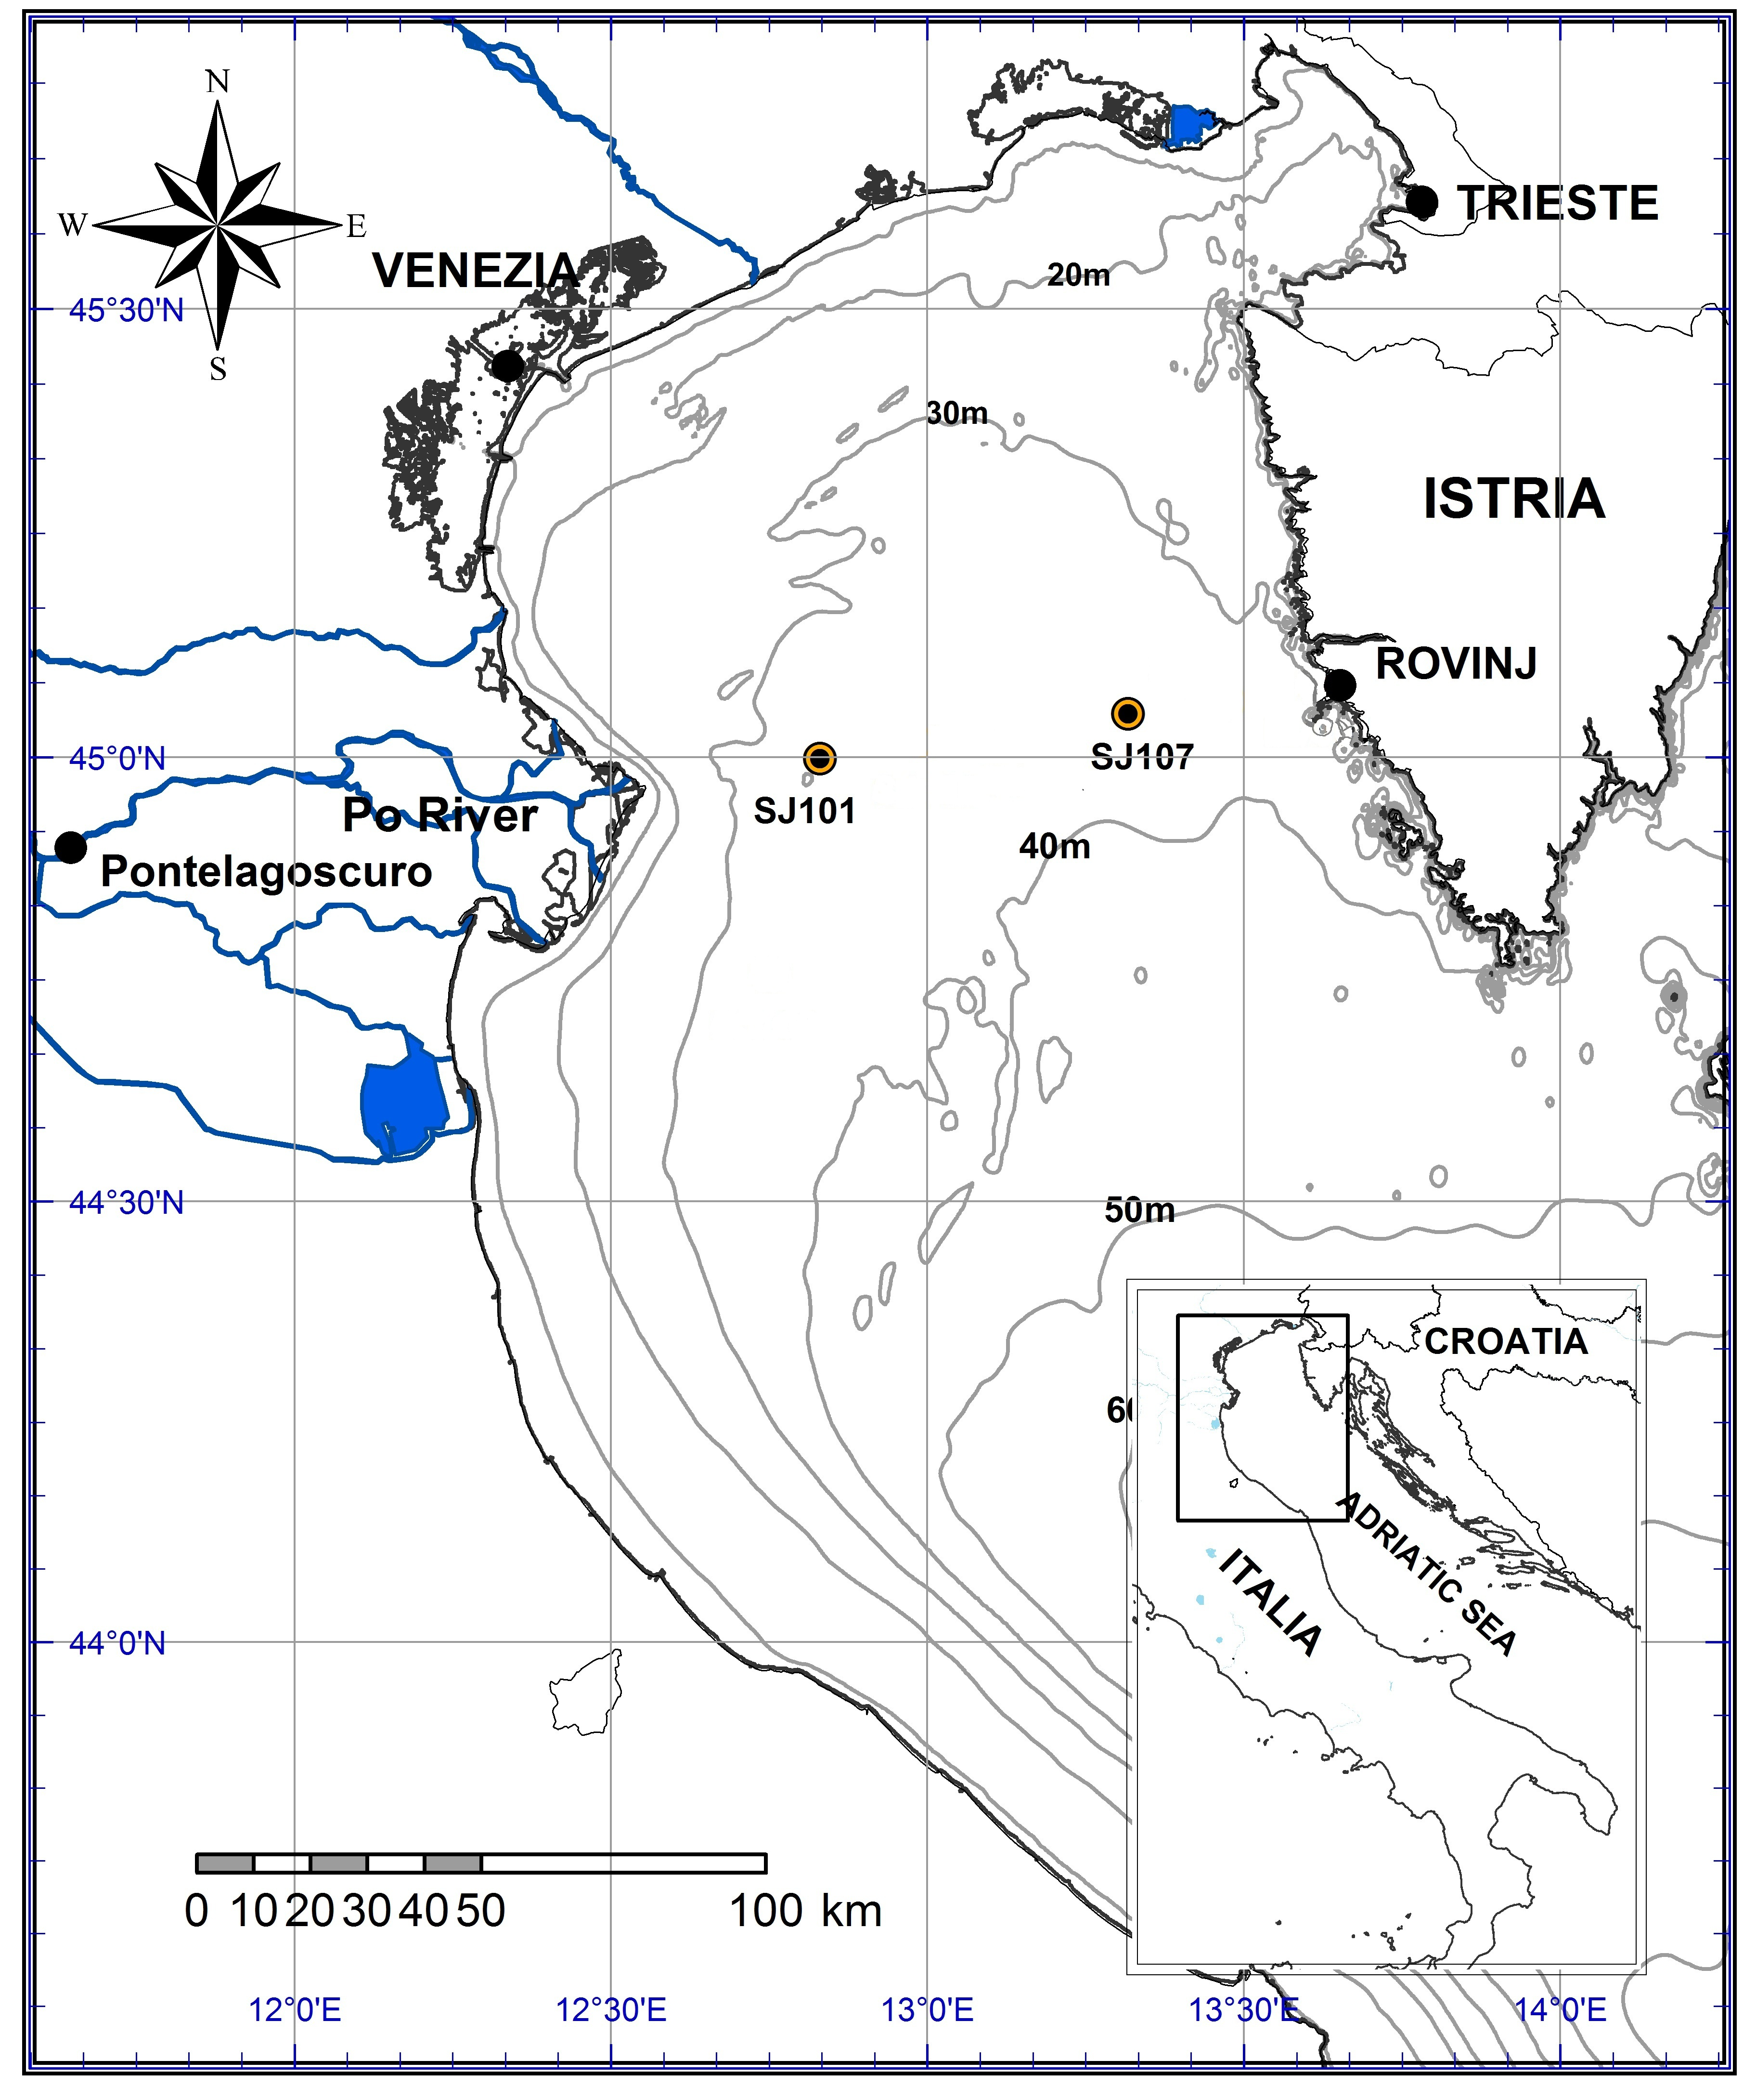

Fig.2.

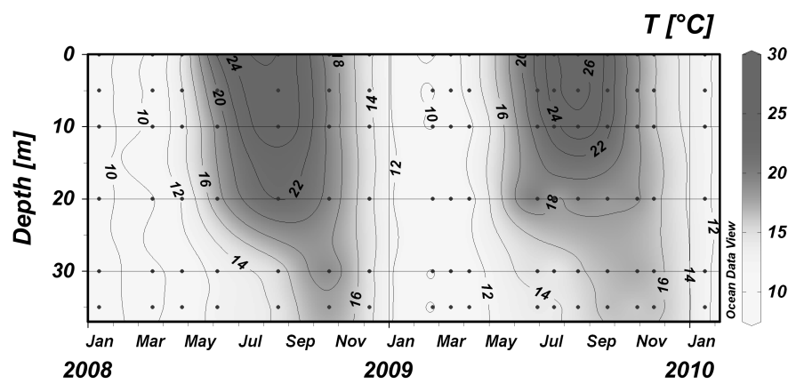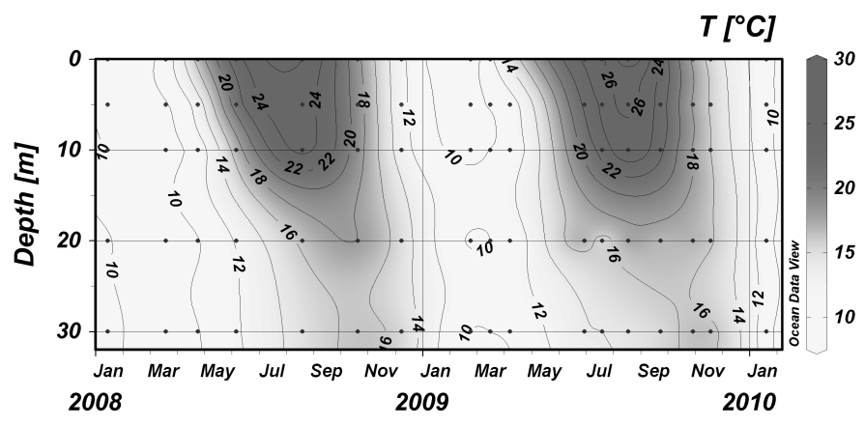

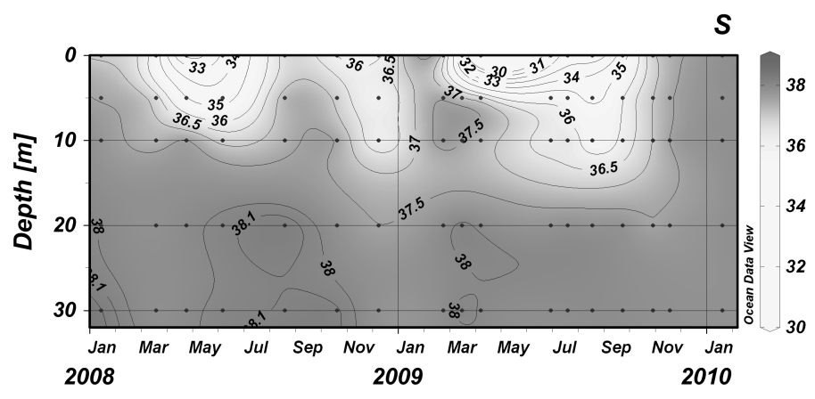

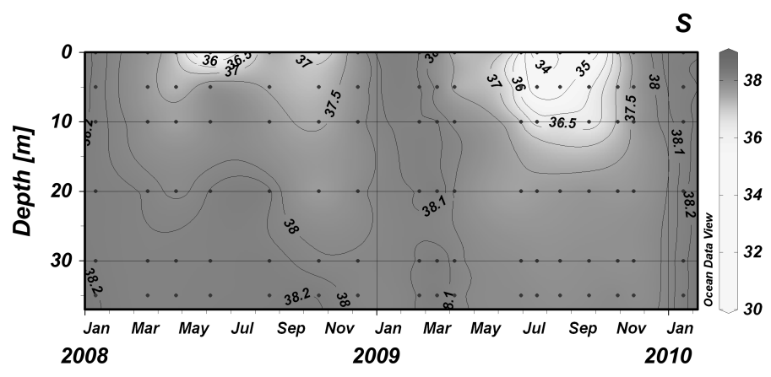

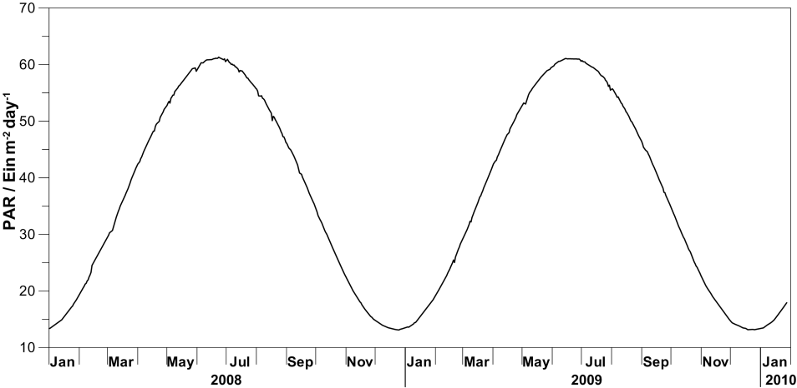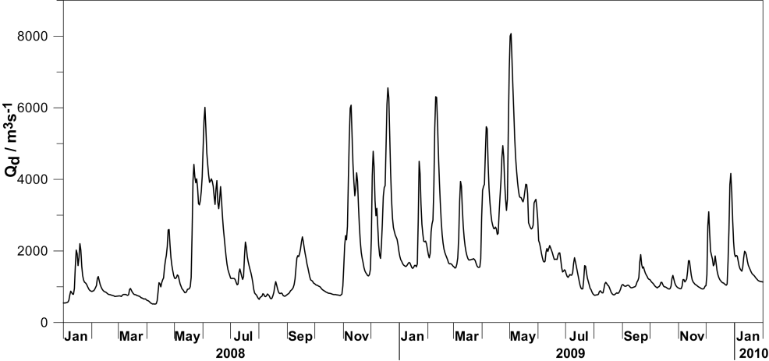Fig. 3.

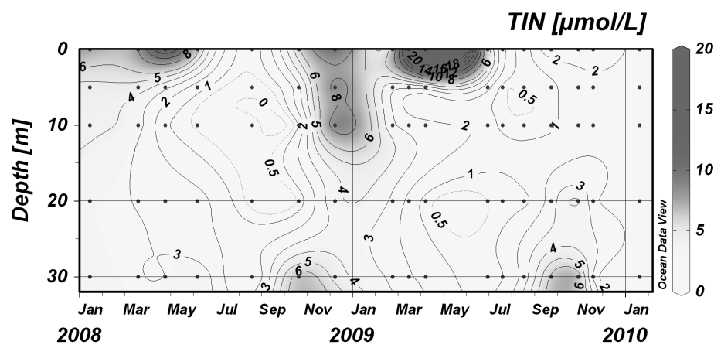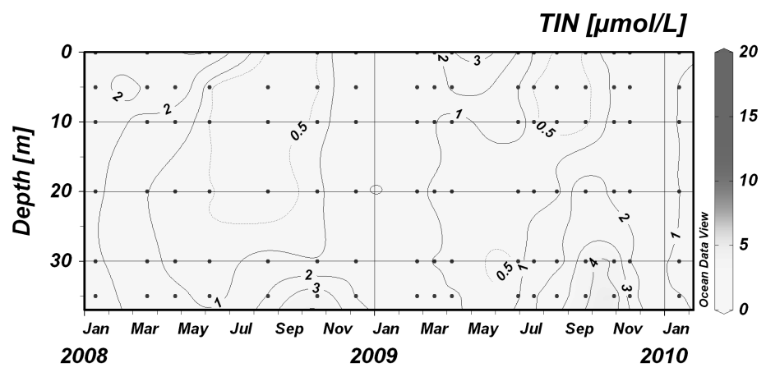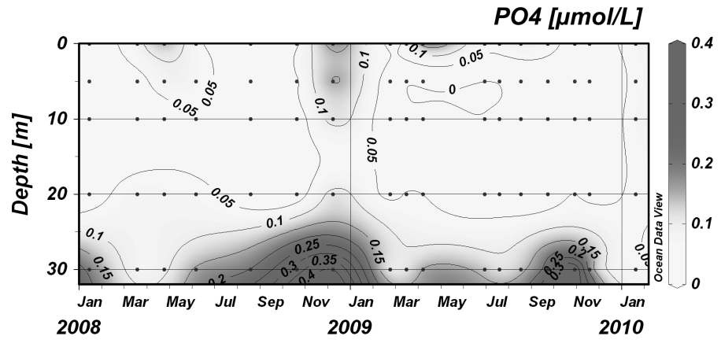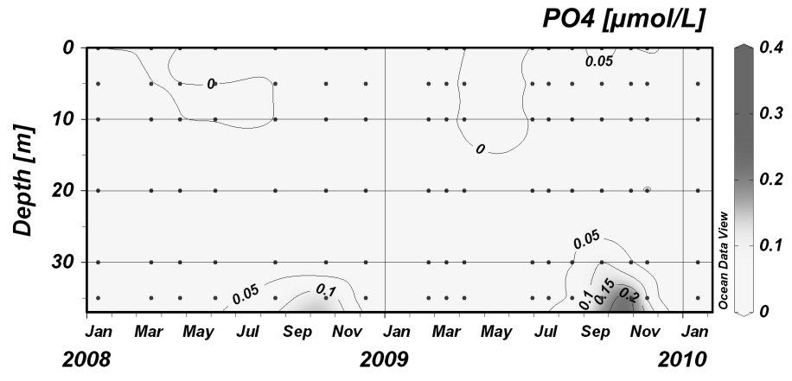

Fig. 4

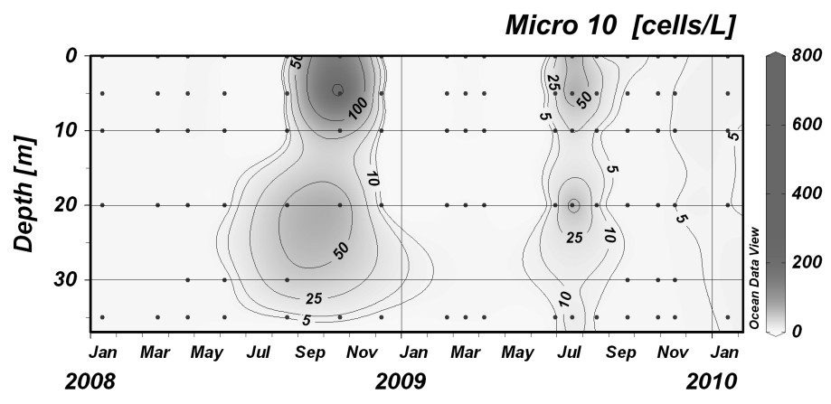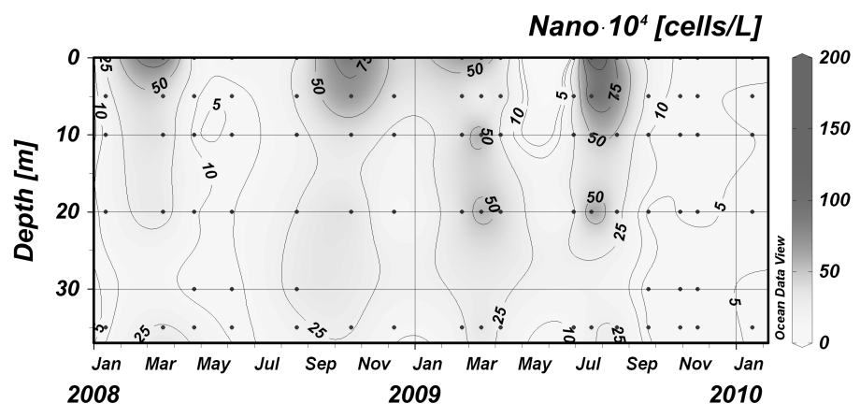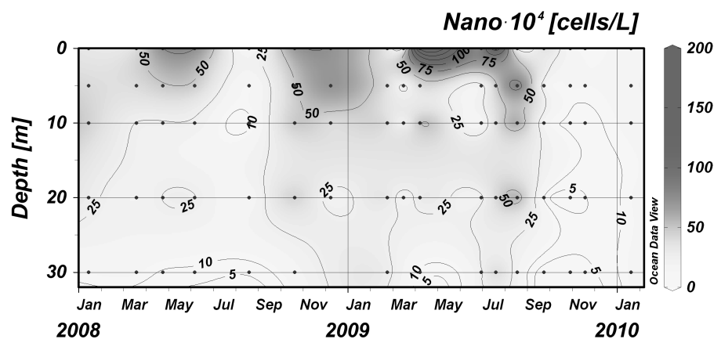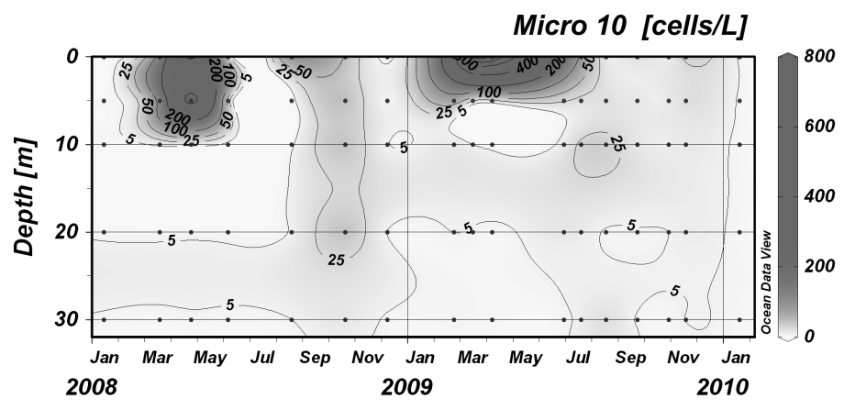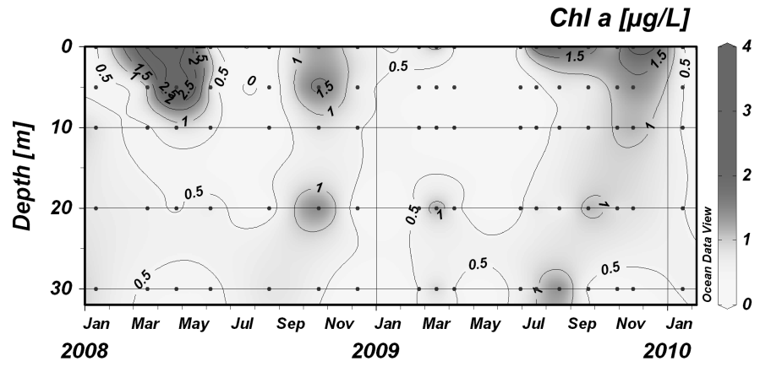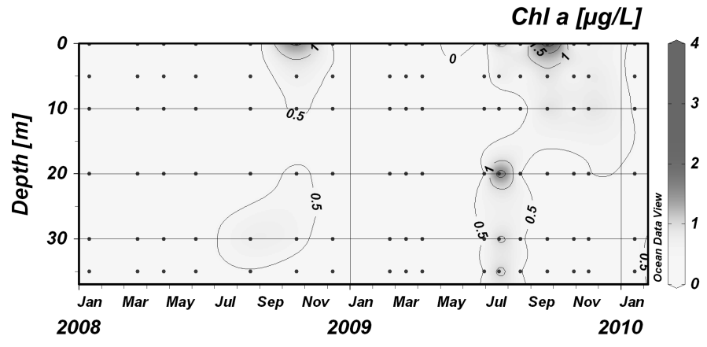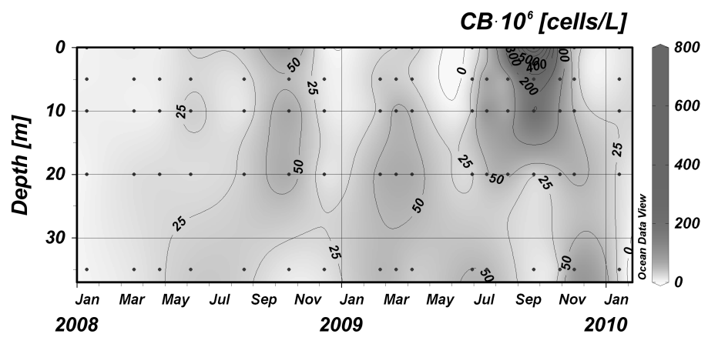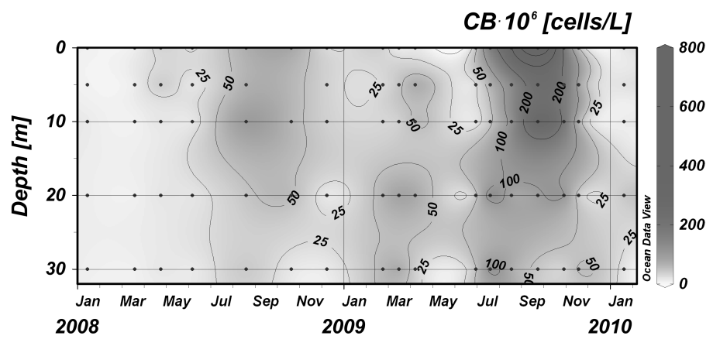

Fig. 5.



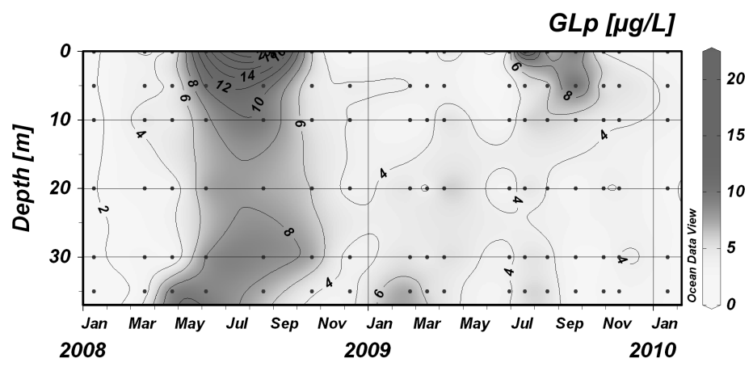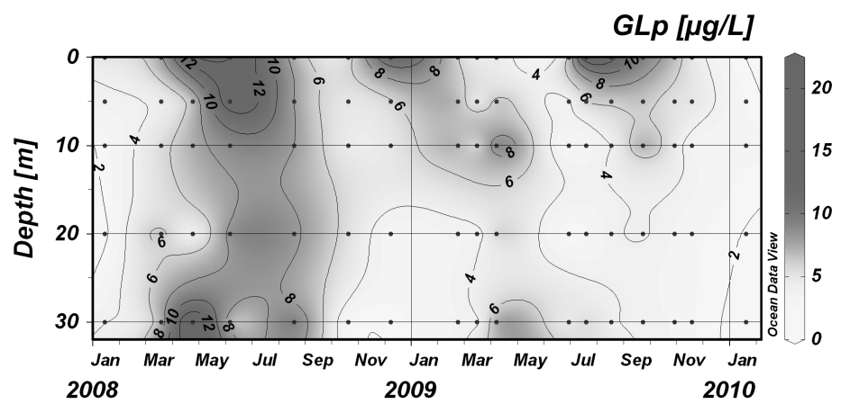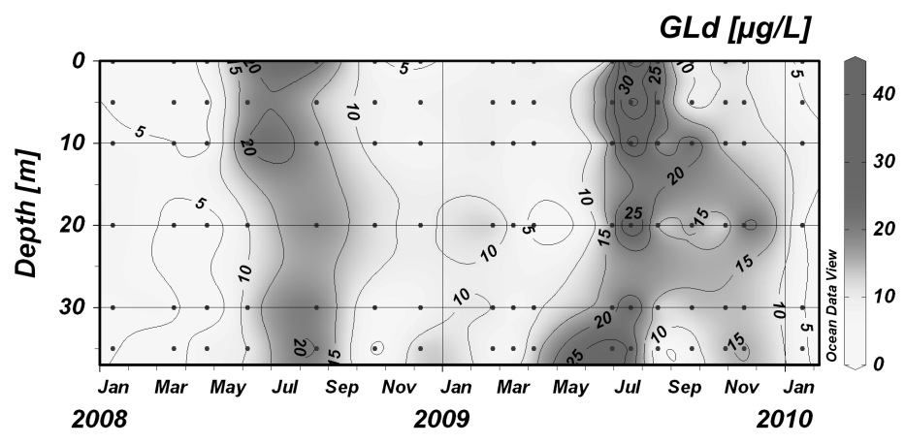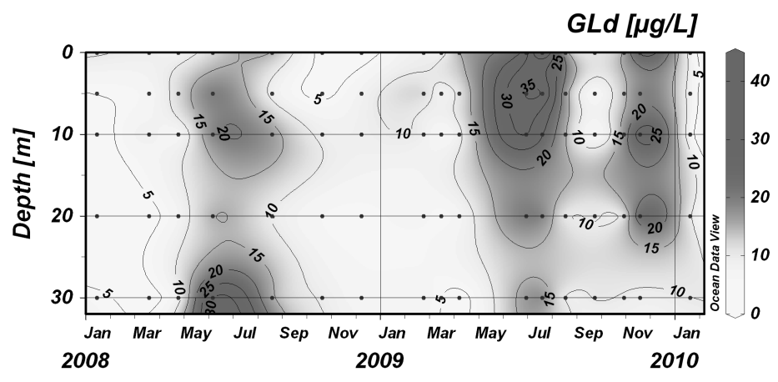





Fig. 6.

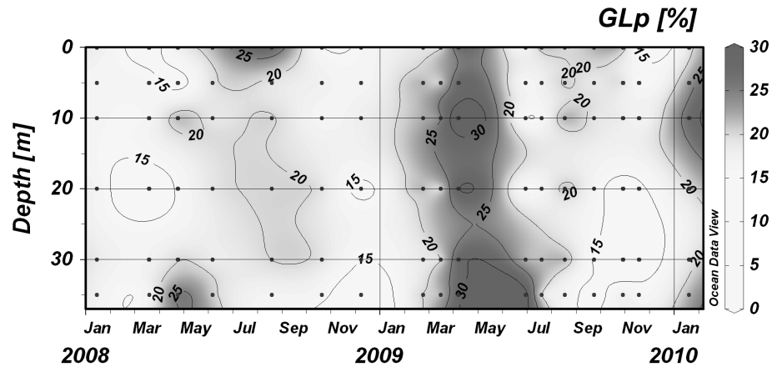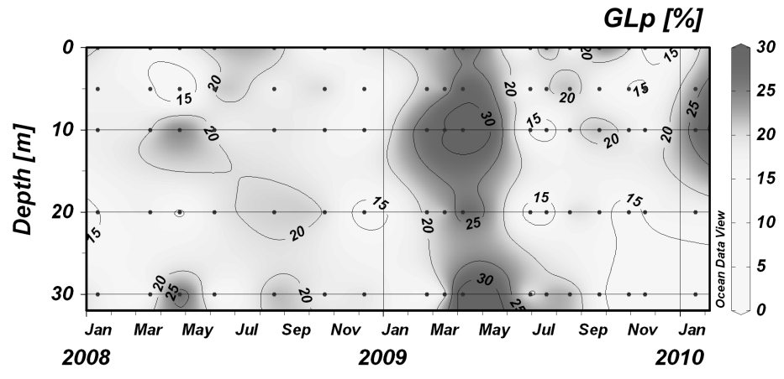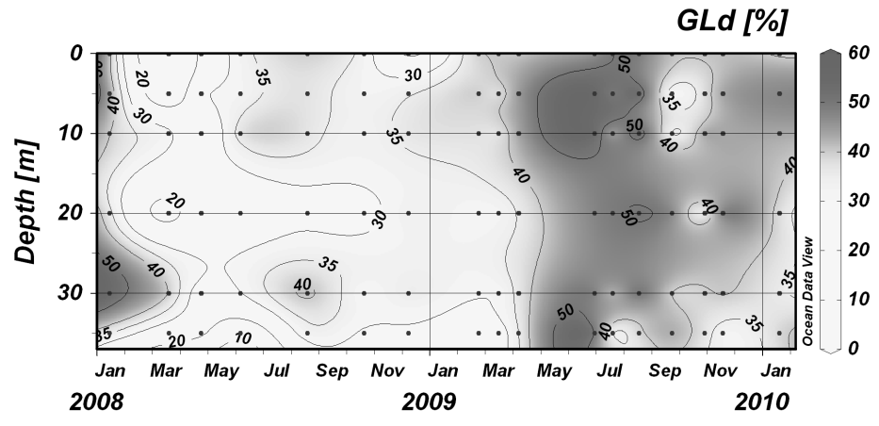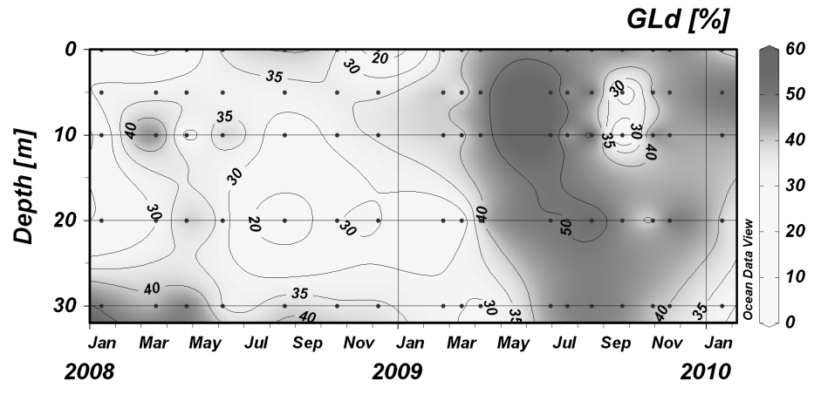

Fig. 7



Fig. 8

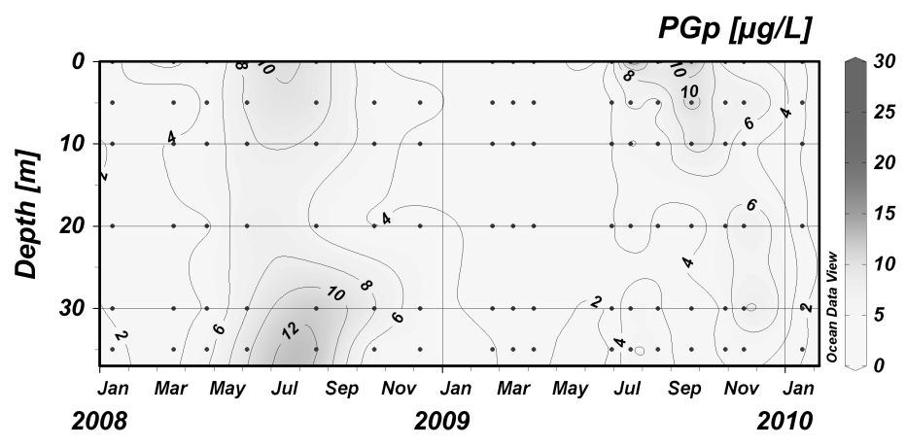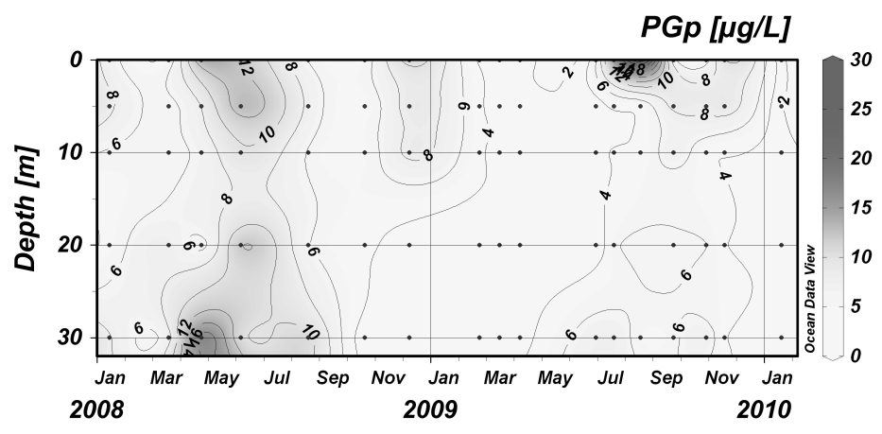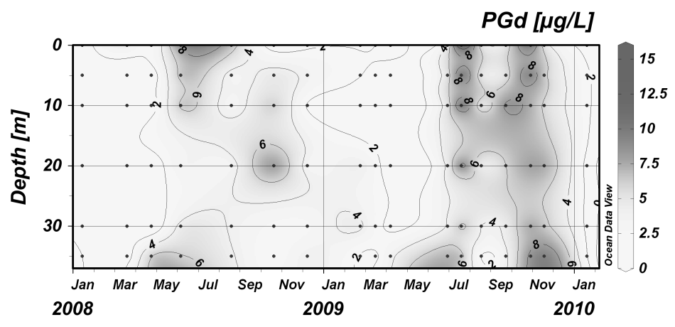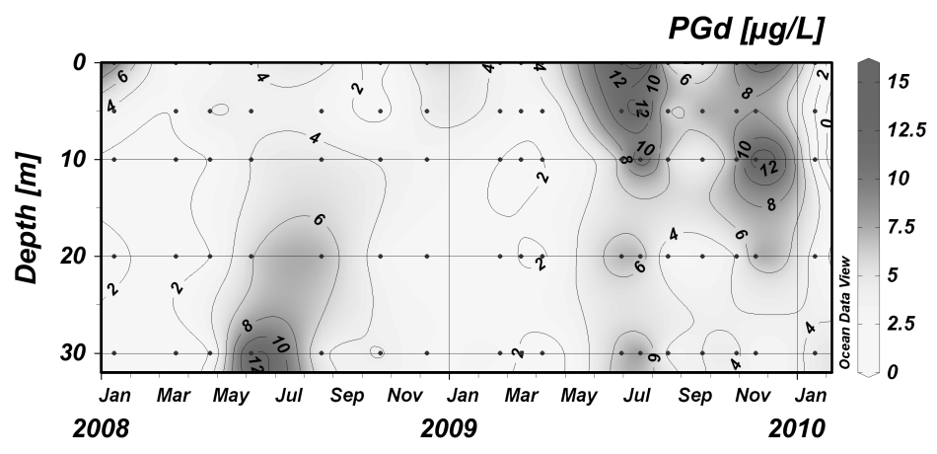

Fig. 9

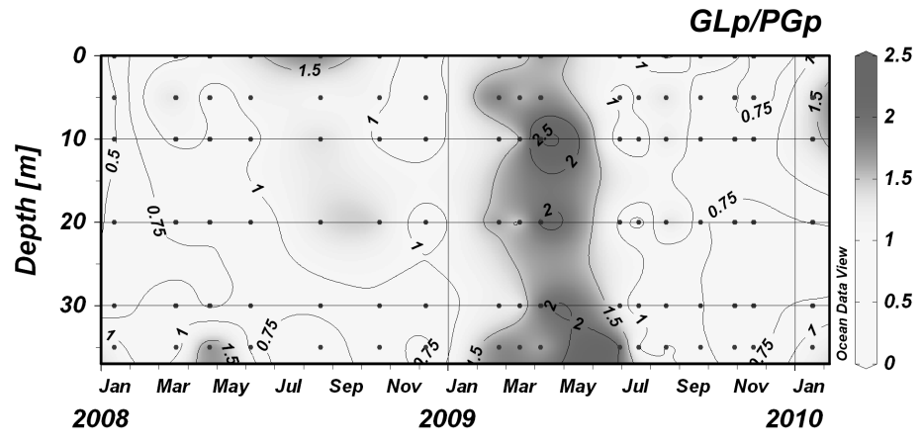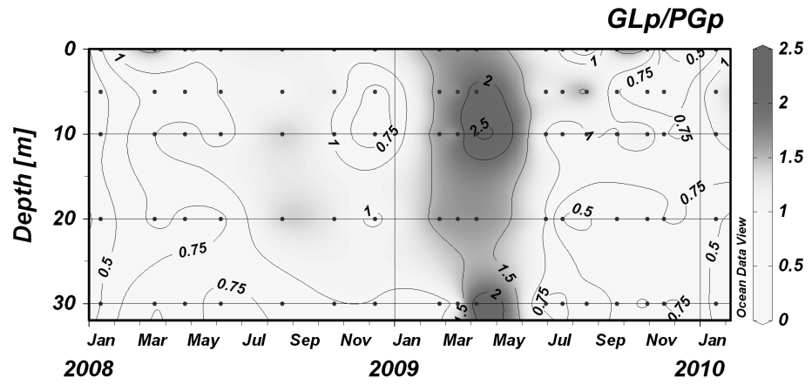

c) 101

a) 107

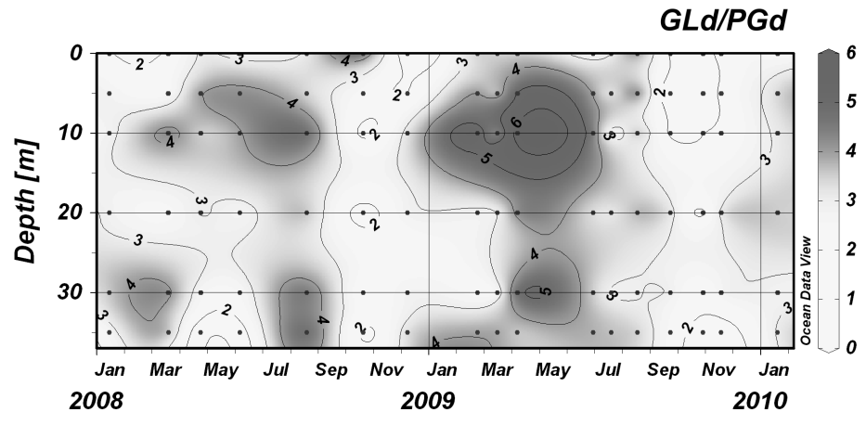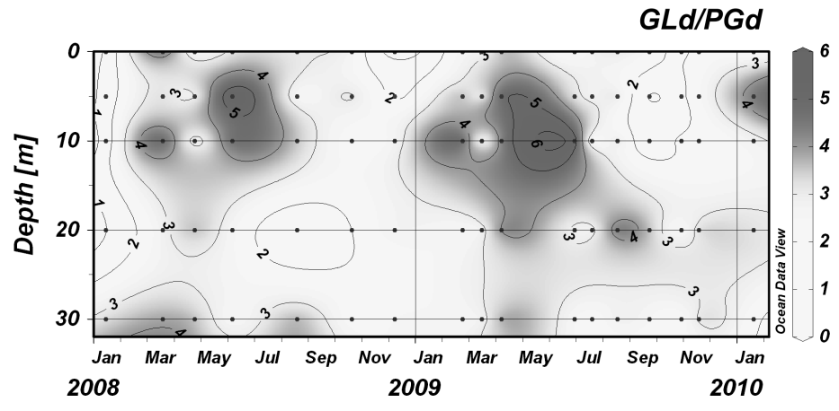

d) 101

b) 107

Fig. 10

