Copper - phospholipid interaction at cell membrane model hydrophobic surfaces
Marina Mlakar*, Vlado Cuculić, Sanja Frka, Blaženka Gašparović
Ruđer Bošković Institute, Division for marine and environmental research, Bijenička cesta 54, 10000 Zagreb, CROATIA
*Corresponding author: tel. +385-1-4561190; fax. +385-1-4680231; mlakar@irb.hr
Abstract
Detailed investigation of Cu (II) binding with natural lipid phosphatidylglycerol (PG) in aqueous solution was carried out by voltammetric measurements at the mercury drop electrode, complemented by monolayer studies in a Langmuir trough and electrophoretic measurements, all used as models for hydrophobic cell membranes. Penetration of copper ions into the PG layer was facilitated by formation of hydrophilic Cu-Phenanthroline (Phen) complex in the subphase, followed by mixed ligand Cu-Phen-PG complex formation at the hydrophobic interface. Electrophoretic measurements indicated a comparatively low abundance of the formed mixed ligand complex within the PG vesicles, resulting it the zeta potential change of +0.83 mV, while monolayer studies confirmed their co-existence at the interface. The Cu-Phen-PG complex was identified in the pH range from 6 to 9. The stoichiometry of the complex ([PhenCuOHPG]), as well as its stability and kinetics of formation, were determined at the mercury drop electrode. Cu-Phen-PG reduces quasireversibly at about -0.7 V vs. Ag/AgCl including reactant adsorption, followed by irreversible mixed complex dissociation, indicating a two-electron transfer - chemical reaction (EC) redox mechanism. Consequently, the surface concentration (γ) of the adsorbed [PhenCuOHPG] complex at the hydrophobic electrode surface was calculated to be (3.35 ± 0.67) × 10⁻¹¹ mol cm⁻². Information on the mechanism of Cu (II) - lipid complex formation is a significant contribution to the understanding of complex processes at natural cell membranes.

Keywords: phospholipid membrane; copper (II) mixed ligand complex; voltammetry Langmuir monolayer; electrophoretic zeta potential.

1. Introduction
Cell physiology is strongly dependent on the interaction of hydrophobic cell membranes with hydrophilic inorganic ions. Cell membranes are mainly composed of lipids, forming bilayer, together with embedded proteins. The key lipid-type defining membrane bilayers of almost all living organisms are glycerol-based phospholipids, among which phosphatidylcholine, phosphatidylethanolamine and phosphatidylglycerol (PG) are the most important ones in algae species [1]. Moreover, PG is a ubiquitous phospholipid constituent of bacterial membranes present regularly within plants and animals [2, 3].
Phospholipid monolayers at model hydrophobic interfaces, such as the air-water interface, considered to be one half of a biological membrane, have been widely used as simple but efficient 2-dimensional models of processes at membrane surfaces [4–8]. These supportive monomolecular layers are typically prepared in a Langmuir trough, which facilitates control of lateral surface pressure (π) as a function of the molecular area (A) and/or time (t), providing fundamental information on their molecular orientation and defects. Numerous studies report on interactions of metal ions, drugs, toxins and other biologically important species with model phospholipid monolayers [8–12]. In most cases, these substances are dissolved within the subphase and their incorporation into the supporting phospholipid monolayer is monitored or they are co-spread with the phospholipids constituting the mixed model layer. As a result, alterations in the monolayer polymorphism induce changes of fundamental monolayer properties such as the area occupied by a molecule. Furthermore, liposomes as uni- or multi-lamellar spherical structures of diameter between 15 nm and >1 μm, are often used in studies of model biological membranes [13, 14]. The measurements of the surface charge of biomembrane models, through the zeta potential, are an additional and complementary tool for elucidating their interactions with host compounds. Zeta potential measurements are often used to evaluate changes in membrane surface in order to obtain more information about the binding patterns between membrane and organic molecules and/or metals [e.g. 15–17]. The adsorption of organic molecules onto the phospholipid membrane causes a membrane surface potential change and/or modifies the dipole potential within the membrane.
A hanging mercury drop electrode (HMDE), being a common model of a hydrophobic surface, has been used to describe adsorption processes on the monolayer of 1,2-dioleoyl-sn-glycero-3-phosphocholine (DOPC) [18]. Moreover, the development of Pt-Hg film microelectrodes facilitated the relocation of the Hg - phospholipid system to a more robust platform appropriate for screening the interactions of membrane active substances [19–21].
Copper is an essential element for metabolic processes in all organisms, being required for electron transport in photosynthesis by various enzyme systems [22–24]. Group B or soft acid metals (e.g. Cu²⁺, Zn²⁺ and Ni²⁺) are mainly involved in enzymatic activities. Cu (II) can interact with lipids causing their peroxidation and opening pores in cell membranes, thereby compromising the integrity of the cells [25]. Metal interactions with phospholipids depend on specific head group regions. Copper as a more electronegative metal has greater affinity for amino, phosphate, carboxyl, and sulfhydryl groups. Hence, phospholipids have metal-reactive phosphoryl and occasionally carboxyl groups in their hydrophilic regions, available to bind metal cations [26]. Numerous studies on transition-metal complexes with various ligands, including diimine such as 1,10-phenanthroline (Phen), have been performed, indicating their incorporation into biological membranes supported by measurements of membrane dynamics [27].
Interactions of micronutrient metal ions with cells, primarily membranes in the marine environment, are of the particular interest as they are crucial for the cell function maintenance. Metals as micronutrient resources are often limited and marine organisms develop different mechanisms for their incorporation, usually involving their complexation with organic ligands so as to make the micronutrient bioavailable [28]. It is therefore essential to understand the various cell-acquisition mechanisms for the micronutrients. Therefore, the aim of this study was to examine copper (II) interaction mechanism with lipids for the first time, being a vital part of hydrophobic cell - membranes, by tracking the formation of the complex at hydrophobic surfaces (such as the hanging mercury drop electrode). This was followed by investigations of copper (II) interaction with the phospholipid monolayer at the air-water interface and zeta potential measurements on liposomes.

2. Experimental
2.1 Equipment and procedure
2.1.1 Electrochemical measurements
The experiments were performed using an Autolab PGSTAT12 potentiostat/galvanostat controlled by GPES 4.9, a general purpose electrochemical system software package, using a PC-based data acquisition routine (ECO Chemie, Utrecht, Netherlands). Repeated voltammetric measurements were automatically controlled via the project mode of the GPES 4.9 software to achieve accurate time intervals between measurements and, therefore, smaller confidence intervals of the measuremens. These were performed in a 50 mL electroanalytical glass cell with an analyte volume of 20 mL. The sensor was a three-electrode Metrohm 663 VA STAND system (Herisau, Switzerland). A hanging mercury drop was used as the working electrode (drop surface of 0.004 cm²), a platinum wire as the counter electrode and a NaCl saturated Ag/AgCl reference electrode. The pH was adjusted and the cell deaerated with extra pure nitrogen (for 15 minutes) prior to the voltammetric measurement. The pH of the solutions was measured using a glass electrode and the ATI Orion PerpHecT meter, model 320 (Cambridge, MA, USA). All measurements were performed at 22±1 °C. Prior to experiments, all analytical vessels were thoroughly washed with 10% nitric acid and rinsed 3 times with Milli-Q® water (Millipore, Billerica, MA, USA) to remove any residual trace metals and organics.
Four voltammetric measurement modes were used: square wave (SWV), alternating current (ACV, out of phase), linear sweep (LSV) and cyclic voltammetry (CV). Voltammetric parameters for SW were as follows: accumulation potential (E_{acc}) = 0 and -0.2 V, accumulation time (t_{acc}) = 0, 60, 180 and 300 s. The step potential was kept constant in all experiments, (E_{step} = 2 mV), while the pulse amplitude (a / mV) and frequency (f / s⁻¹) varied. LSV and CV parameters were: E_{acc} = 0 and -0.2 V, t_{acc} = 0, 60, 180 and 300 s. Initial and final potentials (E_{init} = -1.3 V, E_{fin} = 0 V), together with step potential (E_{step} = 2 mV) were constant, while the pulse amplitude varied. Electrochemical characteristics (redox potential, peak current, half-peak width) of the obtained voltammetric signals (peaks) were analysed using the ECDSOFT (ElectroChemical Data SOFTware) software [29].
2.1.2 Surface pressure measurements
Monolayer studies were done using a Teflon Langmuir-Blodgett trough, model 1212D1 (Nima Technology Ltd, Coventry, United Kingdom) equipped with two movable Teflon barriers, all enclosed in a tight box and placed on an anti-vibration table. The surface pressure was measured at room temperature (21 °C) with an accuracy of ± 0.1 mN m⁻¹ using a Wilhelmy plate pressure sensor. The compression rate was 60 cm² min⁻¹. The experiments were designed to keep constant the maximum area (A_{max} = 830 cm²) of the phospholipid monolayer on the subphase containing dissolved components, allowing their incorporation during 3 h, monitored by the initial surface pressure (π_{i}) changes of the supporting monolayer. Subsequently, the supporting monolayer compression was initiated by variations of the surface pressure due to the change of the molecular packing, while the surface pressure-area isotherms (π-A) were recorded. To ensure consistent results, each measurement was repeated at least five times. The limiting specific area, A_{lim}, was obtained by extrapolating the linear part of the π-A isotherm curve to π = 0 mN m⁻¹, corresponding to the cross-sectional area of maximally ordered molecule.

2.1.3 Zeta potential measurements
The zeta (ξ) potential of PG liposomes was measured using a ZetaPlus Zeta Potential Analyzer (Brookhaven Instruments Corporation, Holtsville, NY, USA). The instrument uses electrophoretic light scattering from a laser source (λ = 659 nm) and the Laser Doppler Velocimetry method for the determination of liposome mobility. The zeta potential was calculated from the measured electrophoretic mobility using the Smoluchowski approximation (f(Ka) = 1.5) of Henry’s equation. The results are reported as the average value of 15 independent measurements. All measurements were performed at 25 °C.

2.2 Chemicals and solutions
A stock solution of the PG (Lipid Products, South Nutfield, UK) was used in this study. The PG stock was industrially prepared as 25 mg of PG dissolved in 5 mL of a chloroform/methanol solution (5 mg mL⁻¹) with an approximate PG molecular weight of 775 g mol⁻¹. The mixture of fatty acids in the phosphatidylglycerol standard was composed of the following 5 components: 22% palmitic acid, 35% monounsaturated derivatives of palmitic acid, 36% linolenic acid, 5% linoleic acid and 2% oleic acid. These fatty acids are normally present in natural seawater. The original stock solution was kept at -20 °C. For electrochemical measurements, subsidiary PG solutions were prepared by dissolution in ≥ 99.9% methanol (Merck, Darmstadt, Germany) until suitable PG concentrations were obtained and kept refrigerated at 4 °C. Subsidiary PG solutions were prepared weekly in order to minimize possible solution instability and methanol vaporization. Electrolyte solutions of 0.55 M sodium chloride were prepared from a stock of saturated 5.5 M NaCl prepared from Suprapur® NaCl (Merck). A stock solution of 10⁻² M Cu (II) was prepared by dissolving Cu(NO₃)₂ salt (Merck) in Milli-Q® water and acidifying with Suprapur® HNO₃ (Merck) to a pH of approximately 2 in order to prevent hydrolysis. Stock solutions (1×10⁻³ M) of the ligand 1,10-phenanthroline (Phen) with the empirical formula C₁₂H₈N₂ were prepared weekly by dissolving appropriate amounts of the p.a. chemical (Merck) in Milli-Q® water. The pH of the experimental solutions was maintained using a 5 mM 4-(2-hydroxyethyl)-1-piperazineethanesulfonic acid (HEPES) buffer. The stock solution of 1.3 M HEPES buffer (p.a., Chempur, Karlsruhe, Germany), pH 8.2, was prepared by the addition of 1 M NH₄OH (p.a., Kemika, Zagreb, Croatia). All buffer solutions were prepared with Milli-Q® water. Fine pH control was done by dilute SupraPur® HCl/NaOH additions (Merck, Darmstadt, Germany).
For the π-A isotherm experiments, aliquots (V = 72 μL) of PG solution (1 mg mL⁻¹) in chloroform were carefully spread onto the aqueous subphase, using a Hamilton microliter syringe. Subsequently, the solution was left for 10 min to facilitate solvent vaporisation. After each run the trough and barriers were carefully cleaned three times with chloroform and Milli-Q® water.
For zeta-potential measurements, PG liposomes were prepared by dissolving 5 mg PG (Lipid Products, South Nutfield, UK) in 10 mL of chloroform (Merck, Darmstadt, Germany). After rotary evaporation of the solvent, the remaining lipid film was dispersed in 10 mL of 1.3 M HEPES buffer by gentle shaking at ~ 50 °C (above the phase transition temperature of PG) [30]. During rehydration, the lipid film was gradually scraped off from the wall of the glass bottle, layer by layer, while cloud-like floaters formed in the solution. The liposome dispersion (6 x10⁻⁴ M) was left to swell and stabilize overnight. After homogenization, 2 mL aliquots of the unilamellar liposome dispersions were used for solution preparation and zeta- potential measurements. The solutions were prepared as follows: (1) pure PG liposome dispersion (6×10⁻⁴ M), (2) in the PG liposome dispersion stock solution of Cu(NO₃)₂ salt (Merck Darmstadt, Germany) was added to adjust the concentration of Cu (II) to 1×10⁻⁵ M, and (3) in the liposome dispersion the stock solution of Cu-Phen complex was added to adjust the concentration to 6×10⁻⁵ M.

3. Results and Discussion
3.1 Voltammetric measurements
Cu (II) interactions with the PG membrane were investigated. We anticipated a simple binding mechanism between PG and Cu (II) via formation of the Cu (II) -
PG2, however, our results indicate a more complex reaction pathway requiring a new approach. By the introduction of 1,10-phenanthroline (Phen) as the intermediate model bioactive ligand, Cu (II) complexation with PG occurred, resulting in the formation of a hydrophobic mixed ligand complex at the mercury drop surface.
Fig. 1 (A and B) presents the adsorptive SWV and adsorptive CV of Cu (II)-Phen-PG system recorded in 0.55 M NaCl at pH = 8.2. When only the PG was in solution, the peak appeared at the potential of -0.62 V indicating a reorientation process of adsorbed PG molecules (Figs. 1A and B, curves 2) [20, 31]. This peak is the consequence of a charging current, due to structural/electrostatic changes in the adsorbed PG layer at the electrode surface [32], when the charge of the mercury surface changes from positive to negative at approximately the same potential (between -0.4 and -0.6 V). Thus, at a potential of -0.62 V the reorientation of the adsorbed PG ions from flat to perpendicular position probably occurs. An adsorption study of the PG monolayer at the electrode surface was conducted with ACV and a phase angle 90º. The PG adsorption region was registered between -0.16 V and -1.04 V. When both Phen and PG were in solution, a reorientation peak was recorded at -0.59 V as Phen molecules solvate (diffuse) into the adsorption layer of PG molecules (Figs. 1A and B, curves 3) [33]. By the addition of Cu (II) ions into the PG solution, a diminished PG reorientation peak at about -0.62 V was recorded, revealing a slight electrostatic influence on the adsorbed layer of PG molecules (Figs. 1A and 1B, curves 5). When both Phen and Cu (II) ions were in solution, a broad reduction signal at about -0.58 V was registered (Fig. 1A, 1B curve 4). This electrode process was assigned to a two-electron reduction step of Cu (II)-Phen complex, poorly adsorbed onto the mercury electrode surface [34]. By addition of Cu (II) (4×10⁻⁷ M) to the PG and Phen solution, a distinctive peak at -0.69 V was recorded, both by SWV and CV (Figs. 1A and 1B, curves 6). This electrode process was ascribed to two-electron reduction of Cu (II) in the mixed ligand complex. It is important to note the absence of the copper (0) oxidation process at the anode, due to a thickly packed PG layer at the electrode surface. Therefore, the reduction process of the mixed ligand complex Cu-Phen-PG is followed by an irreversible dissociation in which case only the PG molecule layer remains at the electrode surface. In the second CV scan at the same mercury drop, a single reorientation peak of PG-Phen was recorded on the cathodic side.
A prolongation of the accumulation time, t_{acc,} from 0 to 180 s at E = 0 V, results in an increase of the PG-Phen reorientation peak (c_{(PG, Phen)} = 4×10⁻⁶ M) while with longer accumulation periods (up to 600 s) electrode surface saturation takes place and the peak decreases. The mixed ligand complex Cu-Phen-PG reduction peak current (c_{Cu(II)} = 4×10⁻⁷ M) does not change, while its potential shifts towards more negative values from -0.65 to -0.78 V, with t_{acc} period from 0 to 180 s, respectively, as the layer is thickly packed and the electron transfer requires more energy for the completion of the reduction process.
Fig. 1. Voltammograms of: (1) Phen, (2) PG, (3) PG+Phen, (4) Phen+Cu, (5) PG+Cu, (6) PG+Phen+Cu; A) SWV: c_{(PG, Phen)} = 4×10⁻⁶ M, c_{Cu(II)} = 4×10⁻⁷ M. SW voltammetric parameters: E_{acc} = 0 V, t_{acc} = 60 s, E_{step} = 2 mV, a = 25 mV, f = 50 s⁻¹; B) CV: E_{acc} = 0 V, t_{acc} = 60 s, , v = 50 mV s⁻¹; 0.55 M NaCl, pH = 8.2, 5 mM HEPES.
The Cu (II) mixed ligand complex formation was followed by titration of a mixed ligand solution with Cu (II) (Fig. 2A). When both ligands were present in solution, a sharp and well defined capacitive peak at -0.60 V was recorded (Fig. 2A, curve 1). By the addition of 1×10⁻⁷ M of Cu (II), the PG-Phen capacitive peak disappeared, while two broad reduction peaks appeared at potentials of -0.59 V to -0.65 V (Fig. 2A, curve 2), corresponding to Cu (II) -Phen and Cu-Phen-PG complexes, respectively. Further addition of Cu (II) increased the reduction currents of both complexes. With 6×10⁻⁷ M Cu (II), the reduction peak of Cu-Phen complex disappeared, while the peak at -0.7 V was the only reduction response of the strongly adsorbed Cu (II) within the mixed ligand complex Cu-Phen-PG (Fig. 2A, curve 5). The Cu-Phen complex is hydrophilic and forms in solution, while the hydrophobic Cu-Phen-PG mixed ligand complex is formed only within the adsorption layer at the mercury drop surface [35]. The inset in Fig. 2 shows the reduction currents and potentials in dependence of Cu (II) concentration. The reduction currents increased linearly up to 2×10⁻⁶ M of Cu (II) (slope 88.7 nA/µM Cu, correlation coefficient, r² = 0.9982), while with further Cu (II) additions the mixed ligand reduction peak reached a maximum and remained almost at the same potential value. The Cu-Phen-PG complex reduction potentials shift towards negative values with a slight sigmoidal shape, from -0.685 to -0.725 V, due to its increasing amount adsorbed at the electrode surface resulting in an increase in the energy required for the mixed ligand complex reduction. The electrode surface was saturated with the Cu-Phen-PG complex where the Cu (II) concentration was 2×10⁻⁶ M.
Fig. 2. A) LSV of: (1) 4×10⁻⁶ M Phen, PG; (2) +1×10⁻⁷ M Cu; (3) +2×10⁻⁷ M Cu; (4) +4×10⁻⁷ M Cu; (5) +6×10⁻⁷ M Cu. Voltammetric parameters: E_{acc} = 0 V, t_{acc} = 60 s, v = 50 mV. Inset: Dependences of reduction peak currents and potentials on the Cu concentration; 0.55 M NaCl, pH = 8.2; E_{acc} = 0 V, t_{acc} = 60 s, v = 50 mV s⁻¹; B) SWV of: (1) 4×10⁻⁶ M PG; (2) 6×10⁻⁷ M Cu + 4×10⁻⁶ M Phen; (3) +10⁻⁶ M PG; (4) +2×10⁻⁶ M PG; (5) +4×10⁻⁶ M PG; E_{acc} = 0 V, t_{acc} = 60 s, E_{step} = 2 mV, a = 25 mV, f = 50 s⁻¹.

A gradual addition of PG results in a decrease of the Cu-Phen reduction peak and a slight shift towards more negative potentials, while a new peak appears around -0.7 V, corresponding to the reduction process of the Cu-Phen-PG mixed ligand complex (Fig. 2B).
The Cu-Phen-PG complex is present in the rather narrow pH range from 6 to 9 (Fig. 3), corresponding to the pH range in which the Cu-Phen complex is present in solution. The reduction current increased linearly in the pH range from 6 to about 8, with a slope of 35.4 nA/pH unit (r² = 0.9969), while at pH above 8 the reduction current decreases. Simultaneously, the Cu-Phen-PG reduction potential shifted towards more negative values, from -0.63 to about -0.72 V. With the Cu (II) concentration below 1×10⁻⁶ M, the pH range in which the mixed ligand complex peak was registered, was narrower. The optimal deposition potential of the Cu-Phen-PG mixed ligand complex at the electrode surface was found to be 0.0 V vs. Ag/AgCl reference electrode.
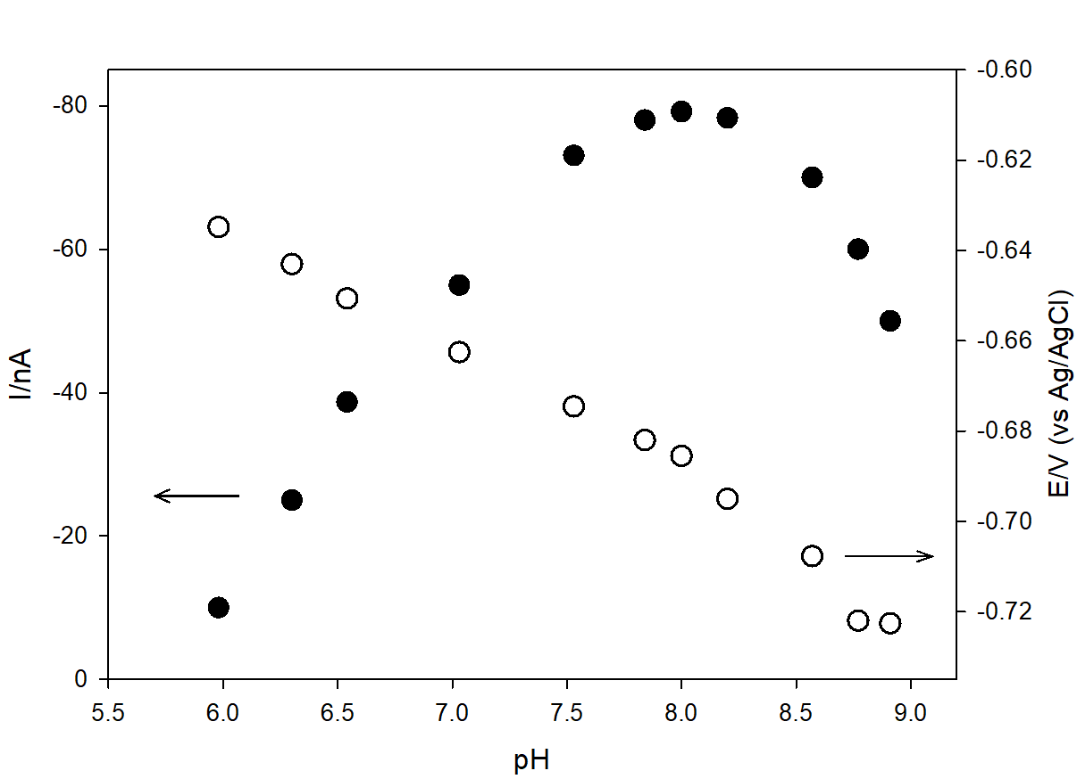
Fig. 3. Dependence of SWV reduction current (full circles) and peak potential (open circles) on pH. 0.55 M NaCl, c_{(PG, Phen, Cu)} = 4×10⁻⁶ M. E_{acc} = 0 V, t_{acc} = 60 s; SWV parameters: E_{step} = 2 mV, a = 25 mV, f = 50 s⁻¹.
The form of the copper mixed ligand complex in the pH range used was evaluated by considering the theoretical distribution of the Cu (II) ion calculated from Cu-Phen stability constants. Namely, in the pH range from 6 – 9 (0.55 M NaCl), copper (II) is present as [CuOH]⁺, and therefore the complex with 1,10-phenanthroline is most probably [CuPhenOH]⁺. One of the conditions that must be fulfilled to achieve adsorption of a hydrophobic complex at the mercury drop surface, is the charge neutralization of the central metal ion. The charge at the central metal ion usually neutralizes the first chelate ligand by the substitution of part of water molecules from the Cu (II) ion coordination sphere, thereby decreasing its hydrophilic character [36, 37]. However, as Phen is a neutral molecule above pH 5, the charge of the [CuPhenOH]⁺ species was neutralized by the monoanionic PG molecule [37, 38]. Consequently, since the Cu (II) mixed ligand complex was formed in the pH range between 6 and 9, it was assumed that its net stoichiometry was [PhenCuOHPG].
3.2 Monolayer surface pressure - area measurements
Further support for the copper (II) association reaction with Phen and membrane forming PG was obtained by Langmuir studies. The subphase 0.55 M NaCl (pH = 8.2; 5 mM HEPES) containing Cu (II) ions (4×10⁻⁶ M), Phen (1.2×10⁻⁵ M) and/or both, Cu (II) ions and Phen, has been allowed to penetrate into the PG monolayer spread onto the surface for 3 h at the initial A_{max} (Fig. 4).
First, the compressional behaviour of the the PG monolayer on the pure subphase has been evaluated (Fig. 4, curve 1). At large area per molecule values (~130 Å²), π_{i} was 3.1 ± 0.2 mN m⁻¹ and phospholipid molecules were in the liquid-expanded (LE) state, having a certain degree of cooperative interaction. When the area per molecule decreased, the surface pressure continued to increase steadily, at an accelerating rate up to A_{lim} of 95 ± 3 Å² and a collapse pressure, π_{c}, of 75 ± 0.8 mN m⁻¹. Namely, at this point there was an abrupt change in the slope of the isotherm attributed to the film collapse as a transition point from monolayer to three-dimensional multilayer films. At π values lower than π_{c} the isotherm was reversible while becoming irreversible beyond the collapse point. Compressional behaviour observed for PG was characteristic for a range of phospholipids studied by monolayer approach at the liquid-gaseous interface [39].
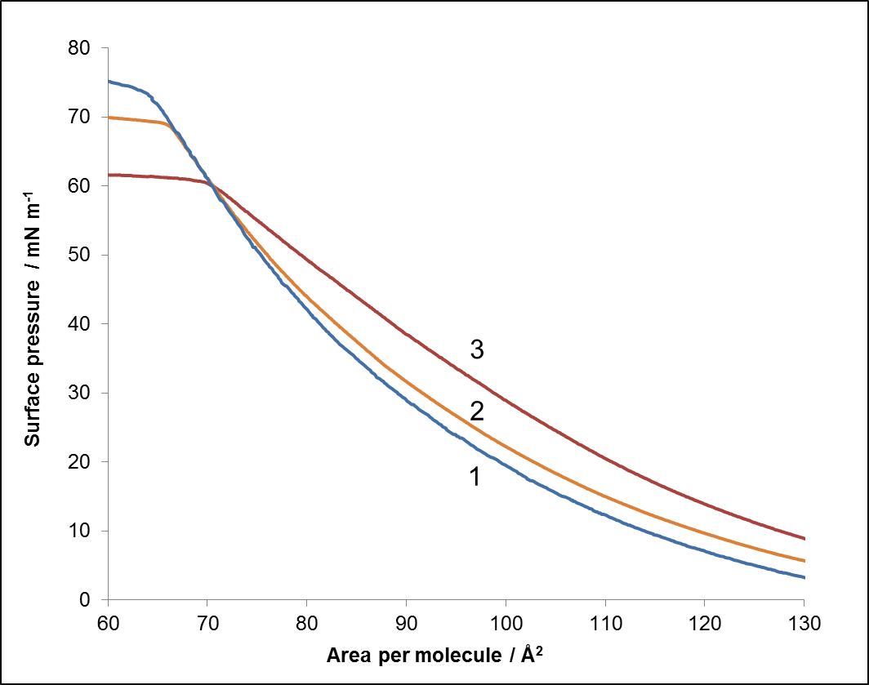
Fig. 4. Surface pressure (π) - area (A) compression isotherms of the PG monolayer obtained after interaction (3 h) with the subphase containing: (1) 0.55M NaCl, 5 mM HEPES, (2) +1.2×10⁻⁵ M Phen, (3) + 4×10⁻⁶ M Cu (II) ions, at pH = 8.2 and 294 K.

As a next step penetration experiments were performed at constant A_{max} ensuring the LE state of the PG monolayer where interactions of the subphase constituents with model membranes were found to be facilitated [11]. Since Phen (1.2×10⁻⁵ M) from the subphase did not adsorb to the clean surface itself under applied experimental conditions (data not shown since isotherms coincide with those obtained for the clean surface), the increase of π_{i} to 5.6 ± 0.2 mN m⁻¹ indicated an adsorption of Phen molecules in the presence of the PG layer (Fig. 4, curve 2). However, only a slight shift of A_{lim} to 97 ± 3 Å² per lipid molecule was noticed as an indication of Phen solvation within the PG molecules layer at higher compression rates. At A_{max}, the LE state of PG enables the incorporation of Phen molecules within its structure, while further compression results in stronger interactions between molecules, destabilizing the mixed PG layer and the eventual Phen displacement beneath the PG layer [5]. On the other side, the compression of the PG layer is affected by the presence of both, Cu (II) ions (4×10⁻⁶ M) and Phen (1.2×10⁻⁵ M) within the subphase, resulting in a more expanded film (Fig. 4, curve 3). The increase of π_{i} to 8.6 ± 0.2 mN m⁻¹ as well as a significant increase of A_{lim} to 125 ± 4 Å² supports previous electrochemical findings of the Cu-Phen complex binding within the PG layer and the formation of mixed Cu-PG-Phen layer at the surface. It should be noted that in the same period the isotherms of subphase containing Cu (II) ions (4×10⁻⁶ M) and Phen (1.2×10⁻⁵ M) did not show any significant adsorption at the clean interface itself (data not shown). This is in accordance with the electrochemical assumption that hydrophilic Cu-Phen complex formation occurs in the bulk of the solution. Moreover, the subphase containing only Cu (II) ions, did not interact with the spread PG monolayer at the surface. Thus, the penetration of Cu (II) ions into the PG layer is significantly enhanced when Cu (II) as Cu-Phen complex is added to the subphase.

3.3 Electrophoretic measurements
Electrophoretic measurements were performed in order to evaluate zeta potential changes induced by the interaction of the PG with Cu (II) and the Cu-Phen complex. Measurements of pure PG liposomes in buffer solution resulted in the zeta potential value of -24.30 ± 0.26 mV due to negatively charged PG polar heads (the PG is negatively charged at our experimental conditions of pH ∼ 8.2). The pKa of dimiristoyl-PG is reported to be 2.9 [40]. Addition of Cu (II) ions to liposomes caused an increase of the zeta potential value to -14.67 ± 0.23 mV. The measured zeta potential reflects the electrostatic binding of positive Cu²⁺ ions to the phosphate group in the PG polar heads. However, the addition of Cu-Phen complex to the liposome dispersion resulted in a zeta potential of -23.47 ± 0.16 mV. In this case, the increase in the zeta potential in comparison to that of pure PG liposomes indicates an interaction between the Cu-Phen complex and PG in the PG bilayer and the formation of the mixed Cu-Phen-PG complex under the described experimental conditions. Since the mixed complex is neutral, the total liposome surface charge is lower in this case. The relative low decrease in the magnitude of the zeta potential might indicate a low proportion of the complexed PG in the layer. A likely reaction pathway is the steric hindrance of the Cu-Phen-PG complex determining the possible packing arrangement of the tails and headgroups in the PG liposome.
3.4 Cu-Phen-PG reduction mechanism
Synergistic adsorption is not a simple adsorption process [36], it is actually the surface complexation reaction followed by reduction and chemical dissociation. Characterization of the Cu (II) mixed ligand complex redox processes was performed by SWV measurements, separating the SWV resultant current into the reduction (forward) and oxidation (backward) currents (Fig. 5A) [41, 42]. The “slow” CV technique with linear sweep potential indicated the EC redox mechanism, while the “fast” SWV with cathodic and anodic potential excitation pulses didn’t show the same behaviour in the case of the Cu-Phen-PG complex redox process. The rate of SWV potential scan was faster than the chemical reaction of the Cu (II) mixed ligand complex dissociation, and consequently in SWV both the anodic and cathodic peaks were recorded (backward and forward scans, Fig. 5A). The absolute value of the forward current (43 nA) was almost twice as high as the backward one (21 nA), which is characteristic for quasireversible redox reactions within the SWV framework [43, 44].
Additional insight into the electrochemical behaviour of Cu mixed ligand complex was obtained by examination of the SWV reduction resultant current in dependence of the SWV frequency (f) and pulse amplitude (a) (Figs. 5 B and C). The SW response was the result of current sampling, hence a complex adsorption depends strongly on the redox reaction characteristics [43]. Both the reduction current and potential depend on variations of the SW frequency and amplitude. These parameters and their dependencies can unequivocally describe redox process mechanism and adsorption properties. Thus, reactant adsorption enhances the SW response, especially when the reduction process is quasi-reversible [44]. SW responses of the Cu-Phen-PG redox process were affected by both frequency and pulse amplitude variation. The Cu-Phen-PG reduction current increases linearly with the increase of the SW frequency with a slope of 1.38 nA × s (r² = 0.9947) confirming reactant adsorption (Fig. 5B). The stripping peak current is enhanced by the amount of additionally accumulated adsorbed reactant when the accumulation time is short, in compliance with the theory of SW adsorptive voltammetry [45].
The reduction current, at an accumulation time of 1 min, varied linearly up to 30 mV with a slope of 1.63 nA/V (r² = 0.9984) with alteration of pulse amplitude (Fig. 5C), while between 30 and 100 mV current increased non-linearly which is characteristic for quasireversible electrode processes with reactant adsorption [36, 44, 45]. The peak potential moves slightly towards positive values following a linear pathway with a slope of 0.734 (r² = 0.9993), suggesting reactant electrode reaction from the adsorbed state, and a dissociation process of the Cu-Phen-PG complex after reduction, leaving the adsorbed PG at the electrode surface and oxidation processes were not recorded in the CV.
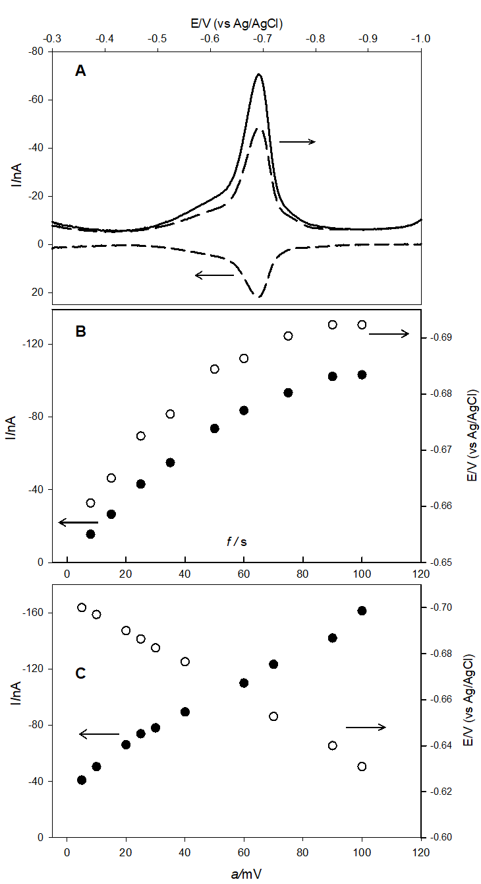
Fig. 5. SW characterization of the Cu-Phen-PG complex. c_{(PG, Phen)} = 4×10^{–6} M, c_{Cu(II)} = 4×10⁻⁷ M. 0.55 M NaCl, pH = 8.2 (5 mM HEPES). A) Backward-forward voltammograms. B) Dependence of reduction currents (full circles) and potentials (open circles) on frequency (a = 25 mV). C) Dependence of reduction currents (full circles) and potentials (open circles) on pulse amplitude f = 50 s⁻¹, E_{acc} = 0 V, t_{acc} = 60 s, E_{step} = 2 mV.
Therefore, the overall process can be summarized as:
PG⁻_{ads} + (CuOHPhen)⁺ (PGCuOHPhen)_{ads} (1)
(PGCuOHPhen)_{ads} + 2e⁻ PG⁻_{ads} + Cu⁰ + Phen + OH⁻ (2)
The reaction scheme (2) is irreversible because the reoxidation of the Cu⁰ is hindered by the monolayer of the adsorbed PG molecules.
For redox reactions with a reactant adsorption, the half-height peak width (ΔE_{p}/2) fit the relationship (Eq. 3) [44]:
ΔE_{p}/2 (mV) = (63.5 ± 0.5)/αn (3)
where α is the average transfer coefficient and n is the number of simultaneously transferred electrons [44]. The half-height peak width of the [PhenCuOHPG] complex amounts to 50.42 mV and α = (0.63 ± 0.01), respectively, since the reduction is a two-electron process.
According to Eq. 4 [36]:
i_{p} = 500qαn²FafΔEγ_{PhenCuOHPG} (4)
the surface concentration of the reactant adsorbed (γ) was calculated from the slope (Δi_{p} / Δa) in the range of low SW amplitudes [36]. The slope (1.63 nA/V) was calculated using the current and amplitude data from Fig. 5C. Used values were α = 0.63 and n = 2 for the [PhenCuOHPG] complex. The area of the mercury drop (q) was 0.004 cm², the SW frequency f = 50 Hz and the scan increment ΔE = 0.002 V, with faraday constant (F). The surface concentration γ of the adsorbed [PhenCuOHPG] complex was calculated to be (3.35 ± 0.67) × 10⁻¹¹ mol cm⁻².

3.4.1 Kinetics and stability of Cu-Phen-PG complex
The basic mechanism of Cu (II) mixed ligand complexation can be described as synergistic solvent extraction [36]. The introduction of the first ligand (Phen) by means of complexing/complexation copper ion, replaces part of the water molecules from its Cu coordination sphere and forms a hydrophilic complex. In the second step, the hydrophobic ligand (PG) substitutes all, or almost all water molecules from the copper ion coordination sphere. Hydrophobic mixed ligand complex is, therefore, formed in the adsorption layer at the hydrophobic mercury drop as well as at monolayer membrane (water/air boundary phase).
By investigation of the Cu-Phen-PG mixed ligand complex formation kinetics and stability over time, very interesting behaviour was observed (Fig. 6). Concentrations of Phen and Cu (II) were kept constant (5×10⁻⁷ M and 4×10⁻⁷ M, respectively) while PG concentrations varied from 1×10⁻⁶ to 1×10⁻⁵ M. The Cu-Phen-PG mixed ligand complex normalized reduction currents (E_{p} =
-0.69 V) were plotted in dependence on time. Normalization of the reduction currents were obtained by dividing each of the measured peak current by the first peak current recorded immediately upon PG addition (I / I₁). In the solution with the lowest PG concentration (1×10⁻⁶ M), the reduction current decreased immediately suggesting that the concentration of PG was too low to maintain the Cu-Phen-PG complex at the electrode surface (Fig. 6, curve 1).
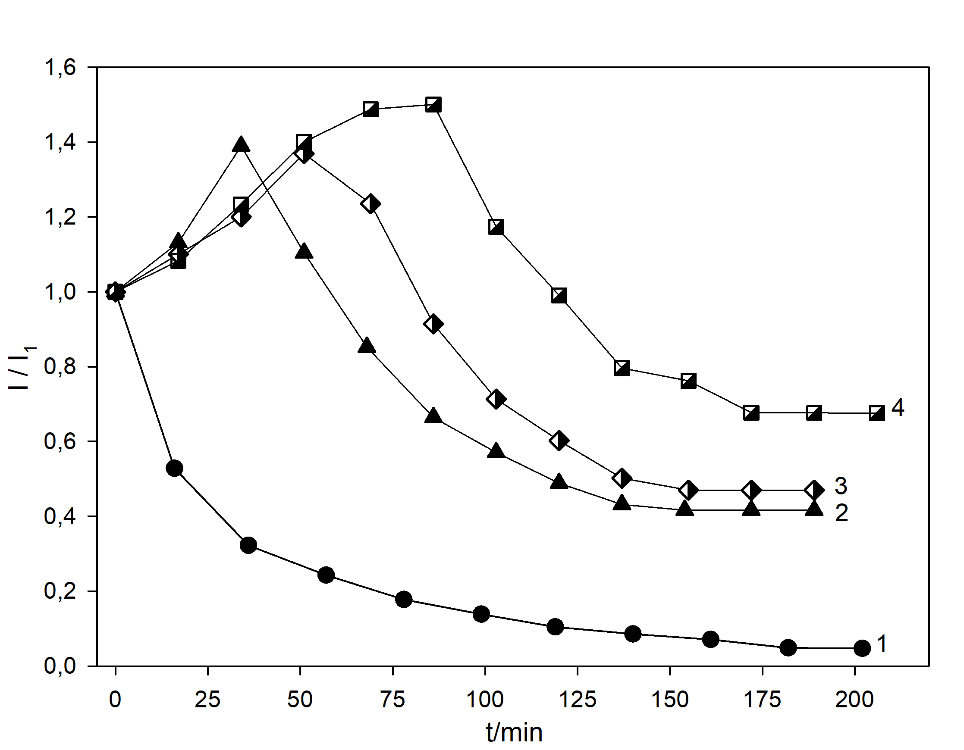
Fig. 6. Dependencies of normalized SW reduction currents on experimental time; c_{(Phen)} = 5×10⁻⁷ M, c_{Cu (II)} = 4×10⁻⁷ M. c_{(PG)}: (1) 1×10⁻⁶ M, (2) 4×10⁻⁶ M, (3) 6×10⁻⁶ M, (4) 1×10⁻⁵ M; 0.55 M NaCl, pH = 8.2; 5 mM HEPES; E_{acc} = 0 V, t_{acc} = 60 s; SWV parameters: E_{step} = 2 mV, a = 25 mV, f = 50 s⁻¹.
Maximum currents of the mixed ligand complex were detected within 30, 50 and 70 min with higher PG concentrations (4×10⁻⁶, 6×10⁻⁶ and 1×10⁻⁵ M), (Fig. 6, curves 2, 3 and 4, respectively). Namely, while the Cu-Phen-PG reduction current at about -0.7 V decreased, the reduction peak at -0.6 V increased. This reduction peak is a response of the Cu (II)-Phen complex reduction [34].
While mixing in the chloride solution at lower PG concentrations, the [CuPhenOH]⁺ complex readily disproportionates to the Cu (I)-Phen complex which does not form a mixed ligand complex with PG. At higher PG concentrations the [Cu^{II}PhenOH]⁺ binds with monoanionic PG⁻. The reduction current (at -0.69 V) increased gradually due to greater adsorption of the [PhenCuOHPG] complex at the electrode surface. Reduction currents of the [PhenCuOHPG] complex reached minimum values approximately 200 min after PG addition.
4. Conclusions
The results in this study describe the formation and electrochemical characteristics of copper (II) association with phospholipid PG at the hydrophobic mercury drop surface as a model for hydrophobic cell membranes in NaCl solution, mimicking seawater conditions. The copper (II) - phospholipid mixed ligand complex formation and its stability is described here for the first time. It is confirmed that direct complexation between Cu (II) and PG is not prominent and a reaction mechanism with an intermediate step should be considered, in which a part of the water molecules in the coordination sphere of the central metal ion (Cu²⁺) is replaced by Phen. The second hydrophobic ligand (PG) substitutes the remaining water molecules from the coordination sphere of the copper ion, forming a hydrophobic Cu-Phen-PG mixed ligand complex. The mixed ligand complex [CuOHPhen]⁺ is stable in the pH range from 6 to 9, where Cu (II) is present as the [CuOH]⁺ species. Consequently, it was presumed that the mixed ligand complex net stoichiometry is [PhenCuOHPG]. Since the formed mixed complex is neutral, its hydrophobic and strong adsorbtion at the electrode surface is expected.
These findings were confirmed by Langmuir studies at the liquid-gaseous interface where the binding effect of the subphase containing Cu (II) ions, Phen and/or both Cu (II) ions and Phen, on supporting PG monolayer structure properties have been followed. A significant variation of the initial surface pressure as well as of the limiting area of compressed monolayer indicated enhanced penetration of Cu ions into the PG layer in the presence of both Cu²⁺ and Phen molecules from the subphase, implying the [PhenCuOHPG] mixed complex formation within the PG layer. In addition, the Cu-Phen-PG complex formation is undoubtedly confirmed by the monolayer studies, showing the enhanced incorporation of the Cu-Phen complex into the PG monolayer, while the zeta potential measurements indicate a comparatively low abundance of the neutral mixed complex within the PG vesicles, decreasing the PG liposome surface charge of +0.83 mV.
The [PhenCuOHPG] complex reduction occurs at about -0.7 V by a quasireversible EC mechanism under SW conditions, i.e. after reduction, the complex dissociates irreversibly, while PG molecules remain adsorbed at the electrode surface. Moreover, zeta potential measurements confirmed that the complexation mechanism involves significant steric effects.
This study performed on a model hydrophobic surfaces is useful for a better understanding of the role and fate of copper (II) - lipid association in various important biogeochemical processes mediated by cell membranes, this being of particular relevance for the marine environment. Therefore, our results are relevant for advanced investigations of essential micronutrients bound to organic ligands and for complexation mechanisms with natural ligands responsible for micronutrient trace metals uptake by phytoplankton and bacterial cells in seawater or freshwater ecosystems.
Acknowledgements
This work has been fully supported by Croatian Science Foundation under the project IP-11-2013-8607. Additionally, we would like to thank colleagues dr.sc. Suzana Šegota for electrophoretic measurements and prof. r.sc. Goran Kniewald for the English revision.
Literature
[1] I.A. Guschina, J.L. Harwood, Algal Lipids and Effect of the Environment on their Biochemistry, in: M.T. Arts, M.T. Brett, M.J. Kainz (Eds.), Lipids in Aquatic Ecosystems, Ch. 1, Springer, Dordrecht, 2009, pp. 1−24.
[2] W. Dowhan, M. Bogdanov, E. Mileykovskaya, Functional roles of lipids in membranes, in: D.E. Vance, J.E. Vance (Eds.), Biochemistry of Lipids, Lipoproteins and Membranes, Ch. 1, Elsevier, Amsterdam, 2008, pp. 1−37.
[3] A.A. Benson, B. Mauro, Plant phospholipids. I. Identification of the phosphatidyl glycerols, Biochim. Biophys. Acta 27 (1958) 189−195.
[4] J.J. Giner-Casares, G. Brezesinski, H. Möhwald, Langmuir monolayers as unique physical models, Curr. Opin. Colloid Interface Sci. 19 (2014) 176−182.
[5] G. Brezesinski, H. Möhwald, Langmuir monolayers to study interactions at model membrane surfaces, Adv. Coll. Interface Sci. 100–102 (2003) 563–584.
[6] R. Maget-Dana, The monolayer technique: a potent tool for studying the interfacial properties of antimicrobial and membrane-lytic peptides and their interactions with lipid membranes, Biochim. Biophys. Acta 1462 (1999) 109−140.
[7] V.B. Fainermann, D. Vollhardt, Penetration of Langmuir Monolayers by Soluble Amphiphilic Molecules, Langmuir 15 (1999) 1784−1790.
[8] S.M. Baumler, G. J. Blanchard, The Influence of Metal Ions on the Dynamics of Supported Phospholipid Langmuir Films, Langmuir 33 (2017) 2986−2992.
[9] A.P. Serro, R. Galante, A. Kozica, P. Paradiso, A.M.P.S. Gonçalves da Silva, K.V. Luzyanin, A.C. Fernandes, B. Saramago, Effect of tetracaine on DMPC and DMPC plus cholesterol biomembrane models: Liposomes and monolayers, Colloids Surf. B 116 (2014) 63−71.
[10] E. Maltseva, A. Kerth, A. Blume, H. Möhwald, G. Brezesinski, Adsorption of Amyloid β(1–40) Peptide at Phospholipid Monolayers, Chem. Bio. Chem. 6 (2005) 1817–1824.
[11] P. N. V. Geraldo, F. J. Pavinatto, T. M. Nobre, L. Caseli, O. N. Oliveira Jr, Langmuir films containing ibuprofen and phospholipids, Chem. Phys. Lett 559 (2013) 99−106.
[12] J. J. Leitch, C. L. Brosseau, S. G. Roscoe, K. Bessonov, J. R. Ducher, J. Lipkovski, Electrochemical and PM-IRRAS characterization of cholera toxin binding at a model biological membrane, Langmuir 29 (2013) 965−976.
[13] A. Akbarzadeh, R. Rezaei-Sadabady, S. Davaran, S.W. Joo, N. Zarghami, Y. Hanifehpour, M. Samei, M. Kouhi, K. NejatiKoshki, Liposome: classiﬁcation, preparation, and applications, Nanoscale Res. Lett. 8 (2013) 1–9.
[14] M.N. Jones, The surface properties of phospholipid liposome systems and their characterization, Adv. Colloid Interface 54 (1995) 93–128.
[15] K. Furusawa, H. Matsumura, Electrical phenomena at the surfaces of phospholipid membranes caused by the binding of ionic compounds, Colloid. Surf. A 92 (1994) 95−105.
[16] F. Santos, L. Teixeira, M. Lúcio, H. Ferreira, D. Gaspar, J.L.F.C. Lima, S. Reis, Interactions of sulindac and its metabolites with phospholipid membranes: An explanation for the peroxidation protective effect of the bioactive metabolite, Free Radical Res. 42 (2008) 639−650.
[17] C. Chen, C.P. Tripp, A comparison of the behavior of cholesterol, 7-dehydrocholesterol and ergosterol in phospholipid membranes, Biochim. Biophys. Acta 1818 (2012) 1673–1681.
[18] A. Nelson, N. Auffret, J. Borlakoglu, Interaction of hydrophobic organic-compounds with mercury adsorbed dioleoylphosphatidylcholine monolayers, Biochim. Biophys. Acta 1021 (1990) 205−216.
[19] Z. Coldrick, P. Steenson, P. Millner, M. Davies, A. Nelson, Phospholipid monolayer coated microfabricated electrodes to model the interaction of molecules with biomembranes, Electrochim. Acta 54 (2009) 4954−4962
[20]. Z. Coldrick, A. Penezić, B. Gasparović, P. Steenson, J. Merrifield, A. Nelson, High throughput systems for screening biomembrane interactions on fabricated mercury film electrodes, J. Appl. Electrochem. 41 (2011) 939−949.
[21] A. Penezić, B. Gašparović, D. Stipaničev, A. Nelson, In situ electrochemical method for detecting freely dissolved polycyclic aromatic hydrocarbons in water, Environ. Chem. 11 (2014) 173−180.
[22] M. Gledhill, M. Nimmo, S.J. Hill, M.T. Brown, The toxicity of copper (II) species to marine algae, with particular reference to macroalgae, J. Phycol. 33 (1997) 2−11.
[23] E. Pinto, T.C.S. Sigaud-Kutner, M.A.S. Leitao, O.K. Okamoto, D. Morse, P. Colepicolo, Heavy metal-induced stress in algae, J. Phycol. 39 (2003) 1008−1018.
[24] M. Mlakar, S. Pavković, L.-M. Tumir, P. Vukosav, B. Gašparović, Electrochemical Characterization of Biochemically Active Cu(II) Mixed Ligand Complex with Histidine and Cysteine, Electroanalysis 29 (2017) 392–397.
[25] W.M. Sunda, Trace Metal-Phytoplankton Interactions in Aquatic Systems, in: Edited by D- R. Lovley (Ed.), Environmental Microbe-Metal Interactions, ASM Press, Washington, D.C. 2000, pp. 79−107.
[26] C. Manzl, J. Enrich, H. Ebner, R. Dallinger, G. Krumschnabel, Copper-induced formation of reactive oxygen species causes cell death and disruption of calcium homeostasis in trout hepatocytes, Toxicology 196 (2004) 57−4.
[27] A. Sharmin, L. Salassa, E. Rosenberg, J. B. A. Ross, G. Abbott, L. Black, M. Terwilliger, R. Brooks, Photophysical Studies of Bioconjugated Ruthenium Metal-Ligand Complexes Incorporated in Phospholipid Membrane Bilayers, Inorg. Chem. 52 (2013) 10835–10845.
[28] T.J. Lyons, D.J. Eide, Transport and Storage of Metal Ions in Biology, in: I. Bertini, H. Gray, E. Stiefel, and J.S. Valentine (Eds.) Biological Inorganic Chemistry: Structure and Reactivity, University Science Books, Sausalito, CA 2007, pp. 57−77.
[29] D. Omanović, M. Branica, Automation of Voltammetric Measurements by Polarographic Analyser PAR 384B, Croat. Chem. Acta 71 (1998) 421−433.
[30] M.T. Lamy-Freund, K.A. Riske, The Peculiar Thermo-Structural Behavior of the Anionic Lipid DMPG, Chem. Phys. Lipids 122 (2003) 19−32.
[31] B. Gašparović, S. Frka, Z. Kozarac, A. Nelson, A method for characterization of sea surface microlayer based on monolayer properties in presence and absence of phospholipids, Anal. Chim. Acta 620 (2008) 64−72.
[32] H. Emons, T. Schmidt and K. Štulík, Tensammetric determination of phospholipids in batch and flow injection systems, Analyst 114 (1989) 1593−1596.
[33] S. Leekumjorn, A.K. Sum, Molecular study of the diffusional process of DMSO in double lipid bilayers, Biochim. Biophys. Acta 1758 (2006) 1751–1758.
[34] I. Čuljak, M. Mlakar and M. Branica, Cathodic Stripping Voltammetry of the Copper-1,l0-Phenanthroline, Electroanalysis 7 (1995) 64–69.
[35] M. Mlakar, M. Branica, The electrode synergistic adsorption of mixed ligand complexes. Part I. Uranium(VI) salicylic acid/TBP system, J. Electroanal. Chem. 256 (1988) 269−279.
[36] M. Mlakar, M. Lovrić and M. Branica, Theory of metal ions accumulation by the synergistic adsorption at mercury electrodes, Collect. Czech. Chem. Commun. 55 (1990) 903–923.
[37] M. Mlakar, M. Branica, Applicability of synergistic adsorption in electroanalysis of dissolved uranium in seawater, Mar. Chem. 46 (1994) 61−66.
[38] M. Frentzen, Phosphatidylglycerol and sulfoquinovosyldiacylglycerol: anionic membrane lipids and phosphate regulation, Curr. Opinion Plant Biol. 7 (2004) 270−276.
[39] H. Möhwald, Phospholipid monolayers, in Hanbook of Biological Physics, R. Lipowsky, E. Sackmann (Eds), Elevier Science B. V. 1995.
[40] A. Watts, K. Harlos, W. Maschke, D. Marsh, Control of the Structure and Fluidity of Phosphatidylglycerol Bilayers by pH Titration, Biochim. Biophys. Acta - Biomembr. 510 (1978) 63−74.
[41] J.J. O'Dea, J.G. Osteryoung, R.A. Osteryoung, Theory of Square Wave Voltammetry for Kinetic Systems, Anal. Chem. 53 (1981) 695−701.
[42] J.G. Osteryoung, R.A. Osteryoung, Square Wave Voltammetry, Anal. Chem. 57 (1985) 101A-110A.
[43] V. Mirčeski, Š. Komorsky-Lovrić, M. Lovrić, Square-Wave Voltammetry - Theory and Application, Springer-Verlag, Berlin, 2007
[44]. F. Garay, M. Lovrić, Square-wave voltammetry of quasi-reversible electrode processes
with coupled homogeneous chemical reactions, J. Electroanal. Chem. 518 (2002) 91–102.
[45] V. Mirčeski, R. Gulaboski, M. Lovrić, I. Bogeski, R. Kappl, M. Hoth, Square-Wave Voltammetry: A Review on the Recent Progress, Electroanalysis 25 (2013) 2411–2422.

