PREDICTION OF LISTERIA MONOCYTOGENES GROWTH AS A FUNCTION OF ENVIRONMENTAL FACTORS
N. Topic Popovicª, A. Benussi Skukan^{b}, P. Dzidara^{b}, I. Strunjak-Perovicª, S. Kepec^{c}, J. Barisic^{a*}, R. Coz-Rakovacª

ªRudjer Boskovic Institute, Laboratory for Ichtyopathology-Biological Materials, Bijenicka cesta 54, 10 000 Zagreb. Croatia
^{b}University of Zagreb, Faculty of Food Technology and Biotechnology, Pierottijeva 6, 10 000 Zagreb. Croatia
^{c}Virkom d.o.o, Public Water Supply and Wastewater Services, Kralja Petra Kresimira IV 30, 33 000 Virovitica. Croatia
* Corresponding author, email: jbarisic@irb.hr, Tel/fax: +385 1 4571 232

Listeria monocytogenes is a bacterium widespread in the environment, which has a capacity to survive and grow under various conditions. The bacterial growth results from interactions when subjected under various temperatures, pH levels, and NaCl concentrations were examined by measurements and predictive modelling. Good correlation across the range of growth conditions was shown among observed and predicted growth values, having similar trends and minimal deflections for pH levels 5.0 and 6.0. The growth condition in the 8% NaCl concentration (pH 7.0, temperature 4 °C) resulted with a growth curve of 1 log interval greater than the fitted curve for all the measurements. In all of the cases, there were consistent increases in the rates and decreases in the lag time when the growth temperature increased. Higher incubation temperatures provided higher growth rates as 30 °C and 35 °C yielded double increase of the fitted rate. Fitted and measured growth rates for salinity conditions were significantly different (P < 0.05). Comparison of doubling times showed good compatibility, particularly at lower temperatures. Critical use of a model is suggested although it may enable microbiologists to limit the need of challenge tests and to make rapid and realistic prediction of the growth of L. monocytogenes in conditions relevant to a range of aquatic and other products examined.
Keywords: predictive modeling; bacterial growth rates

The causative agent of listeriosis, Listeria monocytogenes bacterium, was first isolated from rabbit livers in Sweden in 1911. Murray and co-workers (1926) described a small Gram-positive rod causing 1900 disease cases in laboratory animals. They named the bacterium Bacterium monocytogenes due to its clinical features – mononucleosis in the affected animals. It later became apparent that the disease also affects humans, and the rise in the number of human cases in several countries, along with the evidence for food-borne transmission, renewed the interest in listeriosis (McLauchlin et al. 2004). Indeed, L. monocytogenes has been recognized as an important foodborne pathogen, what’s more the outbreaks of listeriosis have been associated with seafood, milk, cheese, vegetables, and meat products. Of special concern are L. monocytogenes hazards related to urban and natural environments Sauders and co-workers (2012), water environments and sewage Budzinska and co-workers (2012), wastewaters related to farming Dungan and co-workers (2012), and aquatic food products. The organism is particularly problematic for the food industry because it is widespread in the environment (Giffel & Zwietering 1999). As a consequence of foodborne listeriosis, numerous studies have determined the extent to which L. monocytogenes is present in a variety of foods (Skovgaard & Morgen 1988; Farber et al. 1989; Vorster et al. 1993; Wang & Muriana 1994). L. monocytogenes was found to be able to grow over a wide range of temperatures (-1.5 to 45 °C) pH levels (4.39 to 9.4), and osmotic pressures (NaCl concentrations up to 10%) (Giffel & Zwietering 1999). Because of the widespread distribution of L. monocytogenes bacteria in food products of aquatic origins, it is important to understand the capacity of the bacterium to survive and grow under conditions associated with their processing, storage and distribution.
In food microbiology, mathematical modelling relies on databases obtained by laboratory observations of growth and death of microorganisms under defined conditions. Assessing the likelihood and extent of growth, in response to a number of key controlling factors acting in combination via mathematical models, is one of several approaches being used by McClure and co-workers (1997). Mathematical analytics has been used to describe growth responses of microorganisms to combinations of factors (Szigeti & Farkas 2000). Therefore, despite the complexity of many food systems, strategies based on predictive models can simplify problematic areas and allow useful predictions and analyses to be made, giving a rational framework for understanding the microbial ecology of food and water Ross and Mcmeekin (1994).
The aim of this study was to determine the accuracy and reliability of the predictive results of the food micromodel, FMM (Food MicroModel Ltd., Randalls Road, Leatherhead, Surrey, KT22 7RY, UK), screening the growth responses of L. monocytogenes bacteria in culture medium adjusted to various pH and NaCl levels, and stored at wide temperature ranges. The compatibility of bacterial growth in culture medium was compared with bacterial growth predicted by the FMM, having in mind the need for reduction of the challenge tests for securing microbiologically unharmful food of various origins.

1. Material and methods
The ATCC – 7644 (Oxoid 3970) strain of Listeria monocytogenes bacteria was used for this study. Tryptic soy broth (TSB, Biolife, 402155) was used for optimal growth. Batches were made of 300 mL volume sterile media in Erlenmeyer flasks where concentrations of NaCl and pH levels were adjusted. The pH level was adjusted using 2M HCl (Kemika 1824301) or 2M NaOH (Kemika 1452506) before making up to final volume. The NaCl (Kemika 1417506) concentration in broth ranged from 5-80 gL⁻¹.
The pH value of prepared TSB broths was measured by a pH-meter (Iskra MA 5835). The NaCl concentration in TSB broths was measured using the AOAC potentiometric method III (1990).
1.1. Experimental procedure
In prepared TSB 300 mL batches, a 24-hour L. monocytogenes bacterial culture was inoculated with the expected initial number of cells of 10²-10³. Immediately after inoculation, enumeration was conducted using the colony count technique in accordance with the ISO standard (1991) in sight of its specified principle, culture media and the grade the fluid was diluted, apparatus and glassware, sampling, preparation of the test sample, procedure, expression of results and test report. Viable numbers in each batch were determined by plating 20 μL volumes on duplicate plates of tryptone soya agar (TSA, Biolife, 402155) immediately after dispensing. Decimal dilutions were made from separate bottles of TSB and 100 μL of each plated onto duplicate plates of TSA. After incubation of the plates for 48 h at the temperature of 35 °C, the mean number of colonies on the duplicate plates was determined and the number of colony-forming units (CFU) per mL was calculated and expressed as log₁₀ CFU mL⁻¹.
The experiment was conducted on a combination of following conditions in which L. monocytogenes may grow, after a preliminary screening to determine the growth limits of the strain used:
Storage temperature (°C): 4, 20, 30, 35.
NaCl (gL⁻¹): 5, 20, 40, 60, 80.
pH: 4.5, 5.0, 5.5, 6.0, 6.5, 7.0, 7.4.
1.2. Statistical modelling
For statistical evaluation of data a model based on the function of Baranyi and co-workers (1994) was used, assuming the function of specific bacterial growth by Richards (1959). The Baranyi model is an alternative to the tri-linear primary growth model by Pouillot and Lubran (2011). The food micromodel FMM is a polynomial model used to predict the growth of various pathogenic microorganisms used as a function of controlling growth factors (e.g. temperature, pH, NaCl). FMM pathogen models are principally based upon research sponsored by the U.K. Ministry of Agriculture, Fisheries and Food. The data used to generate the models were obtained from extensive experiments performed on microbiological culture media by Giffel and Zwietering (1999). Both experimental and modeled data for doubling times were compared with the ComBase Predictor, an on-line tool for predicting the response of pathogens and spoilage microorganisms to key environmental factors (available at: http://modelling.combase.cc/ComBase_Predictor.aspx).

2. Results and discussion
Laboratory growth curves of L. monocytogenes measured in conditions of constant salinity (0.5 %) and temperature (4 °C), over ten days, with different pH levels (pH = 5.0, 6.0, and 7.0) are presented in Figure 1, with initial counts of 8x10², 6x10² and 3x10² of CFU mL⁻¹, respectively, and compared with predicted values as calculated by the model. In general, good compatibility across the range of growth conditions was shown between observed and predicted growth values, having similar trends and minimal deflections for pH levels 5.0 and 6.0, while for pH 7.0, the growth curve of observed and predicted growth differed up to 2 log intervals by the end of the day 13 (figure demonstrating a 10-day curve). The curve at 6.0 pH level, although higher than predicted curve in all data points, probably due to the observed initial count of 6x10² versus a predicted 5x10² count, was in agreement with the work of Begot and co-workers (1997). The initial count of L. monocytogenes after inoculation, in 1 mL of TSB ranged from 7x10² (with close to optimal growth conditions at pH 7.0, NaCl 0.5%, and temperature 20 °C) to 9x10⁸ CFU mL⁻¹ after a 5-day period. With the increased NaCl concentration at 4 % (pH 7.0, temperature 4 °C), the initial count of L. monocytogenes in 1 mL of broth grew from 4x10² to only 7x10⁶ in 20 days, due to the lowered temperature and unfavorable NaCl concentration. It was in good compatibility with the predicted curve up to the 7th day, while by the end of a 20-day period it was up to 1 log interval lower than the fitted curve. A further increase of the NaCl concentration to 6% and 8% through 20 days, led to the count of 10⁷ and 2x10⁶ CFU mL⁻¹, respectively. Although the predicted curve for the 6% salinity resembled the previous predicted curve for 4% salinity, the 8% NaCl growth condition (pH 7.0, temperature 4 °C) resulted with a growth curve of 1 log interval greater than the fitted curve for all the measurements. In all of the cases, there was a consistent increase in the rates and decrease in the lag time when the growth temperature increased.
Although bacterial growth was significantly slower at 4 °C than at higher temperatures, it was clearly measurable, as opposed to the findings of Park and co-workers (2005) who detected no growth of L. monocytogenes at the storage temperature of 4 °C for 3 weeks in presence of all experimental variables (pH, NaCl). Numerous studies have evaluated the effect of environmental factors such as oxygen, temperature, and level of mixed microbial population on microbial growth (Ross et al. 2000; Shimoni & Labuza 2000). However, the most important factor for controlling microbial growth remains temperature. Growth predictions under suboptimal conditions, such as low temperature and high salinity, are relevant for the food industry, as this situation most likely occurs in food production (Giffel & Zwietering 1999). While slightly elevated salt concentration may inhibit growth rate, it has also been reported to increase the high temperature tolerance of many bacterial species, though the effect is not universal (Ross et al, 2000).
Secondary models were developed for specific growth rates as a function of temperature, salinity and acidic to neutral pH. Specific growth rates, μ (h⁻¹) of L. monocytogenes predicted with mathematical analytics and calculated from earlier laboratory measurements for different pH levels (5.0, 6.0, 7.0), NaCl concentrations (0.5, 2.0, 4.0, 6.0, 8.0 %) and temperature conditions (4, 20, 30, 35 °C) are presented in Figure 2. Higher incubation temperatures between 30 °C and 35 °C which yielded a double increase of the fitted rate, provided higher growth rates, due to a very short time needed for bacterial growth in its optimal conditions. Fitted and measured growth rate for salinity conditions were significantly different (P < 0.05). Although the growth rates of L. monocytogenes was somewhat similar among the different pH levels, it was steadily decreased by increase of NaCl concentration in TSB media stored at 4 °C. Bacterial growth in this assay was observed for all of the combinations of environmental factors and low pH, although Petran and Zottola (1989) found that the minimum pH for L. monocytogenes growth was at or above pH 4.5 at 30 °C. George and co-workers (1988) reported that the maximum pH levels for no growth at 20 °C and 30 °C ranged from 4.2 to 4.43 depending on the strain tested, while at 4 °C none of the strains grew at pH below 5.03.
Comparison of doubling times for L. monocytogenes in laboratory conditions, and as predicted by the model in various temperature and salinity conditions, grouped according to different pH levels, is presented in Table 1. Doubling times in this study at pH 5.0 and 4 °C temperature varied slightly with NaCl concentrations, but were observed between 41.28 and 43.92 h, while the model predicted up to a 7 hour increase in doubling times, except for the 2% salinity where they corresponded with the measured time. Comparison of doubling times generally showed good agreement, particularly at lower temperatures, whereas at 30 °C and 35 °C model mostly predicted slower doubling times than observed. When close to optimal growth conditions (low salinity, pH neutral) temperature related differences in predicted and observed doubling times were the most pronounced, doubling times being equal at low temperatures, and parting at higher temperatures. In all conditions, when noted, most of the discrepancies between modelled and measured doubling times, were related to predicting slower growth than actually observed. The observed and predicted doubling times were close to the line of equivalence, having 85.7% of data on the fail-safe side of the plot (data not shown). Higher temperatures at the same pH level significantly shortened the doubling times, both measured and predicted. When both measured and modeled doubling times were compared with those predicted by the ComBase Predictor, discrepancies were noted in relation to the NaCl concentrations irrespective of the pH level or temperature. In particular, a good correlation was found at higher salinities between the FMM and the ComBase, while low salinities, particularly of 0.5 and 2 % NaCl, yielded a better correlation between the measured times and the ComBase than with the FMM. The inconsistent reports regarding the growth limits for L. monocytogenes may suggest that there are important strain differences, that there may be specific nutritional requirements for growth at lower temperatures, or that the physiological state of the inoculums used in challenge studies influences the minimum growth temperature (Ross et al, 2000).
In this study, although the predictions were close to the observed values, especially at low temperatures, the FMM was generally predicting slower growth than actually observed. However, even when the predictions of doubling times were greater than those observed, they were within an acceptable range and provided biologically plausible parameter estimates. Since most points fell close to the line of equivalence, predicted values were close to the observed values, indicating that the model predicted doubling times similar to those reported in published work. Interestingly, in the most cases for models based on Baranyi and co-workers (1993), predicted doubling times were shorter (i.e. growth rates are faster) than observed values McClure and co-workers (1997). This is not unanticipated, since the liquid experimental systems provide optimal growth conditions, apart from the experimental variations of temperature, pH and NaCl concentration and such models tend to give fail-safe predictions (Giffel and Zwietering 1999). Many published values are very close to the predicted values, supporting the argument that predictive models should be constructed using experimental data in media, which will give the fastest possible growth McClure and co-workers (1997).
Currently, no single model includes the effect of all the variables which may be of interest in all tested matters and foods. Users of models, FMM included, must be aware of the predictive limits of the model, both in terms of the range of conditions and variables that it considers (Baranyi et al. 1996; Ross et al. 2000). The FMM cannot make predictions for the effect of conditions which fluctuate over time, temperature being the factor most likely to change over the storage life of a product. Also, differences between the estimated growth parameters relate to the growth model being used. The use of the Gompertz model (FMM) led to the significant over-estimation of specific growth rates when compared to the Baranyi equation (Augustin and Carlier 2000). Although existing models have been expanded with a higher number of environmental parameters including organic acids, to assess the L. monocytogenes growth rates in shrimp (Mejlholm and Dalgaard 2009), generally applicable predictive microbial model for quantitative risk assessment in sea products is not available. However, they may enable microbiologists to limit the need of challenge tests and to make rapid and realistic prediction of the growth of L. monocytogenes in conditions relevant to a range of aquatic and other products examined.

3. Conclusions
Temperature was the most important factor for controlling L. monocytogenes growth. Higher temperatures at the same pH level significantly shortened the doubling times, both measured and predicted.
The FMM was generally predicting slower growth than actually observed.
The FMM cannot make predictions for the effect of conditions which fluctuate over time, temperature being the factor most likely to change over the storage life of a product.
Critical use of the FMM model is necessary for assumptions in supporting decisions.

References
aoac 943.02 (1990): Official Methods of Analysis of AOAC International Potentiometric Method, 15th Edition, Volume two, Edited by Kenneth Hebrich, Published by the Association of Official analitycal Chemist Inc., 842, USA.
Augustin J.-C., Carlier V. (2000): Mathematical modelling of the growth rate and lag time for Listeria monocytogenes. International Journal of Food Microbiology; 56, 29-51.
Baranyi J., Roberts T.A. (1994): A dynamic approach to predict bacterial growth in food. International Journal of Food Microbiology; 23, 277-294.
Baranyi J., Ross T., McMeekin T.A., Roberts T.A. (1996): Effects of parameterization on the performance of empirical models used in “predictive microbiology”. Food Microbiology; 13, 83-91.
Begot C., Lebert I., Lebert A. (1997): Variability of the response of 66 Listeria monocytogenes and Listeria innocua strains to different growth conditions. Food Microbiology; 14, 403-412.
Budzinska K., Wronski G., Szejniuk B. (2012): Survival time of bacteria Listeria monocytogenes in water environment and sewage. Polish Journal of Environmental Studies; 21, (1) 31-37.
Dungan R.S., Klein M., Leytem A.B. (2012): Quantification of bacterial indicators and zoonotic pathogens in dairy wastewater ponds. Applied and Environmental Microbiology; 78, (22) 8089-8095.
Farber J.M., Sanders G.W., Johnston M.A. (1989): A survey of various foods for the presence of Listeria species. Journal of Food Protection; 52, 456-458.
George S.M, Lund B.M., Brocklehurst T.F. (1988): The effect of pH and temperature on initiation of growth of Listeria monocytogenes. Letters in Applied Microbiology; 6, 153-156.
Giffel M.C., Zwietering M.H. (1999): Validation of predictive models describing the growth of Listeria monocytogenes. International Journal of Food Microbiology; 46, 135-149.
iso 1991 General guidance for the enumeration of micro-organism - Colony count technique at 30ºC, ISO, 4833, International Organization for Standardization, Second edition, 1991, 1-5, Geneva, Switzerland.
McClure P.J., Beaumont A.L., Sutherland J.P., Roberts T.A. (1997): Predictive modelling of growth of Listeria monocytogenes. The effects on growth of NaCl, pH, storage temperature and NaNO₂. International Journal of Food Microbiology; 34, 221-232.
McLauchlin J., Mitchell R.T., Smerdon W.T., Jewell K. (2004): Listeria monocytogenes and listeriosis: a review of hazard characterization for use in microbiological risk assessment of foods. International Journal of Food Microbiology; 94, 15-33.
Mejlholm O., Dalgaard P. (2009): Development and validation of an extensive growth and growth boundary model for Listeria monocytogenes in lightly preserved and ready-to-eat shrimp. Journal of Food Protection; 10, 2028-2225.
Murray E.G.D., Webb R.A., Swann M.B.R. (1926): A disease of rabbits characterized by a large mononuclear leucocytosis, caused by a hitherto undescribed bacillus Bacterium monocytogenes (n.sp.). Journal of Pathology and Bacteriology; 29, 407-439.

Park S.Y., Choi J.W., Yeon J., Lee M.J., Chung D.H., Kim M.G., Lee K.H., KIM K.S., Lee D.H., Bahk G.J., Bae D.H., Kim K.Y., Kim C.H., Ha S.D. (2005): Predictive modelling for the growth of Listeria monocytogenes as a function of temperature, NaCl, and pH. Journal of Microbiology and Biotechnology; 15, (6) 1323-1329.

Petran R.L., Zottola E.A. (1989): A study of factors affecting growth and recovery of Listeria monocytogenes Scott A. Journal of Food Science; 54, 458-460.
Pouillot R., Lubran M.B. (2011): Predictive microbiology vs. modelling microbial growth within Listeria monocytogenes risk assessment: What parameters matter and why. Food Microbiology; 28, 720-726.
Richards F.J. (1959): A flexible growth function for empirical use. Journal of Experimental Botany; 10, 290–300.
Ross T., McMeekin T.A. (1994): Predictive microbiology. International Journal of Food Microbiology; 23, 241-264.
Ross T., Dalgaard P., Tienungoon S. (2000): Predictive modelling of the growth and survival of Listeria in fishery products. International Journal of Food Microbiology; 62, 231-245.
Sauders B.D., Overdevest J., Fortes E., Windham K., Schukken Y., Lembo A., Wiedmann M. (2012): Diversity of Listeria species in urban and natural environments. Applied and Environmental Microbiology; 78, (12) 4420-4433.
Shimoni E., Labuza T.P. (2000): Modelling pathogen growth in meat products: future challenges. Trends in Food Science and Technology; 11, 394-402.
Skovgaard N., Morgen C.A. (1988): Detection of Listeria spp. in faeces from animals, in feeds, and in raw foods of animal origin. International Journal of Food Microbiology; 6, 229-242.
Szigeti E., Farkas J. (2000): Use of conductimetric technique for data capture in predictive microbiology. Acta Alimentaria Budapest; 29, (3) 307-314.
Vorster S.M., Greebe R.P., Nortje G.L. (1993): The incidence of Listeria in processed meats in South Africa. Journal of Food Protection; 56, 169-172.
Wang C., Muriana P.M. (1994): Incidence of Listeria monocytogenes in packages of retail franks. Journal of Food Protection; 57, 382-386.
FIGURE CAPTIONS
Figure 1.
Observed and predicted growth curve for L. monocytogenes in various pH levels, with constant salinity (0.5 %) and temperature (4 °C) conditions, over a 10-day period.
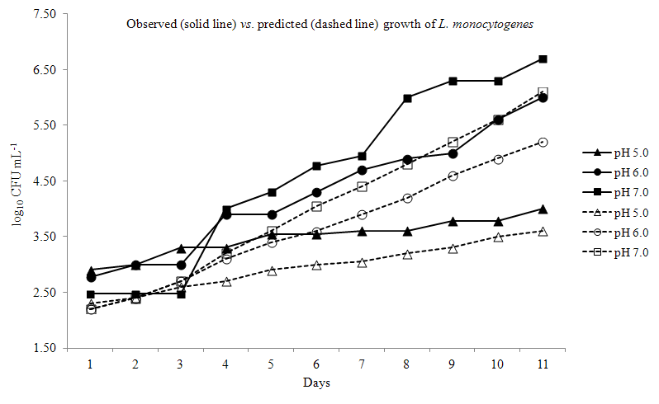
Figure 2. Comparison of laboratory measured specific growth rates, μ (h⁻¹) with specific growth rates μ fitted by the FMM model for L. monocytogenes in conditions of set temperature (a), pH levels (b), and salinity (c) conditions. Solid and dashed lines represent fitted and measured values, respectively.
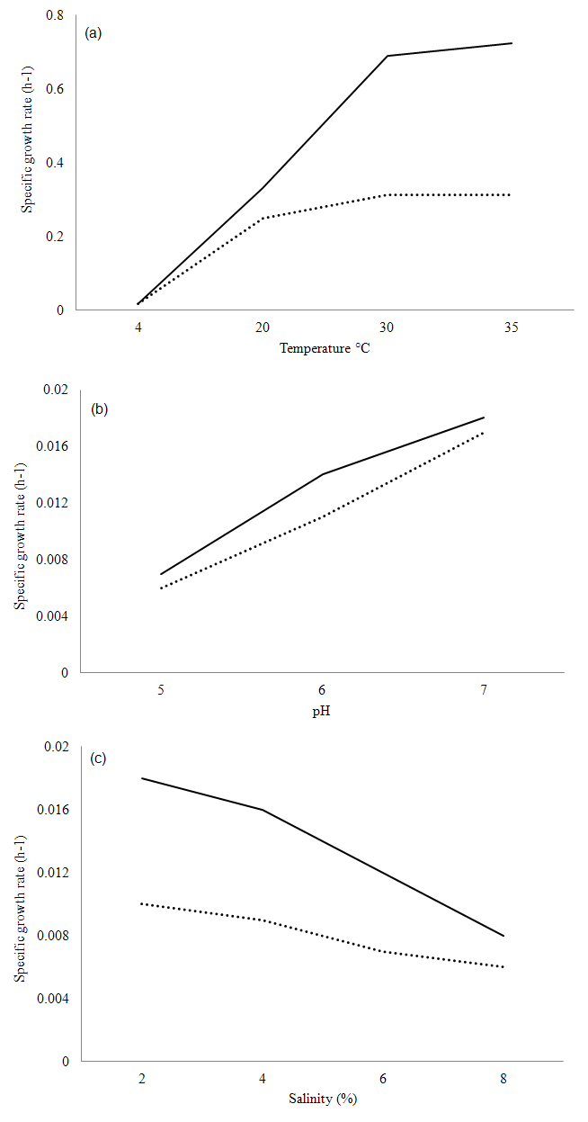
Table 1. Comparison of doubling times (h) for L. monocytogenes in laboratory conditions and as predicted by the FMM model, grouped according to pH levels: 4.5, 5.0, 5.5, 6.0, 6.5, 7.0, 7.4.
Temperature (°C) | NaCl (%) | Doubling times (h)
 |  | Measured | Model
pH = 4.5
20 | 0.5 | 4.08 | 6.72
20 | 2 | 3.84 | 3.84
20 | 4 | 4.32 | 8.4
20 | 6 | 5.76 | 5.28
20 | 8 | 9.12 | 11.52
30 | 0.5 | 1.92 | 4.08
30 | 2 | 1.92 | 4.08
30 | 6 | 3.12 | 5.52
30 | 8 | 5.04 | 12.96
35 | 0.5 | 1.92 | 4.08
35 | 2 | 1.92 | 4.08
35 | 6 | 3.12 | 4.82
35 | 8 | 5.04 | 13.44
pH = 5.0
4 | 0.5 | 43.92 | 50.4
4 | 2 | 41.28 | 42
4 | 4 | 43.92 | 50.4
20 | 0.5 | 2.4 | 2.4
20 | 2 | 2.4 | 2.4
20 | 4 | 2.64 | 3.6
20 | 6 | 3.6 | 2.88
20 | 8 | 5.52 | 4.32
30 | 0.5 | 1.2 | 2.64
30 | 2 | 1.2 | 2.64
30 | 4 | 1.44 | 2.88
30 | 6 | 1.92 | 2.88
30 | 8 | 3.12 | 4.56
35 | 0.5 | 1.2 | 1.68
35 | 2 | 1.2 | 2.4
35 | 4 | 1.44 | 2.4
35 | 6 | 1.92 | 2.4
35 | 8 | 3.12 | 4.08
pH = 5.5
4 | 0.5 | 28.8 | 32.4
4 | 2 | 27.36 | 26.64
4 | 4 | 29.52 | 25.44
4 | 6 | 37.92 | 38.16
20 | 8 | 3.84 | 10.8
pH = 6.0
4 | 0.5 | 21.36 | 21.60
4 | 2 | 20.64 | 13.76
4 | 4 | 22.56 | 21.6
4 | 6 | 29.28 | 36.96
20 | 0.5 | 1.2 | 2.4
20 | 2 | 1.2 | 4.08
20 | 4 | 1.44 | 0.96
20 | 6 | 1.92 | 6
20 | 8 | 3.12 | 3.36
30 | 0.5 | 0.48 | 0.96
30 | 2 | 0.48 | 2.16
30 | 4 | 0.72 | 1.44
30 | 6 | 0.96 | 1.92
30 | 8 | 1.68 | 2.64
35 | 0.5 | 0.48 | 0.96
35 | 2 | 0.48 | 2.16
35 | 4 | 0.72 | 1.44
35 | 6 | 0.96 | 2.16
35 | 8 | 1.68 | 2.64
pH = 6.5
4 | 0.5 | 18 | 11.04
4 | 2 | 17.28 | 12.48
4 | 4 | 21.16 | 23.04
20 | 0.5 | 0.96 | 2.16
20 | 2 | 0.96 | 2.16
20 | 4 | 1.2 | 2.88
20 | 8 | 2.64 | 6.72
30 | 0.5 | 0.48 | 2.88
30 | 2 | 0.48 | 2.16
30 | 4 | 0.48 | 1.92
30 | 6 | 0.96 | 2.16
30 | 8 | 1.44 | 2.16
35 | 0.5 | 0.48 | 2.16
35 | 2 | 0.48 | 1.92
35 | 4 | 0.48 | 2.16
35 | 6 | 0.96 | 2.16
35 | 8 | 1.44 | 2.16
pH = 7.0
4 | 0.5 | 16.80 | 17.76
4 | 8 | 39.12 | 36.72
20 | 0.5 | 0.96 | 1.2
20 | 2 | 0.96 | 1.2
20 | 4 | 1.2 | 2.4
20 | 8 | 2.64 | 3.36
30 | 0.5 | 0.48 | 0.96
30 | 2 | 0.48 | 0.96
30 | 6 | 0.96 | 1.2
30 | 8 | 1.44 | 1.68
35 | 0.5 | 0.48 | 0.96
35 | 2 | 0.48 | 0.96
35 | 6 | 0.96 | 1.44
35 | 8 | 1.44 | 1.92
pH = 7.4
4 | 0.5 | 17.52 | 16.56
4 | 2 | 17.28 | 15.84
4 | 4 | 19.68 | 18.72
4 | 8 | 42.24 | 45.36
20 | 0.5 | 0.96 | 1.92
20 | 2 | 0.96 | 2.4
20 | 4 | 1.2 | 1.92
20 | 6 | 1.68 | 1.68
20 | 8 | 2.88 | 4.08
30 | 0.5 | 0.48 | 1.92
30 | 2 | 0.48 | 1.92
30 | 4 | 0.72 | 1.92
30 | 6 | 0.96 | 2.16
30 | 8 | 1.68 | 1.92
35 | 0.5 | 0.48 | 1.92
35 | 2 | 0.48 | 1.92
35 | 4 | 0.48 | 1.92
35 | 6 | 0.96 | 1.92
35 | 8 | 1.68 | 4.08

