Anodic deposition of lead dioxide on Nafion® covered gold electrode
Sanja Burazerª, Suzana Sopčić^{b}, Zoran Mandić^{b}*
ªRudjer Bošković Institute, Bijeničkacesta 54, 10000 Zagreb, Croatia
^{b}Faculty of Chemical Engineering and Technology, University of Zagreb, Marulićev trg 19, HR-10000 Zagreb, Croatia
*Corresponding author, email: zmandic@fkit.hr

Abstract
Anodic electrodeposition of lead dioxide on the bare and Nafion® covered gold electrode was studied by cyclic voltammetry and chronoamperometry. The results showed that Nafion® layer has a favourable effect on the efficiency of the deposition process which was caused by both thermodynamic and kinetic reasons. Electrodeposition process on Nafion® covered gold electrode goes via Pb(III) intermediate species which are stabilized within Nafion® membrane. The final PbO₂ deposit crystallizes in tetragonal β-PbO₂ form.

Introduction
Anodic deposition of lead(IV) oxide on solid support was one of the most thoroughly investigated electrochemical processes. Huge research efforts have been made in order to elucidate the mechanism of electrodeposition, its kinetics and relationship between deposition conditions and structure of the resulting PbO₂ layers. These researches were driven by at least two strong motivations. First, studies of electrochemical deposition of PbO₂ gained insight into the nucleation and growth process and its kinetics which enabled the development of the general theoretical nucleation and growth theory which could be applied not only to understandsubtle details of PbO₂ electrodeposition but also forthe electrocrystallization processes of other oxide layers as well as cathodically formed metal deposits.Indeed, experimental results and their analysis in the works of Fleishmann[1-6] and later by Abyaneh [7-10], and others [11-16] paved the way toward the development of the 2D,3D instantaneous and progressive nucleation processes.
Another incentive for studying PbO₂ electrodeposition lies in its interesting electrochemical and catalytic properties which opened the ways for the broad applications of this material especially as cathode material in lead acid batteries [17-19] and as catalytic material in various electrochemical and chemical processes [20-23].
Recently, PbO₂ was considered as an active electrode material in hybrid supercapacitors [24,25], devices assembled as a combination of one double layer charging (DLC) electrode and another pseudocapacitive electrode. Its high standard reduction potential, very facile electrochemical kinetics and high conductivity make PbO₂ very attractive for the development of high energy/high power supercapacitor devices.
In order to increase charging/discharging rate of PbO₂ electrodes which is required in high-power applications and at the same time keeping its high energy content, it is of crucial importance to prepare highly porous nano-structured PbO₂ layer which will enable facile ioniccharge transport, especially sulphate ions and protons, into and through the PbO₂ layer.
In this work our idea was to study anodic template deposition of PbO₂ on Nafion® covered solid support, in our case gold electrode. The electrodeposition was expected to be governed by the slow diffusion of Pb(II) ions through Nafion® micro- and nano-channels toward the gold support. Anodic oxidation of Pb(II) should have yielded nano-clustered PbO₂ layer with the structure which would depend on the type of Nafion® used, its porosity and content of hydrophilic groups.
The main goal of this work was not completely achieved but the results we obtained were sufficiently interesting to be demonstrated in this paper. Up to our knowledge no results describing PbO₂ deposition on gold electrode covered by Nafion® layer exist in the literature. There were, however, a couple of papers dealing with PbO₂ electrodeposition from the solutions of Pb(II) ion in the presence of dissolved Nafion® [26,27]. The results of these investigations were very interesting and showed that the presence of Nafion® did not hinder the electrodeposition process but rather facilitated it.

Experimental
Materials.All chemicals used in this work were of analytical grade and they were purchased: Pb(NO₃)₂ from Alfa Aesar, HNO₃ from Sigma Aldrich and Nafion® 117 Solution (5% -in mixture of lower aliphatic alcohols and water) from Fluka. All solutions were prepared from double-distilled water.
Preparation of gold and Nafion® covered gold electrode.
Electrodeposition of PbO₂ was performed on two types of working electrodes; the bare gold electrode and the gold electrode covered with Nafion® layer. The surface area of gold electrode was 0.07 cm². Before electrodeposition, gold electrodes were polished with Al₂O₃ slurry, cleaned with ethanol in ultrasonic bath for 10 min and washed with double distilled water. The Nafion® covered gold electrodes were prepared by casting of Nafion® solution. In order to get several different thickness of Nafion® layers (10, 60, 120, 300 µm), 5 % Nafion® solution was diluted with double-distilled water. The Nafion® covered gold electrodes were dried for 1 hour at room temperature and open air.
Electrochemical measurements.
Electrochemical measurements were performed in three-compartment cell by means of an AutolabPotentiostat/Galvanostat PGSTAT100. Three-electrode system contained working electrode; the bare gold or the Nafion® covered gold electrode, Pt-foil counter electrode and Ag/AgCl (3M KCl) reference electrode. Electrodepositon of PbO₂ was performed from solution of 0.01 M Pb(NO₃)₂ in 1M HNO₃, using method of cyclic voltammetryin potential range from 0 to 1.8 V at scan rate of 50 mV/s. The same solution was used for electrodepostion of PbO₂ at gold rotating disk electrode (RDE) with the method of chronoamperometry at potential of 1.55 V during 200s and the rotation rate of 1000 rpm. The RDE gold electrode was also, either bare or covered with 120 µm of thick Nafion® layer. Mechanism of PbO₂electrodeposition was monitored using current-time transients atseveral different potentials; 1.6, 1.65, 1.7, 1.75 and 1.8 V during period of 20 s. All potentials in this paper are referred to Ag/AgCl reference electrode.
Characterization.
The morphology and the size of electrodeposited PbO₂ and PbO₂ /Nafion® layer were examined by scanning electron microscope (SEM) Vega 3 SEM TESCAN at the efficient voltage of 20 kV.
Structural features of electodeposited PbO₂ and PbO₂ /Nafion® layer were studied by the X-ray powder diffraction (XRPD) at room temperature using a Philips 1830 counter diffractometer with Cu Kα radiation. Samples were recorded in 2ϑ range 10-70°, with the measuring step of 0.02 ° and fixed counting time 1 s/step.

Results and discussion
Cyclic voltammograms of PbO₂ electrodeposition from 0.01 M Pb(NO₃)₂ at a bare gold electrode and at a gold electrode covered with Nafion® are shown in Figure 1. For the sake of comparison, the cyclic voltammogram of PbO₂ at bare gold electrode but in the presence of dissolved Nafion® is also plotted in Figure 1. The cyclic voltammograms at bare gold electrode exhibit familiar shape which consists of several well-defined current peaks, both in anodic and cathodic potential excursion. Pb(II) electrooxidation takes place at the potentials of the current peak of about 1.65 V followed by the current rise which is the result of oxygen evolution reaction. In the cathodic branch of the voltammograms two current peaks corresponding to the dissolution of lead and gold oxides at about 1.1 and 0.75 V, respectively.
Mechanism of Pb(II) electrooxidation and PbO₂ electrodeposition involves the nucleation and growth process as described in the numerous papers dealing with the subject. From these investigations it is now well established that the PbO₂ electrodeposition is a complex process whichinvolves as a first step a mediated oxidation of Pb(II) ion via adsorbed hydroxyl radicals which are formed at the gold electrode:
(1)
The hydroxyl radicals are involved in Pb(II) oxidation resulting in the soluble oxygen containing intermediate lead species. However, despite the huge amount of data it is still the matter of debate what is the nature of these intermediates. One group of authors suggests that Pb(III) species are formed according to the following mechanism [28]:
(2)
(3)
while another group of authors speculate the formation of soluble Pb(IV) as intermediate [1,2,29]:
(4)
(5)
In both cases the formation of nuclei seems to be the critical factor in controlling the overall electrodeposition process. When electrodeposition takes place on a bare gold electrode (black and blue curves, Figure 1) substantial nucleation overpotential was observed as a difference between the potential of the onset of anodic current in the forward scan and the equilibrium potential, i.e. potential where the current trace intersects potential axis in the reverse scan. Depending on the experimental conditions nucleation overpotential varies between 150 – 200 mV.
Counterintuitive feature of the cyclic voltammogram obtained at the gold electrode covered with Nafion® is unexpectedly high registered currents at the potentials of lead(IV) oxide electrodeposition which indicates that Nafion® does not inhibit electrode reaction by blocking the active sites at the surface but rather facilitates it. Another interesting feature of the cyclic voltammograms at the Nafion® covered gold electrode is the diminishing of the nucleation overpotential since the onset of the oxidation current rise coincides with the equilibrium potential of PbO₂. Obviously, the formation of nuclei at Nafion® covered electrode is more favourable than at bare gold electrode which might be caused by both thermodynamic and kinetic factors. Indeed, in the inset of Figure 1 it could be discerned that the current rise starts even before the PbO₂ equilibrium potential resembling the phenomena usually observedinunderpotential depositions of species on foreign substrates. The occurrence of underpotential deposition effect in this case reveals favourable energetics of the PbO₂ nuclei formation in the Nafion® membrane which is most probably due to the strong interactions of soluble lead intermediate species with the polar groups within Nafion® membrane.
In his studies of the effect of dissolved Nafion® [26] and the effect of other fluorine containing compounds [27] on PbO₂ electrodeposition, Velichenko identified at least two types of interactions which might exist between Nafion® and lead compounds and affect electrodeposition kinetics and the properties of the resulting layers. Apart from the bulk effects caused by the interaction of positive lead ions with Nafion®polyanionin bulk electrolyte, he found that the adsorption of polyelectrolyte on PbO₂ occurs not only due to the electrostatic attraction of polyanion to the positively charged surface of PbO₂ but also theexistence of some specific interactions. As the result the increase of electron transfer rates with the increase of Nafion® concentration was observed up to the critical Nafion® concentrations where blocking of the electrode by Nafion® became dominant factor in the control of the reaction.
In our work, the effect of dissolved Nafion® on the PbO₂ electrodeposition is not so pronounced as described in Velichenko’s papers. The only noticeable difference between cyclic voltammograms obtained on bare gold electrode with and without dissolved Nafion® is a decreased height of the cathodic current peak corresponding to PbO₂ reduction for about 15 % in the case when Nafion® is present in the solution. This feature confirms the existence of the bulk interactions between soluble lead intermediate species with Nafion® polyelectrolyte. The interactions are most likely of electrostatic origin.
The cyclic voltammetricresults obtained with Nafion® covered gold electrode offeredseveral new and important insights in the overall process of PbO₂ electrodeposition. It was demonstrated that Nafion® layer does not hinderneither the diffusion of Pb²⁺ ion toward the electrodenor the electron transfer at gold/Nafion® interface. Oxygen reactive species formed at the electrode as a result of the reaction (1) are more stable and longer living species within the Nafion® environment than on the bare gold electrode. Consequently, PbO₂ electrodeposition takes place throughout the whole volume of Nafion® membrane and therefore the current efficiency is increased resulting in the faster PbO₂ nucleation kinetics. If the oxidation of Pb²⁺ ion would proceed directly at the gold electrode the diminishing of the oxidation current could be expected as is the case in the electrodeposition of NiOOH from Ni²⁺ solutions (Figure 2).
Additionally, these results are in favour of the postulated deposition mechanismwhich goes via Pb(III) soluble species as described in equations 2 and 3, while the mechanism involving soluble Pb(IV) species (equation 4) can be excluded due to energetically unfavourable formation of negatively charged hydroxyl ions in the cation-exchanging polymer matrix.
Most frequently used and widely accepted method for the studying mechanism and kinetics of the nucleation and growth processes of the formation of solid layers at electrodes is recording the current-time transients at a fixed potential. Depending on the applied potential, nature of solid support and electrolyte used, current-time transients for PbO₂ formation can assume a sigmoidal shape [30-32] or a current peak can be formed. Current peaks were usually observed during 2D or 3D nucleation with diffusionally controlled growth process [33-35]. Sometimes, a growth inhibition was identified and described [36].
Figure 3 shows the current-time transients obtained from the solution of Pb²⁺ at bare (Figure 3a) and Nafion® covered gold electrode (Figure 3b) in a wide potential range. In both cases familiar shapes were observed with the initial current spike followed by the well-formed current peaks and the final current decay toward steady state values. As might be expected for the transients representing nucleation and growth process, registered current peak maxima shift toward lower times and their height increase as the deposition potential increases. The current decay immediately after the peaks shows Cottrell linearity and, excludingpotentials higher than 1.8 V, the current values for all potentials investigated coincide at longer times. This indicates that the current in this time period is controlled by the planar diffusion of the electroactive species. The increased current at the potentials higher than 1.8 V are due to contribution of the oxygen evolution reaction. In accordance with cyclic voltammetric measurements, currents registered at the Nafion® covered gold electrode are much higher than those recorded on the bare gold electrode. The position and height of the current maximum depends on the Nafion® layer thickness (Figure 4). However, at sufficiently long times after the maximum current reaches the level it had on the bare gold electrode indicating the similarity of both processes in the advanced stage of electrodeposition.
As demonstrated by the voltammetric and chronoamperometric measurements, higher efficiency of the electrodeposition process at Nafion® covered gold electrode is the result of several factors all of them simultaneously affecting in a greater or lesser extent the course of the reaction:
- favourable interaction between positive lead-oxygen intermediate species and Nafion® negatively charged sulfonic groups,
- more favourable energetics of PbO₂ nuclei formation in Nafion® environment comparing to the aqueous medium,
- Nafion® acting as a “cage” for soluble lead species preventing them to diffuse away into the bulk of the solution before their further oxidation and deposition.
The last factor was confirmed by the measurements taken at the rotating disk gold electrode (Figure 5). If the measurements were performed on bare gold electrode then the rotation slowed down the rate of the electrodeposition by prolonging an induction time which was the result of enhanced transport of soluble intermediates toward the bulk solution. At Nafion® covered electrode, however, theopposite effect was observed, the current even increases comparing to the current registered in unstirred solution, and remains high and constant for a long time. Once the first layer of solid PbO₂ is formed further growth is controlled by the diffusion of Pb²⁺ toward the electrode. At the sufficiently long times Nafion® pores are filled up completely by PbO₂, the Nafion®/PbO₂ composite material is formed, and at this stage the electrodeposition in both cases is controlled by the linear diffusion of Pb²⁺. The excess oxidation charge registered in the current transients in Figure 4 is related to the PbO₂ electrodeposited inside the whole volume of the Nafion®. This is confirmed by the constant value of the ratio of the excess charge obtained from current transients on Nafion® covered gold electrode in the time span where differences in current of two transients exists and the mass of casted Nafion® membrane on the electrode.
Figure 6 shows the comparison of SEM micrographs of the PbO₂ deposited on gold and inside the Nafion®. It is visible that the growth of PbO₂ on Nafion®, once the membrane was filled with PbO₂, results in globular structures which protrude from the pores of the Nafion®. In the case of PbO₂ on gold electrode the growth is more uniform although some globular structures could also be discerned.
Figure 7 shows XRPD patterns of PbO₂ deposited on the bare Au electrode (Figure 7a) and PbO₂ deposited on the Au electrode covered with 120 µm thickNafion® (Figure 7b). Diffraction lines at 2ϑ = 25, 32, 36, 49, 54, 59, 61, 63 i 67 ° were noticed in both XRPD patterns which points out that the lead oxide crystallizes as tetragonal β-PbO₂ (with refined unit-cell parameters a = 5.003 Å, c = 3.385 Å), regardless of the electrode type used for the electrodeposition. No other polymorphic forms of PbO₂ has been noticed in the sample as well as any additional impurity phases. Intense diffraction line at 2ϑ = 28° corresponds to silicon holder since a very limited amount of material has been used for diffraction data collection.

Conclusions
Nafion® layer on gold electrode has favourable influence on PbO₂ electrodeposition from both thermodynamic and kinetic standpoints. The electrodeposition follows similar nucleation and growth mechanism as in the case of PbO₂ electrodeposition on the bare gold electrode. However, the presence of Nafion®considerably diminishes nucleation overpotential resulting in the higher efficiency of the complete electrode reaction. Several factors contribute to the rapid kinetics of the process including favourable interaction between positive lead-oxygen intermediate species and Nafion® negatively charged sulfonic groups as well as more favourable energetics of PbO₂ nuclei formation in Nafion® environment comparing to the aqueous medium. PbO₂ layer crystallizes in tetragonal β-PbO₂form.
The results obtained in this work could be applied for the construction of high efficiency and high power positive electrodes in lead acid batteries and supercapacitors.

Acknowledgement
The authors are indebted to Professor GyörgyInzelt for many valuable and fruitful discussions led during joint cooperation in recent years. The support of Croatian Science Foundation under the project ESUP-CAP (IP-11-2013-8825) is greatly acknowledged.

References
- M. Fleischmann, J.R. Mansfield, H.R. Thirsk, H.G. Wilson, Electrochim. Acta, 12 (1967) 967.
- M. Fleischmann, M. Liler, Trans. Faraday Soc., 54 (1958) 1370-1381.
- M. Fleischmann, H.R. Thirsk, Trans. Faraday Soc., 51 (1955) 71.
- A. Bewick, M. Fleischmann, H.R. Thirsk, Trans. Faraday Soc., 58 (1962) 2200.
- R.D. Armstrong, M. Fleischmann, H.R. Thirsk, J. Electroanal Chem., 11 (1966) 208.
- M. Fleishmann, H.R.Thirsk, in Advances in Electrochemistry and Chemical Engineering, Vol. 3, P. Delahay, Editor, Chap. 3, Wiley Intescience, New York (1963).
- M.Y. Abyaneh, Electrochim. Acta, 27 (1982) 1329.
- M.Y. Abyaneh, J. Electroanal. Chem, 209 (1986) 1.
- M.Y. Abyaneh, Electrochim. Acta, 36 (1991) 727.
- M.Y. Abyaneh, V. Saez, J. Gonzalez-Garcia, T.J. Mason, Electrochim. Acta, 55 (2010) 3572-3579.
- E. Bosco, S.K. Rangarajan, J. Electroanal. Chem., 134 (1982) 225.
- G.A. Gunawardena, G.J. Hills, I. Montenegro, B.R. Scharifker, J. Electroanal. Chem., 138 (1982) 225.
- B.R. Scharifker, J. Mostany, J. ELectroanal. Chem., 177 (1984) 13.
- M. Sluyters-Rehbach, J.H.O.J. Wijenberg, E. Bosco, J.H. Sluyters, J. Electroanal. Chem., 236 (1987) 1.
- M.V. Mirkin, A.P. Nilov, J. Electroanal. Chem., 283 (1990) 35.
- J.A. Harrinson, H.R. Thirsk, in A Guide to the Study of the Electrode Kinetics, Chap. 3, Academic Press, New York (1972).
- D. Pavlov, I. Balkanov, T. Halachev, P. Rachev, J. Electrochem. Soc., 136 (1989) 3189.
- P. Ruetschi, J. Electrochem. Soc., 139 (1992) 1347.
- D.A.J. Rand, J. Power Sources, 21 (1987) B1.
- B.S. Hui, C.O. Huber, Anal. Chim. Acta, 134 (1982) 211.
- I.H. Yeo, S. Kim, R.A. Jacobson, D.C. Johnson, J. Electrochem. Soc., 136 (1989) 1395.
- A.M. Polcaro, S. Palmas, F. Renoldi, M. Mascia, J. Appl. Electrochem., 29 (1999) 147.
- N.B. Tahar, A. Savall, J. New Mater: Electrochem. Syst., 2 (1999) 19.
- F. Wang, S. Xiao, Y. Hou, C. Hu, L. Liu, Y- Wu, RSC Advances, 3 (2013) 13059-13084.
- P. Simon, Y. Gogotsi, Nature mat. 7 (2008) 845-854.
- A.B. Velichenko, T.V. Luk’yanenko, N.V. Nikolenko, R. Amadelli, F.I. Danilov, Russ. J. Electrochem.,43 (2007) 118-120.
- A.B. Velichenko, D. Devilliers, J. Fluor. Chem. 128 (2007) 269-276.
- A.B. Velichenko, D.V. Girenko, F.I. Danilov, Electrochim. Acta, 40 (1995) 283-2807.
- I.H. Yeo, Y.S. Lee, D.C. Johnson, J. Electrochem. Soc., 136 (1989) 23.
- D. Gilroy, R. Stevens, J. Appl. Electrochem., 10 (1980) 511.
- H. Chang, D.C. Johnson, J. Electrochem. Soc., 136 (1989) 17.
- A.B. Velichenko, D.V. Girenko, F.I. Danilov, Electrochim. Acta, 40 (1995) 2803.
- L.J. Li, M. Fleischmann, L.M. Peter, Electrochim. Acta, 34 (1989) 459.
- A.C. Ramamurthy, T. Kuwana, J. Electroanal. Chem., 135 (1982) 243.
- H.A. Laitnen, N.H. Watkins, J. Electrochem. Soc., 123 (1976) 804.
- J. Gonzalez-Garcia, F. Gallud, J. Iniesta, V. Montiel, A. Aldaz, A. Lasia, J. Electrochem. Soc., 147 (2000) 2969-2974.

List of Figures
Figure 1. Cyclicvoltammogramof PbO₂ electrodeposition from 0.01 M Pb(NO₃)₂/1M HNO₃ solution at the bare gold electrode(black line), the gold electrode covered with Nafion® (red dashes) and at the bare gold electrode from 0.01 M Pb(NO₃)₂/1M HNO₃ mixed with Nafion® solution ( blue dots). Scan rate of 50 mV/s.
Figure 2.Cyclic voltammogram of NiOOH electrodeposited from 0.1 M NiSO₄ solution at the bare gold electrode (blackline), and at the gold electrode covered with Nafion®layer (red dash). Scan rate of 5 mV/s.
Figure 3. Current-time transients at different potentials, obtained from the0.01 M Pb(NO₃)₂/1M HNO₃ solution at a) the bare gold and b) the gold electrode covered with 10 µm thick Nafion®.
Figure 4.Current-time transients at potential of 1.6 V, obtained from the0.01 M Pb(NO₃)₂/1M HNO₃ solution at the gold electrodes covered with different thickness ofNafion® layer; 10, 60 and 300 µm.
Figure 5. Electrodeposition of PbO₂ from 0.01 M Pb(NO₃)₂/1M HNO₃ on the rotating disk gold electrode(RDE), bare (black and red curves)and covered with 120 µm thick Nafion® layer (blue and green curves), 1000 rpm, E_{dep} = 1.55 V.
Figure 6.SEM micrographs of the PbO₂filmat: a) magnification of 1000x, b) 5000x and PbO₂/Nafion® film of120 µm thickness at: c) magnification of 1000x, d) 5000x.
Figure 7. X-ray diffraction patterns of a) electrodeposited PbO₂ with presence of 120 µm thick Nafion® layer, b) electrodeposited PbO₂ film without Nafion® layer.

Figures

Figure 1.

Figure 2.
Figure 3.

Figure 4.
Figure 5.

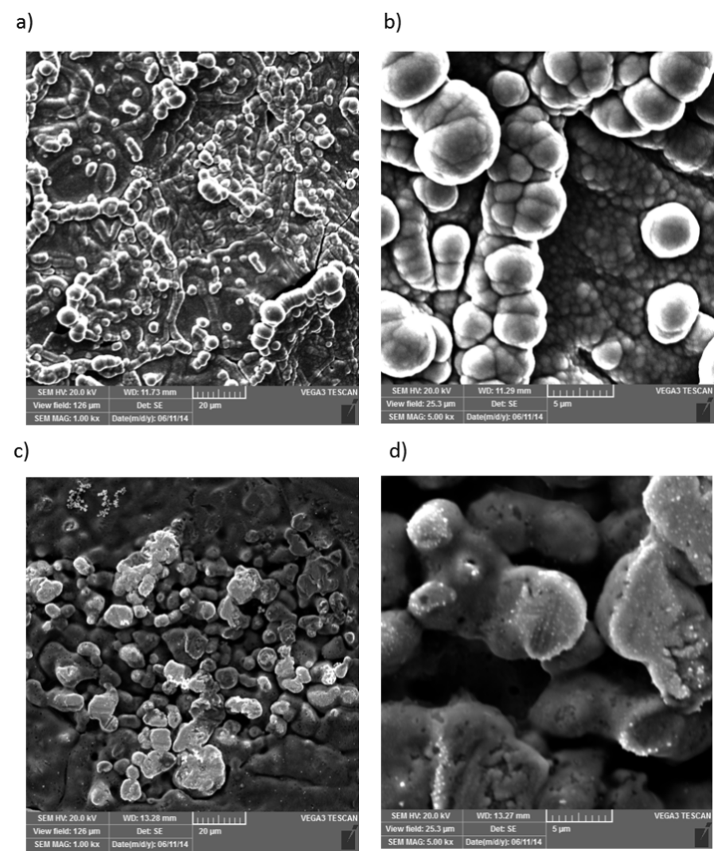
Figure 6.
Figure 7.

