Effect of vitamin D replacement on nutritional status and muscle strength in patients after allogeneic stem cell transplantation and chronic GVHD.
Dina Ljubas Kelecicª, Irena Karasª, Antonela Lelas^{b}, Lana Desnica^{c}, Tamara Vukic^{d}, Ivan Sabol^{e}, Darija Vranesic Benderª, Ana Kunovic^{a,b}, Marina Sabicª, Ranka Serventi Seiwerth^{c}, Nadira Durakovic^{b,c}, Dubravka Vitali Cepo^{f}, Radovan Vrhovac^{b,c}, Steven Pavletic^{g}, Drazen Pulanic^{b,c}, Zeljko Krznaric^{a,b,h}
ª Clinical Unit of Clinical Nutrition, Department of Internal Medicine, University Hospital Centre Zagreb, Croatia
^{b} University of Zagreb School of Medicine, Zagreb, Croatia
^{c} Division of Hematology, Department of Internal Medicine, University Hospital Centre Zagreb, Zagreb, Croatia
^{d} Department of Rehabilitation and Orthopedic Aids, University Hospital Centre Zagreb, Zagreb, Croatia
^{e} Division of Molecular Medicine, Rudjer Boskovic Institute, Zagreb, Croatia
^{f} Department of Food Chemistry, Faculty of Pharmacy and Biochemistry, University of Zagreb, Zagreb, Croatia
^{g} Immune Deficiency Cellular Therapy Program, National Cancer Institute, Center for Cancer Research, National Institutes of Health, Bethesda, USA
^{h} Division of Gastroenterology, Department of Internal Medicine, University Hospital Centre Zagreb, Croatia and University of Zagreb School of Medicine, Zagreb, Croatia

Abstract
Purpose: Following allogeneic hematopoietic stem cell transplantation (allo-HSCT), patients may experience alterations in vitamin D status, muscle strength, and nutritional status. This prospective cohort study study investigated the impact of vitamin D replacement therapy on the nutritional status and muscle strength of allo-HSCT patients, as well as on the characteristics of chronic GVHD (cGVHD).
Methods: Vitamin D levels, nutritional status, and muscle strength were assessed in 65 cGVHD and 37 non-cGVHD patients before and after vitamin D replacement therapy, which was prescribed based on serum vitamin D levels.
Results: Malnutrition was present in approximately 40%, impaired muscle strength in about 50%, and vitamin D deficiency or insufficiency in roughly 50% and 30% of subjects, respectively, regardless of cGVHD status. A strong correlation between nutritional status and muscle strength was found (P<0.0005). Gastrointestinal cGVHD was identified as a risk factor for malnutrition. Both malnutrition and the severity of cGVHD were independent risk factors for low handgrip strength (HGS). No association between serum vitamin D levels and nutritional status or muscle strength was observed. Increase in serum vitamin D after of vitamin D replacement was more significant in patients with vitamin D deficiency. Low vitamin D levels were associated with liver cGVHD (P<0.05). Myeloablative conditioning was an independent risk factor for vitamin D deficiency.
Conclusions: The results indicate that allo-HSCT patients exhibit impaired nutritional status, low muscle strength, and vitamin D deficiency. While vitamin D replacement therapy improved serum vitamin D levels, it did not lead to significant changes in nutritional status or muscle strength.
Keywords: vitamin D, cGVHD, muscle strength, nutritional status.
Corresponding author, e-mail address: ljubas.dina@gmail.com (Dina Ljubas Kelecic)

Introduction
Vitamin D deficiency is common in both pediatric and adult populations of patients after allo-HSCT. The prevalence of suboptimal vitamin D levels largely depends on monitoring serum levels and prescription of the appropriate replacement therapy,,. Vitamin D deficiency may exacerbate clinical outcomes by compromising immune function, bone health, and muscle strength, further complicating recovery and overall health. Changes in nutritional status, muscle mass, and strength may persist in patients after allo-HSCT for several months to several years following transplantation ^{2,}. Significant weight loss (≥ 10%) and malnutrition are associated with worse clinical outcomes, while loss of muscle mass is linked to reduced functional capacity. Vitamin D, malnutrition, and muscle weakness are closely related, as vitamin D plays a crucial role in muscle function and nutritional status. Vitamin D deficiency can lead to muscle weakness and impaired muscle performance. Malnutrition, often resulting from insufficient nutrient intake, worsens muscle weakness by depriving the body of essential nutrients required for muscle repair and maintenance. Low levels of vitamin D have been associated with an increased risk of sarcopenia and frailty in allo-HSCT, particularly cGVHD patients.
Further research is needed in the allo-HSCT population, not only to clearly establish the causal relationships between vitamin D, nutritional, and functional status of patients, but also to develop clear protocols and guidelines for the prevention and treatment of malnutrition and sarcopenia. For this reason, the main objectives of this study were to assess the nutritional and functional status of participants after allo-HSCT, especially in cGVHD patients, and to investigate the impact of vitamin D replacement therapy on their nutritional and functional status.

Materials and methods
Data collection and subjects
This was prospective cohort study comparing the effect of vitamin D replacement on the nutritional status and muscle strength of patients after allo-HSCT, depending on the presence of cGVHD. Patients were followed over 8 months. A total of 102 allo-HSCT patients (54 males and 48 females; age range 39-59 years, median 50) were included in the study from September 2016 to March 2021. Of these, 65 were cGVHD patients and 37 were non-cGVHD patients. At the time of evaluation, non-cGVHD patients had neither current acute GVHD nor a cGVHD diagnosis and were examined at least 100 days post-allo-HSCT. The diagnosis of cGVHD was made based on the established 2005 NIH consensus recommendations, using clinical, laboratory, endoscopic, radiological, and histological criteria, all assessed by qualified hematologists. Each organ or organ system affected by cGVHD was scored according to the 2005 NIH consensus diagnostic criteria, and the overall NIH severity score was determined on a scale from 0 to 3. The severity of cGVHD was also assessed using a global score, rated by a qualified hematologist (Health Care Provider, HCP) on scales from 0 to 3 and 0 to 10. The study protocol was approved by the Ethical Committee of the University Hospital Centre Zagreb and the University of Zagreb School of Medicine, Zagreb, Croatia, and all patients provided written informed consent.
Nutritional, functional and vitamin D status assessment
In all participants, nutritional status, muscle strength, vitamin D levels, and other laboratory parameters were assessed at baseline and follow-up visits. Based on the baseline serum levels, participants were prescribed vitamin D replacement therapy. The following methods were used to assess the nutritional status of all subjects: anthropometric measurements (including body height, body weight, body mass index (BMI), triceps skinfold (TSF), and upper arm circumference (MUAC)), bioelectrical impedance analysis (BIA) and the Patient-Generated Subjective Global Assessment (PG-SGA). Based on the PG-SGA, patients were classified as well-nourished (SGA A), moderately malnourished (SGA B), or severely malnourished (SGA C), with the total PG-SGA score calculated. Body composition was assessed using single-frequency BIA (Tanita BC-420MA with an operating frequency of 50 kHz at 90 μA), and the following indices were calculated: skeletal muscle mass index (SMI), free fat mass index (FFMI), visceral fat (VF), and fat mass index (FMI). Muscle strength was assessed using handgrip strength (HGS), measured with a hydraulic hand dynamometer (Jamar, Sammons Preston Rolyan). Laboratory tests from patient serum samples included standardized measurements of leukocytes, platelets, C-reactive protein (CRP), albumin, total protein, lipid profile (total cholesterol, triglycerides, LDL, HDL), and creatinine. Serum 25-hydroxyvitamin D (25(OH)D) concentration was measured using liquid chromatography-tandem mass spectrometry (LC-MS). Blood vitamin D levels above 75 nmol/L were considered normal, levels between 75 and 50 nmol/L indicated vitamin D insufficiency and those below 50 nmol/L were classified as vitamin D deficiency. The dosage of cholecalciferol was determined for each patient based on their baseline serum 25(OH)D levels (Table 1.).
Table 1. Vitamin D replacement and supplementation therapy considering 25(OH)D serum levels.
Vitamin D | N (%) | Mean 25(OH)D serum level (nmol/L)
800 IU/day (>100 nmol/L) | 7 (10.4) | 94 (12.9)
1200 IU/day (75 - 100 nmol/L) | 6 (9) | 77.2 (6)
1600 IU/day (50 - 75 nmol/L) | 12 (17.9) | 62.1 (5.3)
2000 IU/day (<50 nmol/L)* | 42 (62.7) | 37.4 (18.4)
Total | 67 (100) | 51.3 (25.1)

Vitamin D adherence was monitored using an indirect method, which involved interviewing patients by telephone during the study and at follow-up. Additionally, patients completed a vitamin D questionnaire and maintained a three-day diet diary.
Statistical analysis
Data were collected in MS Excel and analyzed using MedCalc v11.4 (MedCalc Software, Belgium). Categorical variables were described as frequencies and percentages, and compared using the Chi-squared test. Normality of numerical data was checked with the Kolmogorov-Smirnov test. Depending on distribution, data were presented as mean ± SD or median (IQR), and compared using t-test/ANOVA or Mann-Whitney/Kruskal-Wallis tests. Paired measurements were assessed using paired t-test or Wilcoxon test. Correlations were examined using Pearson or Spearman coefficients. Logistic regression was used to identify risk factors for low hand grip strength, low vitamin D levels, or malnutrition. Variables with p<0.1 in univariate analysis were included in multivariate models. P<0.05 was considered statistically significant.

Results
A total of 102 allo-HSCT patients were included in this study. Of these, 67 patients completed 8 months follow-up (±4 weeks): 43 patients with cGVHD and 24 without cGVHD. The demographic characteristics of all participants did not differ significantly, except for the time elapsed from allo-HSCT to enrollment in the study and the primary disease (Table 2).

Table 2. Demographic population characteristics.
 |  | cGVHD (n=65) | Non-cGVHD  (n=37) | Total  (n=102) | P
Gender | Female | 31 (47.7) | 17 (45.9) | 48 (47.1) | 0,8658
Gender | Male | 34 (52.3) | 20 (54.1) | 54 (52.9)
Patient age (median, IQR) |  | 51 (39 - 60) | 50 (39 - 58) | 50 (39 - 59) | 0.9306
 | 65+ | 6 (9.2) | 4 (10.8) | 10 (9.8) | 0.7974
 | <65 | 59 (90.8) | 33 (89.2) | 92 (90.2)
Main disease | ALL /AML / MDS | 46 (70.8) | 24 (64.9) | 70 (68.6) | 0.0406
 | CML | 14 (21.5) | 4 (10.8) | 18 (17.6)
 | Other | 5 (7.7) | 9 (24.3) | 14 (13.7)
 | AA/PNH | 2 (3.1) | 1 (2.7) | 3 (2.9)
 | MF | 0 (0) | 3 (8.1) | 3 (2.9)
 | HL | 0 (0) | 3 (8.1) | 3 (2.9)
 | CLL | 1 (1.5) | 1 (2.7) | 2 (2.0)
 | MPN | 1 (1.5) | 1 (2.7) | 2 (2.0)
 | MM | 1 (1.5) | 0 (0) | 1 (1.0)
Conditioning regimen | RIC | 29 (44.6) | 23 (62.2) | 52 (51.0) | 0.4007
Conditioning regimen | Myeloablative | 30 (46.2) | 12 (32.4) | 42 (41.2)
Conditioning regimen | Myelo + TBI | 3 (4.6) | 1 (2.7) | 4 (3.9)
Conditioning regimen | TBI | 3 (4.6) | 1 (2.7) | 4 (3.9)
Donor relationship | Matched unrelated | 36 (56.4) | 20 (54.1) | 56 (54.9) | 0.8972
Donor relationship | Matched related | 29 (44.6) | 17 (45.9) | 46 (45.1)
Stem cell source | Peripheral blood | 53 (81.5) | 27 (73.0) | 80 (78.4) | 0.3143
Stem cell source | Bone Marrow | 12 (18.5) | 10 (27.0) | 22 (21.6)
History of acute GVHD |  | 42 (64,6) | 17 (45.9) | 56 (57.8) | 0.0677
Time (median, IQR) in days from allo-HSCT to assessment |  | 640  (232-1968) | 258  (153-541) | 400  (197-1501) | 0.0009
cGVHD: chronic graft-versus-host disease, acute lymphoblastic leukemia (ALL), acute myeloid leukemia (AML), myelodysplastic syndrome (MDS), chronic myeloid leukemia (CML), aplastic anemia (AA), paroxysmal nocturnal hemoglobinuria (PHN) ,myelofibrosis (MF), Hodgkin`s lymphoma (HL), non-Hodgkin`s lymphoma (NHL), chronic lymphocytic leukemia (CLL), MPN multiple myeloma (MM), reduced intensity conditioning (RIC), total body irradiation (TBI) allo-HSCT: allogeneic hematopoietic stem cell transplantation

An overview of the cGVHD characteristics of all affected subjects at the baseline and follow-up visits is provided in Table 3. Statistical significance was observed through paired-samples tests for patients who had both baseline and follow-up visits, where applicable. The median time from allo-HSCT to the occurrence of cGVHD was 250 days, with the baseline visit occurring 152 days after the onset of cGVHD. Most subjects (83.1%) had classic cGVHD. There was no statistically significant difference in the evaluation of cGVHD severity according to NIH criteria and HCP assessments between the baseline and follow-up visits, although a greater proportion of patients had milder cGVHD at the follow-up visit. Statistically, fewer patients had liver cGVHD at the follow-up visit (P=0.0133).

Table 3. Characteristics of subjects with cGVHD at the baseline and follow-up visits.
 |  | Baseline visit  (n=65) | Follow up visit  (n=43) | P
cGVHD onset type | De novo | 24 (36.9) | 14 (32.6) | 0.8912*
cGVHD onset type | Progressive | 19 (29.2) | 14 (32.6) | 0.8912*
cGVHD onset type | Quiescent | 22 (33.8) | 15 (34.9) | 0.8912*
cGVHD classification | Classic | 54 (83.1) | 34 (79.1) | 0.5758*
cGVHD classification | Overlap | 11 (16.9) | 9 (20.9) | 0.5758*
Days from allo-HSCT to cGVHD (median, IQR) |  | 250  (157 - 513) | 257  (154 - 570) | 0.8573*
Days from cGVHD to baseline visit (median, IQR) |  | 152  (8 - 1420) | 182  (4 - 1272) | 0.6486*
cGVHD activity | 0 | 15 (23.1) | 14 (32.6) | 0.3423**
cGVHD activity | 1 | 13 (20.0) | 11 (25.6) | 0.3423**
cGVHD activity | 2 | 32 (49.2) | 14 (32.6) | 0.3423**
cGVHD activity | 3 | 5 (7.7) | 4 (9.3) | 0.3423**
cGVHD severity score (NIH criteria) | Mild | 14 (21.5) | 18 (41.9) | 0.0749**
cGVHD severity score (NIH criteria) | Moderate | 27 (41.5) | 14 (32.6) | 0.0749**
cGVHD severity score (NIH criteria) | Severe | 24 (36.9) | 11 (25.6) | 0.0749**
cGVHD severity by clinician (HCP) | Mild | 20 (30.8) | 20 (46.5) | 0.4244**
cGVHD severity by clinician (HCP) | Moderate | 26 (40.0) | 10 (23.3) | 0.4244**
cGVHD severity by clinician (HCP) | Severe | 19 (29.2) | 13 (30.2) | 0.4244**
Karnofsky index (%) | <70 | 3 (4.6) | 0 (0) | 0.5000**
Karnofsky index (%) | 70 | 9 (13.8) | 8 (18.6) | 0.5000**
Karnofsky index (%) | 80 | 18 (27.7) | 10 (23.3) | 0.5000**
Karnofsky index (%) | 90 | 18 (27.7) | 8 (18.6) | 0.5000**
Karnofsky index (%) | 100 | 17 (26.2) | 17 (39.5) | 0.5000**
Number of organs affected by cGVDH | 0 - 1 | 13 (20.0) | 17 (39.5) | 0.3799**
Number of organs affected by cGVDH | 2 | 12 (18.5) | 8 (18.6) | 0.3799**
Number of organs affected by cGVDH | 3 | 21 (32.3) | 12 (27.9) | 0.3799**
Number of organs affected by cGVDH | 4+ | 19 (29.2) | 6 (14) | 0.3799**
cGVHD organ involvement | Lungs | 24 (36.3) | 10 (23.3) | 0.3391**
cGVHD organ involvement | Liver | 15 (23.1) | 2 (4.7) | 0.0133**
cGVHD organ involvement | Gastrointestinal tract | 12 (18.5) | 3 (7) | 0.1810**
cGVHD organ involvement | Joint and fascia | 14 (21.5) | 10 (23.3) | 0.2705**
cGVHD organ involvement | Eyes | 40 (61.5) | 27 (62.8) | 0.1000**
cGVHD organ involvement | Mouth | 39 (60.0) | 22 (51.2) | 0.2791**
cGVHD organ involvement | Skin | 29 (44.6) | 10 (23.3) | 0.1613**
cGVHD organ involvement | Genital tract | 10 (15.4) | 8 (18.6) | 0.5614**
* all baseline patients compared vs all patients completing the study ** Paired patients who had both the first and follow-up examinations were compared. cGVHD - chronic graft-versus-host disease; NIH - National Institute of Health; HCP – health care provider; IQR – interquartile range.

Nutritional status and muscle strength
There were no statistically significant differences in BMI between the groups, and no changes occurred between the two visits (Table 4). According to the PG-SGA, at the baseline visit, 40% of patients with cGVHD and 27% of subjects in the non-cGVHD group were classified as malnourished or at risk of malnutrition (categories B and C). At the follow-up visit, these figures decreased to 18.7% for cGVHD patients and 20.8% for non-cGVHD patients.
Changes in fat mass, specifically an increase in FMI, were more significant in subjects with cGVHD (P=0.0131). Skeletal muscle mass, assessed by SMI using BIA, was noticeably lower at the follow-up visit in patients with cGVHD. The increase in visceral fat (VF) at the follow-up visit was statistically significant in both groups. A statistically significant increase in muscle strength, as measured by HGS, was observed at follow-up in both groups. No differences were observed in changes in individual parameters between the baseline and follow-up visits across the examined groups.

Table 4. Patient’s nutritional status, body composition and HGS at the baseline (n=102) and follow-up visits (for patients completing the study, n=67).
 | cGVHD patients  mean (SD) or n( %) |  |  | Non-cGVHD patients  mean (SD) or n(%) |  |  | Difference between groups**
 | Baseline visit | Follow-up visit | P*** | Baseline visit | Follow-up visit | P*** | P
BMI (kg/m²)* | 24.4 (4.5) | 25.2 (4.7) | 0.2362 | 25.6 (5) | 25.8 (5.2) | 0.0563 | 0.3495
PG-SGA score | 7 (5.1) | 5.1 (3.8) | 0.1992 | 5.4 (4.4) | 3.4 (3.6) | 0.0505 | 0.4147
PG-SGA rating
A | 39 (60.0) | 35 (81.4) | 0.0701 | 27 (73.0) | 19 (79.2) | 0.3593 | 0.9467
B | 18 (27.7) | 6 (14) | 0.0701 | 7 (18.9) | 5 (20.8) | 0.3593 | 0.9467
C | 8 (12.3) | 2 (4.7) | 0.0701 | 3 (8.1) | 0 (0) | 0.3593 | 0.9467
BW 6 m. (kg) | 3.4 (5.5) | 0.9 (2.2) | 0.004 | 3.2 (4.9) | 1 (3.2) | 0.0134 | 0.5609
MUAC (cm) | 28.5 (4.1) | 29.2 (4.3) | 0.0874 | 29.3 (4.7) | 29.5 (5.5) | 0.0321 | 0.5479
TSF (mm) | 18.2 (7.8) | 19.2 (8.6) | 0.1639 | 19.7 (9.3) | 21.5 (10.2) | 0.0304 | 0.4375
FMI (kg/m²) | 6.4 (4.1) | 7.2 (4.4) | 0.0131 | 6.9 (4.0) | 7 (3.8) | 0.0822 | 0.9794
FFMI (kg/m²) | 18.1 (3.0) | 18 (3.2) | 0.1027 | 18.6 (2.5) | 18.8 (2.7) | 0.8671 | 0.1652
SMI (kg/m²) | 9.8 (1.8) | 9.5 (1.6) | 0.1881 | 9.8 (1.7) | 9.6 (1.7) | 0.1209 | 0.4331
VF | 7.3 (4.5) | 7.8 (4.7) | 0.0332 | 7.6 (3.9) | 8.1 (3) | 0.0448 | 0.6221
HGS-D (kg) | 27.8 (12.5) | 31.4  (14.5) | 0.0032 | 31.5  (12.9) | 36.0  (15.6) | 0.0061 | 0.2504
HGS-ND (kg) | 26.1 (12.4) | 29.5  (13.5) | 0.0016 | 29.8  (12.3) | 34.1  (15.8) | 0.0041 | 0.1477
*The change in BMI between visits was calculated as the difference between the values of the follow-up and the baseline visit. For BMI categories, the difference was viewed as a positive or negative change in category between visits. The changes thus calculated for each patient were compared between the groups by an appropriate statistical test.** the change of each variable at the follow-up visit compared to the baseline visit was calculated, and the changes observed in the non-cGVHD and test groups were compared using t-test or Mann-Whitney test.
*** differences in values ​​at the baseline and follow-up visit were compared by paired t-test or Wilcoxon test for paired samples; statistically significant differences are in bold. cGVHD – chronic reaction of the donor against the recipient; BMI – body mass index; PG-SGA – subjective global assessment of the patient; BW 6 m. – body weigh change (loss of body mass in 6 months); MUAC – upper arm circumference; TSF – skinfold thickness, FMI – fat mass index; FFMI – lean mass index; SMI – skeletal muscle mass index; VF – visceral fat.

Vitamin D and other biochemistry parameters

At the baseline visit, approximately 50% of patients in both groups had vitamin D deficiency, while around 30% had vitamin D insufficiency. (Table 5). The cGVHD group demonstrated a statistically significant increase in serum 25(OH)D levels at the follow-up visit (P<0.0001), whereas the increase observed in the non-cGVHD group did not reach statistical significance (P=0.0607). The percentage of subjects with deficiency, insufficiency, or normal vitamin D levels in serum, depending on the time since allo-HSCT is shown in Figure 1. Other biochemical markers measured at the baseline and follow-up visits are presented in Table 4.
Table 5. Vitamin D and other biochemistry parameters at the baseline (n=102) and follow-up visit (for patients completing the study n=67).
 | cGVHD patients  mean (SD) or n(%) |  |  | Non-cGVHD patients  mean (SD) or n(%) |  |  | Difference between groups**
Parametar | Baseline visit | Follow-up visit | P* | Baseline visit | Follow-up visit | P*
25(OH) D (nmol/L) | 55.0 (30.8) | 77.1 (28.3) | <0.0001 | 52.6 (23.1) | 63 (11.0) | 0.0607 | 0.0229
Normal | 13 (20.0) | 22 (51.2) | 0.0003 | 8 (21.6) | 3 (12.5) | 0.0005 | 0.2474
Insufficiency | 21 (32.3) | 14 (32.6) | 0.0003 | 11 (29.7) | 19 (79.2) |  | 0.2474
Deficiency | 31 (47.7) | 7 (16.3) | 0.0003 | 18 (48.6) | 2 (8.3) |  | 0.2474
Leukocytes(x10⁹/L) | 7.9 (3.6) | 8 (3.6) | 0.2183 | 5.6 (2.4) | 6.4 (3) | 0.2940 | 0.9816
Platelets (x10⁹/L) | 213.7 (82.3) | 222.4 (77.6) | 0.0467 | 158.1 (104.8) | 184.3 (75.1) | 0.0119 | 0.3809
CRP (mg/L) | 6.5 (10.2) | 7.6 (12.4) | 0.1276 | 12.4 (25.7) | 6.1 (9.8) | 0.4549 | 0.3125
Albumin (g/L) | 41.9 (6.2) | 45.2 (3.8) | 0.1600 | 42.9 (4.7) | 45.2 (3.2) | 0.0798 | 0.4761
Total protein (g/L) | 67.9 (7.9) | 72 (5.9) | 0.1215 | 69.9 (6.3) | 75.4 (6.2) | 0.0362 | 0.0095
Creatinine (µmol/L) | 82.7 (26.4) | 83.4 (23) | 0.6967 | 79.2 (16.4) | 83 (19.3) | 0.5781 | 0.7698
Creatine kinase*** | 91.7 (165.6) | 119.4 (101.4) | 0.0152 | 57.9 (36.3) | 40.7 (2.5) | NA | NA
Cholesterol (mmol/L) | 5.6 (1.6) | 5.4 (1.3) | 0.5495 | 5.9 (2.4) | 5.5 (1.2) | 0.2500 | 0.297
HDL (mmol/L) | 1.4 (0.7) | 1.4 (0.5) | 0.7009 | 1.2 (0.5) | 1.4 (0.4) | 0.0137 | 0.0249
LDL (mmol/L) | 3.1 (1.3) | 3.1 (1.2) | 0.5028 | 3.8 (2.4) | 3.3 (1.1) | 1.0000 | 0.9507
Triglycerides (mmol/L) | 2.4 (1.3) | 2.2 (1.2) | 0.1288 | 2.3 (1.4) | 1.6 (0.8) | 0.4131 | 0.8344
* differences in levels ​​at the baseline and follow-up visit were compared by paired t-test or Wilcoxon test for paired samples;
** The change in 25(OD)D between visits was calculated as the difference between the levels of the follow-up and the baseline visit. For D vitamin categories, the difference was viewed as a positive or negative change in category between visits. The changes thus calculated for each patient were compared between the groups by an appropriate statistical test.** the change of each variable at the follow-up visit compared to the baseline visit was calculated, and the changes observed in the non-cGVHD and test groups were compared using t-test or Mann-Whitney test. Statistically significant differences are in bold.
*** only 2 non-cGVHD participants had Creatine kinase measurements, thus statistical evaluation was not applicable (NA).
cGVHD – chronic reaction of the donor against the recipient; BMI – body mass index; PG-SGA – subjective global assessment of the patient; BW 6 m. – body weigh change (loss of body mass in 6 months); MUAC – upper arm circumference; TSF – skinfold thickness, FMI – fat mass index; FFMI – lean mass index; SMI – skeletal muscle mass index; VF – visceral fat.

Figure 1. Vitamin D status in patients depending on the time since allo-HSCT (baseline visit).

Adherence to vitamin D therapy
Adherence to vitamin D replacement therapy was observed in 86.1% of the cGVHD group and 66.7% of the non-cGVHD group. A greater change in serum vitamin D levels was seen in the adherent group (26.8) compared to the non-adherent group (-1.9), when considering the direct change in serum 25(OH)D concentrations for each individual patient between the baseline and follow-up visits (P=0.0006) (Figure 2).
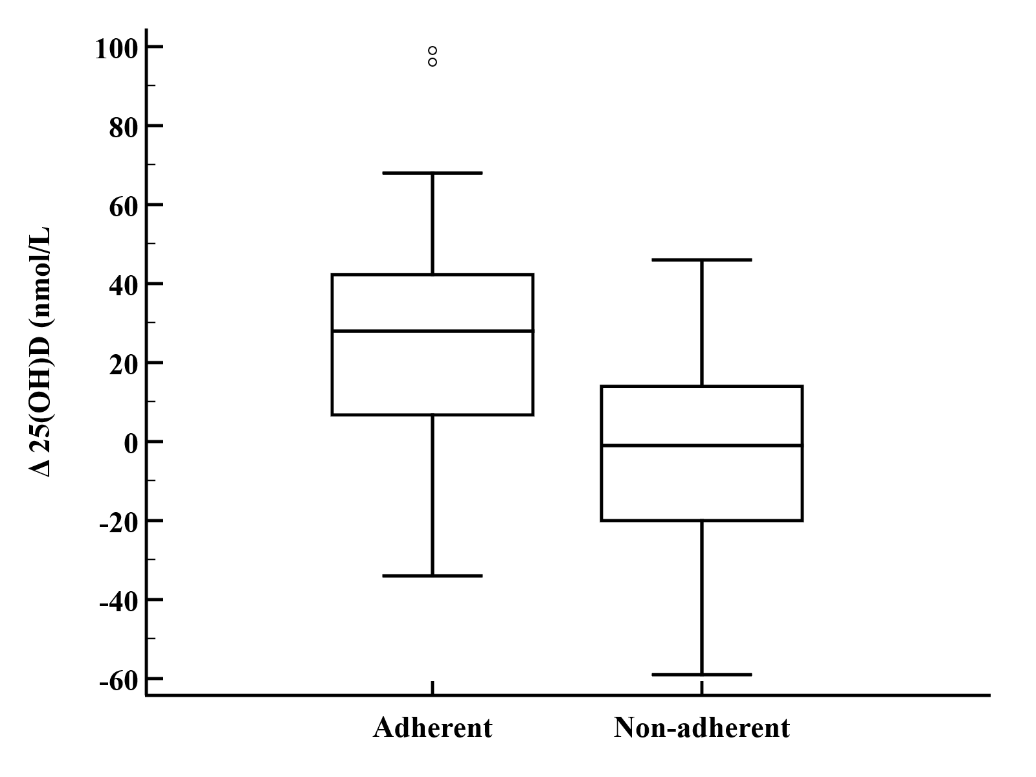
Figure 2. Change in serum vitamin D levels in adherent and non-adherent subjects.
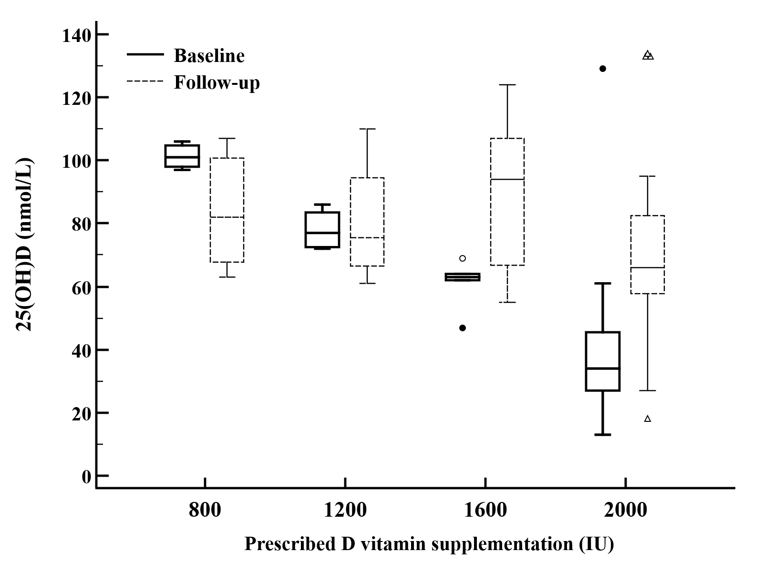
Figure 3. Change in serum 25(OH)D levels ​​in the adherent and non-adherent group at the baseline and follow-up visit.
A significant increase in serum 25(OH)D levels at the follow-up visit was observed in subjects with lower baseline serum 25(OH)D levels (those below 50 nmol/L and those between 50 and 75 nmol/L) who received either 2000 IU or 1600 IU of vitamin D per day (Figure 3). Patients who received lower doses of vitamin D (800 IU or 1200 IU) did not show a significant increase in serum vitamin D at the follow-up visit. The average daily intake of vitamin D, estimated from the three-day diet diary, was 2.11 ± 1.3 µg, with no statistically significant difference between the groups. No correlation was found between the daily intake of vitamin D from food and serum vitamin D concentrations at either the baseline or follow-up visits.

Effect of vitamin D replacement therapy on nutritional status and muscle strength
Improvement in vitamin D status (i.e., transitioning from the deficiency category to insufficiency or normal serum levels, or from insufficiency to normal levels) did not significantly affect the nutritional status or muscle strength of adherent subjects with regard to the observed parameters (Table 6). This trend was also observed for all selected laboratory parameters, with the exception of total proteins, where a statistically significant increase was found in patients who achieved an improvement in vitamin D status (t-test, P=0.018).
Table 6. Association of changes in nutritional status, HGS and selected laboratory parameters with changes in vitamin D serum levels.
Change from the baseline to the non-cGVHD visit | Vitamin D  No change (N=20) | Vitamin D  Improvement (N=33) | P
BMI (kg/m²) | 0.14 (1.96) | 0.45 (1.4) | 0.507
PG-SGA score | -1.3 (3.51) | -1.03 (5.22) | 0.839
VF | 0.21 (1.84) | 0.52 (1.25) | 0.482
FM (kg) | 0.5 (3.81) | 1.61 (3.91) | 0.317
FMI (kg/m²) | 0.17 (1.34) | 0.53 (1.3) | 0.335
FFM (kg) | -0.11 (3.19) | -0.2 (3.25) | 0.92
FFMI (kg/m²) | -0.04 (1.06) | -0.08 (1.05) | 0.892
SMM (kg) | -0.16 (3.18) | -1.16 (4.03) | 0.356
SMI (kg/m²) | -0.04 (1.04) | -0.38 (1.34) | 0.347
LDL (mmol/L) | 0.14 (0.83) | -0.14 (1.08) | 0.438
HDL (mmol/L) | -0.07 (0.82) | -0.04 (0.55) | 0.875
Cholesterol (mmol/L) | 0.07 (1.18) | -0.27 (1.1) | 0.394
Triglycerides (mmol/L) | -0.15 (0.77) | -0.29 (0.88) | 0.654
Albumin (g/L) | 0.11 (3.24) | 1.58 (4.56) | 0.302
Total protein (g/L) | -0.23 (3.85) | 3.65 (4.83) | 0.018
HGS-D | 1.35 (5.16) | 2.78 (5.04) | 0.335
HGS-ND | 1.56 (5.09) | 2.03 (4.26) | 0.723

Patients with liver cGVHD had lower levels ​​of serum vitamin D (P<0.05) (Figure 4). Other organs affected by cGVHD did not correlate with vitamin D.

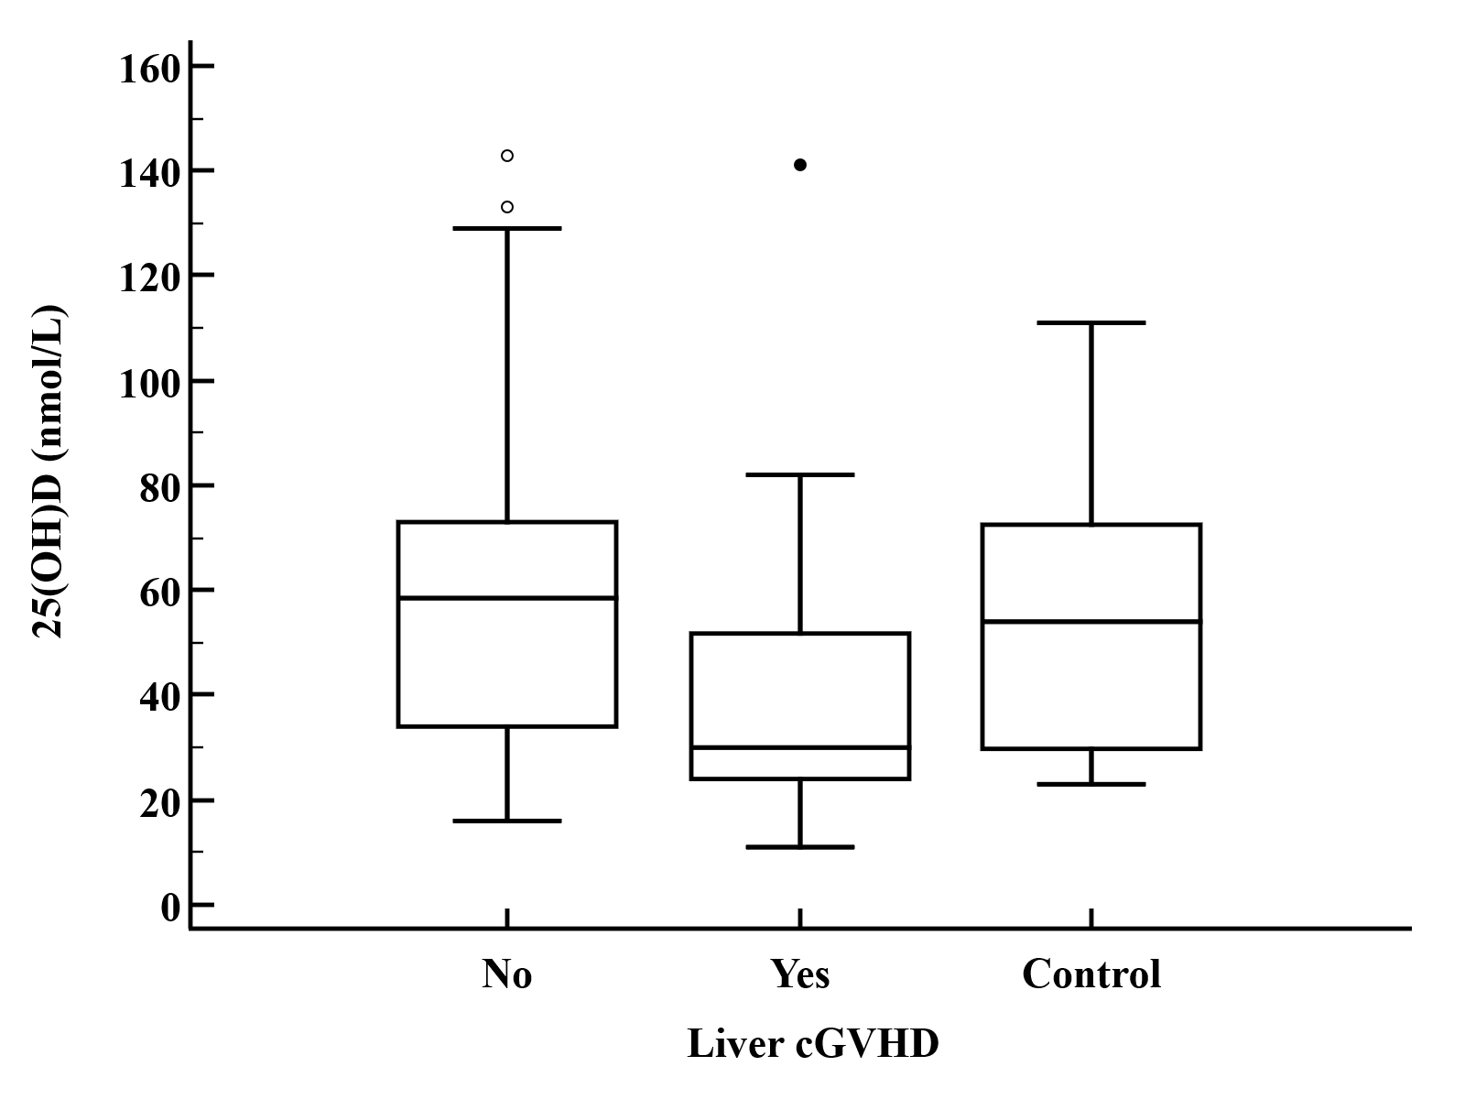
Figure 4. Serum levels of 25(OH)D in patients with liver cGVHD.
Risk factors for malnutrition and low muscle strength
Malnutrition (according to PG-SGA categories B and C) was associated with gastrointestinal cGVHD (OR 8.8, 95% CI 1.1-72.9, p=0,0434) and BMI (OR 0.7, 95%CI 0.6-0.8, p<0.0001) on multivariate analysis. The risk factors for low muscle strength (measured by HGS) included cGVHD status (OR 2.6, p=0.0259), involvement of the digestive system (OR 6.2, p=0.0303), liver (OR 5.3, p=0.0223), and lungs (OR 3.2, p=0.0379), moderate (OR 3.6, p=0.0216) and severe (OR 4.2, p=0.0131) cGVHD activity, PG-SGA-B (OR 5.1, p=0.0035) and -C (OR 12.8, p=0.0181) status, and low BMI (OR 0.8, p=<0.0001) on univariate analysis. According to multivariate analysis, cGVHD disease activity (moderate OR 3.5, CI 1.1-11.2, p=0.0322; severe OR 3.4, CI 1.0-11.5, p=0.0458) and PG-SGA (-B OR 5.2, CI 1.6-16.5, p=0.005; -C OR 10, CI 1.1-87.4, p=0.0377) status were independent risk factors for low muscle strength.
Risk factors for vitamin D deficiency
According to univariate analysis, both cGVHD activity and myeloablative conditioning were identified as risk factors for vitamin D deficiency. However, multivariate analysis revealed that only myeloablative conditioning, as compared to reduced-intensity conditioning (RIC), remained a significant risk factor for vitamin D deficiency in all subjects (Table 7).

Table 7. Predictors for the occurrence of vitamin D deficiency (<50 nmol/L) according to univariate and multivariate regression analysis.
Variable | Vitamin D  ≥50nmol/L | Vitamin D  <50nmol/L | Univariate analysis |  |  | Multivariate analysis
 | n=53 | n=49 | OR | CI | P | OR | CI | P
Time from allo-HSCT (Median IQR) | 448 (227.8 - 1968.3) | 349 (184.8 - 980) | 0.99 | 0.99 - 1.00 | 0.299
cGVHD vs. Non-cGVHD | 34 (64.2 %) | 31 (63.3 %) | 0.96 | 0.43 - 2.16 | 0.926
Skin cGVHD
Non-cGVHD | 19 (35.8) | 18 (36.7) | 1
No | 19 (35.8) | 17 (34.7) | 0.94 | 0.38 - 2.37 | 0.902
Yes | 15 (28.3) | 14 (28.6) | 0.99 | 0.37 - 2.61 | 0.976
Gut cGVHD

Non-cGVHD | 19 (35.8) | 18 (36.7) | 1
No | 30 (56.6) | 22 (44.9) | 0.73 | 0.32 - 1.70 | 0.469
Yes | 4 (7.5) | 8 (16.3) | 2 | 0.51 - 7.78 | 0.317
NIH criteria cGVHD
Non-cGVHD | 19 (35.8) | 18 (36.7) | 1
Mild | 7 (13.2) | 7 (14.3) | 1.06 | 0.31 - 3.61 | 0.931
Moderate | 12 (22.6) | 14 (28.6) | 1.23 | 0.45 - 3.36 | 0.685
Severe | 15 (28.3) | 10 (20.4) | 0.70 | 0.25 - 1.97 | 0.503
cGVHD activity
Non-cGVHD | 19 (35.8) | 18 (36.7) | 1
0 | 11 (20.8) | 4 (8.2) | 0.66 | 0.19 - 2.3 | 0.511 | 0.32 | 0.08 - 1.27 | 0.106
1 – mild | 7 (13.2) | 6 (12.2) | 7.22 | 1.4 - 37.25 | 0.018 | 0.79 | 0.21 - 3.02 | 0.731
2 - moderate | 14 (26.4) | 18 (36.7) | 4.68 | 1.62 - 13.54 | 0.004 | 1.18 | 0.43 - 3.26 | 0.752
3 – severe | 2 (3.8) | 3 (6.1) | 0.88 | 0.13 - 5.87 | 0.891 | 1.17 | 0.16 - 8.53 | 0.876
BMI | 24.7 (4.2) | 24.9 (5.3) | 1.01 | 0.93 - 1.09 | 0.795
Vitamin D from food intake (µg) | 2.3 (1.2) | 1.9 (1.4) | 0.76 | 0.45 - 1.28 | 0.3
Conditioning regime
RIC | 33 (62.3) | 19 (38.8) | 1
Myeloablative | 15 (28.3) | 27 (55.1) | 3.13 | 1.34 - 7.29 | 0.008 | 3.12 | 1.29 - 7.52 | 0.011
TBI | 2 (3.8) | 2 (4.1) | 1.74 | 0.23 - 13.35 | 0.596 | 1.33 | 0.16 - 10.8 | 0.790
Myeloablative and TBI | 3 (5.7) | 1 (2) | 0.58 | 0.06 - 5.97 | 0.646 | 0.49 | 0.04 - 5.16 | 0.549
Age | 48.9 (13.7) | 48.3 (12.3) | 0.99 | 0.97 - 1.03 | 0.828

Discussion
Vitamin D deficiency is a common issue among allo-HSCT patients. In the adult population, vitamin D deficiency is present in 11-70% of patients before,,,,, and in 60-85% after allo-HSCT^{3,5,6,}. Risk factors contributing to vitamin D deficiency in these patients include toxic allo-HSCT treatments, immunosuppressive therapy, especially glucocorticoids, insufficient sun exposure, and, in some cases, impaired nutrient absorption due to drug side effects, GVHD affecting the digestive system, and bacterial overgrowth.
In this study, 30% of patients had vitamin D deficiency, and 50% had vitamin D insufficiency, regardless of the presence of cGVHD. The present data, in line with a meta-analysis, found no statistically significant association between vitamin D deficiency and the occurrence of acute or chronic GVHD. However, the severity of GVHD appears to influence vitamin D status after allo-HSCT. A study by Kreutz et al. demonstrated that patients without or with mild cGVHD experienced an increase in serum 25(OH)D levels, while those with moderate to severe cGVHD had either unchanged or decreased vitamin D status.
Our patients exhibited a significantly low average dietary intake of vitamin D (approximately 2 µg per day), compared to the 5.8-6 µg daily intake in Finns and Swedes, or the 10-15 µg recommended by various health organizations. This low intake likely contributes to vitamin D deficiency, although a direct correlation has not yet been established.
Vitamin D replacement therapy elevated serum 25(OH)D levels in most of our subjects, with a statistically more significant increase observed in patients with cGVHD, probably due to a higher number of adherent individuals in this group.
The increase in serum 25(OH)D levels was influenced by both the initial serum 25(OH)D levels and the prescribed vitamin D replacement dose. A significant increase in serum 25(OH)D was observed in patients with lower initial levels who received higher doses of vitamin D replacement (1600 to 2000 IU per day). In contrast, patients with normal initial 25(OH)D levels who received 800 IU of vitamin D per day showed no significant changes. An observational study involving 95 long-term survivors after allo-HSCT found that most participants adhered to vitamin D replacement therapy, leading to normal vitamin D status (25(OH)D ≥75 nmol/L) in 65% of patients, compared to only 10.5% with inadequate levels (25(OH)D < 50 nmol/L). The authors concluded that a daily dose of 400 to 600 IU of vitamin D is optimal for maintaining serum 25(OH)D levels of at least 75 nmol/L. However, our findings suggest that allo-HSCT patients, regardless of their initial serum 25(OH)D levels, may require a daily dose higher than 800 IU to maintain adequate serum 25(OH)D levels (>75 nmol/L).
Previous research has shown that malnutrition affects approximately 20% of patients from 3 months to several years after allo-HSCT^{4,}. Risk factors for malnutrition in allo-HSCT include preexisting malnutrition, the conditioning regimen, anorexia, infections, mucositis, and GVHD. The prevalence of malnutrition in patients with cGVHD ranges from 29% to 43% (assessed by PG-SGA and BMI). Malnutrition in these patients is associated with cGVHD affecting the lungs, mouth, and intestines, as well as with the NIH severity criteria, impaired functional status, and reduced quality of life,. In our study, malnutrition was observed in 40% of cGVHD patients and 27% of non-GVHD patients. The primary risk factor for malnutrition was cGVHD affecting the digestive system. Similar to previous research in chronic diseases, vitamin D deficiency was not associated with malnutrition or body composition in our allo-HSCT population, regardless of the presence of cGVHD^{3,,,}. The body composition changes observed in our subjects are consistent with findings from other studies on body composition in patients after allo-HSCT and auto-HSCT (6 months to 6 years post-transplantation), which report an increase in total fat mass and a loss of muscle mass. Additionally, although sarcopenia was not diagnosed in our study, low muscle strength, measured by HGS, was present in 30.2% of cGVHD patients and 10.8% of non-cGVHD patients, meeting the first criteria for sarcopenia diagnosis. In cGVHD patients, the risk of low muscle strength was found to be 2.5 times higher compared to those who did not develop cGVHD. According to the mean HGS values of our subjects, it is evident that muscle strength is low in a large proportion, suggesting that the majority of patients experience muscle weakness.
In the group of patients with vitamin D deficiency who received 2000 IU of vitamin D replacement therapy, there was a trend toward increased muscle strength as measured by HGS, although it did not reach statistical significance. This is consistent with previous meta-analyses, which suggest a small positive effect of vitamin D replacement therapy on muscle strength, but without statistical significance,,. Therefore, further research focusing on specific conditions and diseases is needed to better clarify the potential benefits of vitamin D therapy on muscle strength.
In this study, the severity of cGVHD, as defined by NIH criteria, was not found to be related to vitamin D deficiency. Univariate analysis identified cGVHD activity as a risk factor for vitamin D deficiency in cGVHD patients, while multivariate analysis revealed that myeloablative conditioning, in comparison to reduced-intensity conditioning (RIC), was a risk factor for low vitamin D levels in all subjects. The aforementioned observation may be explained by the fact that patients with active cGVHD have a higher intensity of systemic immunosuppression, and thus an additional risk of vitamin D deficiency. Among the organs affected by cGVHD, only cGVHD of the liver was associated with vitamin D status. Subjects with liver cGVHD had lower vitamin D levels compared to those with cGVHD affecting other organs and non-cGVHD patients. Given the liver's role in the biological activation (first hydroxylation) of vitamin D, it is expected that impaired liver function may affect the synthesis of 25(OH)D in patients with liver cGVHD. Additionally, a high prevalence of vitamin D deficiency has been established in various liver diseases, and vitamin D is considered to play a key role in the etiology of these diseases due to its immunomodulatory effect. However, there is currently no clinical evidence regarding the potential therapeutic effect of vitamin D replacement in liver disease, nor its impact on quality of life or morbidity associated with liver conditions. Contrary to expectations, vitamin D deficiency was not associated with skin cGVHD. This is most likely because all allo-HSCT patients, regardless of whether they developed skin cGVHD, are advised to avoid sun exposure and use high UV protection factors due to the increased risk of non-melanoma skin cancer and the potential for activating cGVHD.
Meta-analyses have associated vitamin D deficiency in patients prior to auto- and allo-HSCT with worse overall survival. In allo-HSCT, lower vitamin D levels are linked to a higher rate of disease recurrence, which is associated with a poorer prognosis but not with non-relapse survival. However, this latest meta-analysis has several limitations. The threshold for defining vitamin D deficiency is not consistent, as it varies across studies (e.g., <20, 30, 50, or 62.5 nmol/L). Additionally, different methods were used to measure vitamin D levels in serum, and some studies did not report on vitamin D replacement therapy. The meta-analysis included a small number of studies, and it is also difficult to determine cause-and-effect relationships or reverse causality.
According to previous studies, the optimal dose of vitamin D necessary to prevent complications in the HSCT population has not been clearly established. Available recommendations suggest daily doses ranging from 400 to 4000 IU. Additionally, the threshold serum levels of vitamin D status linked to HSCT complications have not been defined, as most published studies are either not prospective or involve a small number of patients.
Moreover, allo-HSCT patients are at an increased risk of osteopenia and osteoporosis. Long-term survivors of HSCT have shown a rapid loss of bone mineral density in the post-transplantation period, along with a decrease in serum 25(OH)D levels, despite receiving calcium (1 g of calcium carbonate) and vitamin D (1000 IU).
The results of this study indicate that a higher intake of vitamin D is necessary not only to correct vitamin D deficiency but also to maintain normal levels in our patients. An individualized approach to prescribing vitamin D replacement therapy considering factors such as disease activity, involvement of other organs by cGVHD, glucocorticoid therapy, malabsorption syndrome, obesity, osteoporosis, and infections would be more effective than routine dosing based solely on a glucocorticoid regimen. The presence of vitamin D deficiency, as well as impaired nutritional and functional status in allo-HSCT patients, highlights the need to implement a protocol for monitoring nutritional and functional status, with a focus on muscle mass and strength (including vitamin D status), and timely intervention by qualified specialists.
The main limitations of this study are the small sample size and the heterogeneity of patient groups in terms of demographics. In cGVHD patients, additional limitations include variability in disease characteristics (affected organs, time since diagnosis, and immunosuppressive therapy). Controls without cGVHD after allo-HSCT are not ideal, as they may still develop cGVHD later, possibly without early recognition. Other limitations include limited data on vitamin D levels, nutritional and functional status before allo-HSCT, and incomplete information on previous immunosuppressive treatments, especially glucocorticoids. The wide range of time from allo-HSCT or cGVHD onset to study inclusion also affects consistency.

Acknowledgements
This study was supported, in part by the Croatian Science Foundation project IP-2016-06-8046 entitled “New biomarkers for chronic graft-versus-host disease”. We would like to thank all other members of the multidisciplinary cGVHD team at the University Hospital Center Zagreb, for their contributions and dedicated care for patients.

Author contributions:
Conception and design of the study, Dina Ljubas Kelecic, Darija Vranesic Bender, Zeljko Krznaric, Dubravka Vitali Cepo, Steven Pavletic; Research supervision, Zeljko Krznaric, Radovan Vrhovac, Drazen Pulanic; Funding acquisition, Pulanic Drazen; Patient recruitment, data analysis and interpretation, Antonela Lelas, Lana Desnica, Ranka Serventi Seiwerth, Nadira Durakovic, Radovan Vrhovac; Patient assessment, data collection, data analysis and interpretation, Dina Ljubas Kelecic, Irena Karas, Ana Kunovic, Marina Sabic, Tamara Vukić; Writing manuscript, Dina Ljubas Kelecic and Antonela Lelas; Statistical analysis, Ivan Sabol; Review and editing, all authors.

Arain A, Matthiesen C. Vitamin D deficiency and graft-versus-host disease in hematopoietic stem cell transplant population. Hematol Oncol Stem Cell Ther. 2019 Sep;12(3):133–9.
Ljubas Kelecic D, Lelas A, Karas I, Desnica L, Vukic T, Sabol I, et al. Sarcopenia among patients after allogeneic hematopoietic stem cell transplantation and the impact of chronic graft-versus-host disease. J Cancer Res Clin Oncol. 2020 Nov;146(11):2967–78.
Katić M, Pirsl F, Steinberg SM, Dobbin M, Curtis LM, Pulanić D, et al. Vitamin D levels and their associations with survival and major disease outcomes in a large cohort of patients with chronic graft-vs-host disease. Croat Med J. 2016 Jun 30;57(3):276–86.
Brotelle T, Lemal R, Cabrespine A, Combal C, Hermet E, Ravinet A, et al. Prevalence of malnutrition in adult patients previously treated with allogeneic hematopoietic stem-cell transplantation. Clin Nutr Edinb Scotl. 2018 Apr;37(2):739–45.
Fuji S, Mori T, Khattry N, Cheng J, Do YR, Yakushijin K, et al. Severe weight loss in 3 months after allogeneic hematopoietic SCT was associated with an increased risk of subsequent non-relapse mortality. Bone Marrow Transplant. 2015 Jan;50(1):100–5.
Kyle UG, Chalandon Y, Miralbell R, Karsegard VL, Hans D, Trombetti A, et al. Longitudinal follow-up of body composition in hematopoietic stem cell transplant patients. Bone Marrow Transplant. 2005 Jun 1;35(12):1171–7.
Heike A. Bischoff-Ferrari. Vitamin D and muscle function. International Congress Series. 2007 Mar; 1297: 143-147.
Rashid N, Arora M, Jurdi NE, Onstad L, Pidala JA, Flowers ME, Lee SJ. Frailty in Patients with Chronic Graft-versus-Host Disease. Transplant Cell Ther. 2023 Jun;29(6):367-374.
Glotzbecker B, Ho VT, Aldridge J, Kim HT, Horowitz G, Ritz J, et al. Low levels of 25-hydroxyvitamin D before allogeneic hematopoietic SCT correlate with the development of chronic GVHD. Bone Marrow Transplant. 2013 Apr 1;48(4):593–7.
von Bahr L, Blennow O, Alm J, Björklund A, Malmberg KJ, Mougiakakos D, et al. Increased incidence of chronic GvHD and CMV disease in patients with vitamin D deficiency before allogeneic stem cell transplantation. Bone Marrow Transplant. 2015 Sep;50(9):1217–23.
Joseph RW, Alousi A, Konda B, Komanduri K, Neumann J, Trevino C, et al. High incidence of vitamin D deficiency in patients undergoing allogeneic stem cell transplantation. Am J Hematol. 2011 Nov;86(11):954–6.
Urbain P, Ihorst G, Biesalski HK, Bertz H. Course of serum 25-hydroxyvitamin D(3) status and its influencing factors in adults undergoing allogeneic hematopoietic cell transplantation. Ann Hematol. 2012 May;91(5):759–66.
Florenzano P, Ernst D, Lustig N, Rojas P, Ramírez P, Campusano C. [Vitamin D and parathyroid hormone levels and bone mineral density in patients undergoing hematopoietic cell transplantation]. Rev Med Chil. 2016 Sep;144(9):1119–24.
Sproat L, Bolwell B, Rybicki L, Dean R, Sobecks R, Pohlman B, et al. Vitamin D level after allogeneic hematopoietic stem cell transplant. Biol Blood Marrow Transplant J Am Soc Blood Marrow Transplant. 2011 Jul;17(7):1079–83.
Kenny SA, Collum K, Featherstone CA, Farooki A, Jakubowski A. Impact of a Replacement Algorithm for Vitamin D Deficiency in Adult Hematopoietic Stem Cell Transplant Patients. J Adv Pract Oncol. 2019/03/01 ed. 2019 Mar;10(2):109–18.
Simmons J, Sheedy C, Lee H, Koh S, Alvarez J, Koyama T, et al. Prevalence of 25-hydroxyvitamin D deficiency in child and adolescent patients undergoing hematopoietic cell transplantation compared to a healthy population. Pediatr Blood Cancer. 2013 Dec;60(12):2025–30.
van der Meij BS, de Graaf P, Wierdsma NJ, Langius JAE, Janssen JJWM, van Leeuwen PAM, et al. Nutritional support in patients with GVHD of the digestive tract: state of the art. Bone Marrow Transplant. 2013 Apr 1;48(4):474–82.
Chiengthong K, Cheungpasitporn W, Thongprayoon C, Lertjitbanjong P, Cato LD, Bathini T, et al. Vitamin D deficiency is not associated with graft versus host disease after hematopoietic stem cell transplantation: A meta-analysis. J Evid-Based Med. 2020 Aug;13(3):183–91.
Kreutz M, Eissner G, Hahn J, Andreesen R, Drobnik W, Holler E. Variations in 1α,25-dihydroxyvitamin D3 and 25-hydroxyvitamin D3 serum levels during allogeneic bone marrow transplantation. Bone Marrow Transplant. 2004 Apr 1;33(8):871–3.
Głąbska D, Guzek D, Sidor P, Włodarek D. Vitamin D Dietary Intake Questionnaire Validation Conducted among Young Polish Women. Nutrients. 2016 Jan 5;8(1).
Lenssen P, Sherry ME, Cheney CL, Nims JW, Sullivan KM, Stern JM, et al. Prevalence of nutrition-related problems among long-term survivors of allogeneic marrow transplantation. J Am Diet Assoc. 1990 Jun;90(6):835–42.
Hirose EY, de Molla VC, Gonçalves MV, Pereira AD, Szor RS, da Fonseca ARBM, et al. The impact of pretransplant malnutrition on allogeneic hematopoietic stem cell transplantation outcomes. Clin Nutr ESPEN. 2019 Oct;33:213–9.
Iestra JA, Fibbe WE, Zwinderman AH, van Staveren WA, Kromhout D. Body weight recovery, eating difficulties and compliance with dietary advice in the first year after stem cell transplantation: a prospective study. Bone Marrow Transplant. 2002 Mar;29(5):417–24.
Espinoza M, Perelli J, Olmos R, Bertin P, Jara V, Ramírez P. Nutritional assessment as predictor of complications after hematopoietic stem cell transplantation. Rev Bras Hematol E Hemoter. 2016 Feb;38(1):7–14. Kreutz M, Eissner G, Hahn J, Andreesen R, Drobnik W, Holler E. Variations in 1α,25-dihydroxyvitamin D3 and 25-hydroxyvitamin D3 serum levels during allogeneic bone marrow transplantation. Bone Marrow Transplant. 2004 Apr 1;33(8):871–3.
Bassim CW, Fassil H, Dobbin M, Steinberg SM, Baird K, Cole K, et al. Malnutrition in patients with chronic GVHD. Bone Marrow Transplant. 2014/07/14 ed. 2014 Oct;49(10):1300–6.
Jacobsohn DA, Margolis J, Doherty J, Anders V, Vogelsang GB. Weight loss and malnutrition in patients with chronic graft-versus-host disease. Bone Marrow Transplant. 2002 Feb;29(3):231–6.
Mentella MC, Scaldaferri F, Pizzoferrato M, Gasbarrini A, Miggiano GAD. The Association of Disease Activity, BMI and Phase Angle with Vitamin D Deficiency in Patients with IBD. Nutrients. 2019 Oct 26;11(11):2583.
Lagunova Z, Porojnicu AC, Lindberg F, Hexeberg S, Moan J. The dependency of vitamin D status on body mass index, gender, age and season. Anticancer Res. 2009 Sep;29(9):3713–20.
Trukova K, Gupta D, Vashi PG, Adams A, Lambert GM, Grutsch JF, et al. Serum 25-hydroxy vitamin D and nutritional status: Implications for vitamin D assessment and dietary supplementation in oncology. J Clin Oncol. 2009 May 20;27(15_suppl):9638–9638.
Tabrizi R, Hallajzadeh J, Mirhosseini N, Lankarani KB, Maharlouei N, Akbari M, et al. The effects of vitamin D supplementation on muscle function among postmenopausal women: a systematic review and meta-analysis of randomized controlled trials. EXCLI J. 2019 Aug 6;18:591–603.
Rosendahl-Riise H, Spielau U, Ranhoff AH, Gudbrandsen OA, Dierkes J. Vitamin D supplementation and its influence on muscle strength and mobility in community-dwelling older persons: a systematic review and meta-analysis. J Hum Nutr Diet Off J Br Diet Assoc. 2016/07/27 ed. 2017 Feb;30(1):3–15.
Beaudart C, Buckinx F, Rabenda V, Gillain S, Cavalier E, Slomian J, et al. The Effects of Vitamin D on Skeletal Muscle Strength, Muscle Mass, and Muscle Power: A Systematic Review and Meta-Analysis of Randomized Controlled Trials. J Clin Endocrinol Metab. 2014 Nov 1;99(11):4336–45.
Filipovich AH, Weisdorf D, Pavletic S, Socie G, Wingard JR, Lee SJ, Martin P, Chien J, Przepiorka D, Couriel D, Cowen EW, Dinndorf P, Farrell A, Hartzman R, Henslee-Downey J, Jacobsohn D, McDonald G, Mittleman B, Rizzo JD, Robinson M, Schubert M, Schultz K, Shulman H, Turner M, Vogelsang G, Flowers ME (2005) National institutes of health consensus development project on criteria for clinical trials in chronic graft-versus-host disease: I. Diagnosis and staging working group report. Biol Blood Marrow Transplant 11(12):945–956
Elangovan H, Chahal S, Gunton JE. Vitamin D in liver disease: Current evidence and potential directions. Biochim Biophys Acta BBA - Mol Basis Dis. 2017 Apr 1;1863(4):907–16.
Bjelakovic G, Nikolova D, Bjelakovic M, Gluud C. Vitamin D supplementation for chronic liver diseases in adults. Cochrane Database Syst Rev. 2017 Nov 3;11(11):CD011564–CD011564.
Kenny SA, Collum K, Featherstone CA, Farooki A, Jakubowski A. Impact of a Replacement Algorithm for Vitamin D Deficiency in Adult Hematopoietic Stem Cell Transplant Patients. J Adv Pract Oncol. 2019/03/01 ed. 2019 Mar;10(2):109–18.
Ito Y, Honda A, Kurokawa M. Impact of vitamin D level at diagnosis and transplantation on the prognosis of hematological malignancy: a meta-analysis. Blood Adv. 2022 Mar 8;6(5):1499–511.
Ros-Soto J, Anthias C, Madrigal A, Snowden JA. Vitamin D: is it important in haematopoietic stem cell transplantation? A review. Bone Marrow Transplant. 2019 Jun 1;54(6):810–20.
Schulte C, Beelen DW, Schaefer UW, Mann K. Bone loss in long-term survivors after transplantation of hematopoietic stem cells: a prospective study. Osteoporos Int J Establ Result Coop Eur Found Osteoporos Natl Osteoporos Found USA. 2000;11(4):344–53.

