Potentially toxic elements in the soil of an urban area in Croatia: a multimethodological approach for the assessment of mobility, environmental and human health risks

Sanja Sakan^{1*}, Stanislav Frančišković-Bilinski^{2*}, Josip Peco³, Nenad Sakan⁴, Biljana Dojčinović⁵, Gordana Dević⁵, Dragana Đorđević¹

¹ Centre of Excellence in Environmental Chemistry and Engineering, University of Belgrade, Institute of Chemistry, Technology and Metallurgy, National Institute of the Republic of Serbia, Belgrade, Serbia
² Division for Marine and Environmental Research, Ruđer Bošković Institute, Zagreb, Croatia
³ Department of Geology, University of Zagreb, Faculty of Science, Zagreb, Croatia
⁴ Institute of Physics Belgrade, National Institute of the Republic of Serbia, University of Belgrade, Belgrade, Serbia
⁵ Institute of Chemistry, Technology and Metallurgy, National Institute of the Republic of Serbia, University of Belgrade, Belgrade, Serbia

* Correspondence: ssakan@chem.bg.ac.rs (sanja.sakan@ihtm.bg.ac.rs); francis@irb.hr
Email addresses of other authors: josip.peco@student.pmf.hr (J.P.); nsakan@ipb.ac.rs (N.S.); bmatic@gmail.com (B.D.); gordanadevic@gmail.com (G.D.); dragadj@chem.bg.ac.rs (D.Đ.)

Abstract

The contamination of soils in the urban area of Zagreb with potentially toxic elements (PTEs) was assessed by predicting their mobility and evaluating the risk to the environment and human health. Sequential extraction was performed using the optimized BCR (Community Bureau of Reference) method. The enrichment factor (EF) was calculated to assess soil contamination. The mobility risk assessment was calculated using the risk assessment code (RAC) and the modified risk assessment code (mRAC). In the mobile fraction, Ca, Sr, and Mg are only weakly bound by carbonate compounds, while the other elements are strongly bound to the soils. Mn, Pb, Ba, and Cd are bound to oxides, and the least mobile elements such as Al, As, Co, Fe, Zn, K, Na, Ni, Cr, Sb, Cu and Li occurred mainly in the residual fraction. High extraction efficiency (above 40%) for Pb, Cd, and Cu was obtained when 0.43 M HNO₃ was used for extraction, and this acid is recommended for analyzing the geochemical reactivity of PTEs. The increased content of Ni, Cu, Cr, and As is accompanied by a high EF, indicating the existence of anthropogenic sources of these elements. The hazard index (HI) for adults and children is < 1.0, indicating that these PTEs have no significant non-carcinogenic effects on the human body. The cancer risk (CR) for children is highest for Ni, Cr and As and for adults for Ni. The Monte Carlo simulations show that Cd and As are the most important risk factors in the soils studied.

Keywords: soil, extraction method, Monte Carlo simulation, potentially toxic elements (PTEs), risk to human health

Introduction

PTEs enter the soil from natural (Li et al. 2023) and anthropogenic sources. Since toxic elements are not biodegradable, their presence in soil is evidence of pollution over a long period of time (Antonijević Nikolić, 2021). From an ecochemical point of view, it is of fundamental importance to know the form of PTEs in the soil. The behaviour of PTEs depends on the binding to each soil phase, and therefore the determination of the chemical forms of PTEs is important for estimating the mobility and bioavailability of trace elements (Wali et al. 2014). The most available fraction that could be consumed by biota is the most reactive fraction of PTEs, which could exclude the inert fraction (Groenenberg et al. 2017).
Sequential extraction procedures (SEP) allow the identification of the association of elements with soil components (Žemberyová et al. 2006) and the assessment of the mobility and bioavailability of elements that directly affect the potential hazard to the environment (Alan and Kara, 2019). Various sequential extraction methods have been applied in many research (Sakan et al. 2010; Sakan et al. 2011; Sharma et al. 2024), and common to all methods is that the mobility and availability of elements decreases during the extraction sequence (Marković et al. 2016). Based on the results obtained with SEP for the mobility of elements, RAC and mRAC are calculated and determined in many studies (Gruszecka-Kosowska et al. 2019; Sakan et al. 2023). These factors are used for the determination of mobile and bioavailable PTEs in soils and sediments. RAC belongs to the simple fractionation indices, and mRAC belongs to the group of complex fractionation indices (Gruszecka-Kosowska et al. 2019).
When considering individual extraction methods, the literature describes the use of CaCl₂, HCl, HNO₃, BaCl₂, CH₃COOH and many other extraction solutions (Rauret, 1998). Recently, 0.43 M HNO₃ (NA) has also been used for the extraction of elements from soil. NA extraction (standard ISO17586:2016) has been used to assess element leaching, bioavailability and bioavailability to humans (Groenenberg et al. 2017; Rodrigues et al. 2018; Pelfrêne et al. 2020).
Several pollution indices are used to assess the pollution level of toxic elements. These indices are mainly based on the total content of elements in soil and/or sediment. One of them is the enrichment factor (EF), which is used to determine the contribution of anthropogenic sources in topsoil (Sakan et al. 2017; Sappa et al. 2020). In addition to various eco-chemical assessments of pollution of an environment by PTEs, human exposure to the effects of these elements is also monitored and is a very important part of any impact assessment in recent research. Risk assessment models are applied to evaluate the health risk, non-cancer and cancer (Huang et al. 2018; Relić et al. 2019). Humans can be exposed to PTEs through contaminated surface soils (Boumaza et al. 2024) and many health problems can result from their accumulation in the organism (El-Sorogy et al. 2024).
Among the methods already mentioned, Monte Carlo simulation is often used in risk assessment (Panqing et al. 2023), which can help to reduce uncertainty in the determination of PTEs as well as their influence on toxicity (Liu et al. 2023). The final assessment of the pollution level is crucial for the estimation of toxicity, and therefore various methods have been conducted to analyze the data. These data analysis methods are also crucial for the development of models to identify and differentiate sources of soil pollution by toxic elements (e.g., statistical approach, Zarei et al. 2023).
In this article, the soils of the city of Zagreb were investigated with the aim of evaluating and estimating the contamination with PTEs in the urban area. The elements from the soils were extracted using the three-step BCR extraction method. The potentially environmentally available and bioavailable trace elements are extracted with 0.43 M HNO₃. The pH of the soil extracts was measured with a digital pH meter and the electrical conductivity (EC) with a digital conductivity meter. Different methods to assess and quantify the pollution level as well as the risks for the whole environment were performed using different numerical and statistical methods (correlation analysis, principal component analysis - PCA) as well as by applying Monte Carlo simulations. The main purpose of this article is: (1) to determine the content, mobility and potential sources of PTEs; (2) to quantify the pollution of urban soils by PTEs; (3) to assess the bio-accessible trace elements; (4) to evaluate the environmental risk and the potential risk to human health (non-carcinogenic and carcinogenic); and (5) to apply Monte Carlo simulations to assess the ecological risk. In this article, a detailed assessment of PTEs contamination in the soils of the city of Zagreb is carried out using different approaches and methods. As has been shown in other research areas, a combination of several methods can often lead to a more accurate determination of soil parameters. This approach is not yet common in this field of research and is expected to lead to a more in-depth analysis. It is expected that the conclusions gained will be useful and significant for many other researchers and will feed into further research into different urban soils.

Materials and methods

Study area, sampling and sample preparation

Sampling for the current study was carried out as part of the previous research, in which a comprehensive study was conducted to measure the magnetic susceptibility of Zagreb city soils with in-situ measurements at 125 locations throughout the Zagreb city territorial unit, excluding some rural parts such as Brezovica and part of Sesvete (Frančišković-Bilinski et al. 2023). Elevated values of magnetic susceptibility indicate that the content of toxic elements could also be elevated at this location. Based on the elevated magnetic susceptibility values and some other important facts, e.g. locations close to possible pollution sources, locations with extremely low magnetic susceptibility values, etc., and after a detailed statistical evaluation, the 20% most interesting locations were selected for soil sampling. The soil samples were taken from 25 locations. In Frančišković-Bilinski et al. (2023), a detailed analysis of the results of magnetism and the relationship between magnetism and the total content of elements was carried out. In this article, a mobility analysis and an assessment of the risk to the environment and human health of potentially toxic elements were carried out. The locations of the sampling sites are shown in Table 1 and Figure 1.
The sampling protocol is described in detail by Frančišković-Bilinski et al. (2023) and here the most important things are mentioned: the microsite of the previous in situ measurement was determined for sampling; the grass or foliage cover was removed, the 2 cm deep soil layer was sampled with a spade; the samples were air-dried at 40°C and then sieved through a 2 mm sieve and finally homogenized by crushing in a mechanical mortar; 40 g of each sample was prepared for chemical analyzes and the rest was kept for the archive.
At the Novi Jelkovec site, with the lowest magnetic susceptibility values (Frančišković-Bilinski et al. 2023), a sample was taken at a depth of 15 – 25 cm. This sample is used as a background sample for calculating the pollution indices.
Analysis of the soil samples

To analyze the PTE mobility in soil samples, the sequential extraction method BCR was applied in this article (Sutherland 2010; Relić et al. 2013). The content of elements in the filtrates after each extraction step was determined by Inductively Coupled Plasma-Optical Emission spectrometry - ICP-OES (iCAP 6500 Duo ICP, Thermo Fisher Scientific, Cambridge, United Kingdom). A detailed description of BCR extraction and quality control can be found in Suppl. Material.
For the extraction of reactive/bioavailable forms of metals, 1 g of soil material was shaken with 40 ml of a 0.43 M HNO₃ solution for 2 h at room temperature (a modified soil : 0.43 M HNO₃ ratio was used according to Rodrigues et al. (2010)).
To determine the pH and electrical conductivity of the soil, approximately 10 g of the soil sample was weighed into a cuvette and 25 ml of distilled water was added. The whole was shaken by hand for about 20 minutes and then centrifuged at 3000 rpm for 10 minutes. The extracts were then filtered through quantitative filter paper and the pH and electrical conductivity in the filtered extracts were measured. Edmeades and Wheeler (1990) show that the method of measuring pH in water, soil:solution 1:2.5 adequately represents the prevailing pH in the field. The pH value of the soil extracts was measured with the WTW pH 3110 Set SM PRO, LLG Premium Line. The portable WTW conductivity meter ProfiLine Cond 3310 was used to measure the electrical conductivity.
Mobility risk assessments (RAC and mRAC)
The RAC method was developed by Perin et al. (1985). The degrees of RAC classification are presented together with the results of the calculated indices.
Based on the RAC method, Saeedi and Jamshidi Zanjani (2015) developed a new index called mRAC. The classification of this index is shown along with the results of the calculated mRAC. The formulas used for the calculation of RAC and mRAC can be found in Suppl. Material.
Enrichment factor (EF)
The EF is used to assess the presence and intensity of anthropogenic pollutants (Mediola et al. 2008; Barbieri, 2016). The formula for calculating the EF is given in Suppl. Material. Aluminum was used as the element for normalization in this article. Aluminum has already been successfully used as a normalizing element by several scientists (e.g. Birch, 2020). As background values for the calculation of EF, the element contents in the soil of Novi Jelkovec (depth 15-25 cm) are used in this article.

Potential risk to human health

According to the methodology described by the United States Environmental Protection Agency (USEPA, 2004) and applied in Kusin et al. (2019), Wang et al. (2019) and Boumaza et al. (2024), the following equations were used in this article. These equations consist of estimating the average daily dose (ADD) due to exposure to toxic elements:
${ADD}_{ing }$= C $×$ $\frac{ I_{ing}R ×EF × ED}{BW × AT}$ $×$ CF

${ADD}_{dermal }$= C $×$ $\frac{AF × SA × ABS × EF × ED}{BW × AT}$ $×CF$

${ADD}_{inhalation}$ = C $×$ $\frac{I_{inh}R × EF ×ED }{PEF ×BW ×AT}$,

where C is the content of PTE in the soil.
The hazard index (HI) is calculated as the sum of the hazard quotients (HQ):
HQ = $\frac{ADD}{RfD}$

HI = NCR = $\sum{HQ}$ = HQ_{ing} + HQ_{der} + HQ_{inh}

USEPA (2002) suggests that a health protective value (HQ) should be equal to or less than 1 (HQ ≤ 1). HQ > 1 indicates the probability of adverse health effects. Values of HI < 1 indicate that there is no appreciable risk of non-carcinogenic effects. The carcinogenic health risk, expressed by the total cancer risk (TCR), was calculated using the following equation:
CR = ADD x CSF

TCR = CR_{total} = CR_{ing} + CR_{der} + CR_{inh}

The acceptable cancer risk (CR) threshold is 1.0E-04, although tolerable CR_{total} values can vary between 1.0E-06 and 1.0E-04 (USEPA, 2002). If TCR is greater than 1.0E-04, the risk is unacceptable.
Ecological risk assessment of PTEs using Monte Carlo simulation

The Monte Carlo simulation was applied to estimate the distribution of the toxic element content (or Eri and HRI) in soils to evaluate the uncertainty associated with the risk of toxic elements in the studied area.

Statistical analysis

The statistical methods used in this article were performed using Statistica 21 software (StatSoft, Tulsa, USA).

Results and discussion

Accuracy and precision of the BCR method

The quality of the analytical sequential extraction data was checked by analysing the reference material (BCR-701). The data on accuracy and precision can be found in Suppl. Material.

Chemical properties of the soil

The pH values of the aqueous solutions of the soil samples analysed (Table S1.) ranged from 4.70 to 6.64 (mean value of 6.10). Table S1 shows that the soil samples were slightly acidic to almost neutral. Very similar values for pH were determined in surface soils from Japan (Kashem et al. 2011). The authors mentioned associate relatively low pH values in some of these soils with a high humus content and acidic wastewater from nearby industrial plants. The soil conductivity (Table S1.) in this study ranged from 66.5 to 306 µS/cm (mean 138 µS/cm). In general, the conductivity of the soil influences the availability of nutrients for the plants. A higher conductivity indicates that the availability of minerals from the soil is greater for the plant (Nikolić et al. 2019). The maximum conductivity value is below 400 µS/cm and the investigated soils can be classified as slightly saline or non-saline, which is consistent with the classification of Zaiad (2010).

Spatial distribution of the elements

Tables 2 and 3 show the contents of the elements in the fractions of the BCR extraction, the total element contents (sum of the individual fractions), the background values and the data on the soils in Serbia and Europe. Table 2. also shows the element content limits according to the European Union Directive. The spatial distribution of Pb, Ni, Cu, Cr, Cd and As is shown in Figure 2.
The results of the comparison of the total content of Cd, Ni, Pb, Cu and Zn with the limit values for the element content specified in the EU Directive 86/278/EEC allow the conclusion that both the mean values and the maximum contents of all toxic elements investigated are below the values specified in this Directive. The values for As and Cr are lower than the maximum permissible concentrations given by Kabata-Pendias (2011). The results of these comparisons indicate that there is no significant contamination with the toxic elements in the soils of the Zagreb urban area. The contents of the analysed elements were lower compared to the results for European agricultural soils - EAS (mean, median and maximum value) published by Reimann et al. (2018). Comparing the mean content of elements in the soils from Zagreb with the median values of the EAS, all values of the mean content of the analysed elements are higher, with the exception of As, whose values are lower than the average value of European soils. When comparing the maximum levels of the soils, the maximum levels of the analysed elements in Zagreb are lower than the average values for soils from European locations. This conclusion is in line with expectations, considering that the study of agricultural land in Europe included different soils, so it is to be expected that there are high values for some elements in certain locations. These elevated values can be caused by the specific geological composition of the soil (natural elevated content) or by anthropogenic pollution. Subsequently, the contents of the elements in the investigated soils in this article were compared with the results obtained for urban soils from the city of Šabac, Serbia (Antonijević Nikolić et al. 2021). The comparison of the results obtained shows that the mean values of Cd, Ni, Pb, Cr and Cu contents in the urban soils of the city of Šabac are higher compared to the soils of the city of Zagreb. Only Co contents (average content and maximum value) are higher in the soils from Zagreb than in those from Šabac, which is a consequence of the specific geology. It can be observed that only the maximum value of Cu is slightly higher in the soils from Zagreb compared to Šabac, while all other maximum values are lower compared to the soils from Šabac. Antonijević Nikolić et al. (2021) concluded that Pb, Cd and Cu in Šabac soils are predominantly of anthropogenic origin, whereby traffic can be considered as an emission source for these elements. For Co, Mn, Ni and Cr, they showed that they are mainly of lithogenic origin, although the possibility that Ni and Mn originate from anthropogenic activities was also pointed out.
Based on the observation of the spatial distribution of Pb, Ni, Cu, Cr, Cd and As (Figure 2.), an increased content of the following elements can be observed in the mentioned locations: Pb (6, 23); Ni (19); Cu (6); Cr (6); Cd (7,8); and As (19). By applying additional calculations and techniques, we will try to assess later in the article whether the increased content of elements in the mentioned locations is a consequence of anthropogenic pollution or whether there may be an increased content of finer fractions in the soil sample or/and a specific geochemical composition that may cause an increased content of certain elements.

Distribution of elements by fraction

Based on the mean contents (Tables 2. and 3.), the distribution of the elements by fraction is calculated in this article. The distribution of elements by fraction was expressed as a percentage. In general, the binding strength of the elements associated with the different fractions increases from the first to the fourth fraction.

Al, As, Co, Fe, Zn, K, Na, Ni, Cr, Sb, Cu, and Li

The elements most bound in the least mobile, fourth fraction are Al, As, Co, Fe and Zn, followed by K, Na, Ni, Cr, Sb, Cu and Li. The high content of elements bound in this least mobile fraction indicates that they are predominantly of geochemical origin in the investigated soils. The presence of these elements also in the extracts of the first extraction stage is a consequence of the desorption of these elements from the surface of the clay minerals and the partial destruction of the clay minerals by acetic acid. The significant content of K and Na extracted in the first fraction can confirm the destruction of the clay minerals during the extraction with acetic acid. The oxidic and organic fractions are of great importance for the binding of Al, As, Co, Fe and Zn (the content in the second phase is higher than that in the third), as well as Ni, Cr, Sb, Cu and Li (the content in the third phase is higher than that in the second). A significant content of Ni and Cu was extracted in the third extraction phase. The literature (Žemberyová et al. 2006) shows that Cu in soil is preferably bound to humic substances, while Ni is rather bound as sulfide (Žemberyová et al. 2006). Zinc is mainly present in the water extractable fraction and in the reducible fraction, which is also shown by Žemberyová et al. (2006). The highest content of most elements was extracted in this fourth fraction, which indicates low contamination of the investigated soils. Fernádez et al. (2004) also came to this conclusion in their study.

Ba, Mn, Cd and Pb

The oxide fraction is most important for the binding of Ba, Mn, Cd and Pb. Ba and Mn have a greater mobility in the soils studied, considering that a significant percentage of these elements are bound to the first fraction, while in the case of Cd and Pb, the next phase in terms of presence of extracted elements is the fourth, residual fraction. A higher proportion of the acid-recoverable fraction can be attributed to the affinity of these elements to combine with manganese and iron oxides or hydroxides. Only a small proportion of Pb and Cd is present as acid-exchangeable species. The predominance of the reducible form of these elements was also observed by Žemberyová et al. (2006). The distribution of Pb by fraction in Sarkar et al. (2014) and Marković et al. (2016) is the same as in the present study.

Ca, Mg, Sr and B

The most mobile elements studied in this article are Ca, Mg and Sr, since the highest percentage of these elements is bound in the first and second fractions of the sequential extraction. Ca and Mg in the first stage of extraction are of carbonate origin, as is Sr. The incorporation of Sr (and other elements) into calcite and other calcium carbonate phases has been the subject of several studies (e.g. Brinza et al. 2013). Su et al. (2023) have shown that the carbonate precipitates triggered by microbes are mainly in the form of calcium carbonate minerals, which usually incorporate some divalent metal cations such as Mg²⁺, Cu²⁺, Pb²⁺, Sr²⁺ and Ba²⁺.
Boron also has a high mobility, as the highest percentage of this element is recovered in the first fraction, but also in the fourth fraction. This distribution was described in Kumari et al. (2017), where it is shown that B can be specifically adsorbed on clay surfaces in soil. The content of available B in soils is influenced by many factors (Varol et al. 2023). The adsorption of boron occurs at the clay edges of illite and montmorillonite (Padbushan and Kumar, 2017).

Extraction with 0.43 M HNO₃

The content of elements obtained by extraction with 0.43 M HNO₃ is very important for the evaluation of the geochemically reactive fraction of PTE in soil. To evaluate the efficiency of element extraction, the content of elements extracted with 0.43 M HNO₃ was compared with the content of elements in the first stage of extraction (0.11 M acetic acid) and with the total extracted content of elements.
The results of the comparison of the element contents extracted with acetic acid (AA) and with HNO₃ (NA) (Table S2.) show that:
1. when observing the mean values, the lowest efficiency of AA/NA extraction was shown for the elements Cr, Cu, Fe, Pb, As and Al (< 7 %), followed by Ba, Cd, Co, Li, Mn, Ni and Zn (11.45 to 33.30 %) and the highest efficiency for Ca, K, Mg and Sr (> 50 %).
2. when looking at the maximum values, the lowest efficiency of AA/NA extraction was found for the elements Cr, Cu, Fe, Pb and Al (< 13%), followed by As, Cd, Co, Li and Ni (19.87 to 46.64%) and the highest efficiency was found for Ba, Ca, K, Mg, Mn, Sr and Zn (> 50%).
The results obtained are a consequence of the fact that the application of 0.11 M acetic acid leads to the desorption of weakly bound elements as well as to the dissolution of weakly crystallized hydroxides and carbonates, so that the high efficiency of this acid is evident for elements that are mainly carbonates and/or sorbed on the surface of certain substrates (mainly Ca, K, Mg and Sr). The differences in efficiency when considering the mean and maximum values are due to the different geochemical composition of the soil. For the PTEs, the most important elements from an eco-chemical point of view, 0.11 M acetic acid proved to be effective for evaluating the most mobile fraction of Cd and Zn. The large differences in the element contents when using 0.11 M acetic acid and 0.43 M HNO₃ are since most amorphous oxides and oxyhydroxides of Fe and Al are dissolved when 0.43 M HNO₃ is used.
The results of the comparison of 0.43 M HNO₃ (NA) / total content (T) (Table S2, Figure 3. and Figure S1.) show that:
1. when looking at the mean values, the lowest NA/T extraction efficiency was shown for the elements Cr, Mn, Fe, Li, As, Sb and Al (< 14 %), followed by B, Co, Cu, K, Na, Ni and Zn (18.17 to 39.80 %) and the highest efficiency for Ba, Ca, Cd, Mg, Pb and Sr (> 48.33 %).
2. when considering the maximum values, the lowest NA/T extraction efficiency was shown for the elements Cr, Fe, Li and Sb (< 19%), followed by Al, As, Mn and Ni (23.76 to 40.49%), and the highest efficiency was shown for B, Ba, Ca, Cd, Co, Cu, K, Mg, Na, Pb, Sr and Zn (> 50%).
Table S2 shows the mean values for the NA/T element content ratio and it can be concluded that the extraction efficiency decreases using 0.43M HNO₃ in the following order: Ca > Sr > Ba > Pb > Mg > Cd > Cu > B > K > Co > Zn > Na > Ni > As > Al > Mn > Cr > Fe > Li > Sb. Looking at the studied PTEs, it can be seen that high content of Pb, Cd, but also Cu was extracted with 0.43M HNO₃. In Figure 3, where box-plot diagrams are shown, extreme values and outliers of elements representing mostly substrates (except Cr) can be seen. Considering that the increased Cr content at site 20 is accompanied by a higher Fe and Al content, it can be concluded that the slightly higher Cr content at this site is a consequence of the specific geology and perhaps an increased content of the oxide fraction. Due to the high efficiency of extraction with 0.43M HNO₃, which is above 40% for many of the elements studied, extraction with this acid can be used to analyze the geochemical reactivity and bioavailability of elements in soil, especially Pb, Cd and Cu.

Mobility risk assessments (RAC and mRAC)

RAC

The risk assessment code (RAC) indices are shown in Figure 4. The RAC values for As, Cd, Cr, Cu, Ni, Pb and Zn were 0-12.55%, 0-21.51%, 0.10-1.02%, 0.18-1.35%, 0.92-3.87%, 0-1.05% and 0.28-22.68, respectively. The average RAC values were in the order Cd > Zn > Ni > As > Cu > Cr > Pb. The descending maximum RAC values were in the order Zn > Cd > As > Ni > Cu > Cr. Using the RAC factor for environmental risk classification, there were 96% and 4% of soils with no and low Cr, Cu and Pb risk; 64%, 32% and 4% of soils with no, low and medium As risk; 4% and 96% of soils with no and medium Ni risk; 40% and 60 of soils with low and medium Cd risk; and 20%, 64% and 16% of soils with no, low, and medium Zn risks, respectively. Most sites showed no risk for Cr, Cu and Pb, with RAC values < 1% for 96% of the sites; no to medium risk for Zn, Ni and As and low to medium risk for Cd. The RAC values determined indicate that there is no significant mobility for most of the elements investigated and that there is no significant risk of contamination by the mentioned elements, with the exception of Cd and Zn at some sites and As at one site (site No. 21).

mRAC

Figure 5. shows the mRAC of the PTEs in the soil samples. The mRAC values were between 1 and 10 at most sites, indicating low potential adverse effects. The fact that the mRAC values were greater than 1 in all locations is a consequence of the exposure of the studied area to anthropogenic impacts from various sources, i.e. to an urban environment. There are three sites where the mRAC value is greater than 10, namely sites numbered 1, 8 and 24. Based on the classification of mRAC in these sites, it can be said that there is a medium potential for damage. Site 1 is located directly at a major highway intersection, and some effects of traffic on the content of certain elements can be observed here (Cd, Cr, Cu, Ni and Zn). Yan et al. (2018) show that roadside soils in Shanghai were significantly contaminated with Cu, Cd and Zn. In general, traffic on regional highways and roads is the main anthropogenic activity affecting soil pollution. The sample marked with the number 8 is located on the lower part of the Činovnička meadow, which is a ski slope and is covered with artificial snow. A certain amount of pollution from atmospheric pollutant particles from distant areas is to be expected here. Site 24 is located in front of the Kunišćak weir. In addition, some alluvial sediment from the Sava River is expected in this sample, which may also be related to a slightly higher mobility of the elements at this location. In general, the values of the mRAC factor here are not high (the maximum is 11.73), considering that the value 10 represents the lower limit for the transition to the category with medium damage potential and the associated possibility of easy bioavailability of the heavy metal. Based on the environmental risk classification using the mRAC values, there were 88% of soils with low potential adverse effect and 12% of soils with medium adverse effect.

Enrichment factor (EF)

The results of the calculated EF factors are shown in Table 4 and the gradations of EF can be found in Table S3. The average EF values decrease as follows: Pb (3.96) > Zn (2.28) > Cu (1.81) > Ni (1.77) > As (1.60) > Cd (1.44) > Cr (1.34). The highest EF values were observed for Pb at Site 13, and in addition to Pb, high EF values for Ni, Zn and Cd were also observed at this site. Site 13 is located close to the oil terminal, so the increased EF values of the elements mentioned at this site are related to the influence of the activities related to the oil terminal. It has been shown in the literature that the cadmium, lead, nickel and copper content in soil correlates positively with the increasing gasoline dose (Wyszkowski and Kordala, 2022). Iwegbue (2011) showed an increase in the mobility and content of Cd, Cu, Pb, Ni, Cr, Zn and Mn in soils contaminated with crude oil.
At most sites, the value of the calculated EF for the investigated elements is between 1 and 3, which corresponds to low enrichment, followed by the category no enrichment (EF < 1). The highest EF values were observed for lead (the degree of pollution ranges from no enrichment to high). An elevated EF value for arsenic was observed at site number 19. This soil sample was collected from a ravine located approximately 400 meters from the cogeneration plant loop. The heating plant currently uses natural gas and heating oil as fuel. Until about 15 years ago, the thermal power station was operated with heating oil. Given the proximity of the thermal power plant, it can be assumed that it is the cause of the elevated arsenic levels at this location. The occurrence of arsenic in natural gas and liquid hydrocarbons is described in the literature. The presence of arsenic in petroleum liquids is the cause of various problems for oil companies (Mere et al. 2022). It should be noted that an increase in EF for Ni was also observed at this site compared to other sites (2.46), which may confirm the assumption about the source of arsenic pollution, as Ni is known to have been used to provide information on the origin, migration and maturation of crude oils (Schreiber and Cozzarelli, 2021). Schreiber and Cozzarelli (2021) also show that the combustion of hydrocarbons can release As. The slightly elevated lead levels in certain locations (except Site 13, where the high EF for Pb is already indicated) may originate from various sources, considering that the locations are mainly within the city or near the Sava River, which is contaminated with various types of pollution along its course. Based on the data from the website of the Soil Science Society of America (SSSA, 2024), most common type of pollution in an urban soil is lead. Lead and zinc are heavy metals that are often found in the same work (Wani et al. 2021), which also explains the observed effect that in certain locations the elevated EF values for Pb are followed by elevated EF values for zinc.
Comparing the results obtained for the calculated EF with the results shown in Figure 2 (spatial distribution), it can be concluded that the increased content of Ni, Cu, Cr and As in the same locations is accompanied by a high EF, indicating anthropogenic sources of the elements in the mentioned locations. As for Pb and Cd, the locations where elevated levels of these elements were observed were also accompanied by elevated EF values, but there are locations with even higher EF values, although the content of elements in these places is not high. The above conclusions confirm the importance of applying the EF factor in assessing the origin of toxic elements, and we recommend that the calculation of the enrichment factor be included in research related to toxic elements.

Statistical analysis

Correlation analysis

The correlation analysis was performed using Person's correlation coefficients. The results obtained are shown in Table S4. Pearson correlation coefficients are the most common method for measuring a linear relationship between two variables and can provide information on the sources and pathways of micro- and macro elements in the environment. A significant positive correlation was found between Fe and Al, Cd, Co, Cr, Cu, Li, K, Mn and Sb. Literature (Laribi et al. 2019; Tume et al. 2011) shows that a good correlation between the levels of Cd, Ni, Zn, Pb, Cu, Cr and Fe indicates that these elements are associated with Fe oxides. In addition to iron oxides, manganese oxides are also of great importance for the binding of numerous investigated elements, as the positive correlations of Mn with Cd, Co, Cr, Cu, Fe, Li, Pb, Sb and Zn show. The negative correlations of Mn with Ca and Sr are a consequence of the predominant carbonate origin of these elements. The positive correlation of manganese and iron indicates the existence of mixed oxides of these elements, which can also be substrates for many elements.
Aluminum is a major constituent of most soils. In general, the positive correlation between aluminum and toxic elements serves to assess whether the origin of the elements is predominantly geochemical or anthropogenic. Because there is a positive correlation between Al and Cd, Co, Cr, Cu, Sb and Mn in the soils studied, it can be concluded that the origin of these elements is predominantly geochemical. Correlations of Al with Fe and Li (positive) are the result of associations of iron and aluminum oxides, as well as associations of oxides with lithium-containing clay minerals. The negative correlations of aluminum with Ca, Mg and Sr are due to the fact that these elements are of carbonate origin. This indicates that reduced Ca, Mg and Sr contents are associated with increased aluminum content.
Potassium is positively correlated with As, B, Cu and Fe, while Li is positively correlated with Al, As, Cd, Cu and Fe. Considering that K and Li represent clay fractions, it can be concluded that clay minerals are important for the binding of the mentioned elements. In Marković et al. (2016), it was shown that increased content of the clay fraction was associated with increased K content, confirming that K represents the clay fraction in the soil. The negative correlation of Li with Ca is due to the carbonate origin of Ca.
Positive correlations of Cd, Co, Cr, Sb and Cu with Fe, Li and Mn and of Cu with K confirm their dominant oxidic origin as well as the fact that Cd, Co, Cr and Cu are formed by desorption from clay minerals into the environment, which is consistent with the previous discussion. Lead is mostly associated with manganese minerals and has a similar origin to Cr and Co, as shown by the positive correlations between these elements. The negative correlation of Pb with Sr indicates that carbonates are probably not significant substrates for lead in the soil studied.
Arsenic is positively correlated with B and Ni as well as with K and Li, which are clay minerals, while boron is positively correlated with potassium. The positive correlations of Zn with Ba, Cd, Cu and Mn indicate that these elements have a common origin and that manganese oxides are important for the binding of these elements. Ca, Mg and Sr are positively correlated with each other, while Sr is positively correlated with Ba. These elements are known to participate in ion exchange reactions. Sr²⁺ and Ba²⁺ ions originate from carbonate and silicate rocks, while Ca²⁺ and Mg²⁺ originate mainly from carbonates. Sr and Ba are able to replace Ca and K and form a range of minerals (Kaleem et al. 2021).
Soil pH in H₂O solution is correlated with the content of B, Ca, Mg and Sr, indicating that soil pH affects the behavior of these elements in the soil. According to Nikolić et al. (2019), soil pH has a major influence on the solubility or retention of metals in soils. Soil pH in H₂O was negatively correlated with Al, Cd, Co, Cr, Cu, Fe, Li, Mn and Sb. In Marković et al. (2016), soil pH was found to decrease with increasing Al content, which is consistent with the results in this article. There was no significant correlation between soil conductivity and element contents.

Principal component analysis (PCA)

In this study, PCA was applied using the Varimax method with Kaiser normalization to determine the principal components (PC) for ten elements. The results are shown in Table 5 and Figure 6. PCA showed that there are two principal components (eigenvalue > 1).
Component 1 (PC1) contributed 50.342% of the total variance. The contents of Cd, Co, Cr, Cu and Fe showed positive values according to PC1, while Ca exerted a negative influence on PC1. It can be concluded that the geogenic source (parent minerals, weathering processes) of the mentioned elements is predominant in the investigated soils. The negative relationship of Ca to the other elements in PC1 indicates that calcium has a different origin compared to the other elements. Calcium represents carbonates, while iron oxides are substrates for Cd, Co, Cr and Cu. Although the origin of cadmium is mostly related to anthropogenic activities, its natural origin is probably more dominant in the investigated soils.
Component 2 (PC2) contributed 19.280 % of the total variance. The contents of Pb and Zn showed positive values according to PC2, while As and Ni had a negative influence on PC2. The PC2 could be related to anthropogenic activities, as usually Pb, Zn and As have been determined as anthropogenic markers. Nickel can also often be an indicator of pollution. The negative ratio of As and Ni to the other elements (Pb and Zn) indicates different sources of the mentioned elements.

Potential risk to human health

The factors used for the calculation of ADD, HQ, HI, CR and TCR are listed in Tables S5 and S6.

Non-carcinogenic risk

The mean values of the average daily doses (ADD), hazard quotients (HQ) and hazard index (HI) of the PTEs from the exposure pathways (inhalation, ingestion and dermal contact) are listed in Tables S7-S9. The HI hazard index for adults and children is shown in Figures S2 and S3. Looking at the HQ values, it can be seen that for all elements the highest values for HQing > HQder > HQinh apply to both adults and children. Ingestion of soil particles was much higher than dermal contact and inhalation for all elements studied, indicating that ingestion was the most common route of exposure.
It should be noted that the HI values determined for all elements studied, both for adults and children, are around < 1, indicating that adverse effects on human health are unlikely, i.e. there is no significant risk of non-carcinogenic effects. The highest values were observed in the localities: for adults - 19 (As, Cr, Ni); 4 (As); 6 (Pb, Cr); 8 (Pb) and 16 (As); for children - 19 (As); 4 (As); 6 (Pb, Cr); 8 (Pb) and 16 (As). The HI values for children were higher than the HI values for adults, sometimes even 10 times higher. In Alarifi et al. (2023), this observation is explained by their physiological characteristics (differences between children and adults).

Carcinogenic risk

The carcinogenic risk to human health (CR) and the lifetime cancer risk (LCR) are shown in Tables 6, S9 and S10 and in Figures S4. and S5. The overall cancer risk (LCR) for PTEs in adults and children is shown in Table 6. The LCR values for adults are higher than the LCR values for children. For most elements and most locations, the LCR values are below < 1.0E-06 (indicating no significant health risks) and the tolerable level, as the other LCR values vary between 1.0E-06 and 1.0E-04. For Cd and Pb, all values are < 1.0E-04, which indicates that there is no significant carcinogenic effect of Pb and Cd from the soil on humans. However, for As, Ni and Cr (children) and Ni (adults), it is possible to observe that in some localities TCR > 1.0E-04, which means that the risk for these elements is unacceptable in these locations. Looking at the values for adults, the LCRs at two sites (13 and 19) are slightly above 1.0E-04 and at one site (6) equal to 1.0E-04, indicating a non-high risk. In children, the highest risks were observed for Ni (sites 4, 6, 13 and 19), followed by Cr (5, 6, 15 and 21). In children, elevated LCR values for As were observed at sites 4, 10, 15, 16, 20 and 22, but the values obtained are slightly elevated compared to the upper limits, so we can say that the risk is not high. It can be concluded that in the studied localities the CR risk is highest for Ni, Cr and As for children and for adults Ni.
Ecological risk assessment of PTEs using Monte Carlo simulation
The distribution curve of the E_{r}^{i} and HRI values is shown in Figure 7. The classification into risk levels and the probability of an ecological risk occurring are shown in Tables S11 and S12. The results of the ecological risk analysis for each toxic element show that the probability of low risk (E_{r}^{i} < 40) was 98.13% for Ni, 100% for Zn, 97.99% for Pb, 100% for Cu, 94.76% for Cr, 26.83% for Cd and 32.83% for As. The probability of a lower ecological risk (40 ≤ E_{r}^{i} < 80) was 1.87% for Ni, 2.01% for Pb, 5.24% for Cr, 70.01% for Cd and 53.45% for As. The Monte Carlo simulations show that the probability of mean risk (80 ≤ E_{r}^{i} < 160) was 3.16% for Cd and 13.72% for As, indicating that Cd and As were the most important risk factors in the soils studied. The results of the total ecological risk analysis show that the probability of low risk (HRI < 150) was 100%.

Conclusion

In this article, a detailed assessment of PTE contamination of soils in the urban area of Zagreb was carried out using different approaches and methods. The availability of several independent methods allows not only a better knowledge of the sought soil contamination by PTEs, but also a more in-depth analysis of both mobility and toxicity. It is expected that in the near future a more detailed combination of methods and the development of a simplified procedure will be possible, at least for an initial assessment of toxicity.
Although there is no significant contamination with PTEs in the soils of the city of Zagreb, a comparison of the results obtained with data from other places in the world was carried out. In some places, an increased content of Pb, Ni, Cu, Cr, Cd and As was found. It is noticeable that an increased content of Ni, Cu, Cr and As is associated with high EF values at the same locations. This relationship indicates the dominant anthropogenic origin of these elements and confirms the importance of using the EF factor in assessing the origin of toxic elements. We therefore recommend that the calculation of the enrichment factor should be included in research on toxic elements.
The results obtained with BCR extraction show that the elements bound in the least mobile, fourth fraction are Al, As, Co, Fe and Zn, followed by K, Na, Ni, Cr, Sb, Cu and Li. These elements are predominantly of geochemical origin, indicating a low level of contamination of the soil investigated. The oxide fraction is most important for the binding of Ba, Mn, Cd and Pb. The most mobile elements investigated in this study are Ca, Mg and Sr. Boron is highly mobile in Zagreb soils, but the RAC values indicate that there is no significant risk of contamination from the PTEs, with the exception of Cd and Zn (few sites) and As at one site (19). The environmental risk classification based on the mRAC values showed that 88 % of the soils have a low damage potential and 12 % a medium damage potential. In the present work, the extraction of soil samples with 0.43M HNO₃ was carried out to evaluate the potential environmental availability and the content of bioavailable trace elements. The results obtained showed that this acid can be successfully used to analyze the geochemical reactivity of PTEs in soil, especially for Pb, Cd and Cu, simplifying further analytical procedures.
The PCA showed that the geogenic source of Cd, Co, Cr, Cu and Fe is predominant in the investigated Zagreb soils. The origin of Pb, Zn, Ni and As is mostly related to anthropogenic activities, whereas the negative relationship of As and Ni to the other elements (Pb and Zn) indicates different sources of the mentioned elements.
The following order of hazard quotients was observed for all elements: HQing > HQder > HQinh, for both adults and children. For all elements studied, ingestion was the most common route of exposure for both children and adults. There is no significant risk of non-carcinogenic effects. In the soils studied, the CR risk for children is highest for Ni, Cr and As and for adults for Ni. The Monte Carlo simulations show that the probability of mean risk (80 ≤ E_{r}^{i} < 160) is 3.16% for Cd and 13.72% for As, indicating that Cd and As are the most important risk factor in the soils studied.
The results obtained show that it is necessary and important to control industrial discharges to protect human health from the risk of cancer. For a detailed assessment of the status of soil pollution, as well as for recommendations to solve problems related to polluted sites, it is necessary to use a combination of many methods, as sometimes even lower levels of PTEs can be a problem for plants, animals and humans due to the cumulative effect. By using different methods, it is possible to assess the impact of anthropogenic sources and make recommendations to reduce this negative impact, especially on human health.

Acknowledgements

Author Contributions SS: formal analysis, investigation, resources, data curation, conceptualization, methodology, writing-original draft. SFB: methodology, formal analysis, writing-review and editing. JP: formal analysis, conceptualization. NS: software, writing-review and editing. BD: formal analysis. GD: methodology. DĐ: investigation, writing-review and editing. All authors reviewed the manuscript.

Funding This research was financially supported by the Ministry of Science, Technological Development and Innovation of the Republic of Serbia (Contract No: 451-03-66/2024-03/200026 and 0801–116/1). Part of the field work was funded by the Ministry of Science and Education of the Republic of Croatia, to whom we are grateful.

Declarations

Conflict of interest The authors have no relevant financial or non-financial interests to disclose.

Ethical approval This study was conducted in compliance with all ethical standards and conforms to best ethical practices in research.

Consent for publication No data or parts of the article have been used in another publication. It is therefore not applicable.

Consent to participate No human experiments were performed, therefore not applicable.

References

Alan M, Kara D (2019) Comparison of a new sequential extraction method and the BCR sequential extraction method for mobility assessment of elements around boron mines in Turkey. Talanta 194:189-198.
https://doi.org/10.1016/j.talanta.2018.10.030
Alarifi SS, El-Sorogy AS, Al-kahtany K, Saddam A, Hazaea SA (2023) Contamination and health risk assessment of potentially toxic elements in Al-Ammariah agricultural soil, Saudi Arabia. J King Saud Univ Sci:35, 102826
Antonijević Nikolić M, Đuričić Milanković J, Nikolić Đ, Stanojević D (2021) Sadržaj elemenata u tragu u urbanom zemljištu Šapca i procena ekološkog rizika. Zast Mater 62(2):83–94. https://doi.org/10.5937/zasmat2102083A (in Serbian)
Barbieri M (2016) The Importance of Enrichment Factor (EF) and Geoaccumulation Index (Igeo) to Evaluate the Soil Contamination. JGG 5:237. doi:10.4172/2381-8719.1000237
Birch GF (2020) An assessment of aluminum and iron in normalisation and enrichment procedures for environmental assessment of marine sediment. Sci Total Environ 727:138123
Boumaza B, Kechiched R, Chekushina TV, Benabdeslam N, Senouci K, Hamitouche A, Merzeg FA, Rezgui W, Rebouh NY, Harizi K (2024) Geochemical distribution andenvironmental assessment of potentially toxic elements in farmland soils, sediments, and tailingsfrom phosphate industrial area (NE Algeria). J Hazard Mater 465:133110. https://doi.org/10.1016/j.jhazmat.2023.133110
Brinza L, Quinn PD, Schofield PF, Mosselmans JFW, Hodson ME (2013) Incorporation of strontium in earthworm-secreted calcium carbonate granules produced in strontium-amended and strontium-bearing soil. Geochim Cosmochim Acta 113:21-37
Cao C, Zhang Q, Ma Z-B, Wang X-M, Chen H, Wang J-J (2018) Fractionation and mobility risks of heavy metals and metalloids in wastewater-irrigated agricultural soils from greenhouses and fields in Gansu, China. Geoderma, 328:1-9
Council of the European Communities (CEC) (1986) The protection of the environment, and in particular of the soil, when sewage sludge is used in agriculture. Council Directive of 12 june 1986. Official Journal of the European Communities 181.
Edmeades DC, Wheeler DM (1990) Measurement of pH in New Zealand soils: an examination of the effect of electrolyte, electrolyte strength, and soil:solution ratio. New Zealand J Agri Res 33 (1):105-109.
El-Sorogy AS, Al-Hashim MH, Almadani SA, Giacobbe S, Nour HE (2024) Potential contamination and health risk assessment of heavy metals in Hurghada coastal sediments, Northwestern Red Sea. Mar Pollut Bull 198:115924. https://doi.org/10.1016/j.marpolbul.2023.115924
European Union directive 86/278/EEC
Fernádez E, Jiménez R, Lallena AM, Aguilar J (2004) Evaluation of the BCR sequential extraction procedure applied for two unpolluted Spanish soils. Environ Pollut 131:355-364.
https:// doi.org/10.1016/j.envpol.2004.03.013
Frančišković-Bilinski S, Peco J, Sakan S, Ðordević D, Inđić D (2023) Magnetic and geochemical properties of Zagreb city area soils. Minerals 13:1481.
https:// doi.org/10.3390/min13121481
Groenenberg JE, Römkens PFAM, Zomeren AV, Rodrigues SM, Comans RNJ (2017) Evaluation of the single dilute (0.43 M) nitric acid extraction to determine geochemically reactive elements in soil. Environ Sci Technol 51:2246−2253.
https:// doi.org/ 10.1021/acs.est.6b05151
Gruszecka-Kosowska A, Baran A, Mazur-Kajta K, Czech T (2019). Geochemical fractions of the agricultural soils of Southern Poland and the assessment of the potentially harmful element mobility. Minerals 9(11):674.
https://doi.org/10.3390/min9110674
Huang J, Guo S, Zeng G-M, Li F, Gu Y, Sni Y, Shi L, Liu W, Peng S (2018) A new exploration of health risk assessment quantification from sources of soil heavy metals under different land use. Environ Pollut 243:49-58.
Iwegbue CMA (2011) Assessment of heavy metal speciation in soils impacted with crude oil in the Niger Delta, Nigeria. Chem Speciat Bioavailab 23:7–15
Kabata-Pendias A (2011) Trace Elements in soils and Plants, 4th edition. CRC Press, Boca Raton.
Kaleem M, Naseem S, Bashir E, Shahab B, Rafique T (2021). Discrete geochemical behavior of Sr and Ba in the groundwater of Southern Mor Range, Balochistan, a tracer for igneous and sedimentary rocks weathering and related environmental issues. Appl Geochem 130:104996
https://doi.org/10.1016/j.apgeochem.2021.104996
Kashem MA, Singh BR, Huq SMI, Kawai S (2011) Fractionation and mobility of cadmium, lead and zinc in some contaminated and non-contaminated soils of Japan. J Soil Sci Environ Manage 3(9):241-249
Kumari K, Nazir G, Singh A, Kumar P (2017) Studies on Boron Fractions with Different Physico-Chemical Properties of Cultivated Soils of Himachal Pradesh, India. Int J Curr Microbiol Appl Sci 6(6):1547-1555
Kusin FM, Awang NHC, Hasan SNMS, Rahim HAA, Azmin N, Jusop S et al (2019) Geo-ecological evaluation of mineral, major and trace elemental composition in waste rocks, soils and sediments of a gold mining area and potential associated risks. Catena 183:104229. https://doi.org/10.1016/j. catena.2019.104229.
Laribi A, Shand C, Wendler R, Mouhouche B, Colient G (2019) Concentrations and sources of Cd, Cr, Cu, Fe, Ni, Pb and Zn in soil of the Mitidja plain, Algeria. Toxicol Environ Chem 101(1-2):59-74
https://doi.org/10.1080/02772248.2019.1619744.
Li J, Li K-M, Jiao L, Zang F, Li X, Yang Y-Q, Mao X-X, Tai X-S (2023) Contamination, ecological-health risk, and sources of potentially toxic elements in road-dust sediments and soils of the largest urban riverfront scenic park in China. Environ Geochem Hlth 45:8169-8186.
https://doi.org/10.1007/s10653-023-01715-4
Liu Z, Du Q, Guan Q, Luo H, Shan Y, Shao W (2023) A Monte Carlo simulation-based health risk assessment of heavy metals in soils of an oasis agricultural region in northwest China. Sci Total Environ 857:159543.
Marković J, Jović M, Smičiklas I, Pezo L, Šljivić-Ivanović M, Onjia A, Popović A (2016). Chemical speciation of metals in unpolluted soils of different types: Correlation with soil characteristics and an ANN modelling approach. J Geochem Explor 165:71–80. https://doi.org/10.1016/j.gexplo.2016.03.004
Mediola LL, Dominguez MCD, Sandoval MRG (2008) Environmental Assessment of and Active Tailings Pile in the State of Mexico (Central Mexico). Res J Environ Sci 2:197–208. https://doi.org/10.3923/rjes.2008.197.208
Mere A, Enrico M, Zhou H, Tessier E, Bouyssiere B (2022) Arsenic Analysis in the Petroleum Industry: A Review. ACS Omega, 7:38150−38157
Nikolić JS, Mitić VD, Dimitrijević MV, Ilić MD, Ćirić SA, Stankov Jovanović VP (2019) Mineral composition of soil from urban area of Niš – chemometric approach. Chemia Naissensis 2 (1):114-133.
Padbushan R, Kumar D (2017) Fractions of soil boron: a review. J Agric Sci 155:1023–1032
https://doi.org/10.1017/S0021859617000181
Panqing, Y., Abliz, A., Xiaoli, S., Aisaiduli, H. (2023) Human health-risk assessment of heavy metal–contaminated soil based on Monte Carlo simulation. Sci Rep 13:7033
Pelfrêne A, Sahmer K, Waterlot C, Glorennec P, Douay F, Le Bot B (2020). Evaluation of single-extraction methods to estimate the oral bioaccessibility of metal(loid)s in soils. Sci Total Environ 727:138553.
https://doi.org/10.1016/j.scitotenv.2020.138553
Perin G, Craboledda L, Lucchese M, Cirillo R, Dotta L, Orio AA (1985) Heavy metal speciation in thesediments of Northern Adriatic sea: A new approach for environmental toxicity determination. In Proceedings of the International Conference Heavy Metals in the Environment, Athens, Greece, 10–13 September 1985, pp. 454–456
Rauret G (1998) Extraction procedures for the determination of heavy metals in contaminated soil and sediment. Talanta 46:449-455
Reimann C, Fabian K, Birke M, Filmozer P, Demetriades A, Negrél P, Oorts K, Matschullat J, Caritat P The GEMAS Project Team (2018). GEMAS: Establishing geochemical background and threshold for 53 chemical elements in European agricultural soil. Appl Geochem 88:302-318
Relić D, Đorđević D, Sakan S et al (2013) Conventional, microwave, and ultrasound sequential extractions for the fractionation of metals in sediments within the Petrochemical Industry Serbia. Environ Monit Assess185:7627–7645
Relić D, Sakan S, Anđelković I, Popović A, Đorđević D (2019) Pollution and health risk assessments of potentially toxic elements in soil and sediment samples in a petrochemical industry and surrounding area. Molecules 24(11):2139
https://doi.org/10.3390/molecules24112139
Rodrigues SM, Henriques B, Ferreira da Silva E, Pereira ME, Duarte AC, Römkens PFAM (2010) Evaluation of an approach for the characterization of reactive and available pools of twenty potentially toxic elements in soils: part I—the role of key soil properties in the variation of contaminants’ reactivity. Chemosphere 81: 1549–1559.
Rodrigues SM, Cruz N, Carvalho L, Duarte AC, Pereira E, Boim AGF, Alleoni LRF, Römkens, PFAM (2018) Evaluation of a single extraction test to estimate the human oral bioaccessibility of potentially toxic elements in soils: Towards more robust risk assessment. Sci Total Environ 635:188–202
Saeedi M, Jamshidi-Zanjani A (2015) Development of a new aggregative index to assess potential effect of metals pollution in aquatic sediments. Ecol Indic 58:235-243
Sakan S, Đorđević D (2010) Evaluation of heavy metal contamination in sediments using the method of total digestion and determination of the binding forms-Tisa River Basin, Serbia. J Environ Sci Health A 45:783–794
Sakan S, Đordević D, Trifunović S (2011) Geochemical and statistical methods in the evaluation of trace elements contamination: An application on canal sediments. Pol J Environ Stud 20(1):187–199
Sakan S, Sakan N, Anđelković I, Trifunović S, Đorđević D (2017) Study of potential harmful elements (arsenic, mercury and selenium) in surface sediments from Serbian rivers and artificial lakes. J Geochem Explor 180:24-34
Sakan S, Mihajlidi-Zelić A, Ašković K, Sakan N, Trifunović S, Đorđević D (2023) The significance of applying different factors for the evaluation of sediment contamination by toxic elements and estimation of the ecological risk. Environ Sci Pollut Res 30:53461–53477
https://doi.org/10.1007/s11356-023-26111-4
Sappa G, Barbieri M, Andrei F (2020) Assessment of trace elements natural enrichment in topsoil by some Italian case studies. SN Appl Sci 2:1409.
https://doi.org/10.1007/s42452-020-03214-y
Sarkar SK, Favas PJC, Rakshit D, Satpathy KK (2014) Geochemical speciation and risk assessment of heavy metals in soils and sediments. In book: Hernandez-Soriano, M.C. (Ed.), Environmental Risk Assessment of Soil Contamination. InTech, p. 918 http://dx.doi. org/10.5772/57295.
Schreiber ME, Cozzarelli IM (2021) Arsenic release to the environment from hydrocarbon production, storage, transportation, use and waste management. J Hazard Mater 411:125013.
https://doi.org/10.1016/j.jhazmat.2020.125013
Sharma D, Inbaraj MP, Naz A, Chowdhury A (2024) Fate, source apportionment and fractionation of potentially toxic elements in agricultural soil around a densely populated, semiarid urban center of India: baseline study and ecological risk assessment. Environ Geochem Health 46:207
Soil Scienece Society of Amerivca (SSSAA) (2024). Viewed 28.02.2024
https://www.soils.org/about-soils/contaminants/lead
Su Z, Deng Z, Wang Y, Ji C, Li F, Yang G, Huang L (2023) Effects of the Sr/Ca ratio on the bioremediation of strontium based on microbially-induced carbonate precipitation. J Environ Chem Eng 11:108990
Sutherland RA (2010) BCR-701: A Review of 10-years of Sequential Extraction Analyses. Anal Chim Acta 680: 10–20.
Tume P, Bech J, Reverter F, Bech J, Longan L, Tume L, Sepúlveda, B (2011) Concentration and Distribution of twelve metals in Central Catalonia surface soils. J Geochem Explor 109(1–3):92–103.
doi:10.1016/j.gexplo.2010.10.013
USEPA, 2002. Supplemental guidance for developing soil screening levels for superfund sites. Washington: U. S. In: Environmental Protection Agency, Office of Emergency and Remedial Response. Available online at: www.epa.gov
USEPA, 2004. User’s Guide for the AMS/EPA Regulatory Model – AERMOD. EPA454/B03–001. U.S. Environmental Protection Agency, Research Triangle Park, NC. Available online at: https://nepis.epa.gov
Varol M, Deliboran A, Aytop H, Ateş, Ö (2023) Boron contamination and related health risk assessment in the soils collected from olive groves in ˙Izmir province, Türkiye. Chemosphere 343:140210
https://doi.org/10.1016/j.chemosphere.2023.140210
Yan G, Mao L, Liu S, Mao Y, Ye H, Huang T, Li F, Chen L (2018) Enrichment and sources of trace metals in roadside soils in Shanghai, China: A case study of two urban/rural roads. Sci Total Environ 631–632:942–950
Wali A, Colinet G, Ksibi M (2014) Speciation of heavy metals by modified BCR sequential extraction in soils contaminated by phosphogypsum in Sfax, Tunisia. Environ Res Eng Manag 4(70):14–26
http://dx.doi.org/10.5755/j01.erem.70.4.7807
Wang M, Li X, He WY, Li JX, Zhu YY, Liao YL et al (2019) Distribution, health risk assessment, and anthropogenic sources of fluoride in farmland soils in phosphate industrial area, southwest China. Environ Pollut 249:423–433
https://doi.org/10.1016/j.envpol.2019.03.044
Wani AL, Shabad GGHA, Afzal M (2021) Lead and zinc interactions – An influence of zinc over lead related toxic manifestations. J Trace Elem Med Biol 64:126702. https://doi.org/10.1016/j.jtemb.2020.126702
Wyszkowski M, Kordala N (2022) Trace Element Contents in Petrol-Contaminated Soil Following the Application of Compost and Mineral Materials. Materials 15:5233.
https://doi.org/10.3390/ ma15155233
Zaiad GM (2010) Physico-Chemical Analysis of Soils in Al-Khums city, Libya. J Appl Sci Res 6(8):1040-1044.
Zarei S, Karbassi A, Sadrinasab M, Sarang A (2023) Development and application of novel risk indices for assessing heavy metal pollution in aquatic sediments. Mar Pollut Bull 195:115554.
Žemberyová M, Barteková J, Hagarová I (2006). The utilization of modified BCR three-step sequential extraction procedure for the fractionation of Cd, Cr, Cu, Ni, Pb and Zn in soil reference materials of different origins. Talanta 70:973-978.
doi:10.1016/j.talanta.2006.05.057

Tables

Table 1. Description of sampling locations
No. | Location | Grid
1 | Hrušćica highway interchange | 45.7923624810942, 16.1289417187834
2 | Bauhaus mall Buzin | 45.7535884190359, 15.9945891742625
3 | Baseball Club Jarun near Sava River | 45.7801066807969, 15.9101155889901
4 | Borongaj | 45.8077755773537, 16.0300792820734
5 | Bundek - East | 45.7830193018431, 15.9962064322574
6 | St. Jakov church | 45.8827660820915, 15.9320763181073
7 | Činovnička meadow – lower part – forest | 45.899776961168, 15.9542611013382
8 | Činovnička meadow - bottom | 45.9003829526604, 15.9536296894939
9 | Headship of the city of Zagreb | 45.8006493678313, 15.9757123995982
10 | Grubišnopoljski put - Rudeš | 45.7989998655385, 15.9158978041369
11 | Jakuševec landfill, East 2 | 45.7594193882746, 16.039880584166
12 | Jakuševec landfill, middle 2 | 45.7624959067962, 16.023948068522
13 | JANAF oil terminal Žitnjak | 45.7963635020115, 16.0668635105983
14 | Ravine Rebar Kozjak | 45.8309304456805, 16.0019013715374
15 | Stream in Maksimir Park near Bukovačka street | 45.8227843572939, 16.0138624328225
16 | Mala Mlaka – near water supply station | 45.7462743121562, 15.9747169833504
17 | Mikuševa street - Dubec | 45.8290197790321, 16.0846014842222
18 | Novi Jelkovec | 45.8119603937189, 16.0858977873957
19 | Righteous Among the Nations Park* | 45.806420820498, 15.9445828324816
20 | Prisavlje – along the Sava River | 45.788756, 15.966418
21 | Sljeme peak - meadow | 45.8995911580052, 15.9475478174519
22 | Strossmayer Square | 45.8084638970296, 15.9781433068071
23 | The wider area around the Kunišćak weir | 45.7904523086803, 15.9872517164222
24 | Trnjan embankment | 45.7905337201412, 15.9877194091573
25 | Tuškanac - meadow | 45.8244339310412, 15.9690668982057
* Park Pravednika među narodima (Righteous Among the Nations Park) – ravine

Table 2. Elements content (mg kg⁻¹), distribution by fractions (%), BV and comparison with similar data
 |  | F1 | F2 | F3 | R | Σ** | EU*** | MAC**** | BV# | EAS& | ŠS$
As | Min | < DL* | < DL | < DL | 0.29 | 0.33 |  |  |  | < 0.05
As | Max | 0.24 | 1.13 | 0.40 | 10.43 | 12.07 | n.a. | 20 | 6.01 | 666
As | Mean | 0.05 | 0.26 | 0.03 | 4.36 | 4.69 |  |  |  | 5.5⁺
As | % | 1 | 5 | 1 | 93 | -
Cd | Min | 0.03 | 0.13 | 0.04 | 0.08 | 0.37 |  |  |  | < 0.01 | 0.3
Cd | Max | 0.25 | 0.64 | 0.18 | 0.32 | 1.16 | 1-3 |  | 0.9 | 7.5 | 3.0
Cd | Mean | 0.07 | 0.31 | 0.08 | 0.18 | 0.65 |  |  |  | 0.18⁺ | 1.6
Cd | % | 12 | 48 | 12 | 28 | -
Ni | Min | 0.19 | 0.15 | 1.36 | 10.28 | 14.24 |  |  |  | < 0.1 | 34.8
Ni | Max | 1.97 | 14.46 | 24.43 | 31.77 | 57.11 | 30-75 |  | 35.74 | 2475 | 78.5
Ni | Mean | 0.62 | 3.62 | 4.83 | 18.32 | 27.49 |  |  |  | 15⁺ | 47.6
Ni | % | 24 | 13 | 18 | 67 | -
Co | Min | 0.02 | 0.00 | 0.63 | 2.82 | 4.58 |  |  |  | < 0.1 | 6.8
Co | Max | 1.07 | 9.94 | 5.31 | 16.54 | 26.30 |  |  | 9.42 | 128 | 15.4
Co | Mean | 0.35 | 4.02 | 1.54 | 6.24 | 12.15 |  |  |  | 7.5⁺ | 11.0
Co | % | 3 | 33 | 13 | 51 | -
Pb | Min | < DL | 0.77 | 0.98 | 4.34 | 15.21 |  |  |  | 1.6 | 45.8
Pb | Max | 0.44 | 51.62 | 25.77 | 24.06 | 68.82 | 50-300 |  | 20.89 | 1309 | 155.8
Pb | Mean | 0.13 | 22.34 | 5.83 | 9.87 | 38.17 |  |  |  | 16⁺ | 82.0
Pb | % | < DL | 59 | 15 | 26 | -
Cr | Min | 0.03 | 0.12 | 1.96 | 7.75 | 10.75 |  |  |  | 0.4 | 36.2
Cr | Max | 0.19 | 2.37 | 15.56 | 57.45 | 71.53 |  | 200 | 40.8 | 696 | 81.3
Cr | Mean | 0.12 | 1.19 | 5.26 | 22.08 | 28.64 |  |  |  | 20⁺ | 59.8
Cr | % | 1 | 4 | 18 | 77 | -
Cu | Min | 0.05 | < gd | 2.30 | 6.41 | 12.52 |  |  |  | 0.3 | 25.9
Cu | Max | 0.45 | 7.03 | 16.39 | 37.28 | 54.73 | 50-140 |  | 33.2 | 395 | 51.5
Cu | Mean | 0.21 | 2.53 | 6.01 | 22.24 | 30.99 |  |  |  | 15⁺ | 37.6
Cu | % | 1 | 8 | 19 | 72 | -
Zn | Min | 0.17 | 5.36 | 4.93 | 22.50 | 52.09 |  |  |  | 2.8
Zn | Max | 25.04 | 58.78 | 28.37 | 101 | 153 | 150-300 |  | 85.7 | 1396
Zn | Mean | 5.35 | 22.60 | 11.06 | 49.80 | 88.81 |  |  |  | 45⁺
Zn | % | 6 | 25 | 13 | 56 | -
Fe | Min | < DL | 182.3 | 258.9 | 9257 | 9770 |  |  |  | 392
Fe | Max | 21.48 | 4126 | 1411 | 31367 | 35025 |  |  | 31012 | 133926
Fe | Mean | 6.90 | 1800 | 634 | 20035 | 22476 |  |  |  | 17200
Fe | % | 0 | 8 | 3 | 89 | -
Mn | Min | 30.1 | 62.2 | 11.0 | 43.1 | 212 |  |  |  | 2 | 497
Mn | Max | 202 | 997 | 87.2 | 437.0 | 1641 |  |  | 329 | 14969 | 1038
Mn | Mean | 104 | 372 | 27.8 | 150.4 | 654 |  |  |  | 445⁺ | 701
Mn | % | 23 | 52 | 8 | 17 | -
Sb | Min | < DL | < DL | 0.09 | 0.50 | 0.88 |  |  |  | < 0.02
Sb | Max | 0.18 | 0.30 | 0.88 | 5.91 | 6.75 |  |  | 2.32 | 17
Sb | Mean | 0.04 | 0.14 | 0.37 | 2.13 | 2.69 |  |  |  | 0.23
Sb | % | 2 | 5 | 14 | 79 | -
* below detection limit; ** Σ = F1+F2+F3+R; ****Limits according to the European Union directive 86/278/EEC (CEC, 1986); ****Maximum allowable concentrations as reported by Kabata-Pendias (2011, p. 24). # Background value (study area); & European agricultural soil (Reimann et al. 2018); ⁺ mediana; $ Šabac urban soil, Serbia, Antonijević Nikolić et al. (2021).

Table 3. Elements content (mg kg⁻¹), distribution by fractions (%) and comparison with similar data
 |  | F1 | F2 | F3 | R | Σ** | BV# | EAS&
K | Min | 65.6 | 41.17 | 16.8 | 180 | 325 |  | 40
K | Max | 536 | 185 | 88.4 | 1275 | 2033 | 1474 | 26739
K | Mean | 212 | 86.4 | 39.0 | 749 | 1087 |  | 1250
K | % | 19 | 8 | 4 | 69 | -
Li | Min | 0.02 | 0.10 | 0.44 | 4.46 | 5.70 |  | 0.16
Li | Max | 0.58 | 1.19 | 3.63 | 24.1 | 26.0 | 23.9 | 136
Li | Mean | 0.20 | 0.46 | 1.76 | 13.9 | 16.3 |  | 11$
Li | % | 1 | 3 | 11 | 85 | -
B | Min | < DL* | < DL | < DL | < DL | 0.77 |  | < 0.05
B | Max | 5.58 | 2.20 | 0.31 | 2.53 | 8.31 | 3.41 | 49
B | Mean | 1.73 | 0.33 | 0.01 | 0.97 | 3.04 |  | 1.7$
B | % | 57 | 11 | 0 | 32 | -
Mg | Min | 241 | 64.9 | 219 | 695 | 2789 |  | 59
Mg | Max | 6175 | 7778 | 3430 | 5452 | 15449 | 4561 | 20797
Mg | Mean | 3077 | 2668 | 570 | 2570 | 8886 |  | 1836
Mg | % | 35 | 30 | 64 | 29 | -
Ba | Min | 7.9 | 18.0 | 2.0 | 7.4 | 40.7 |  | 2.6
Ba | Max | 44.6 | 88.1 | 30.1 | 47.8 | 204 | 104.9 | 818
Ba | Mean | 20.0 | 44.8 | 6.9 | 14.0 | 85.7 |  | 62$
Ba | % | 23 | 52 | 8 | 17 | -
Ca | Min | 1525 | 473 | 50.8 | 84 | 2660 |  | < 100
Ca | Max | 47194 | 32840 | 7130 | 1857 | 82694 | 8768 | 347847
Ca | Mean | 20048 | 11364 | 742 | 556 | 32709 |  | 3034
Ca | % | 61 | 35 | 2 | 2 | -
Na | Min | < DL | < DL | < DL | 1.33 | 2.55 |  | < 2
Na | Max | 21.3 | 21.4 | 21.1 | 47.6 | 105 | 14.94 | 543
Na | Mean | 6.66 | 2.67 | 0.85 | 8.63 | 18.80 |  | 41
Na | % | 35 | 14 | 5 | 46 | -
Sr | Min | 2.61 | 0.99 | 0.21 | 1.35 | 9.08 |  | 0.8
Sr | Max | 47.8 | 24.0 | 4.3 | 12.4 | 81.1 | 49.31 | 3777
Sr | Mean | 17.8 | 8.40 | 0.89 | 4.49 | 31.6 |  | 18
Sr | % | 56 | 27 | 3 | 14 | -
Al | Min | 2.32 | 14.58 | 267 | 2225 | 2929 |  | 329
Al | Max | 179 | 3802 | 2544 | 13281 | 19627 | 21964 | 65090
Al | Mean | 29.0 | 1521 | 1269 | 9201 | 12021 |  | 10993
Al | % | 0 | 13 | 11 | 76 | -
* below detection limit; ** Σ = F1+F2+F3+R; # Background value (study area); & European agricultural soil (Reimann et al. 2018); $mediana.

Table 4. Values of EF factor for studied elements
Site/EF | As | Cd | Cr | Cu | Ni | Pb | Zn
1 | *1.90 | 1.35 | 1.06 | 1.59 | 1.67 | 2.25 | 2.15
2 | 2.03 | 1.38 | 1.05 | 1.53 | 1.87 | 2.11 | 1.74
3 | 1.61 | 1.65 | 1.04 | 1.69 | 1.65 | 2.92 | 2.40
4 | 2.25 | 0.94 | 1.24 | 2.01 | 1.59 | 1.48 | 1.27
5 | 0.98 | 1.18 | 1.68 | 1.95 | 1.59 | 1.95 | 1.59
6 | 0.35 | 1.24 | 2.28 | 2.14 | 1.49 | 4.28 | 1.30
7 | 0.45 | 1.16 | 1.35 | 1.12 | 0.84 | 2.35 | 1.21
8 | 0.58 | 1.57 | 0.74 | 1.14 | 0.63 | 3.92 | 1.58
9 | 2.01 | 1.47 | 1.27 | 2.08 | 1.64 | 5.06 | 2.52
10 | 1.83 | 1.27 | 1.12 | 2.24 | 1.60 | 3.15 | 2.23
11 | 2.04 | 1.37 | 1.32 | 1.77 | 1.58 | 3.17 | 4.21
12 | 2.21 | 1.74 | 1.61 | 2.20 | 1.70 | 8.78 | 3.44
13 | 1.91 | 3.68 | 2.62 | 2.82 | 9.69 | 16.22 | 7.51
14 | 1.12 | 1.18 | 1.02 | 1.95 | 0.74 | 2.66 | 2.17
15 | 1.86 | 1.39 | 1.60 | 1.79 | 1.23 | 5.40 | 1.96
16 | 1.84 | 1.35 | 0.97 | 2.37 | 1.66 | 2.46 | 1.66
17 | 1.21 | 1.04 | 1.08 | 1.14 | 1.32 | 1.28 | 1.13
18 | 0.87 | 0.97 | 1.01 | 1.01 | 1.05 | 1.13 | 1.08
19 | 3.08 | 1.21 | 1.36 | 1.73 | 2.46 | 1.91 | 1.53
20 | 2.95 | 2.27 | 1.78 | 2.27 | 1.48 | 4.69 | 4.27
21 | 0.07 | 1.32 | 1.51 | 1.75 | 0.89 | 3.94 | 2.25
22 | 2.21 | 1.53 | 1.46 | 2.85 | 1.54 | 6.16 | 2.58
23 | 1.44 | 1.56 | 0.95 | 1.30 | 1.44 | 2.12 | 1.32
24 | 1.69 | 1.53 | 1.24 | 1.87 | 2.02 | 4.03 | 2.91
25 | 1.57 | 0.67 | 1.01 | 0.94 | 0.75 | 5.69 | 1.05
Min | 0.07 | 0.67 | 0.74 | 0.94 | 0.63 | 1.13 | 1.05
Max | 3.08 | 3.68 | 2.62 | 2.85 | 9.69 | 16.22 | 7.51
Mean | 1.60 | 1.44 | 1.34 | 1.81 | 1.77 | 3.96 | 2.28
* EF < 1 |  | 1 - 3 |  | 3 - 5 |  | 5 - 10 |  | 10 -25
* EF values

Table 5. PCA Rotated Component Matrix
 | Component
 | 1 | 2
As | 0.098 | -0.784
Ca | -0.821 | -0.059
Cd | 0.780 | 0.206
Co | 0.879 | 0.135
Cr | 0.876 | 0.085
Cu | 0.854 | -0.055
Fe | 0.909 | -0.096
Pb | 0.436 | 0.599
Zn | 0.411 | 0.536
Ni | 0.437 | -0.654
Eigenvalues | 4.938 | 1.772
% of variance | 49.384 | 17.722
Cumulative % | 49.384 | 67.106
Extraction Method: Principal Component Analysis. Rotation Method:
Varimax with Kaiser Normalization. Bold values represent significant loadings.

Table 6. Total cancer risk (TCR) for PTEs in adults and children, considering ingestion, dermal, and inhalation routes
 | As |  | Cd |  | Ni |  | Pb |  | Cr
 | Adults | Children | Adults | Children | Adults | Children | Adults | Children | Adults | Children
1 | 7.69E-06 | 7.15E-05 | 3.30E-06 | 3.08E-05 | 4.96E-05 | 0.00045 | 1.78E-07 | 1.66E-06 | 1.13E-05 | 9.99E-05
2 | 1.03E-05 | 9.73E-05 | 4.20E-06 | 3.96E-05 | 6.90E-05 | 0.00075 | 2.08E-07 | 1.96E-06 | 1.39E-05 | 0.00016
3 | 5.08E-06 | 4.82E-05 | 3.15E-06 | 2.96E-05 | 3.81E-05 | 0.00041 | 1.81E-07 | 1.70E-06 | 8.63E-06 | 9.95E-05
4 | 1.89E-05 | 0.00018 | 4.80E-06 | 4.51E-05 | 9.76E-05 | 0.00106 | 2.43E-07 | 2.28E-06 | 2.73E-05 | 0.00031
5 | 6.62E-06 | 6.27E-05 | 4.81E-06 | 4.52E-05 | 7.81E-05 | 0.00085 | 2.56E-07 | 2.41E-06 | 2.95E-05 | 0.00034
6 | 3.34E-06 | 3.16E-05 | 7.19E-06 | 6.76E-05 | 0.00010 | 0.0011 | 8.05E-07 | 7.56E-06 | 5.74E-05 | 0.00066
7 | 5.03E-06 | 4.77E-05 | 7.81E-06 | 7.34E-05 | 6.91E-05 | 0.00075 | 5.14E-07 | 4.83E-06 | 3.94E-05 | 0.00045
8 | 5.90E-06 | 5.59E-05 | 9.71E-06 | 9.13E-05 | 4.72E-05 | 0.00051 | 7.84E-07 | 7.36E-06 | 1.99E-05 | 0.00023
9 | 1.02E-05 | 9.70E-05 | 4.52E-06 | 4.25E-05 | 6.10E-05 | 0.00066 | 5.03E-07 | 4.72E-06 | 1.68E-05 | 0.00019
10 | 1.13E-05 | 0.00011 | 4.73E-06 | 4.45E-05 | 7.24E-05 | 0.00079 | 3.81E-07 | 3.58E-06 | 1.81E-05 | 0.00021
11 | 7.80E-06 | 7.4E-05 | 3.18E-06 | 2.99E-05 | 4.44E-05 | 0.00048 | 2.37E-07 | 2.23E-06 | 1.33E-05 | 0.00015
12 | 6.48E-06 | 6.15E-05 | 3.08E-06 | 2.90E-05 | 3.65E-05 | 0.00040 | 5.03E-07 | 4.72E-06 | 1.23E-05 | 0.00014
13 | 3.18E-06 | 3.02E-05 | 3.71E-06 | 3.49E-05 | 0.00012 | 0.00128 | 5.29E-07 | 4.97E-06 | 1.14E-05 | 0.00013
14 | 9.87E-06 | 9.36E-05 | 6.29E-06 | 5.91E-05 | 4.75E-05 | 0.00052 | 4.57E-07 | 4.29E-06 | 2.34E-05 | 0.00027
15 | 1.25E-05 | 0.00012 | 5.61E-06 | 5.27E-05 | 6.04E-05 | 0.00066 | 7.05E-07 | 6.63E-06 | 2.81E-05 | 0.00032
16 | 1.39E-05 | 0.00013 | 6.19E-06 | 5.82E-05 | 9.20E-05 | 0.00100 | 3.64E-07 | 3.42E-06 | 1.91E-05 | 0.00022
17 | 1.03E-05 | 9.80E-05 | 5.36E-06 | 5.04E-05 | 8.24E-05 | 0.00089 | 2.13E-07 | 2.01E-06 | 2.42E-05 | 0.00028
18 | 9.13E-06 | 8.66E-05 | 6.15E-06 | 5.78E-05 | 8.06E-05 | 0.00088 | 2.33E-07 | 2.19E-06 | 2.80E-05 | 0.00032
19 | 2.51E-05 | 0.00024 | 5.95E-06 | 5.60E-05 | 0.00015 | 0.00159 | 3.04E-07 | 2.85E-06 | 2.91E-05 | 0.00034
20 | 1.29E-05 | 0.00012 | 6.00E-06 | 5.64E-05 | 4.75E-05 | 0.00052 | 4.00E-07 | 3.76E-06 | 2.03E-05 | 0.00023
21 | 6.84E-07 | 6.48E-06 | 7.95E-06 | 7.48E-05 | 6.50E-05 | 0.00071 | 7.66E-07 | 7.19E-06 | 3.94E-05 | 0.00045
22 | 1.26E-05 | 0.00012 | 5.24E-06 | 4.93E-05 | 6.41E-05 | 0.00070 | 6.84E-07 | 6.42E-06 | 2.18E-05 | 0.00025
23 | 1.31E-05 | 0.00012 | 8.57E-06 | 8.06E-05 | 9.65E-05 | 0.00105 | 3.77E-07 | 3.54E-06 | 2.27E-05 | 0.00026
24 | 9.17E-06 | 8.70E-05 | 5.03E-06 | 4.72E-05 | 8.00E-05 | 0.00087 | 4.27E-07 | 4.01E-06 | 1.76E-05 | 0.00020
25 | 1.28E-05 | 0.00012 | 3.34E-06 | 3.14E-05 | 4.51E-05 | 0.00049 | 9.10E-07 | 8.55E-06 | 2.17E-05 | 0.00025

Figures
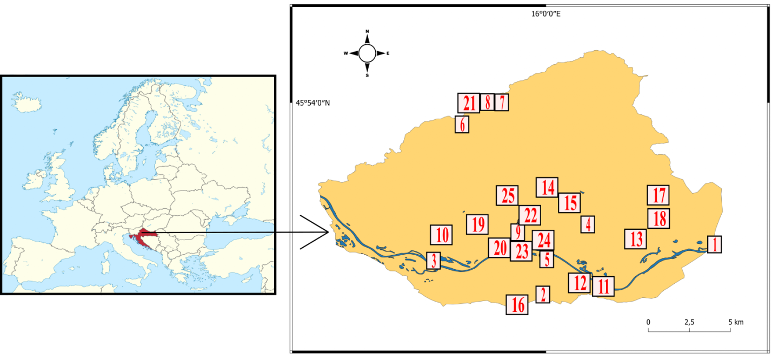
Figure 1. Sampling locations: Hrušćica highway interchange (1); Bauhaus mall Buzin (2); Baseball Club Jarun near Sava River (3); Borongaj (4); Bundek - East (5); St. Jakov church (6); Činovnička meadow – lower part – forest (7); Činovnička meadow - bottom (8); Headship of the city of Zagreb (9); Grubišnopoljski put - Rudeš (10); Jakuševec landfill, East 2 (11); Jakuševec landfill, middle 2 (12); JANAF oil terminal Žitnjak (13); Ravine Rebar Kozjak (14); Stream in Maksimir Park near Bukovačka street (15); Mala Mlaka – near water supply station (16); Mikuševa street - Dubec (17); Novi Jelkovec (18); Righteous Among the Nations Park (19); Prisavlje – along the Sava River (20); Sljeme peak - meadow (21); Strossmayer Square (22); The wider area around the Kunišćak weir (23); Trnjan embankment (24); Tuškanac - meadow (25).

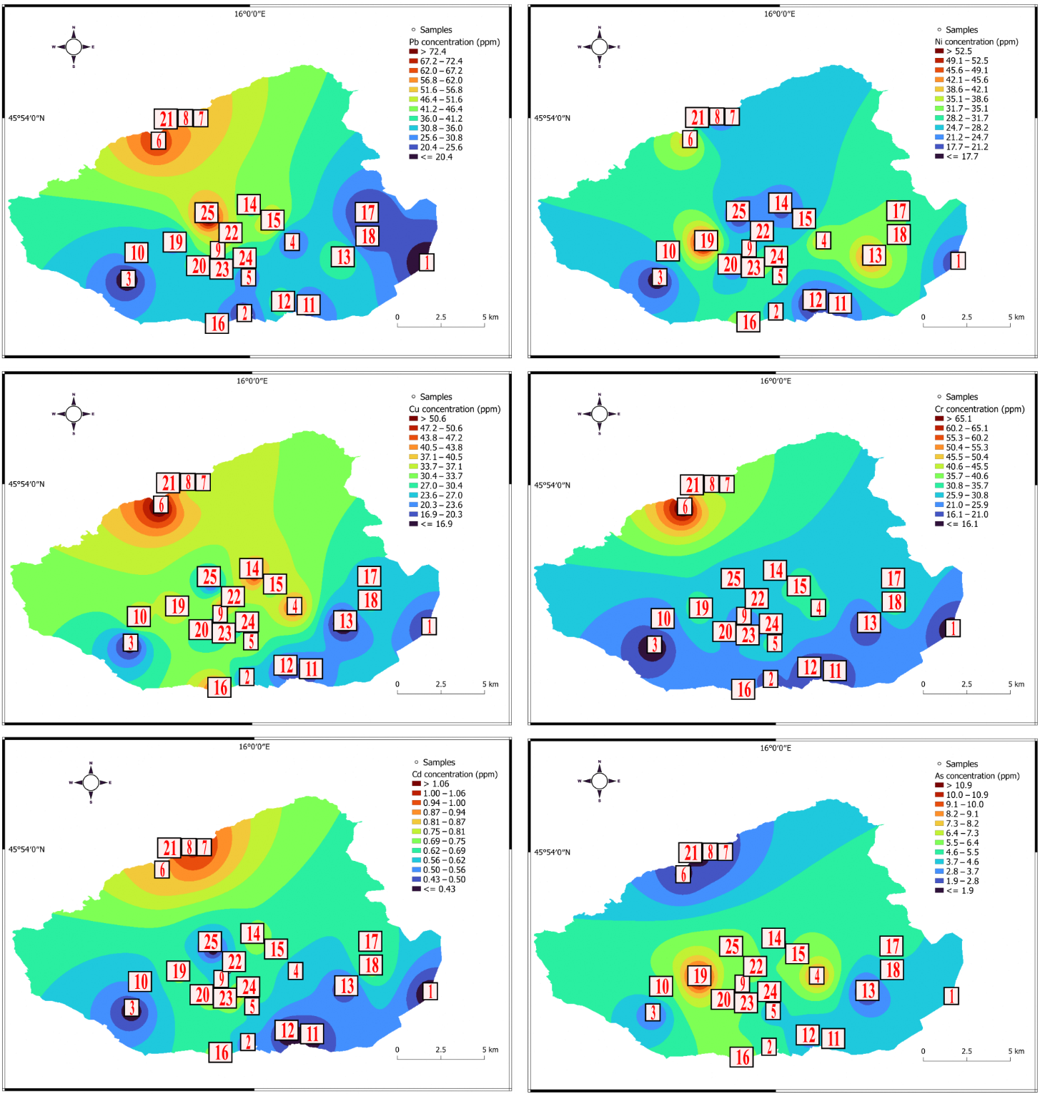
Figure 2. Spatial distribution map of the content of Pb, Ni, Cu, Cr, Cd, and As created by using the QGIS software.

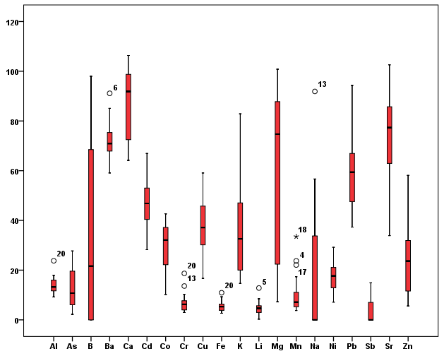
Figure 3. Box-plot diagram for ratio: Element Content (0.43M HNO₃) / Element Content (total)

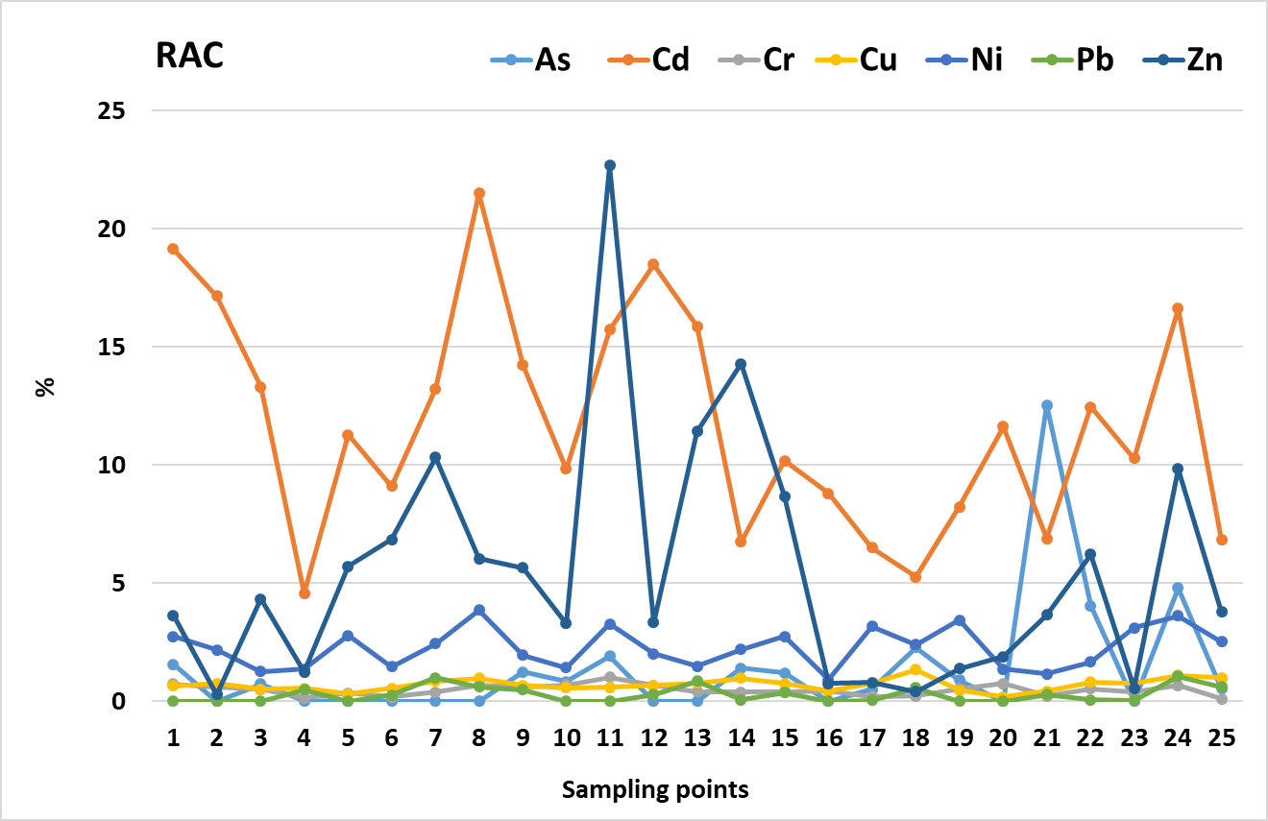
Figure 4. Values of RAC and class: I, no risk (RAC ≤ 1); II, light risk (1 < RAC ≤ 10); III, medium risk (10 < RAC ≤ 30); IV, high risk (30 < RAC ≤ 50); and V, very high risk (50 < RAC)

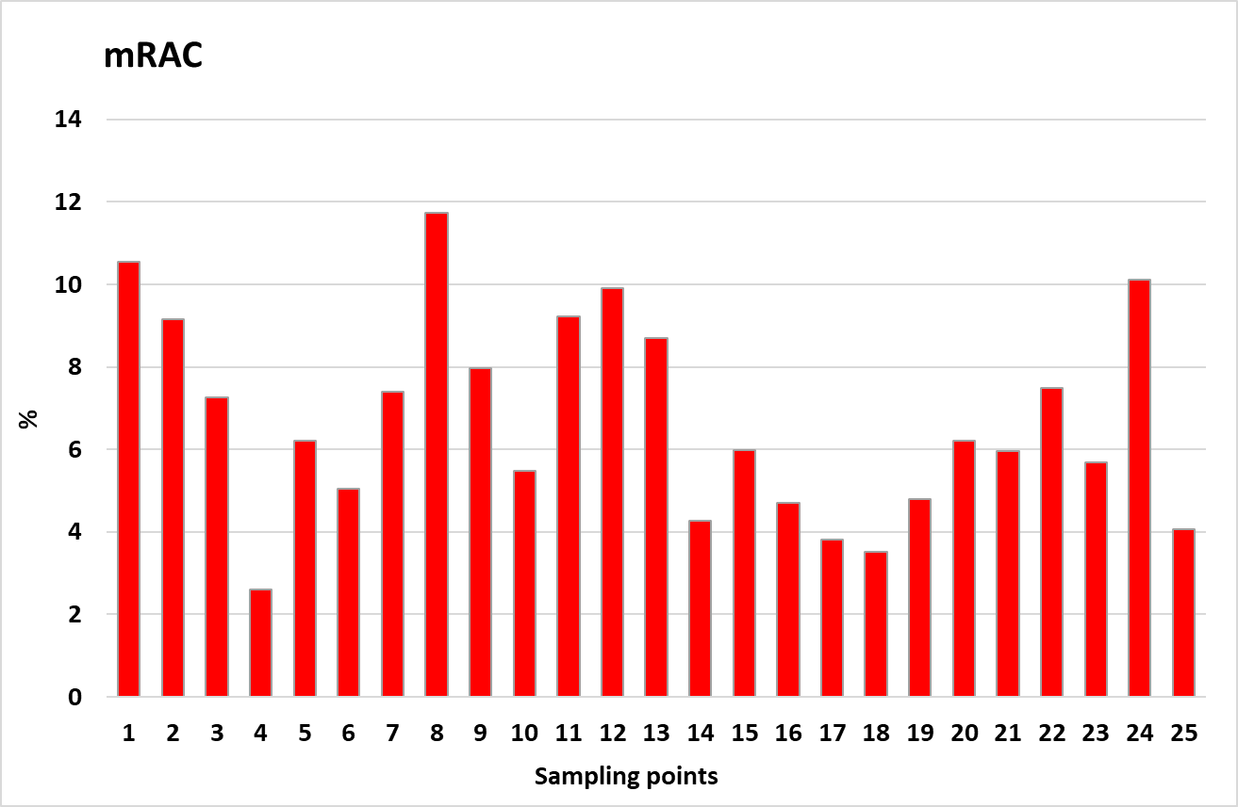
Figure 5. mRAC values in studied soils: mRAC < 1% indicates no potential adverse efect; mRAC = 1–10 % shows low potential adverse efect; mRAC = 10–30 % refects medium potential adverse efect; mRAC = 30–50 % indicates high potential adverse efect; and mRAC ≥ 50% shows that aquatic sediments may have very high adverse effect.
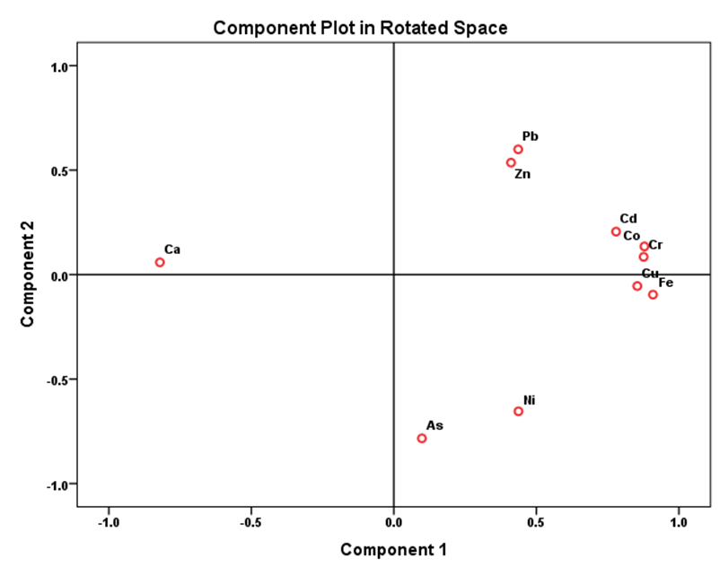
Figure 6. Principal component analysis (R mode) of elements content in studied soils.
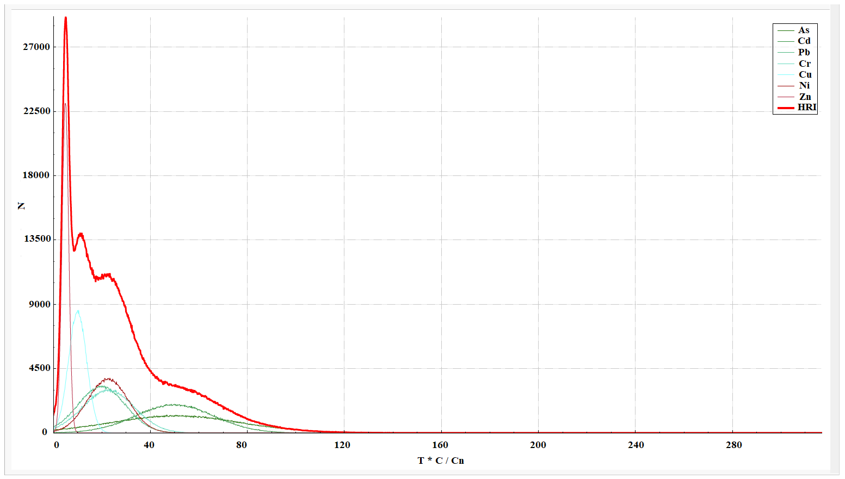
Figure 7. Distribution curve and exceedance probability curves of the risk index (RI) and total ecological risk comprehensive index HRI based on a Monte Carlo simulation run 100,000 times.

