The northern Adriatic circulation regimes in the future winter climate

Natalija Dunić¹, Nastjenjka Supić², Florence Sevault³, Ivica Vilibić^{4*}

¹ Institute of Oceanography and Fisheries, Split, Croatia
² Ruđer Bošković Institute, Centre for Marine Research, Rovinj, Croatia
³ CNRM, Université de Toulouse, Météo-France, CNRS, Toulouse, France
⁴ Ruđer Bošković Institute, Division for Marine and Environmental Research, Zagreb, Croatia

* Correspondence to: I. Vilibić, ivica.vilibic@irb.hr

Abstract

Reliability of climate change projections in coastal and shallow seas may be largely influenced by complex air-ocean-land interactions, like in the northernmost shelf of the Mediterranean, the Northern Adriatic (NAd). However, classification of winter characteristics in the NAd may be simplified following the observed cross-basin bottom density distributions. Two main types of winter circulation occur: (i) type A, when the basin is strongly affected by the freshwater load and (ii) type B, in which the dense water formation is occurring. Neutral winter circulation type with characteristics between types A and B is called type C. This paper evaluates a usage of such a classification in climate models, defines the best proxy index for the winter NAd characteristics and then quantifies winter regimes in the future climate. The latter is assessed by regional coupled atmosphere-ocean model CNRM-RCSM4 for three different scenarios. Acknowledging an offset in density differences, the historical climate run perfectly fits the observations. The number of type C circulation, i.e. with low cross-basin density differences, is projected to increase in the future climate, in particular in RCP4.5 scenario. The number of type A circulation is showing a decrease in all climate scenarios, while type B circulation is decreasing in RCP4.5 and RCP8.5 scenarios. As two main circulation types are conjoined with large differences in biogeochemical properties and fish stocks, these projected changes may have a substantial impact to the future productivity of this least oligotrophic basin in the Eastern Mediterranean.

1 Introduction

The Northern Adriatic Sea (NAd, Fig. 1), 250-km wide northernmost shelf of the Mediterranean basin with depths lower than 80 m, reflects a complex dynamics driven by: (i) the release of one of the largest Mediterranean rivers, Po River (Raicich 1996), (ii) northeasterly bora wind, which may reach gale force and last for more than one week (Grisogono and Belušić 2009), cool the shallow sea and result in formation of the densest Mediterranean water mass that ventilate the deep Adriatic and Ionian Sea (Zore-Armanda 1963; Mihanović et al. 2013), and (iii) by the second largest Mediterranean tides, which may reach substantial height, surpassing one metre (Tsimplis et al. 1995). The freshwater coming from rivers is mostly confined to coastlines during wintertime (e. g. Supić et al. 2004), while springtime surface heating is allowing their spread over most of the basin (Franco and Michelato 1992). Vertical stratification is developed during summer and broken in autumn (October-November). The basin is also affected by quasi-decadal salinity variations (Vilibić et al. 2019), driven by the Adriatic-Ionian Bimodal Oscillating System (BiOS, Gačić et al. 2010), competing with local processes in driving both thermohaline and biogeochemical properties (Vilibić et al. 2020; Ciglenečki et al. 2020).

Indeed, the NAd has been recognized as one of the most productive areas of the Mediterranean Sea due to substantial riverine loads (Degobbis et al. 2000; Bosc et al. 2004). Primary production with its winter maxima, together with the fish stocks, is found to be influenced by the wintertime circulation regimes (Kraus and Supić 2011; Kraus et al. 2015). The regimes have a footprint in the near bottom density distributions (Supić et al. 2012). Such circulation regimes may persist throughout the season, from December to February, reflecting the processes that are occurring in the region (Supić et al. 2012). When near bottom density was found higher in the western part of the NAd, the dense water formation was quite strong within its core in the cyclonic gyre off the Po River delta (Zore-Armanda and Gačić 1987; Beg Paklar et al. 2001; Kuzmić et al. 2007). Under these circumstances, freshened surface waters are confined to the western coast, and - together with the dense water outflow along the western shore (Artegiani et al. 1989; Vilibić and Supić 2005) - they are supporting a strong along-Adriatic exchange and replenishment of the northern Adriatic waters (Orlić et al. 2007). When bottom density was found to be higher along the eastern part of the NAd, such a distribution reflected a strong freshwater influence, whose footprint was found even at the bottom off the Po River delta, implying its strong spreading offshore. In such conditions, the exchange of water masses and the water transport alongshore, i.e. towards southeast, is restricted. Freshened waters are kept inside the shelf region supporting much higher primary production in the basin. Supić et al. (2012) used cross-basin density difference, observed over the repeatedly surveyed transects, as the proxy for circulation patterns in the NAd and defined three types of winter conditions based on a threshold difference value.

Such circulation types, spanning over spatial scales of just a few tens of kilometres, are known to be a challenge for the existing regional models (Somot et al. 2018). Indeed, most of the Mediterranean ocean and coupled atmosphere-ocean climate models are downscaled to a resolution of 6-12 km (Darmaraki et al. 2019), which is still not enough to capture coastal complex NAd circulation. As an example, state-of-the-art atmosphere-ocean coupled system ENEA-REG (Anav et al., 2021) has resolution of 15 km of atmospheric and 1/12º (ca. 9 km) for oceanic part, still not enough to properly capture wintertime NAd dynamics. In particular, to properly quantify the processes in the complex eastern coastal region important for the NAd generation of dense waters, one would need a model with atmospheric and oceanic parts that have resolutions no more than 3-4 and 1-2 km (Pullen et al., 2003; Janeković et al., 2014; Vilibić et al., 2018). As a consequence, dense water formation rates in the NAd are quite underestimated in climate models, with a significant temperature and salinity bias over long-term periods (Dunić et al. 2019). As the evaluated regional models are z-types of models, a poor vertical resolution over shelf regions is affecting vertical stratification reproductivity which reflects on the model-to-measurement biases. Further, the atmospheric forcing used in these models are in the range of 10 to 50 km of resolution, which is not appropriate to properly represent the bora wind and the associated fluxes. Therefore, it is necessary to downscale the climate models to a kilometre resolution (Rockel 2015; Kendon et al. 2021), which was recently done for the Adriatic Sea (Pranić et al., 2021), yet only for the evaluation period (1987-2017). Acknowledging these shortcomings, we propose to use a proxy that reflects the circulation regimes in the NAd, e.g. the cross-basin bottom density difference as it was suggested in Supić et al. (2012). Such an approach will give a possibility to quantify changes in small basin circulation regimes, provided that a proxy is evaluated on reanalysis or observational data.

It should be also highlighted that, to allow estimations of uncertainty in climate models, an ensemble of climate models and their projections should be used. However, these types of models are mostly still in development and not available at the kilometre scale resolution in the NAd, required to reproduce the dynamics of winter bora wind in the coastal eastern Adriatic region. This region is full of channels that extend up to 50 km offshore from the mainland, in which a substantial portion of dense waters in known to form (Janeković et al., 2014; Vilibić et al., 2018). Therefore, in this paper, we aim to show that a rather simple proxy-based approach used to quantify the occurrences of different types of winters in future climate in the NAd, that was previously evaluated on the real data (Supić et al. 2012), can also be used to assess these processes in climate models with inadequate horizontal and vertical resolutions. To achieve that, we assessed CNRM-RCSM4 fully-coupled regional climate model, from which a cross-basin density difference proxy of the historical run is evaluated on the long-term observations. For the future climate, the proxy is quantified for the RCP2.6, RCP4.5 and RCP8.5 climate scenarios based on the concentrations of the greenhouse gases emission. Section 2 describes the model, the observational data and the proxy. Section 3 presents an evaluation of the historical model run, while Section 4 quantifies changes in the NAd over the 30-year intervals, i.e. in the near (2011-2040), middle (2041-2070) and far (2071-2100) futures. Section 5 discusses results and methodology and provides conclusions.

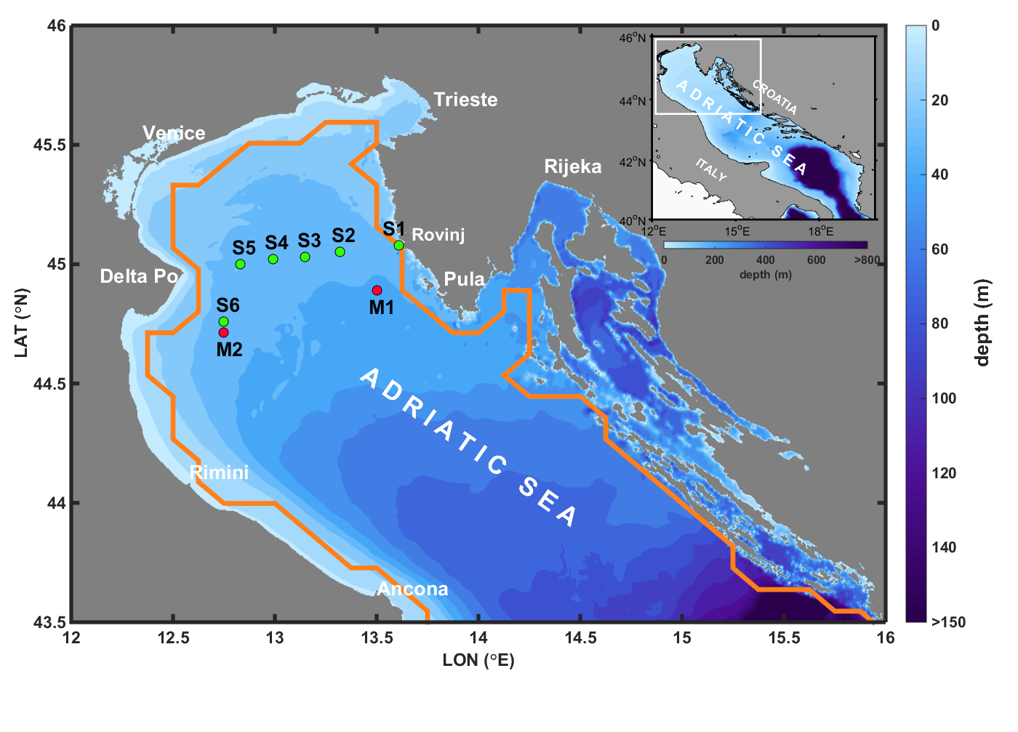
Figure 1. The Northern Adriatic Sea position and bathymetry, with locations where temperature and salinity measurements (S1 to S6) were taken and climate model grid points (M1, M2) used for wintertime cross-basin density gradients computations. Orange line represents the model’s boundary regarding the land.

2 Data and methods

2.1 Observational data

Temperature and salinity data have been collected monthly to bimonthly along the Po River delta – Rovinj transect at six sampling stations (S1 to S6, Fig. 1) between 1981 and 2012. Cruises were organised by the Centre for Marine Research of the Ruđer Bošković Institute, Rovinj, Croatia. The data were sampled at standard depths (0 m, 5 m, 10 m, 20 m and 2 m above the bottom). Temperature was determined using reversed digital thermometers (SIS RTM 4002, SiS Sensoser Instrumente Systeme GmbH, precision ±0.003 °C). For the salinity, high precision laboratory salinometers with accuracy of ±0.01 were used, following IAPSO standard seawater (Culkin and Smed 1979). After mid-2000s, CTD probes were used to cross-check the data; however, they were not included in the dataset to keep the consistency of the measuring technique for the whole time series.

Potential density anomaly (PDA) was determined using the TEOS-10 algorithms (http://www.teos-10.org) with a reference pressure set to zero. When necessary, seasonal signal was removed from all series by fitting annual (12 months) and semi-annual (6 months) cosine functions separately for each parameter (temperature, salinity and PDA), station and depth. The procedure is based on general harmonic regression model (Chatfield 2004; Wilks 2011) and was proven to provide proper estimation of annual averages for the timeseries that are not uniformly sampled throughout a year.

2.2. The model

The model used in our analysis is fully-coupled regional climate model CNRM-RCSM4 (Sevault et al. 2014), consisting of ocean (NEMOMED8 model), atmospheric (ALADIN-Climate model), land (ISBA model) and river (TRIP model) components, mutually coupled with the OASIS3 coupler (Valcke 2013). This particular model is taken from the Med-CORDEX pool of models, as known to have lower biases in the NAd compared to other Med-CORDEX models (Dunić et al., 2019), and since it is a coupled atmosphere-ocean model with full set of projected climate scenarios.

NEMOMED8 ocean model (Regional version of NEMO-V2.3, Madec 2008, Beuvier et al. 2010) has a varying spatial resolution (9-12 km; 9 km in the NAd), with specially designed mesh for the Strait of Gibraltar, to get a realistic transport of the Atlantic water masses to the Mediterranean and vice versa. Bathymetry is based on the ETOPO database (5’ x 5’ resolution, Smith and Sandwell 1997). The model is using z-type vertical grid with 43 unequally distributed vertical z-cells for the whole Mediterranean, of which 7 are overlying the northern Adriatic. Vertical mixing is parametrized using the turbulent kinetic energy scheme (Blanke and Delecluse 1993), with intensified coefficients for vertical diffusion of 10 m²/s for convective adjustments, and of 10⁻⁵ m²/s for interior background diffusion. Lateral boundary conditions are imposed off the Strait of Gibraltar with Atlantic Ocean characteristics (reanalysis or global ocean simulation), while the Black Sea is introduced as a river source to the model, with discharge rates coming from the TRIP model applied to the Black Sea drainage (the details may be found in Sevault et al., 2014) combined with the Evaporation-Precipitation total on the Black Sea from the ALADIN-Climate model. Initial conditions for the historical run are based on the MEDAR/MEDATLAS II climatology (MEDAR/MEDATLAS Group 2002).

Atmospheric component of the model is ALADIN-Climate (Radu et al. 2008) with a horizontal resolution of 50 km. For the river component, TRIP-river routing model (Oki and Sud 1998), with a resolution of 0.5º is used (Szczypta et al. 2012). Interactions between the soil and the atmosphere is resolved using a land scheme of hydrological parameters with ISBA model (Noilhan and Mahfouf 1996). All surface fluxes between atmosphere, ocean and rivers are numerically exchanged with the OASIS3 coupler (Valcke 2013). A complete description of CNRM-RCSM4 configuration can be found in Sevault et al. (2014), with an evaluation on the 1980-2012 period. The difference with the present paper is in the forcing and the period of the simulation.

Three main greenhouse gas emission scenarios given by the Intergovernmental Panel for Climate Change (IPCC) were used for CNRM-RCSM4 future climate simulations: low-emission (RCP2.6), middle-emission (RCP4.5) and high-emission (RCP8.5). All of these simulations imposed atmospheric and ocean boundary conditions coming from the global climate model CNRM-CM5 (Voldoire et al. 2013). In total, after 130 years of coupled spin-up, five different simulations were performed: historical run (HIST) that covers the period from 1950-2005, control run (CTRL) taking the greenhouse gas forcing from the 1950-1979 period and extending it to the whole period of 1950-2100, and three future projections (RCP2.6, RCP4.5, RCP8.5) that started at 2005. To match the sampling size between the observations (1981-2012) and HIST simulation, we considered the period 1980-2005 for evaluation of bottom PDA changes. The comparison between climate scenarios and the HIST simulation is carried out for the near-future (2011-2040), middle-future (2041-2070) and far-future (2071-2100) periods.

A preliminary assessment of the future climate projections of the CNRM-RCSM4 model focused on the Adriatic Sea was performed by Dunić (2019). In the climate simulations, it appears that: (i) surface temperature will expectedly increase when approaching the next century, the most in the RCP8.5 scenario (about 3 ºC in far-future), (ii) surface salinity will initially increase in near- and middle-future periods in RCP2.6 and RCP4.5 scenarios, followed by a decrease in far-future due to stronger Atlantic waters influx to the Mediterranean (Soto-Navarro et al. 2020) – this is not the case for RCP 8.5 scenario, in which salinity will continuously increase till the end of the projected period (up to 1.0), and (iii) the BiOS will be moved towards the anticyclonic regime, abetting Western Mediterranean waters inflow into the Adriatic, preserving its intensity except for the far-future period in RCP8.5 scenario, in which it is foreseen to intensify. The same simulations were analysed in Soto-Navarro et al. (2020).

It should be noted that both, sampled and modelled salt-related data are provided in practical salinity units (PSU), which were used in analyses. For the simplicity, practical salinity is referred as salinity.

2.3 The proxy

As a proxy for determining the type of winter circulation in the northern Adriatic, we implemented the solution provided by Supić et al. (2012) based on the 1981-2007 observations along the Po River delta – Rovinj transect (Fig. 1). They defined three types of ocean winters and the associated circulation, based on the cross-basin bottom density data, specifically as:

${PDA}_{diff}={PDA}_{S2_{30m}}-{\left({PDA}_{S5_{30m}}+{PDA}_{S6_{30m}}\right)}/2$,

where PDAs on the right side of the equation are taken at 30 m depth layer. The analyses were performed monthly using PDA values during winter period (January, February, March - JFM).

Three types of ocean winters based on the PDA_{diff} proxy were introduced: type A occurs when PDA_{diff} > 0.1 kg/m³, type B occurs when PDA_{diff} < -0.1 kg/m³, while type C occurs when the PDA cross-basin gradients are not significant, i.e. for when -0.1 kg/m³ < PDA_{diff} < 0.1 kg/m³. According to Fig. 13 in Supić et al. (2012), type A is characterized with large anticyclonic gyre advecting the freshened Po River waters towards the open Adriatic and blocking the Eastern Adriatic Coastal Current (EACC, Orlić et al. 1992; Artegiani et al. 1997). Instead of entering the NAd area, EACC is cyclonically detoured towards the western coastline. During type B winter, EACC is entering the NAd to its closed end, after which cyclonically detours towards the Po River delta. In this case, fresh water coming from the Po River are flowing as a narrow coastal strip towards the southeast (Supić et al. 2012). Type C winter circulation has not been conceptualized, but a combination of type A and B circulation features may be expected.

3 Model verification

3.1 Po River delta – Rovinj transect climatology

To quantify performance and reliability of climate models in the NAd, the statistics between observed and modelled HIST values of temperature, salinity and PDA along the Po River delta – Rovinj transect have been compared. For the whole year we used de-seasoned values, and for the winter (JFM) the original ones. It should be noted that only part of the HIST simulation period is covered with the observations (1980-2005), due to the time span of the observed series. However, 25 years is enough to capture mesoscale physical processes that occur in the northern Adriatic, and therefore applicable for the evaluation. Modelled values were compared to in situ observations using data from nearest available grid point. Further, it is worth to mention that CTRL simulation didn’t show any deviations (spikes or trends) in the Adriatic region throughout the whole simulation (Dunić 2019).

De-seasoned annual averages of HIST temperature, salinity and PDA profiles show a general resemblance with the observations (Fig. 2), with respective biases averaged over the whole transect of 0.84 ºC, -0.88 and -0.84 kg/m³. The HIST simulation is incapable to reproduce the intensity of both thermocline and halocline – presumably due to insufficient layering in vertical - and, as such, its bottom temperature and salinity values are strongly overestimated and underestimated, respectively. Still, all important (for our analysis) features may be seen in both HIST model and observations: (i) surface layer heating, (ii) spreading of the Po River waters with salinity gradients in the surface and near surface layer from the western to the eastern section of the transect, and (iii) near-bottom cores of the coldest, most saline and densest waters, positioned in the middle of the transect. This is even more relevant for the PDA values, whose changes along the transect are properly reproduced, i.e. maximum bottom values in the middle of the transect, aside a strong underestimation in the bottom layer. An overall PDA increase is found from the western section affected by the Po River fresh waters towards the eastern section of the transect. The item (iii) is relevant for our study, as it points to the conclusion that geostrophic circulation is also qualitatively reproduced by the model. Namely, the large low salinity and low-density pool extending between Po delta and Rovinj is a core of the anticyclonic gyre appearing in climatological fields of the NAd (Krajcar 1993).

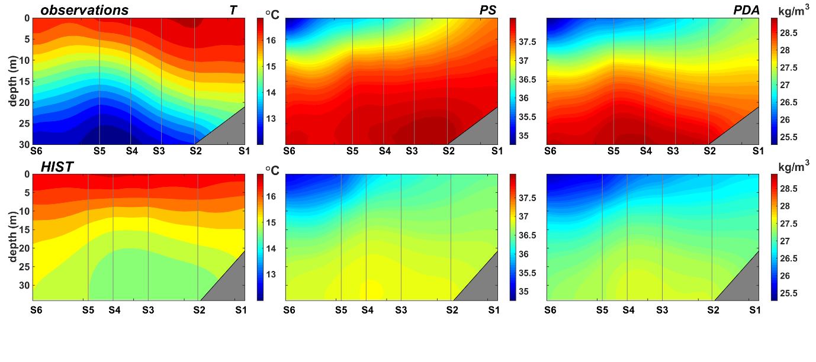
Figure 2. Annual averages of de-seasoned temperature, practical salinity and potential density anomaly (PDA) observed along the Po-Rovinj transect (up) and reproduced by the HIST simulation (bottom).

An effect of having a coarse vertical resolution in the model may also be seen in the averaged winter (JFM) profiles (Fig. 3). Here, the temperature, salinity and PDA biases averaged over the whole transect are 0.41 ºC, -1.20 and -1.00 kg/m³, respectively. Freshened surface waters are having larger influence on the bottom salinity than seen on observations. However, salinity horizontal gradients are relatively well reproduced over the whole water column. The modelled temperature is slightly overestimated and has a weak stratification that is not present in observations. Most likely this appeared due to improper surface cooling rates coming from quite coarse resolution of the ALADIN model. Because of both temperature and salinity effects, bottom PDA is more underestimated along the western than along the eastern section of the transect, which has a potential to create an offset in the east-west density difference (see Section 3.2).

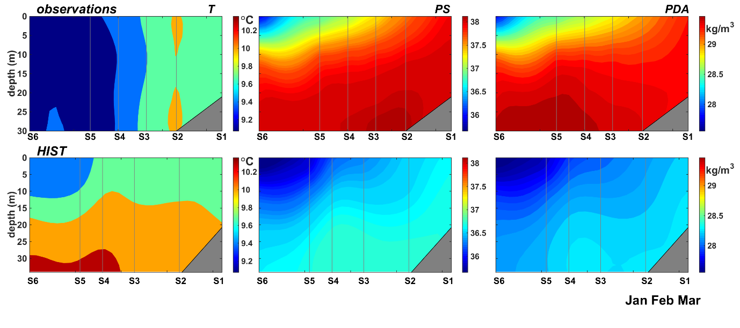
Figure 3. Winter averages (JFM) of temperature, practical salinity and PDA observed along the Po-Rovinj transect (up) and reproduced by the HIST simulation (bottom).

3.2 Cross-basin bottom density difference

We found several potential problems while attempting to quantify PDA_{diff} in the HIST simulation. First, the NEMOMED8 model resolution is coarse, with the coastal strip from the Gulf of Trieste down to the complex coastal region of the Kvarner Bay not properly present in the model’s domain (Fig. 1, orange line). These areas are found to contribute to different processes in the NAd, like the dense water formation (Raicich et al. 2013; Janeković et al. 2014). Second, a coarse horizontal and vertical resolution of NEMOMED8 model is affecting vertical and horizontal mixing, preventing precise reproduction of fine circulation patterns in the NAd (e.g. Beg Paklar et al. 2001; Kuzmić et al. 2007). Third, a coarse resolution of the ALADIN-Climate model cannot reproduce the bora wind jets, and thus the dense water formation is underestimated (Dunić et al. 2019). Lastly, the Po River discharges reproduced by the TRIP model are overestimated for the period between 1950-2005 (of about 232 m³/s on average, Fig. 4). During winter (JFM), Po discharges are only slightly underestimated (of about 134 m³/s), but this still may affect its spreading towards the eastern part of the NAd. Interestingly, there is a one-month shift in annual cycle of the HIST simulation, in particular with the summer maximum in discharges (furthermore overestimated due to the absence of dams in TRIP). However, this shift is not present during the winter (JFM), which is the period of interest in this study. The shift might be the result of misrepresentations of snow melting in the ISBA model, as the spring/summer maximum of the Po River discharge is mostly driven by it (Ravazzani et al. 2015).

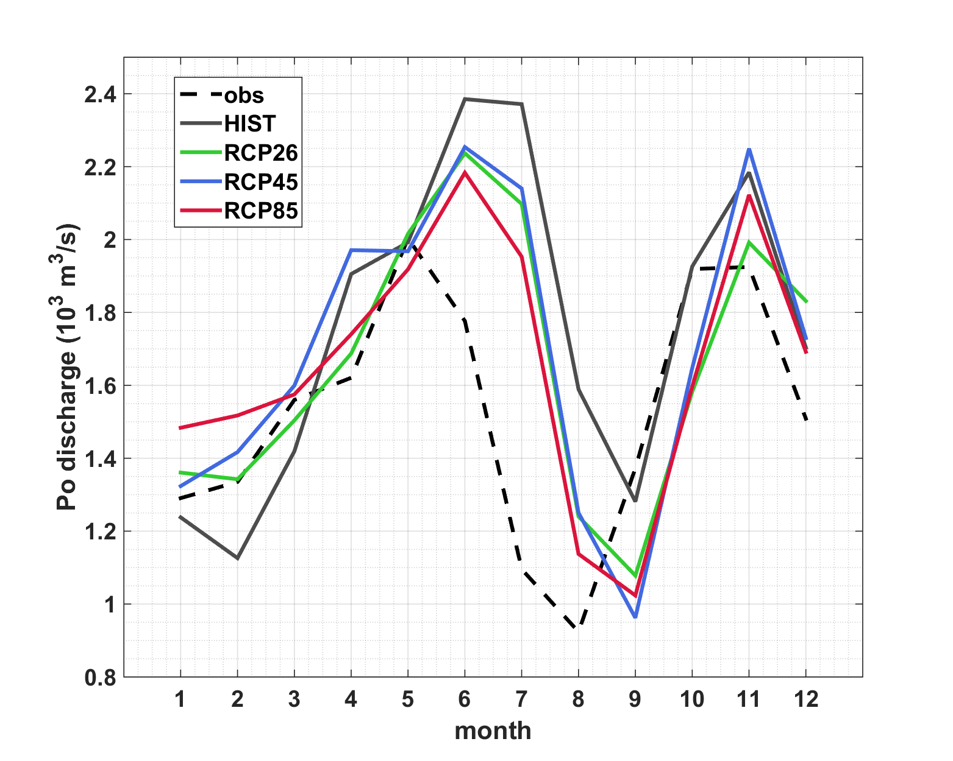
Figure 4. Averaged annual cycle of Po River discharges. For the observed and HIST data, values were estimated for the period 1950-2005, and for the projections, values were estimated for the period 2006-2100.

For those reasons, and to properly determine PDA_{diff} within climate simulations, we considered different choices of grid points in the CNRM-RCSM4 model, specifically their bottom PDA values. Precisely, we took several model grid points that are close to the S2 station and several grid points close to the centre between S5 and S6 stations and then defined model PDA_{diff} as a difference of their bottom PDA values. The criterion was to find a PDA_{diff} distribution in the HIST simulation that most resembles PDA_{diff} estimated from the observations (which presents a normal distribution), conjoined with a minimum bias between HIST and observational distributions. Fig. 5 shows the slopes of 11 HIST PDA_{diff} distributions and the observed PDA_{diff} distribution (slope = 0.15), together with the conjoined biases estimated between HIST and the observational PDA_{diff} distributions. Among all examined HIST PDA_{diff} distributions, we chose the distribution no. 9 (Fig. 5), having the closest slope of ~0.15 and a small bias of 0.20 kg/m³, also acknowledging the proximity of the chosen grid points to the transect stations (M1 and M2 in Fig. 1). Therefore, PDA_{diff} of the HIST simulation is computed as the difference between the modelled bottom PDA at grid points M1 and M2, both points located about 20 kilometres southeast from the stations where PDA was measured.

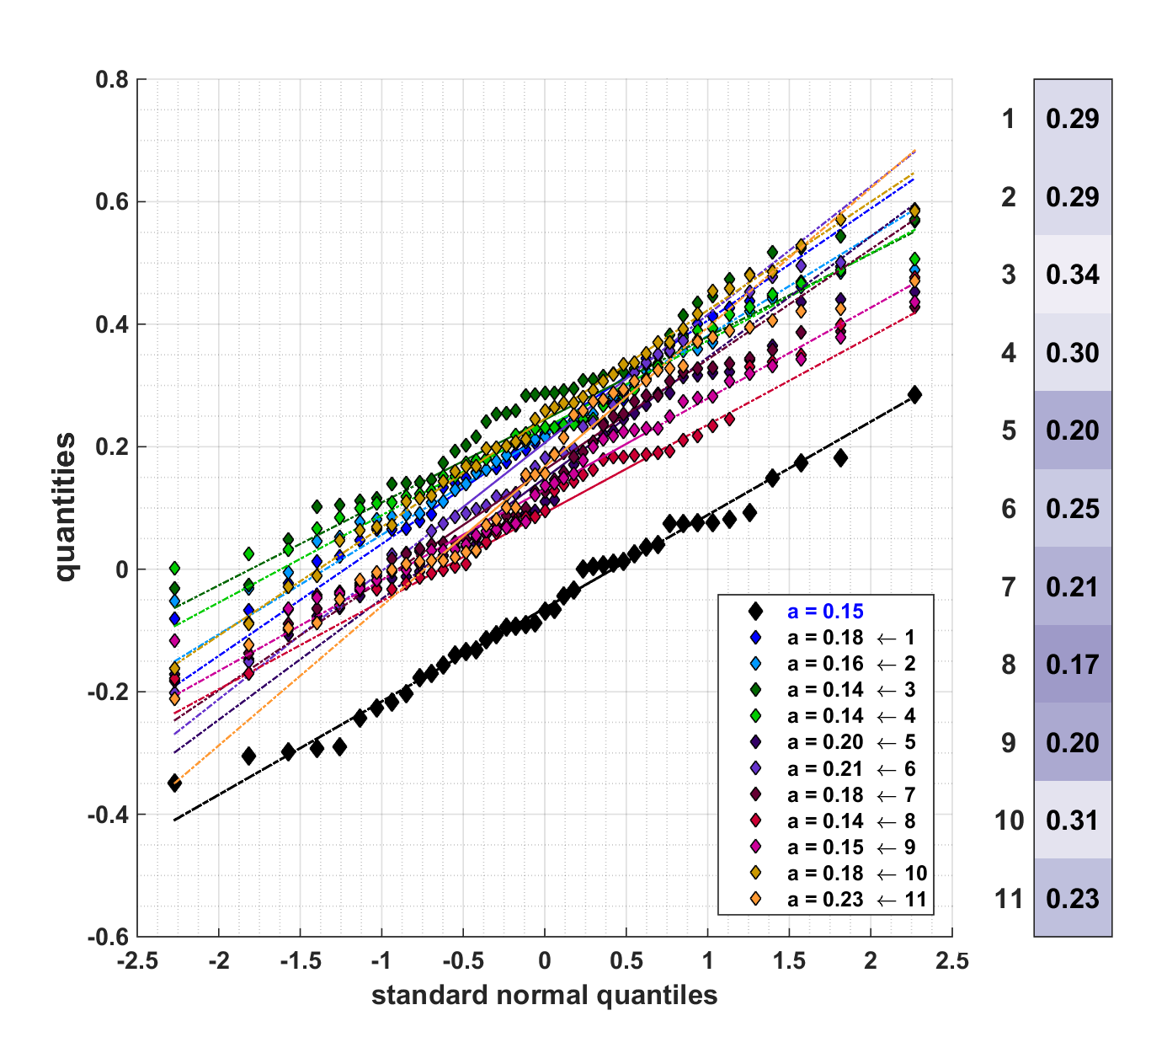

Figure 5. Standard normal quantile distributions of observed (black) and modelled (other colours) monthly winter PDA differences (JFM) between eastern and western northern Adriatic. Only 11 different possible sets of positions considered for the HIST run are shown. The slopes of the distributions are listed in the inset, while the biases between modelled and observed distributions are presented to the right.

To double-check the resemblance of the HIST PDA_{diff} distribution to the observational one, we removed the bias from the modelled PDA_{diff} (Fig. 6). The resulting distribution is showing a substantial resemblance with the observations, including the transitions observed between winter months of the same winter (not shown). Both in observations and HIST simulation, most of the years are showing perseverance of circulation type B throughout a winter, resembling pronounced dense water formation in the NAd. Winters with the transition from neutral type of circulation C in January towards circulation type B in March also appeared to be frequent, indicating the appearance of moderate dense water formation. Winters associated with the spreading of fresher river Po waters appeared only as moderate ones, in which A type of circulation in February is followed by a neutral type C. Similar was observed within the measurements.

To get an overall insight into the model ability to recognize three different types of winter circulation, we investigated the frequencies of circulation types occurrences in general (Fig. 6 right panel). It seems that the frequency of occurrences is coinciding between observations and HIST. Precisely, type A circulation occurred 6 times in HIST simulation (of totally 43 conjoined with observations), while being classified in 4 observations. On the other hand, type B circulation occurred 20 times in the HIST run versus 17 in observations. Neutral type C mostly occurred during January and March, slightly less present in the HIST run (17 times) than in observations (22 times). Even though CNRM-RCSM4 model has coarser resolution that in general resulted with oversimplification of NAd winter physical processes, it seems that a relatively simple method of calculating the PDA_{diff}, previously shown to represent circulation patterns in the NAd, could be a reasonable alternative to assess the future winter macro-circulation types under different climate scenarios of these types of models.

Bottom density NAd conditions in HIST simulation are resembling the classification as described in Section 2 (Fig. 7). During winter type B circulation, bottom PDA is largely homogeneous in space, with densest waters located at the northernmost part of the domain and along the western slope of the NAd. Such distribution is resembling bottom density distribution as it was observed and modelled after the dense water formation events, when dense waters already started to spread southeastward as a bottom density current (Artegiani et al. 1989; Mihanović et al. 2013; Janeković et al. 2014). It seems that this type of circulation is relatively frequent in NAd, with approximatively 40% of occurrences. Conversely, strong along-basin PDA gradients are present during winter type A, with density increment towards southeast. Along the western coastline, the density is largely influenced by the salinity. These situations happen relatively seldom, for about 10% of all cases. Bottom PDA distribution during winter type C is characterized by a large central area of densest waters everywhere, except along the northern and western coastal strip, obviously affected by the freshened riverine waters.

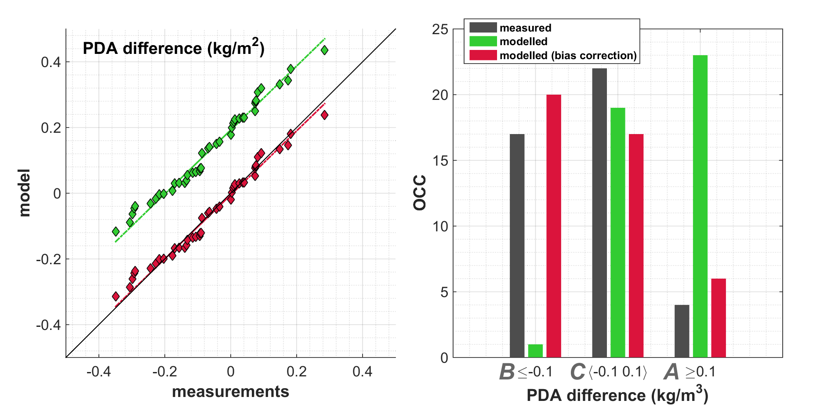

Figure 6. Model-to-observations Q-Q plot (left) and distributions (right) of bottom PDA difference between the eastern and the western northern Adriatic associated with three types of monthly winter circulation. Both plots are showing results for the original model data (green) and for those with the bias correction (red). Observed PDA values are taken at stations S2, S5 and S6, while modelled PDA values are taken at grid points M1 and M2 from the HIST simulation.

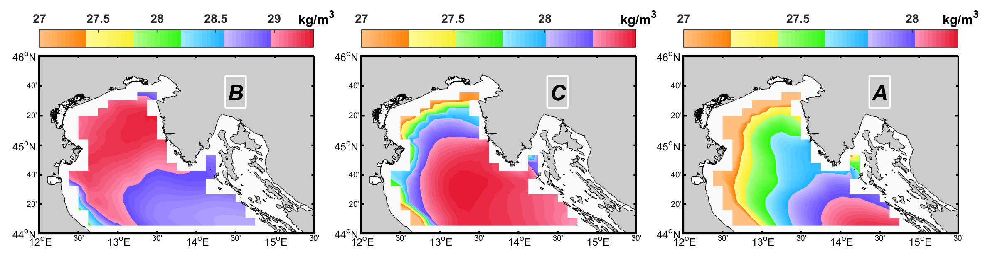

Figure 7. Distributions of HIST bottom PDA values during single winter month in which PDA difference between eastern and western northern Adriatic was the lowest negative (type B) and the largest positive (type A). Single winter month representing neutral type of winter, when the PDA difference was closest to zero, is denoted with C.

4. Climate projections

Averaged annual cycle of Po River discharge in HIST simulation is projected to slightly decrease for all simulations, in particular during June-October period (Fig. 4). The highest differences can be seen during the winter minima (JFM), for which in RCP8.5 the discharges are projected to be about 264 m³/s higher. The trends of the scenarios in the 2006-2100 period are 3.6 m³/s/yr, non-significant and -3.2 m³/s/yr for RCP2.6, RCP4.5 and RCP8.5, respectively. The winter (JFM) trends are only significant for RCP2.6 with a value of 4.2 m³/s/yr, while RCP4.5 and RCP8.5 have substantially negative trends in summer (JAS), -4.8 m³/s/yr and -4.4 m³/s/yr (not significative for RCP2.6).

Compared to the HIST run, a general decrease of the NAd bottom PDA from the near (2011-2040) to the far future (2071-2100) can be seen in all climate scenarios (Fig. 8). It should be noted that bottom PDA is initially increasing during the middle future (2041-2070) of RCP2.6 and RCP4.5 due to an increase in salinity (not shown), then rapidly decreasing as the temperature effect starts to strongly dominate. Interestingly, the positive anomalies in relation to the HIST simulation have been found in the near future, in particular in the RCP2.6 and RCP4.5 scenarios. This is probably the result of the salinity effect in the HIST simulation, as the 1980-2005 period (which we choose as a match with the observations) is characterized by somewhat lower salinities compared to the whole HIST period (1950-2005; Dunić 2019). Bottom PDA decrease till the end of the analysed period is dominantly the result of the heating, and thus increased temperatures (not shown). On the other hand, salinity increase (not shown) is acting oppositely and slowing down bottom PDA decrease in time. The salinity effect is as strong as the temperature effect to the bottom PDA between RCP8.5 middle-future (2041-2070) and far-future (2071-2100) period. Another exception is the salinity decrease between middle-future and far-future in RCP2.6 and RCP4.5 scenarios, which is boosting bottom PDA decrease in the NAd. This is attributed to larger advection of Atlantic waters that overcompensate increased evaporation reproduced for the Central Mediterranean (Soto-Navarro et al. 2020) and Po River discharge trends, that are positive in winter in all scenarios.

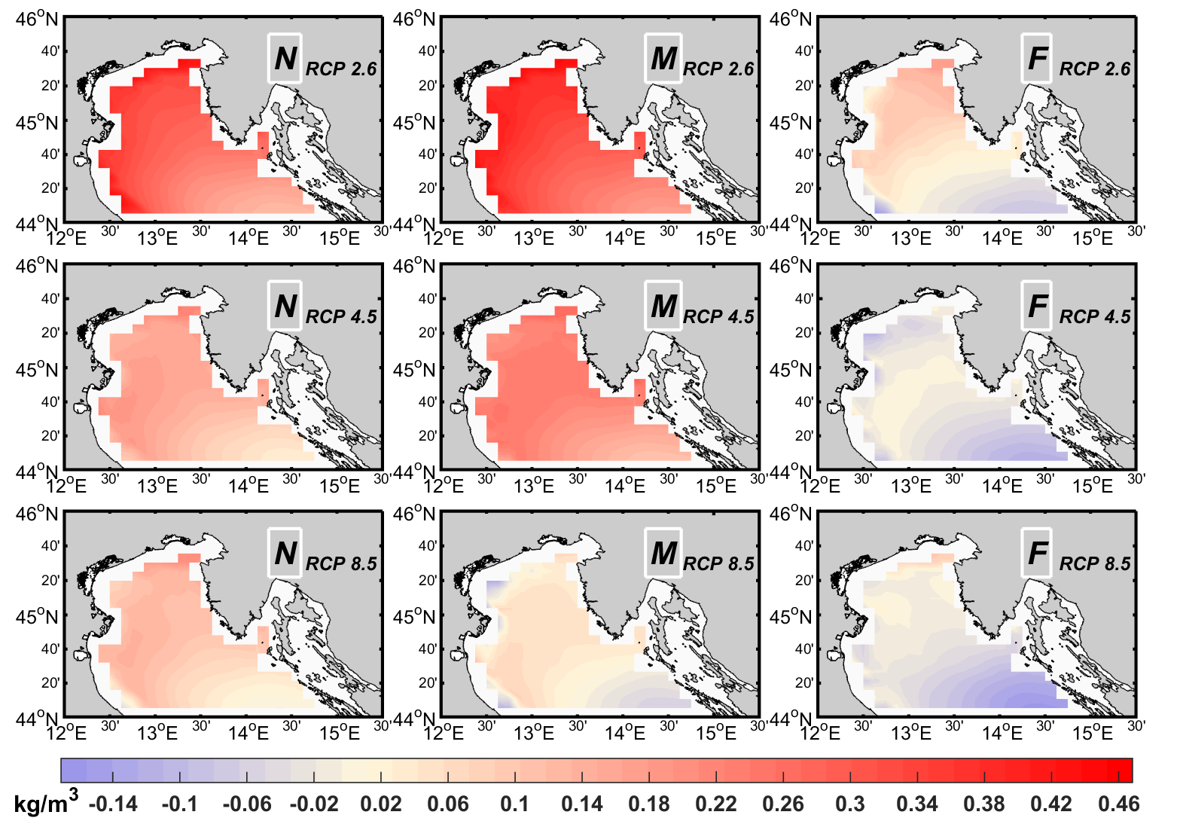

Figure 8. Distributions of bottom PDA anomalies for RCP2.6 (up), RCP4.5 (middle) and RCP8.5 (bottom) scenarios in the near (N, 2011-2040), middle (M, 2040-2070) and far future (F, 2071-2100), during the winter (JFM) with respect to the HIST simulation (1980-2005).

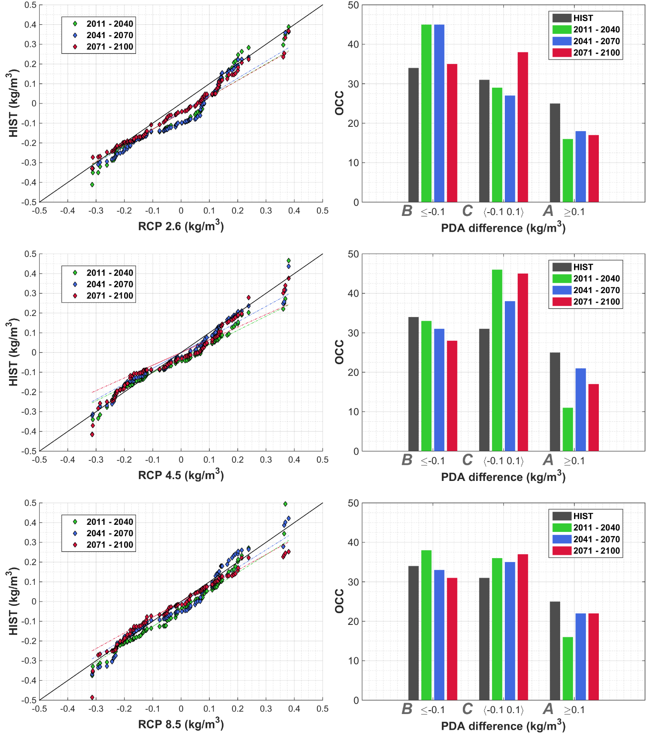

Figure 9. CNRM-RCSM4 projections-to-HIST Q-Q plots (left) and distributions (right) of monthly winter (JFM) bottom PDA difference between the eastern and the western northern Adriatic, for the near (2011-2040), middle (2041-2070) and far (2071-2100) future.

Regarding PDA_{diff} in future climate scenarios (Fig. 9), their distributions didn’t show substantial changes compared to the HIST simulation (1980-2005). For RCP2.6, the distributions are better aligned with HIST at their tails, while higher PDA_{diff} values may be found approximately between -0.13 and 0.09 kg/m³. For RCP4.5 and RCP8.5 scenarios, the differences between distributions are even less pronounced and spread over the whole range of percentiles. The occurrences of both ocean winter circulation type A and type B in RCP4.5 and RCP8.5 are slightly decreased in NAd, followed by an increase of the neutral circulation type C. In RCP2.6 climate scenario, type A is expected to be more present. To some extent, the decrease of occurrences in both situations - one with the pronounced dense water formation in the NAd (type B) and the other with unrestricted spreading of freshened waters toward the open NAd (type A) - is envisaged, as dense water formation events are projected to stagnate or to decrease in the extreme climate projection scenarios (Gampe et al. 2017; Soto-Navarro et al. 2020). For river freshwater load, winter Po discharges are somewhat larger during winter months (JFM, Fig. 4), however decreasing through the rest of a year, presumably contributing to an overall less freshwater presence in the NAd. This is especially evident in RCP8.5 scenario.

Although the PDA distributions associated with the types A, B and C of ocean winter circulation are changed in the future climate (Fig. 10), the dominant characteristics are preserved. Precisely, type B bottom PDA is characterized with highest values of bottom PDA in the northernmost part of the NAd in RCP2.6 and RCP8.5. Compared to the HIST run, these values are much lower (for about 0.5-0.7 kg/m³). East-to-west bottom PDA gradients, recognizably for this type of circulation, are present in all far-future scenarios, with limited spreading of lighter waters to the west due to lower salinity. The same was found in the HIST simulation. PDA distributions during winter ocean circulation type C have maximum PDA located to the south. Bottom PDA in type C was found much higher than in type B, classifying this type as a combination between dense water generation and the flooding of the NAd with freshened waters, as reproduced by the HIST simulation. During A type of winter ocean circulation in all scenarios, horizontal bottom PDA distributions have strong west to east gradients, revealing the spreading of the Po-origin fresh waters. These gradients are the strongest in RCP8.5 scenario.

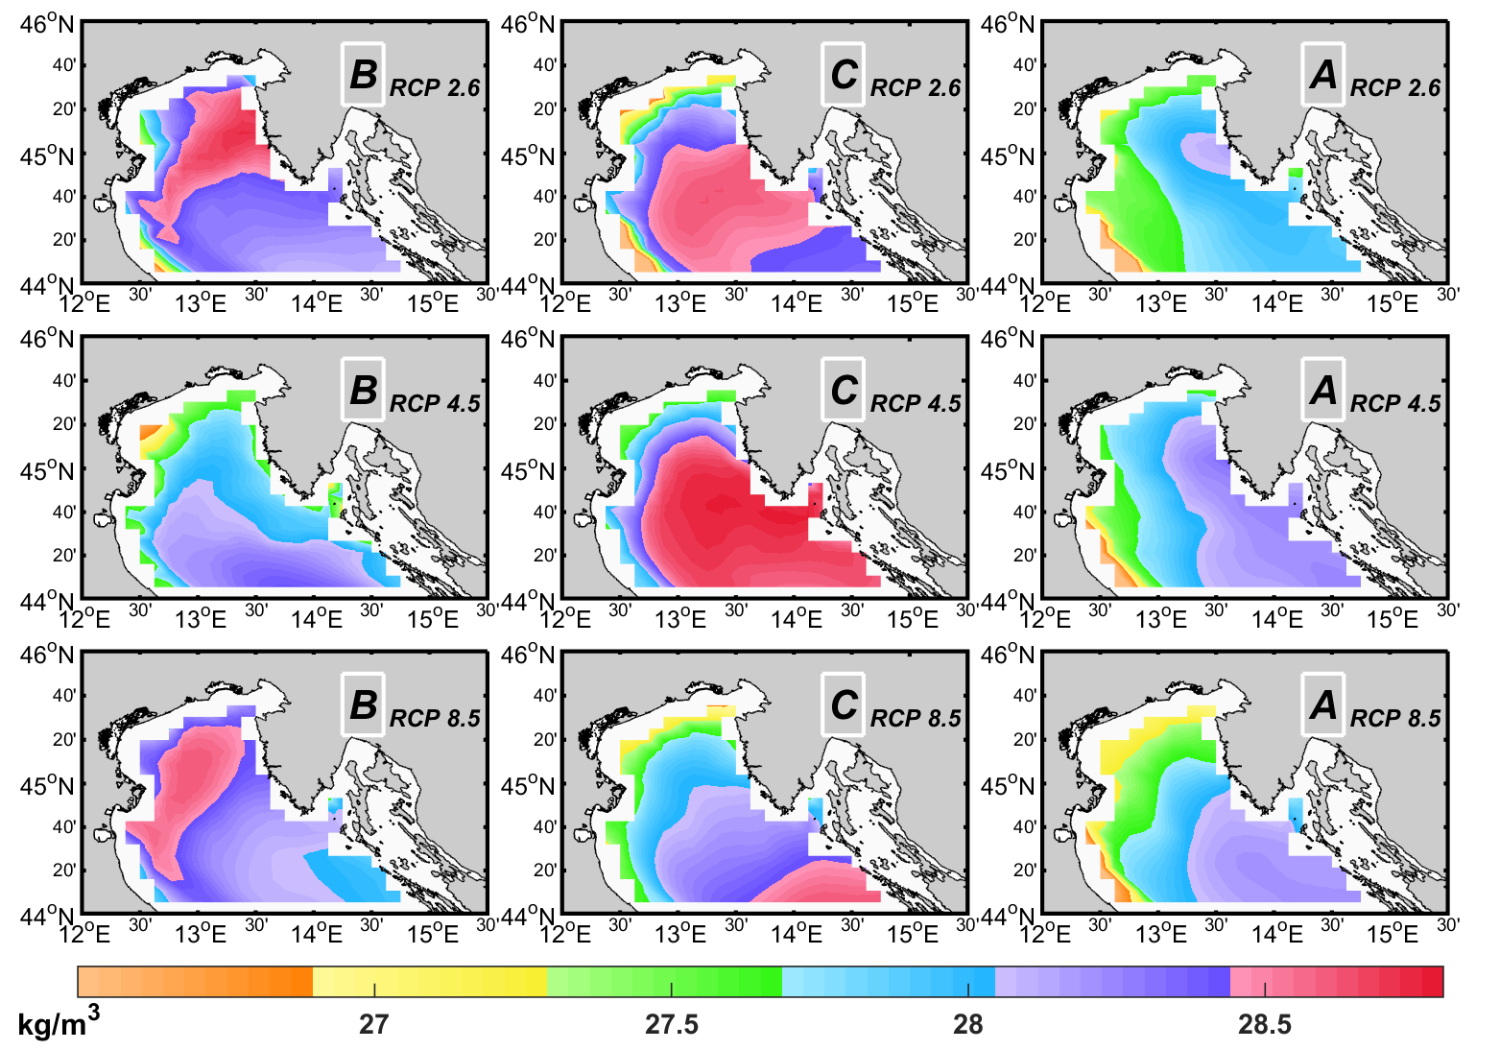

Figure 10. Distributions of bottom PDA values for RCP2.6 (up), RCP4.5 (middle) and RCP8.5 (bottom) scenarios in the far future (2071-2100), during single winter month in which PDA difference between the eastern and the western northern Adriatic was lowest negative (B type; left), closest to zero (C type; middle), and largest positive (A type; right).

5. Discussion and conclusions

There are several issues that are needed to discuss, following our analysis which opens a window to the possible future of the NAd thermohaline properties and dynamics. First, there is the question if such a proxy approach, defined by the density difference between two NAd coastlines, may capture the real circulation, which might be quite complex in the NAd. In detail it cannot, however our intention is not to map all the details of the circulation, rather to classify the basic types of ocean winter basin-wide circulation patterns. The circulation of the NAd is composed by a large number of smaller features (Brana and Krajcar 1995, Supić et al. 2000; Krajcar 2003; Lyons et al. 2007; Bolaños et al. 2014); however, these features are embedded in the basin-wide circulation that is shaped by two major mechanisms: (i) surface heat losses and currents driven by strong winds, in particular of bora that is generating NAd dense waters, and (ii) substantial freshwater load, in particular of Po River, that is changing the buoyancy in this shallow region. As shown by Supić et al. (2012), two different phenomena, the dense water formation and the spread of freshened waters, can be documented by the bottom density distribution and used to classify NAd ocean winter climate and circulation patterns. Even though regional climate models are still far from their full capacity to reproduce mesoscale variability mostly due to their insufficient resolution for such purposes (Giorgi and Gao 2018), they are still useful to assess major classifications. Greatest advantage of the presented simulations is that CNRM-RCSM4 model has a stable control run (Dunić 2019) and three scenarios under presumed climate changes. This allowed us to make the assessment of appearance of three major ocean circulation types using a relatively simple method, that we have shown to be suitable for the models with coarser resolutions.

The next question is: "Will ocean climate and circulation associated with the basic identified typologies (A, B and C) remain approximately the same in the future?". Our analysis showed that some differences are visible between the projections and the present climate, as seen in the bottom PDA values. However, both driving processes – the dense water formation and the riverine discharges – will prevail. Bora wind is orographically driven and just small spatial differences may occur in cooling rates over the NAd, while the major wind jets and the associated cooling banners will prevail (Denamiel et al. 2020). Regarding the NAd rivers, their discharges might increase in RCP2.6 or decrease in RCP8.5 scenarios (increase mostly during winter and decrease during summer), yet keeping its seasonal cycle. Further, it is expected a substantial warming of the shallow NAd, following already large observed temperature trends, found in both in situ and remote sensing data (Shaltout and Omstedt 2014; Pastor et al., 2018; Vilibić et al. 2019). As the shallowest Mediterranean region, the NAd is more sensitive to radiational increase expected in future climate. In parallel, NAd salinity will increase, following the projected overall salinity increase in the Eastern Mediterranean, river discharge decrease in the Adriatic and an increase in evaporation rates over the area (Adloff et al., 2015; Soto-Navarro et al. 2020).

The analysis of NAd ocean winter climate and circulation in the projections may be used to quantify future changes in biogeochemical and biological variables and general activities, including fishery. The projected types of ocean winters were already associated with primary production in Supić et al. (2012), in which type A of circulation is characterized – due to increased advection of riverine nutrients towards the open NAd – with higher production rates. Kraus et al. (2015) extended the analysis to zooplanktons and anchovy, showing that zooplankton abundances are increased during type A of ocean winter circulation, in which ciliates are dominated. The consequence is an increase in anchovy abundance, since they are zooplanktivorous. Even a slight change of circulation type A winter, as it is foreseen as a possible future in all climate projections, may have an impact to the fisheries in the NAd, where substantial anchovy catches are taken (Cingolani et al. 1996). Of course, such a change cannot be derived by hydrodynamical climate models only, in particular in the era of changes in primary production and trophic chains (Lotze et al. 2019; Pages et al. 2020; Budiša et al. 2022).

Finally, our analyses are based only on a single climate model projection, therefore not capable to quantify the uncertainty of such an approach. To get more reliable information on possible futures under a climate scenario, an ensemble of climate models is necessary (Dubois et al. 2012; Flato et al. 2013; Llasses et al. 2018). However, the building of a robust Med-CORDEX ensemble is still undergoing, as the present 15 ocean simulations in a Med-CORDEX ensemble (Soto-Navarro et al., 2020) are ranging in horizontal resolutions from 9 to 30 kilometres, while some of them having 21 z-levels in vertical only and therefore only a few in the NAd. This points to a precaution for assessing such ensembles that should be placed on single-model evaluations in coastal, complex and shallow regions such as the northern Adriatic Sea. In these regions some models may also fail due to improper introduction of boundary conditions, e.g. coupled rivers or atmospheric forcing (Dunić et al. 2019). To conclude, our research is presenting a method to breakthrough into future climate of dominant circulation patterns for a small coastal complex region, while the ensemble-based estimation of reliability of the method and projection uncertainties should follow.

Declarations

Acknowledgements: We are grateful to all colleagues, including the research vessel crew
of the Centre for Marine Research of the Ruđer Bošković Institute, that collected the data along the Po River – Rovinj transect within frame of various funding schemes since 1972. Comments raised by two anonymous reviewers greatly improved the manuscript.

Funding: This study is supported by the Croatian Science Foundation through projects BivACME (grant no. IP-2019-04-8542) and EcoRENA (grant no. IP-2016-4764).

Competing interests: The authors have no relevant financial or non-financial interests to disclose.

Data availability: Observations used in this study are available in the Open Science Framework repository at https://osf.io/4j7sp, while the climate simulations are accessible through the Med-CORDEX webpages at https://www.medcordex.eu.

References

Adloff F, Somot S, Sevault F, Jorda G, Aznar R, Deque M, Herrmann M, Marcos M, Dubois C, Padorno E, Alvarez-Fanjul E, Gomis D (2015) Mediterranean Sea response to climate change in an ensemble of twenty first century scenarios. Clim Dyn 45:2775-2802. https://doi.org/10.1007/s00382-015-2507-3

Anav A, Carillo A, Palma M, Struglia MV, Turuncoglu, UU, Sannino G (2021) The ENEA-REG system (v1.0), a multi-component regional Earth system model: sensitivity to different atmospheric components over the Med-CORDEX (Coordinated Regional Climate Downscaling Experiment) region. Geosci Model Dev 14:4159–4185. https://doi.org/10.5194/gmd-14-4159-2021

Artegiani A, Azzolini R, Salusti E (1989) On the dense water in the Adriatic Sea. Oceanol Acta 12:151–160.

Artegiani A, Bregant D, Paschini E, Pinardi N, Raicich F, Russo A (1997) The Adriatic Sea general circulation. Part I: air-sea interactions and water mass structure. J Phys Oceanogr 27:1492-1514. https://doi.org/10.1175/1520-0485(1997)027<1492:TASGCP>2.0.CO;2

Beg Paklar G, Isakov V, Koračin D, Kourafalou V, Orlić M (2001) A case study of bora-driven flow and density changes on the Adriatic Shelf (January 1987). Cont Shelf Res 21:1752-1783. https://doi.org/10.1016/S0278-4343(01)00029-2

Beuvier J, Sevault F, Herrmann M, Kontoyiannis H, Ludwig W, Rixen M, Stanev E, Béranger K, Somot S (2010) Modelling the Mediterranean Sea interannual variability during 1961–2000: focus on the Eastern Mediterranean Transient. J Geophys Res 115:C0817. https://doi.org/10.1029/2009JC005950

Blanke B, Delecluse P (1993) Variability of the tropical Atlantic Ocean simulated by a general circulation model with two different mixed layer physics. J Phys Oceanogr 23:1363-1388. https://doi.org/10.1175/1520-0485(1993)023<1363:VOTTAO>2.0.CO;2

Bolaños R, Tornfeldt Sørensen JV, Benetazzo A, Carniel S, Sclavo M (2014) Modelling ocean currents in the northern Adriatic Sea. Cont Shelf Res 87:54-72. https://doi.org/10.1016/j.csr.2014.03.009

Bosc E, Bricaud A, Antoine D (2004) Seasonal and interannual variability in algal biomass and primary productionin the Mediterranean Sea, as derived from 4 years of SeaWiFS observations. Global Biogeochem Cycles 18:GB1005, https://doi.org/10.1029/2003GB002034

Brana JH, Krajcar V (1995) General circulation of the northern Adriatic Sea: Results of long-term measurements. Estuar Coastal Shelf Sci 40:421-434. https://doi.org/10.1006/ecss.1995.0029

Bryden HL, Candela J, Kinder TH (1994) Exchange through the Strait of Gibraltar. Prog Oceanogr 33:201-248. https://doi.org/10.1016/0079-6611(94)90028-0

Budiša A, Paliaga P, Juretić T, Lučić D, Supić N, Pasarić Z, Đakovac T, Mladinić M, Dadić V, Tičina V (2022) Distribution, diet and relationships of the invasive ctenophore Mnemiopsis leidyi with anchovies and zooplankton, in the northeastern Adriatic Sea. Medit Mar Sci 22:827-842. https://doi:10.12681/mms.23305

Chatfield C (2004) The Analysis of Time Series: An Introduction, sixth ed., Chapman and
Hall/CRC, 352 pp.

Ciglenečki I, Vilibić I, Dautović J, Vojvodić V, Ćosović B, Zemunik P, Dunić N, Mihanović H (2020) Dissolved organic carbon and surface active substances in the northern Adriatic Sea: Long-term trends, variability and drivers. Sci Tot Environ 730:139104. https://doi.org/10.1016/j.scitotenv.2020.139104

Cingolani N, Giannetti G, Arneri E (1996) Anchovy fisheries in the Adriatic Sea. Sci Mar 60 (Suppl. 2):269-277.

Culkin F, Smed J (1979) The history of standard seawater. Oceanol Acta 2:355–364.

Darmaraki S, Somot S, Sevault F, Nabat P (2019) Past variability of Mediterranean Sea marine heatwaves. Geophys Res Lett 46:9813-9823, https://doi.org/10.1029/2019GL082933

Degobbis D, Precali R, Ivančić I, Smodlaka N, Fuks D, Kveder S (2000) Long–term
changes in the northern Adriatic ecosystem related to anthropogenic eutrophication.
Int J Environ Poll 13:495-533. https://doi.org/10.1504/IJEP.2000.002332

Denamiel C, Tojčić I, Vilibić I (2020) Far future climate (2060–2100) of the northern Adriatic air–sea heat transfers associated with extreme bora events. Clim Dyn 55:3043-3066. https://doi.org/10.1007/s00382-020-05435-8

Dubois C, Somot S, Calmanti S, Carillo A, Deque M, Dell'Aquilla A, Elizalde A, Gualdi S, Jacob D, L'Heveder B, Li L, Oddo P, Sannino G, Scoccimarro E, Sevault F (2012) Future projections of the surface heat and water budgets of the Mediterranean Sea in an ensemble of coupled atmosphere-ocean regional climate models. Clim Dyn 39:1859-1884. https://doi.org/10.1007/s00382-011-1261-4

Dunić N (2019) Thermohaline properties and dynamical processes in the Adriatic Sea simulated with regional climate models (in Croatian). PhD Thesis, University of Zagreb, 141 pp. https://urn.nsk.hr/urn:nbn:hr:217:557448

Dunić N, Vilibić I, Šepić J, Mihanović H, Sevault F, Somot S, Waldman R, Nabat P, Arsouze T, Pennel R, Jordà J, Precali R (2019) Performance of multi-decadal ocean simulations in the Adriatic Sea. Ocean Model 134:84-109. https://doi.org/10.1016/j.ocemod.2019.01.006

Franco P, Michelato A (1992) Northern Adriatic Sea: oceanography of the basin proper
and of the western coastal zone. Sci Tot Environ Suppl. 1992:35-62.

Flato G, Marotzke J, Abiodun B, Braconnot P, Chou SC, Collins W, Cox P, Driouech F, Emori S, Eyring V, Forest C, Gleckler P, Guilyardi E, Jakob C, Kattsov V, Reason C, Rummukainen M (2013) Evaluation of Climate Models. In: Climate Change 2013: The Physical Science Basis. Contribution of Working Group I to the Fifth Assessment Report of the Intergovernmental Panel on Climate Change [Stocker, T.F., D. Qin, G.-K. Plattner, M. Tignor, S.K. Allen, J. Boschung, A. Nauels, Y. Xia, V. Bex and P.M. Midgley (eds.)]. Cambridge University Press, Cambridge, United Kingdom and New York, NY, USA.

Gačić M, Borzelli GLE, Civitarese G, Cardin V, Yari S (2010) Can internal processes
sustain reversals of the ocean upper circulation? The Ionian Sea example. Geophys
Res Lett 37:L09608. https://doi.org/10.1029/2010GL043216

Gampe D, Nikulin G, Ludwig R (2016) Using an ensemble of regional climate models to assess climate change impacts on water scarcity in European river basins. Sci Tot Environ 573:1503-1518. https://doi.org/10.1016/j.scitotenv.2016.08.053

Giorgi F, Gao X-J (2018) Regional earth system modeling: review and future directions, Atmos Ocean Sci Lett 11:189-197. https://doi.org/10.1080/16742834.2018.1452520

Grisogono B, Belušić D (2009) A review of recent advances in understanding the meso- and microscale properties of the severe Bora wind. Tellus A 61:1-16. https://doi.org/10.1111/j.1600-0870.2008.00369.x

Janeković I, Mihanović H, Vilibić I, Tudor M (2014) Extreme cooling and dense water formation estimates in open and coastal regions of the Adriatic Sea during the winter of 2012. J Geophys Res 119:3200-3218. https://doi.org/10.1002/2014JC009865

Kendon EJ, Prein AF, Senior CA, Stirling A (2021) Challenges and outlook for convection-permitting climate modelling. Phil Trans Roy Soc A 379:20190547. http://doi.org/10.1098/rsta.2019.0547

Krajcar V (2003) Climatology of geostrophic currents in the Northern Adriatic. Geofizika 20:105-114.

Kraus R, Supić N, Lučić D, Njire J (2015) Impact of winter oceanographic conditions on zooplankton abundance in northern Adriatic with implications on Adriatic anchovy stock prognosis. Estuar Coast Shelf Sci 167:56-66. https://doi.org/10.1016/j.ecss.2015.10.008

Kraus R, Supić N, Lučić D, Njire J (2015) Impact of winter oceanographic conditions on zooplankton abundance in northern Adriatic with implications on Adriatic anchovy stock prognosis. Estuar Coast Shelf Sci 167:56-66. https://doi.org/10.1016/j.ecss.2015.10.008

Kuzmić M, Janeković I, Book JW, Martin PJ, Doyle JD (2007) Modeling the northern Adriatic double-gyre response to intense bora wind: A revisit. J Geophys Res 112:C03S13, https://doi.org/10.1029/2005JC003377

Llasses J, Jorda G, Gomis D, Adloff F, Macias D, Harzallah A, Arsouze T, Akthar N, Li L, Elizalde A, Sannino G (2018) Heat and salt redistribution within the Mediterranean Sea in the Med-CORDEX model ensemble. Clim Dyn 51:1119-1143. https://doi.org/10.1007/s00382-016-3242-0

Lotze HK, Tittensor DP, Bryndum-Buchholz A, Eddy TD, Cheung WWL, Galbraith ED, Barange M, Barrier N, Bianchi D, Blanchard JL, Bopp L, Buchner M, Bulman CM, Carozza DA, Christensen V, Coll M, Dunne JP, Fulton EA, Jennings S, Jones MC, Mackinson S, Maury O, Niiranen S, Oliveros-Ramos R, Roy T, Fernandes JA, Schewe J, Shin YJ, Silva TAM, Steenbeek J, Stock CA, Verley P, Volkholz J, Walker ND, Worm B (2019) Global ensemble projections reveal trophic amplification of ocean biomass declines with climate change. Proc Nat Acad Sci USA 116:12907-12912. https://doi.org/10.1073/pnas.1900194116

Luthi S, Ban N, Kotlarski S, Steger CR, Jonas T, Schär C (2019) Projections of Alpine snow-cover in a high-resolution climate simulation. Atmosphere 10:463. https://doi.org/10.3390/atmos10080463

Lyons DM, Supić N, Smodlaka N (2007) Geostrophic circulation patterns in the northeastern Adriatic Sea and the effects of air-sea coupling: May–September 2003. J Geophys Res Oceans 12:C03S08, https://doi.org/10.1029/2005JC003100

Madec G (2008) NEMO ocean engine, Note Pôle Model. 27, Inst. Pierre‐Simon Laplace des Sci. de l’Environ., Paris, France.

MEDAR/MEDATLAS Group (2002) MEDAR/MEDATLAS 2002 Database: Cruise inventory, Observed and Analysed Data of Temperature and Bio-Chemical Parameters [4 CDROMs]. Inst. FR. De Rech. Pour l'Esploit, de la Mer, Brest, France.

Mihanović H, Vilibić I, Carniel S, Tudor M, Russo A, Bergamasco A, Bubić N, Ljubešić Z, Viličić D, Boldrin A, Malačič V, Celio M, Comici C, Raicich F (2013) Exceptional dense water formation on the Adriatic shelf in the winter of 2012. Ocean Sci 9:561-572. https://doi.org/10.5194/os-9-561-2013

Noilhan J, Mahfouf JF (1996) The ISBA land surface parameterisation scheme. Global and Planetary Change, 13, 145–159. https://doi.org/10.1016/0921-8181(95)00043-7

Oki T, Sud YC (1998) Design of total runoff integrating pathways (TRIP). A global river channel network. Earth Interact 2:1-36. https://doi.org/10.1175/1087-3562(1998)002<0001:DOTRIP>2.3.CO;2

Orlić M, Gačić M, La Violette PE (1992) The currents and circulation of the Adriatic Sea, Oceanol Acta:15, 109-124.

Orlić M, Dadić V, Grbec B, Leder N, Marki A, Matić F, Mihanović H, Beg Paklar G, Pasarić M, Pasarić Z, Vilibić I (2007) Wintertime buoyancy forcing, changing seawater properties and two different circulation systems produced in the Adriatic. J Geophys Res Oceans 112:C03S07, https://doi.org/10.1029/2005JC003271

Pages R, Baklouti M, Barrier N, Ayache M, Sevault F, Somot S, Moutin T (2020) Projected effects of climate-induced changes in hydrodynamics on the biogeochemistry of the Mediterranean Sea under the RCP 8.5 regional climate scenario. Front Mar Sci 7:563615. https://doi.org/10.3389/fmars.2020.563615

Pastor F, Valiente, JA, Palau, JL (2018) Sea surface temperature in the Mediterranean: Trends and spatial patterns (1982–2016). Pure Appl Geophys 175:4017–4029.
https://doi.org/10.1007/s00024-017-1739-z

Pullen J, Doyle JD, Hodur R, Ogston A, Book JW, Perkins H, Signell R (2003) Coupled ocean-atmosphere nested modeling of the Adriatic Sea during winter and spring 2001. J Geophys Res 108:3320. https://doi.org/10.1029/2003JC001780

Radu R, Déqué M, Somot S (2008) Spectral nudging in a spectral regional climate model. Tellus A 60:898-910. https://doi.org/10.1111/j.1600-0870.2008.00341.x

Raicich F (1996) On the fresh balance of the Adriatic Sea. J Mar Syst 9:305-319. https://doi.org/10.1016/S0924-7963(96)00042-5

Raicich F, Malačič V, Celio M, Giaiotti D, Cantoni C, Colucci R, Čermelj B, Pucillo A (2013) Extreme air-sea interactions in the Gulf of Trieste (North Adriatic) during the strong Bora event in winter 2012. J Geophys Res Oceans 118: 5238-5250. https://doi.org/10.1002/jgrc.20398

Rajczak J, Pall P, Schär C (2013) Projections of extreme precipitation events in regional climate simulations for Europe and the Alpine Region. J Geophys Res Oceans 118:3610-3626. https://doi.org/10.1002/jgrd.50297

Ravazzani G, Barbero S, Salandin A, Senatore A, Mancini M (2015) An integrated hydrological model for assessing climate change impacts on water resources of the upper Po River basin. Water Res Manag 29:1193-1215. https://doi.org/10.1007/s11269-014-0868-8

Rockel B (2015) The regional downscaling approach: a brief history and recent advances. Curr Clim Change Rep 1:22-29. https://doi.org/10.1007/s40641-014-0001-3

Szczypta C, Decharme B, Carrer D, Calvet J-C, Lafont S, Somot S, Faroux S, Martin E (2012) Impact of precipitation and land biophysical variables on the simulated discharge of European and Mediterranean rivers, Hydrol Earth Syst Sci 16:3351–3370. https://doi.org/10.5194/hess-16-3351-2012

Sevault F, Somot S, Alias A, Dubois C, Lebeaupin-Brossier C, Nabat P, Adloff F, Déqué M, Decharme B (2014) A fully coupled Mediterranean regional climate system model: design and evaluation of the ocean component for the 1980–2012 period. Tellus A 66:23967. https://doi.org/10.3402/tellusa.v66.23967

Shaltout M, Omstedt A (2014) Recent sea surface temperature trends and future scenarios for the Mediterranean Sea. Oceanologia 56:411–443. https://doi.org/10.5697/oc.56-3.411

Smith W, Sandwell D (1997) Global sea floor topography from satellite altimetry and ship depth sounding. Science 277:1957–1962. https://doi.org/10.1126/science.277.5334.1956

Somot S, Ruti P, Ahrens B, Coppola C, Jordà G, Sannino G, Solmon F (2018) Editorial for the Med-CORDEX special issue. Clim Dyn 51:771–777. https://doi.org/10.1007/s00382-018-4325-x

Soto-Navarro J, Jordá G, Amores A, Cabos W, Somot S, Sevault F, Macías D, Djurdjevic V, Sannino G, Li L, Sein D (2020) Evolution of Mediterranean Sea water properties under climate change scenarios in the Med-CORDEX ensemble. Clim Dyn 54:2135-2165. https://doi.org/10.1007/s00382-019-05105-4

Supić N, Orlić M, Degobbis D (2000) Istrian Coastal Countercurrent and its year-to-year variability. Estuar Coast Shelf Sci 51:385-397. https://doi.org/10.1006/ecss.2000.0681

Supić N, Grbec B, Vilibić I, Ivančić I (2004) Long-term changes in hydrographic conditions in northern Adriatic and its relationship to hydrological and atmospheric processes. Ann Geophys 22:733-745. https://doi.org/10.5194/angeo-22-733-2004

Supić N, Kraus R, Kuzmić M, Paschini E, Precali R, Russo A, Vilibić I (2012) Predictability of northern Adriatic winter conditions. J Mar Syst 90:42-57. https://doi.org/10.1016/j.jmarsys.2011.08.008

Tsimplis MN, Proctor R, Flather RA (1995) A two‐dimensional tidal model for the Mediterranean Sea. J Geophys Res 100:16223-16239. https://doi.org/10.1029/95JC01671

Valcke S (2013) The OASIS3 coupler: a European climate modelling community software. Geosci Model Dev 6:3-388. https://doi.org/10.5194/gmd-6-373-2013

Vilibić I, Supić N (2005) Dense water generation on a shelf: the case of the Adriatic Sea. Ocean Dyn 55:403-415. https://doi.org/10.1007/s10236-005-0030-5

Vilibić I, Mihanović H, Janeković I, Denamiel C, Poulain P-M, Orlić M, Dunić N, Dadić V, Pasarić M, Muslim S, Gerin R, Matić F, Šepić J, Mauri E, Kokkini Z, Tudor M, Kovač Ž, Džoić T (2018) Wintertime dynamics in the coastal northeastern Adriatic Sea: the NAdEx 2015 experiment. Ocean Sci 14:237-258. https://doi.org/10.5194/os-14-237-2018

Vilibić I, Zemunik P, Šepić J, Dunić N, Marzouk O, Mihanović H, Denamiel C, Precali R, Djakovac T (2019) Present-climate trends and variability in thermohaline properties of the northern Adriatic shelf. Ocean Sci 15:1351-1362. https://doi.org/10.5194/os-15-1351-2019

Vilibić I, Zemunik P, Dunić N, Mihanović H (2020) Local and remote drivers of the observed thermohaline variability on the northern Adriatic shelf (Mediterranean Sea). Cont Shelf Res 199:104110. https://doi.org/10.1016/j.csr.2020.104110

Voldoire A, Sanchez-Gomez E, Salas y Mélia D, Decharme B, Cassou C, Sénési S, Valcke S, Beau I, Alias A, Chevallier M, Déqué M, Deshayes J, Douville H, Fernandez E, Madec G, Maisonnave E, Moine MP, Planton S, Saint-Martin D, Szopa S, Tyteca S, Alkama R, Belamari S., Braun A, Coquart L, Chauvin F (2013) The CNRM-CM5.1 global climate model: description and basic evaluation. Clim Dyn 40:2091-2121. https://doi.org/10.1007/s00382-011-1259-y

Wilks DS (2011) Statistical methods in the atmospheric sciences. Internat Geophys 100:2-676.

Zore-Armanda M (1963) Les masses d′eau de la mer Adriatique. Acta Adriat 10:5-88.

Zore-Armanda M, Gačić M (1987) Effects of Bora on the circulation in the North
Adriatic. Ann Geophys 5B:93-102.

