Reorientation of interfacial water molecules during melting of brain sphingomyelin is associated with the phase transition of its C24:1 sphingomyelin lipids
Petra Malešª, Jana Munivrana^{b}, Lea Pašalićª, Barbara Pemª, Danijela Bakarićª*
ª Division for Organic Chemistry and Biochemistry, Ruđer Bošković Institute, Bijenička 54, 10000 Zagreb, Croatia
^{b} Division of Analytical Chemistry, Department of Chemistry, Faculty of Science, University of Zagreb, Horvatovac 102a, 10000 Zagreb, Croatia
Abstract:
Melting of brain sphingomyelin (bSM) manifests as a broad feature in the DSC curve that encompasses the temperature range of 25 – 45 °C, with two distinguished maxima originating from the phase transitions of two the most abundant components: C24:1 (T_{m,1}) and C18:0 (T_{m,2}). While C24:1/C18:0 sphingomyelin transforms from the gel/ripple phase to the fluid/fluid phase, the dynamics of water molecules in the interfacial layer remain completely unknown. Therefore, we carried out a calorimetric (DSC), spectroscopic (temperature-dependent UV-Vis and fluorescence) and MD simulation study of bSM in the absence/presence of Laurdan® (bSM ± L) suspended in Britton-Robinson buffer with three different pH values, 4 (BRB4), 7 (BRB7) and 9 ​​(BRB9), and of comparable ionic strength (I = 100 mM). According to DSC, $\overline{T}$_{m, 1} (≈ 34.5 °C/≈ 32.1 °C) and $\overline{T}$_{m, 2} (≈ 38.0 °C/≈ 37.2 °C) of bSM suspended in BRB4, BRB7, and BRB9 in the absence/presence of Laurdan® are found to be practically pH-independent. Turbidity-based data (UV-Vis) detected both qualitative and quantitative differences in the response of bSM suspended in BRB4/BRB7/BRB9 ($\overline{T}$_{m}: ∼ 35 °C/32.0 ± 0.2 °C/36.4 ± 0.4), suggesting an intricate interplay of weakening of van der Waals forces between their hydrocarbon chains and of increased hydration in the polar headgroups region during melting. The temperature-dependent response of Laurdan® reported a discontinuous, pH-dependent change in the reorientation of interfacial water molecules that coincides with the melting of C24:1 lipids (on average, $\overline{T}$_{m (LTC/HTC)}: ≈ 31.8 °C/30.6 °C/30.5 °C). MD simulations elucidated the impact of Laurdan® on a change in the physicochemical properties of bSM lipids and characterized the hydrogen bond network at the interface at 20 °C and 50 °C.

Keywords: Brain sphingomyelin (bSM); Differential scanning calorimetry; Temperature-dependent UV-Vis and fluorescent spectroscopies; Laurdan®; Multivariate curve resolution approach

- Introduction
Sphingomyelins (SMs) are the most common class of sphingolipids dominantly found in the outer leaflets of plasma membranes in plant and animal cells (Li et al., 2016). As the only phospholipids that instead of a glycerol backbone contain a sphingosine one (Zheng et al., 2006), by employing both alcohol and amino groups SMs are more prone to both inter- and intramolecular hydrogen bonding than, for instance, phosphocholines (PCs) which contain the same polar headgroup as SMs (Arsov et al., 2018; Massey, 2001; Slotte, 2016). Moreover, owing to their capability to associate with cholesterol, SMs are essential for the formation of lipid rafts, i.e. transient and unique lateral nanodomains (Cebecauer et al., 2018; Hirano et al., 2022; Olsen and Færgeman, 2017; Simons and Toomre, 2000; Simons and Vaz, 2004) that are considered to be responsible cell signaling and membrane trafficking (De Wit et al., 2015). Along with the already mentioned sphingosine backbone and polar phosphocholine moiety, SMs contain an amide-bonded acyl chain with variable length and (un)saturation degree. In particular, the length of N-linked acyl chains usually varies between 14 and 24 C-atoms (Barenholz and Thompson, 1980; Manni et al., 2018; Niemelä et al., 2006) and their saturation or the presence of a single cis double bond in acyl chain drive the structural, thermotropic and functional features of SMs (Niemelä et al., 2006; Schmieder et al., 2022; Van Meer et al., 2008).
Brain SM (bSM) is a natural SM concentrated in myelin, a lipid-enriched multibilayered membrane wrapped around the axon that ensures efficient conduction of neural impulses (Barnes-Vélez et al., 2023). As other SMs obtained from natural sources (Arsov et al., 2018; Barenholz et al., 1976; Quinn and Wolf, 2009; Shaw et al., 2012), bSM exists as a mixture of SMs with different acyl chain lengths/(un)saturation degree. Dominant components are N-stearoyl-D-erythro-sphingosylphosphorylcholine (C18:0) having 50% of mole fraction and N-nervonoyl-D-erythro-sphingosylphosphorylcholine (C24:1) having 21% of mole fraction (other components are C22:0 (7%), C24:0 (5%), C20:0 (5%) and C16:0 (2%) (Byrdwell and Perry, 2006; Calhoun and Shipley, 1979)
To understand the role of bSM in maintaining the insulating and supporting properties of myelin, the structural and thermotropic properties of pure bSM membranes were assessed using nuclear magnetic resonance spectroscopy (NMR) combined with high-performance liquid chromatography (HPLC) (Byrdwell and Perry, 2006; Cullis and Hope, 1980), X-ray diffraction (Maulik and Shipley, 1995; Tristram-Nagle, 2007), differential scanning calorimetry (DSC) (Calhoun and Shipley, 1979), steady-state probe-partitioning FRET (SP-FRET) (Heberle et al., 2010), small-angle neutron scattering (SANS) (Petruzielo et al., 2013) and matrix-assisted laser desorption ionization time-of-flight mass spectrometry (MALDI-TOF MS) (Oborina and Yappert, 2003). Among the properties that have attracted considerable attention, almost central is the melting profile of fully hydrated bSM lipids spanning the physiological temperature range (25-45 °C) (Calhoun and Shipley, 1979; Meyer et al., 1999). Discrepancies observed in the literature regarding the number of peaks in the DSC curves were dominantly attributed to differences in the proportions of individual components (sphingomyelins of a certain acyl chain length) (Barenholz et al., 1976; Barenholz and Thompson, 1980; Calhoun and Shipley, 1979; Kodama et al., 2004) and to a certain degree in the preparation fashion (Meyer et al., 1999). In a calorimetric and microscopic study of bSM prepared in the form of multilamellar liposomes (MLVs) Meyer et al. observed an envelope in the melting profile of bSM with two maxima at 35 °C and 38 °C and demonstrated that thermotropic properties can be also affected by the bSM preparation procedure (Meyer et al., 1999). More importantly, using freeze-fracture electron microscopy (FFEM) they detected rippled surface of bSM bilayers in the range of physiological temperatures, which seems to be common for egg SM (eSM) and milk SM (mSM), i.e. for all SMs of natural origin (Arsov et al., 2018; Barriga et al., 2015; Leidy et al., 2002). To associate the thermotropic events that generate the observed melting profile of bSM with the structural features, Shaw et al. conducted a detailed study on fully hydrated bSM (along with eSM and mSM) (Shaw et al., 2012). Using SAXS and WAXS measurements they concluded that the melting profile of bSM can be separated into two dominant events: i) the melting of C24:1 lipids at lower temperatures, i.e. their transition from the gel phase (L_{β}) to the fluid phase (L_{α}) mainly as a consequence of the weakening of the van der Waals interactions between the hydrocarbon chains with a peak at the melting temperature (T_{m,1} in bSM); and ii) the melting of C18:O lipids at higher temperatures (T_{m,2} in bSM). As C18:0 lipids form a ripple phase (P_{β'}), the second maximum in the DSC curve originates from the phase transition P_{β'} → L_{α} (T_{m,2} in bSM) (Shaw et al., 2012). Interestingly, once C24:1 lipids are melted, along with C18:0-originated ripples at the bSM surface, additional curved patterns such as macro ripples and sponge-like networks are seen in FFEM images. Owing to the packing frustration of long-chained and melted C24:1 lipids, the latter presumably form smaller vesicles (exclusively C24:1-based) that exist in the equilibrium along with MLVs formed from other bSM components (Meyer et al., 1999; Shaw et al., 2012).
Although several decades of research into the thermotropic properties of bSM lipids have enabled the breakdown of their melting into dominant steps with the characterization of accompanying structural features, it is necessary to emphasize that most of the described properties relate mostly to the lipid molecules themselves, especially the hydrocarbon chains (Quinn and Wolf, 2009). As opposed to that, the findings on the structural and functional role of water as a component essential for MLVs existence are more than scarce, especially in the context of variations in medium pH values that influence interfacial electrostatics of zwitterionic lipid bilayers (Watanabe et al., 2019; Zhou and Raphael, 2007). Aiming to characterize the fundamental dynamical features of water molecules found in the interfacial layer of bSM (Fig. 1), we performed a detailed calorimetric (DSC) and spectroscopic (UV-Vis and fluorescence) study of bSM hydrated with Britton-Robinson buffer (BRB) with pH values 4, 7 and 9. The temperatures of the dominant thermotropic events (T_{m,1} and T_{m,2}) and accompanied calorimetric enthalpies (ΔH_{cal}) were determined from DSC curves and compared with the values obtained from turbidity-based measurements. The latter addresses the utility of temperature-dependent UV-Vis spectroscopy in the determination of not only the phase transition temperatures of the lipid bilayer, regardless of their cooperativity degree (Maleš et al., 2022a), but also in temperature-induced variations in structural features at liposome surface (Maleš et al., 2023, 2022b; Pašalić et al., 2023). Additionally, we have recently demonstrated that the temperature-dependent fluorescent spectra of Laurdan® incorporated in a lipid bilayer can record their phase transition temperatures.(Brkljača et al., 2022). As Laurdan® senses the changes in reorientation dynamics of water molecules in the interfacial layer (Bagatolli, 2006; Orlikowska-Rzeznik et al., 2023) upon lipid phase transitions (Chandra et al., 2023), when incorporated in bSM-constituted MLVs it reports which event is crucial for the change of reorientation dynamics of bSM lipids. Along with experimental research, we performed a computational (MD) study to elucidate potential Laurdan®-induced changes in bSM physicochemical properties, as well as the hydration pattern of bSM at 20 °C and 50 °C.
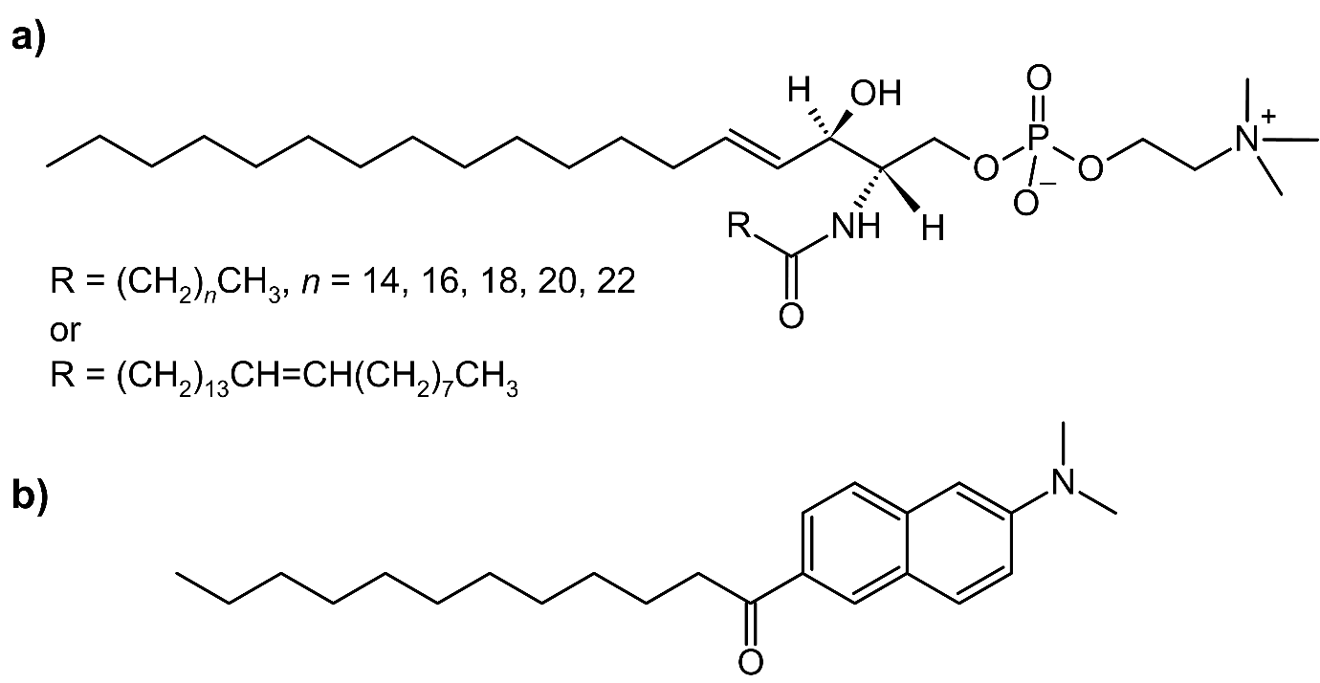
Fig. 1. Structural formula of: a) bSM and b) Laurdan®.
- Experimental
2.1 Chemicals and lipid suspensions preparations
Brain sphingomyelin (bSM) was purchased as a white powder from Avanti Polar Lipids (≥ 99 %, porcine) and used for the preparation of stock solution in concentration of γ(bSM) = 10 mg ml⁻¹ in chloroform (CHCl₃; colorless liquid, p.a., Carlo Erba). The lipophilic probe Laurdan® (L; 6-dodecanoyl-2-dimethylaminonaphthalene, white powder, Mr = 353.54, purity ≥ 98 %) purchased from ThermoFisher Scientific was dissolved in chloroform (CHCl₃; colorless liquid, p.a., Carlo Erba) to make up the concentration of γ(L) = 7 mg ml⁻¹. The prepared solutions were kept under −4 °C. An amount of 3 ml of bSM stock solution was pipetted in four flasks; two of them contained only the solution of bSM, whereas in the other two Laurdan® stock was added in an amount needed to gain x(L) = 2%. The films of bSM ± 2% mol Laurdan® (bSM ± L) were made on a rotary evaporator under pressure (600 to 100 mbar) to eliminate CHCl₃ from the samples and each film was then dried under an Ar stream.
bSM ± L films were hydrated with Britton-Robinson (BRB) buffer composed by NaOH (T.T.T. doo, p.a.), CH₃COOH (Gram-Mol, p.a.), H₃PO₄ (Kemika, w= 85%), H₃BO₃ (Krka, p.a.), NaCl (Kemika, p.a.) (Cerdrá and Mongay, 2017). The measured pH values of BRB were 4.0 (≈ 4; BRB4), 7.3 (≈ 7; BRB7), and 9.0 (≈ 9; BRB9). After that, films were dissolved with 6 ml of BRB4/BRB7/BRB9 to gain a mass concentration of γ =5 mg ml⁻¹. The multilamellar liposomes (MLVs) preparation is a three-step cycle that is repeated multiple times until a homogeneous white suspension is obtained. The first step is vortexing, then heating in a hot H₂O bath (heated up to 50 °C) and cooling in an ice bath (~ 4 °C). Each step took 2 minutes and the whole procedure was performed in three to five cycles. Finally, the prepared multilamellar bSM+2% mol Laurdan® white suspensions (γ = 5 mg ml⁻¹) were used for DSC measurements and were diluted for other measurements: γ = 1 mg ml⁻¹ (UV/ Vis), γ = 0.05 mg ml⁻¹ (DLS) and γ = 0.125 mg ml⁻¹ (fluorimetry).
  - Determination of the size of liposomes: DLS measurements and data analysis
The size distribution of bSM MLVs was measured with dynamic light scattering using a photon correlation spectrophotometer equipped with a 532 nm (green) laser (Zetasizer Nano ZS, Malvern Instruments, Worcestershire, UK). The average hydrodynamic diameter (d_{h}) was specified as the value at the peak maximum of the volume-size distribution. The reported results correspond to the average of six measurements at 25 °C. The data processing was done by the Zetasizer software 7.13 (Malvern Instruments). The average hydrodynamic diameter values of the bSM MLVs (γ = 0.05 mg ml⁻¹) were in the range of 100 nm ≤ d_{h} ≤ 550 nm, and bSM+L MLVs were in the range of 100 nm ≤ d_{h} ≤ 300 nm (Fig. S1).
  - DSC: data acquisition and analysis
The microcalorimeter Nano-DSC, TA Instruments (New Castle, USA) was used for DSC measurements of bSM ± L MLVs. Before the samples were put in the instrument, they were in a degassing station for 10 min. The temperature interval for samples was 10– 60 °C at scan rates of 1 °C min⁻¹, as well as for reference solutions (BRB4, BRB7, and BRB9). Every lipid suspension was recorded two times in two heating-cooling cycles, whereas the reference buffers were recorded once. Since the second heating run is considered to be free from thermal history (Chen et al., 2010), thermotropic properties of bSM in two buffers were determined using Nano Analyze software package as follows: i) DSC trace of particular buffer was subtracted from corresponding DSC trace of respective bSM suspension, ii) in the temperature range 20-50°C the resulting trace was baseline corrected, iii) by integrating the surface under the curve ΔH_{cal} obtained (Lewis et al., 2006).
  - Temperature-dependent UV-Vis and fluorescent spectroscopy: Data acquisition and spectral analysis
UV-Vis spectra were measured on the UV-Vis spectrophotometer Thermo Scientific Nanodrop 2000 (Thermo Fisher Scientific, USA) in the spectral range of 250– 500 nm. The samples were pipetted into quartz cuvettes of 1 ml total volume and placed in a temperature-controlled cuvette holder. Every sample was recorded in the temperature interval of 20–50 °C in four different cuvettes, except for BRB4, BRB7, and BRB9 solutions which were recorded only once.
Fluorescence measurements were performed on an Agilent Cary Eclipse fluorometer by use of slits corresponding to the bandpass of 2.5 nm for the excitation and 5 nm for the emission. The sample concentrations were adjusted to 0.125 mg ml⁻¹ and measurements were performed by exciting the samples at the wavelength of 380 nm in three separated cuvettes. The temperature increased from 20 °C to 50 °C in intervals of 1°C. The references were recorded cuvettes with buffers.
Obtained temperature-dependent UV-Vis/fluorescent spectra were smoothed (Savitzky-Golay; polynomial of a 3rd degree and 10 points) (F. Menges, 18.03.2024) and examined in the wavelength range 250–300 nm/400-600 nm that displays the greatest sensitivity on sample turbidity change/the signal of Laurdan® (Brkljača et al., 2022; Maleš et al., 2022a, 2022b) (Fig. 2a/2b present representative temperature-dependent UV-Vis/fluorescent spectra of bSM suspended in BRB7).
The temperature-dependent fluorescence spectra were baseline-corrected in the spectral range 400-600 nm ensuring that at x = 600 all spectra have value 0 at the ordinate. Expectedly, Laurdan® incorporated in bSM lipid bilayers displayed displacement of the signal maximum to the high-wavelength region upon heating bSM suspensions, with a discontinuity observed at/near the phase transition temperature (Brkljača et al., 2022) (Fig. 2b).
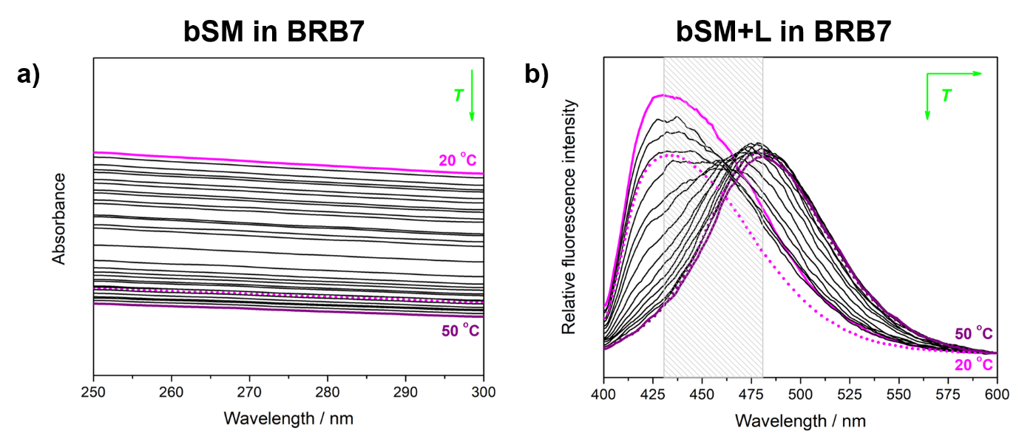
Fig. 2. Temperature-dependent: a) UV-Vis and b) fluorescent spectra of bSM ± L MLVs suspended in BRB7 acquired in the temperature range 20-50 °C. The spectra obtained at the lowest (20 °C) and the highest (50 °C) temperatures are highlighted with magenta/purple solid curves. The spectral profiles of the first/first and second principal component/principal components obtained from MCA are labeled with magenta/magenta and purple dotted curves. The position and the displacement of the signal maximum in temperature-dependent fluorescence spectra are emphasized with a gray rectangle.

The prepared temperature-dependent UV-Vis/fluorescent spectra were further analyzed by multivariate curve analysis (MCA) thoroughly described in (Maleš et al., 2022a). Briefly, this approach is based on representing the spectral data as a matrix (D) that can be obtained as a product of two factors: one of them is the spectrum of particular species in a certain wavelength range (matrix of the spectral profile of particular species, S), and another is the concentration of the particular species (matrix of the concentration profile of particular species, C):
D = CS^{T} + E (1)
In the expression above E stands for residual matrix that contains unexplained data, i.e. the information not contained in C and S.
Before performing MCA (De Juan et al., 2014) using publicly available Matlab code (Jaumot et al., 2005), the number of components that constitute the data matrix D has to be assumed. In the temperature-dependent UV-Vis spectra, owing to a heating-induced decrease in suspension turbidity in the wavelength range 250-300 nm and consequently absorbance decrease, one (first) principal component exhausts all spectral variance with the temperature.
On the contrary, in temperature-dependent fluorescence spectra Laurdan® signal displays not only the intensity change but also the displacement of the signal maximum (wavelength range 400-600 nm) as a consequence of the lipid bilayer phase change (Osella and Knippenberg, 2019). Thus, in the fluorescent spectra, the total temperature-dependent spectral variance is expressed as a linear combination of two components: a low- and a high-temperature component (LTC and HTC/first and second principal component), where the concentration of one component increases/decreases at the expense of a decrease/increase of the other component.
The concentrational profiles of the (first) principal component (UV-Vis) and the LTC and HTC (fluorescence) are sigmoidal and their inflection points, associated with structural changes within lipid bilayers (Brkljača et al., 2022; Maleš et al., 2023, 2022b; Pašalić et al., 2023), are obtained by fitting the curves on a single Boltzmann profile.
The inflection point of the obtained curve for bSM in BRB4 was visually estimated to be at ~ 35 °C, but mathematically was not possible to obtain a physically meaningful value. On the contrary, for bSM in BRB7, the inflection point gave T_{m} = 32.0 ± 0.2 °C (R² = 0.999) and for bSM in BRB9 the inflection point was at T_{m} = 36.4 ± 0.4 °C (R² = 0.999). On the other hand, the concentrational profiles of LTC and HTC obtained from MCA of temperature-dependent fluorescent spectra, exhibited physically and statistically reasonable values for all three systems: T_{m (LTC)} = 32.4 ± 0.3 °C (R² = 0.999) and T_{m (HTC)} = 31.2 ± 0.2 °C (R² = 0.999) for bSM+L in BRB4, T_{m (LTC)} = 30.3 ± 0.2 °C (R² = 0.999) and T_{m (HTC)} = 30.8 ± 0.1 °C (R² = 0.999) for bSM+L in BRB7, and T_{m, LTC} = 30.2 ± 0.1 °C and T_{m, HTC} = 30.8 ± 0.2 °C for bSM+L in BRB9. The corresponding intersection points were found at T_{i} ≈ 31.4 °C/ 30.0 °C/31.9 °C for bSM+L in BRB4/BRB7/BRB9 (all values are additionally listed in Table 1).
Additionally, the temperature at which lipid order was altered was determined from Laurdan® generalized polarization (GP) data. The results are presented in Supporting Information (Fig. S2) and briefly compared with those obtained by MCA.
- Molecular dynamics simulations
Simulations of bSM bilayers in gel and fluid phases in the presence and absence of Laurdan® were conducted by classical molecular dynamics (MD) in the program package GROMACS 2020.0 (Abraham et al., 2015). The bilayer was generated by the CHARMM-GUI Membrane Builder module (Wu et al., 2014). It consisted of a total of 192 lipid molecules evenly divided into two leaflets: 4 of C16:0, 108 of C18:0, 10 of C20:0, 16 of C22:0, 10 of 24:0, and 44 of C24:1. It was solvated with 14400 water molecules, and 9 Na⁺ and 9 Cl⁻ ions were added to achieve the experimental ionic strength. The lipids were modeled using the CHARMM36m force field (Klauda et al., 2010), and the TIP3P model was used for water (Jorgensen et al., 1983). Standard CHARMM-GUI procedure was used to equilibrate the bilayers at 20 °C and 50 °C. Laurdan® was parametrized using CGenFF (VANOMMESLAEGHE et al., 2010) and the parameters are listed in Table S1 in Supporting Information. 4 Laurdan® molecules (2%) were added into each simulation box into the water phase. They were introduced into the membrane by short (5 ns) pull simulations using the umbrella harmonic potential. The probes were pulled at the rate of 0.0008 nm/ps and with the force constant of 1000 kJ mol⁻¹ nm⁻², across 4 individual reaction coordinates following the z-axis, between the center of mass of the molecule and the center of mass of a cylindrical cross-section of the bilayer below the probe. bSM+L bilayers were re-minimized and re-heated for 200 ps in the NVT ensemble. Both bSM and BSM+L systems then underwent a production run of 500 ns in the NpT ensemble at 20 °C and 50 °C. Temperature control was achieved through the Nosé-Hoover thermostat (Nosé, 1984) with a time constant of 1 ps, and pressure control through the Parrinello-Rahman barostat (Parrinello and Rahman, 1981) with semi-isotropic pressure coupling and the time constant of 2 ps (target pressure of 1 bar). The cutoff for van der Waals and short-range Coulomb interactions was 1.2 nm with the switching function activated at 1.0 nm. Particle mesh Ewald (PME) was used for long-range Coulomb interactions (Essmann et al., 1995). LINCS was used to constrain bonds involving hydrogen. 3D periodic boundary conditions were used in all simulations, and the time step was 2 fs. Data analysis and visualization were conducted using GROMACS modules and Visual Molecular Dynamics (VMD) (Humphrey et al., 1996). The equilibration period of the production runs was determined based on the stabilization of the membrane surface (defined by x and y box lengths), and only the last 200 ns were included in the analysis. All results are presented as an average of 3 independent replicates.
- Results and discussion
4.1 Thermotropic and spectroscopic response of bSM suspended in BRB4, BRB7 and BRB9
Existing as a mixture of lipids with different lengths and degrees of unsaturation of hydrocarbon chains (Byrdwell and Perry, 2006), dominated by those of C18:0 and C24:1, the melting profile of bSM observed by DSC extends from, roughly, 20 °C to 45 °C (Fig. 3a, b and c). Agreeing to the previously published data (Calhoun and Shipley, 1979; Kodama et al., 2004; Meyer et al., 1999; Shipley et al., 1974), it shows two maxima in all three buffers, i.e. at all three pH values: in BRB4 at T_{m, 1} = 34.7 ± 0.1 °C and T_{m, 2} = 37.9 ± 0.1 °C, in BRB7 at T_{m, 1} = 34.5 ± 0.1 °C and T_{m, 2} = 38.2 ± 0.1 °C, and in BRB9 at T_{m, 1} = 34.4 ± 0.1 °C and T_{m, 2} = 37.8 ± 0.1 °C. For suspensions of bSM with incorporated Laurdan® the maxima in DSC curves are, expectedly (Brkljača et al., 2022; Heimburg, 2007), slightly displaced to the lower temperatures; for bSM+L suspended in BRB4 the maxima are registered at T_{m, 1} = 31.9 ± 0.1 °C and T_{m, 2} = 37.4 ± 0.1 °C, and for bSM+L suspended in BRB7 at T_{m, 1} = 32.0 ± 0.1 °C and T_{m, 2} = 37.0 ± 0.1 °C, and for bSM+L suspended in BRB9 at T_{m, 1} = 32.3 ± 0.1 °C and T_{m, 2} = 37.0 ± 0.1 °C. Accordingly, the change in the medium pH while maintaining the ionic strength does not alter the melting profile of bSM in qualitative terms, irrespective to the presence of Laurdan®. Additionally, ΔH_{cal} values determined in this work were on average 31 ± 4 kJ mol⁻¹ (Table 1), regardless to the buffer pH or the absence/presence of Laurdan®, and they coincide with the literature-reported values for other sphingomyelins (Jiménez-Rojo et al., 2014).
The UV-Vis spectra of bSM lipid bilayers show an expected turbidity decrease upon heating from 20-50 °C (Fig. 2) (Maleš et al., 2022a). Since the turbidity of lipid suspensions is a function of the temperature-dependent change in the refractive index of a medium as well as of the lipid phase transition(s) (see Supporting Information in (Maleš et al., 2021) for more details), the former exhibits a discontinuity which seems to be more distinguished in bSM suspension made in neutral or alkaline BRB than in acidic one (Fig. 3d, e and f). By comparing the DSC data of bSM suspended in BR4B/BRB7/BRB9 (Fig. 3a, b and c) with corresponding UV-Vis spectra (Fig. 3d, e and f), which is possible since both data sets reflect thermotropic properties of the suspensions (Maleš et al., 2023, 2022a, 2022b), two important findings rise. First, for bSM suspended in BRB4, the inflection point cannot be obtained by fitting, although visually it is assumed to be at about 35 °C (T_{m}). On the contrary, the corresponding quantity for bSM suspended in BRB7 and BRB9 is T_{m} = 32.0 ± 0.2 °C and T_{m} = 36.4 ± 0.4 °C, respectively. The origin for this phenomenon probably derives from the larger uncertainty in bSM in RB4B system so that discontinuity in the temperature-dependent spectral response of the latter is not as sharp as for bSM in BRB7 or BRB9. Second, there is only one inflection point estimated (BRB4)/obtained (BRB7 and BRB9) from concentrational profile of the measured data set, while in DSC measurements there are two maxima, i.e. two (the most significant) thermotropic events appear; according to the literature known data, the first event most likely originates from the melting (L_{β}→L_{α}) of C24:1 sphingomyelin, while another from melting (P_{β’}→L_{α}) of C18:0 sphingomyelin (Calhoun and Shipley, 1979; Jiménez-Rojo et al., 2014; Quinn and Wolf, 2009; Shaw et al., 2012). The detection of only one phase transition in temperature-dependent UV-Vis measurements is further entangled by the fact that estimated (bSM in BRB4) value of T_{m} is almost the same as T_{m,1} obtained from the corresponding DSC curves, opposite to the obtained values (bSM in BRB7 and BRB9) of T_{m} that are for about 2 °C lower (BRB7)/higher (BRB9) that T_{m,1} obtained from DSC curves (see greenish mark x on Fig. 3a, b and c). As T_{m,1} is read at the maximum of DSC curve, i.e. at the point at which about 50 % of (certain) lipids are melted (Lewis et al., 2006), the discrepancies between T_{m,1} (DSC) and T_{m} values (UV-Vis) for bSM suspended in BRB7/BRB9 might be related with the fact that the maximum in the turbidity change occurs at the beginning of melting (L_{β}→L_{α}) of C24:1 sphingomyelin lipids/when almost 50 % of C18:0 sphingomyelin lipids undergo P_{β’}→L_{α} phase transition. Furthermore, the detection of one inflection point only in turbidity-based measurements needs to be discussed as well. Since freeze-fracture electron microscopy data (Meyer et al., 1999) and structural (and NMR) data (Shaw et al., 2012) reported on formation of small vesicles made up from exclusively C24:1 sphingomyelin, it may be that this event simply dominates the change in turbidity for bSM in BRB7 and obscures P_{β’}→L_{α} transition of C18:0 sphingomyelin (and other sphingomyelin lipids having saturated hydrocarbon chains), whereas for bSM in BRB9 the reverse scenario occurs, i.e. the peak of the turbidity decrease occurs during P_{β’}→L_{α} phase transition of C18:0 sphingomyelin. Moreover, it cannot be neglected that the concentrational profile of a projection of temperature-dependent UV-Vis spectra does not display steep sigmoid transition for bSM, as it displays for, for instance, pure lipids like 1,2-dipalmitoyl-sn-glycero-3-phosphocholine (DPPC) (Maleš et al., 2022a) or 1,2-dipalmitoyl-sn-glycero-3-phosphoethanolamine (DPPE) (Maleš et al., 2023). Instead, a slight sigmoidal transition can also represent a cumulative change in the turbidity of suspensions where the maximum appears at the temperatures observed (BBR4) or determined by fitting (BRB7 and BRB9) on a single Boltzmann profile.
Since Laurdan® signal contains important information about the aqueous medium to which it is exposed to some extent, its fluorescence spectra should reflect the changes in interfacial water when bSM undergoes a phase transition (Bagatolli, 2006). Accordingly, the concentration profiles of LTC and HTC, i.e. the projections of temperature-dependent response of Laurdan® inserted in bSM (Fig. 3g, h and i), gave the inflection point (= phase transition temperature) as follows: T_{m (LTC)} = 32.4 ± 0.3 °C (R² = 0.999) and T_{m (HTC)} = 31.2 ± 0.2 °C (with T_{i} ≈ 31.4 °C) for BRB4, T_{m, LTC} = 30.3 ± 0.2 °C and T_{m, HTC} = 30.8 ± 0.1 °C (with T_{i} ≈ 31.3 °C) for BRB7, and T_{m, LTC} = 30.2 ± 0.1 °C and T_{m, HTC} = 30.8 ± 0.2 °C (with T_{i} ≈ 31.9 °C) for BRB9, respectively. Comparing the obtained quantities with those measured from DSC of bSM+L, two phenomena emerged: i) only one inflection point is seen from concentration profiles of LTC and HTC, whereas the DSC curve displays two maxima and ii) obtained T_{m (HTC/LTC)} values are only partially comparable with T_{m, 1} value of bSM+L (T_{m, 1} = 31.9 ± 0.1 °C in BRB4, 32.0 ± 0.1 °C in BRB7, and 32.3 ± 0.1 °C in BRB9), i.e. the latter is either practically equal to T_{m (LTC/HTC)} in BRB4, or is for about 2 °C higher than T_{m (LTC/HTC)} obtained in BRB7 and BRB9, respectively (see yellowish mark x on Fig. 3a, b and c). Estimated T_{i} values, usually associated with the temperature at which two lipid phases (low- and high-temperature phase) are in a 50% : 50% mol ratio (Maleš et al., 2021), are slightly higher than T_{m (LTC/HTC)} and hence deviate twice less than those determined from T_{m (LTC/HTC)} (1 °C/1 °C/2 °C in BRB4/BRB7/BRB9). As for T_{i} enhancement in comparison with T_{m (LTC/HTC)} values is concerned, we tentatively suggest that the former somehow generates an average response of the change in lipid order (the values provided from DSC) and reorientation of interfacial water molecules (the value obtained from Laurdan® response). Ultimately, it appears that Laurdan® incorporated in BRB4-suspended bSM senses the water reorientation when about 50% of C24:1 sphingomyelin is melted, whereas the one incorporated in BRB7/BRB9-suspended bSM registers water reorientation few degrees before then in BRB4. As the most likely cause of the deviation of the response of Laurdan® in BRB4 in relation to BRB7 and BRB9, the possibility of protonation of N-atom in N, N-dimethyl-1-naphtylamino moiety of Laurdan® in BRB4 is suggested. More specifically, since pK_{a} value of structurally similar N, N-dimethyl-1-naphtylamine is 4.83 (at 25 °C) (Hall and Sprinkle, 1932), N-atom in Laurdan® is expected to be protonated in BRB4, but not in BRB7 and BRB9, which might modulate interfacial water reorientation dynamics (more detailed discussion on the protonation of N-atom in N, N-dimethyl-1-naphtylamino moiety is discussed in the continuation of the text).
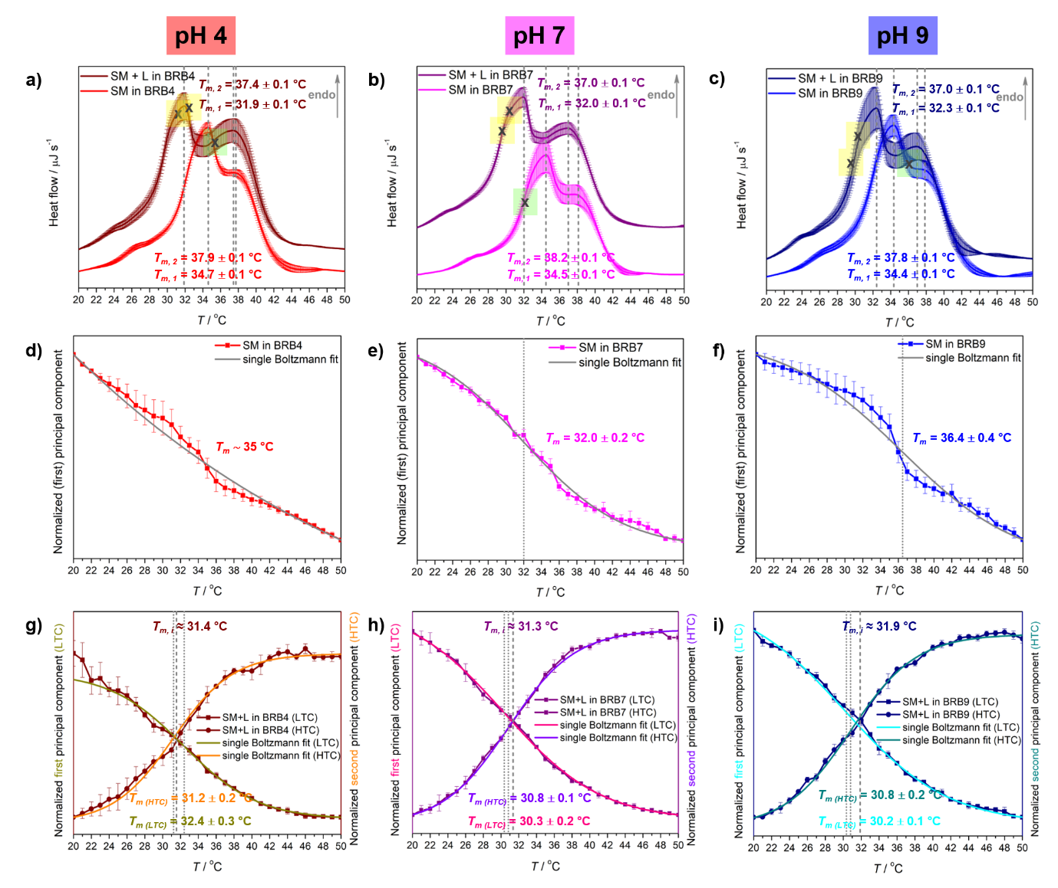
Fig. 3. Thermotropic properties of bSM suspended in BRB4 (left column), BRB7 (middle column) and BRB9 (right column) obtained from: DSC measurements (a) bSM ± L in BRB4, b) bSM ± L in BRB7, and c) bSM ± L in BRB9); the concentrational profile of the (first) principal component obtained by MCA of temperature-dependent UV-Vis spectra (d) bSM in BRB4, e) bSM in BRB7 and f) bSM in BRB9); the concentrational profiles of the first (LTC) and second (HTC) principal components obtained by MCA of temperature-dependent fluorescent spectra (g) bSM+L in BRB4, h) bSM+L in BRB7 and i) bSM+L in BRB9). Obtained DSC and spectroscopy-derived data, as well as fitting results of the latter, are presented with solid curves. The melting temperatures obtained from DSC curves maxima (T_{m,1/2}) and from fitting the concentration profiles of the component(s) obtained from MCA (UV-Vis and fluorescence data; T_{m} and T_{m} _{(LTC/HTC)}) are highlighted with dashed and dotted lines, respectively, and also written in the particular graph. Intersection points of LTC and HTC (e) and f)) are designated with short dashed lines and labeled on graphs.

Table 1. Temperatures of the phase transitions (T_{pt}) and accompanied calorimetric enthalpies (ΔH_{cal}) of bSM arranged as MLVs determined from the maxima of DSC curves (T_{m, 1} and T_{m, 2} for the main phase transition) andfrom inflection points of concentration profiles obtained from multivariate curve analysis (MCA) of temperature-dependent UV-Vis (T_{m}) and fluorescent spectra (T_{m (LTC/HTC)}) spectra. Note: 1st PC = LTC, 2nd PC = HTC
system | T_{pt}ª (and ΔH_{cal}^{b}) as obtained from DSC, UV-Vis, and fluorescence spectroscopy
system | DSC |  |  | UV-Vis | Fluorescence
system | T_{m, 1}ª | T_{m, 2}ª | ΔH_{cal}(L_{β}/P_{β'} → L_{α})^{b} | T_{m}ª | T_{m, LTC}ª | T_{m, HTC}ª
bSM in BRB4 | 34.7 ± 0.1 | 37.9 ± 0.1 | 28 ± 2 | ∼ 35 | − | −
bSM+L in BBR4 | 31.9 ± 0.1 | 37.4 ± 0.1 | 39 ± 1 | − | 32.4 ± 0.3 | 31.2 ± 0.2
bSM in BRB7 | 34.5 ± 0.1 | 38.2 ± 0.1 | 33 ± 2 | 32.0 ± 0.2 | − | −
bSM+L in BRB7 | 32.0 ± 0.1 | 37.0 ± 0.1 | 22 ± 1 | − | 30.3 ± 0.2 | 30.8 ± 0.1
bSM in BRB9 | 34.4 ± 0.1 | 37.8 ± 0.1 | 39 ± 1 | 36.4 ± 0.4
bSM+L in BBR9 | 32.3 ± 0.1 | 37.0 ± 0.1 | 22 ± 1 | − | 30.2 ± 0.1 | 30.8 ± 0.2
ª In °C; ^{b} In kJ mol⁻¹.

In addition to the differences between the values ​​of phase transition temperatures obtained by DSC (T_{m, 1/2}) and fluorescence spectroscopy (T_{m, LTC/HTC}), it is also necessary to compare the deviations of the phase transition temperatures between spectroscopic measurements (see Table 1). Although the T_{m} values ​​obtained from the UV-Vis data in all three buffers are higher than T_{m (LTC/HTC)}, it is evident that the magnitude of the deviation depends on the pH value: ∼ 3-4 °C for pH 4, ∼ 1-2 °C for pH 7 and ∼ 5-6 °C for pH 9. The presence of Laurdan® and its possible influence on the change in the physicochemical properties of bSM certainly emerges as one of the main causes of the aforementioned deviation (examined by molecular dynamics and explained in more detail in subsection 4.2). However, the inconsistency of the observed discrepancies suggests that the influence of the pH value on the turbidity of the bSM suspension (UV-Vis) and on the reorientation dynamics of water in the interfacial layer (fluorescence), is more significant than the interference of the bSM bilayer by the presence of Laurdan®. Even though the protonation of N-atom of N, N-dimethyl-1-naphtylamino moiety of Laurdan® at pH 4 (Hall and Sprinkle, 1932), the contribution of which is inseparable from Laurdan® overall response in BRB4 (i.e for bSM + L in BRB4) in our experiments, it has to be emphasized that certain pH-dependent variations are observed from Laurdan®-free UV-Vis measurements. Thus, in the continuation of the text, we will focus on the undoubtedly important pH impact on the bSM thermotropic and molecular properties.
As Chemin et al. showed to what extent the pH value of the medium affect the thermotropic properties of eSM (Chemin et al., 2008), it is expected that different pH values of the same buffer (independent of the protonation of the N-atom of Laurdan® at pH 4) will lead to different interfacial water reorientation temperatures. The most probable cause of a pH-induced difference in the temperature at which water dynamics significantly changes stems from the electrostatic interactions of H₃O⁺ and OH⁻ with charged functional groups of lipid molecules (cholines, phosphates) (Lee et al., 2019; Schönfeldová et al., 2021; Zhou and Raphael, 2007), as well as from the different pattern of the network of hydrogen bonds woven from water molecules, anions and HB donor/acceptor functional groups of lipids (phosphates, carbonyls, and sphingosine backbone) (Zhou and Raphael, 2007). As a result of the interactions between the mentioned species or functional groups (Garcia-Manyes et al., 2005), the surface charge density of the membrane modulates T_{m} and, in general, the lipid melting profile (Heimburg, 2007), and which in turn affects HB arrangement and dynamics in interfacial water layer (Schönfeldová et al., 2021). The characterization of the latter in terms of intermolecular interactions, emphasizing hydrogen bonds formed between various HB donors and HB acceptors (Alfredsson et al., 2021; de la Arada et al., 2020; Slotte, 2016), was accomplished by MD simulations. Since all three suspensions had the same composition in terms of anions and cations, the interactions of the latter with lipid functional groups were taken as systematic uncertainty and the simulations did not take them into account. Additionally, the effect of pH change was not examined due to the complexity of adequately modeling.
  - MD simulations: Hydration of bSM surface at 20 °C and 50 °C and the impact of Laurdan® on bSM structural parameters
MD simulations were conducted to explore the changes in lipid-water interface at gel and fluid phases, while also examining the potential impact of Laurdan® incorporation on biasing experimental results.
The validity of simulations was checked by analyzing basic structural parameters - area per lipid (APL) and membrane thickness (MT). Calculated APL values were ~0.49 nm² at 20 °C and ~0.55 nm² at 50 °C, which was in good agreement with previously reported values for some SM lipids (0.44-0.52 nm² in gel phase or 0.52-0.60 nm² in fluid phase (Chiu et al., 2003; Hyvönen and Kovanen, 2003; Niemelä et al., 2004)). The values of MT (4.7-5.0 nm at 20 °C or 4.5-4.6 nm at 50 °C) also correspond well to literature reports (4.4-5.0 nm/ 3.8-4.4 nm gel/fluid (Chiu et al., 2003; Hyvönen and Kovanen, 2003; Niemelä et al., 2004), indicating that the simulations equilibrated to the correct phase. The significant interdigitation of opposing leaflet lipids was not observed at 20 °C. The presence of 2% Laurdan® resulted in minimal changes in membrane structural parameters which fall under simulation error (Fig. S3, Table S2 and further details can be found in Supplementary Information).
Additional confirmation of the bilayer phase is obtained through acyl chain order parameters (-S_{CD}), where high values correspond to strongly ordered gel phase lipids, while disordered fluid phase chains have low -S_{CD} (Fig. 4, Fig. S4). In addition, the difference in ordering of C18:0 vs. C24:1 lipids can be shown as the indication of the lower melting point of C24:1, considering its degree of order is lower in gel phase compared to C18:0, even in the structurally identical sphingosine chains (Fig S4). Laurdan® appears to slightly increase ordering at 20 °C. Though not statistically significant, it is contrary to the experimental finding of lower T_{m} in bSM+L systems. Laurdan® and its parent compound Prodan are reported to have a complex influence on membrane organization, both introducing order or disorder depending on the location within the membrane and the excitation state (Suhaj et al., 2020, 2018). Here, the probe has only been modeled in its ground state, which is a possible cause of the discrepancy with the experiment. No effect on ordering was observed at 50 °C, possibly because the location of Laurdan® within the simulated bilayers differed in gel and fluid phases (Fig. S5, further discussion in SI).
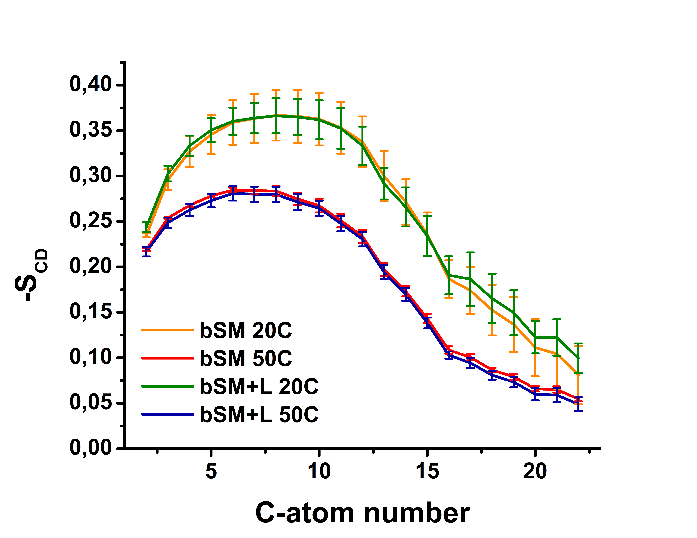
Fig. 4. Average acyl chain order parameters for fatty acid chain of bSM lipids in select systems, weighted according to the percentage of each lipid. The error bars represent the standard deviation.
The hydration of SM lipids in regards to the polar head and the backbone was first examined by analyzing water penetration and HB formation around choline (N(CH₃)₃⁺), phosphate (PO₄⁻), hydroxyl (OH) and amide (NHC=O) groups. Firstly, the borders of the solvation shells were determined from the first minimum of the radial distribution function of water oxygen (O_{WAT}) around each group’s chosen atom (Fig. S6 in Supporting Information). Then, the number of water molecules within the solvation shells of those groups was counted, and the HB formation was examined (Table 2). Bilayer hydration diminishes the further a group is located from the bilayer surface, and also with the reduced size of the group. As expected from the experimental data, there is a slight increase in the number of molecules in the hydration shells at higher temperatures, but it is still within error. The only group not showing any increase is the amide.
Table 2. The average number of water molecules around choline, phosphate, hydroxyl, and amide groups of studied systems, as well as the average number of hydrogen bonds formed by select groups/molecules.
No. of waters | bSM 20 °C | bSM 50 °C | bSM+L 20 °C | bSM+L 50 °C
N(CH₃)₃⁺ | 2106 ± 20 | 2121 ± 30 | 2073 ± 19 | 2157 ± 28
PO₄⁻ | 829 ± 8 | 844 ± 11 | 822 ± 8 | 855 ± 11
OH | 165 ± 5 | 170 ± 7 | 162 ± 6 | 176 ± 6
NHC=O | 341 ± 6 | 324 ± 9 | 329 ± 6 | 336 ± 10
HB type | bSM 20 °C | bSM 50 °C | bSM+L 20 °C | bSM+L 50 °C
SM-water | 1250 ± 14 | 1200 ± 16 | 1235 ± 20 | 1225 ± 18
SM-SM | 267 ± 4 | 271 ± 5 | 270 ± 4 | 268 ± 5
PO₄⁻-water | 855 ± 8 | 835 ± 9 | 844 ± 7 | 842 ± 9
OH-water | 120 ± 4 | 121 ± 5 | 117 ± 4 | 125 ± 5
NHC=O-water | 200 ± 4 | 184 ± 5 | 191 ± 4 | 187 ± 5

Not all waters within a hydration shell form HBs, since those require particular alignment of donors and acceptors. The criteria for recognition of an HB in the simulation are a donor-acceptor distance of ≤0.35 nm and an acceptor-donor-hydrogen angle of ≤30 °. HB analysis shows very little difference between the systems. SM lipids form slightly fewer HBs with water at 50 °C compared to 20 °C, but the addition of Laurdan® negates that effect. Lipid-lipid bonding is the same regardless of temperature or probe insertion. When monitoring specific groups, phosphate and amide form slightly more bonds at 20 °C without Laurdan®, but OH is showing no difference. The choline group did not form HBs with water due to steric effects and its hydration is due to dipole-charge interactions. Further investigation of HB network patterns (Table S3) showed that the majority of water molecules form only one HB with one lipid molecule (~ 80%), 14-16 % of waters form a bridge by binding two neighboring lipids, and 3-4 % establish two HBs with the same lipid. Other patterns represent <1% of bonds. Again, neither temperature nor the presence of Laurdan® seems to affect the network. The absence of meaningful effects is notable in itself since the differences in the system should result in some discrepancies. The increase in temperature and higher kinetic energy of molecules should result in an HB decrease (Swiatla-Wojcik et al., 2008). On the other hand, the increase in APL and membrane disorder in the fluid phase should allow for better penetration of water into the bilayer, and more lipid-water HBs, but lipid-lipid interactions are expected to reduce (Kagawa et al., 2013). Here, the interplay of both effects appears to result in similar H-bonding all around.
The lack of HB differences at high temperatures may also be related to water dynamics at the bilayer interface. Following the procedure of Kagawa et al. (Kagawa et al., 2013), interfacial water was defined as all water within 1 nm of the P-atom, because that is the distance at which the water-P RDF becomes constant (Fig S6b). The dynamics of interfacial water were analyzed and compared to bulk water. In agreement with previous research (Chandra et al., 2023; Srivastava and Debnath, 2018), interfacial water has a lower diffusion coefficient compared to bulk: ~2.8∙10⁻⁵/~4.7∙10⁻⁵ cm² s⁻¹ at 20/50 °C vs. ~5.0∙10⁻⁵/~7.0∙10⁻⁵ cm² s⁻¹ at 20/50 °C (Table S4). Still, interfacial water mobility is almost doubled at higher temperatures, indicating a faster exchange with bulk. Rotational autocorrelation functions calculated for a period of 200 ps (Fig. 5) show a faster drop towards zero at higher temperatures, confirming significant temperature-driven rotational fluctuations. Therefore, both parameters indicate a faster rate of HB perturbation at 50 °C. However, they also show that the interfacial water is more strongly affected by temperature changes than bulk water since its dynamics are not solely dependent on kinetic energy increase, but also on the rearrangement of the bilayer and lipid interactions, which is the key to understanding experimental phenomena.
Though MD did not fully reproduce experimental results, the absence of notable differences at the ends of the observed temperature spectrum might suggest large perturbations occur predominantly at melting points, or that they are driven by factors absent from the simulation, such as anions from the buffer. In addition, MD shows that Laurdan® may be more than just a reporter probe, but that it participates in ordering and hydration changes, as was previously suggested by Suhaj et al. (Suhaj et al., 2020). An important limitation of this study is the lack of pH-dependent simulations, which were not performed due to the difficulty of obtaining accurate parameters for protonated Laurdan®. It is possible that Laurdan® protonation would further impact water HB formation and re-orientation, since charged species will locate more among lipid headgroups (Pem et al., 2024), which would result in better agreement with the experiment.
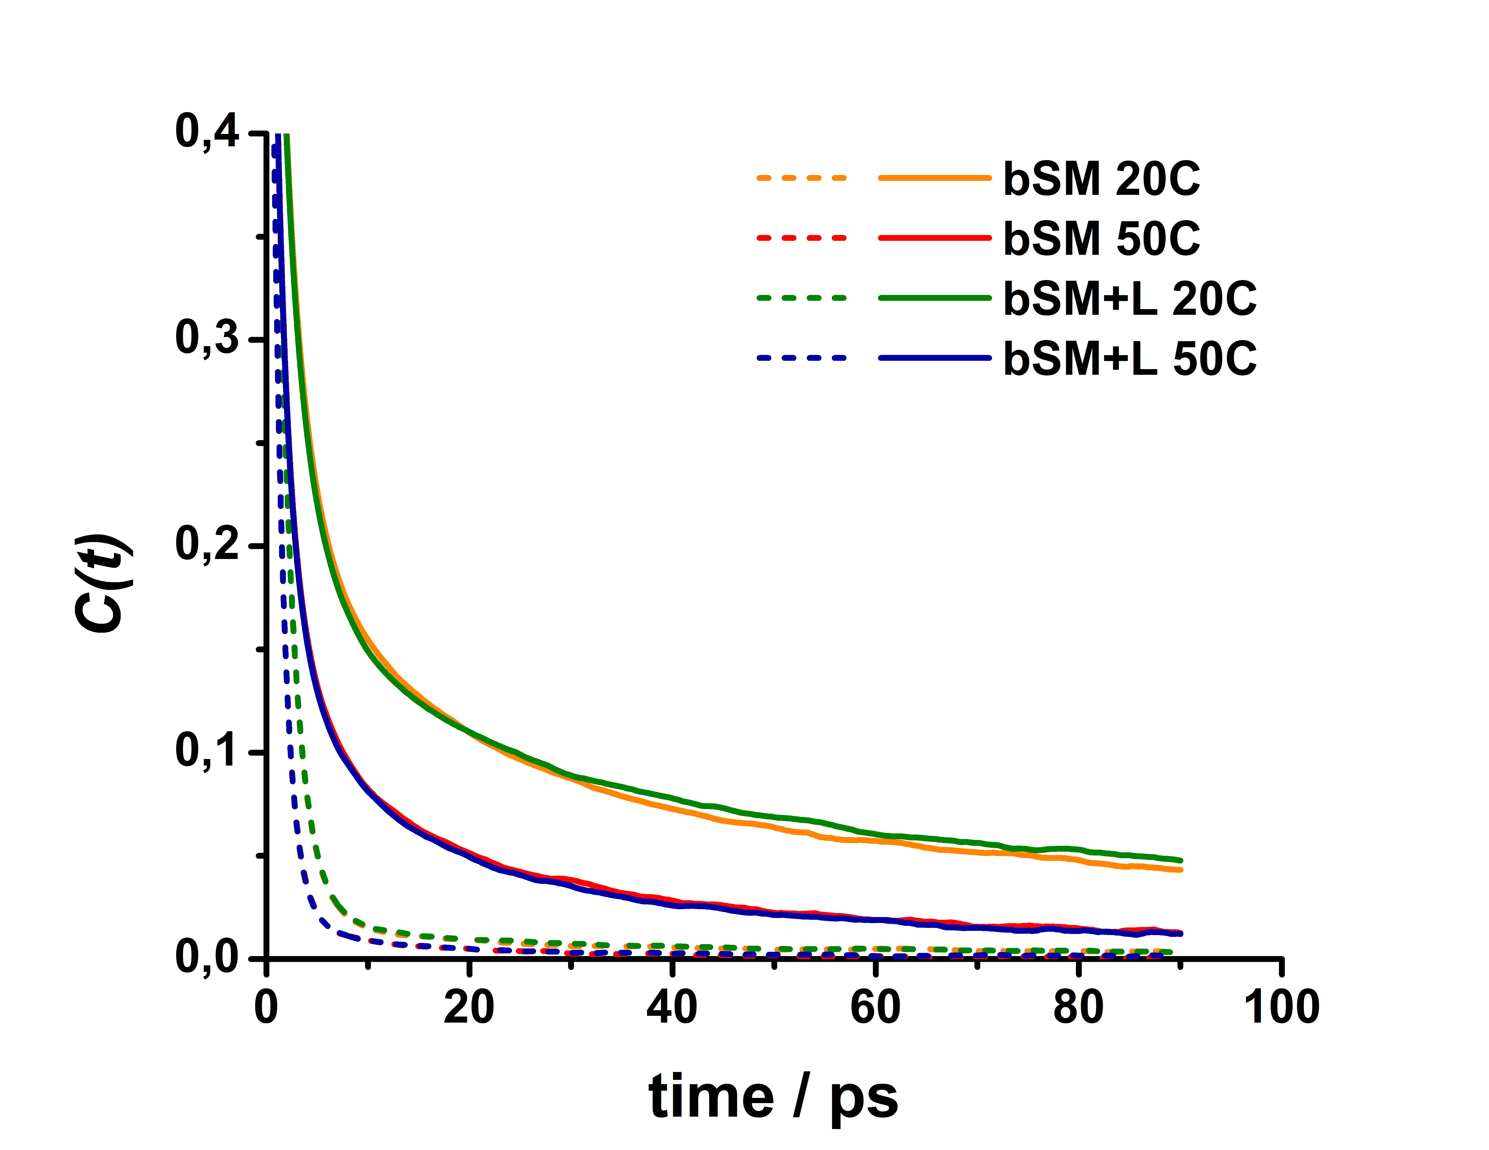
Fig. 5. Rotational autocorrelation functions of interfacial (full line) and bulk water (dashed line) for select systems.
Ultimately, all experimental results presented in this work confirmed that the key changes in the reorientation dynamics of the interfacial water are associated with the melting (L_{β}→L_{α} phase transition) of C24:1 sphingomyelin lipids. Leaving aside the most likely systematic influence of Laurdan® on the change in the physicochemical properties of bSM suspended in buffers of different pH values, the medium pH affects both turbidity and water reorientation dynamics (the data provided by DSC appear to be pH-insensitive). Regarding UV-Vis data, the absence of a trend in T_{m} values obtained from UV-Vis data for BRB4, BRB7, and BRB9 prevents us from providing a conclusive explanation for the observed phenomenon at this moment. However, as far as the fluorescent data is concerned, it appears that H₃O⁺ ions at pH 4, along with the protonation of N-atom of Laurdan®, enhance the local heterogeneities in sphingosine backbone hydration, reinforce the interactions between lipid polar moieties and interfacial water molecules, and overall contribute to the stabilization of the gel phase of C24:1 sphingomyelin lipids ($\overline{T}$_{m (LTC/HTC)}: ≈ 31.8 °C (pH 4) > ∼ 30.6 °C (pH 7 and pH 9) (Garcia-Manyes et al., 2005). In the context of previously reported calorimetric, structural, and microscopic findings (Kodama et al., 2004; Meyer et al., 1999; Shaw et al., 2012), it seems reasonable to assume that water pockets on bSM surface, created upon release of C24:1 vesicles from the rest of bSM, are the hotspots in which interfacial water experience the change in reorientation dynamics.
- Conclusion
Melting of lipid bilayers is a process that is usually divided into two contributions: the first and dominant one is the weakening of van der Waals interactions between hydrocarbon chains, and the second one are hydration-related changes in the polar headgroup region. In this work, we demonstrated how water molecules in the interfacial region of bSM experience a sudden pH-dependent change in reorientation dynamics not in the whole melting temperature range, but at the point/temperature at which C24:1 lipids melt and form small vesicles that coexist with the rippled surface of MLVs constituted from the rest of bSM lipids (mainly C18:0). The appearance of a maximum of reorientation dynamics change suggests their connection with the formation of water pockets upon C24:1 release. More importantly, in acidic conditions Laurdan® incorporated in bSM experienced the change in reorientation dynamics at almost 2 °C higher temperature than in neutral or alkaline conditions, suggesting the contribution of H₃O⁺ concentration on the stabilization of the gel phase of C24:1 sphingomyelin lipids.
Supporting Information
Supporting Information associated with this paper can be found in the online version at http://.
Conflicts of interest
There are no conflicts of interest to declare.
Acknowledgement
This paper was supported by Croatian Science Foundation through financing the project UIP-2020-02-7669 (“Model of demyelination on a molecular scale at physiological and pathological conditions”, DEMYMOLSCALE). The authors gratefully acknowledge members of Laboratory for biocolloids and surface chemistry (Division for Physical Chemistry, Ruđer Bošković Institute) for enabling the access to the Zetasizer Nano ZS (Malvern) and Dr. Ivo Crnolatac (Laboratory for Biomolecular Interactions and Spectroscopy, Ruđer Bošković Institute) for the assistance in temperature-dependent fluorescent measurements.
References:
Abraham, M.J., Murtola, T., Schulz, R., Páll, S., Smith, J.C., Hess, B., Lindah, E., 2015. Gromacs: High performance molecular simulations through multi-level parallelism from laptops to supercomputers. SoftwareX 1–2, 19–25. https://doi.org/10.1016/j.softx.2015.06.001
Alfredsson, V., Lo Nostro, P., Ninham, B., Nylander, T., 2021. Morphologies and Structure of Brain Lipid Membrane Dispersions. Front. Cell Dev. Biol. 9, 1–14. https://doi.org/10.3389/fcell.2021.675140
Arsov, Z., González-Ramírez, E.J., Goñi, F.M., Tristram-Nagle, S., Nagle, J.F., 2018. Phase behavior of palmitoyl and egg sphingomyelin. Chem. Phys. Lipids 213, 102–110. https://doi.org/10.1016/j.chemphyslip.2018.03.003
Bagatolli, L.A., 2006. To see or not to see: Lateral organization of biological membranes and fluorescence microscopy. Biochim. Biophys. Acta - Biomembr. 1758, 1541–1556. https://doi.org/10.1016/j.bbamem.2006.05.019
Barenholz, Y., Suurkuusk, J., Mountcastle, D., Thompson, T.E., Biltonen, R.L., 1976. A Calorimetric Study of the Thermotropic Behavior of Aqueous Dispersions of Natural and Synthetic Sphingomyelins. Biochemistry 15, 2441–2447. https://doi.org/10.1021/bi00656a030
Barenholz, Y., Thompson, T.E., 1980. SPHINGOMYELINS IN BILAYERS AND BIOLOGICAL MEMBRANES. Biochim. Biophys. Acta 604, 129–155.
Barnes-Vélez, J.A., Aksoy Yasar, F.B., Hu, J., 2023. Myelin lipid metabolism and its role in myelination and myelin maintenance. Innovation 4, 100360. https://doi.org/10.1016/j.xinn.2022.100360
Barriga, H.M.G., Parsons, E.S., McCarthy, N.L.C., Ces, O., Seddon, J.M., Law, R. V., Brooks, N.J., 2015. Pressure-temperature phase behavior of mixtures of natural sphingomyelin and ceramide extracts. Langmuir 31, 3678–3686. https://doi.org/10.1021/la504935c
Brkljača, Z., Ćehić, M., Portada, T., Butumović, M., Bakarić, D., Crnolatac, I., 2022. Monitoring lipid phase transition temperatures using fluorescent probes and temperature-dependent fluorescence spectroscopy. Dye. Pigment. 206, 110621, 10.
Byrdwell, W.C., Perry, R.H., 2006. Liquid chromatography with dual parallel mass spectrometry and 31P nuclear magnetic resonance spectroscopy for analysis of sphingomyelin and dihydrosphingomyelin. I. Bovine brain and chicken egg yolk. J. Chromatogr. A 1133, 149–171. https://doi.org/10.1016/j.chroma.2006.08.014
Calhoun, W.I., Shipley, G.G., 1979. FATTY ACID COMPOSITION AND THERMAL BEHAVIOR OF NATURAL SPHINGOMYELINS. Biochim. Biophys. Acta 555, 436–441.
Cebecauer, M., Amaro, M., Jurkiewicz, P., Sarmento, M.J., Šachl, R., Cwiklik, L., Hof, M., 2018. Membrane Lipid Nanodomains. Chem. Rev. 118, 11259–11297. https://doi.org/10.1021/acs.chemrev.8b00322
Cerdrá, V., Mongay, C., 2017. A Britton-Robinson buffer of known ionic strangth. Ann. Chim. 65, 409–412.
Chandra, Abhilash, Kayal, A., Das, B., Chandra, Amalendu, 2023. Dynamical Crossover of Interfacial Water upon Melting of a Lipid Bilayer: Influence of Different Parts of the Headgroups. J. Phys. Chem. B 127, 10478–10487. https://doi.org/10.1021/acs.jpcb.3c04792
Chemin, C., Bourgaux, C., Péan, J.M., Pabst, G., Wüthrich, P., Couvreur, P., Ollivon, M., 2008. Consequences of ions and pH on the supramolecular organization of sphingomyelin and sphingomyelin/cholesterol bilayers. Chem. Phys. Lipids 153, 119–129. https://doi.org/10.1016/j.chemphyslip.2008.03.002
Chen, C., Han, D., Cai, C., Tang, X., 2010. An overview of liposome lyophilization and its future potential. J. Control. Release 142, 299–311. https://doi.org/10.1016/j.jconrel.2009.10.024
Chiu, S.W., Vasudevan, S., Jakobsson, E., Mashl, R.J., Scott, H.L., 2003. Structure of Sphingomyelin Bilayers: A Simulation Study. Biophys. J. 85, 3624–3635. https://doi.org/10.1016/S0006-3495(03)74780-8
Cullis, P.R., Hope, M.J., 1980. The bilayer stabilizing role of sphingomyelin in the presence of cholesterol. A 31P NMR study. BBA - Biomembr. 597, 533–542. https://doi.org/10.1016/0005-2736(80)90225-4
De Juan, A., Jaumot, J., Tauler, R., 2014. Multivariate Curve Resolution (MCR). Solving the mixture analysis problem. Anal. Methods 6, 4964–4976. https://doi.org/10.1039/c4ay00571f
de la Arada, I., González-Ramírez, E.J., Alonso, A., Goñi, F.M., Arrondo, J.L.R., 2020. Exploring polar headgroup interactions between sphingomyelin and ceramide with infrared spectroscopy. Sci. Rep. 10, 1–9. https://doi.org/10.1038/s41598-020-74781-8
De Wit, G., Danial, J.S.H., Kukura, P., Wallace, M.I., 2015. Dynamic label-free imaging of lipid nanodomains. Proc. Natl. Acad. Sci. U. S. A. 112, 12299–12303. https://doi.org/10.1073/pnas.1508483112
Essmann, U., Perera, L., Berkowitz, M.L., Darden, T., Lee, H., Pedersen, L.G., 1995. A smooth particle mesh Ewald method. J. Chem. Phys. 103, 8577–8593. https://doi.org/10.1063/1.470117
F. Menges, 18.03.2024. “Spectragryph - optical spectroscopy software.” https://www.effemm2.de/spectragryph/.
Garcia-Manyes, S., Oncins, G., Sanz, F., 2005. Effect of ion-binding and chemical phospholipid structure on the nanomechanics of lipid bilayers studied by force spectroscopy. Biophys. J. 89, 1812–1826. https://doi.org/10.1529/biophysj.105.064030
Hall, N.F., Sprinkle, M.R., 1932. Relations between the structure and strength of certain organic bases in aqueous solution. J. Am. Chem. Soc. 54, 318–326.
Heberle, F.A., Wu, J., Goh, S.L., Petruzielo, R.S., Feigenson, G.W., 2010. Comparison of three ternary lipid bilayer mixtures: FRET and ESR reveal nanodomains. Biophys. J. 99, 3309–3318. https://doi.org/10.1016/j.bpj.2010.09.064
Heimburg, T., 2007. Thermal Biophysics of Membranes, First. ed. Wiley-VCH, Weinheim.
Hirano, K., Kinoshita, M., Matsumori, N., 2022. Impact of sphingomyelin acyl chain heterogeneity upon properties of raft-like membranes. Biochim. Biophys. Acta - Biomembr. 1864, 184036. https://doi.org/10.1016/j.bbamem.2022.184036
Humphrey, W., Dalke, A., Schulten, K., 1996. VMD: Visual Molecular Dynamics. J. Mol. Graph. 14, 33–38. https://doi.org/10.1016/j.carbon.2017.07.012
Hyvönen, M.T., Kovanen, P.T., 2003. Molecular dynamics simulation of sphingomyelin bilayer. J. Phys. Chem. B 107, 9102–9108. https://doi.org/10.1021/jp035319v
Jaumot, J., Gargallo, R., De Juan, A., Tauler, R., 2005. A graphical user-friendly interface for MCR-ALS: A new tool for multivariate curve resolution in MATLAB. Chemom. Intell. Lab. Syst. 76, 101–110. https://doi.org/10.1016/j.chemolab.2004.12.007
Jiménez-Rojo, N., García-Arribas, A.B., Sot, J., Alonso, A., Goñi, F.M., 2014. Lipid bilayers containing sphingomyelins and ceramides of varying N-acyl lengths: A glimpse into sphingolipid complexity. Biochim. Biophys. Acta - Biomembr. 1838, 456–464. https://doi.org/10.1016/j.bbamem.2013.10.010
Jorgensen, W.L., Chandrasekhar, J., Madura, J.D., Impey, R.W., Klein, M.L., 1983. Comparison of simple potential functions for simulating liquid water. J. Chem. Phys. 79, 926–935. https://doi.org/10.1063/1.445869
Kagawa, R., Hirano, Y., Taiji, M., Yasuoka, K., Yasui, M., 2013. Dynamic interactions of cations, water and lipids and influence on membrane fluidity. J. Memb. Sci. 435, 130–136. https://doi.org/10.1016/j.memsci.2013.02.006
Klauda, J.B., Venable, R.M., Freites, J.A., O’Connor, J.W., Tobias, D.J., Mondragon-Ramirez, C., Vorobyov, I., MacKerell Jr, A.D., Pastor, R.W., 2010. Update of the CHARMM all-atom additive force field for lipids: Validation on six lipid types. J Phys Chem B 114, 7830–7843. https://doi.org/10.1021/jp101759q.Update
Kodama, M., Abe, M., Kawasaki, Y., Hayashi, K., Ohira, S., Nozaki, H., Katagiri, C., Inoue, K., Takahashi, H., 2004. Estimation of interlamellar water molecules in sphingomyelin bilayer systems studied by DSC and X-ray diffraction. Thermochim. Acta 416, 105–111. https://doi.org/10.1016/j.tca.2003.01.003
Lee, E., Kundu, A., Jeon, J., Cho, M., 2019. Water hydrogen-bonding structure and dynamics near lipid multibilayer surface: Molecular dynamics simulation study with direct experimental comparison. J. Chem. Phys. 151, 114705, 10. https://doi.org/10.1063/1.5120456
Leidy, C., Kaasgaard, T., Crowe, J.H., Mouritsen, O.G., Jørgensen, K., 2002. Ripples and the formation of anisotropic lipid domains: Imaging two-component supported double bilayers by atomic force microscopy. Biophys. J. 83, 2625–2633. https://doi.org/10.1016/S0006-3495(02)75273-9
Lewis, R.N.A.H., Mannock, D.A., McElhaney, R.N., 2006. Differential Scanning Calorimetry in the Study of Lipid Phase Transitions in Model and Biological Membranes, in: Dopico, A.M. (Ed.), Methods in Membrane Lipids. Humana Press, New Jersey, pp. 171–195.
Li, G., Kim, J., Huang, Z., St Clair, J.R., Brown, D.A., London, E., 2016. Efficient replacement of plasma membrane outer leaflet phospholipids and sphingolipids in cells with exogenous lipids. Proc. Natl. Acad. Sci. U. S. A. 113, 14025–14030. https://doi.org/10.1073/pnas.1610705113
Maleš, P., Brkljača, Z., Crnolatac, I., Bakarić, D., 2021. Application of MCR-ALS with EFA on FT-IR spectra of lipid bilayers in the assessment of phase transition temperatures: Potential for discernment of coupled events. Colloids Surfaces B Biointerfaces 201, 111645, 8. https://doi.org/10.1016/j.colsurfb.2021.111645
Maleš, P., Brkljača, Z., Domazet Jurašin, D., Bakarić, D., 2022a. New Spirit of an Old Technique: Characterization of Lipid Phase Transitions via UV/Vis Spectroscopy. Spectrochim. Acta Part A Mol. Biomol. Spectrosc. 272, 121013, 7. https://doi.org/10.1016/j.saa.2022.121013
Maleš, P., Butumović, M., Erceg, I., Brkljača, Z., Bakarić, D., 2023. Influence of DPPE Surface Undulations on Melting Temperature Determination: UV/Vis spectroscopic and MD study. Biochim. Biophyica Acta Biomembr. 1865, 184072, 9.
Maleš, P., Pem, B., Petrov, D., Domazet Jurašin, D., Bakarić, D., 2022b. Deciphering the origin of the melting profile of unilamellar phosphatidylcholine liposomes by measuring the turbidity of its suspensions. Soft Matter 18, 6703–6715. https://doi.org/https://pubs.rsc.org/en/Content/ArticleLanding/2022/SM/D2SM00878E
Manni, M.M., Sot, J., Arretxe, E., Gil-Redondo, R., Falcón-Pérez, J.M., Balgoma, D., Alonso, C., Goñi, F.M., Alonso, A., 2018. The fatty acids of sphingomyelins and ceramides in mammalian tissues and cultured cells: Biophysical and physiological implications. Chem. Phys. Lipids 217, 29–34. https://doi.org/10.1016/j.chemphyslip.2018.09.010
Massey, J.B., 2001. Interaction of ceramides with phosphatidylcholine, sphingomyelin and sphingomyelin/cholesterol bilayers. Biochim. Biophys. Acta - Biomembr. 1510, 167–184. https://doi.org/10.1016/S0005-2736(00)00344-8
Maulik, P.R., Shipley, G.G., 1995. X-ray diffraction and calorimetric study of N-lignoceryl sphingomyelin membranes. Biophys. J. 69, 1909–1916. https://doi.org/10.1016/S0006-3495(95)80061-5
Meyer, H.W., Bunjes, H., Ulrich, A.S., 1999. Morphological transitions of brain sphingomyelin are determined by the hydration protocol: Ripples re-arrange in plane, and sponge-like networks disintegrate into small vesicles. Chem. Phys. Lipids 99, 111–123. https://doi.org/10.1016/S0009-3084(99)00029-8
Niemelä, P., Hyvönen, M.T., Vattulainen, I., 2004. Structure and dynamics of sphingomyelin bilayer: Insight gained through systematic comparison to phosphatidylcholine. Biophys. J. 87, 2976–2989. https://doi.org/10.1529/biophysj.104.048702
Niemelä, P.S., Hyvönen, M.T., Vattulainen, I., 2006. Influence of chain length and unsaturation on sphingomyelin bilayers. Biophys. J. 90, 851–863. https://doi.org/10.1529/biophysj.105.067371
Nosé, S., 1984. A molecular dynamics method for simulations in the canonical ensemble. Mol. Phys. An Int. J. Interface Between Chem. Phys. 52, 255–268.
Oborina, E.M., Yappert, M.C., 2003. Effect of sphingomyelin versus dipalmitoylphosphatidylcholine on the extent of lipid oxidation. Chem. Phys. Lipids 123, 223–232. https://doi.org/10.1016/S0009-3084(03)00003-3
Olsen, A.S.B., Færgeman, N.J., 2017. Sphingolipids: Membrane microdomains in brain development, function and neurological diseases. Open Biol. 7. https://doi.org/10.1098/rsob.170069
Orlikowska-Rzeznik, H., Krok, E., Chattopadhyay, M., Lester, A., Piatkowski, L., 2023. Laurdan Discerns Lipid Membrane Hydration and Cholesterol Content. J. Phys. Chem. B 127, 3382–3391. https://doi.org/10.1021/acs.jpcb.3c00654
Osella, S., Knippenberg, S., 2019. Laurdan as a Molecular Rotor in Biological Environments. ACS Appl. Bio Mater. 2, 5769–5778. https://doi.org/10.1021/acsabm.9b00789
Parrinello, M., Rahman, A., 1981. Polymorphic transitions in single crystals: A new molecular dynamics method. J. Appl. Phys. 52, 7182–7190. https://doi.org/10.1063/1.328693
Pašalić, L., Pem, B., Bakarić, D., 2023. Lamellarity-Driven Differences in Surface Structural Features of DPPS Lipids: Spectroscopic, Calorimetric and Computational Study. Membranes (Basel). 13, 83, 22.
Pem, B., Pišonić, M., Momčilov, M., Crnolatac, I., Brkljača, Z., Vazdar, M., Bakarić, D., 2024. Protonation of palmitic acid embedded in DPPC lipid bilayers obscures detection of ripple phase by FTIR spectroscopy. Spectrochim. Acta - Part A Mol. Biomol. Spectrosc. 322. https://doi.org/10.1016/j.saa.2024.124773
Petruzielo, R.S., Heberle, F.A., Drazba, P., Katsaras, J., Feigenson, G.W., 2013. Phase behavior and domain size in sphingomyelin-containing lipid bilayers. Biochim. Biophys. Acta - Biomembr. 1828, 1302–1313. https://doi.org/10.1016/j.bbamem.2013.01.007
Quinn, P.J., Wolf, C., 2009. Thermotropic and structural evaluation of the interaction of natural sphingomyelins with cholesterol. Biochim. Biophys. Acta - Biomembr. 1788, 1877–1889. https://doi.org/10.1016/j.bbamem.2009.07.005
Schmieder, S.S., Tatituri, R., Anderson, M., Kelly, K., Lencer, W.I., 2022. Structural basis for acyl chain control over glycosphingolipid sorting and vesicular trafficking. Cell Rep. 40, 111063, 15. https://doi.org/10.1016/j.celrep.2022.111063
Schönfeldová, T., Piller, P., Kovacik, F., Pabst, G., Okur, H.I., Roke, S., 2021. Lipid Melting Transitions Involve Structural Redistribution of Interfacial Water. J. Phys. Chem. B 125, 12457–12465. https://doi.org/10.1021/acs.jpcb.1c06868
Shaw, K.P., Brooks, N.J., Clarke, J.A., Ces, O., Seddon, J.M., Law, R. V., 2012. Pressure-temperature phase behaviour of natural sphingomyelin extracts. Soft Matter 8, 1070–1078. https://doi.org/10.1039/c1sm06703f
Shipley, G.G., Avecilla, L.S., Small, D.M., 1974. Phase behavior and structure of aqueous dispersions of sphingomyelin. J. Lipid Res. 15, 124–131. https://doi.org/10.1016/s0022-2275(20)36814-0
Simons, K., Toomre, D., 2000. Lipid rafts and signal transduction. Nat. Rev. Mol. Cell Biol. 1, 31–39. https://doi.org/10.1038/35036052
Simons, K., Vaz, W.L.C., 2004. Model systems, lipid rafts, and cell membranes. Annu. Rev. Biophys. Biomol. Struct. 33, 269–295. https://doi.org/10.1146/annurev.biophys.32.110601.141803
Slotte, J.P., 2016. The importance of hydrogen bonding in sphingomyelin’s membrane interactions with co-lipids. Biochim. Biophys. Acta - Biomembr. 1858, 304–310. https://doi.org/10.1016/j.bbamem.2015.12.008
Srivastava, A., Debnath, A., 2018. Hydration dynamics of a lipid membrane: Hydrogen bond networks and lipid-lipid associations. J. Chem. Phys. 148, 094901, 11. https://doi.org/10.1063/1.5011803
Suhaj, A., Gowland, D., Bonini, N., Owen, D.M., Lorenz, C.D., 2020. Laurdan and Di-4-ANEPPDHQ influence the properties of lipid membranes: A classical molecular dynamics and fluorescence study. J. Phys. Chem. B 124, 11419–11430. https://doi.org/10.1021/acs.jpcb.0c09496
Suhaj, A., Le Marois, A., Williamson, D.J., Suhling, K., Lorenz, C.D., Owen, D.M., 2018. PRODAN differentially influences its local environment. Phys. Chem. Chem. Phys. 20, 16060–16066. https://doi.org/10.1039/c8cp00543e
Swiatla-Wojcik, D., Pabis, A., Szala, J., 2008. Density and temperature effect on hydrogen-bonded clusters in water - MD simulation study. Cent. Eur. J. Chem. 6, 555–561. https://doi.org/10.2478/s11532-008-0059-7
Tristram-Nagle, S.A., 2007. Preparation of oriented, fully hydrated lipid samples for structure determination using X-ray scattering. Methods Mol. Biol. 400, 63–75. https://doi.org/10.1385/1-59745-519-9:63
Van Meer, G., Voelker, D.R., Feigenson, G.W., 2008. Membrane lipids: Where they are and how they behave. Nat. Rev. Mol. Cell Biol. 9, 112–124. https://doi.org/10.1038/nrm2330
VANOMMESLAEGHE, K., HATCHER, E., ACHARYA, C., KUNDU, S., ZHONG, S., SHIM, J., DARIAN, E., GUVENCH, O., LOPES, P., VOROBYOV, I., MACKERELL, A.D.J., 2010. CHARMM General Force Field: A Force Field for Drug-Like Molecules Compatible with the CHARMM All-Atom Additive Biological Force Fields. J. Comput. Chem. 31, 671–690. https://doi.org/10.1002/jcc
Watanabe, N., Goto, Y., Suga, K., Nyholm, T.K.M., Slotte, J.P., Umakoshi, H., 2019. Solvatochromic Modeling of Laurdan for Multiple Polarity Analysis of Dihydrosphingomyelin Bilayer. Biophys. J. 116, 874–883. https://doi.org/10.1016/j.bpj.2019.01.030
Wu, E.L., Cheng, X., Jo, S., Rui, H., Song, K.C., Dávila-Contreras, E.M., Qi, Y., Lee, J., Monje-Galvan, V., Venable, R.M., Klauda, J.B., Im, W., 2014. CHARMM-GUI Membrane Builder toward realistic biological membrane simulations. J. Comput. Chem. 35, 1997–2004. https://doi.org/10.1002/jcc.23702
Zheng, W., Kollmeyer, J., Symolon, H., Momin, A., Munter, E., Wang, E., Kelly, S., Allegood, J.C., Liu, Y., Peng, Q., Ramaraju, H., Sullards, M.C., Cabot, M., Merrill, A.H., 2006. Ceramides and other bioactive sphingolipid backbones in health and disease: Lipidomic analysis, metabolism and roles in membrane structure, dynamics, signaling and autophagy. Biochim. Biophys. Acta - Biomembr. 1758, 1864–1884. https://doi.org/10.1016/j.bbamem.2006.08.009
Zhou, Y., Raphael, R.M., 2007. Solution pH alters mechanical and electrical properties of phosphatidylcholine membranes: Relation between interfacial electrostatics, intramembrane potential, and bending elasticity. Biophys. J. 92, 2451–2462. https://doi.org/10.1529/biophysj.106.096362

