Influence of DPPE Surface Undulations on Melting Temperature Determination: UV/Vis spectroscopic and MD study
Petra Malešª, Marija Butumović^{b}, Ina Erceg^{c}, Zlatko Brkljača^{a, *}, Danijela Bakarić^{a, *}
ª Division for Organic Chemistry and Biochemistry, Ruđer Bošković Institute, Bijenička 54, 10000 Zagreb, Croatia
^{b} Division of Analytical Chemistry, Department of Chemistry, Faculty of Science, University of Zagreb, Horvatovac 102a, 10000 Zagreb, Croatia
^{c} Division for Physical Chemistry, Ruđer Bošković Institute, Bijenička 54, 10000 Zagreb, Croatia
*Corresponding author. E-mail: zbrkljaca@gmail.com (Zlatko Brkljača), danijela.bakaric@irb.hr (Danijela Bakarić)
Abstract
One of the most distinguished quantities that describes lipid main phase transition, i.e. the transition from the gel (L_{β(‘)}) to the fluid (L_{α}) phase, is its melting temperature (T_{m}). Because melting is accompanied by a large change in enthalpy the, L_{β(‘)} → L_{α} transition can be monitored by various calorimetric, structural and spectroscopic techniques and T_{m} should be the same regardless of the metric monitored or the technique employed. However, in the case of DPPE multilamellar aggregates there is a small but systematic deviation of T_{m} values determined by DSC and FTIR spectroscopy. The aim of this paper is to explain this discrepancy by combined UV/Vis spectroscopic and MD computational approach. Multivariate analysis performed on temperature-dependent UV/Vis spectra of DPPE suspensions demonstrated that at 55 ± 1 °C certain phenomenon causes a small but detectable change in suspension turbidity, whereas a dominant change in the latter is registered at 63.2 ± 0.4 °C that coincides with T_{m} value determined from DSC curve. If this effect should be ignored, the overall data give T_{m} value the same as FTIR spectra data (61.0 ± 0.4 °C). As the classical MD simulations suggest that about 10 degrees below T_{m} certain undulations appear at the surface of DPPE bilayers, we concluded that certain discontinuities in curvature fluctuations arise at reported temperature which are to some extent coupled with lipid melting. Ultimately, such events and the associated changes in curvature affect T_{m} value measured by different techniques.
Keywords: surface undulations; melting temperature (T_{m}); 1,2-dipalmitoyl-sn-glycero-3-phosphoethanolamine (DPPE); 1,2-dipalmitoyl-sn-glycero-3-phosphocholine (DPPC); UV/Vis spectroscopy; MD simulations

- Introduction
The most significant thermotropic event inherent in the lipid bilayers used as model lipid membranes is their transition from the gel (L_{β(‘)}) to the fluid (L_{α}) phase. As a highly cooperative transition accompanied by a large enthalpy change, L_{β(‘)} → L_{α} is addressed as the main phase transition that displays a peak at melting temperature (T_{m}) [1,2]. Since the melting of lipid bilayers originates from weakening of van der Walls interactions between hydrocarbon chains of individual lipid molecules [2,3], T_{m} primarily depends on the length and degree of unsaturation of hydrocarbon chains in the lipid and secondarily on the type of polar group [2,4,5]. Melting of lipid bilayers is reflected in a sudden change in the structural and dynamic properties of lipids such as bilayer thinning [6], elasticity change [7] and increase of diffusion rate in both lateral direction and across the bilayer [8,9]. Accordingly, L_{β(‘)} → L_{α} transition itself and its inherent quantities can be characterized and measured by various structural, microscopic, spectroscopic and thermoanalytical techniques [1,10]. Among the latter differential scanning calorimetry (DSC) stands out as rather simple and inexpensive technique that, along with readily available T_{m}, provides the insight into the melting-associated thermodynamics and cooperativity degree [10]. One of the prominent advantages of DSC is the ability to register thermotropic events such as pre-transition in which significantly less heat is absorbed. Pretransition is a low-enthalpy transition that interrupts melting of lipid multibilayers (T_{p}; T_{p} < T_{m}) constituted from some phosphatidylcholine (PC), phosphatidylglycerol (PG) or sphingomyelin (SM) lipids [11,12] with saturated hydrocarbon chains and of certain lengths [4,13]. Its most distinguished features are periodic undulations at the bilayer surface and is referred as the ripple phase (P_{β‘}). The manifestation of a P_{β‘} in the bilayers composed from lipids with large headgroups (PCs, PGs, SMs) is presumably associated with their tendency to exhibit a splay [14,15], which goes along with the fact that in the bilayers made from lipids with smaller headgroups like phosphatidylethanolamines (PEs) the P_{β‘} has not been detected not just in calorimetric [16–18], but also in spectroscopic [19], structural [20,21] or computational studies [22–29].
The lack of knowledge about events at the molecular level during the phase transition, which is essentially the main shortcoming of the DSC, can be compensated by including, for example, spectroscopic techniques that gain insight into the behavior of molecules as well as of their particular functional groups during phase transitions. However, when a quantity such as phase transition temperature is to be obtained with different techniques, the characteristics of each technique applied should be considered in order to justify and explain eventual deviations between the measured values. For instance, thermal behavior and accompanied T_{m} and T_{p} values of multibilayers of 1,2-dipalmitoyl-sn-glycero-3-phosphocholine (DPPC), as one of the most commonly used model lipid membranes, have been reported, reexamined and verified in numerous papers and are found to be T_{p} ≈ 34 ± 3 °C and T_{m} ≈ 41 ± 2 °C [2,13]. More specifically, their values determined by DSC and FTIR spectroscopy show excellent agreement, especially when it comes to T_{m} (40.8 ± 0.1 °C from DSC and 40.7 ± 0.3 °C from FTIR in [30]) [31]. A small discrepancy in obtained T_{p} (33.4 ± 0.2 °C from DSC and 35 ± 1 °C from FTIR) is attributed to the pretransition kinetics to which DSC is very sensitive [10], while FTIR spectroscopy seems to be completely invariant [30].
For 1,2-dipalmitoyl-sn-glycero-3-phosphoethanolamine (DPPE) lipid, whose multilamellar aggregates are usually taken as a referent pretransition-free system in the context of ripple phase research, the situation slightly differs. Koynova and Caffrey listed T_{m} values of DPPE measured with different techniques (along with the accompanied references) from which it is obvious not only that determination of T_{m} of DPPE by DSC is far more frequent than by any other (spectroscopic or microscopic) technique, but also that mean T_{m} values of DPPE ​​obtained from DSC and FTIR data show a small but systematic difference: T_{m} ≈ 64 ± 2 °C for DSC and T_{m} ≈ 61 ± 2 °C for FTIR [16]. By applying a multivariate approach in the processing of temperature-dependent FTIR spectra of multilamellar DPPE aggregates, which are complemented by DSC measurements, we also obtained a difference in the measured / determined T_{m} value of about 2 °C: T_{m} = 63.5 ± 0.1 °C from DSC and T_{m} = 61.5 ± 0.4 °C from FTIR data [30]. To our best knowledge, this discrepancy remains unresolved.
The scarcely reported characterization of liposomes by turbidimetric measurements [32,33] was significantly improved by the work of Wang et al. who, by modeling the turbidity of lipid suspensions, showed how the latter can be used in determination of lipid bilayer thickness or in identifying the eventual presence of encapsulating content [34]. We have recently shown that UV/Vis spectroscopy, based on a temperature-dependent change in suspension turbidity, can also be applied in determination of lipids phase transitions temperatures of DPPC [35] as well as in identification of the key structural and geometrical factors that distinguish uni- and multilamellar DPPC liposomes [36]. Moreover, the advantage of the mentioned technique over other techniques routinely used for this purpose is equal sensitivity in registration of both low- and high-cooperativity phase transitions [35]. With this respect, we aim to apply this essentially cooperativity-invariant technique in examination of temperature-dependent phase behavior of DPPE suspensions and, in combination with MD simulations, to elucidate the events that might cause the discrepancy in the T_{m} value determined by DSC and FTIR spectroscopy. Accordingly, along with temperature-dependent UV/Vis measurements we perform extensive computational study, in which a set of classical molecular dynamics (CMD) simulations, spanning the temperature region of interest, was used to examine DPPE bilayer on equal footing with DPPC, with DPPC now being used as a reference for the behavior of DPPE. For the sake of completeness, our spectroscopic and computational results are supplemented with DSC measurements, the details of which are presented in Supporting Information (section S1).
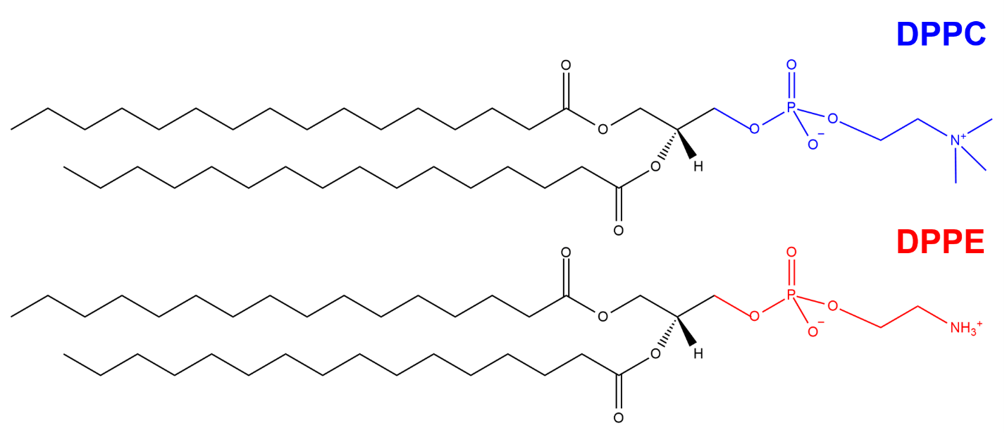
Fig. 1. Structural formulas of 1,2-dipalmitoyl-sn-glycero-3-phosphocholine (DPPC – blue polar headgroup) and 1,2-dipalmitoyl-sn-glycero-3-phosphoethanolamine (DPPE – red polar headgroup).

- Experimental
  - Chemicals and DPPC and DPPE suspensions preparation
1,2-dipalmitoyl-sn-glycero-3-phosphoethanolamine (DPPE; white powder, ≥ 98 %) was purchased from Cayman Chemical and used as received. A water solution of NaCl (prepared from NaCl (Kemika, p. a. grade) and milli-Q water) of ionic strength (concentration) I = 100 mM and pH ≈ 6.5 (determined with pH test strips) was used as a hydrating medium. The stock solution of DPPE in chloroform (CHCl₃; colorless liquid, p.a., Carlo Erba) was prepared in a way that the mass concentration was γ(DPPE) = 5 mg ml⁻¹. After pipetting 1 ml of the stock solution into the separate flasks, CHCl₃ was evaporated on a rotary evaporator in order to obtain DPPE films. After drying the films under an Ar stream, the latter were hydrated with 5 ml of aqueous solution of NaCl. The resulting suspensions underwent at least five consecutive vortexing, heating (in a hot H₂O bath) and cooling (in an ice bath) cycles [37], each step lasting about two minutes. The final mass concentration of DPPE lipids intended for UV/Vis measurements was γ = 1 mg ml⁻¹. The suspensions of multilamellar DPPE aggregates, the existence of which was confirmed by DLS measurements, were additionally measured using DSC technique. The details associated with them are presented and briefly discussed in Supporting Information, section S1.
  - UV/Vis spectroscopy: Temperature-dependent spectral acquisition, data preparation and spectral analysis of hydrated DPPE multilamellar aggregates
UV/Vis spectra of DPPE suspensions were measured on UV/Vis spectrophotometer NanoDrop Thermo Scientific Nanodrop 2000 (Thermo Fisher Scientific, USA) in the spectral range 250 − 500 nm (raw DPPC data were taken from our previous work [35]). Sealed quartz cuvettes (sample volume 1 ml) were filled up with DPPE suspensions and aqueous solution of NaCl and placed in a temperature-controlled cuvette holder. The suspensions of DPPE, along with the reference solution, were heated in a temperature interval of 52 − 74 °C with a heating rate of approximately 1 °C min⁻¹; UV/Vis spectra of the suspensions were acquired three times (in three different cuvettes), whereas the aqueous solution of NaCl once.
Acquired spectra of DPPE suspensions were smoothed (Savitzky-Golay; polynom of a 3rd degree and 10 points) and, together with DPPC suspensions data taken from our previous work [35], baseline-corrected by a vertical set-off at 330 nm (the coordinates obtained are (330, 0)) [38]. The prepared UV/Vis spectra of both DPPC and DPPE suspensions were further examined in the range 250 − 300 nm (Fig. 3a, b) which is most sensitive to changes in suspension turbidity [35].
The analysis of equally treated temperature-dependent UV/Vis spectra of DPPC and DPPE suspensions was performed in a multivariate manner following two approaches: differential spectral analysis (DSA) and multivariate curve analysis (MCA) [35].
Differential spectral analysis (DSA). The initial step in DSA is to subtract consecutive UV/Vis spectra in order to get the average absorbance difference between two neighboring spectra, which is further divided with the number of data points in the examined spectral range:
$$ΔA_{T+0.5}= \frac{A_{T+1}-A_{T}}{m}$$
In the above expression $ΔA_{T+0.5}$ is the average absorbance difference, $A_{T(+1)}$ denotes the spectrum acquired at temperature T(+1), and m is the number of data points in spectral range 250 − 300 nm (m = 51). For DPPC T goes from 30 to 51 °C, and for DPPE from 52 to 74 °C.
Finding the cumulative absorbance difference ($A_{T^{'}}^{c}$) using the relation
$$A_{T^{'}}^{c}=\sum_{T=30.5}^{T^{'}}{{∆A}_{T}}$$
is followed by normalization, i.e. by dividing the $A_{T^{'}}^{c}$ data with a cumulative absorbance difference value at 51.5 °C for DPPC and 73.5 °C for DPPE, making the final data limited to the interval 0−1.
Multivariate curve analysis (MCA). As MCA is thoroughly described in a number of papers (for instance, in [39–41]), only the basic principles will be shortly introduced in this manuscript. The ultimate goal of MCA is to solve the following system of equations:
D = CS^{T} + E
where D is the data matrix (temperature-dependent UV/Vis spectra), and C and S^{T} are the concentration (C) and spectral (S^{T}) profiles of the components that exhaust the most variance from the data, respectively. The rest unexplained by the product CS^{T} constitutes E, the residuals matrix. As explained in our previous paper [35], we assumed that only one component is sufficient to represent our multidimensional data.
In DSA and MCA projections of temperature-dependent UV/Vis spectra of the DPPC suspension two inflection points can be unambiguously detected, with almost equal differences between the plateaus of the corresponding sigmoid transitions (Fig. 3c). As demonstrated in our previous paper, the inflection points coincide with pre- and main phase transition temperature [35]. This finding also implies that the baseline correction of UV/Vis spectra does not introduce the changes in spectral projections nor does it affect the determination of the inflection points. Analogous projections of DPPE suspensions show comparable behavior, with the difference that the first sigmoidal transition is not as pronounced as the second one (Fig. 3d). Due to the difference in the steepness and depth of the first sigmoidal transition compared to the second, as well as because DPPE lipids do not display a pretransition (or any other phase transition about ten degrees below the main phase transition), the obtained curves were fitted on both single and double Boltzmann functions, respectively. The quality of fit, expressed as R² values, suggests that for spectral projections of both DPPC and DPPE suspensions double sigmoid fit produces statistically more significant results than a single one, respectively: R² (DPPC) = 0.982 and 0.985 from the single sigmoid fit of DSA and MCA data, respectively, and 0.997 and 0.997 from the double sigmoid fit of DSA and MCA data, respectively; R² (DPPE) = 0.976 and 0.981 from the single sigmoid fit of DSA and MCA data, respectively, and 0.998 and 0.999 from the double sigmoid fit of DSA and MCA data, respectively. The values of the corresponding inflection points, i.e. phase transition temperatures are displayed in Table 1, whereas other fitting parameters related with double sigmoid fit are presented in Supporting Information (section S2, Table S2), as well as the residual analysis (section S3).

3. Molecular Dynamics (MD) Simulations Setup
To investigate the phase transition phenomena in membrane systems, we performed a set of classical MD simulations. The simulated systems consist of either a pure DPPC or a pure DPPE bilayer. The systems were prepared using the membrane builder module of CHARMM-GUI [42–45], with each system containing 192 lipid molecules, 14660 water molecules (TIP3P water model), and 25 sodium chloride species to emulate experimental conditions (I = 0.1 M). For each of the two simulated membrane systems we performed nine distinct simulations. More precisely, we simulated aforementioned two types of bilayers at nine different temperatures, in such a way that the chosen set of temperatures spans both their gel and fluid phases, i.e. with the aim to capture the systems at/in the vicinity of their respective phase transitions. In this regard, we simulated systems containing DPPC at T = 10, 15, 20, 25, 30, 35, 40, 45, 50 °C, with the temperature set for DPPE being T = 31, 36, 41, 46, 51, 56, 61, 66, 71 °C. CHARMM-GUI membrane builder minimization and equilibration procedure was used for all 18 prepared systems, with temperature in this respect being set 55 °C and 71 °C for DPPC and DPPE, respectively (fluid phase). After equilibration, we simulated each system for 500 ns (example system setups are shown in Fig. 2) using unbiased all-atom molecular dynamics (MD) utilizing CHARMM36m force field [46] and TIP3P water model [47,48].
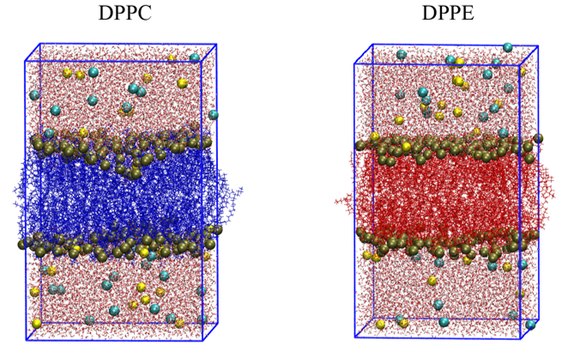
Fig. 2. Snapshots of the equilibrated DPPC (left) and DPPE (right) systems. DPPC and DPPE are colored blue and red, respectively, phosphorus atoms belonging to lipid heads are shown in dark yellow spherical representation, sodium and chloride ions are colored in yellow and cyan, also presented using spherical representation, with water molecules being shown in licorice representation. Graphics obtained using VMD software. [49]
The simulations were performed in GROMACS 2018.4 [50] with a time step of 2 fs, van der Waals and short-range Coulomb cut-offs of 12 Å, three-dimensional periodic boundary conditions, incorporating the particle mesh Ewald (PME) procedure [51]. The production simulations were propagated using Nosé-Hoover thermostat [52] with Parrinello-Rahman barostat [53] (p = 1 bar, semiisotropic pressure coupling). The subsequent analysis is performed taking into account last 100 ns of the propagated simulations.

4. Results and Discussion
  - UV/Vis spectroscopy
UV/Vis signature of chromophore-free lipids DPPC and DPPE is reflected through the vertical shift of the background signal as a function of the temperature (Fig. 3a, b). Since the turbidity of the suspensions more or less abruptly changes upon heating in examined temperature ranges, acquired spectra are sensitive reporters of the phase transition temperatures.
Spectral projections obtained either using DSA or MCA as a function of temperature display a somewhat similar trend for DPPC and DPPE suspensions (Fig. 3c, d). Two inflection points obtained from double sigmoid fit (cyan curve in Fig. 3c and 3d) of DPPC spectral projections coincide with the pre- and main phase temperatures: T_{p} = 33.4 ± 0.2 °C from DSA and T_{p} = 33.9 ± 0.2 °C from MCA, respectively, and T_{m} = 41.1 ± 0.2 °C from DSA and T_{m} = 41.6. ± 0.2 °C from MCA, respectively [30,35] (see also references therein). When the curves are fitted on only one sigmoid transition (green curve in Fig. 3c and 3d), the inflection point is found at T_{pt} = 32 ± 3 °C and T_{pt} = 34 ± 2 °C from DSA and MCA, respectively (T_{pt} stands for the Temperature of the phase transition).
When the same approach is applied to DPPE spectral projections, the inflection point values obtained from the double sigmoid fit are T_{p’} = 55 ± 1 °C and T_{p’} = 55 ± 1 °C from DSA and MCA, respectively, and T_{m} = 62.9 ± 0.1 °C and T_{m} = 63.4 ± 0.1 °C from DSA and MCA, respectively (T_{p’} stands for pretransition-like temperature). The corresponding values obtained from the single sigmoid fit are T_{pt} = 60.9 ± 0.4 °C and T_{pt} = 61.1 ± 0.4 °C from DSA and MCA, respectively. All phase transition temperatures are additionally displayed in Table 1, along with the data obtained through MD simulations of DPPC and DPPE bilayers.
According to the all reported data on the thermal behavior of DPPE [16,30], the only phase transition of DPPE expected in the examined temperature range (53-74 °C) is the main phase transition L_{β} → L_{α} at 61.5 ± 0.4 °C (FTIR) and 63.5 ± 0.1 °C (DSC) [30]. This discrepancy in about 2 °C between FTIR and DSC data is equal to the difference in (main) phase transition temperatures obtained when UV/Vis spectral projections of DPPE suspensions are fitted on one and two sigmoid transitions, respectively; when DSA and MCA data of each fit are averaged one gets ${\overline{T}}_{m}$ = 61.0 ± 0.4 °C from one sigmoid transition fit (displaying excellent agreement with FTIR data determined in [30]) and ${\overline{T}}_{m}$ = 63.2 ± 0.4 °C from two sigmoid transition fit (displaying excellent agreement with DSC data measured in [30]).
In order to eliminate the eventual influence of a heating rate on measured phase transition temperatures, we performed DSC measurements of these suspensions at different heating rates: 1 °C min⁻¹ and 0.25 °C min⁻¹. We obtained equal values ​​within the uncertainty limits (these data are presented in Supporting Information, Section S1.)
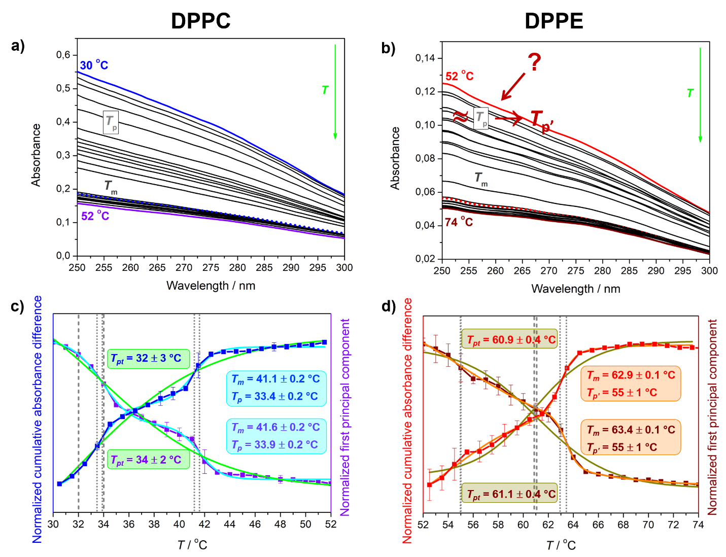
Fig. 3. Baseline-corrected temperature-dependent UV/Vis spectra of: a) DPPC in NaCl (I = 100 mM) and b) DPPE in NaCl (I = 100 mM). The lowest (30 °C for DPPC (blue) and 52 °C for DPPE (red)) and the highest temperatures (52 °C for DPPC (violet) and 74 °C for DPPE (wine)) are highlighted as well as the spectral profile of the first principal component obtained from MCA (dotted blue and red lines, respectively). Normalized cumulative absorbance difference (DSA) and spectra projected onto the normalized first principal component (MCA) as a function of temperature, with the inflection point(s) highlighted with dashed vertical gray lines for single sigmoidal fit (green curves) and dotted vertical gray lines for double sigmoidal fit (cyan curves), of: c) DPPC in NaCl (I = 100 mM) designated with blue (DSA) and violet (MCA) lines and d) DPPE in NaCl (I = 100 mM) designated with red and wine lines. Inflection point(s) reveal phase transition temperatures (labelled with corresponding colors): T_{pt} obtained from the single sigmoidal fit of DPPC and DPPE and T_{m} and T_{p (p’)} obtained from the double sigmoidal fit of DPPC (T_{m} and T_{p}) and DPPE (T_{m} and T_{p’}).
Statistically more significant double sigmoid fit requires introducing possible physical explanation of the event that appears, averaging DSA and MCA data, at ${\overline{T}}_{p'}$ = 55 ± 1 °C. Since the absence of a ripple phase in DPPE suspensions is demonstrated in all structural, and microscopic measurements [1,16,54], some other, perhaps similar phenomenon might be responsible for the appearance of the first sigmoid transition. DPPE multilamellar aggregates are sac-like entities [18] whose average curvature inevitably experiences certain temperature-induced curvature fluctuations (the same goes for multilamellar DPPC liposomes). We suggest that small yet significant discontinuity in curvature fluctuations, producing time- and temperature-dependent undulations, arise at ${\overline{T}}_{p'}$ = 55 ± 1 °C. Although the undulation appearance does not represent a phase transition, it is easily possible that they are coupled with the main phase transition to some extent and thus influence the determination of the temperature at which the mentioned event (T_{m}) takes place. Accordingly, these undulations are the origin of the discrepancies between T_{m} of DPPE obtained from DSC and FTIR measurements. If such undulations exist on DPPE surface, they probably exist on the surface of multilamellar DPPC liposomes, but are either screened by the ripple phase or are somehow coupled with a ripple phase formation; moreover, they might even contribute to the amplification of this phase transition (the detail consideration of this assumption is out of the scope of this paper). Due to the presumed undulations of DPPE multilamellar aggregates, we label the transition temperature at ${\overline{T}}_{p'}$ = 55 ± 1 °C the pretransition-like temperature. The assumption that discontinuities in curvature fluctuations produce DPPE surface undulations which can be captured by temperature-dependent UV/Vis spectroscopy are additionally explored with MD simulations. The phase transition temperatures obtained from temperature-dependent UV/Vis spectra analysis, along with data obtained from MD simulations, are displayed in Table 1.

Table 1. Phase transition temperatures obtained from the double sigmoid fit of spectral projections of temperature-dependent UV/Vis spectra of DPPC and DPPE and obtained from MD simulations
Suspension | T_{pt}ª
Suspension | UV/Vis^{b} |  |  |  | MD
Suspension | DSA |  | MCA |  | Area per lipid / bilayer thickness |  | Deuterium order parameter |  | 3D heating maps
Suspension | T_{p} / T_{p’} | T_{m} | T_{p} / T_{p’} | T_{m} | T_{p} / T_{p’} | T_{m} | T_{p} / T_{p’} | T_{m} | T_{p} / T_{p’} | T_{m}
DPPC | 33.4 ± 0.2 | 41.1 ± 0.2 | 33.9 ± 0.2 | 41.6 ± 0.2 | 41 | 47 | 35 | 40 | 35 | n. p.
DPPE | 55 ± 1 | 62.9 ± 0.1 | 55 ± 1 | 63.4 ± 0.1 | 52 | 64 | 52 °C | 66 | 51 | n. p.
ª In °C; ^{b} Data obtained with double sigmoid fit; n. p. stands for not provided.

4.2 Computational data
The main data obtained by MD simulations presented in what follows are addressed to the area per lipid and the bilayer thickness, deuterium order parameter and acyl chains interdigitation, whereas 2D heating maps are presented in Supporting Information (section S4).
Area per lipid and the bilayer thickness. Firstly, we inspect the metric corresponding to the global behavior of the bilayers with respect to the change in temperature, i.e. membrane thickness (Fig. 4).
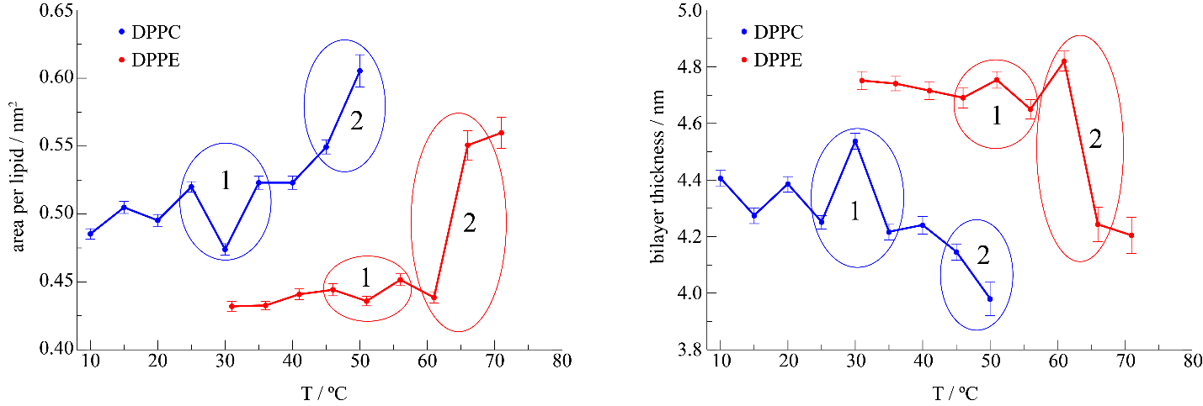
Fig. 4. Dependence of the area per lipid (left panel) and the bilayer thickness (right panel) of both DPPC and DPPE bilayers on temperature. Standard deviations of the measured values are presented by error bars. Important temperature regions are given numerical designation and denoted with ellipses.
The area per lipid was estimated by finding the average area of the membrane during the course of the last 100 ns, and then dividing it with the number of lipids residing in the upper/lower leaflet (in this case by dividing with 96), with the thickness of the membrane being calculated by finding the average difference between the z-coordinates of the phosphorus atoms belonging to upper and lower lipid leaflet, for each snapshot of the system. These differences are then averaged over the entire ensemble (last 100 ns), giving rise to the average thickness of the bilayer during the course of the simulation, at all investigated temperatures. We find that the DPPC and DPPE membranes show a drastic decrease in their thickness at approximately 47 °C and 64 °C, coinciding with the increase in area per lipid (Fig. 4, region 2), respectively, thereby correlating very well with the experimentally observed T_{m} in both cases (T_{m} ≈ 41 °C and T_{m} = 64 °C for DPPC and DPPE, respectively, see also Supporting Information, Section S1). Thus, at the aforementioned temperatures the membranes experience their well-known L_{β(‘)} → L_{α} transition [13,16]. On the other hand, and significantly more importantly, DPPC membrane shows a readily observable change in its behavior at around T = 30 °C (Fig. 4, region 1, DPPC), temperature aligning very well with T_{p} of DPPC, i.e. temperature at which its pretransition occurs (experimentally measured T_{p} ≈ 34 °C, see also Supporting Information, Section S1). Markedly, while somewhat weaker, DPPE seems to possess the equivalent feature, appearing at approximately T = 51 °C (Fig. 4, region 2, DPPE). This latter feature, corresponding in the case of DPPC to its known pretransition, is thus unexpectedly, albeit in a weaker form, found also in DPPE, which is considered not to experience pretransition. It is exactly this that motivated us to venture into significantly more refined analysis of the observed phenomenon.
Deuterium order parameter. To obtain a more detailed description of the systems at hand, we calculate deuterium order parameter, for both lipids and their acyl chains in both sn1 and sn2 positions (see Figs. S3 and S4 for acyl chains in sn1 and sn2 positions, respectively). The deuterium order parameter for both saturated and unsaturated lipid tails in fully atomistic force fields are calculated using
$$S_{CD}=\left.\left\langle \frac{3\cos^{2}θ-1}{2}\right.\right\rangle ,$$
with θ being the angle the C−H bond vectors along the lipid tails close with the membrane normal, taken as the z-axis for planar bilayers. Order parameters are a measure of the level of order or entropy in the lipid tails, thereby providing insight into the fluidity of the membrane, due to the fact that gel lipids exhibit a greater degree of order over fluid lipids. To compare the behavior of the two lipids we present temperature dependence of the average deuterium order parameters (${\overline{S}}_{CD}$) for both DPPC and DPPE, calculated taking into account both sn1 and sn2 acyl chains. The average parameters were obtained taking into account the buried halves of the acyl chains, designated as carbon atoms 8 to 14 in Fig. S3 and Fig. S4 (average deuterium order parameters over the entire set of 14 carbon atoms for both DPPC and DPPE are given in Fig. S5). In this respect, it can be readily observed from Fig. 5 that a rather drastic change occurs in the average order parameter when gel to fluid transition occurs (compare 45 °C and 50 °C in the case of DPPC and likewise, 61 °C and 66 °C in the case of DPPE). Thus, the lower the deuterium order parameters on average, the higher the disorder in the lipid tails. While this behavior of the deuterium order parameters is completely expected, reflecting the main phase transition of both studied lipid bilayers, notably more interesting and revealing is the behavior of the parameters before lipids reach their melting point. In this respect, while the general trend of the DPPC bilayer is to slowly proceed from the more disordered to the ordered, in its region 1 the DPPC bilayer experiences a reverse trend, jumping to a more disordered state (25 °C to 30 °C), afterwards showing rather stable behavior with respect to this order parameter.
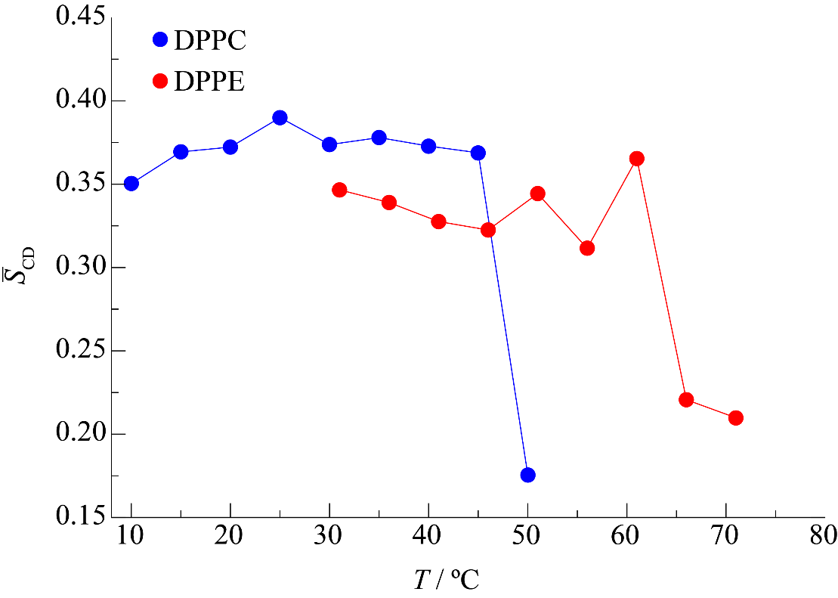
Fig. 5. Temperature dependence of the average deuterium order parameter (averaging over deuterium order parameters of carbon atoms 8 to 14 belonging to both acyl chains), for DPPC (blue) and DPPE (red) bilayers.
On the other hand, and rather interestingly, we observe that DPPE bilayer possesses a somewhat similar feature in this respect, albeit with a marked difference. Firstly, DPPE bilayer exhibits very ordered state at the lowest simulated temperature (T = 31 °C), slowly proceeding toward the more unordered states as the temperature rises, which is already a distinction compared to the DPPC bilayer (Fig. 5). Interestingly, deuterium order parameters reveal very similar picture to the one observed in Fig. 4 with respect to region 1, with DPPE showing a rather discontinuous behavior when considering 46 °C – 51 °C – 56 °C simulations. More precisely, the bilayer exhibits significantly more ordered state at 51 °C compared to its state at both former and latter temperatures, showing certain level of similarity with DPPC. Surprisingly, and to differ from the first two investigated metrics, namely area per lipid and bilayer thickness, DPPE is the one giving rise to significantly higher fluctuations in the average deuterium order parameter in the region 1 (compare Figs. 4 and 5). The reason behind this phenomenon lies in the fact that the very shapes of the curves denoting deuterium order parameters change in the case of DPPC (see Figs. S3 and S4, left panels), reflecting the fact that different parts of the acyl chain become more ordered/disordered in the temperature region of interest. In this respect, even though the aforementioned curves change shape, their average remains similar, with averaging “hiding” the information regarding the asymmetric changes in deuterium order parameters. On the other hand, we can observe that the curves denoting deuterium order parameters exhibit virtually same trends in the case of DPPE (consider the shapes of curves denoting the deuterium order parameters for DPPE, Figs. S3 and S4, right panels). Thus, while a significant change in the terms of ordering of acyl chains indeed occurs in DPPE, the ordering of the different sections of the chain changes homogenously, this not being the case in DPPC.
Overall, the insights obtained from deuterium order parameters showcase that both DPPC and DPPE, despite certain differences in their behavior (see the previous paragraph), undergo a certain process in their respective regions 1 (see Fig. 4). We can at this point thus note that, regardless of the differences between the two bilayers, the analysis of both the area per lipid/bilayer thickness and deuterium order parameters suggest that a certain event, resembling a pretransition, occurs at ~ 51 °C even in the case of DPPE, which was thought to be nonexistent.
Interdigitation. However, and rather unsurprisingly, the difference in the two bilayers becomes rather obvious with respect to the interdigitation of their upper and lower leaflets, respectively (see Supporting Information, Section S4, Figs. S6 and S7). More precisely, while DPPC readily forms interdigitated nanodomains even at T = 10 °C, with a fully formed ripple phase appearing at around 35 - 40 °C (Supporting Information, Fig. S6), virtually no interdigitation is observed in the case of DPPE (Supporting Information, Fig. S7), which agrees with all previous studies of the two systems. Thus, a conundrum appears. While on one hand one can observe that DPPE indeed follows relatively similar trends to DPPC with respect to the discussed metrics (area per lipid/bilayer thickness, deuterium order parameters), on the other hand, and rather unsurprisingly [26], DPPE does not exhibit co-existence of the two phases, i.e. it does not coincide in this respect with the behavior of DPPC bilayer. However, and as can be concluded from the aforementioned discussion, the pretransition phenomenon is obviously not in one-to-one correspondence with the existence of the interdigitated nanodomains, as one readily observes the co-existence of interdigitated nanodomains and L_{α} phases significantly below expected T_{p} of DPPC. Rather than that, the quantitative differences, namely the sudden shift from the nanodomains to the fully formed ripple phase in the case of DPPC, occurring between 30 °C and 35 °C, denotes the pretransition phenomenon. Thus, while DPPE indeed does not form P_{β’} phase, this does not necessarily imply that it does not undergo pretransition-like event. To fully reveal the details behind the behavior of the DPPE bilayer and to reconcile the apparent discrepancies behind the presented analyses, we further analyze the simulations of DPPE bilayer, thereby finding that, while DPPE bilayer does not form ripple per se, it does exhibit significantly different behavior at exactly 51 C°, compared to all other simulated conditions, as observed from all the investigated metrics. Namely, we find that, while not possessing the signature ripple/P_{β} phase, which is a hallmark feature of DPPC bilayers (Fig. 6, left panel), it indeed undergoes undulations at T = 51 C° and to a lesser extent at T = 56 C° (see Fig. 6, right panel), which are of significantly weaker extent at other simulated temperatures. This finding is corroborated by calculating difference of average Gaussian curvatures of upper and lower leaflets for both DPPE and DPPC, results of which are presented in Fig. S8.
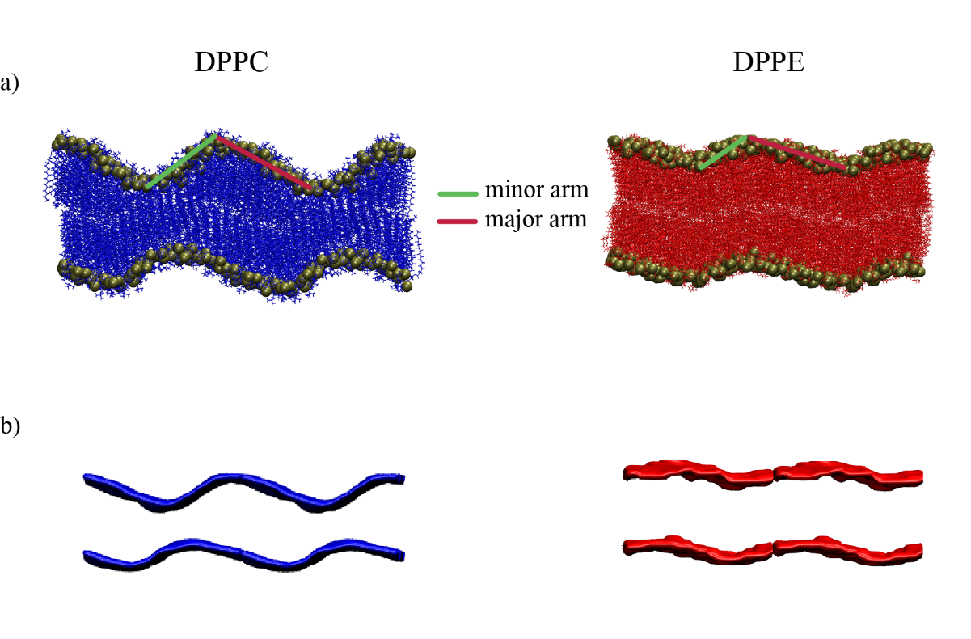
Fig. 6. a) Snapshots of DPPC (left) and DPPE (right) systems and b) 3D maps depicting average positions of the centers of mass of lipids in the 20 ns span (isosurface value = 0.5) at 40 °C and 51 °C, respectively. Presented maps are obtained using g_lomepro tool.[55] Minor and major arms are depicted as green and red lines, respectively. Four periodic images (two in the x- and y- directions) are used to present the data. Graphics are obtained using VMD software. [49]
The difference between the two systems can now be readily observed, with DPPC exhibiting a fully formed P_{β‘}/wavelike phase, with the minor and major arms being on average approximately 30 Å and 42 Å long, coinciding nicely with the finding of Khakbaz and Klauda [25], whereas one is inclined to describe it as an almost completely out-of-phase (“destructive interference pattern”) alignment of the upper and the lower lipid leaflets. On the other hand, DPPE indeed forms, albeit much weaker, undulating phase, whereby the two leaflets of the DPPE bilayer are virtually in phase (“constructive interference”), with the minor and the major arms being approximately 20 Å and 33 Å long. Moreover, while the ripple is readily observed in the case of DPPC (throughout the course of the simulations at T = 35 °C and T = 40 °C), this undulating regime in the case of DPPE appears and disappears, with the average time DPPE bilayer “lives” in this state being around 10-20 ns (see Fig. 6b for averaged 3D maps of the upper and lower leaflets in the duration of 20 ns for both DPPE and DPPC bilayers). Importantly, it has to be noted that, while significant undulations in the case of DPPE were observed after 100 ns of equilibration time at T = 51 °C, this by itself would not be enough of an argument to conclude that this undulating behavior represents particularly significant observation, as it is well expected that biological membranes undergo wavelike behavior during CMD simulations. However, the difference in the behavior of the DPPE bilayer at this particular temperature compared to the all other simulated conditions, being perceivable both in all of the monitored metrics and in the appearance of the undulating regime, which is virtually nonexistent at all other temperatures, strongly suggests that the observed phenomenon is an inherent property of the DPPE bilayer.
Ultimately, the peak of the temperature-dependent undulations of DPPE bilayer provided by MD simulations shows more than satisfactorily agreement with T_{p’} values of DPPE multibilayers obtained from UV/Vis experiments (see Table 1). With this respect, our assumption that discontinuity in curvature fluctuations, i.e. surface undulations, slightly below T_{m} can cause the discrepancies in T_{m} values measured by different techniques, serves as a plausible explanation.

5. Conclusion
We performed temperature-dependent UV/Vis measurements and classical all-atom molecular dynamics (CMD) simulations of DPPC and DPPE (multi)bilayers in an aqueous solution of NaCl (I = 100 mM) in order to investigate the origin of discrepancies in T_{m} values of DPPE obtained by DSC and FTIR spectroscopy, the phenomenon of which was not observed in DPPC. Twofold multivariate analysis of temperature-dependent UV/Vis spectra of DPPC and DPPE suspensions revealed sigmoidal spectral projections with two inflection points for both suspensions with one important difference: in DPPC the difference in the plateaus of both sigmoid transitions is almost equal, whereas in DPPE the first sigmoid transition is significantly less steep than the second one, respectively. The inflection points of associated sigmoid transitions in DPPC correspond to ${\overline{T}}_{p}$ (33.7 ± 0.3 °C ) and ${\overline{T}}_{m}$(41.4 ± 0.3 °C), whereas in DPPE the low-temperature inflection point (${\overline{T}}_{p'}$= 55 ± 1 °C) is attributed to the discontinuity in temperature-dependent curvature fluctuations accompanied with surface undulations and is labeled as pretransition-like event. High-temperature inflection point (${\overline{T}}_{m}$= 63.2 ± 0.4 °C) coincides with the main phase transition temperature as determined with DSC. If the spectral projection of DPPE is fitted on one sigmoid transition only, one gets T_{m} value as obtained from FTIR spectra, ${\overline{T}}_{m}$ = 61.0 ± 0.4 °C. The assumption that UV/Vis spectra can detect the change in temperature-dependent surface undulations with the maximum about 10 degrees below T_{m} is additionally examined with MD simulations. Examining area per lipid, deuterium order parameter and 3D heating maps for DPPC and DPPE we found that, even though the DPPE bilayer indeed does not exhibit P_{β’} phase, it seemingly undergoes a certain pretransition-like event in the temperature region approximately 10 °C below its T_{m}, which agrees with our UV/Vis data. Additionally, our results imply that temperature-dependent UV/Vis spectroscopy is not just powerful enough to detect the P_{β’} phase of DPPC due to the change in suspension turbidity, but also the discontinuities in curvature fluctuations that, on average, go unnoticed contribute to the amplification of this low-cooperativity phase transition. Finally, the research of the potential of turbidimetric measurements in the detection and characterization of lipid phase transitions that do not start from the gel phase is currently underway.

Acknowledgment
This article was supported by the Croatian Science Foundation, Project No. UIP-2020-02-7669 and by the grant obtained from the Croatian Academy of Sciences and Arts.

Supporting Information
Supporting Information associated with this paper can be found in the online version at http://.

References:
[1] T. Heimburg, Thermal Biophysics of Membranes, First, Wiley-VCH, Weinheim, 2007.
[2] D. Marsh, Structural and thermodynamic determinants of chain-melting transition temperatures for phospholipid and glycolipids membranes, Biochim. Biophys. Acta - Biomembr., 1798 (2010) 40–51.
[3] D. Marsh, Lateral order in gel, subgel and crystalline phases of lipid membranes: Wide-angle X-ray scattering, Chem. Phys. Lipids, 165 (2012) 59–76.
[4] G. Cevc, Polymorphism of the bilayer membranes in the ordered phase and the molecular origin of the lipid pretransition and rippled lamellae, Biochim. Biophys. Acta, 1062 (1991) 59–69.
[5] S. Garcia-Manyes, G. Oncins, F. Sanz, Effect of ion-binding and chemical phospholipid structure on the nanomechanics of lipid bilayers studied by force spectroscopy, Biophys. J., 89 (2005) 1812–1826.
[6] T. Kaasgaard, C. Leidy, J.H. Crowe, O.G. Mouritsen, K. Jørgensen, Temperature-controlled structure and kinetics of ripple phases in one- and two-component supported lipid bilayers, Biophys. J., 85 (2003) 350–360.
[7] T. Mužić, F. Tounsi, S.B. Madsen, D. Pollakowski, M. Konrad, T. Heimburg, Melting transitions in biomembranes, BBA - Biomembr., 1861 (2019) 183026.
[8] M.B. Schneider, W.K. Chan, W.W. Webb, Fast diffusion along defects and corrugations in phospholipid P_{β’} liquid crystals, Biophys. J., 43 (1983) 157–165.
[9] M. Ge, J.H. Freed, Hydration, Structure, and Molecular Interactions in the Headgroup Region of Dioleoylphosphatidylcholine Bilayers: An Electron Spin Resonance Study, Biophys. J., 85 (2003) 4023–4040.
[10] R.N.A.H. Lewis, D.A. Mannock, R.N. McElhaney, Differential Scanning Calorimetry in the Study of Lipid Phase Transitions in Model and Biological Membranes, in: A.M. Dopico (Ed.), Methods Membr. Lipids, Humana Press, New Jersey, 2006: pp. 171–195.
[11] U. Bernchou, H. Midtiby, J.H. Ipsen, A.C. Simonsen, Correlation between the ripple phase and stripe domains in membranes, Biochim. Biophys. Acta - Biomembr., 1808 (2011) 2849–2858.
[12] Z. Arsov, E.J. González-Ramírez, F.M. Goñi, S. Tristram-Nagle, J.F. Nagle, Phase behavior of palmitoyl and egg sphingomyelin, Chem. Phys. Lipids, 213 (2018) 102–110.
[13] R. Koynova, M. Caffrey, Phases and phase transitions of the phosphatidylcholines, Biochim. Biophys. Acta, 1376 (1998) 91–145.
[14] O. Lenz, F. Schmid, Structure of symmetric and asymmetric “ripple” phases in lipid bilayers, Phys. Rev. Lett., 98 (2007) 2–5.
[15] T.R. Galimzyanov, P.I. Kuzmin, P. Pohl, S.A. Akimov, Undulations Drive Domain Registration from the Two Membrane Leaflets, Biophys. J., 112 (2017) 339–345.
[16] R. Koynova, M. Caffrey, Phases and phase transitions of the hydrated phosphatidylethanolamines, Chem. Phys. Lipids, 69 (1994) 1–34.
[17] B. Tenchov, R. Koynova, G. Rapp, New ordered metastable phases between the gel and subgel phases in hydrated phospholipids, Biophys. J., 80 (2001) 1873–1890.
[18] J.M. Seddon, G. Cevc, D. Marsh, Calorimetric Studies of the Gel-Fluid (L_{β}-L_{α}) and Lamellar-Inverted Hexagonal (L_{α}-H_{II}) Phase Transitions in Dialkyl- and Diacylphosphatidylethanolamines, Biochemistry, 22 (1983) 1280–1289.
[19] H.L. Casal, H.H. Mantsch, The thermotropic phase behavior of N-methylated dipalmitoylphosphatidylethanolamines, BBA - Biomembr., 735 (1983) 387–396.
[20] H. Yao, I. Hatta, R. Koynova, B. Tenchov, Time-resolved x-ray diffraction and calorimetric studies at low scan rates, Biophys. J., 61 (1992) 683–693.
[21] B. Stidder, G. Fragneto, S.J. Roser, Structure and stability of DPPE planar bilayers, Soft Matter, 3 (2007) 214–222.
[22] L. Sun, R.A. Böckmann, Membrane phase transition during heating and cooling: molecular insight into reversible melting, Eur. Biophys. J., 47 (2018) 151–164.
[23] D.A. Pink, S. McNeil, B. Quinn, M.J. Zuckermann, A model of hydrogen bond formation in phosphatidylethanolamine bilayers, Biochim. Biophys. Acta - Biomembr., 1368 (1998) 289–305.
[24] S. Youssefian, N. Rahbar, C.R. Lambert, S. Van Dessel, Variation of thermal conductivity of DPPC lipid bilayer membranes around the phase transition temperature, J. R. Soc. Interface, 14 (2017).
[25] P. Khakbaz, J.B. Klauda, Investigation of phase transitions of saturated phosphocholine lipid bilayers via molecular dynamics simulations, Biochim. Biophys. Acta - Biomembr., 1860 (2018) 1489–1501.
[26] R.M. Cordeiro, Molecular Structure and Permeability at the Interface between Phase-Separated Membrane Domains, J. Phys. Chem. B, 122 (2018) 6954–6965.
[27] S. Leekumjorn, A.K. Sum, Molecular simulation study of structural and dynamic properties of mixed DPPC/DPPE bilayers, Biophys. J., 90 (2006) 3951–3965.
[28] S. Leekumjorn, A.K. Sum, Molecular studies of the gel to liquid-crystalline phase transition for fully hydrated DPPC and DPPE bilayers, Biochim. Biophys. Acta - Biomembr., 1768 (2007) 354–365.
[29] K. Uppulury, P.S. Coppock, J.T. Kindt, Molecular Simulation of the DPPE Lipid Bilayer Gel Phase: Coupling between Molecular Packing Order and Tail Tilt Angle, J. Phys. Chem. B, 119 (2015) 8725–8733.
[30] P. Maleš, Z. Brkljača, I. Crnolatac, D. Bakarić, Application of MCR-ALS with EFA on FT-IR spectra of lipid bilayers in the assessment of phase transition temperatures: Potential for discernment of coupled events, Colloids Surfaces B Biointerfaces, 201 (2021) 111645, 8.
[31] D.A. Mannock, R.N.A.H. Lewis, R.N. McElhaney, Comparative calorimetric and spectroscopic studies of the effects of lanosterol and cholesterol on the thermotropic phase behavior and organization of dipalmitoylphosphatidylcholine bilayer membranes, Biophys. J., 91 (2006) 3327–3340.
[32] G. Cevc, J.M. Seddon, R. Hartung, W. Eggert, Phosphatidylcholine-fatty acid membranes I Effects of protonation, salt concentration, temperature and chain-length on the colloidal and phase properties of mixed vesicles, bilayers and nonlamellar structures, BBA - Biomembr., 940 (1988) 219–240.
[33] K. Matsuzaki, O. Murase, K. Sugishita, S. Yoneyama, K. Akada, M. Ueha, A. Nakamura, S. Kobayashi, Optical characterization of liposomes by right angle light scattering and turbidity measurement, Biochim. Biophys. Acta - Biomembr., 1467 (2000) 219–226.
[34] A. Wang, C. Chan Miller, J.W. Szostak, Core-Shell Modeling of Light Scattering by Vesicles: Effect of Size, Contents, and Lamellarity, Biophys. J., 116 (2019) 659–669.
[35] P. Maleš, Z. Brkljača, D. Domazet Jurašin, D. Bakarić, New Spirit of an Old Technique: Characterization of Lipid Phase Transitions via UV/Vis Spectroscopy, Spectrochim. Acta Part A Mol. Biomol. Spectrosc., 272 (2022) 121013.
[36] P. Maleš, B. Pem, D. Petrov, D. Domazet Jurašin, D. Bakarić, Deciphering the origin of the melting profile of unilamellar phosphatidylcholine liposomes by measuring the turbidity of its suspensions, Soft Matter, accepted (2022). https://doi.org/10.1039/D2SM00878E
[37] M. Leitgeb, Ž. Knez, M. Primožič, Sustainable technologies for liposome preparation, J. Supercrit. Fluids, 165 (2020) 104984.
[38] F. Menges, “Spectragryph, - optical spectroscopy software”, Version 1.2.15, 2015, http://www.effemm2.de/spectragryph/ (31.01.2022)
[39] H.R. Keller, D.L. Massart, Evolving factor analysis, Chemom. Intell. Lab. Syst., 12 (1991) 209–224.
[40] A. De Juan, J. Jaumot, R. Tauler, Multivariate Curve Resolution (MCR) Solving the mixture analysis problem, Anal. Methods, 6 (2014) 4964–4976.
[41] M. Maeder, A. de Juan, Two-Way Data Analysis: Evolving Factor Analysis, Compr. Chemom., 2 (2009) 261–274.
[42] http://www.charmm-gui.org/, (08.09.2022).
[43] J. Lee, M. Hitzenberger, M. Rieger, N.R. Kern, M. Zacharias, W. Im, CHARMM-GUI supports the Amber force fields, J. Chem. Phys., 153 (2020).
[44] E.L. Wu, X. Cheng, S. Jo, H. Rui, K.C. Song, E.M. Dávila-Contreras, Y. Qi, J. Lee, V. Monje-Galvan, R.M. Venable, J.B. Klauda, W. Im, CHARMM-GUI Membrane Builder Toward Realistic Biological Membrane Simulations, J. Comput. Chem., 35 (2015) 1997–2004.
[45] S. Jo, T. Kim, W. Im, Automated builder and database of protein/membrane complexes for molecular dynamics simulations, PLoS One, 2 (2007).
[46] J. Huang, S. Rauscher, G. Nawrocki, T. Ran, M. Feig, B.L. De Groot, H. Grubmüller, A.D.J. MacKerell, B. de la Groot, H. Grubmueller, A.D.J. MacKerell, CHARMM36m: An Improved Force Field for Folded and Intrinsically Disordered Proteins, Nat. Methods, 14 (2017) 71–73.
[47] W.L. Jorgensen, J. Chandrasekhar, J.D. Madura, R.W. Impey, M.L. Klein, Comparison of simple potential functions for simulating liquid water, J. Chem. Phys., 79 (1983) 926–935.
[48] A.D. MacKerell, D. Bashford, M. Bellott, R.L. Dunbrack, J.D. Evanseck, M.J. Field, S. Fischer, J. Gao, H. Guo, S. Ha, D. Joseph-McCarthy, L. Kuchnir, K. Kuczera, F.T.K. Lau, C. Mattos, S. Michnick, T. Ngo, D.T. Nguyen, B. Prodhom, W.E. Reiher, et al., All-atom empirical potential for molecular modeling and dynamics studies of proteins, J. Phys. Chem. B, 102 (1998) 3586–3616.
[49] W. Humphrey, A. Dalke, K. Schulten, VMD: Visual Molecular Dynamics, J. Mol. Graph., 14 (1996) 33–38.
[50] M.J. Abraham, T. Murtola, R. Schulz, S. Páll, J.C. Smith, B. Hess, E. Lindah, Gromacs: High performance molecular simulations through multi-level parallelism from laptops to supercomputers, SoftwareX, 1–2 (2015) 19–25.
[51] U. Essmann, L. Perera, M.L. Berkowitz, T. Darden, H. Lee, L.G. Pedersen, A smooth particle mesh Ewald method, J. Chem. Phys., 103 (1995) 8577–8593.
[52] S. Nosé, A molecular dynamics method for simulations in the canonical ensemble, Mol. Phys. An Int. J. Interface Between Chem. Phys., 52 (1984) 255–268.
[53] M. Parrinello, A. Rahman, Polymorphic transitions in single crystals: A new molecular dynamics method, J. Appl. Phys., 52 (1981) 7182–7190.
[54] G. Pabst, M. Rappolt, H. Amenitsch, P. Laggner, Structural information from multilamellar liposomes at full hydration: Full q-range fitting with high quality X-ray data, Phys. Rev. E - Stat. Physics, Plasmas, Fluids, Relat. Interdiscip. Top., 62 (2000) 4000–4009.
[55] V. Gapsys, B.L. De Groot, R. Briones, Computational analysis of local membrane properties, J. Comput. Aided. Mol. Des., 27 (2013) 845–858.

Present address: Selvita d.o.o. Prilaz baruna Filipovića 29, 10000 Zagreb, Croatia.

