Chemistry and Reactivity of 4-hydroxy-2-nonenal (HNE) in Model Biological Systems

Katarina Vazdar*, Sanja Škulj, Danijela Bakarić, Davor Margetić, Mario Vazdar*
Division of Organic Chemistry and Biochemistry, Rudjer Bošković Institute, Bijenička 54, HR-10000 Zagreb, Croatia

Corresponding authors: Dr. Katarina Vazdar, Dr. Mario Vazdar
Rudjer Bošković Institute, Bijenička 54, HR-10000 Zagreb, Croatia
Phone: +385-1-4571-382
Fax: +385-1-4680-195
E-mail: katarina.vazdar@irb.hr, mario.vazdar@irb.hr

ABSTRACT

Among many reactive oxygen species (ROS) which are constantly generated during oxidative stress in cellular membranes, formation and subsequent reactivity of ubiquitous 4-hydroxy-2-nonenal (HNE) with nearby amino acids and lipids represents one of the main research targets in cell physiology in the last decades. Starting from the first synthesis of HNE in 1967, chemistry and reactivity of HNE are constantly under intense scrutiny. This review shows recent advances in the field which are discussed with the special emphasis on revealing intricate details of numerous reaction mechanisms of HNE with lipids and amino acids, with the goal of understanding the reactivity of HNE at the molecular level.

KEYWORDS: 4-hydroxy-2-nonenal; oxidative stress; covalent modifications; model biological systems; reaction mechanism; lipid modification; protein modification

- INTRODUCTION
Oxidative stress is a pathophysiological condition occurring in all living cells, characterized by the massive production of reactive oxygen species in the mitochondria (ROS; radicals such as hydroxyl (.OH), alkoxyl (RO.), peroxyl (ROO.), and others) [1,2]. The presence of ROS in higher concentrations results in disruption of the redox signaling in the cell as well as in direct damage to the mitochondrial and cellular membranes and the proteins located within. The damage that the ROS cause is the result of a chain process that starts with the oxidative degradation of membrane lipids. During the oxidative degradation of membranes, several different highly reactive species are formed, usually termed reactive aldehydes (RA) [3]. The most abundant of such RAs is 4-hydroxy-2-nonenal (HNE) but other aldehydes have also been detected, ranging in length and extent of unsaturation [4]. Since these RAs are formed inside the cellular membrane, their high reactivity leads to formation of different adducts with the surrounding membrane lipids [5] and proteins [6], as well as DNA or RNA bases [4]. The RA-lipid and RA-protein adducts have a disrupting effect on the stability and functionality of the cell membrane. The RA-lipid adducts change the biophysical properties of the membrane thus affecting the environment of membrane proteins and consequently their function, but RA-protein adducts can also directly damage proteins. Usually, the cell proteasome system tends to detect and metabolize modified proteins present in low concentrations [7]. However, modified proteins at high concentrations can lead to severe metabolic disorders, autoimmune diseases such as diabetes, neurodegenerative disorders such as Parkinson’s and Alzheimer’s disease, cancer etc [8,9,10]. The increasing knowledge about the detrimental effect of RAs present in high concentration has led to numerous investigations of RA reactivity, the identification and formation of their adducts. This review focuses on the chemical synthesis of HNE and similar RAs, formation of HNE adducts within model biological systems, such as lipids and amino acids, and elucidation of the mechanism of adduct formation by theoretical investigations. We present an overview of experimental accounts of HNE chemical reactivity as well as highlight the points of investigation that still remain a challenge.

- BIOCHEMICAL SYNTHESIS OF HNE
In order to stress the importance of the chemical synthesis and analysis of reactivity of HNE and similar RAs, it is essential to show a short summary of its biochemical origin. A generally accepted pathway of HNE formation from linoleic acid involving peroxyl radicals [3] is shown in Scheme 1.

Scheme 1. Non-enzymatic radical pathway for biochemical synthesis of HNE

It is known that ω-6 fatty acids such as linoleic and arachidonic acid undergo radical oxidation resulting in formation of HNE and similar RAs, but some phospholipids can also undergo a similar process [1,3]. The first step includes an attack of a peroxyl radical to the conjugated double bond system of linoleic acid in which two isomers of peroxy fatty acid are formed. Both of the peroxy forms can lead to the formation of HNE in several radical transformations [11] (Scheme 1). It is important to emphasize that a parallel enzymatic pathway is also present. Different lipoxygenases and cytochrome hydroperoxide lyases have been identified; they are a part of the regular activation system of lipids but their products can also be affected by the free radical chain and lead to the formation of RAs [12,13].

- CHEMICAL SYNTHESIS OF HNE
Since the discovery of HNE and similar RAs and their detrimental effect on the functionality of cells, there have been numerous attempts to prepare such molecules in the laboratory and making them accessible for investigation of their reactivity. It would be out of the scope of this review to present all of the efforts given in the field, but we will focus our attention to significant breakthroughs in such syntheses and highlight specific results arising from them. The first reported synthesis of HNE [14] dates back to 1967 as a continuation of the work that Esterbauer and Weger conducted on the autooxidation of unsaturated fatty acids in water. The authors noticed the appearance of different aldehydes during the autoxidation including HNE. Even though the main aim of the synthesis was actually 4-hydroxyoctenal, Esterbauer and Wager give the general synthetic pathway (Scheme 2) for all aldehydes with –CHOH-CH=CH-CHO group which is emphasized as the main structural characteristic of aldehydes responsible for biological activity against healthy and malignant cells.

Scheme 2. Breakthroughs in chemical synthesis of HNE.

In the following years, several approaches have been developed for the synthesis of HNE and similar aldehydes. Such procedures have used variations of the Grignard reaction [14,15,16], ruthenium catalyzed isomerization of 2-yne-l,4-diols [17] and a method via 1,3-bis(methylthio)allyl-lithium [18]. All of these reaction sequences have been cumbersome and usually involved a lengthy synthesis resulting in a low yield of desired aldehydes. A significant breakthrough happened in 1992 when Gardner and coauthors [19] developed a facile and simple method for synthesis of HNE using epoxyaldehydes. The procedure involved two reaction steps resulting in 48% total yield of HNE (Scheme 2). Yu and Wang [20] developed in 1993 a similar procedure using 2,3-epoxy aldehydes in the Wittig reaction for the production of different (E)-4-hydroxyalkenals including HNE in high yields (Scheme 2). This reaction system also provides an efficient route towards chiral (E)-4-hydroxyalkenals. Deng and Solomon [21] reported an interesting synthesis of three different tritium labeled HNE variants in 1998. The rationale behind such an idea was to facilitate HNE reactivity monitoring in biological environments. Brinson and Jones [22] developed a very interesting approach to HNE synthesis in 2004. The synthesis was centered on a photolabile protecting group which would be, at a given moment, cleaved by UV or visible light giving the free HNE. Such “caged” molecules allow significant control in distribution of bioactivity and give the possibility of targeted modification of membranes or proteins. Jones and coworkers have also developed a water soluble variant of ”caged” HNE [23] and demonstrated the high efficiency of HNE release by visible light irradiation in different buffers and pH. In 2007, Soulere and coworkers [24] employed Hoveyda-Grubbs 2nd generation catalyst for the synthesis of HNE, similar aldehydes and their acetal forms. This procedure proved to be very efficient since it can produce HNE in one synthetic step from commercial compounds in high yield (Scheme 2).
Among the synthetic protocols for HNE production from the last decade, we will emphasize two with similar efficiency and yield to the Soulere synthesis. The first paper by Garibyan and coworkers [25] describes the utilization of alkylmagnesium bromides in the Grignard reaction with (2E)-4,4-dimethoxybut-2-enal, a commercially available aldehyde. This procedure gives HNE in one synthetic step in 44% yield (Scheme 2). On the other hand, Fernandes and coworkers [26] have used the oxidation of syn-diol carbonates by IBX for the synthesis of (E)-4-hydroxyalkenals, including HNE. The required syn-diol carbonates can be prepared in two reaction steps from the corresponding unsaturated alcohols. The reaction provides HNE in one step and 94% yield (Scheme 2).
Finally, Aye and coworkers [27] demonstrated the efficiency of photoinduced release of “caged” HNE first developed by Brinson and Jones in 2004 [22]. The authors developed several photocleavable molecules, which act as a delivery system for HNE, targeting directly proteins in cytosol. This strategy represents a proof of concept of selective delivery of reactive, biologically active molecules inside cells and targeting proteins of interest.

- REACTIVITY OF HNE WITH LIPIDS
In 1998, a new topic in the HNE reactivity research appeared that was unexplored until then. In contrast to HNE reactivity towards amino acids and proteins, which has been studied extensively since the discovery of RAs, the possibility of lipid and fatty acid modification has passed somewhat unnoticed. Guichardant et al. [28] have demonstrated that HNE can indeed modify lipids containing the amino moiety, such as phosphatidylethanolamine (PE) or phosphatidylserine (PS). To determine the products that arise from such reactions, HNE was incubated with either PE or PS in an aqueous-organic biphasic system and the resulting products have been identified by liquid chromatography-mass spectrometry (LC-MS). The authors have identified three main HNE-PE adducts - pyrrole, Schiff base and Michael adduct (Scheme 3) and confirmed their structure by mass spectrometry (MS). In the case of HNE-PS adducts, only the Michael adduct was identified in very low yields. The main conclusion of this article is that aminolipids react with HNE in the same manner as amino acids, giving rise to identical types of product. This information opened a new field of investigation since it confirms the fact that RAs can modify the membrane and depending on their concentration inflict damage to the membrane functionality.

Scheme 3. Aminolipid adducts with HNE

Guichardant and collaborators have revisited the problem of PE and HNE adducts in two more publications. In 2003 they studied the behavior of hydroxyl-alkenals of different chain length (4-hydroxy-2-hexenal HHE, 4-hydroxy-dodeca-2,6-dienal HDDE and HNE) in reaction with ethanolamine phospholipids [29]. In the first part of the study, it has been demonstrated that HNE forms by lipid peroxidation along with several other aldehydes but the amount of HNE produced is about 500 times larger than the amount of other aldehydes. In the second part, the isolated aldehydes have been reacted with different subclasses of ethanolamine phospholipids extracted from rat brain tissue and the amount of formed adducts compared by aldehyde type. The results demonstrate that even though HNE is the most abundant, longer chain aldehydes are significantly more reactive than HNE whereas shorter chain aldehydes are less reactive than HNE. The authors speculate that the reactivity of longer chain aldehydes is favored by their hydrophobicity and the availability of the phospholipid type in the membrane. In 2007 Guichardant et al. [30] extended their study of PE-hydroxy-alkenal adducts to human blood platelets and for the first time prove the formation of PE adducts in biological systems. They also report the change in aggregation of human blood platelets enriched with PE-hydroxy-alkenal Michael adducts. All of these findings strongly confirm the premise that PE adducts with hydroxyl-alkenals can serve as specific markers for membrane disorders occurring during oxidative stress [31].
In 2017 our group extended the investigation of lipid and HNE reactivity to the reaction of 1-palmitoyl-2-oleoyl-sn-glycero-3-phosphoethanolamine (POPE) with HNE in dichloromethane at 40 °C [32]. In the reaction of POPE and HNE, three different products were isolated – Michael adduct as a mixture of aldehyde and hemiacetal form, Schiff base and pyrrole (Scheme 4).

Scheme 4. POPE adducts with HNE

The products were identified using nuclear magnetic resonance (NMR), mass spectrometry (MS) and Fourier transformed infrared (FT-IR) spectroscopy and the details of the reaction mechanism are revealed by quantum chemical calculations (Figure 1). It should be mentioned that in this study FT-IR spectroscopy was used for the first time in the investigation of HNE reactivity in organic solvents (Figure 1a), which in addition to MS spectrometry (Figure 1b) provided the basis for suggestion of reaction mechanism how HNE reacts with lipids which was investigated in details using quantum chemical calculations (Figure 1c and 1d) [32].
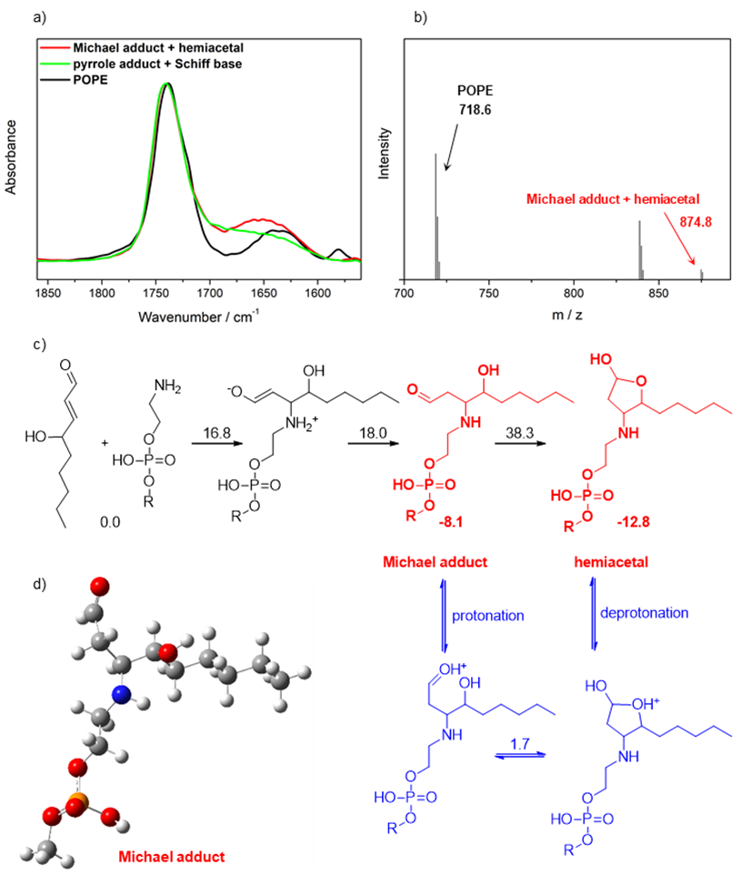

Figure 1. FT-IR spectra of product mixtures formed by reaction of HNE with POPE lipid (panel a), together with MS spectrometry identification of Michael adduct/hemiacetal of HNE with POPE (panel b). Figure 1c shows suggested reaction mechanism of HNE with model POPE lipid, together with the energetics data (free energy barriers are given on the top of arrows and stability of Michael adduct aldehyde and hemiacetal forms are presented below products) calculated at the SMD(dichloromethane)/M06-2X/6-311++G(2d,p)//M06-2X/6-31G(d) level of theory. All energies are given in in kcal mol⁻¹. Figure 1d shows optimized structure of the model POPE Michael adduct in the aldehyde form.

Additionally, we wanted to extend the knowledge on lipid behavior further, utilizing FT-IR spectroscopy in monitoring the interactions and positioning of various RAs inside the lipid bilayer in liposomes [33]. We employed vibrational Fourier-transform infrared (FTIR) spectroscopy aided with molecular dynamics (MD) simulations for studying the interaction of several RAs, nonanal (NA), 2-nonenal (NE), 4-hydroxy-2-nonenal (HNE) and 4-oxo-2-nonenal (ONE), with 1-palmitoyl-2-oleoyl-sn-glycero-3-phosphocholine (POPC) bilayer. The results obtained by the combination of these two techniques, supported also by electron paramagnetic resonance (EPR) spectroscopy, showed that NA has the strongest stabilization in the bilayer, followed by less stabilized NE, HNE and ONE. We also revealed that HNE readily makes hydrogen bonds to carbonyl groups of POPC (but not to phosphate groups), in contrast to other RAs which are hydrogen bond acceptors and do not make hydrogen bonds with lipids. Employing all of these findings together, we set up a benchmark for future characterization of realistic lipid bilayer systems under oxidative stress.
Finally, we investigated the effect of covalently modified phosphatidylethanolamine by HNE on proton conductivity as well as on sodium permeability across DOPC/DOPE phospholipid bilayers [34,35]. It has been shown that HNE readily reacts with DOPE lipid forming various adducts. In particular, it was found that more complicated double DOPE-Schiff base adducts severely thin the membrane (in contrast to simple Michael and Schiff base adducts) and significantly increase the flux of protons and sodium ions across model biological bilayers.

- REACTIVITY OF HNE WITH AMINO ACIDS
One of the first investigations of HNE reactivity with amino acids, peptides and proteins was conducted in 1975 by Esterbauer and collaborators [36], who reacted HNE with glutathione, a biologically available tripeptide. At that time, it was already suspected (but not confirmed) that the one of biochemical roles of glutathione is the removal of reactive oxygen species from cells. Esterbauer at al. have demonstrated that glutathione reacts with HNE forming a Michael adduct which subsequently cyclizes to its more stable hemiacetal form (Scheme 5). Even though authors do not speculate on the mechanism of HNE removal, they claim that the described reaction of glutathione and HNE reflects best the ability of thiol -SH containing compounds to quench reactive aldehydes.
Besides the pioneering work by Esterbauer, the work of Sayre and collaborators on the topic of HNE reactivity towards amines (as model nucleophiles) and amino acids should be emphasized. Since Sayre’s work in the field started in 1993 and lasted for more than 20 years, we will describe only the most crucial findings. In 1993 Sayre and collaborators [37] investigated the formation of pyrrole adducts as main products in the reaction of HNE and primary amines (Scheme 5). They also comment on the formation of the Schiff base adduct and Michael adduct which they claim form in a much smaller amount than the pyrrole adduct.

Scheme 5. HNE reaction with primary amines

It is important to point out the fact that only the pyrrole adduct was isolated in its “original” form in the reaction mixtures of HNE and different amines (1 equiv of HNE versus 5 equiv of amine, in CH₃CN:H₂O = 1:1 mixture, pH 7). The Michael adduct was isolated after the reduction of the reaction mixtures with NaBH₄ as the aminodiol form and the Schiff base was confirmed only by NMR experiments. Consequently, many mechanistic questions on the reactivity of amino moiety towards HNE remained opened. Nadkarni and Sayre [38] extended this investigation on the reaction of histidine and lysine with HNE. In the reaction of model histidine compound (N-acetyl histamine) and HNE (1:1 molar ratio of reactants, CH₃CN:H₂O = 4:1 mixture as solvent, pH 7 (phosphate buffer)) only the Michael adduct is confirmed and isolated after reduction with NaBH₄ as the aminodiol form in high yield. However, when protected amino acids were used in the procedure (N-acetyl-L-histidine, His and N-acetyl-L-lysine-NHCH₃, Lys) the yield of Michael adduct (in the form of the corresponding aminodiol) is low and other products are not isolated. In the case where an almost 10-fold excess of n-butylamine is reacted with HNE in the same reaction conditions, a novel double Michael and Schiff adduct was isolated [38]. The authors speculate that the double adduct forms by consecutive Michael reaction and Schiff base formation reaction, but do not confirm this result on amino acid reactants. In addition, the paper gives no mention of pyrrole adduct confirmed in earlier results. Surprisingly, Sayre gives immunochemical evidence for the formation of pyrrole adduct in the reaction of proteins and HNE in 1996, but restrains from any explanation of the mechanism of reaction [39].
An independent research by Itakura and coauthors [40] complicates the story of amine reactivity towards HNE even further. The authors perform the reaction with HNE and a 10-fold excess of N^{α}-hippuryllysine, a lysine-containing dipeptide. The reaction was conducted in phosphate buffer solution of pH 7.4 at RT for 7 days. The major product isolated from such experiments was an HNE-derived fluorescent compound, presumably formed by cyclization and oxidation of the HNE double Michael and Schiff adduct (previously detected by Sayre and coworkers [38]) but the mechanism of formation was not commented. Sayre et al. [41,42] confirmed later the same type of compound separately and state that for optimal fluorescent adduct formation, an HNE to amine ratio of 5-10:1 and neutral or slightly basic reaction conditions (typically, phosphate buffer pH 7.5 and acetonitrile or methanol in ratio of 3:1). Also, the formation of the fluorescent adduct required the presence of oxygen in the reaction mixture and the presence of Cu(II) salts in catalytic amounts accelerated the reaction. This was consistent with the presumption of Itakura [40] that the fluorescent adduct could be formed by the oxidation of double Michael and Schiff adduct [38,39]. Interestingly, addition of radical scavengers inhibited the reaction only by 10% indicating that the reaction does not proceed by a radical mechanism. In addition, the authors claim that 4-oxo-2-nonenal (ONE) can also lead to the formation of the identical fluorescent adduct but by a somewhat different reaction pathway. Finally, the authors isolated the fluorescent products of HNE reaction with n-butylamine and n-propylamine in a very low 0.14-0-18% yield and concluded that these products could be significant contribution factors for the formation of pathological protein cross-links. Furthermore, Sayre and coworkers tested this hypothesis by reacting HNE or ONE with protected Lys in the conditions developed for the synthesis of fluorescent double adducts. The fluorescent HNE(ONE)-Lys adduct was isolated in 0.8% starting from HNE and in 22% yield starting from ONE. The adduct was further incubated with KLH (keyhole limpet hemocyanin, a vaccine carrier protein) for the production of selective antibodies for detection of fluorescent HNE(ONE) adduct in vivo. The authors claim that these antibodies represent a physiologically stable Lys-Lys crosslink and suggest that it can be used as a marker for protein damage occurring during lipid peroxidation [43].
Doorn and Petersen [44] further investigated the reaction of amino acid nucleophiles and HNE and ONE in 2002. Different amino acids and peptides were submitted to the reaction with 10 or more equivalents of HNE or ONE in phosphate buffer solution of pH 7.4 and the products were analyzed by mass spectrometry. The authors concluded that both aldehydes form primarily Michael adducts with Cys, His and Lys in aqueous solutions and other adducts such as Schiff base or pyrrole were not detected. In 2015 Globisch et al. [45] conducted the research of modification of proteins by lipid peroxidation products occurring during the peanut roasting industrial process. The authors identified Lys as the main amino acid residue susceptible to modification by HNE and in a series of model reaction determined the main products formed during Lys modification. The authors incubated equivalent amounts of HNE and N-acetyl-Lys in methanol at 37 °C and analyzed the products by HPLC-ESI-MS/MS. Several HNE-Lys adducts were identified; the known Michael, Schiff and pyrrole adducts, but also propose the formation of a pyridinium adduct (Scheme 5) was proposed, the latter being isolated so far only in the reactions of acrolein [46] or trans-2-hexenal [47] with Lys. The authors claim that the most abundant adduct formed is the pyrrole adduct and suggest the possibility of using it as a marker of protein modification by HNE [45].
Considering all the literature data mentioned above which is quite scattered and unfocused, we came to a conclusion that much of the HNE reactivity is unfortunately still vaguely described and the main products of HNE reaction with amino acids not sufficiently classified. Moreover, in spite of many experiments performed with HNE, a number of reactions with different reactant ratios, different solvents and different conditions exist in the literature and it is quite difficult to predict and understand HNE reactivity. Thus, we decided to completely revisit the reactivity of HNE and Lys in various model reaction systems with controlled stoichiometry comprising of 1:1 molar ratio of HNE to Lys and different solvents with increasing water content (dichloromethane (DCM), acetonitrile (ACN), ACN:phosphate buffer pH 7.4=1:1 and phosphate buffer pH 7.4) [48]. The reaction mixtures were stirred at 40 °C for 24 hours and analyzed by tandem liquid chromatography/mass spectrometry (LC-MS) setup. We showed that non-aqueous reaction systems (DCM and ACN) predominantly yield the nonpolar pyrrole adduct, while more polar Michael, hemiacetal and pyridinium adducts become prominent as the water content in the solvent increases. The experiments are supported by detailed quantum chemical calculations of the reaction mechanism in different solvents and reaction mechanism is analyzed in full details (Figure 2), showing that water molecules are efficiently catalyzing proton transfer reactions.
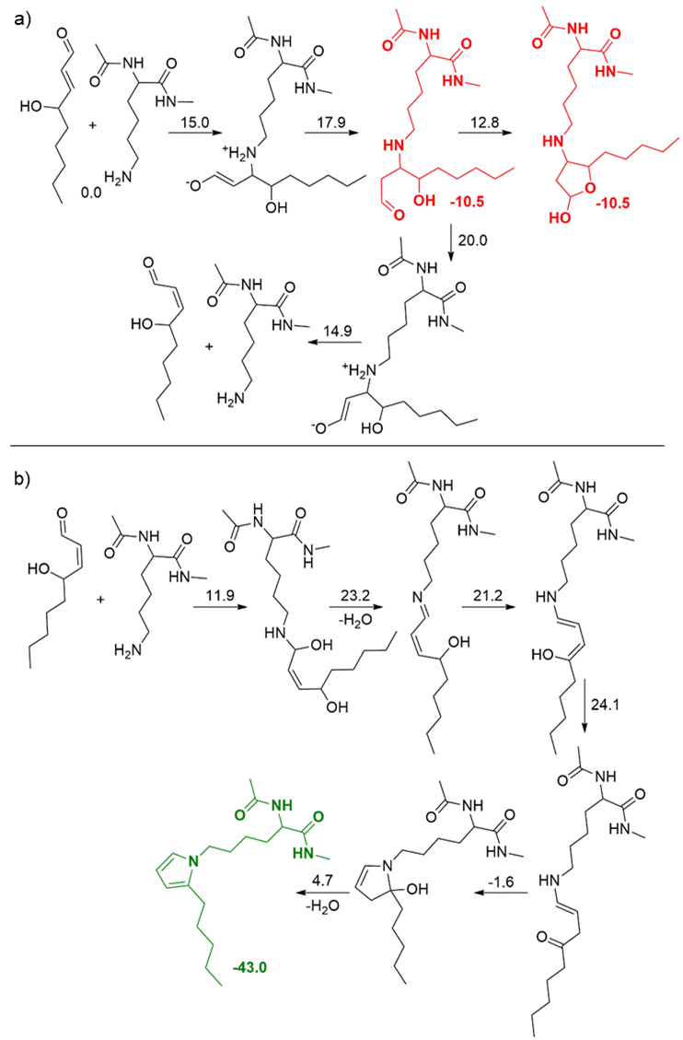
Figure 2. Reaction mechanism of formation of Michael adduct in aldehyde and hemiacetal form (panel a) and the thermodynamically most stable pyrrole adduct (panel b). The quantum chemical calculations are performed at the SMD(acetonitrile)/MP2/6-311++G(d,p)//B3LYP/6-31G(d) level of theory. Free energy barriers are given on the top of arrows whereas stabilities of Michael adduct aldehyde and hemiacetal forms, together with the pyrrole adduct are indicated below the main products. All energies are given in kcal mol⁻¹.
Finally, let us mention that we also studied in detail the reaction mechanisms of arginine (Arg), cysteine (Cys) and histidine (His) model amino acids modification in reaction with HNE in acetonitrile and acetonitrile/water systems by using high level ab initio calculations [49]. We found out that in the Michael addition pathway, Arg has the lowest reaction barriers, whereas Cys and His have prohibitively large barriers, even with the addition of water, which significantly lowers high free energy barriers in proton transfer reactions for all systems. In the case of Schiff base adduct pathway, the results are similar for all studied amino acids. These results are in contradiction with available experimental results where it has been found that Cys is more reactive than other amino acids [44], but we should stress that these experiments have been performed in water in contrast to the present study which used acetonitrile and acetonitrile/water as model solvents.

CONCLUSIONS
The wealth of literature data presented above demonstrates the fact that the reactivity of HNE towards lipids and proteins is very rich, full of intricate details and still remains an intriguing field of investigations. Quantification and isolation of different HNE adducts is highly sensitive to the reaction conditions and presents a great challenge that needs to be overcome by synergistic efforts in experimental and theoretical chemistry. Also, knowing the detailed reaction mechanisms of HNE adduct formation in model systems becomes an important step towards elucidation and better understanding of oxidative stress in living cells and thus enabling further development of medicinal chemistry.

ACKNOWLEDGMENT
The authors thank the Croatian Science Foundation for financial support (Project UIP-2014-09-6090). The computational part of the research was performed using the resources of computer cluster Isabella based in SRCE-University of Zagreb University Computing Center.

REFERENCES
- Catalá, A. Lipid Peroxidation of Membrane Phospholipids Generates Hydroxy-Alkenals and Oxidized Phospholipids Active in Physiological and/or Pathological Conditions. Chem. Phys. Lipids 2009, 157(1), 1–11.
- Murphy, M. P. How Mitochondria Produce Reactive Oxygen Species. Biochem. J. 2009, 417(1), 1–13.
- Yin, H.; Xu, L.; Porter, N. A. Free Radical Lipid Peroxidation: Mechanisms and Analysis. Chem. Rev. 2011, 111(10), 5944–5972.
- Esterbauer, H.; Schaur, R. J.; Zollner, H. Chemistry and Biochemistry of 4-Hydroxynonenal, Malonaldehyde and Related Aldehydes. Free Radic. Biol. Med. 1991, 11(1), 81–128.
- Jovanović, O.; Pashkovskaya, A. A.; Annibal, A.; Vazdar, M.; Burchardt, N.; Sansone, A.; Gille, L.; Fedorova, M.; Ferreri, C.; Pohl, E. E. The Molecular Mechanism behind Reactive Aldehyde Action on Transmembrane Translocations of Proton and Potassium Ions. Free Radic. Biol. Med. 2015, 89, 1067–1076.
- Žarković, N.; Čipak, A.; Jaganjac, M.; Borović, S.; Žarković, K. Pathophysiological Relevance of Aldehydic Protein Modifications. Journal of Proteomics. 2013, 239–247.
- Alary, J.; Gueraud, F.; Cravedi, J. P. Fate of 4-Hydroxynonenal in Vivo: Disposition and Metabolic Pathways. Mol. Aspects Med. 2003, 24(4–5), 177–187.
- Lowell, B. B.; Shulman, G. I. Mitochondrial Dysfunction and Type 2 Diabetes. Science 2005, 307(5708), 384–387.
- Valko, M.; Leibfritz, D.; Moncol, J.; Cronin, M. T. D.; Mazur, M.; Telser, J. Free Radicals and Antioxidants in Normal Physiological Functions and Human Disease. Int. J. Biochem. Cell Biol. 2007, 39(1), 44–84.
- Siems, W.; Grune, T. Intracellular Metabolism of 4-Hydroxynonenal. Mol. Aspects Med. 2003, 24(4–5), 167–175.
- Schneider, C.; Tallman, K. A.; Porter, N. A.; Brash, A. R. Two Distinct Pathways of Formation of 4-Hydroxynonenal. Mechanisms of Nonenzymatic Transformation of the 9- and 13-Hydroperoxides of Linoleic Acid to 4-Hydroxyalkenals. J. Biol. Chem. 2001, 276(24), 20831–20838.
- Schneider, C.; Porter, N. A.; Brash, A. R. Routes to 4-Hydroxynonenal: Fundamental Issues in the Mechanisms of Lipid Peroxidation. J. Biol. Chem. 2008, 283(23), 15539–15543.
- Griesser, M.; Boeglin, W. E.; Suzuki, T.; Schneider, C. Convergence of the 5-LOX and COX-2 Pathways: Heme-Catalyzed Cleavage of the 5S-HETE-Derived Di-Endoperoxide into Aldehyde Fragments. J. Lipid Res. 2009, 50(12), 2455–2462.
- Esterbauer, H.; Weger, W. Uber Die Wirkungen Synthese von Aldehyden Auf Gesunde Und Maligne Zellen, 2 . Mitt.: Synthese von Homologen 4-Hydroxy-2-Alkenalen, I . Monatshefte für Chemie 1967, 180(1964), 1884–1891.
- Gree, R.; Tourbah, H.; Carrie, R. Fumaraldehyde Monodimethyl Acetal: An Easily Accesible And Versatile Intermediate. Tetrahedron 1986, 27(41), 4983–4986.
- Iriye, R.; Konishi, A.; Uno, T. Pyranyloxy-2-Butenal and Their Antimutagenic Effect Against. Agric. Biol. Chem. 1990, 54(5), 1303–1305.
- Ma, D.; Lu, X. A Simple Route to α,β-Unsaturated Aldehydes from Prop-2-Ynols. J. Chem. Soc. Chem. Commun. 1989, 14, 890–891.
- Erickson, B. W. α-Hydroxy-β,β-Unsaturated Aldehydes Via 1,3-Bis(Methylthio)Allyllithium: Trans-4-Hydroxy-2-Hexenal. Org. Synth. 1974, 54, 19–27.
- Gardner, H. W.; Bartelt, R. J.; Weisleder, D. A Facile Synthesis of 4-Hydroxy-2(E)-Nonenal. Lipids 1992, 2(12), 686–689.
- Yu, L.; Wang, Z. The Reactions of 2,3-Epoxyaldehydes With. J. Chem. Soc., Chem. Commun 1993, 89(232), 232–234.
- Deng, Y.; Salomon, R. G. Synthesis of [9- 3 H]- Trans -4-Hydroxy-2-Nonenal. J. Org. Chem. 1998, 63(10), 3504–3507.
- Brinson, R. G.; Jones, P. B. Caged Trans-4-Hydroxy-2-Nonenal. Org. Lett. 2004, 6(21), 3767–3770.
- Jones, P. B.; Brinson, R. G.; Sarma, S. J.; Elkazaz, S. Observation of Heavy Atom Effects in the Development of Water Soluble Caged 4-Hydroxy-Trans-2-Nonenal. Org. Biomol. Chem. 2008, 6(22), 4204–4211.
- Soulère, L.; Queneau, Y.; Doutheau, A. An Expeditious Synthesis of 4-Hydroxy-2(E)-Nonenal (4-HNE), Its Dimethyl Acetal and of Related Compounds. Chem. Phys. Lipids 2007, 150(2), 239–243.
- Garibyan, O. A.; Ovanesyan, A. L.; Makaryan, G. M.; Petrosyan, A. L.; Chobanyan, Z. A. (2E)-4-Hydroxyalk-2-Enals and 2-Substituted Furans as Products of Reactions of (2E)-4,4-Dimethoxybut-2-Enal with Grignard Compounds. Russ. J. Org. Chem. 2010, 46(3), 406–409.
- Kumari, A.; Gholap, S. P.; Fernandes, R. A. Tandem IBX-Promoted Primary Alcohol Oxidation/Opening of Intermediate β,γ-Diolcarbonate Aldehydes to (E)-γ-Hydroxy-α,β-Enals. Chem. - An Asian J. 2019, 14(13), 2278–2290.
- Fang, X.; Fu, Y.; Long, M. J. C.; Haegele, J. A.; Ge, E. J.; Parvez, S.; Aye, Y. Temporally Controlled Targeting of 4-Hydroxynonenal to Specific Proteins in Living Cells. J. Am. Chem. Soc. 2013, 135(39), 14496–14499.
- Guichardant, M.; Taibi-Tronche, P.; Fay, L. B.; Lagarde, M. Covalent Modifications of Aminophospholipids by 4-Hydroxynonenal. Free Radic. Biol. Med. 1998, 25(9), 1049–1056.
- Bacot, S.; Bernoud-Hubac, N.; Baddas, N.; Chantegrel, B.; Deshayes, C.; Doutheau, A.; Lagarde, M.; Guichardant, M. Covalent Binding of Hydroxy-Alkenals 4-HDDE, 4-HHE, and 4-HNE to Ethanolamine Phospholipid Subclasses. J. Lipid Res. 2003, 44(5), 917–926.
- Bacot, S.; Bernoud-Hubac, N.; Chantegrel, B.; Deshayes, C.; Doutheau, A.; Ponsin, G.; Lagarde, M.; Guichardant, M. Evidence for in Situ Ethanolamine Phospholipid Adducts with Hydroxy-Alkenals. J. Lipid Res. 2007, 48(4), 816–825.
- Pohl, E. E.; Jovanovic, O. The Role of Phosphatidylethanolamine Adducts in Modification of the Activity of Membrane Proteins under Oxidative Stress. Molecules 2019, 24(24), 1–15.
- Vazdar, K.; Vojta, D.; Margetić, D.; Vazdar, M. Reaction Mechanism of Covalent Modification of Phosphatidylethanolamine Lipids by Reactive Aldehydes 4-Hydroxy-2-Nonenal and 4-Oxo-2-Nonenal. Chem. Res. Toxicol. 2017, 30(3), 840–850.
- Bakarić, D.; Carić, D.; Vazdar, K.; Vazdar, M. Vibrational Spectroscopy Combined with Molecular Dynamics Simulations as a Tool for Studying Behavior of Reactive Aldehydes Inserted in Phospholipid Bilayers. Chem. Phys. Lipids 2019, 225, 104793.
- Jovanovic, O.; Pashkovskaya, A. A.; Annibal, A.; Vazdar, M.; Burchardt, N.; Sansone, A.; Gille, L.; Fedorova, M.; Ferreri, C.; Pohl, E. E. The Molecular Mechanism behind Reactive Aldehyde Action on Transmembrane Translocations of Proton and Potassium Ions. Free Radic. Biol. Med. 2015, 89, 1067–1076.
- Jovanović, O.; Škulj, S.; Pohl, E. E.; Vazdar, M. Covalent Modification of Phosphatidylethanolamine by 4-Hydroxy-2-Nonenal Increases Sodium Permeability across Phospholipid Bilayer Membranes. Free Radic. Biol. Med. 2019, 143, 433–440.
- Esterbauer, H.; Zollner, H.; Scholz, N. Reaction of Glutathione with Conjugated Carbonyls. Zeitschrift fur Naturforsch. - Sect. C J. Biosci. 1975, 30(7–8), 466–473.
- Sayre, L. M.; Arora, P. K.; Iyer, R. S.; Salomon, R. G. Pyrrole Formation from 4-Hydroxynonenal and Primary Amines. Chem. Res. Toxicol. 1993, 6(1), 19–22.
- Nadkarni, D. V.; Sayre, L. M. Structural Definition of Early Lysine and Histidine Adduction Chemistry of 4-Hydroxynonenal. Chem. Res. Toxicol. 1995, 8(2), 284–291.
- Sayre, L. M.; Sha, W.; Xu, G.; Kaur, K.; Nadkarni, D.; Subbanagounder, G.; Salomon, R. G. Immunochemical Evidence Supporting 2-Pentylpyrrole Formation on Proteins Exposed to 4-Hydroxy-2-Nonenal. Chem. Res. Toxicol. 1996, 9(7), 1194–1201.
- Itakura, K.; Osawa, T.; Uchida, K. Structure of a Fluorescent Compound Formed from 4-Hydroxy-2-Nonenal and N α -Hippuryllysine: A Model for Fluorophores Derived from Protein Modifications by Lipid Peroxidation . J. Org. Chem. 1998, 63(1), 185–187.
- Xu, G.; Sayre, L. M. Structural Characterization of a 4-Hydroxy-2-Alkenal-Derived Fluorophore That Contributes to Lipoperoxidation-Dependent Protein Cross-Linking in Aging and Degenerative Disease. Chem. Res. Toxicol. 1998, 11(4), 247–251.
- Xu, G.; Liu, Y.; Sayre, L. M. Independent Synthesis, Solution Behavior, and Studies on the Mechanism of Formation of a Primary Amine-Derived Fluorophore Representing Cross- Linking of Proteins by (E)-4-Hydroxy-2-Nonenal. J. Org. Chem. 1999, 64(16), 5732–5745.
- Xu, G.; Liu, Y.; Sayre, L. M. Polyclonal Antibodies to a Fluorescent 4-Hydroxy-2-Nonenal (HNE)-Derived Lysine-Lysine Cross-Link: Characterization and Application to HNE-Treated Protein and in Vitro Oxidized Low-Density Lipoprotein. Chem. Res. Toxicol. 2000, 13(5), 406–413.
- Doorn, J. A.; Petersen, D. R. Covalent Modification of Amino Acid Nucleophiles by the Lipid Peroxidation Products 4-Hydroxy-2-Nonenal and 4-Oxo-2-Nonenal. Chem. Res. Toxicol. 2002, 15(11), 1445–1450.
- Globisch, M.; Kaden, D.; Henle, T. 4-Hydroxy-2-Nonenal (4-HNE) and Its Lipation Product 2-Pentylpyrrole Lysine (2-PPL) in Peanuts. J. Agric. Food Chem. 2015, 63(21), 5273–5281.
- Furuhata, A.; Ishii, T.; Kumazawa, S.; Yamada, T.; Nakayama, T.; Uchida, K. Nε-(3-Methylpyridinium)Lysine, a Major Antigenic Adduct Generated in Acrolein-Modified Protein. J. Biol. Chem. 2003, 278(49), 48658–48665.
- Baker, A.; Žídek, L.; Wiesler, D.; Chmelík, J.; Pagel, M.; Novotny, M. V. Reaction of N-Acetylglycyllysine Methyl Ester with 2-Alkenals: An Alternative Model for Covalent Modification of Proteins. Chem. Res. Toxicol. 1998, 11(7), 730–740.
- Škulj, S.; Vazdar, K.; Margetić, D.; Vazdar, M. Revisited Mechanism of Reaction between a Model Lysine Amino Acid Side Chain and 4-Hydroxynonenal in Different Solvent Environments. J. Org. Chem. 2019, 84(2), 526–535.
- Škulj, S.; Vazdar, M. A Computational Insight into Reaction Between Different Amino Acids with Reactive Aldehydes 4-Hydroxy-2-Nonenal and 4-Oxo-2-Nonenal. Croat. Chem. Acta 2019, 92(2), 229–239.

Graphical Abstract
