The signature of fluctuations of the hydrogen bond network formed by water molecules in the interfacial layer of anionic lipids
Ana-Marija Pavlek^{a,} , Barbara Pem^{b, *}, Danijela Bakarić^{b, *}
ª Faculty of Chemical Engineering and Technology, Trg Marka Marulića 19, 10000 Zagreb, Croatia
^{b} Division of Organic Chemistry and Biochemistry, Ruđer Bošković Institute, Bijenička 54, 10000 Zagreb, Croatia
*Corresponding author. Tel.: +385 1 4571 382; E-mail: barbara.pem@irb.hr (Barbara Pem), danijela.bakaric@irb.hr (Danijela Bakarić)

Abstract
As the water molecules found at the interface of lipid bilayers exhibit distinct structural and reorientation dynamics compared to water molecules found in bulk, the fluctuations in their hydrogen bond (HB) network are expected to be different than those generated by the bulk water molecules. The research presented here aims to gain an insight into temperature-dependent fluctuations of a HB network of water molecules found in an interfacial layer of multilamellar liposomes (MLVs) composed from anionic 1,2-dimyristoyl-sn-glycero-3-phospho-L-serine (DMPS) lipids. Beside suspending DMPS lipids in phosphate buffer saline (PBS) of different pH values (6.0, 7.4 and 8.0), the changes in HB network fluctuations are altered by incorporation of a non-polar flavonoid molecule myricetin (MCE) within the hydrocarbon chain region. By performing a multivariate analysis on the water combination band observed in temperature-dependent FTIR spectra, the results of which were further mathematically analyzed, the temperature-dependent fluctuations of interfacial water molecules were captured; the latter were the greatest for DMPS in PBS having pH value 7.4 and in general were greater for DMPS multibilayers in the absence of MCE. The presence of MCE made DMPS lipids more separated, allowing deeper penetration of water molecules towards non-polar region and their restricted motion that resulted with decreased fluctuations. The experimentally observed results were supported by MD simulations of DMPS (+ MCE) lipid bilayers.
Keywords: 1,2-dimyristoyl-sn-glycero-3-phospho-L-serine (DMPS), phosphate buffer saline (PBS); myricetin (MCE); multivariate analysis of FTIR spectra; temperature-dependent fluctuations in water hydrogen bond network

- Introduction
Fundamental biological phenomena such as enzyme activity [1,2], cell adhesion [3], membrane fusion [4] or lipid diffusion [5] are intimately related with the structural features and reorientation dynamics of the water molecules found at the biomembrane interface. In exclusively lipid membranes, often investigated with the aim of simplifying and understanding events on the surface of biomembranes, the arrangement and orientation of water molecules within the interfacial aqueous layer are primarily a function of the magnitude and of the charge distribution on lipid molecules polar head-groups [6,7]. In bulk water a single water molecule is hydrogen-bonded to tetrahedrally surrounded water molecules from the first solvation shell that can be exchanged with those from a second solvation shell owing to the concerted reorientation and cleavage of the existing hydrogen bond (HB) [8]. However, a disruption of tetrahedral ordering of water molecules due to the proximity of lipid membrane interface [9] imposes significant limitations for water reorientation dynamics.
The understanding of structural and reorientation dynamics of interfacial water usually involve ultrafast vibrational spectroscopic techniques such as vibrational sum frequency generation (VSFG) and two-dimensional IR spectroscopy (2D-IR) [10–13]. Despite the inherent limitation of application to exclusively lipid monolayers, VSFG unraveled that H-atoms of water molecules near choline (positive) [14] and phosphate (negative) [15,16] moieties are oppositely oriented, and these findings are further corroborated by the independent computational studies [17–19]. Besides identifying differently oriented H-atoms, VSFG unraveled that oppositely oriented water molecules in the vicinity of choline (positive) and phosphate (negative) groups obey different HB dynamics [20]. Specifically, as water molecules near positively charged functional groups display the maintenance of tetrahedral arrangement, their reorientation dynamics resembles those of bulk water [14], whereas near negatively charged functional groups the opposite scenario is found; the loss of the tetrahedral ordering of water molecules [9] is accompanied with the retardation of HB exchange dynamics due to the reduced number of partners in a HB arrangement [9,13,21–26]. Unlike VSFG, 2D IR is not an intrinsically surface-sensitive technique, but nevertheless it allows distinguishing the events that occur at different time scales [27]; in particular, by using the appropriate vibrational echo pulse sequence it becomes possible to decipher the position of the oscillator, commonly of environmentally sensitive C=O moiety, within the heterogeneous sample such as a hydrated bilayer [28].
Along with mentioned and briefly introduced state-of-the-art spectroscopic techniques, whose main disadvantage is the price, i.e. the limitation to the small number of laboratories in the world, the use of widely available conventional linear FTIR spectroscopy [29] occasionally produces a spark of progress in the characterization of water-based HB systems. Although it contains the averaged signal of all water molecules present in the lipid suspension (bulk and interfacial water), the analysis of the band(s) loaded with water HB network fingerprints [30,31], as well as defining/introducing an arbitrary metric that can the acquired spectroscopic data are expressed in terms of water HB network fluctuations [32].
Accordingly, Tong et al. managed to distinguish bulk water molecules and those at air-water interface by inspection of water librations (δ_{L}), i.e. intermolecular vibrations between water molecules, for the existence of which is the result of HBs [31]. Further, Verma et al. conducted a comprehensive concentration and temperature study of aqueous solutions of various salts in order to elucidate the impact of particular anion/cation on the water combination band (usually centered at about 2130 cm⁻¹) that originates from the fundamental transition of water bending (δHOH) and ρ_{L} [30]. As the direction and the magnitude of water combination band maximum displacement to higher/lower frequencies in the presence of ions coincided with their position in a Hoffmeister series, this approach provided the platform for monitoring both local and global water dynamics through the impact of kosmotropes/chaotropes on a HB network.
The quantification of temperature-dependent fluctuations of a water molecules-based HB network in the presence of anions of Na⁺ and K⁺ salts (Cl⁻, Br⁻, I⁻, CH₃COO⁻, NO₃⁻, NO₂⁻) was presented for the first time in the study conducted by Brkljača et al. [32]. Briefly, water combination band was subjected to a multivariate analysis by which the response of water molecules in a certain temperature range (25-75 °C) was divided into two contributions: the one produced by low-temperature (high-density) water and the other produced by high-temperature (low-density) water [33,34]. The observed hysteresis between the responses of these two kinds of water, expresses in terms of mathematical quantities that reflect HB network-associated phenomena, unraveled that temperature-dependent fluctuations in a HB network are actually ion-invariant. The validity of obtained results is confirmed by independent study conducted on equivalent systems investigated using femtosecond elastic second harmonic scattering (fs-ESHS) technique that produced analogous findings [35].
As the synergy of linear FTIR spectroscopy and multivariate analysis managed to provide the insight into the fluctuations in water HB network in the presence of anions, this study aims to apply the same approach in characterizing the fluctuations in HB network of water molecules found at the interface of negatively charged supramolecular aggregates. Accordingly, multilamellar liposomes (MLVs) of 1,2-dimyristoyl-sn-glycero-3-phospho-L-serine (DMPS) were prepared in a phosphate buffer saline (PBS) and examined by FTIR spectroscopy in the temperature range which spans about ± 10 °C around their melting point (T_{m}). The latter points the temperature at which van der Waals interactions between hydrocarbon chains get reduced so lipids undergo from more ordered gel (L_{β}) phase to a disordered fluid (L_{α}) phase, and which is for DMPS lipids reported to be between 37-39 °C [36,37]. Overal, this L_{β}→L_{α} transition is accompanied with thinning of lipid bilayer, loss of lipid lateral arrangement and consequently greater hydration of polar groups and the glycerol backbone that encompasses the HB network between water molecules in the interfacial layer [38].
By knowing that negativelly charged phosphatidylserine (PS) lipids are generally very unstable in terms of curvature variations and local pH change [39], especially in the form of large unilamellar liposomes (LUVs) [40], the presumed fluctuations in the interfacial HB network of DMPS in L_{β} and in L_{α} phase were enhanced in two ways: i) MLVs of DMPS were prepared in PBS having three pH values: 6.0, 7.4 and 8.0, at which all DMPS lipids are negatively charged; ii) the incorporation of flavonoid myricetin (MCE), a non-polar molecules that prefer accommodation in a hydrocarbon chain region [41], should induce separation of lipid molecules and provide deeper penetration of interfacial water that consequently modulates fluctuations in their HB network. The results obtained in this study are aimed to be applied in further studies addressed to the fluctuations in the interfacial water layer of other supramolecular aggregates carrying the charges of different magnitudes and distributions.
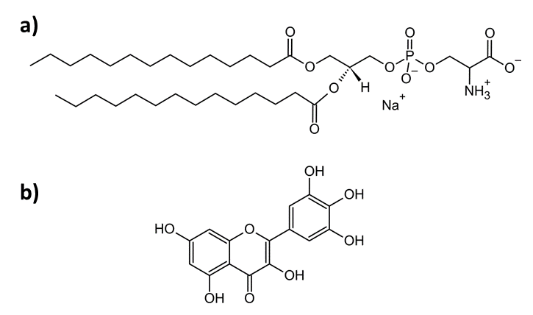
Fig. 1. Structural formulas of: a) 1,2-dimyristoyl-sn-glycero-3-phospho-L-serine (sodium salt) (DMPS); b) myricetin (MCE)
- Experimental
2.1 Chemicals and suspensions preparations
Commercially available 1,2-dimyristoyl-sn-glycero-3-phospho-L-serine (sodium salt) (DMPS; M = 679.9 gmol⁻¹, white powder, Avanti, ≥ 99 %), myricetin, (MCE; M = 318.2 gmol⁻¹, yellow powder, Sigma-Aldrich, ≥ 96 %), chloroform (CHCl₃; Merck, Darmstadt, Germany, p. a.), methanol (MeOH, Merck, Darmstadt, Germany ≥ 98 %) and powders used for phosphate buffer saline (PBS) preparation (dissolution of NaCl, KCl, Na₂HPO₄, KH₂PO₄ (Kemika, p. a. grade) in milli-Q water®) of ionic strength I = 100 mM and pH values of 6.0, 7.4 and 8.0 were used as received. The stock solutions of DMPS/MCE in CHCl₃/MeOH were prepared by weighing of DMPS (≈ 90 mg)/MCE (≈ 6 mg) that were dissolved in 6 ml CHCl₃/0.9 ml MeOH. In six (6)/three (3) round-bottom flasks a 1 ml of DMPS stock solution (in CHCl₃) was added/0.3 ml of MCE stock solution (in MeOH). In this way, in 6/3 flasks there was about 15 mg of DMPS/2 mg of MCE so that mole ratio of MCE in DMPS lipid bilayers is x(MCE) ≈ 0.3. Films of DMPS (+MCE) were obtained upon evaporating CHCl₃ (+MeOH) on a rotary evaporator and, after drying with N_{2(g)}, the films were suspended in PBS having pH values of 6.0, 7.4 and 8.0. The suspensions of multilamellar liposomes (MLVs) of DMPS were made by successive heating (~ 80 °C) - vortexing (RT) - cooling (~ 4 °C) cycles, where each step lasted about one minute. The suspensions prepared were milky white (DMPS only) or slightly yellow (DMPS+MCE).
2.2 FT-IR spectroscopy
2.2.1 FT-IR spectra acquisition
FT-IR spectra were measured on an ABB Bomem MB102 spectrometer, equipped with CsI optics and a DTGS detector in a transmission. FT-IR spectra of DMPS (+MCE) lipid suspensions in PBS of three different pH values (6.0, 7.4 and 8.0) were acquired in a sealed cell equipped with CaF₂ windows with the path length of the cell d = 27.37 μm [42]. Temperature was regulated by Specac 3000 Series high stability temperature controller with heating jacket. The spectra of all suspensions were acquired as duplicates in the temperature range 30 – 50 °C using the heating rate of 1 °C min⁻¹, at nominal resolution of 2 cm⁻¹ and 10 scans.
2.2.2 FT-IR spectra analysis
After measuring FT-IR spectra of DMPS (+MCE) suspensions in PBS having three pH values, the obtained spectra were divided into two separate spectral regions (D₁, D₂): i) 2980-2820 cm⁻¹ that display the bands originated from the (anti)symmetric stretching of methylene (CH₂) groups of hydrocarbon chains (ν_{(a)s}CH₂) and ii) 2650 – 1800 cm⁻¹ where only water absorbs (a combination band that originates from water bending (δHOH) and water libration (ρ_{L}H₂O); H₂O comb). The analysis of spectral region D₁ is thoroughly presented in Supporting Information, section S1 (Fig. S1) and here the analysis of D₂ spectral region is presented. Two-points baseline correction at the band minima in spectral region D₂ was followed after smoothing (Savitzky-Golay; polynomial of a 3rd degree through 50 points [43]). Additionally, spectral part 2650-2300 cm⁻¹ was eliminated from the analysis because of the band originated from ν_{as}CO₂, the amount of which varies during the measurement, obscure the results [32]. The information obtained by analyzing the first spectral region (D₁) concerned determination of the melting temperature (T_{m}) [44,45], i.e. the temperature of breaking of van der Waals interactions between hydrocarbon chains and its change in the presence of MCE (Table S1 in Supporting Information), whereas the second one addresses temperature-dependent fluctuations in a HB network formed by water molecules, both bulk-ones and those that are found in the interfacial water layers [32].
Prepared spectra underwent further analysis using the Multivariate Curve Resolution-Alternating Least Squares (MCR-ALS) method. This mathematical method examines a data set for main sources of variation and, when applied to spectroscopic data, identifies the spectra of system components with no prior knowledge of their identity, position or signal shape [46,47]. The requirements of MCR-ALS are for data to be structured as a two-way matrix, and for that matrix to be bilinear (i.e. a product of two matrices). In the case of FTIR spectra in this study, raw data forms a matrix describing signal intensity at particular temperatures and wavenumbers. The matrix is the result of contributions of smaller matrices describing individual species and their concentrations. This relationship is described mathematically as:
D = CS^{T} + E (1)
Where D is the raw data matrix, S^{T} is a spectral matrix of individual components, C is the concentration matrix of those components and E is the matrix of unexplained residuals.
Before starting the MCR-ALS analysis, initial guesses of contributions are required. First, the Singular Value Decomposition (SVD) method is applied to estimate the number of components. As Libnau et al. demonstrated [33], the spectral evolution of the water signals as a function of temperature can be presented in the form of a matrix whose rank is two; in other words, two components contain all the information about the system under investigation. Thus, two components are expected to meaningfully contribute to our spectral data [48]. Evolving Factor Analysis (EFA) is then utilized to obtain initial guesses of the concentration profiles of those components [46,47]. Subsequently, MCR-ALS equation with provided initial estimates can be solved iteratively to produce the final S^{T} and C. The MCR-ALS procedure with EFA is publicly available and implemented in MATLAB [49], and further explanations of theory may be found elsewhere [46,50,51]. It is important to note that constraints need to be applied when analyzing FTIR data: all spectral profiles and concentration values must be kept positive (non-negativity constraint) and the individual pure spectra are regarded as unimodal (unimodality constraint).
Spectral and concentration profiles obtained will depend on the examined spectral region and the nature of the chemical species producing signals. Since the examined system contains species that undergo a phase transition in the explored temperature range, a sigmoid profile is expected, with the inflection point around the transition temperature [48]. Thus, the contributions of the species existing below T_{m} will be referred to as the low-temperature component (LTC), and those above T_{m} will be referred to as the high-temperature component (HTC).
The concentration profiles generated by MCR-ALS were of sigmoid character for D₁ spectral range (examined in Supporting Information, Fig. S2), and of polynomial for the spectral range D₂. Obtained curves in spectral range D₂ were fitted on a 2nd degree polynomial (parabolic fit; R² (DMPS/DMPS+MCE) ≥ 0.998/0.999) expressed in the form $y=B_{0}+B_{1}x+ B_{2}x^{2}$. In mathematical context obtained coefficients $B_{0}$ (dimensionless quantity), $B_{1}$ (in °C⁻¹) and $B_{2}$ (in °C⁻²) indicate relative concentration of the particular component (LTC or HTC) at 0 °C, the rate of a decrease of LTC/HTC in favor of increase HTC/LTC and a profile curvature, respectively. As thoroughly describes in previous paper [32], $B_{2}$ values obtained for LTC and HTC reflect the hysteresis between the temperature-dependent fluctuations in a HB network meshed by water molecules.
- Molecular dynamics simulations
Simulations of DMPS bilayers with and without the presence of MCE were conducted using classical molecular dynamics (MD). Homogeneous DMPS bilayers were prepared with the CHARMM-GUI Membrane Builder module [52] and consisted of 200 lipid molecules. DMPS+MCE bilayers were generated by randomly adding 60 MCE molecules to the bilayer (MCE-to-lipid ratio 0.3). Bilayers were solvated with 50 water molecules per bilayer component. 21 Na⁺ and Cl⁻ ions were added to achieve the experimental ion concentration of 100 mM, along with additional 200 Na⁺ to neutralize bilayer charge. All simulations were conducted the GROMACS 2020.0 software [53], CHARMM36m force field [54] and the TIP3P water model [55]. MCE was parametrized using CGenFF [56]. NBFIX corrections for Na-carbonyl interactions have been included in all simulations, as provided in the July 2021 version of CHARMM36m force field [57]. The systems underwent energy minimization followed by 200 ps of equilibration in the NVT ensemble with the V-rescale algorithm. The production run was conducted for 300 ns in the NpT ensemble using the Nosé-Hoover thermostat [58] with a time constant of 1 ps and the Parrinello-Rahman barostat [59] with semi-isotropic pressure coupling and a time constant of 2 ps (target pressure 1 bar). When conducting trajectory analysis, the first half of the production run was discarded as equilibration time, and only the last 150 ns were examined. In all simulations, the cutoff for short-range Coulomb interactions and van der Waals interactions was set to 1.2 nm with a switching function turned on after 1 nm. Particle mesh Ewald (PME) procedure [60] was used to handle long-range Coulomb interactions. LINCS algorithm was employed to constrain bonds involving hydrogen. Three-dimensional periodic boundary conditions were used throughout for all systems. And the time step was 2 fs. Visualization and analysis were conducted with Gromacs modules and Visual Molecular Dynamics (VMD) [61].
- Results and Discussion
The multivariate analysis of D₂ spectral region (Fig. 2) produced spectral (Fig. 2, dotted curves) and, more important, concentration profiles of LTC and HTC (Fig. 3). Expected low-frequency shift of the combination band maximum upon heating is found in all systems (~ 2131 cm⁻¹ at 30 °C and ~ 2117 cm⁻¹ at 50 °C), regardless of the absence/presence of MCE or the pH (see Table 1). However, it appears that for DMPS suspension in the absence of MCE there is a little bit greater shift of the band maximum than in its presence, especially when it comes for pH value of 7.4 (2130 cm⁻¹ at 30 °C and 2114 cm⁻¹ at 50 °C), which is the closest to the physiologically relevant pH value.

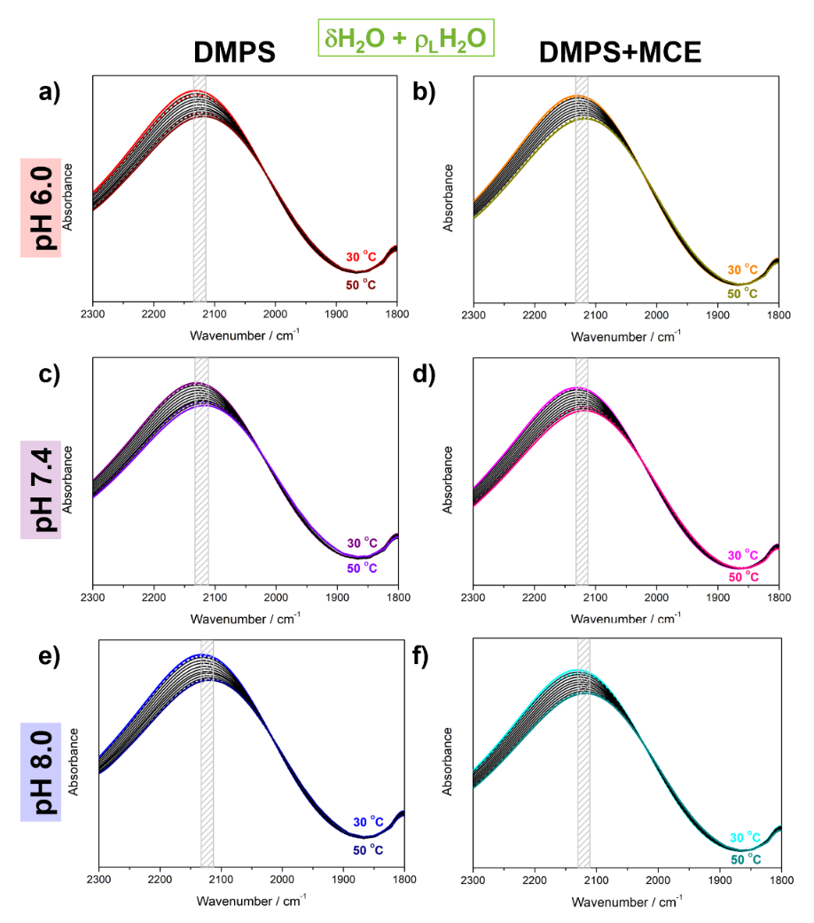
Fig. 2. Baseline-corrected and Savitzky-Golay smoothed temperature-dependent FT-IR spectra of DMPS in the absence (left column) and the presence of MCE (right column) suspended in PBS at pH 6.0 (upper row), 7.4 (middle row), and 8.0 (bottom row). The lowest/highest (30 °C/50 °C) temperatures were highlighted with red/wine (DMPS, pH 6.0, 30 °C/50 °C), orange/dark yellow (DMPS+MCE, pH 6.0, 30 °C/50 °C), purple/violet (DMPS, pH 7.4, 30 °C/50 °C), purple/pink (DMPS+MCE, pH 7.4, 30 °C/50 °C), blue/navy (DMPS, pH 8.0, 30 °C/50 °C) and cyan/dark cyan (DMPS+MCE, pH 8.0, 30 °C/50 °C). The temperature-dependent FTIR spectra are designated with solid curves, whereas spectral profiles of low- and high-temperature components obtained from MCR-ALS with EFA using dotted curves.

At the first glance, polynomial fits of LTC and HTC (Fig. 3) reveal deviations from the experimental values for DMPS suspensions in the absence of MCE. Although the deviations are observed at all pH values, for DMPS suspension in PBS of pH value 6.0, 7.4 and 8.0 they are the most significant in the temperature range 43-45 °C, 42-48 °C and 37-44 °C, respectively. Interestingly, this is not observed for DMPS+MCE suspensions, regardless to the pH value of PBS.
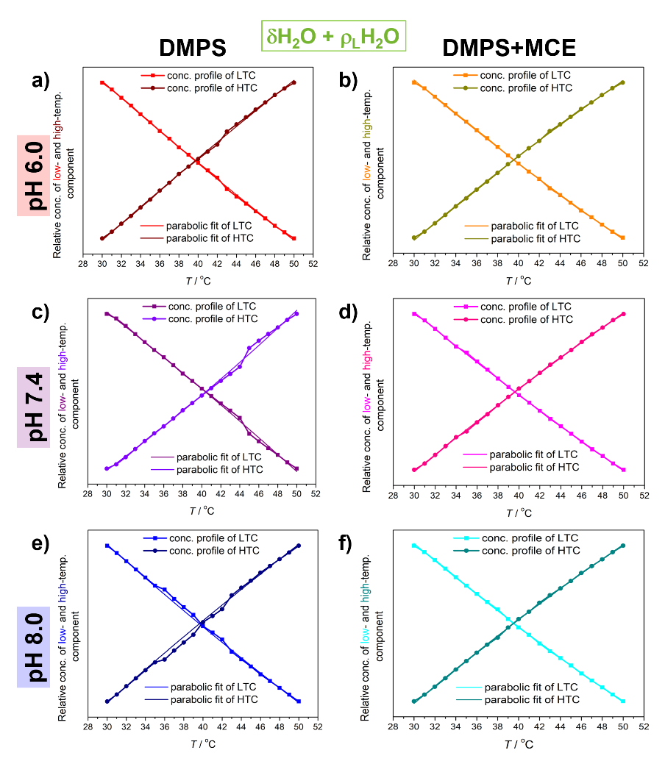
Fig. 3. The concentration profiles of low- and high-temperature component of DMPS in the absence (left column) and the presence of MCE (right column) suspended in PBS at pH 6.0 (upper row), 7.4 (middle row), and 8.0 (bottom row). Experimentally obtained low- and high-temperature components were labeled with solid curves colored red/wine (DMPS, pH 6.0), orange/dark yellow (DMPS+MCE, pH 6.0), purple/violet (DMPS, pH 7.4), purple/pink (DMPS+MCE, pH 7.4), blue/navy (DMPS, pH 8.0) and cyan/dark cyan (DMPS+MCE, pH 8.0). Their fit on a polynomial of a 2nd degree is designated with dotted curves of the corresponding color.
Another interesting phenomenon obtained from FTIR data of DMPS suspensions tackles the difference in absolute values of B₁ (Δ⏐B₁⏐) and especially of B₂ (Δ⏐B₂⏐) coefficients of LTC and HTC (Table 1); Δ⏐B₁⏐values for DMPS in PBS having pH values 6.0, 7.4 and 8.0 are about 0.003 C⁻¹, 0.009 C⁻¹ and 0.002 C⁻¹, whereas for DMPS+MCE in PBS having pH values 6.0, 7.4 and 8.0 are about 0.003 C⁻¹, 0.001 C⁻¹ and 0.002 C⁻¹. Regarding Δ⏐B₂⏐, for DMPS in PBS of pH values 6.0, 7.4 and 8.0 are about 0.3-0.5 C⁻², 1 C⁻² and 0.1 C⁻², whereas for DMPS+MCE in PBS of pH values 6.0, 7.4 and 8.0 are about 0.3 C⁻², 0.1 C⁻² and 0.3 C⁻². When the uncertainty is taken in consideration, it can appear that Δ⏐B₁⏐ and Δ⏐B₂⏐ for all suspensions are of the same value. However, it cannot be ignored that dissipation in Δ⏐B₁⏐ and especially in Δ⏐B₂⏐ is much larger for DMPS only than when MCE is incorporated in the bilayers.

Table 1. Parameters obtained from polynomial regression (B₀, B₁, B₂) of the results produced by multivariate analysis conducted on spectral range 2300 – 1800 cm⁻¹
System/pH | ν_{max} (30° C/50 °C)ª | B₀^{b} | B₁^{c} | B₂^{d} ⋅10⁴ | ~Δ⏐B₀⏐^{b} | ~Δ⏐B₁⏐^{c} | ~Δ⏐B₂⏐^{d} ⋅10⁴
DMPS/6.0 | 2131/2118 | 2.80 ± 0.07  −1.8 ± 0.1 | −0.065 ± 0.004  0.062 ± 0.005 | 1.8 ± 0.5  −1.3 ± 0.6 | 1 | 0.003 | 0.3-0.5
DMPS/7.4 | 2130/2114 | 2.3 ± 0.1  −1.1 ± 0.2 | −0.036 ± 0.007  0.027 ± 0.009 | 1.9 ± 0.9  −3 ± 1 | 1 | 0.009 | 1
DMPS/8.0 | 2132/2119 | 2.83 ± 0.08  −1.8 ± 0.1 | −0.067 ± 0.004  0.065 ± 0.006 | 1.9 ± 0.5  −1.8 ± 0.7 | 1 | 0.002 | 0.1
DMPS+MCE/6.0 | 2131/2117 | 2.91 ± 0.06  −1.96 ± 0.07 | −0.070 ± 0.003  0.073 ± 0.004 | 2.4 ± 0.4  −2.7 ± 0.4 | 1 | 0.003 | 0.3
DMPS+MCE/7.4 | 2130/2118 | 2.83 ± 0.05  −1.83 ± 0.06 | −0.067 ± 0.003  0.066 ± 0.003 | 2.0 ± 0.3  −1.9 ± 0.4 | 1 | 0.001 | 0.1
DMPS+MCE/8.0 | 2132/2117 | 2.92 ± 0.06  −1.93 ± 0.06 | −0.071 ± 0.003  0.073 ± 0.003 | 2.5 ± 0.4  −2.8 ± 0.4 | 1 | 0.002 | 0.3
ª In cm⁻¹; ^{b} Dimensionless quantity; ^{c} In °C⁻¹; ^{d} °C⁻².
Following the analogy developed in a previous study, these results can be examined in the context of a decrease of temperature-dependent fluctuations in water HB network when it surrounds MLVs of DMPC+MCE suspensions, which is not the case for pure DMPS lipids. As this approach catches the response of all water molecules, i.e. both bulk (the contribution of which is dominant) and interfacial ones, it seems reasonable to assume that bulk water contribution is near the same for all suspensions, regardless to the pH value or the presence of MCE. The major variable that changes in this consideration is the amount of interfacial HB water and how its HB pattern is changed when MCE is inserted in DMPS lipids. A potential explanation for this phenomenon might be that the motions (primarily librations) of water molecules in the interfacial regions are more restricted when MCE is incorporated in MLVs. If the DMPS lipids are more separated even at lower temperatures (due to the inclusion of MCE), then more water will be able to penetrate into the interfacial region, that is, it will penetrate deeper into the liposome itself and will certainly show different dynamics compared to interfacial water which does not penetrate so deeply into the lipid double layer (as with DMPS itself).
Finally, it should be noted that the incorporation of MCE, in addition to affecting the change in the dynamics of the interfacial layer of water molecules, also affects the separation or interaction between lipid molecules both in the gel phase and in the fluid phase. The most obvious indicators of the consequences of incorporating MCE into the DMPS lipid bilayer are changes in the lipid T_{m} and the cooperativity of the phase transition [38], both of which are available and can be determined from the temperature-dependent FTIR spectra in the spectral region D₁ (Figs. S1 and S2 and Table S1) [48,62]. Although the reduction in T_{m} due to the incorporation of MCE was observed only in DMPS lipid bilayers hydrated with PBS of pH 8.0 (Table S1, Fig. S2), which might be associated with greater rigidity and compactness of anionic lipid bilayers in comparison with zwitterionic ones [40,41,44,63,64], in all of three lipid suspensions (i.e. at all three pH values) it is evident that the melting is not characterized by such a steep sigmoidal transition in the presence of MCE as it is in its absence, which is a clear indication of a decrease in the cooperativity of the transition [62,65].
The structure and hydration of DMPS bilayers at different temperatures with or without MCE were also examined using MD simulations. Examination of bilayer structural parameters indeed yielded larger spatial separation of DMPS lipids following MCE inclusion, as demonstrated by Table 2. Additional information on the structural analysis is found in Supporting Information. APL and membrane thickness are common parameters describing lipid organization: smaller APLs indicate tighter packing, while larger thicknesses are due to ordered lipid acyl chains with less interdigitation. Thus, the values obtained for pure DMPS bilayers reflect lipid tendency to pack more tightly at lower temperatures (gel phase) compared to higher temperatures (fluid phase) [66,67], and are consistent with literature reports for similar systems. Wide angle X-ray scattering data on DMPS at 30 °C pointed to APL of 0.415 nm² [68], which is close to the calculated figure. Also, pressure isotherm studies have shown DMPS monolayers collapse at APL ⁓0.40 nm² [69]. Computational studies provided estimations of 47.6 nm² in gel (30 °C) and 55.6 nm² in fluid phase (60 °C) for pure bilayers or ~0.60 nm² for bilayers containing small molecules [70]. The respective studies also provided bilayer thickness estimates of 4.0-4.4 nm, or ⁓3.5 nm. Experimental data on DMPS bilayer thicknesses are lacking. X-ray diffraction of DMPS MLVs yielded the lamellar repeat distance in phosphate buffer to decrease from 6.2 nm to 5.2 nm following the increase of temperature from 20 °C to 53 °C, however those values include the layer of interlamellar water [71].
MCE addition disrupted DMPS ability to pack tightly, and interfered with the close interactions between lipid chains that are crucial for bilayer organization, resulting in significant APL increase and the decrease of thickness. Greater fluidity of acyl chains is shown by analyzing acyl chain order parameters (Fig. S3 in Supporting Information), which are significantly decreased in DMPS+MCE systems. Notably, the effect of MCE is larger at 30 °C, where structural parameters are changed enough to be consistent with fluid phase despite the low temperature, thus confirming membrane disruption. Even visually, the equilibrated DMPS+MCE system at 30 °C is more alike the fluid phase of pure DMPS (Fig. S4 in Supporting Information), and the distribution of chain tilt angles is broadened (Fig. S5 in Supporting Information). The change in structural parameters followed the same trend in the simulations of MCE + 1,2-dimyristoyl-sn-glycerol-phosphocholine by Sadžak et al. [41]. Other bioflavonoids such as quercetin, genistein or daidzein were also shown to raise APL and lower bilayer thickness [72,73]. However, the existence of fluid phase at 30 °C is in contrast with experimental results, which have not suggested a meaningful reduction of T_{m.} Still, some changes in the transition process were noted, and it is known from literature that hydrophobic flavonoids may influence the melting [41,74–76]. Considering the relatively small gap of ⁓8 °C between the simulation temperature and T_{m}, and the known tendency of simulated membranes to melt at temperatures up to 5 °C below experimental [66], this discrepancy is not unusual. Nevertheless, since the gel phase was not successfully achieved in DMPS+MCE systems, the comparison of DMPS and DMPS+MCE at 30 °C will be considered unreliable.

Table 2. Structural parameters of DMPS and DMPS+MCE bilayers obtained from molecular dynamics simulations.
System |  | Area per lipidª | Membrane thickness^{b}
DMPS | 30 °C | 0.467 ± 0.005 | 4.255 ± 0.021
DMPS | 50 °C | 0.553 ± 0.009 | 3.867 ± 0.009
DMPS+MCE | 30 °C | 0.623 ± 0.012 | 3.820 ± 0.010
DMPS+MCE | 50 °C | 0.659 ± 0.010 | 3.465 ± 0.009
ª In nm²; ^{b} In nm.
Since bilayer disruption may lead to changes in water penetration and interfacial interactions, membrane hydration was examined. Density profiles of water (Fig. 4) were used to visualize the presence of water molecules in the bilayer.
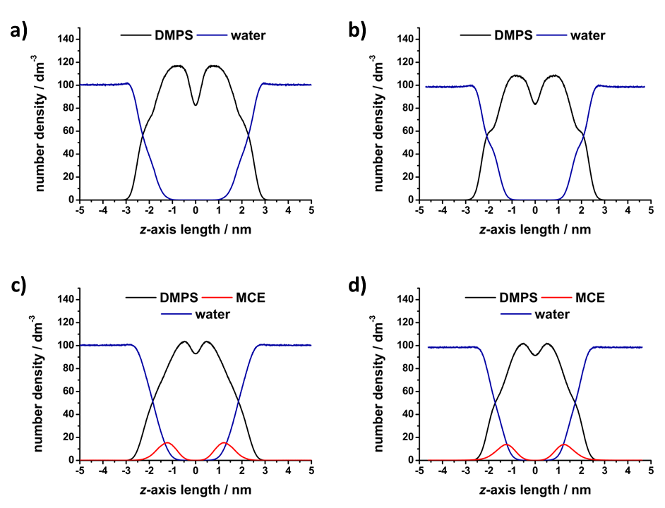
Fig. 4. Number density profiles of DMPS, MCE and water molecules along the z-axis of the simulation box, obtained from molecular dynamics simulations: a) DMPS at 30 °C, b) DMPS at 50 °C, c) DMPS+MCE at 30 °C and d) DMPS+MCE at 50 °C.

Water was able to penetrate the surface of the bilayers in all cases, showing some presence among the polar headgroups oriented outwards. In the center of the bilayer, water was excluded due to the hydrophobicity of the acyl chains. Then, the HB network was analyzed in order to confirm lipid-water interactions. As expected, MD simulations show better hydration and more HBs established in fluid phase systems (Table 3), since the separation of lipids due to expanding surface area allowed for more water to penetrate and bind to the lipid. The impact was notably greater for DMPS functional groups that are situated deeper into the bilayer, in accordance with findings showing solvent accessibility to be the greatest barrier to lipid group hydration [17]. Thus, the COO⁻ group which sits at the bilayer surface exposed to water showed no major change in H-bonding, while PO₂⁻ and carbonyl C=O were significantly better hydrated in fluid phase. Considering the aforementioned unreliability of DMPS+MCE results at lower temperature, we cannot draw conclusions on MCE impact. However, comparison of higher temperature simulations with and without MCE suggests some effect on increased water interactions, particularly with the deeply situated C=O group.

Table 3. Average number of hydrogen bonds (HBs) between select molecules or functional groups for DMPS and DMPS+MCE systems at 30 °C and 50 °C.
HBs | DMPS |  | DMPS+MCE
HBs | 30 °C | 50 °C | 30 °C | 50 °C
DMPS-water | 2165 ± 32 | 2257 ± 38 | 2355 ± 41 | 2334 ± 41
DMPS-MCE | / | / | 124 ± 10 | 119 ± 10
COO⁻-water | 910 ± 16 | 883 ± 20 | 929 ± 18 | 910 ± 18
NH₃⁺-water | 227 ± 9 | 242 ± 11 | 255 ± 14 | 266 ± 12
PO₂⁻-water | 574 ± 18 | 621 ± 19 | 647 ± 18 | 634 ± 19
C=O-water | 225 ± 10 | 274 ± 12 | 299 ± 14 | 307 ± 14

Deeper analysis of HB networks examined the average number of HBs an interfacial water molecule may form with lipids and surrounding water molecules. DMPS-water binding patterns (Table S2) show that most water molecules establish one HB with one DMPS molecule (1-1 pattern), but 15-20 % of waters form “bridges”, linking two lipids together (1-2 pattern). There is also a small amount of waters that establish two HBs with a single lipid, while other patterns are negligibly rare. When comparing the systems, it is notable that gel to fluid transition increases the percentage of 1-1 patterns from 75.8 ± 1.9 % to 80.1 ± 1.9 %, which is accompanied by the reduction in 1-2 patterns from 20.1 ± 1.2 % to 16.0 ± 1.0 %. On the other hand, water-water binding patterns revealed the amount of additional water-water HBs that each lipid-bound water may establish (Table S3). In all systems, the majority of bonded water at the interface established 1 or 2 more HBs with other waters, with less than 10% fulfilling their maximum of 3 additional HBs. Roughly a quarter of waters were not bonded to any other water, having been isolated within the bilayer, with all donor or acceptor sites occupied by DMPS or MCE. This is consistent with observations on the loss of the tetrahedral HB network in interfacial water [77]. However, the fluctuations in water network appeared to be insignificant between the systems. There is a small trend of decreasing the number of isolated waters (0 extra HBs), accompanied with a small increase in waters with 3 extra HBs when going from gel to fluid. Again, MCE effects at lower temperature must be dismissed as unreliable. Thus, DMPS-water and to a lesser extent water-water networks show some changes as a consequence of increased water penetration, though the MCE effect is inconclusive.
Despite the small scale of the effects on the simulated bilayer segments, in combination with experimental work they serve to confirm the temperature-dependent change in water behavior at the interface exacerbated by the presence of MCE. Ultimately, as demonstrated by Schönfeldová et al. [36], the melting itself induces redistribution of water molecules in the interfacial water layer. As this feature is changed upon the presence of MCE, as well as the characteristics of the melting itself (see Fig. S2), it is somewhat expected that the water HB network features are changed in DMPS±MCE situations. In the approach applied in this manuscript, this reflects on the difference in the fluctuations of a water HB network. Due to the great potential of the former, further development its methodology is underway.
- Conclusion
The research presented in this paper tackles the characterization of the fluctuations of HB network of water molecules found in the interfacial region of liposomes constituted from negative DMPS lipids. Using the presented multivariate-based approach, two important fluctuations-related findings are deciphered: i) when pH value of a PBS is changed, it appears that for pH 7.4 the fluctuations are slightly larger than for pH values 6.0 or 8.0; ii) when MCE, a non-polar flavonoid molecule, is inserted in the hydrocarbon region of DMPS multibilayers, the fluctuations are significantly reduced. The suggested enhancement of water molecules number in the interfacial region upon incorporation of MCE is also suggested from MD simulations, as well as a perturbation of membrane ordering.
Supporting Information
Supporting Information associated with this paper can be found in the online version at http://.
Conflicts of interest
There are no conflicts of interest to declare.
Acknowledgement
This paper was supported by Croatian Science Foundation through financing the project UIP-2020-02-7669 (“Model of demyelination on a molecular scale at physiological and pathological conditions”, DEMYMOLSCALE). The authors gratefully acknowledge members of Dr. Suzana Šegota (Laboratory for biocolloids and surface chemistry, Division for Physical Chemistry, Ruđer Bošković Institute) and to retired Dr. Goran Baranović (Laboratory for molecular spectroscopy, Division for Organic Chemistry and Biochemistry, Ruđer Bošković Institute) for their generosity in purchasing needed chemicals (DMPS and MCE).
Literature:
1. Kamenac, A.; Obser, T.; Wixforth, A.; Schneider, M.F.; Westerhausen, C. The Activity of the Intrinsically Water-Soluble Enzyme ADAMTS13 Correlates with the Membrane State When Bound to a Phospholipid Bilayer. Sci. Rep. 2021, 11, 1–9, doi:10.1038/s41598-021-04083-0.
2. Damodaran, S. Water at Biological Phase Boundaries: Lts Role in Interfacial Activation of Enzymes and Metabolic Pathways. In Membrane Hydration; E.A. Disalvo (ed.), Ed.; Madison, WI 53706, USA, 2015; Vol. 71, pp. 233–261 ISBN 9783319190600.
3. Schneck, E.; Sedlmeier, F.; Netz, R.R. Hydration Repulsion between Biomembranes Results from an Interplay of Dehydration and Depolarization. Proc. Natl. Acad. Sci. U. S. A. 2012, 109, 14405–14409, doi:10.1073/pnas.1205811109.
4. Kasson, P.M.; Lindahl, E.; Pande, V.S. Water Ordering at Membrane Interfaces Controls Fusion Dynamics. J. Am. Chem. Soc. 2011, 133, 3812–3815, doi:10.1021/ja200310d.
5. Chattopadhyay, M.; Krok, E.; Orlikowska, H.; Schwille, P.; Franquelim, H.G.; Piatkowski, L. Hydration Layer of Only a Few Molecules Controls Lipid Mobility in Biomimetic Membranes. J. Am. Chem. Soc. 2021, 143, 14551–14562, doi:10.1021/jacs.1c04314.
6. Saak, C.M.; Dreier, L.B.; Machel, K.; Bonn, M.; Backus, E.H.G. Biological Lipid Hydration: Distinct Mechanisms of Interfacial Water Alignment and Charge Screening for Model Lipid Membranes. Faraday Discuss. 2024, 249, 317–333, doi:10.1039/d3fd00117b.
7. Dreier, L.B.; Nagata, Y.; Lutz, H.; Gonella, G.; Hunger, J.; Backus, E.H.G.; Bonn, M. Saturation of Charge-Induced Water Alignment at Model Membrane Surfaces. Sci. Adv. 2018, 4, 1–9, doi:10.1126/sciadv.aap7415.
8. Laage, D.; Hynes, J.T. A Molecular Jump Mechanism of Water Reorientation. Science (80-. ). 2006, 311, 832–835, doi:10.1126/science.1122154.
9. Stirnemann, G.; Rossky, P.J.; Hynes, J.T.; Laage, D. Water Reorientation, Hydrogen-Bond Dynamics and 2D-IR Spectroscopy next to an Extended Hydrophobic Surface. Faraday Discuss. 2010, 146, 263–281, doi:10.1039/c005270c.
10. Re, S.; Nishima, W.; Tahara, T.; Sugita, Y. Mosaic of Water Orientation Structures at a Neutral Zwitterionic Lipid/Water Interface Revealed by Molecular Dynamics Simulations. J. Phys. Chem. Lett. 2014, 5, 4343–4348, doi:10.1021/jz502299m.
11. Kundu, A.; Kwak, K.; Cho, M. Water Structure at the Lipid Multibilayer Surface: Anionic Versus Cationic Head Group Effects. J. Phys. Chem. B 2016, 120, 5002–5007, doi:10.1021/acs.jpcb.6b02340.
12. Singh, P.C.; Inoue, K.I.; Nihonyanagi, S.; Yamaguchi, S.; Tahara, T. Femtosecond Hydrogen Bond Dynamics of Bulk-like and Bound Water at Positively and Negatively Charged Lipid Interfaces Revealed by 2D HD-VSFG Spectroscopy. Angew. Chemie - Int. Ed. 2016, 55, 10621–10625, doi:10.1002/anie.201603676.
13. Flanagan, J.C.; Valentine, M.L.; Baiz, C.R. Ultrafast Dynamics at Lipid-Water Interfaces. Acc. Chem. Res. 2020, 53, 1860–1868, doi:10.1021/acs.accounts.0c00302.
14. Livingstone, R.A.; Zhang, Z.; Piatkowski, L.; Bakker, H.J.; Hunger, J.; Bonn, M.; Backus, E.H.G. Water in Contact with a Cationic Lipid Exhibits Bulklike Vibrational Dynamics. J. Phys. Chem. B 2016, 120, 10069–10078, doi:10.1021/acs.jpcb.6b07085.
15. Ohto, T.; Backus, E.H.G.; Hsieh, C.S.; Sulpizi, M.; Bonn, M.; Nagata, Y. Lipid Carbonyl Groups Terminate the Hydrogen Bond Network of Membrane-Bound Water. J. Phys. Chem. Lett. 2015, 6, 4499–4503, doi:10.1021/acs.jpclett.5b02141.
16. Livingstone, R.A.; Nagata, Y.; Bonn, M.; Backus, E.H.G. Two Types of Water at the Water-Surfactant Interface Revealed by Time-Resolved Vibrational Spectroscopy. J. Am. Chem. Soc. 2015, 137, 14912–14919, doi:10.1021/jacs.5b07845.
17. Lopez, C.F.; Nielsen, S.O.; Klein, M.L.; Moore, P.B. Hydrogen Bonding Structure and Dynamics of Water at the Dimyristoylphosphatidylcholine Lipid Bilayer Surface from a Molecular Dynamics Simulation. J. Phys. Chem. B 2004, 108, 6603–6610, doi:10.1021/jp037618q.
18. Shen, H.; Wu, Z.; Zou, X. Interfacial Water Structure at Zwitterionic Membrane/Water Interface: The Importance of Interactions between Water and Lipid Carbonyl Groups. ACS Omega 2020, 5, 18080–18090, doi:10.1021/acsomega.0c01633.
19. Karathanou, K.; Bondar, A.N. Dynamic Water Hydrogen-Bond Networks at the Interface of a Lipid Membrane Containing Palmitoyl-Oleoyl Phosphatidylglycerol. J. Membr. Biol. 2018, 251, 461–473, doi:10.1007/s00232-018-0023-1.
20. Inoue, K.I.; Singh, P.C.; Nihonyanagi, S.; Yamaguchi, S.; Tahara, T. Cooperative Hydrogen-Bond Dynamics at a Zwitterionic Lipid/Water Interface Revealed by 2D HD-VSFG Spectroscopy. J. Phys. Chem. Lett. 2017, 8, 5160–5165, doi:10.1021/acs.jpclett.7b02057.
21. Srivastava, A.; Malik, S.; Debnath, A. Heterogeneity in Structure and Dynamics of Water near Bilayers Using TIP3P and TIP4P/2005 Water Models. Chem. Phys. 2019, 525, 110396, doi:10.1016/j.chemphys.2019.110396.
22. Calero, C.; Stanley, H.E.; Franzese, G. Structural Interpretation of the Large Slowdown of Water Dynamics at Stacked Phospholipid Membranes for Decreasing Hydration Level: All-Atom Molecular Dynamics. Materials (Basel). 2016, 9, 1–14, doi:10.3390/ma9050319.
23. Zhao, L.; Ma, K.; Yang, Z. Changes of Water Hydrogen Bond Network with Different Externalities. Int. J. Mol. Sci. 2015, 16, 8454–8489, doi:10.3390/ijms16048454.
24. Fayer, M.D. Dynamics of Water Interacting with Interfaces, Molecules, and Ions. Acc. Chem. Res. 2012, 45, 3–14, doi:10.1021/ar2000088.Dynamics.
25. Piskulich, Z.A.; Laage, D.; Thompson, W.H. On the Role of Hydrogen-Bond Exchanges in the Spectral Diffusion of Water. J. Chem. Phys. 2021, 154, 064501, 9, doi:10.1063/5.0041270.
26. Gruenbaum, S.M.; Skinner, J.L. Vibrational Spectroscopy of Water in Hydrated Lipid Multi-Bilayers. I. Infrared Spectra and Ultrafast Pump-Probe Observables. J. Chem. Phys. 2011, 135, 075101, 13, doi:10.1063/1.3615717.
27. Valentine, M.L.; Waterland, M.K.; Fathizadeh, A.; Elber, R.; Baiz, C.R. Interfacial Dynamics in Lipid Membranes: The Effects of Headgroup Structures. J. Phys. Chem. B 2021, 125, 1343–1350, doi:10.1021/acs.jpcb.0c08755.
28. Flanagan, J.C.; Cardenas, A.E.; Baiz, C.R. Ultrafast Spectroscopy of Lipid-Water Interfaces: Transmembrane Crowding Drives H-Bond Dynamics. J. Phys. Chem. Lett. 2020, 11, 4093–4098, doi:10.1021/acs.jpclett.0c00783.
29. Maréchal, Y. The H₂O Molecules in Liquid Water. In The Hydrogen Bond and the Water Molecule; Elsevier Ltd, 2007; pp. 215–248.
30. Verma, P.K.; Kundu, A.; Puretz, M.S.; Dhoonmoon, C.; Chegwidden, O.S.; Londergan, C.H.; Cho, M. The Bend+Libration Combination Band Is an Intrinsic, Collective, and Strongly Solute-Dependent Reporter on the Hydrogen Bonding Network of Liquid Water. J. Phys. Chem. B 2018, 122, 2587–2599, doi:10.1021/acs.jpcb.7b09641.
31. Tong, Y.; Kampfrath, T.; Campen, R.K. Experimentally Probing the Libration of Interfacial Water: The Rotational Potential of Water Is Stiffer at the Air/Water Interface than in Bulk Liquid. Phys. Chem. Chem. Phys. 2016, 18, 18424–18430, doi:10.1039/c6cp01004k.
32. Brkljača, Z.; Butumović, M.; Bakarić, D. Water Does Not Dance as Ions Sing: A New Approach in Elucidation of Ion-Invariant Water Fluctuation. Spectrochim. Acta Part A Mol. Biomol. Spectrosc. 2022, 271, 120907.
33. Libnau, F.O.; Toft, J.; Christy, A.A.; Kvalheim, O.M. Structure of Liquid Water Determined from Infrared Temperature Profiling and Evolutionary Curve Resolution. J. Am. Chem. Soc. 1994, 116, 8311–8316, doi:10.1021/ja00097a043.
34. Czarnik-Matusewicz, B.; Pilorz, S.; Hawranek, J.P. Temperature-Dependent Water Structural Transitions Examined by near-IR and Mid-IR Spectra Analyzed by Multivariate Curve Resolution and Two-Dimensional Correlation Spectroscopy. Anal. Chim. Acta 2005, 544, 15–25, doi:10.1016/j.aca.2005.04.040.
35. Chen, Y.; Dupertuis, N.; Okur, H.I.; Roke, S. Temperature Dependence of Water-Water and Ion-Water Correlations in Bulk Water and Electrolyte Solutions Probed by Femtosecond Elastic Second Harmonic Scattering. J. Chem. Phys. 2018, 148, 222835, 7, doi:10.1063/1.5023343.
36. Schönfeldová, T.; Piller, P.; Kovacik, F.; Pabst, G.; Okur, H.I.; Roke, S. Lipid Melting Transitions Involve Structural Redistribution of Interfacial Water. J. Phys. Chem. B 2021, 125, 12457–12465, doi:10.1021/acs.jpcb.1c06868.
37. Bach, D.; Miller, I.R. Hydration of Phospholipid Bilayers in the Presence and Absence of Cholesterol. Biochim. Biophys. Acta 1998, 1368, 216–224, doi:10.1016/j.chemphyslip.2005.04.001.
38. Heimburg, T. Thermal Biophysics of Membranes; Wiley-VCH Verlag GmbH, Ed.; Weinheim, 2007; ISBN 9783527404711.
39. May, S. Curvature Elasticity and Thermodynamic Stability of Electrically Charged Membranes. J. Chem. Phys. 1996, 105, 8314–8323, doi:10.1063/1.472686.
40. Pašalić, L.; Pem, B.; Bakarić, D. Lamellarity-Driven Differences in Surface Structural Features of DPPS Lipids: Spectroscopic, Calorimetric and Computational Study. Membranes (Basel). 2023, 13, doi:10.3390/membranes13010083.
41. Sadžak, A.; Brkljača, Z.; Crnolatac, I.; Baranović, G.; Šegota, S. Flavonol Clustering in Model Lipid Membranes: DSC, AFM, Force Spectroscopy and MD Simulations Study. Colloids Surfaces B Biointerfaces 2020, 193, 111147, doi:10.1016/j.colsurfb.2020.111147.
42. Dale Keefe, C. Computer Programs for the Determination of Optical Constants from Transmission Spectra and the Study of Absolute Absorption Intensities. J. Mol. Struct. 2002, 641, 165–173, doi:10.1016/S0022-2860(02)00184-9.
43. F. Menges “Spectragryph - Optical Spectroscopy Software.” (03.01.2024). https://www.effemm2.de/spectragryph/.
44. Cevc, G.; Watts, A.; Marsh, D. Titration of the Phase Transition of Phosphatidylserine Bilayer Membranes. Effects of pH, Surface Electrostatics, Ion Binding, and Head-Group Hydration. Biochemistry 1981, 20, 4955–4965.
45. Lewis, R.N.A.H.; McElhaney, R.N. Calorimetric and Spectroscopic Studies of the Thermotropic Phase Behavior of Lipid Bilayer Model Membranes Composed of a Homologous Series of Linear Saturated Phosphatidylserines. Biophys. J. 2000, 79, 2043–2055, doi:10.1016/S0006-3495(00)76452-6.
46. Maeder, M.; de Juan, A. Two-Way Data Analysis: Evolving Factor Analysis. Compr. Chemom. 2009, 2, 261–274, doi:10.1016/B978-044452701-1.00047-8.
47. Keller, H.R.; Massart, D.L. Evolving Factor Analysis. Chemom. Intell. Lab. Syst. 1991, 12, 209–224, doi:10.1016/0169-7439(92)80002-L.
48. Maleš, P.; Brkljača, Z.; Crnolatac, I.; Bakarić, D. Application of MCR-ALS with EFA on FT-IR Spectra of Lipid Bilayers in the Assessment of Phase Transition Temperatures: Potential for Discernment of Coupled Events. Colloids Surfaces B Biointerfaces 2021, 201, 111645, 8, doi:10.1016/j.colsurfb.2021.111645.
49. Jaumot, J.; Gargallo, R.; De Juan, A.; Tauler, R. A Graphical User-Friendly Interface for MCR-ALS: A New Tool for Multivariate Curve Resolution in MATLAB. Chemom. Intell. Lab. Syst. 2005, 76, 101–110, doi:10.1016/j.chemolab.2004.12.007.
50. De Juan, A.; Jaumot, J.; Tauler, R. Multivariate Curve Resolution (MCR). Solving the Mixture Analysis Problem. Anal. Methods 2014, 6, 4964–4976, doi:10.1039/c4ay00571f.
51. Fega, K.R.; Wilcox, D.S.; Ben-Amotz, D. Application of Raman Multivariate Curve Resolution to Solvation-Shell Spectroscopy. Appl. Spectrosc. 2012, 66, 282–288, doi:10.1366/11-06442.
52. Jo, S.; Kim, T.; Iyer, V.G.; Im, W. CHARMM-GUI: A Web-Based Graphical User Interface for CHARMM. J. Comput. Chem. 2008, 29, 1859–1865, doi:10.1002/jcc.20945.
53. Abraham, M.J.; Murtola, T.; Schulz, R.; Páll, S.; Smith, J.C.; Hess, B.; Lindah, E. Gromacs: High Performance Molecular Simulations through Multi-Level Parallelism from Laptops to Supercomputers. SoftwareX 2015, 1–2, 19–25, doi:10.1016/j.softx.2015.06.001.
54. Klauda, J.B.; Venable, R.M.; Freites, J.A.; O’Connor, J.W.; Tobias, D.J.; Mondragon-Ramirez, C.; Vorobyov, I.; MacKerell Jr, A.D.; Pastor, R.W. Update of the CHARMM All-Atom Additive Force Field for Lipids: Validation on Six Lipid Types. J Phys Chem B 2010, 114, 7830–7843, doi:10.1021/jp101759q.Update.
55. Jorgensen, W.L.; Chandrasekhar, J.; Madura, J.D.; Impey, R.W.; Klein, M.L. Comparison of Simple Potential Functions for Simulating Liquid Water. J. Chem. Phys. 1983, 79, 926–935, doi:10.1063/1.445869.
56. VANOMMESLAEGHE, K.; HATCHER, E.; ACHARYA, C.; KUNDU, S.; ZHONG, S.; SHIM, J.; DARIAN, E.; GUVENCH, O.; LOPES, P.; VOROBYOV, I.; et al. CHARMM General Force Field: A Force Field for Drug-Like Molecules Compatible with the CHARMM All-Atom Additive Biological Force Fields. J. Comput. Chem. 2010, 31, 671–690, doi:10.1002/jcc.
57. MacKerell Lab Available online: http://mackerell.umaryland.edu/charmm_ff.shtml#gromacs. (12.02.2024).
58. Nosé, S. A Molecular Dynamics Method for Simulations in the Canonical Ensemble. Mol. Phys. An Int. J. Interface Between Chem. Phys. 1984, 52, 255–268.
59. Parrinello, M.; Rahman, A. Polymorphic Transitions in Single Crystals: A New Molecular Dynamics Method. J. Appl. Phys. 1981, 52, 7182–7190, doi:10.1063/1.328693.
60. Essmann, U.; Perera, L.; Berkowitz, M.L.; Darden, T.; Lee, H.; Pedersen, L.G. A Smooth Particle Mesh Ewald Method. J. Chem. Phys. 1995, 103, 8577–8593, doi:10.1063/1.470117.
61. Humphrey, W.; Dalke, A.; Schulten, K. VMD: Visual Molecular Dynamics. J. Mol. Graph. 1996, 14, 33–38, doi:10.1016/j.carbon.2017.07.012.
62. Lewis, R.N.A.H.; McElhaney, R.N. Membrane Lipid Phase Transitions and Phase Organization Studied by Fourier Transform Infrared Spectroscopy. Biochim. Biophys. Acta - Biomembr. 2013, 1828, 2347–2358, doi:10.1016/j.bbamem.2012.10.018.
63. Browning, J.L.; Seelig, J. Bilayers of Phosphatidylserine: A Deuterium and Phosphorus Nuclear Magnetic Resonance Study. Biochemistry 1980, 19, 1262–1270, doi:10.1021/bi00547a034.
64. Ge, M.; Freed, J.H. Hydration, Structure, and Molecular Interactions in the Headgroup Region of Dioleoylphosphatidylcholine Bilayers: An Electron Spin Resonance Study. Biophys. J. 2003, 85, 4023–4040, doi:10.1016/S0006-3495(03)74816-4.
65. Šegota, S.; Vojta, D.; Kendziora, D.; Ahmed, I.; Fruk, L.; Baranović, G. Ligand-Dependent Nanoparticle Clustering within Lipid Membranes Induced by Surrounding Medium. J. Phys. Chem. B 2015, 119, 5208–5219, doi:10.1021/acs.jpcb.5b00898.
66. Khakbaz, P.; Klauda, J.B. Investigation of Phase Transitions of Saturated Phosphocholine Lipid Bilayers via Molecular Dynamics Simulations. Biochim. Biophys. Acta - Biomembr. 2018, 1860, 1489–1501, doi:10.1016/j.bbamem.2018.04.014.
67. Moradi, S.; Nowroozi, A.; Shahlaei, M. Shedding Light on the Structural Properties of Lipid Bilayers Using Molecular Dynamics Simulation: A Review Study. RSC Adv. 2019, 9, 4644–4658, doi:10.1039/C8RA08441F.
68. Hishida, M.; Endo, A.; Nakazawa, K.; Yamamura, Y.; Saito, K. Effect of N-Alkanes on Lipid Bilayers Depending on Headgroups. Chem. Phys. Lipids 2015, 188, 61–67, doi:10.1016/j.chemphyslip.2015.05.002.
69. Korchowiec, B.; Gorczyca, M.; Rogalska, E.; Regnouf-De-Vains, J.B.; Mourer, M.; Korchowiec, J. The Selective Interactions of Cationic Tetra-p-Guanidinoethylcalix[4]Arene with Lipid Membranes: Theoretical and Experimental Model Studies. Soft Matter 2015, 12, 181–190, doi:10.1039/c5sm01891a.
70. Yousefpour, A.; Amjad-Iranagh, S.; Goharpey, F.; Modarress, H. Effect of Drug Amlodipine on the Charged Lipid Bilayer Cell Membranes DMPS and DMPS + DMPC: A Molecular Dynamics Simulation Study. Eur. Biophys. J. 2018, 47, 939–950, doi:10.1007/s00249-018-1317-z.
71. Hauser, H.; Paltauf, F.; Shipley, G.G. Structure and Thermotropic Behavior of Phosphatidylserine Bilayer Membranes. Biochemistry 1982, 21, 1061–1067, doi:10.1021/bi00534a037.
72. Eid, J.; Jraij, A.; Greige-Gerges, H.; Monticelli, L. Effect of Quercetin on Lipid Membrane Rigidity: Assessment by Atomic Force Microscopy and Molecular Dynamics Simulations. BBA Adv. 2021, 1, doi:10.1016/j.bbadva.2021.100018.
73. Raghunathan, M.; Zubovski, Y.; Venable, R.M.; Pastor, R.W.; Nagle, J.F.; Tristram-Nagle, S. Structure and Elasticity of Lipid Membranes with Genistein and Daidzein Bioflavinoids Using X-Ray Scattering and MD Simulations. J. Phys. Chem. B 2012, 116, 3918–3927, doi:10.1021/jp211904j.
74. Selvaraj, S.; Krishnaswamy, S.; Devashya, V.; Sethuraman, S.; Krishnan, U.M. Influence of Membrane Lipid Composition on Flavonoid-Membrane Interactions: Implications on Their Biological Activity. Prog. Lipid Res. 2015, 58, 1–13, doi:10.1016/j.plipres.2014.11.002.
75. Abram, V.; Berlec, B.; Ota, A.; Šentjurc, M.; Blatnik, P.; Ulrih, N.P. Effect of Flavonoid Structure on the Fluidity of Model Lipid Membranes. Food Chem. 2013, 139, 804–813, doi:10.1016/j.foodchem.2013.01.100.
76. Altunayar-Unsalan, C.; Unsalan, O.; Mavromoustakos, T. Insights into Molecular Mechanism of Action of Citrus Flavonoids Hesperidin and Naringin on Lipid Bilayers Using Spectroscopic, Calorimetric, Microscopic and Theoretical Studies. J. Mol. Liq. 2022, 347, 118411, doi:10.1016/j.molliq.2021.118411.
77. Srivastava, A.; Debnath, A. Hydration Dynamics of a Lipid Membrane: Hydrogen Bond Networks and Lipid-Lipid Associations. J. Chem. Phys. 2018, 148, 094901, 11, doi:10.1063/1.5011803.

Neé Ana-Marija Čižmek. Present address: Eurofins Croatiakontrola laboratory, Karlovačka 4 L, 10000 Zagreb, Croatia.

